

**INDUSTRIAL VISIT REPORT**

Program: M.Sc. (Data Science & Analytics)

Semester: II

Session:2022-2023

**Submitted by:**

Student Name: Vaibhav Kumar

System ID: 2022401002

**Submitted to:**

Dr. R.K. Pavan Kumar Pannala

Head Of the Department

Department of Mathematics

Sharda School of Basic Sciences and Research

Sharda University

Knowledge Park -III , Greater Noida, Uttar Pradesh

* **Overview Of the Trip**

On April 24th 2023 , Sharda University organized a field trip to Vividh Packaging Industries, a leading packaging company located in the industrial area of Greater Noida. The trip was organized for the students of the Department of Mathematics, and it aimed to provide practical exposure to the students about the various packaging techniques and processes used in the industry.

The students were then taken on a guided tour of the company's manufacturing plant, where they got to see the various stages of the packaging process. They also got an opportunity to interact with the company's production team and understand the different aspects of the packaging industry.

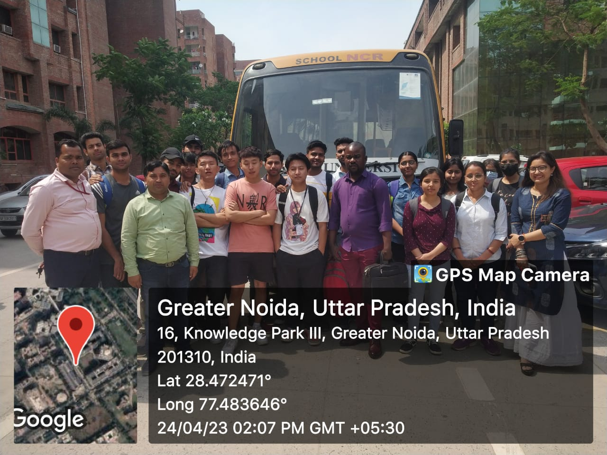

* **Company Profile**

**Introduction**

Founded by Sh. K.P. Singh Ex. official (U.P.C.B.M.A.) in 1994.

Vividh Packaging Industries is a leading packaging company located in the industrial area of Greater Noida, India. The company was established in the year 1994 and has since then been providing innovative and customized packaging solutions to various industries.

This ISO 9001 - 2015 corrugated box manufacturing industry was established in 1994 with wide array of corrugated packaging material. In 2004 – addition of vacuum forming & blister packaging.

They work to economize the existing packaging, for these activities they have received appreciation from the customers and awards from reputed associations. One of such innovation was done for a well reputed company manufacturing T-5 and T-8 tubes and incurring heavy losses due to transit breakage, various options were tried but desired results were not obtained. They studied the probable reasons and used air as cushions, Used 3-ply trays in all the 6 sides and the problem was completely eliminated. For this innovation the company won UP Star Corrugator Award in 2012.

Vividh Packaging Industries has a team of highly skilled and experienced professionals who are dedicated to providing the best packaging solutions to their clients. The company's focus on innovation, quality, and customer satisfaction has helped it to establish itself as a trusted brand in the industry.

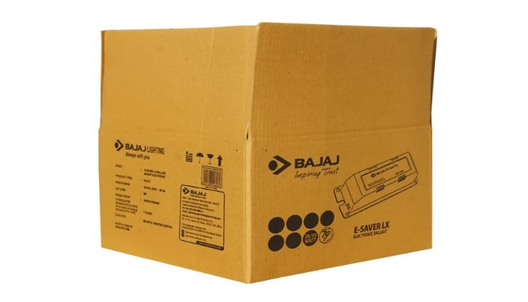**Product Range**

* Regular slotted carton
* Mono cartons
* Telescope type
* POS displays
* Folding carton
* Liner carton
* One-Piece case
* Blister packaging
* Vaccum formed thermoplastic sheets

**Machines used for manufacturing**

Premium quality raw materials are employed in the production process sourced from authentic vendors having a reputed name in the industry. The machines used in the industry are :

* 2- Paper corrugating machines
* 2-Automatic Corrugated Paper Cutting Machine with Slitter
* 2-Rotary Cutting & Creasing
* 2-Eccentric Slot
* 4-Sheet pasting
* 3-Die Punching
* Board Cutter
* 4-Box Stitching
* Flexo Board Printer
* Offset Printing Machine

We work in collaboration with automatic 5- Ply line 2200 mm width and 4000 mt ton/month. Our work force comprises of experienced engineers and supervisors who have served the industry for many decades and have developed firm expertise in this field.

Material Type: PVC, PET, HIPS, ABS

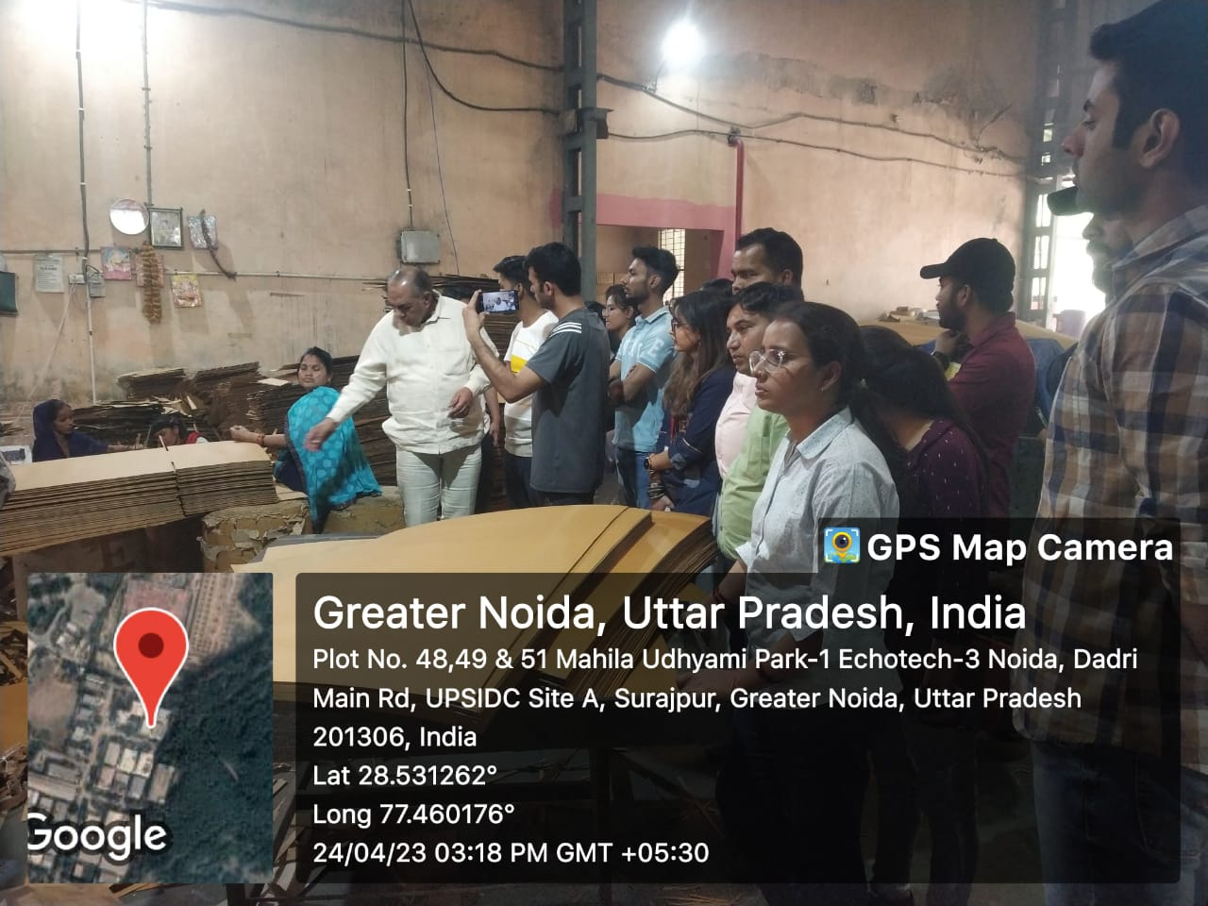

**Testing Facility**

* Gramage
* Cobb Value
* Drop Test
* Bending Stiffness
* Bursting Strength
* Moisture Content
* Vibration Test
* Edgewise compression strength
* Puncture Resistance
* Inclined impact Test
* Box Compression Strength

**Clients**

* Samsung
* Luxor
* Sony
* Halonix
* Orient Electric
* Overdrive
* Romsons
* Pheonix
* Aisen
* PPAP
* Dixon
* Protonix
* BKB
* Indo Solar
* Mayfair

and many more.

* **Dangers**

Chemical risks: Hazardous chemicals that can be dangerous to the health of employees may be present in packaging materials including adhesives, inks, and solvents used in the manufacturing process.

Physical risks: Workers who operate with the machinery used in the packaging business run the danger of becoming hurt. Additionally, there is a chance that workers could trip, fall, or be hit by objects that are falling.

Fire risks: The packaging sector is susceptible to fires due to the use of heat during the manufacturing process and the presence of combustible materials.

Environmental risks: If packaging materials are disposed of improperly, environmental risks may result. Among other environmental problems, improper garbage disposal can lead to soil and water pollution

* **Learnings from the Visit**
* Practical Exposure: The visit provided the students with practical exposure to the packaging industry, giving them a better understanding of the various techniques and processes used in the industry.
* Knowledge of Latest Technology: The students got an opportunity to see the latest technology and equipment used in the industry, which helped them understand the importance of innovation in the packaging industry.
* Interpersonal Skills: The visit helped students to develop their interpersonal skills, as they interacted with the production team and senior executives of the company.
* Career Prospects: The visit also helped students to explore career prospects in the packaging industry, giving them insights into the different roles and responsibilities in the industry.

Overall, the industrial visit to Vividh Packaging Industries was a great learning experience for the students, providing them with valuable insights into the practical aspects of the packaging industry and helping them to develop important skills and knowledge.

* **Use of Data Science in the company to increase the profit**
* Predictive Maintenance: Data science can be used to analyze the data from the machinery and equipment used in the production process. This can help to predict when maintenance is required, which can reduce downtime and increase production efficiency, ultimately leading to increased profits.
* Quality Control: Data science can be used to analyze data from the production process to identify patterns and trends that can help to improve quality control. This can reduce the number of defective products, reduce waste, and improve customer satisfaction, ultimately leading to increased profits.
* Demand Forecasting: Data science can be used to analyze market trends and customer behavior to forecast demand for the company's products. This can help to optimize production and inventory management, reduce costs, and increase profits.
* Pricing Optimization: Data science can be used to analyze customer behavior and market trends to optimize pricing strategies. This can help to maximize profits while remaining competitive in the market.
* Supply Chain Optimization: Data science can be used to analyze supply chain data to optimize logistics, inventory management, and procurement. This can help to reduce costs, improve efficiency, and ultimately increase profits.

In summary, data science can be used in several ways in Vividh Packaging Industries to improve profits by optimizing production processes, improving quality control, forecasting demand, optimizing pricing strategies, and optimizing the supply chain.