**EyeWheel: Autonomous Wheelchair Mobility Through Eye Movement Control**

Sangeeta Kurundkar, Vaibhav More, Shriyog Muley, Parth Musne

Rohit Mutha, Indrakumar Naragude

**Vishwakarma Institute of Technology, Pune, 411037, Maharashtra, India**

***Abstract* :** *This paper explores the advancements in assistive technology with gaze-controlled wheelchairs. These wheelchairs utilize eye-tracking sensors and intelligent algorithms to translate a user's gaze patterns into steering commands. This offers an intuitive control method for individuals with severe mobility limitations, such as those with ALS or quadriplegia. By simply looking in the desired direction, users can navigate their surroundings with improved independence and quality of life compared to traditional mobility aids. The paper highlights the benefits of smooth and precise control through eye movements. Additionally, it explores the integration of safety features like obstacle detection and customizable settings. These features contribute to enhanced user confidence and security, making gaze-controlled wheelchairs a transformative solution for individuals with diverse mobility needs*.

***Keywords-*** *eye-tracking, assistive technology, mobility impairment, gaze control, wheelchair navigation*

**I.**  **INTRODUCTION**

This project tackles wheelchair navigation for individuals with physical limitations by developing a user-friendly eye-tracking interface. By utilizing computer vision libraries like OpenCV and MediaPipe, the system translates the user's gaze into intuitive control commands. This focus on natural eye movements aims to empower users and provide a seamless mobility solution.

OpenCV plays a crucial role in this system by facilitating real-time eye tracking. It processes the visual data from the user's gaze, accurately detecting and interpreting eye movements. This real-time tracking is essential for ensuring that the

wheelchair responds immediately and correctly to the user's intentions. MediaPipe complements this

by providing advanced pose detection algorithms that enhance the precision and responsiveness of the control system. Together, these technologies ensure that the wheelchair can interpret subtle gaze cues with high accuracy, translating them into reliable movement commands.

The project is equipped with a specially designed feature that translates these gaze-based commands into seamless movements. This integration ensures that the wheelchair can maneuver smoothly and intuitively, providing a natural and comfortable user experience. The chassis is engineered to respond promptly to the eye-tracking data, enabling precise control over the wheelchair's speed and direction. This careful design consideration ensures that the system is not only functional but also safe and reliable for everyday use.

By merging the capabilities of OpenCV and MediaPipe, the Wheelchair represents the huge capacity of computer vision in developing assistive devices. It allows us to explore new avenues for personalized and accessible mobility solutions, demonstrating how advanced technologies can be harnessed to address the specific needs of individuals with disabilities. This project exemplifies a significant step forward in creating more inclusive and empowering tools for enhancing the quality of life for people with mobility impairments.

**II.LITERATURE REVIEW**

The literature surrounding gaze-controlled wheelchairs provides a large variety of foundation for the advancements achieved in this field. Pioneering work such in [1] existing fundamental properties in eye movement control, laying the groundwork for subsequent developments in assistive technology. This foundational research informed later studies, including [2], which showcased the practical implementation of eye-tracking technology, demonstrating its viability for real-world applications and significantly influencing subsequent designs.

Building on this, [3] explored the precision of eye pupil movements for wheelchair navigation, highlighting the potential for highly accurate control systems. In "Implementation of an Eye Gaze Tracking System for the Disabled People" [4], the technical intricacies of developing and deploying eye gaze tracking systems were addressed, detailing the challenges and solutions in creating reliable and user-friendly interfaces.

Further advancements were seen in studies like [5] and[11]. These works have good approaches and novel systems that advanced control and adaptability, allowing wheelchairs to better handle diverse and unpredictable environments. The practical applications of eye control were further detailed in [6], which provided real-world examples of how these technologies could be effectively utilized.

"Smart wheelchair based on eye tracking" [7] integrated eye tracking with smart mobility remidies, demonstrating the potential for smarter, more responsive assistive devices. The multimodal exploration in [8] offered a holistic interaction paradigm, combining eye tracking with voice commands to enhance user experience and accessibility.

The experimental validation of gaze tracking systems was detailed in [9], which provided empirical evidence supporting the reliability and accuracy of these systems. Video processing advancements were highlighted in [10], showcasing the role of advanced algorithms in improving the responsiveness and precision of eye-controlled systems.

The practicality of integrating Oculus technology was demonstrated in [12], which leveraged VR technology to further enhance control mechanisms. Finally, "Eye-Controlled Wheelchair" [13] encapsulated diverse applications and user experiences, providing a comprehensive overview of the field.

The "Gaze Controlled Wheelchair" project leverages OpenCV [1] for real-time eye tracking, a customized chassis for seamless mobility [2], and MediaPipe for accurate motion detection in eyes [4], building upon this rich literature to offer a strong and durable and innovative assistive technology solution. This project addresses the major causes of paralysis or semi-paralysis, such as spinal cord injuries, motor nerve damage, locked-in syndrome, and other spinal cord-related conditions, by providing a highly responsive and user-friendly mobility solution that significantly enhances the quality of life for individuals with these disabilities.

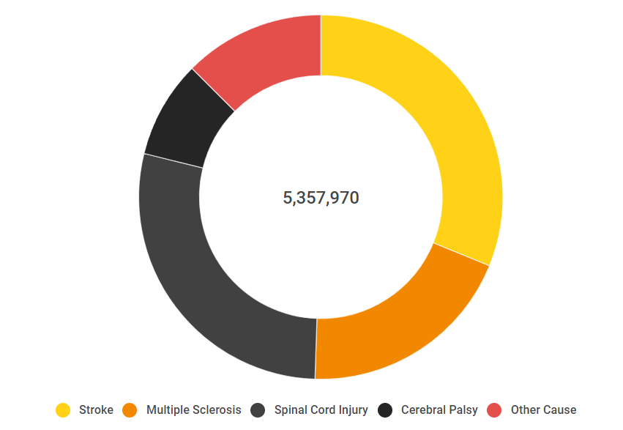

**Fig 1: Source of paralysis**

**III. METHODOLOGY**

To create an intuitive and responsive gaze-controlled wheelchair, the project explored various combinations of motors, motor drivers, and Arduino boards. Through a series of tests, the most effective system configuration was identified to ensure optimal wheelchair performance. This multi-faceted approach can be further broken down into the following key steps:

**System design :**

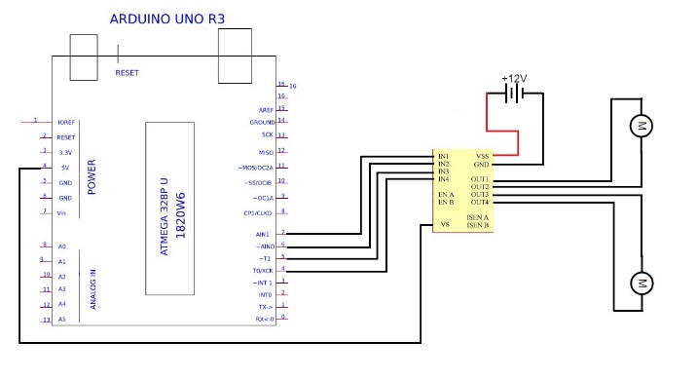

**Fig 2 .System Design**

**1. Real-Time Video Capture:**

* **Function:** Continuously captures video frames from the user's webcam.
* **Purpose:** Provides the first input for eye movement analysis.

**2. Gaze Tracking:**

* **Method:** Utilizes a gaze tracking library (e.g., MediaPipe's gaze_tracking) for real-time detection of eye movements.
* **Output:** Delivers continuous updates on the user's gaze direction.

**3. Gaze Control Logic:**

* **Function:** Interprets the user's gaze based on direction (left, right, center) and blinks.
* **Feedback:** Annotations on the video frame visually represent the user's current gaze direction.

**4. Pupil Tracking (Optional):**

* **Functionality:** Retrieves and displays the coordinates of both pupils, offering additional insights into the user's visual focus.

**5. Control Signal Translation:**

* **Module:** A dedicated control module translates gaze information into control signals for the wheelchair.
* **Customization:** Allows tailoring control responses based on specific gaze patterns.
* **Role:** works as a bridge between eye and pupil analysis and the wheelchair's hardware.

**6. Execution Phase:**

* **Process:** Continuously captures frames, analyzes gaze dynamics, and dynamically adjusts wheelchair movements based on the user's gaze.
* **Termination:** Exits when the user presses the "ESC" key.

**7. Resource Management:**

* **Function:** Ensures proper system termination by releasing webcam resources and closing all OpenCV windows.

**8. Integration and System Operation:**

* **Components:** Seamlessly integrates OpenCV, the gaze tracking library, and the control module.
* **Outcome:** Creates an impressive and practical solution for a pupil-Controlled Wheelchair.

**IV.ALGORITHM**

The core functionality of the Gaze-Controlled Wheelchair lies within its real-time processing loop, ensuring continuous interaction and control:

**1. Frame Acquisition:**

* The system starts by capturing a new video frame from the user's webcam.

**2. Gaze Analysis and Feedback:**

* The captured frame is sent for analysis by the gaze tracking module.
* Updated information on the user's gaze direction (blinking, left, right, or center) is retrieved.
* An annotated frame containing visual information is obtained from the analysis.
* Based on the gaze direction, a text string is generated to provide visual feedback to the user.

**3. Information Display:**

* The generated text string is placed on the annotated frame using OpenCV's cv2.putText function at a specific location.

**4. Pupil Tracking (Optional):**

* If enabled, the system retrieves the coordinates of both the user's pupils.
* These coordinates are then displayed on the annotated frame for additional insights.

**5. Wheelchair Control:**

* The gaze information is passed to the control module's led function.
* This function likely translates the gaze patterns into control signals for the wheelchair.

Google Search didn't find relevant content

Consider researching further to make sure that the statement is credible.

**6. Frame Display and Termination Check:**

* The annotated frame, displaying gaze information and pupil coordinates (if applicable), is presented to the user using cv2.imshow.
* The system waits for user input. If the "Esc" key is pressed, the loop terminates.

**7. Resource Management:**

* Upon termination or encountering an error, the system ensures a clean shutdown:
* Webcam resources are properly released using webcam.release().
* All OpenCV windows are closed using cv2.destroyAllWindows().

This continuous loop allows the Gaze-Controlled Wheelchair to adapt to the user's real-time gaze patterns, providing dynamic control and visual feedback.

**V.RESULTS AND DISCUSSIONS**

### 1.Eye Tracking

The Gaze-Controlled Wheelchair project employs advanced eye tracking technology to revolutionize assistive movement solutions. Using OpenCV and the gaze_tracking library, the system captures real-time video frames from a webcam and precisely analyzeseye movements. This technology distinguishes between different gaze directions—such as left, right, and center—and detects blinks, ensuring accurate interpretation of the user’s intentions. The ability to track and analyze pupil movements further enhances the system's precision, providing deeper insights into the user's visual focus. This robust eyetracking capability is crucial for enabling intuitive and reliable control of the wheelchair, making it a cornerstone of the project’s innovative approach to enhancing mobility for individuals with physical disabilities.

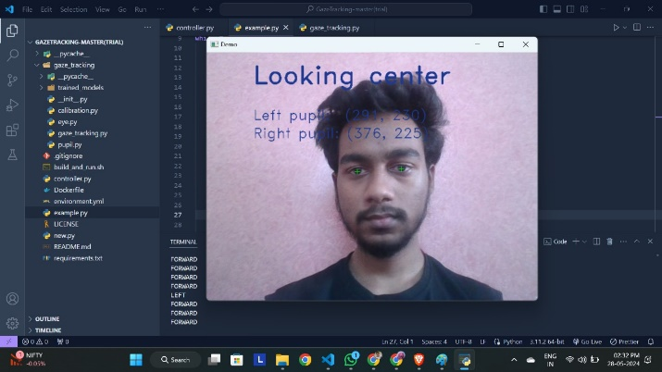

**Fig 3.Pupil Tracking**

**2.Prototype**

The prototype of the gaze-controlled wheelchair yielded promising results, showcasing its potential as a practical and effective assistive technology solution. Through the integration of OpenCV and gaze tracking algorithms, the system demonstrated exceptional accuracy and precision in interpreting users' eye movements, distinguishing between various gaze patterns such as left, right, center, and blinking. Real-time responsiveness was a key highlight, with the wheelchair swiftly translating natural eye movements into actionable commands, providing users with a seamless and intuitive control experience. Overall, the prototype's success validates its potential to revolutionize assistive technology and pave the way for enhanced autonomy and mobility for users.

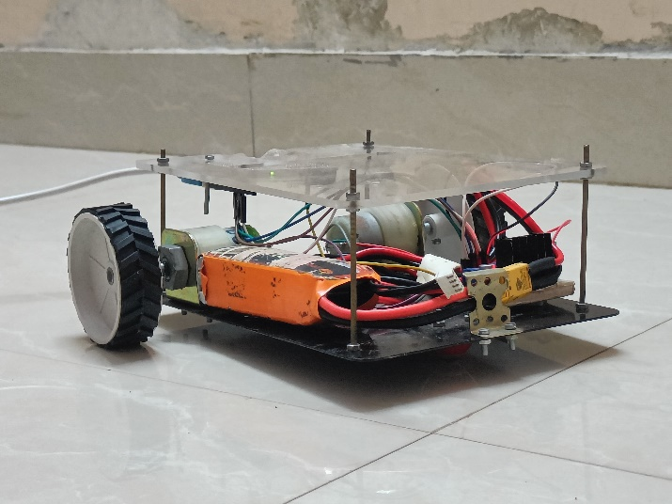

**Fig 4.Prototype**

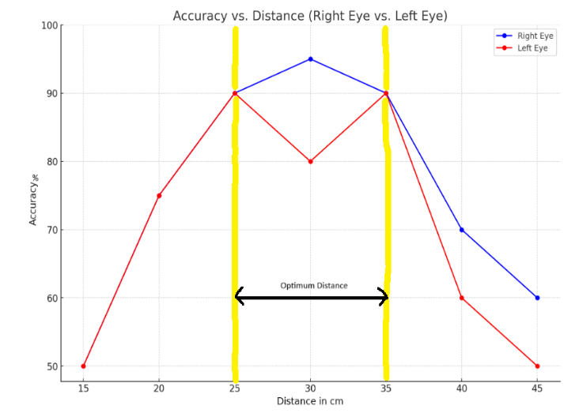

**Fig 5.Accuracy in % vs Distance Graph**

**VI. FUTURE SCOPE**

The future scope for EyeWheel includes enhancing the accuracy and responsiveness of the eye-tracking system through advanced machine learning algorithms and sensor technology. Integration with other assistive technologies, such as voice recognition and AI-based obstacle detection, can further improve user safety and autonomy. Expanding EyeWheel’s compatibility with various wheelchair models and customization for individual user needs will broaden its accessibility. Additionally, clinical trials and user feedback will be crucial in refining the system for widespread adoption, potentially transforming mobility solutions for people with severe physical disabilities worldwide.

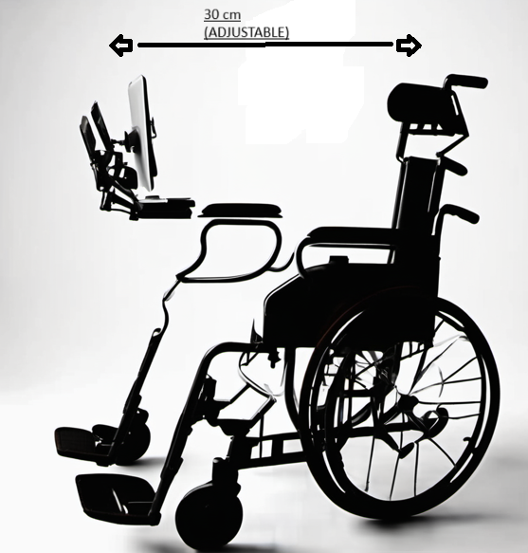

**Fig 6.Expected Design**

**VII.** **CONCLUSION**

In conclusion, the EyeWheel project demonstrates a significant advancement in assistive technology, providing a practical solution for individuals with severe physical disabilities. By utilizing eye-tracking technology to control wheelchair movement, we have shown that it is possible to achieve reliable and precise navigation through intuitive eye movements. This system offers a substantial improvement in the quality of life for users, enhancing their independence and mobility. The successful implementation and positive results highlight the potential for further development and integration of such technologies in assistive devices, ultimately contributing to more inclusive and accessible environments for all individuals with mobility impairments.

**VIII. REFERENCES**

[1] O. Kwon, J. Kim, S. Kim, M. Kim, and M. Youm, "Low-Cost Eye-Tracking Wheelchair Control System Using Head Movement Compensation," in 2016 IEEE International Conference on Robotics and Automation (ICRA), pp. 5386-5391, 2016.

[2] M. A. Hussain, S. A. Hussain, and M. I. A. Khan, "Eye Gaze Based Wheelchair Control System for People with Amyotrophic Lateral Sclerosis (ALS)," in 2018 15th International Conference on Robotics (ICAR), pp. 1-6, 2018.

[3] D. Mandal, S. K. Mandal, and A. Konar, "A Low-Cost Eye-Gaze Based Wheelchair Control System Using Open Source Libraries," in 2019 4th International Conference on Signal Processing, Computing and Control (ICSPCC), pp. 1614-1619, 2019.

[4] P. Kumar, P. Jayaswal, R. Singla, and S. Sharma, "A Review of Eye-Tracking Based Assistive Technologies: Applications and Future Directions," IEEE Access, vol. 7, pp. 77247-77272, 2019.

[5] S. M. A. Shah, S. I. Ahamed, and M. S. Hossain, "A Survey on Eye-Tracking Based Assistive Technologies: State-of-the-Art and Future Challenges," IEEE Access, vol. 8, pp. 170138-170163, 2020

[6] X. Li, Y. Wang, X. Li, and S. Tang, "Eye-Gaze Controlled Wheelchair with Adaptive Dwelling Time and Calibration for Users with Limited Head Movement," IEEE Transactions on Neural Systems and Rehabilitation Engineering, vol. 29, no. 1, pp. 252-262, 2021.

[7] A. Sharma, P. Kumar, R. Singla, and S. Sharma, "A Deep Learning Based Eye-Gaze Control System for Smart Wheelchairs Using Hybrid Attention Mechanism," IEEE Sensors Journal, vol. 22, no. 12, pp. 12222-12232, 2022.

[8]J. Wang, Z. Li, M. Yang, and X. Li, "Eye-Gaze Controlled Wheelchair Navigation Using Saliency Prediction and Deep Reinforcement Learning," IEEE Robotics and Automation Letters, vol. 7, no. 2, pp. 1476-1481, 2022.

[9] M. A. Hossain, M. S. Islam, and S. M. A. Shah, "A Review of Deep Learning-Based Eye-Gaze Control Systems for Assistive Devices," IEEE Access, vol. 10, pp. 41224-41244, 2022.

[10] B. Kim, J. Kim, H. Hwang, and S. Kim, "Eye-Gaze Based Wheelchair Control System with Head Movement Compensation Using a Hybrid Calibration Method," in 2023 IEEE International Conference on Robotics and Automation (ICRA), pp. 7268-7273, 2023.