Data Audit Report
Buffer Delay Allocation Engine: Aircraft Rotation Buffer Optimisation
Analytics Capstone Project (ANCP) | Deliverable D2 | Version 1.0 | 21 October 2026

Team T19 | Vaibhav Maheshwari (BA05057), Prashansa Naomi Konduru (BA05042), Anil Kumar (BA05008)
Faculty | Mr. Nikhil D Jonathan
Dataset | data-v1.0 | aa_clean_v1.0.parquet | 1,641,071 rows | 59 columns
Repository | github.com/vaibhavmaheshwari5141-sketch/buffer-allocation-engine

1. What this report covers
An airline usually flies the same aircraft on several flights in one day, so the flights depend on each other. If the first flight lands late, the aircraft normally leaves late on the next one, and the delay is carried forward through the rest of the day. To protect against this, airlines plan some spare time on the ground between flights. We call this spare time buffer. It costs money, because an aircraft that is waiting on the ground earns nothing, so an airline can only afford a limited amount of it.
Our project is a tool that decides where a fixed buffer budget should be placed so that as little delay as possible is passed on. It continues our D1 work, where we predicted whether an American Airlines (AA) flight would arrive 15 minutes or more late.
This report audits the dataset that the next stages will rely on, called aa_clean_v1.0. It contains every AA mainline flight published by the US Bureau of Transportation Statistics (BTS) between 1 January 2025 and 31 August 2026.
We followed one rule throughout: no row is ever deleted. When we find a problem we mark the row with a flag and write down what we did about it. This way nothing disappears quietly, and anyone can check our choices or reverse them.
The main findings are:
- The data holds no personal information, so the DPDP Act, 2023 does not apply to it (Section 3).
- Almost all empty values are empty by design. Only 11 of 96.8 million cells were unexpectedly empty (Section 4.1).
- There are no duplicate flights, but 140 pairs of flights suggest a wrong aircraft registration (Section 4.2).
- Extreme delays are real events, so we keep them, flag them, and cap them only in a separate column (Section 4.3).
- The data is one airline, domestic only, busy-airport heavy, and 20 months long with one very large storm (Section 5).
- Our feature log has 68 entries. 25 are barred as model inputs and 19 need review before use (Section 6).
Every number in this report comes from a script and is saved in the repository. Section 8 gives the one command that rebuilds all of it from the raw downloads.

2. Where the data came from
Source | What we used | Licence or terms | Accessed
BTS Reporting Carrier On-Time Performance | 20 monthly files, January 2025 to August 2026, with 11,730,351 flights from all carriers. We kept American Airlines only (1,641,071 flights) and 43 of the 109 columns. | Not found. We looked on the download page, the TranStats home page and the database information page and found no licence, terms of use or copyright notice. The bts.gov site also blocked automated requests. Because of this, we do not state any licence on the publisher's behalf. | 21 Oct 2026
OurAirports airports.csv | Coordinates for 136 of our 137 airports (used to work out time zones) and country codes. | The repository carries an Unlicense public-domain dedication, but it talks about "software". The page describing the data itself was down, so we could not confirm a statement about the data. | 21 Oct 2026
OpenFlights airports.dat | Coordinates for one airport (PBI) that OurAirports no longer lists under that code. | Open Database License (ODbL), quoted in full in the source log. | 21 Oct 2026
timezonefinder library and data | Converts airport coordinates into time zone names for all 137 airports. | The library is MIT. The boundary data is ODbL and comes from OpenStreetMap. | 21 Oct 2026

We copy licence wording exactly as the official page states it, and where we found none we write "not found" instead of guessing. The full quotations and links are in data/reference/source_log.csv, with a plain summary in DATA_NOTICE.md. Our own code is released under the MIT licence, and we claim no ownership of any source data.

3. Consent, purpose and the DPDP Act, 2023
Our conclusion is that the dataset contains no personal data, so the Digital Personal Data Protection Act, 2023 does not apply to it and no consent is needed.
The Act protects information about identifiable people. Our 59 columns describe flights and aircraft: dates, flight numbers, airport codes, scheduled and actual times, delay minutes, cancellation flags and the registration of the aircraft. There are no passengers, crew names, staff records, bookings or free text. A tail number identifies an aircraft owned by a company, not a person. Since there is no individual in the data, there is nobody whose consent we would need to ask for.

Why we do not use the "publicly available" exemption
The Act sets aside personal data that was made public because an Indian law required it. BTS publishes under United States rules, not Indian law, so that exemption does not fit well. We rely on the simpler point instead: there is no personal data here to begin with.

We still follow the principles
The Act does not bind this dataset, but we follow its main ideas as good practice:
- Purpose limitation. The data is used only to study how delays pass between flights and where buffer should go. It is not used commercially, and never to judge an individual employee, crew member or passenger.
- Collect only what is needed. We kept 43 of the 109 available columns and never downloaded the rest.
- No re-identification. We do not join this data to anything that could identify a person, and we do not plan to.
- Storage. Raw and intermediate files stay out of version control. Only the cleaned dataset and its checksum are published.
Limitation. This is the team's own assessment for a student project and not legal advice. If a later stage ever adds crew rosters, passenger connections or any personal identifier, this assessment has to be done again before that data is used.

4. Quality audit

4.1 Missing values are almost all structural
The main finding here is that nearly every empty value means the event never happened, not that a number was lost. BTS leaves departure and arrival fields empty for cancelled flights, arrival fields empty for diverted flights, and the five delay-cause columns empty unless a flight arrived 15 or more minutes late. If we filled these in we would be inventing events. Putting a zero in CarrierDelay for an on-time flight would claim a measurement that nobody made.
We wrote down a rule for when each column should be empty and checked every empty value against it. Out of 1,641,071 rows and 59 columns, only 11 empty values were unexpected. All 11 are missing aircraft registrations, and all of them are on cancelled flights.
Column group | Empty | % of rows | Unexpected | What we did
CancellationCode | 1,605,826 | 97.85 | 0 | Left empty
Five delay-cause columns | 1,227,040 | 74.77 | 0 | Left empty, flagged
Arrival fields (6 columns) | 41,202 | 2.51 | 0 | Left empty, flagged
Departure fields (5 columns) | about 34,000 to 35,400 | 2.08 to 2.16 | 0 | Left empty, flagged
Tail_Number | 11 | 0.0007 | 11 | Row kept and flagged; cannot join a chain
All 34 other columns | 0 | 0.00 | 0 | No action needed

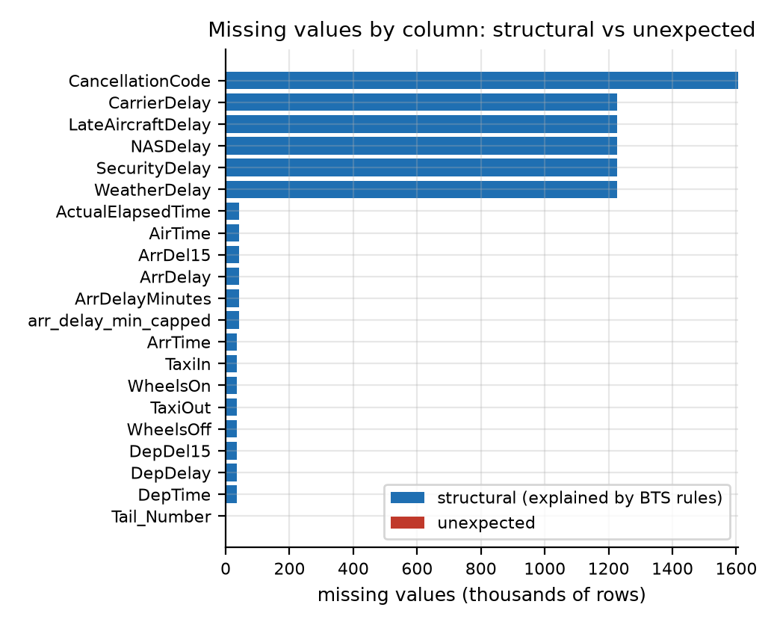
Missing values by column. The unexpected part (red) cannot be seen at this scale: 11 values out of 96.8 million cells.

4.2 Duplicates
We found no duplicate flight records. Four separate checks all returned zero. They were the flight key (date, flight number, origin, destination and scheduled departure), the same key plus the aircraft, our own flight_id, and an exact match across all 45 BTS columns.
A fifth check turned up something different. 140 pairs of flights show the same aircraft departing from two places in the same minute, and 351 pairs if cancelled flights are included. These are not duplicate rows. One of the two registrations has to be wrong. This matters because we build aircraft chains from exactly these registrations, so the affected links are left out when chains are formed.

4.3 Outliers
Extreme values in this data are almost always real: aircraft held overnight, long ground stops, weather holds. Deleting them would make delays look smaller than they are, which is the opposite of what this project needs. So we keep every original value, flag it, and add a separate capped column for models that cannot handle extremes.
Variable | Rule | Rows | % | What we did
ArrDelay | more than 24 hours late | 750 | 0.046 | Kept and flagged
ArrDelay | outside -42 to 454 minutes | 17,033 | 1.038 | Capped only in the new column
DepDelay | more than 24 hours late | 769 | 0.047 | Kept and flagged, not capped
TaxiIn / TaxiOut | more than 3 hours | 65 | 0.004 | Kept and flagged
Actual vs planned flight time | differs by over 3 hours | 63 | 0.004 | Kept and flagged
Distance | zero, negative or over 5,000 miles | 0 | 0.000 | None found
Recorded times disagree | block time vs BTS flight time | 1 | 0.0001 | Kept and flagged

Three points about the capping rule:
- The limits come from training-period flights only, so nothing from the validation or test period leaks into them.
- The original ArrDelay is never changed. Capping lives in a new column. With it, the spread of arrival delay drops from 82.4 to 59.1 minutes, while the middle value stays at 5 minutes early.
- The one time conflict falls on 2 November 2025, the day US clocks changed. The BTS value seems to ignore the clock change. We flagged the row and did not alter it, and we have not confirmed this with BTS.
Four more checks found nothing at all: airborne time longer than total flight time, the 15-minute flag disagreeing with the delay, a flight that operated but has no arrival delay, and a cancelled flight that somehow arrived.

4.4 What we decided, and why
Issue | Treatment | Reason
Empty by design (cancelled, diverted, delay causes) | Left empty and flagged with struct_null columns | Filling them in would invent measurements. A flag lets a model tell "did not happen" from "unknown".
11 missing registrations | Rows kept, flagged dq_missing_tail | They are all cancelled flights and cannot join a chain anyway. Deleting them would change the cancellation count.
Duplicates | None found, nothing removed | Four independent key checks all gave zero.
Same aircraft in two places (140 pairs) | Unchanged; the links are excluded from chains | We cannot tell which of the two registrations is wrong, so we do not guess.
Extreme delays | Kept and flagged; capped in a separate column using training data only | They are real events. Removing them would hide the very risk we want to reduce.
One time conflict | Kept and flagged dq_time_conflict | We could not confirm whether BTS or the clock change caused it.

5. Representativeness and bias
A buffer recommendation is only as general as the flying it was learned from. This section sets out what the dataset does not describe well.

5.1 Which airline, and how much of the industry
American Airlines mainline makes up 14.0% of all US reporting-carrier flights (between 13.7% and 14.5% depending on the month). It is not a sample of the whole industry, and it behaves differently: 25.9% of its flights arrive late, compared with 22.8% across all carriers.
One gap matters a lot for this project. Regional "American Eagle" flights are filed under the partner airlines' own codes, so the regional flying that feeds the hubs is missing from our chains.
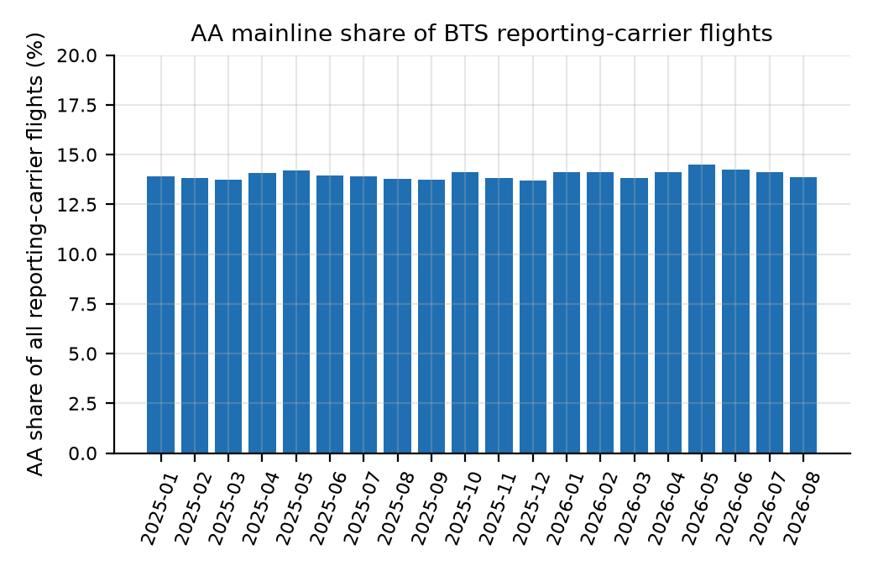
The share stays near 14% in every month, so the gap to the industry is structural and not seasonal.

5.2 Where and when the flights are
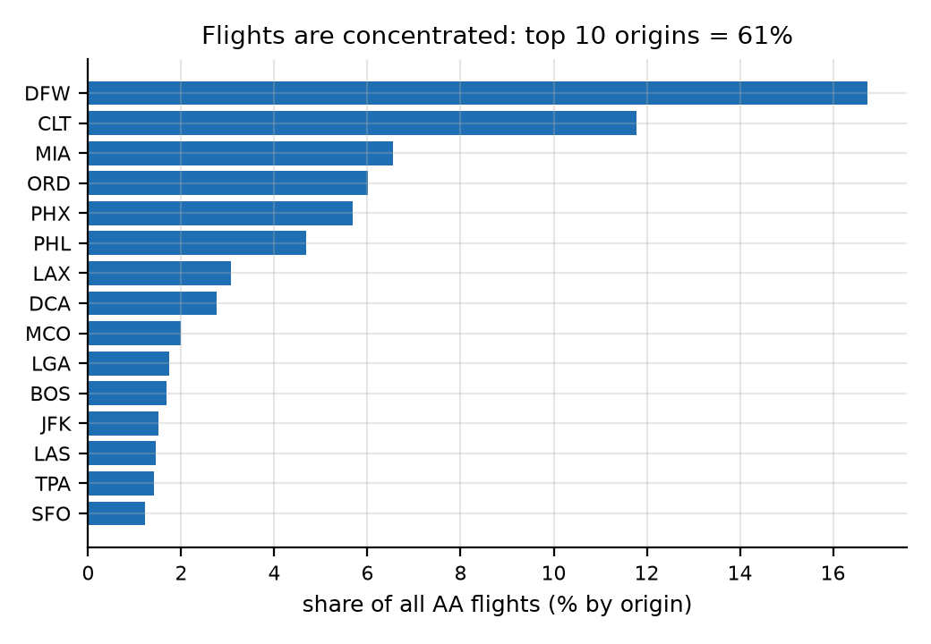 | 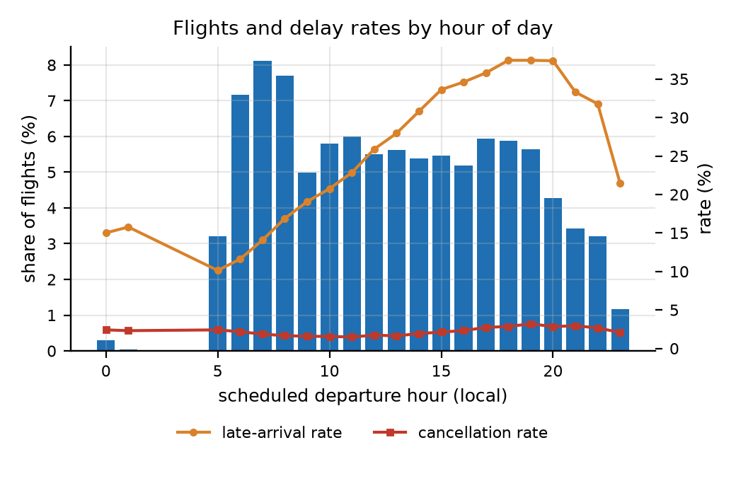
Left: flights cluster in a few airports. Right: departures by hour. The quiet night hours give unreliable delay rates.
The 10 busiest airports carry 61.0% of flights and the top 25 carry 77.1%. At the other end, 42 of our 137 airports hold under 0.1% each and 1.6% between them. They also behave differently: 28.4% of flights arrive late at the top 10, against 22.1% and 21.7% elsewhere. Our results will therefore mostly describe hubs.
Flights scheduled between midnight and 5 am are only 0.33% of the total, and late rates by hour swing between 10.1% and 37.4%. The quiet hours therefore give unstable figures.
The dataset covers domestic flights only. We checked this instead of assuming it. Matching every airport against country codes found zero foreign airports, and 26,456 flight ends in US territories such as Puerto Rico. American Airlines does fly internationally, as our D1 charter notes, but none of that flying is in this data.

5.3 The calendar, and one dominant storm
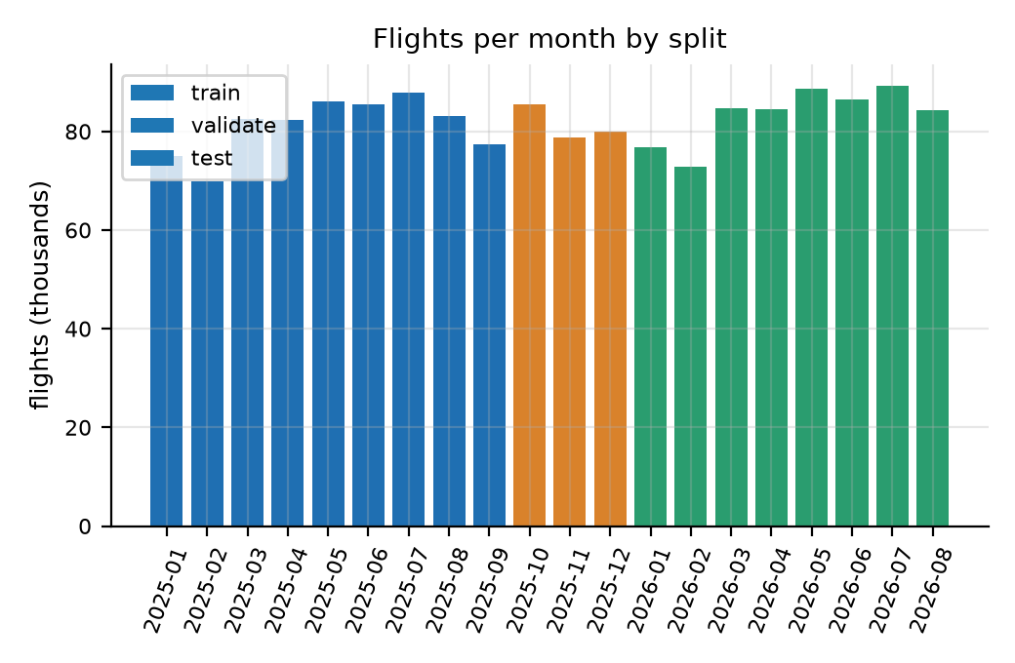 | 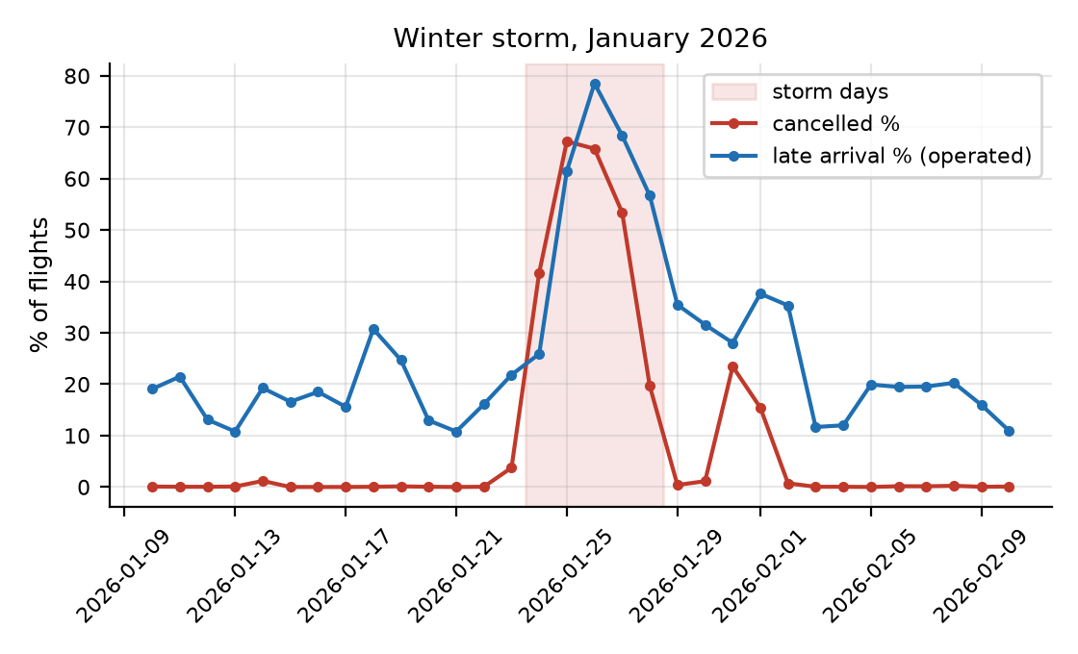
Left: September to December never appear in the test period. Right: the January 2026 storm against the days around it.
The data covers 20 months, so each calendar month appears only once or twice, and season and year effects cannot be told apart. September to December are missing from the test period because BTS had only published up to August 2026, and October to December appear only in the validation period. Any claim about a season rests on a single observation of it.
Five days, 24 to 28 January 2026, carry a severe winter storm, and they fall inside the test period:
 | Storm days (24-28 Jan 2026) | All other days
Flights cancelled | 50.1% | 1.8%
Flights arriving late | 55.9% | 26.0%
Average arrival delay | 88.7 min | 14.0 min
Flights in a usable chain | 30.6% | 86.3%

These five days are about 1.8% of test flights but pull the averages a long way. Every backtest in the later phases will be reported twice, once with them and once without.

5.4 Chains are scarcest when disruption is worst
The optimiser works on aircraft chains, and chains fall apart exactly when the airline is under pressure. On storm days only 30.6% of flights sit in a usable chain, against 86.3% on normal days. Across months the share runs from 71.3% to 83.6%, with the low point in January 2026.
Aircraft swaps are uneven as well: 4.52 suspected swaps per 100 candidate links at the top 10 airports, 0.72 at the next 20, and 0.16 everywhere else. The hubs are both the busiest and the most swap-prone, so chain building is least reliable exactly where the optimiser has the most to decide.

5.5 Summary: what is under-represented
Under-represented | Evidence
Other airlines and the regional feed | AA mainline is 14.0% of reporting-carrier flights; regional flying is filed elsewhere
Small airports | 42 airports hold under 0.1% each, 1.6% combined
Overnight and early-morning flying | 0.33% of flights depart between midnight and 5 am
International flying | Zero foreign airports in the data
September to December in testing | The test period covers January to August 2026 only
October to December in training | Training stops at 30 September 2025
Severe disruption | One five-day storm in 20 months
Disrupted days generally | They give the fewest usable chains, 71.3% at worst

6. Feature log and avoiding leakage
Leakage means letting a model see information it could not have at the moment it has to predict. It makes results look excellent and useless. Our feature log has 68 entries: 45 already built and 23 planned for the prediction model. Each has a verdict. 24 are allowed as model inputs, 19 need more review, and 25 are barred.
Feature | What it is | Verdict
crs_dep_utc, crs_arr_utc | Scheduled times converted to UTC using airport time zones | Allowed. Known when the schedule is published.
sched_ground_min | Planned minutes on the ground before the next flight | Allowed. Comes from the schedule alone.
mtt_min | Estimated shortest possible turnaround at this airport | Needs review. It is estimated from past outcomes.
planned_buffer_min | Spare ground time: planned ground minus minimum turnaround | Needs review. It inherits the issue above.
primary_delay_min | Delay that started with this flight and was not inherited | Barred as an input. It is what the simulator predicts.
leg_idx, n_downstream_legs | Position in the aircraft's chain of flights | Needs review, see below.
Historical delay rates | How often this flight or airport has been late before | Needs review, see below.
arr_delay_min_capped | Arrival delay with extremes pulled in | Barred. It is the target in disguise.
split, storm_day_flag | Labels that select rows | Barred. They choose rows and never feed the model.

Two risks need a closer look because they are easy to miss.
Chain position looks harmless but is not. A flight's place in its aircraft's chain is only known once the day's cancellations, diversions and aircraft swaps have happened. Using it to predict that same day's delay means borrowing from the future. We allow these fields for the optimiser, which assumes the planned chain matches the chain actually flown, but we keep them away from the prediction model until they have been reviewed properly.
Historical delay rates can leak through their own arithmetic. If a flight's own outcome is part of the average used to predict it, the model is reading its own answer. The log requires each training row to be left out of its own average, and validation and test rows to use training-period values only.
No field describing what actually happened can ever be an input. This covers departure and arrival delay, taxi times, wheels times, delay causes, late-aircraft delay, and the cancellation and diversion flags.

7. Building aircraft chains
The buffer problem needs aircraft chains, but BTS does not publish them. We rebuild them from the aircraft registration on each flight. Every one of the 1,641,071 flights falls into exactly one category, and the build stops with an error if the numbers do not add up.
Category | Flights | % | What it means
In a usable chain | 1,408,848 | 85.85 | Flew, inside a run of 2 or more linked flights (363,041 chains)
Chain of one flight | 191,021 | 11.64 | Flew, but stands alone, so no turnaround follows
Cancelled | 35,245 | 2.15 | Breaks the chain
Diverted | 5,957 | 0.36 | Breaks the chain
Unknown aircraft / other | 0 | 0.00 | The 11 flights without a registration were all cancelled
Total | 1,641,071 | 100.00 | Matches the source table exactly

Chains break for reasons we record: 41,574 links at a cancellation, 33,461 at a suspected aircraft swap, 11,990 where the aircraft did not land where the next flight starts, and 6,433 at a diversion.
The most important assumption in the project follows from this. BTS records the aircraft that actually flew, not the one that was planned. The chains we rebuild are therefore the chains as flown, and the later stages assume the planned chain and the flown chain are the same. The 33,461 swap links measure how often that assumption breaks.
Minimum turnaround time is the one real assumption inside the data, because nobody publishes it. We estimate it for each airport and time of day as the 10th percentile of ground time on turnarounds where the aircraft was visibly rushed. We use training data only and hold the result between 25 and 60 minutes. We show the uncertainty instead of hiding it: the share of turnarounds with no buffer at all is 5.7%, 7.7% or 13.9%, depending on how strict the estimate is.

8. Reproducing the dataset, and what it cannot tell you
One command rebuilds everything from nothing: python -m bufferengine.pipeline.run_all. It downloads the BTS files, builds the base and reference tables, rebuilds the chains, cleans the data, regenerates the evidence and writes the checksums. We ran it from start to end and every checksum matched the earlier run exactly, so the dataset can be reproduced.
The cleaned file (68.4 MB, 1,641,071 rows, 59 columns) is committed to the repository at data/processed/aa_clean_v1.0.parquet under the tag data-v1.0. Next to it are the SHA-256 checksums, a manifest with row counts, source dates and library versions, the data dictionary, the cleaning code and a 5,000-row sample for quick inspection. The same cleaning is also available as two PySpark notebooks for Databricks, which reproduce the published file row for row.

Limitations we carry forward
- Minimum turnaround is an estimate and not a published figure, and buffer depends on it directly.
- Chains are as flown, not as planned.
- The 140 registration conflicts mean some aircraft identities are simply wrong.
- We could not verify the BTS licence position.
- One timing conflict on the daylight-saving date is still unexplained.
- Delay-cause fields, including the late-aircraft delay we use as ground truth, exist only for flights 15 or more minutes late. Propagation therefore has to be checked in aggregate, not flight by flight.
- The dataset supports no claim about international flights, regional partners, other airlines, or any period after August 2026.

Appendix: Datasheet for aa_clean_v1.0
Following Gebru et al., Datasheets for Datasets

A1. Motivation
Why was the dataset created?
We needed it for a student project that spreads a limited budget of ground-time buffer across aircraft chains so that the fewest delays are passed on to later flights. Public flight data tells you what happened to each flight on its own. Our dataset adds the schedule and chain structure needed to see how a delay on one flight reaches the next. We built it because no public dataset links flights into aircraft chains with correct, time-zone-aware ground times.
Who created it, and who paid for it?
Team T19 (Vaibhav Maheshwari, Prashansa Naomi Konduru and Anil Kumar) made it as coursework for the Analytics Capstone Project under Mr. Nikhil D Jonathan. There was no funding and no commercial sponsor. Every tool we used is free or open source.

A2. Composition
What does each row represent?
One scheduled American Airlines mainline flight. Rows are not people. The columns cover the schedule (date, flight number, airports, planned times), what actually happened (actual times, taxi times, delays, cancellation and diversion flags, and the airline's own split of delay causes), the aircraft registration, and fields we added ourselves (UTC times, period labels, quality flags and a capped delay column).
How many rows are there?
There are 1,641,071 rows and 59 columns, from 1 January 2025 to 31 August 2026. That is 973,653 flights in 2025 and 667,418 in January to August 2026, flown by 1,033 aircraft across 137 airports and 1,317 routes. The chain tables add 1,045,807 turnarounds and 93,458 rejected links.
Is it a sample, or everything?
It is every AA mainline flight BTS published for the period, so it is complete for that scope. It is not a sample of US aviation. AA mainline is 14.0% of reporting-carrier flights, and regional "American Eagle" flights are filed under other airline codes and are not in the data.
Is anything missing?
Yes, and in a predictable pattern. Cancelled flights have no departure or arrival measurements, and diverted flights have no arrival measurements. The five delay-cause columns are filled only for flights 15 or more minutes late, so they are empty 74.8% of the time. None of this is lost data. It is data that never existed, so we flag it and do not fill it in. Only 11 empty values in the whole dataset are truly unexpected.
Are there errors or noise?
Three known problems. First, 140 pairs of flights share an aircraft registration at the same moment in different places, which is impossible, so one registration is wrong. Second, one flight's planned flight time disagrees with the BTS figure on the day the clocks changed. Third, 33,461 chain links show a flight due to leave before the aircraft was due to land, which happens when the airline swaps aircraft. All three are counted and flagged, and none are quietly corrected.
Is there a target, and are there recommended splits?
The natural targets are the 15-minute late flag (arr_del15) and the arrival delay in minutes. Every row also carries a split label based on its date: training is January to September 2025, validation is October to December 2025, and test is January to August 2026. We split by date and not at random, because a model has to predict the future from the past, and random splits would mix the two.
How are rows related to each other?
Flights of the same aircraft are linked in the rotation tables through flight_id and tail number. Each flight appears in exactly one chain. Turnarounds and rejected links point back to the flights they come from, so the seven tables can be joined without guessing.
Does it contain confidential or sensitive information?
No. There are no people in it, no commercial terms, no prices and no free text. Everything comes from a government statistics agency. Section 3 of the report gives our DPDP Act assessment.
Does it identify sub-groups?
Not of people. It does identify airports, routes and aircraft, and behaviour differs a lot between them: hub against small airport, hour of day, month, and ordinary days against storm days. Section 5 of the report puts numbers on these differences.

A3. How it was collected
How was the data obtained?
It was observed and reported, not surveyed or estimated. US airlines above a revenue threshold must report their on-time performance to BTS, which publishes monthly files. We downloaded the 20 monthly files for January 2025 to August 2026 on 21 October 2026, using a script that can resume and that logs the file name, size, row count and time for each month.
How was the sample chosen?
There was no statistical sampling. We applied one filter, the airline code AA, which kept 1,641,071 of 11,730,351 rows. We also kept 43 of the 109 available columns, chosen for scheduling, chain building and delay measurement.
Who was involved, and over what period?
The project team did all the collection and processing on 21 October 2026. The flights themselves took place over the 20 months before that. No third parties, annotators or crowdworkers were involved, and nobody was paid.
Was anyone asked for consent, and was there an ethical review?
Consent does not apply, because no personal data is collected and there is nobody to ask. The source is a compulsory government publication about commercial flight operations. No formal ethical review was needed or sought, since the data is not about people. The team did the privacy assessment in Section 3 of the report.

A4. Cleaning and preparation
What was done to the raw data?
Four stages, each reproducible by script. First, we filtered to American Airlines, kept 43 columns, set the data types (logging any failures) and tidied the aircraft registrations. Second, we worked out the time zone of each of the 137 airports from its coordinates. Third, we ordered each aircraft's flights by scheduled UTC departure and linked consecutive flights where the aircraft landed where the next flight starts and the schedule allows it. We then calculated ground time, minimum turnaround and buffer. Fourth, we added UTC timestamps, period labels, flags for structural empties, five quality flags and a capped delay column.
Was the raw data kept?
Yes. The raw monthly files are kept locally and can be downloaded again from the published address, and the base table is saved unchanged. No row is removed at any stage and no original BTS column is altered. The capped delay sits in a new column beside the original.
Is the cleaning code available?
Yes. It is in the repository under src/bufferengine/pipeline/, with one entry point and a test suite. The tests check that row counts reconcile, that time conversion handles overnight flights and daylight saving, that flags agree with the source data, and that the checksums match. Two PySpark notebooks (in the databricks folder) repeat the import and cleaning on Databricks and give an identical result.

A5. Uses
What has it been used for so far?
Within this project, it was used to build aircraft chains, estimate minimum turnaround time, and carry out the quality and representativeness analysis in this report. The planned uses are a delay-risk model that runs before departure, a simulator that spreads delays through the chains, and an optimiser that places buffer under a fixed budget.
What else could it support?
It could support comparisons of on-time performance, studies of airport and route congestion, measures of how hard aircraft are worked, research on how robust a schedule is, and teaching in time-series or operations analytics.
Could it be used unfairly or inappropriately?
There are two cautions. The dataset describes hub-heavy, domestic, mainline operations (the 10 busiest airports carry 61% of flights, and no international or regional flying is present), so conclusions should not be stretched to other networks, airlines or regions. Also, the delay causes are the airline's own categories, so using them to assign blame repeats the airline's view and is not an independent finding.
What should it not be used for?
It should not be used for live operational or safety decisions: it is historical, published months late, and our project is a simulation with no connection to any airline system. It should not be used to judge individual employees or crews, because the data cannot support that and attempting it would bring in personal data that our privacy assessment does not cover. And it should not be used commercially under this release.

A6. Distribution
How is it distributed?
It is committed to the GitHub repository at data/processed/aa_clean_v1.0.parquet (68.4 MB) under the tag data-v1.0, together with the cleaning code, the data dictionary, the SHA-256 checksums, the manifest and a 5,000-row sample. Distribution began on 21 October 2026.
Under what licence, and are there restrictions?
Our code is released under the MIT licence. The BTS data carries no licence statement that we could find on the publisher's pages, so we state none on its behalf, and users should check with BTS directly. The reference data keeps the terms of its sources: OurAirports (Unlicense), OpenFlights (ODbL) and the timezonefinder boundary data (ODbL). The exact wording is in data/reference/source_log.csv and DATA_NOTICE.md. We know of no other restrictions, but we did not assess what the ODbL share-alike terms mean for our small derived airport time-zone table, so we cite the sources instead.

A7. Maintenance
Who looks after it, and will it be updated?
Team T19 looks after it through the repository's issue tracker for the duration of the capstone. BTS publishes monthly, so the dataset can be extended past August 2026 by running the pipeline again, which skips files that are already downloaded. We do not promise an update schedule. Any change to a column name, type, unit or empty-value rule raises the data contract version and creates a new tag, and the data-v1.0 tag itself never changes.
What happens to older versions?
Each version is a git tag with its own checksums and manifest, so earlier versions stay available and can be verified. If a version becomes obsolete we would say so in the release notes and not delete it.
Can other people build on it?
Yes. The pipeline is scripted from start to end and the data contract is written down, so a different airline, period or turnaround assumption can be used just by changing parameters. Contributions are welcome as pull requests. Anything built from this data should cite both this release and the original BTS source.

