Data Audit Report
Buffer Delay Allocation Engine — Aircraft Rotation Buffer Optimisation
Analytics Capstone Project (ANCP) | Deliverable D2 | Version 1.0 | 21 October 2026

Team T19 | Vaibhav Maheshwari (BA05057), Prashansa Naomi Konduru (BA05042), Anil Kumar (BA05008)
Faculty | Mr. Nikhil D Jonathan
Dataset | data-v1.0 • aa_clean_v1.0.parquet • 1,641,071 rows • 59 columns
Repository | github.com/vaibhavmaheshwari5141-sketch/buffer-allocation-engine

1. What this report covers
An airline flies one aircraft on several flights a day, one after another. If an early flight lands late, the plane leaves late on its next flight, and the delay spreads down the day like dominoes. Airlines prevent this by leaving spare time on the ground between flights, called buffer. Buffer is not free: a plane sitting on the ground earns nothing, so an airline can only afford a limited amount of it.
This project builds a tool that decides where to place a fixed budget of buffer so that the fewest delays spread. It continues the team's D1 work, which predicted whether an American Airlines flight would arrive 15 or more minutes late.
This report audits the dataset that the later modelling and optimisation stages will use. That dataset is aa_clean_v1.0: every American Airlines mainline flight recorded by the US Bureau of Transportation Statistics (BTS) between 1 January 2025 and 31 August 2026.
One rule shapes the whole pipeline: no row is ever deleted. When we find a problem, we mark it with a flag and write down how we treated it. Nothing is quietly dropped, so anyone can check our decisions and reverse them.
Every number in this report is produced by a script and saved to a file in the repository. Section 8 gives the single command that rebuilds all of it from the raw downloads.

2. Where the data came from
Source | What we used | Licence or terms | Accessed
BTS Reporting Carrier On-Time Performance | 20 monthly files, Jan 2025 to Aug 2026. 11,730,351 flights by all carriers. We kept American Airlines only (1,641,071 flights) and 43 of the 109 columns. | Not found. We searched the download page, the TranStats home page and the database information page, and found no licence, terms of use or copyright notice. The bts.gov site blocked automated requests. We therefore state no licence on the publisher's behalf. | 21 Oct 2026
OurAirports airports.csv | Coordinates for 136 of our 137 airports, used to work out time zones, plus country codes. | The repository's licence file is an Unlicense public-domain dedication, but it speaks of "software". The page documenting the data itself was down, so we could not verify a statement about the data. | 21 Oct 2026
OpenFlights airports.dat | Coordinates for one airport (PBI), which OurAirports no longer lists under that code. | Open Database License (ODbL), quoted in full in the source log. | 21 Oct 2026
timezonefinder library and its data | Turns airport coordinates into time zone names for all 137 airports. | Library is MIT. The boundary data is ODbL and comes from OpenStreetMap. | 21 Oct 2026

We record licence wording exactly as the official page states it. Where we could not find a licence, we write "not found" rather than guess. Full quotations and URLs are in data/reference/source_log.csv, with a plain summary in DATA_NOTICE.md. Our own code is released under the MIT licence. We claim no ownership over any source data.

3. Privacy: the DPDP Act, 2023
Our conclusion: the dataset contains no personal data, so the Digital Personal Data Protection Act, 2023 does not apply to it.
The Act protects data about identifiable people. Our 59 columns describe flights and aircraft: dates, flight numbers, airport codes, scheduled and actual times, delay minutes, cancellation flags, and the registration of the aircraft. There are no passengers, no crew names, no staff records, no bookings and no free text. A tail number identifies an aircraft owned by a company, not a person. Because there is no individual in the data, there is nobody whose consent could be required.

Why we do not lean on the "publicly available" exemption
The Act also sets aside personal data that someone published because an Indian law required them to. BTS publishes under United States rules, not Indian law, so that exemption does not fit neatly. We therefore rely on the simpler and stronger point: there is no personal data here in the first place.

We still apply the principles
The Act does not bind this dataset, but we follow its ideas as good practice:
- Purpose limitation. The data is used only to study how delays spread between flights and where buffer should go. It is not used commercially, and never to judge any individual employee, crew member or passenger.
- Collect only what is needed. We kept 43 of the 109 available columns. Fields about extra diversion airports, gate returns and duplicate geography were never downloaded.
- No re-identification. We do not join this data to anything that could identify a person, and we do not plan to.
- Storage. Raw and intermediate files stay out of version control. Only the cleaned dataset and its checksum are published.
Limitation. This is the team's assessment for a student project, not legal advice. If a later stage ever adds crew rosters, passenger connections or any personal identifier, this assessment must be redone before that data is used.

4. Quality audit

4.1 Missing values are almost all structural
The main finding is simple. Nearly every empty value in this dataset means the event never happened, not that a number was lost.
BTS leaves departure and arrival fields empty for cancelled flights, arrival fields empty for diverted flights, and the five delay-cause columns empty unless a flight arrived 15 or more minutes late. Filling these in would invent events. Writing a zero into CarrierDelay for an on-time flight would claim a measurement that nobody ever took.
We checked every empty value against a written rule for when it should be empty. Out of 1,641,071 rows and 59 columns, only 11 empty values were unexpected — all of them missing aircraft registrations, and all on cancelled flights.
Column group | Empty | % of rows | Unexpected | What we did
CancellationCode | 1,605,826 | 97.85 | 0 | Left empty
Five delay-cause columns | 1,227,040 | 74.77 | 0 | Left empty, flagged
Arrival fields (6 columns) | 41,202 | 2.51 | 0 | Left empty, flagged
Departure fields (5 columns) | ~35,000 | 2.08 - 2.16 | 0 | Left empty, flagged
Tail_Number | 11 | 0.0007 | 11 | Row kept and flagged; cannot join a chain
All 34 other columns | 0 | 0.00 | 0 | —

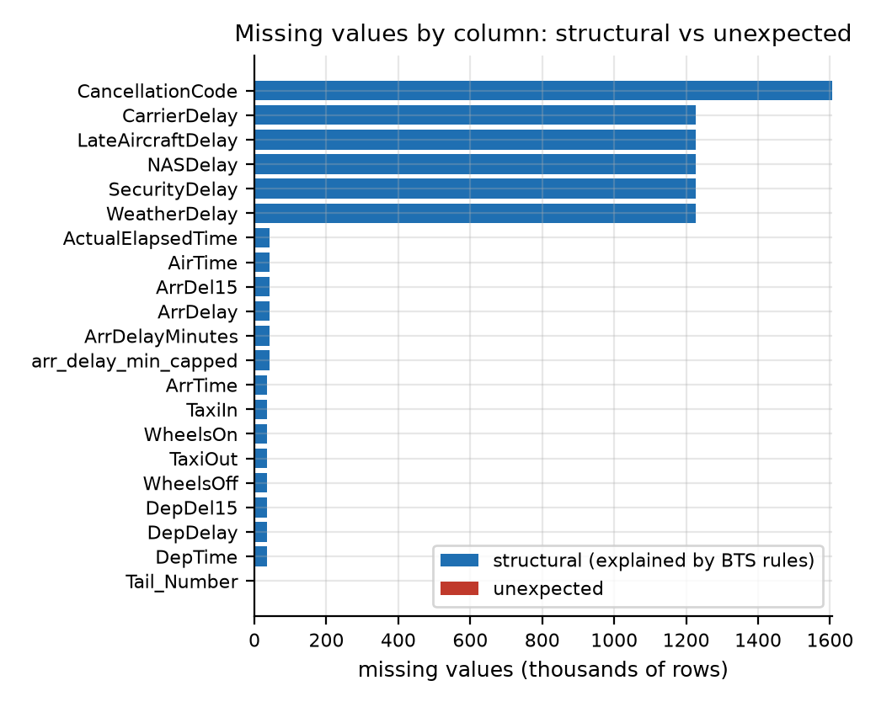
Missing values by column. The unexpected part (red) is invisible here: 11 values out of 96.8 million cells.

4.2 Duplicates
There are no duplicate flight records. Four separate checks all returned zero: the flight key (date, flight number, origin, destination and scheduled departure), that key plus the aircraft, our own flight_id, and an exact match across all 45 BTS columns.
A fifth check found something different and more interesting. 140 pairs of flights show the same aircraft departing from two places in the same minute (351 pairs if cancelled flights are included). These are not duplicate rows. One of the two registrations must be wrong. This matters because we build aircraft chains from exactly these registrations, so the affected links are excluded when chains are formed.

4.3 Outliers
Extreme values here are nearly always real: aircraft held overnight, long ground stops, weather holds. Deleting them would make delays look smaller than they are, which is the opposite of what this project needs. So we keep every original value, flag it, and add a separate capped column for models that cannot cope with extremes.
Variable | Rule | Rows | % | What we did
ArrDelay | more than 24 hours late | 750 | 0.046 | Kept and flagged
ArrDelay | outside -42 to 454 minutes | 17,033 | 1.038 | Capped only in the new column
DepDelay | more than 24 hours late | 769 | 0.047 | Kept and flagged, not capped
TaxiIn / TaxiOut | more than 3 hours | 65 | 0.004 | Kept and flagged
Actual vs planned flight time | differs by over 3 hours | 63 | 0.004 | Kept and flagged
Distance | zero, negative or over 5,000 miles | 0 | 0.000 | None found
Recorded times disagree | block time vs BTS flight time | 1 | 0.0001 | Kept and flagged

Three things are worth noting about the capping rule:
- The limits come from training-period flights only, so no information from the validation or test period leaks into them.
- The original ArrDelay is never changed. Capping lives in a new column. Between the two, the spread of arrival delay falls from 82.4 to 59.1 minutes, while the middle value stays the same at 5 minutes early.
- The single time conflict falls on 2 November 2025, the day US clocks changed. The BTS value appears to ignore the clock change. We flagged the row rather than altering it, and we have not confirmed this with BTS.
Four further checks found nothing at all: airborne time longer than total flight time, the 15-minute flag disagreeing with the delay, a flight that operated without an arrival delay, and a cancelled flight that somehow arrived.

5. Representativeness and bias
A buffer recommendation is only as general as the operations it was learned from. This section sets out what the dataset does not describe.

5.1 Which airline, and how much of the industry
American Airlines mainline is 14.0% of all US reporting-carrier flights (between 13.7% and 14.5% depending on the month). It is not a sample of the industry, and it behaves differently: 25.9% of its flights arrive late, against 22.8% across all carriers.
One gap matters especially for this project. Regional "American Eagle" flights are filed under the partner airlines' own codes, so the regional network that feeds the hubs is missing from our chains.
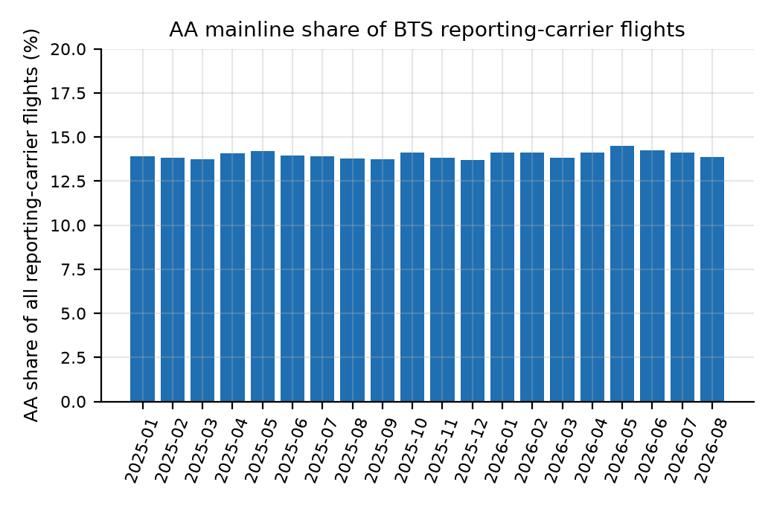
The share stays near 14% every month, so the gap to the industry is structural, not seasonal.

5.2 Where and when the flights are
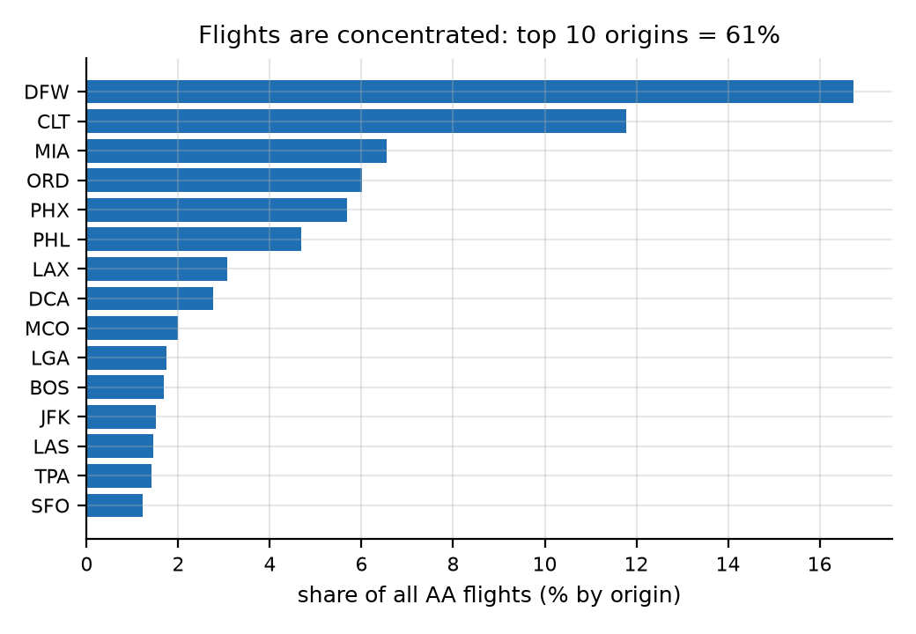 | 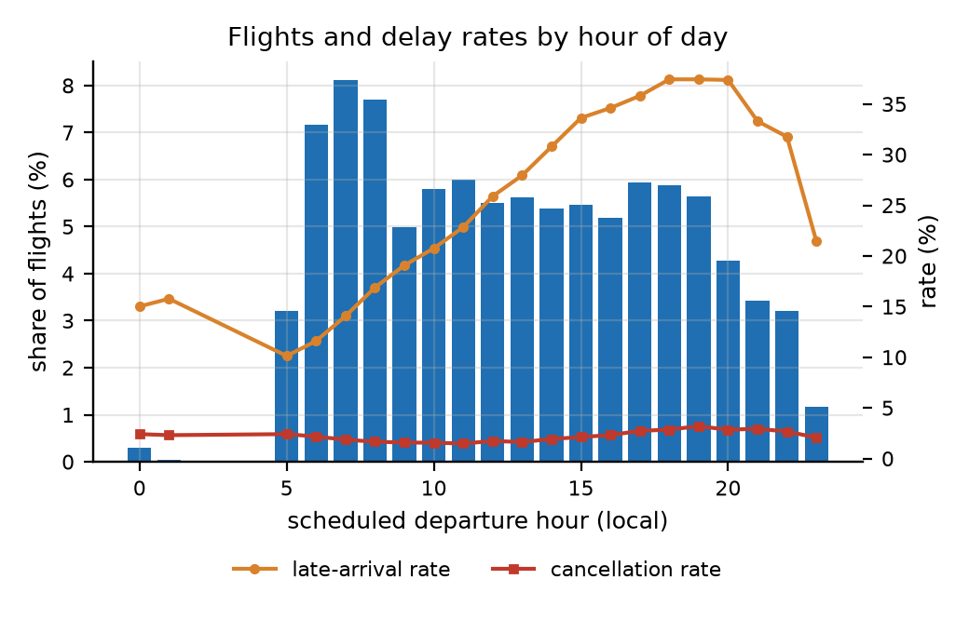
Left: flights cluster in a few airports. Right: departures by hour; the quiet night hours give unreliable delay rates.
The 10 busiest airports carry 61.0% of flights and the top 25 carry 77.1%. At the other end, 42 of our 137 airports hold under 0.1% each and 1.6% between them. They behave differently too: 28.4% of flights arrive late at the top 10, against 22.1% and 21.7% elsewhere. Our results will therefore mostly describe hubs.
Flights scheduled between midnight and 5 am are only 0.33% of the total. Late rates by hour swing from 10.1% to 37.4%, so the quiet hours give unstable figures.
The dataset covers domestic flights only. We checked rather than assumed: matching every airport against country codes found zero foreign airports, with 26,456 flight ends in US territories such as Puerto Rico. American Airlines does fly internationally, as the D1 charter notes, but none of that flying is in this data.

5.3 The calendar, and one dominant storm
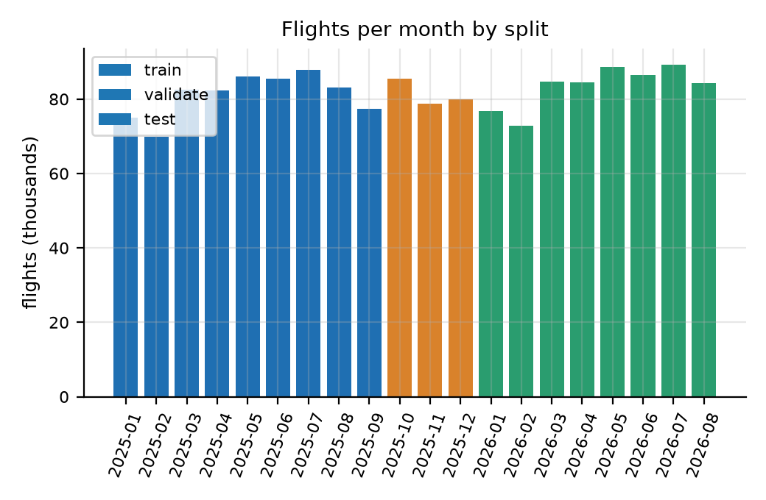 | 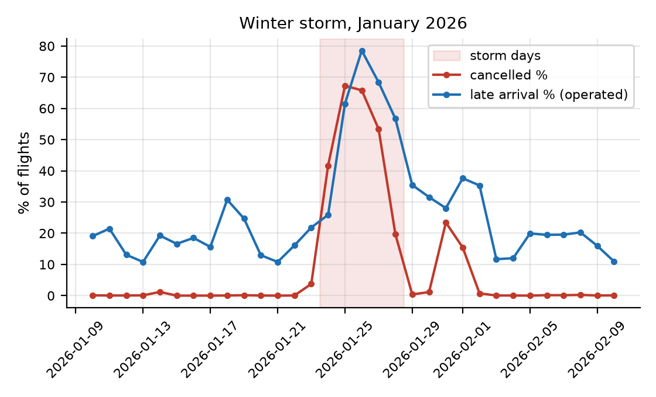
Left: September to December never appear in the test period. Right: the January 2026 storm against the days around it.
The data covers 20 months, so each calendar month appears only once or twice. Season and year effects cannot be separated. September to December are missing from the test period, because BTS had only published up to August 2026, and October to December appear only in the validation period. Any claim about a season therefore rests on a single observation of it.
Five days, 24 to 28 January 2026, carry a severe winter storm, and they sit inside the test period:
 | Storm days (24-28 Jan 2026) | All other days
Flights cancelled | 50.1% | 1.8%
Flights arriving late | 55.9% | 26.0%
Average arrival delay | 88.7 min | 14.0 min
Flights in a usable chain | 30.6% | 86.3%

Those five days are about 1.8% of test flights but pull the averages a long way. Every backtest in later phases will be reported twice: with them and without them.

5.4 Chains are scarcest when disruption is worst
The optimiser works on aircraft chains, and chains fall apart exactly when the airline is under pressure. On storm days only 30.6% of flights sit in a usable chain, against 86.3% normally. Across months, the share runs from 71.3% to 83.6%, with the low point in January 2026.
Aircraft swaps are uneven too: 4.52 suspected swaps per 100 candidate links at the top 10 airports, 0.72 at the next 20, and 0.16 everywhere else. Hubs are both the busiest and the most swap-prone, so chain reconstruction is least reliable exactly where the optimiser has most to decide.

5.5 Summary: what is under-represented
Under-represented | Evidence
Other airlines and the regional feed | AA mainline is 14.0% of reporting-carrier flights; regional flying is filed elsewhere
Small airports | 42 airports hold under 0.1% each, 1.6% combined
Overnight and early-morning flying | 0.33% of flights depart between midnight and 5 am
International flying | Zero foreign airports in the data
September to December in testing | Test period covers January to August 2026 only
October to December in training | Training stops at 30 September 2025
Severe disruption | One five-day storm in 20 months
Disrupted days generally | They contribute the fewest usable chains, 71.3% at worst

6. Feature log and avoiding leakage
Leakage means letting a model see information it could not possibly have at the moment it must predict. It makes results look excellent and useless. Our feature log records 68 entries: 45 already built and 23 planned for the prediction model. Each one carries a verdict. 24 are allowed as model inputs, 19 need further review, and 25 are barred.
Feature | What it is | Verdict
crs_dep_utc, crs_arr_utc | Scheduled times converted to UTC using airport time zones | Allowed — known when the schedule is published
sched_ground_min | Planned minutes on the ground before the next flight | Allowed — comes from the schedule alone
mtt_min | Estimated shortest possible turnaround at this airport | Needs review — estimated from past outcomes
planned_buffer_min | Spare ground time: planned ground minus minimum turnaround | Needs review — inherits the above
primary_delay_min | Delay that started with this flight rather than being inherited | Barred as an input; it is what the simulator predicts
leg_idx, n_downstream_legs | Position in the aircraft's chain of flights | Needs review — see below
Historical delay rates | How often this flight or airport has been late before | Needs review — see below
arr_delay_min_capped | Arrival delay with extremes pulled in | Barred — it is the target in disguise
split, storm_day_flag | Labels that select rows | Barred — they choose rows, never feed the model

Two risks deserve a closer look, because both are easy to miss.
Chain position looks harmless but is not. A flight's place in its aircraft's chain is only known once the day's cancellations, diversions and aircraft swaps have happened. Using it to predict that same day's delay means borrowing the future. We allow these fields for the optimiser, which assumes the planned chain matches the one actually flown, but we withhold them from the prediction model until we have reviewed them properly.
Historical delay rates leak through their own arithmetic. If a flight's own outcome is inside the average used to predict it, the model is reading its own answer. The log requires each training row to be excluded from its own average, and validation and test rows to use training-period values only.
No field describing what actually happened — departure or arrival delay, taxi times, wheels times, delay causes, late-aircraft delay, or the cancellation and diversion flags — may ever be an input.

7. Building aircraft chains
The buffer problem needs aircraft chains, but BTS does not publish them. We rebuild them from the aircraft registration on each flight. Every one of the 1,641,071 flights lands in exactly one category, and the build fails if the numbers do not add up:
Category | Flights | % | What it means
In a usable chain | 1,408,848 | 85.85 | Flew, inside a run of 2 or more linked flights (363,041 chains)
Chain of one flight | 191,021 | 11.64 | Flew, but stands alone, so no turnaround follows
Cancelled | 35,245 | 2.15 | Breaks the chain
Diverted | 5,957 | 0.36 | Breaks the chain
Unknown aircraft / other | 0 | 0.00 | The 11 flights without a registration were all cancelled
Total | 1,641,071 | 100.00 | Matches the source table exactly

Chains break for reasons we record: 41,574 links at a cancellation, 33,461 at a suspected aircraft swap, 11,990 where the aircraft did not land where the next flight starts, and 6,433 at a diversion.
This leads to the single most important assumption in the project. BTS records the aircraft that actually flew, not the one that was planned. So the chains we rebuild are the chains as flown. Later stages assume the planned chain and the flown chain are the same. The 33,461 swap links are the measured size of where that assumption breaks down.
Minimum turnaround time is the one real assumption inside the data, because nobody publishes it. We estimate it for each airport and time of day as the 10th percentile of ground time on turnarounds where the aircraft was visibly rushed, using training data only, held between 25 and 60 minutes. We carry the uncertainty rather than hiding it: the share of turnarounds with no buffer at all is 5.7%, 7.7% or 13.9% depending on how strict the estimate is.

8. Reproducing the dataset, and what it cannot tell you
One command rebuilds everything from nothing: python -m bufferengine.pipeline.run_all. It downloads the BTS files, builds the base table and reference tables, rebuilds the chains, cleans, regenerates the evidence and writes the checksums. We ran it end to end and every checksum matched the earlier run exactly, so the dataset is genuinely reproducible.
The cleaned file (68.4 MB, 1,641,071 rows, 59 columns) is committed to the repository at data/processed/aa_clean_v1.0.parquet under the tag data-v1.0. Alongside it sit the SHA-256 checksums, a manifest recording row counts, source dates and library versions, the data dictionary, the cleaning code and a 5,000-row sample for quick inspection.

Limitations we carry forward
- Minimum turnaround is an estimate, not a published figure, and buffer depends on it directly.
- Chains are as flown, not as planned.
- 140 aircraft registration conflicts mean some aircraft identities are simply wrong.
- We could not verify the BTS licence position.
- One timing conflict on the daylight-saving date remains unexplained.
- Delay-cause fields, including the late-aircraft delay we rely on as ground truth, exist only for flights 15 or more minutes late. Propagation must therefore be checked in aggregate, not flight by flight.
- The dataset supports no claim about international flights, regional partners, other airlines, or any period after August 2026.

Appendix: Datasheet for aa_clean_v1.0
Following Gebru et al., Datasheets for Datasets

A1. Motivation
Why was the dataset created?
To support a student project that spreads a limited budget of ground-time buffer across aircraft chains so that the fewest delays spread to later flights. Public flight data reports what happened to each flight on its own. This dataset adds the schedule and chain structure needed to see how a delay on one flight reaches the next. We built it because no public dataset links flights into aircraft chains with correct, time-zone-aware ground times.
Who created it, and who paid for it?
Team T19 — Vaibhav Maheshwari, Prashansa Naomi Konduru and Anil Kumar — as coursework for the Analytics Capstone Project under Mr. Nikhil D Jonathan. There was no funding and no commercial sponsor. Every tool used is free or open source.

A2. Composition
What does each row represent?
One scheduled American Airlines mainline flight. Rows are not people. The columns cover the schedule (date, flight number, airports, planned times), what actually happened (actual times, taxi times, delays, cancellation and diversion flags, and the airline's own breakdown of delay causes), the aircraft registration, and fields we derived (UTC times, period labels, quality flags and a capped delay column).
How many rows are there?
1,641,071 rows and 59 columns, covering 1 January 2025 to 31 August 2026. That is 973,653 flights in 2025 and 667,418 in January to August 2026, flown by 1,033 aircraft across 137 airports and 1,317 routes. The chain tables add 1,045,807 turnarounds and 93,458 rejected links.
Is it a sample or everything?
It is every AA mainline flight BTS published for the period, so it is complete for that scope. It is not a sample of US aviation: AA mainline is 14.0% of reporting-carrier flights, and regional "American Eagle" flights are filed under other airline codes and are therefore absent.
Is anything missing?
Yes, and in a predictable pattern. Cancelled flights have no departure or arrival measurements. Diverted flights have no arrival measurements. The five delay-cause columns are filled in only for flights 15 or more minutes late, so they are empty 74.8% of the time. None of this is lost data; it is data that never existed, and we flag it rather than filling it in. Only 11 empty values in the whole dataset are genuinely unexpected.
Are there errors or noise?
Three known problems. 140 pairs of flights share an aircraft registration at the same moment in different places, which is impossible and means a registration is wrong. One flight's planned flight time disagrees with the BTS figure on the day the clocks changed. And 33,461 chain links show a flight due to leave before the aircraft was due to land, which happens when the airline swaps aircraft. All three are counted and flagged. None are quietly corrected.
Does it contain confidential or sensitive information?
No. There are no people in it, no commercial terms, no prices and no free text. Everything comes from a government statistics agency. Section 3 of the report sets out the DPDP Act assessment.
Does it identify sub-groups?
Not of people. It does identify airports, routes and aircraft, and behaviour varies sharply between them: hub against small airport, hour of day, month, and ordinary days against storm days. Section 5 of the report quantifies these differences.

A3. How it was collected
How was the data obtained?
It was observed and reported, not surveyed or estimated. US airlines above a revenue threshold are required to report their on-time performance to BTS, which publishes monthly files. We downloaded the 20 monthly files covering January 2025 to August 2026 on 21 October 2026, using a script that can resume and that logs the file name, size, row count and timestamp for each month.
How was the sample chosen?
There was no statistical sampling. We applied one filter — the airline code AA — which kept 1,641,071 of 11,730,351 rows, and kept 43 of the 109 available columns, chosen for scheduling, chain building and delay measurement.
Who was involved, and over what period?
The project team did all collection and processing on 21 October 2026. The flights themselves took place over the preceding 20 months. No third parties, annotators or crowdworkers were involved, and nobody was paid.
Was anyone asked for consent?
Not applicable. No personal data is collected, so there is nobody to ask. The source is a compulsory government publication about commercial flight operations.
Was there an ethical review?
No formal review was needed or sought, because the dataset contains no data about people. The team carried out the privacy assessment in Section 3 of the report.

A4. Cleaning and preparation
What was done to the raw data?
Four stages, each reproducible by script. First, we filtered to American Airlines, kept 43 columns, set data types with any failures logged, and tidied the aircraft registrations. Second, we worked out the time zone of each of the 137 airports from its coordinates. Third, we ordered each aircraft's flights by scheduled UTC departure, linked consecutive flights where the aircraft landed where the next flight starts and the schedule allows it, and calculated ground time, minimum turnaround and buffer. Fourth, we added UTC timestamps, period labels, flags for structural empties, five quality flags and a capped delay column.
Was the raw data kept?
Yes. The raw monthly files are kept locally and can be downloaded again from the published address. The base table is preserved unchanged. No row is removed at any stage, and no original BTS column is altered: the capped delay sits in a new column beside the original.
Is the cleaning code available?
Yes, in the repository under src/bufferengine/pipeline/, with one entry point and a test suite that checks the row counts reconcile, that time conversion handles overnight flights and daylight saving, that flags agree with the source data, and that the checksums match.

A5. Uses
What has it been used for so far?
Within this project: building aircraft chains, estimating minimum turnaround time, and the quality and representativeness analysis in this report. Planned uses are a delay-risk model that runs before departure, a simulator that spreads delays through the chains, and an optimiser that places buffer under a fixed budget.
What else could it support?
Comparing on-time performance, studying airport and route congestion, measuring how hard aircraft are worked, researching how robust a schedule is, and teaching time-series or operations analytics.
Could it be used unfairly or inappropriately?
Two cautions. The dataset describes hub-heavy, domestic, mainline operations: the 10 busiest airports carry 61% of flights, and no international or regional flying is present, so conclusions should not be stretched to other networks, airlines or regions. Separately, the delay causes are the airline's own categories, so using them to assign blame repeats the airline's view rather than producing an independent finding.
What should it not be used for?
Not for live operational or safety decisions: it is historical, published months late, and this project is a simulation with no connection to any airline system. Not for judging individual employees or crews — the data cannot support that, and attempting it would introduce personal data that our privacy assessment does not cover. And not for commercial purposes under this release.

A6. Distribution
How is it distributed?
It is committed to the public GitHub repository at data/processed/aa_clean_v1.0.parquet (68.4 MB) under the tag data-v1.0, together with the cleaning code, the data dictionary, the SHA-256 checksums, the manifest and a 5,000-row sample. Distribution began on 21 October 2026.
Under what licence?
Our code is released under the MIT licence. The underlying BTS data carries no licence statement that we were able to find on the publisher's pages, so we state none on its behalf and users should check with BTS directly. The reference data inherits its terms from OurAirports (Unlicense), OpenFlights (ODbL) and the timezonefinder boundary data (ODbL). The exact wording of each is in data/reference/source_log.csv and DATA_NOTICE.md.
Are there any restrictions?
None that we know of. We did not assess what the ODbL share-alike terms mean for our small derived airport time-zone table; we cite the sources instead.

A7. Maintenance
Who looks after it?
Team T19, through the GitHub repository's issue tracker, for the duration of the capstone.
Will it be updated?
BTS publishes monthly, so the dataset could be extended past August 2026 by running the pipeline again, which skips files already downloaded. No update schedule is promised. Any change to a column name, type, unit or empty-value rule bumps the data contract version and creates a new tag. The data-v1.0 tag itself never changes.
What happens to older versions?
Each version is a git tag with its own checksums and manifest, so earlier versions stay available and verifiable. If a version becomes obsolete we would say so in the release notes rather than delete it.
Can other people build on it?
Yes. The pipeline is scripted from end to end and the data contract is written down, so a different airline, period or turnaround assumption can be used by changing parameters. Contributions are welcome as pull requests. Anything derived from this data should cite both this release and the original BTS source.

