**Neem Consulting Test**

1. Click on Home menu add the details.

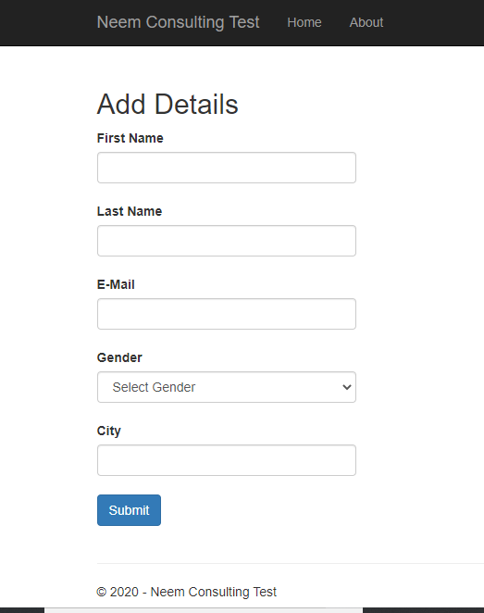

1. All the details are required.

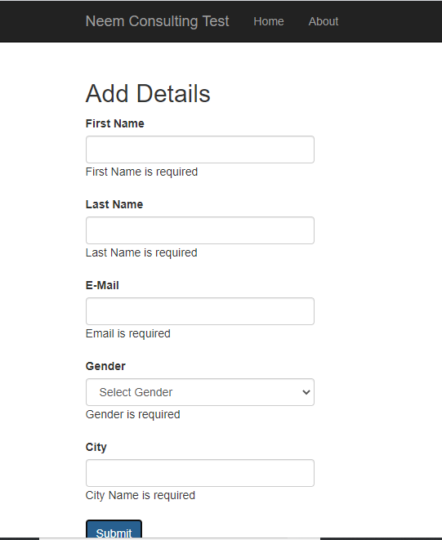

1. Email address should be valid.

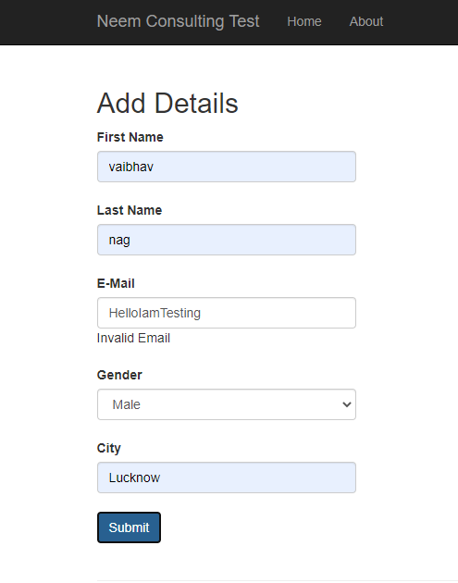

1. On successful Submit will get the message as Data Recorded successfully.

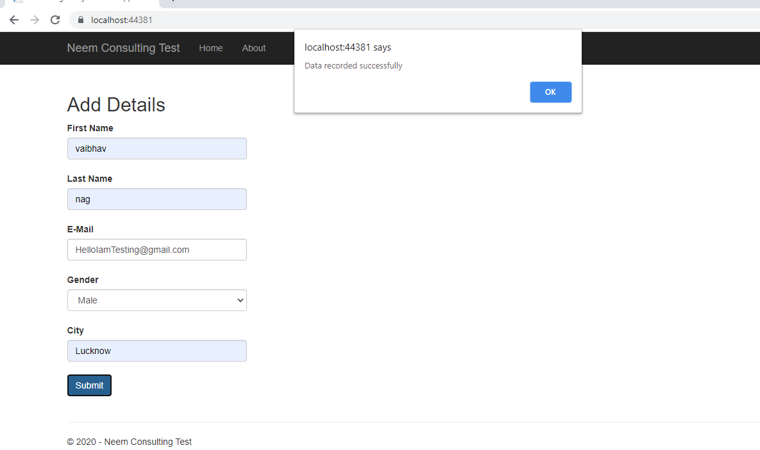

1. Email address is unique and cannot have duplicate values.

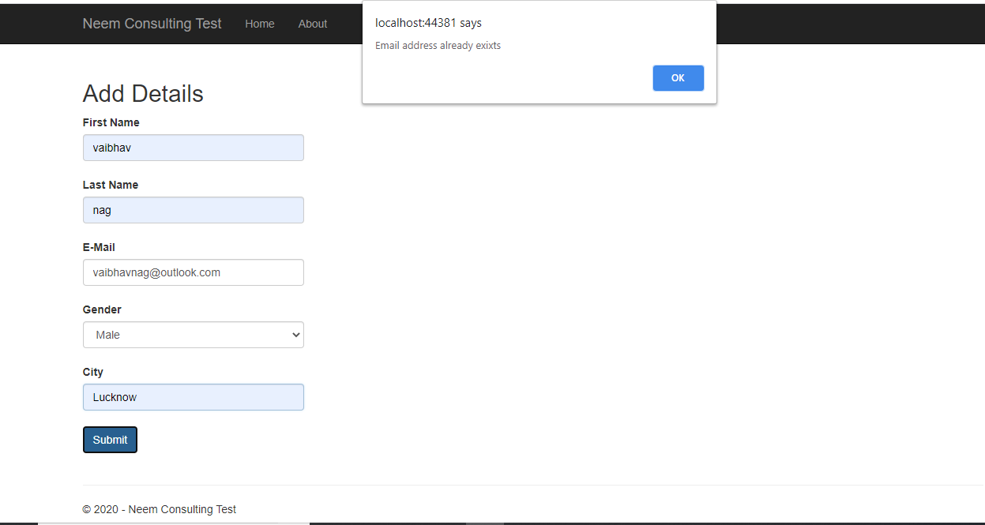

1. Submitted details will be visible on about menu. Here details can be edited and deleted.

Email address is non-editable field.

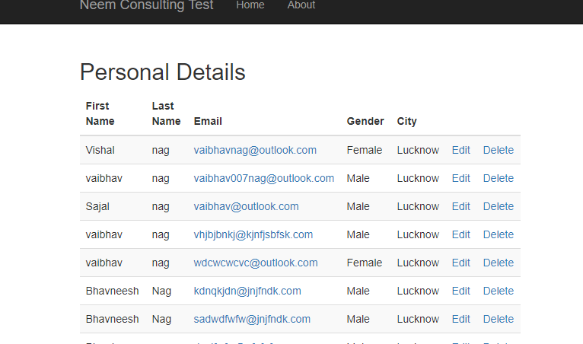

1. Edit