1. Getting Started with langchain

Create folder -> right click on it -> open with visual studio

Go to terminal on top -> new terminal

create new environment

need python >3.8

-----

Setup conda environment

1. Open Anaconda Prompt

1. Check Conda Installed Location.

1. Open Advanced System Settings

1. Click on Environment Variables

1. Edit path

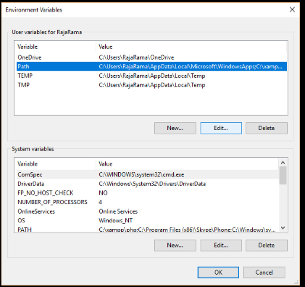

1. Add new path

1. Open Command Prompt and Check Versions

1. After 7th step type “conda install anaconda-navigator” in cmd then after processing press “y”

For reference ->

YOU CAN CLEAR SCREEN USING cls command

-------

Type – conda create -p myenv python==3.9 -y

It will create local folder and packages will be installed (it will take time)

Now Activate conda

Type conda activate myenv/ – enter

Now on left side on vs code there we will be in same folder, there create new file

File name – requirements.txt (create libraries list and install using terminal)

Type the libraries names and run it using

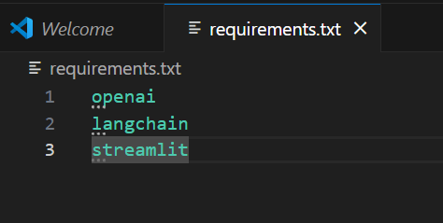

Command – pip install requirements.txt -> enter (wait till installation done)

Let’s start with calling OpenAI API

Create file constant.py

Create api key in above file as

Openai_key = ‘asjkskskkjk’ (example)

Save it

Create new .py file

Main.py file and start coding

Refer below

Now run the main.py using streamlit