MINI PROJECT REPORT
ON
“GET UPDATED”

Submitted by
VAIBHAV PANDEY (191500888)

Department of Computer Engineering & Applications
Institute of Engineering & Technology


GLA University
Mathura- 281406, INDIA
2020-2021
Department of computer Engineering and Applications
GLA University, Mathura
17 km. Stone NH#2, Mathura-Delhi Road, P.O. – Chaumuha,
Mathura – 281406

Declaration
I/we hereby declare that the work which is being presented in the Bachelor of technology. Project “Get Updated”, in partial fulfillment of the requirements for the award of the Bachelor of Technology in Computer Science and Engineering and submitted to the Department of Computer Engineering and Applications of GLA University, Mathura, is an authentic record of my/our own work carried under the supervision of Dr. Manoj Varshney, Assistant Professor, Dept. of CEA, GLA University.
The contents of this project report, in full or in parts, have not been submitted to any other Institute or University for the award of any degree.
Group Member(s): VAIBHAV PANDEY (191500888)
Course: B.Tech (Computer Science and Engineering)

Supervised by:
Dr. Manoj Varshney,
Assistant Professor,
GLA University, Department of Computer Engineering & Application

Department of computer Engineering and Applications
GLA University, Mathura
17 km. Stone NH#2, Mathura-Delhi Road, P.O. – Chaumuha,
Mathura – 281406

Certificate

This is to certify that the project entitled “Get Updated”, carried out in Mini Project – I Lab, is a bonafide work by Vaibhav Pandey and is submitted in partial fulfillment of the requirements for the award of the degree Bachelor of Technology (Computer Science & Engineering)

_______________________
Supervisor
Dr. Manoj Varshney
Assistant Professor,
Dept of CEA, GLA University

Training Certificate

Department of computer Engineering and Applications
GLA University, Mathura
17 km. Stone NH#2, Mathura-Delhi Road, P.O. – Chaumuha,
Mathura – 281406

Acknowledgment

We thank the almighty for giving us the courage and perseverance in completing the project. We extend our sincere thanks to Dr. Manoj Varshney, Assistant Professor at GLA University, Mathura for providing his valuable time and guidance at every stage of this project. We are profoundly grateful towards the unmatched services rendered by him. And last but not least, we would like to express our deep sense of gratitude and earnest thanksgiving to our dear parents for their moral support and heartfelt cooperation.

GET UPDATED

Abstract

Get Updated is a news browsing website, which provides latest news from various sources all around world and weather forecasts. It facilitates the user to filter news as per the numerous filter choices available on the website.
The project is based on news browsing, which provides users easy access to news from various sources. There is a weather section as well, so the people who want to know weather forecasts, can also use this website. People with a hectic schedule can read news quickly and get updated with the world. In future, the sports lover can view a list of sports events.

Contents
- Acknowledgment………………………………………………….5
- Abstract……………………………………………………………6
- About the project ………………….………………………………8
- Motivation…………………………………………………………9
- Requirements…………………………………………………….10
- Technologies Used……………………………………………11-12
- Data Flow………………………………………………………...13
- ER Diagram………………………………………………………14
- List of Figures………………………………………………...15-19
- Software Engineering………………………………………...20-24
- Conclusion……………………………………………………….25
- Bibliography……………………………………………………..26

About the Project

Get Updated is a news browsing website, which provides latest news from various sources all around world and weather forecasts. It facilitates the user to filter news as per the numerous filter choices available on the website.

Motivation

The existing system on internet is doing a pretty good job. But there are some short-comings. For example, most of them disturb user with advertisements and pop-ups covering the main content. Some of them just provide ‘bogus’ links which further opens up a page with next ‘bogus’ link, thus wasting the precious time of user and not providing the actual content in one go. Although browsing experience fundamentally depends on the network speed, few sites are slow to load.

Requirements

- Software Requirements:
- Technology implemented: React, TailwindCSS, Axios, React-Router
- Languages used: HTML, TypeScript.
- IDE used: VS Code.
- Web Browser: Google Chrome
- Source Code: A repository is needed on Github, to contain the project files.
- Deployment: A Netlify account is needed for the deployment of the website.

- Hardware Requirements:
- Processor: Intel i3
- Operating System: Windows, MacOS, Linux
- RAM: 4 GB
- Devices: Desktop/Laptop
- Hard Disk: 100 Mb

Technologies Used

React: React is a free and open-source front-end JavaScript library for building user interfaces based on UI components. It is maintained by Meta (formerly Facebook) and a community of individual developers and companies. React can be used as a base in the development of single-page or mobile applications. However, react is only concerned with state management and rendering that state to the DOM, so creating React applications usually requires the use of additional libraries for routing, as well as certain client-side functionality.

Tailwind CSS: Tailwind is basically a utility-first CSS framework for rapidly building custom user interfaces. It is a highly customizable, low-level CSS framework that gives you all of the building blocks you need to build designs without any annoying opinionated styles you have to fight to override. The beauty of Tailwind is that it doesn’t impose design specification or how your site should look like, you simply bring tiny components together to construct a user interface that is unique. What Tailwind simply does is take a ‘raw’ CSS file, processes this CSS file over a configuration file, and produces an output.

TypeScript: TypeScript is a programming language developed and maintained by Microsoft. It is a strict syntactical superset of JavaScript and adds optional static typing to the language.

TypeScript is designed for the development of large applications and transcompiles to JavaScript. As TypeScript is a superset of JavaScript, existing JavaScript programs are also valid TypeScript programs. TypeScript supports definition files that can contain type information of existing JavaScript libraries, much like C++ header files can describe the structure of existing object files. This enables other programs to use the values defined in the files as if they were statically typed TypeScript entities.

Axios: Axios is a simple promise based HTTP client for the browser and node.js. Axios provides a simple to use library in a small package with a very extensible interface. It is isomorphic (= it can run in the browser and nodejs with the same codebase). On the server-side it uses the native node.js http module, while on the client (browser) it uses XMLHttpRequests.

React-Router: React Router is a fully-featured client and server-side routing library for React, a JavaScript library for building user interfaces. React Router runs anywhere React runs; on the web, on the server with node.js, and on React Native. React Router is a collection of React components, hooks and utilities that make it easy to build multi-page applications with React. This reference contains the function signatures and return types of the various interfaces in React Router.

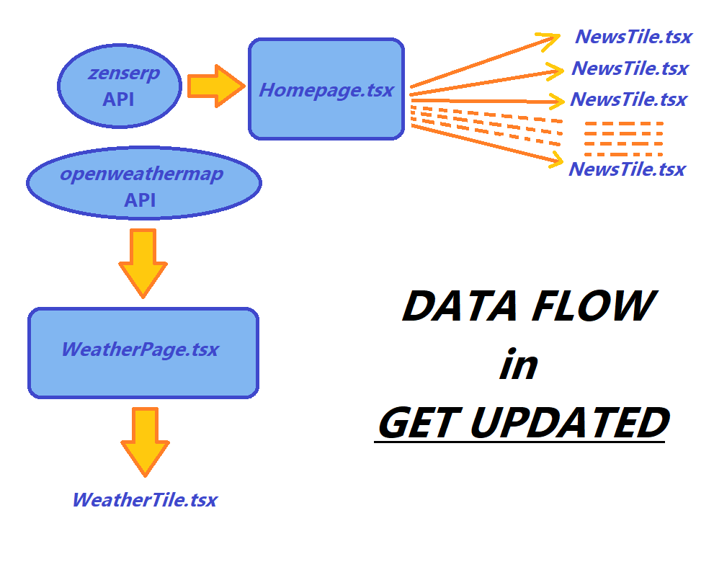
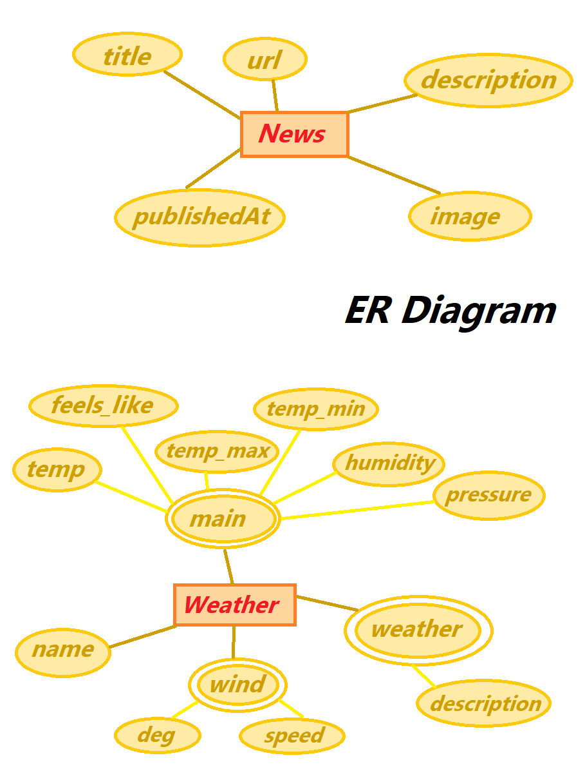

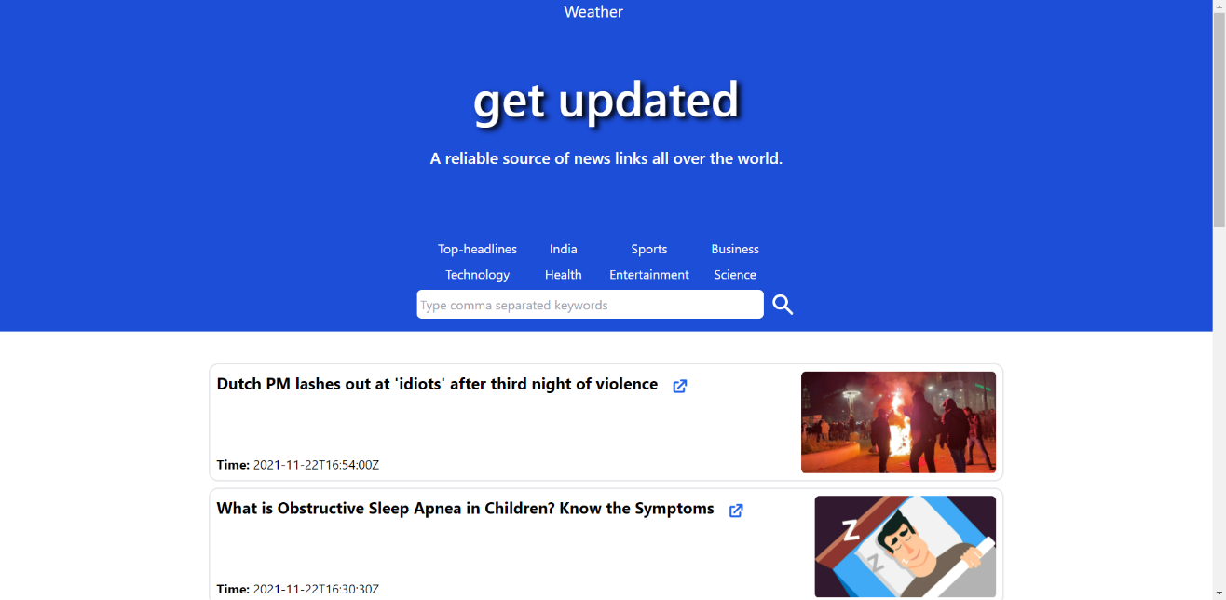
List of Figures

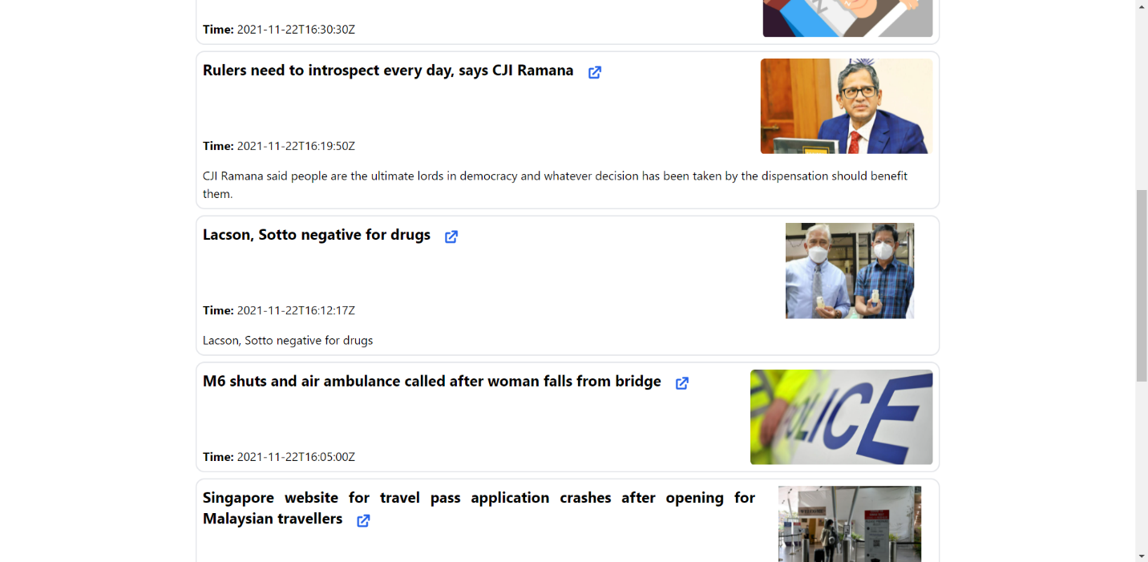
Home Page
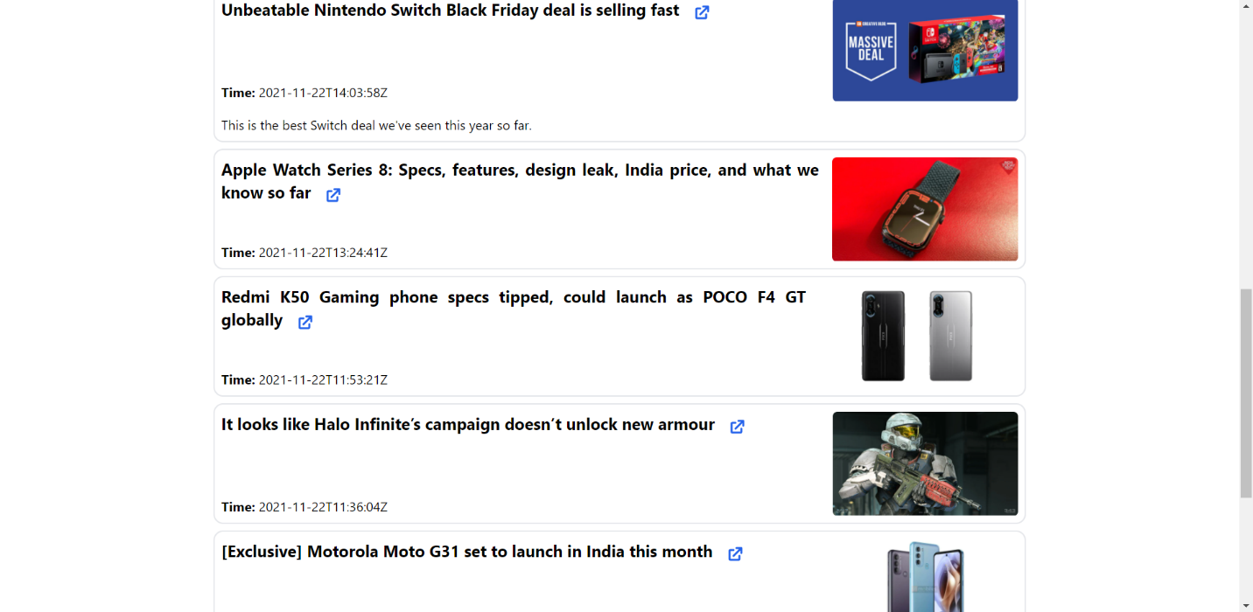
Technology Page

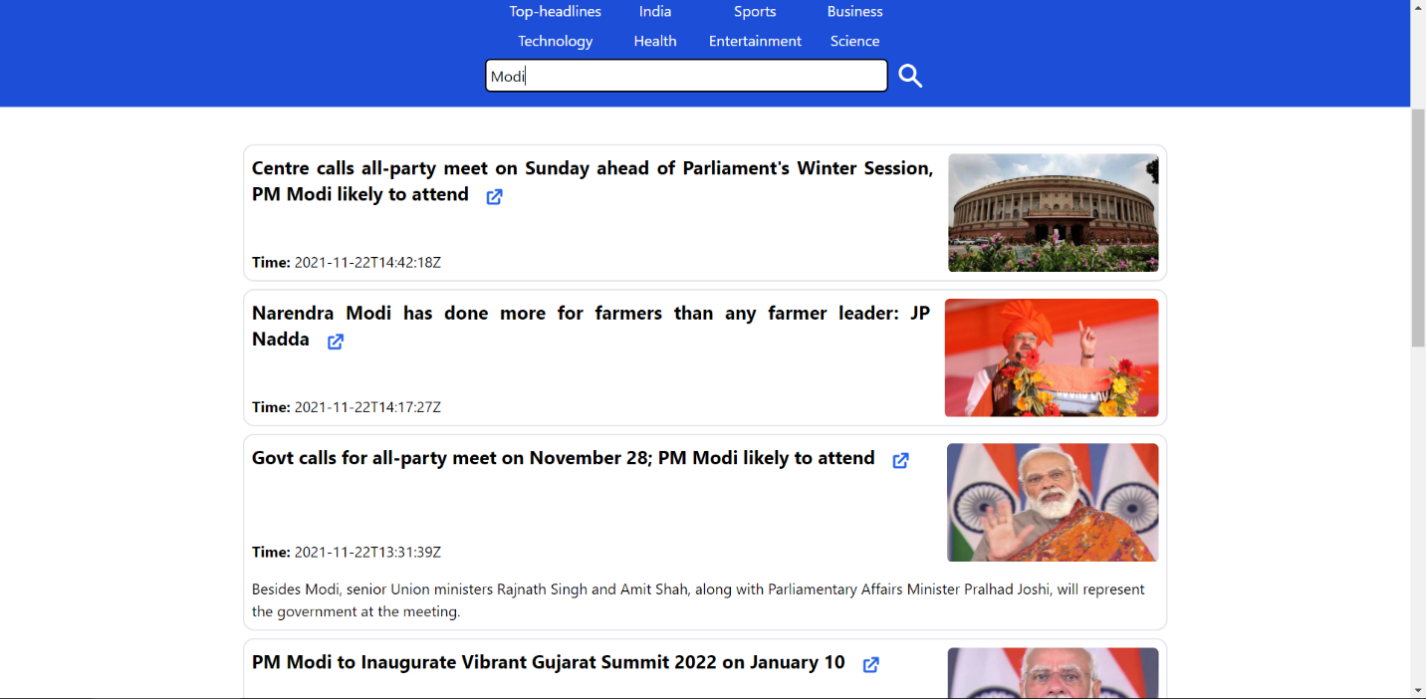
Searching keywords

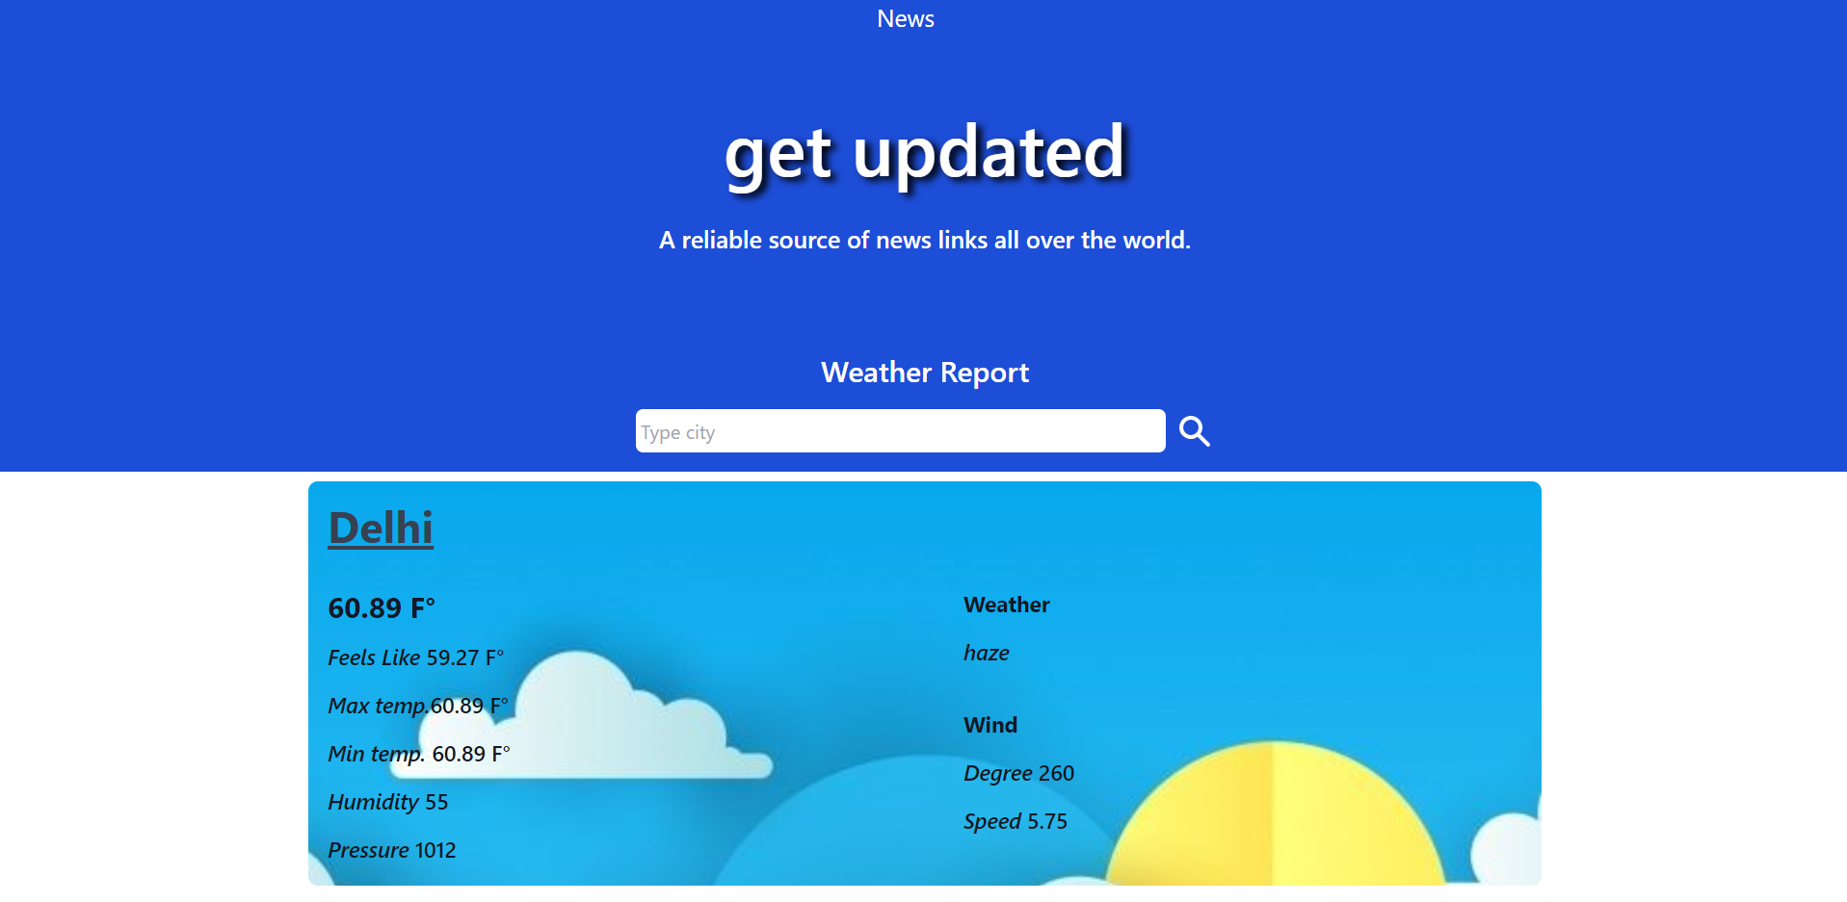
Weather Page

Searching City
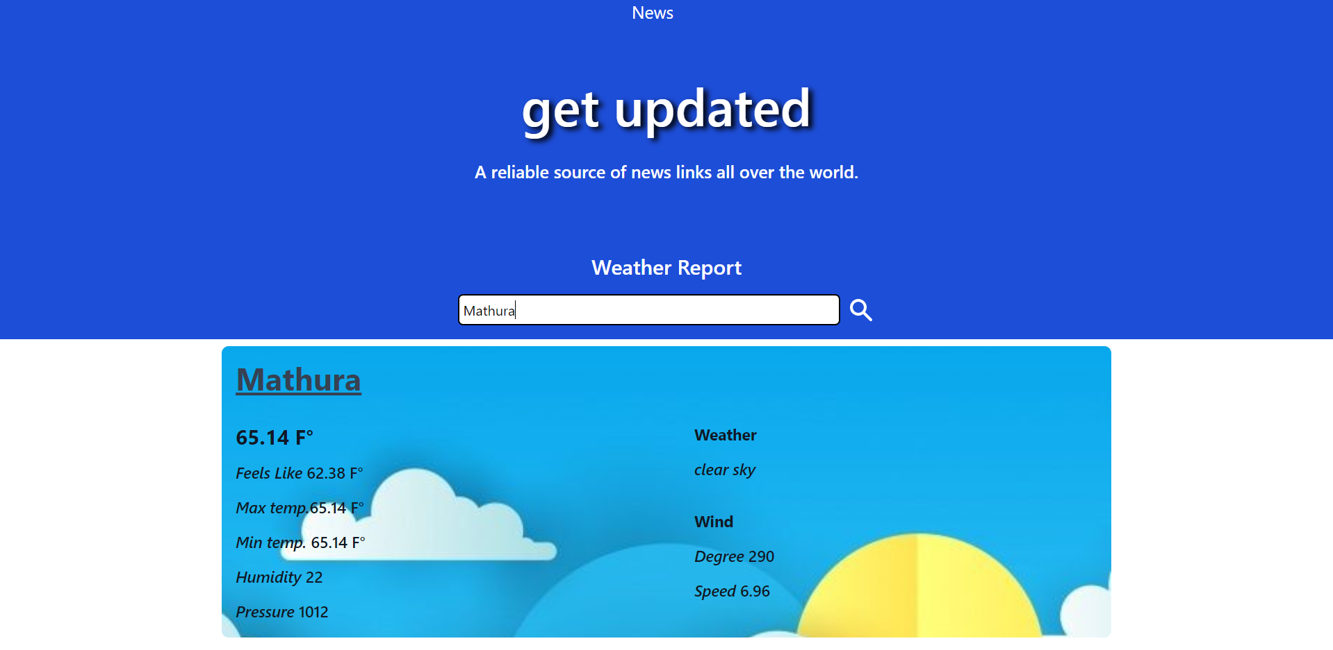
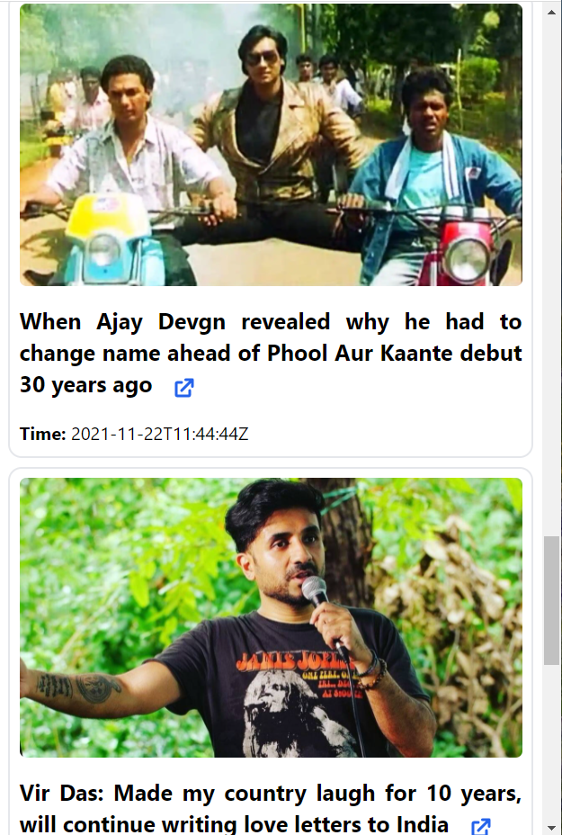
Responsive Home Page

Responsive Weather Page
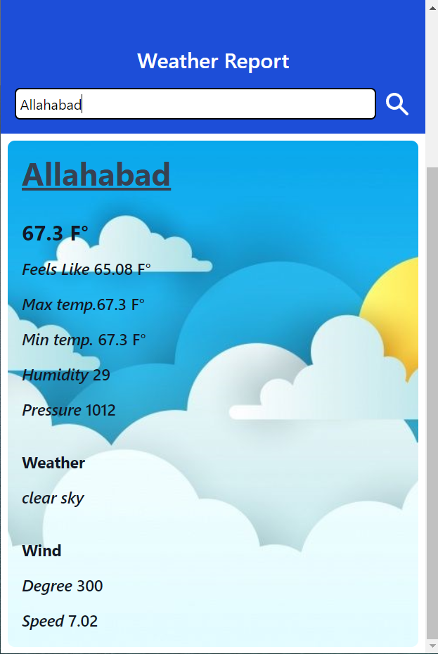

Software Testing

Once source code has been generated, software must be tested to uncover as many errors as possible before delivery. It is very important to work the system successfully and achieve high quality of software. Testing include designing a series of test cases that have a high likelihood of finding errors by applying software-testing techniques. System testing makes logical assumptions that if all the parts of the system are correct, the goal will be successfully achieved. The system should be checked logically. Validations and cross checks should be there. Avoid duplications of record that cause redundancy of data. In other Words, Testing is the process of evaluating a system or its component(s) with the intent to find whether it satisfies the specified requirements or not. It is executing a system in order to identify any gaps, errors, or missing requirements in contrary to the actual requirements.

The preliminary goal of implementation is to write source code and internal documentation so that conformance of the code to its specifications can be easily verified, and so that debugging, testing and modifications are eased. This goal can be achieved by making the source code as clear and straightforward as possible. Simplicity, clarity and

elegance are the hallmark of good programs, obscurity, cleverness, and complexity are indications of inadequate design and misdirected thinking. Source code clarity is enhanced by structured coding techniques, by good coding style, by, appropriate supporting documents, by good internal comments, and by feature provided in modern programming languages. The implementation team should be provided with a well-defined set of software requirement, an architectural design specification, and a detailed design description. Each team member must understand the objectives of implementation.

4.1 TERMINOLOGY

Error The term error is used in two ways. It refers to the difference between the actual output of software and the correct output, in this interpretation, error is essential a measure of the difference between actual and ideal. Error is also to used to refer to human action that result in software containing a defect or fault.

Fault is a condition that causes to fail in performing its required function. A fault is a basic reason for software malfunction and is synonymous with the commonly used term Bug.

Failure is the inability of a system or component to perform a required function according to its specifications. A software failure occurs if the behavior of the software is the different from the specified behavior. Failure may be caused due to functional or performance reasons.

4.2 TYPES OF TESTING

a. Unit Testing The term unit testing comprises the sets of tests performed by an individual programmer prior to integration of the unit into a larger system. A program unit is usually small enough that the programmer who developed it can test it in great detail, and certainly in greater detail than will be possible when the unit is integrated into an evolving software product. In the unit testing the programs are tested separately, independent of each other. Since the check is done at the program level, it is also called program teasing.

b. Module Testing A module and encapsulates related component. So can be tested without other system module.

c. Subsystem Testing Subsystem testing may be independently design and implemented common problems are sub-system interface mistake in this checking we concenton it. There are four categories of tests that a programmer will typically perform on a program unit.
i Functional test
ii Performance test
iii Stress test
iv Structure test
Functional Test Functional test cases involve exercising the code with Nominal input values for which expected results are known; as well as boundary values (minimum values, maximum values and values on and just outside the functional boundaries) and special values.

Performance Test Performance testing determines the amount of execution time spent in various parts of the unit, program throughput, response time, and device utilization by the program unit. A certain amount of avoid expending too much effort on fine-tuning of a program unit that contributes little to the overall performance of the entire system. Performance testing is most productive at the subsystem and system levels.

Stress Test Stress test are those designed to intentionally break the unit. A great deal can be learned about the strengths and limitations of a program by examining the manner in which a program unit breaks.

Structure Test Structure tests are concerned with exercising the internal logic of a program and traversing particular execution paths. Some authors refer collectively to functional performance and stress testing as “black box” testing. While structure testing is referred to as “white box” or “glass box” testing. The major activities in structural testing are deciding which path to exercise, deriving test date to exercise those paths, determining the test coverage criterion to be used, executing the test, and measuring the test coverage achieved when the test cases are exercised.

Conclusion

I have completed my project within time limit under the supervision of our mentor Dr. Manoj Varshney.

Project repository is available at
https://github.com/vaibhavpandeyprayag/getupdated

Deployment is available at
https://getupdated.netlify.app/

Bibliography

https://tailwindcss.com/docs
https://reactjs.org/docs/getting-started.html
https://medium.com/
https://reactrouter.com/docs/en/v6
https://www.postman.com/
http://svgicons.sparkk.fr/
https://www.iconfinder.com/
https://www.tutorialspoint.com/index.htm

