# **C:\Users\Muhammad\Documents\Shafique August 2014\SheridanCollegeApril2015\Winter-2016\PROG24178-Winter2016\CourseAdministeration\CourseOutlines\PROG24178-Java2-W2016_files\slogo.jpgPROG32758 Enterprise Java Development**

**Section P09 (1199-91243)** Fall 2019 (Sept. 3, 2019 – Dec. 13, 2019)

Class: Tuesday 4:00 pm – 7:00 pm (B308)

Thursday 1:00 pm – 4:00 pm (M31)

# **Web Application Problem Statement** Date: Sept. 12, 2019

--------------------------------------------------------------------------------------------------------------------------------------

Student Number: 991548013 Student Name: Vaibhav Parsana

--------------------------------------------------------------------------------------------------------------------------------------

NOTE: The completed document will be assessed for 10 points and it will be part of Assignment 1.

----------------------------------------------------------------------------------------------------------------------------------------

**Problem Statement**

Web applications with dynamic contents can provide 24/7 access to organizational resources in many domains. Some examples can include clinics, gyms, restaurants, charity organizations, and sports clubs.

Each organization develops web applications for various tasks. For example, a sports club can have a web application for the interested persons to register for its summer camps and another application to keep record of its players for a sport.

You can choose a web application from any domain of your choice. Write a problem statement for your choice.

Problem statement should

1. provide a brief introduction to the web application
2. give design of three web pages of your application. Page 1 can be a hyperlink as entry point to the application; page 2 can be to collect some data from the user of the application; page 3 can be a presentation of the processed input data.

**Submission**

Complete this word document and save it as “*LastNameFirstName-*WebAppProblem”. Upload the document to SLATE in WebAPPProblem folder in Assignments tag by Saturday September 14, 2019 11:59 pm.

**Problem Statement:**

Mississauga Swimming Club

1. The application would have first page as welcome to swimming club and will ask user to register to club by click on register button. On the second page, there will be various data field in which user will going to fill data regarding personal information. On the end of second page there will be submit button which takes user to confirmation page and display his personal details which will be third page and also on third page there are two buttons main page and update details which will takes user to main page(first page) and second page respectively.
2. Design:
3. First Page:

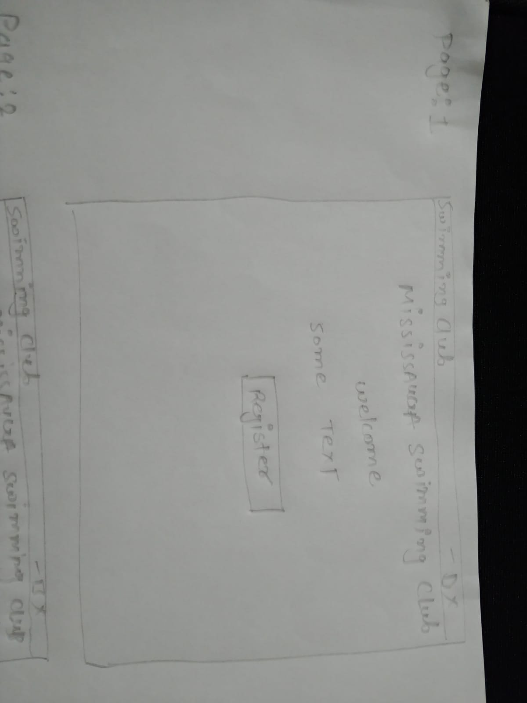

1. Second Page:

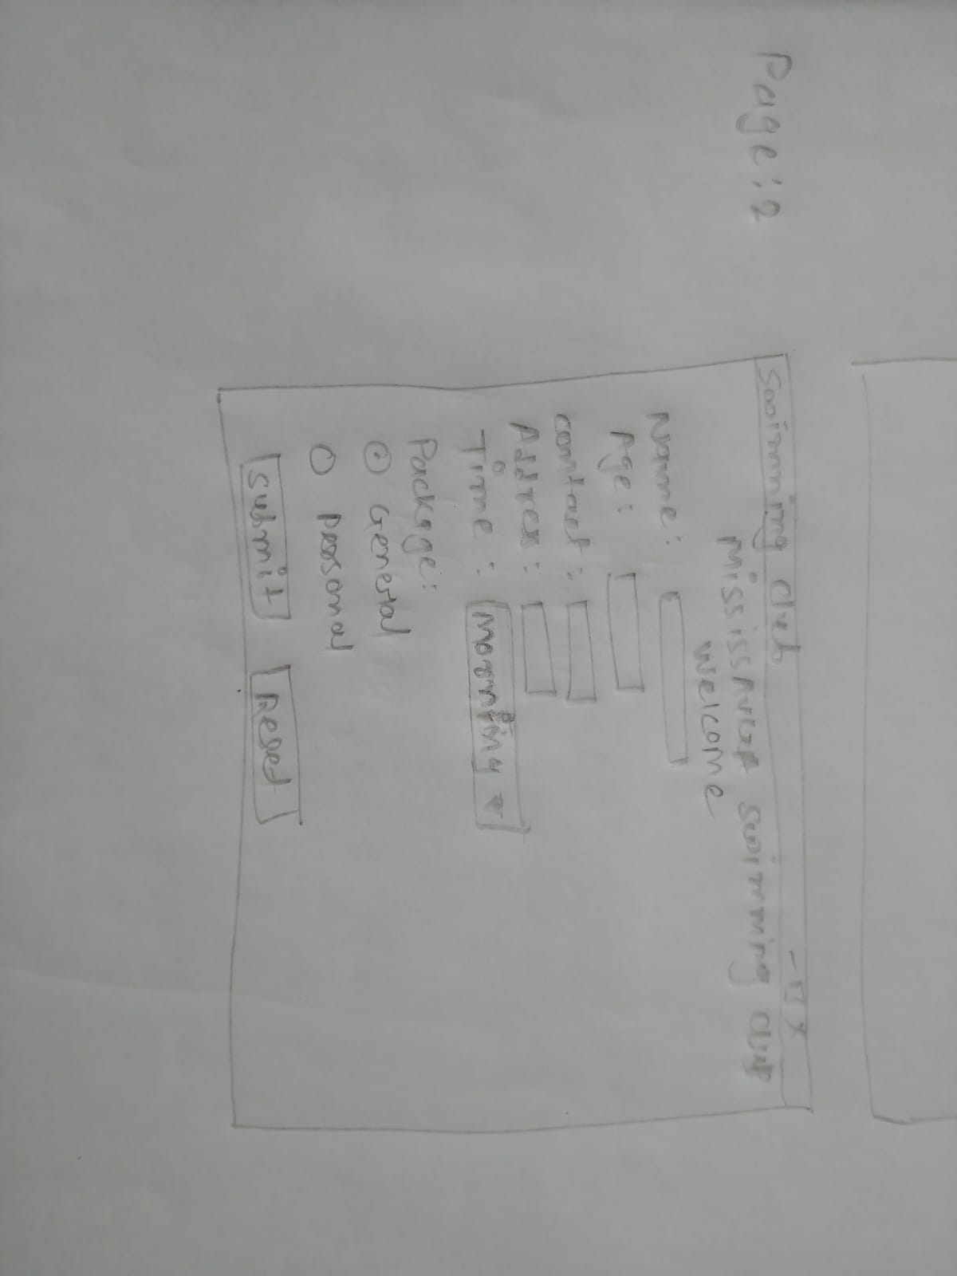

1. Third Page:

