## Database ER Data & Diagram:

## Entity-Relationship (ER) Diagram for Staff Management System:

The ER diagram for the employee management system, the system data, and their attributes. The data and the attributes are represented by the table, and the table shows how they are related to each other.

## Database Design for the Employee Management System:

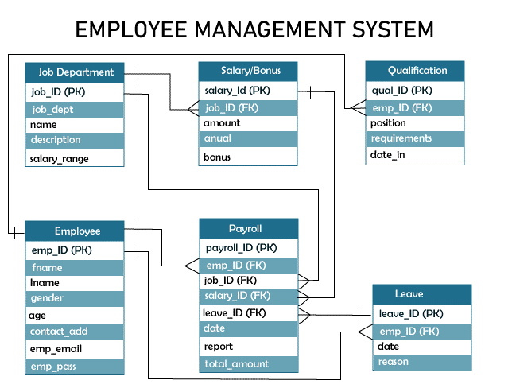

|  |
| --- |
| **Login** |
| Login_username |
| User_password |

|  |
| --- |
| Employee |
| emp_ID (PK) |
| FirstName |
| LastName |
| gender |
| age |
| contact_add |
| emp_email |
| emp_pass |

|  |
| --- |
| **Finance_User** |
| admin_ID (PK) |
| fname |
| lname |
| gender |
| age |
| contact_add |
| admin_email |
| admin_pass |

HAS

Table 1: login_tbl

|  |  |  |  |
| --- | --- | --- | --- |
| **Field** | **Description** | **Type** | **Length** |
| Login_username | Login username | Varchar | 255 |
| User_password | User password | Varchar | 255 |

#### Staff Management System ER Tables:

#### The below table shows all about the field name of the table, description, datatype, and character length. Each table of the ER diagram defines and explains the data storage. The field column lists all the attributes of the database that describes each column. The types table of the database shows what kind of data each attribute is, and the length shows how many characters it has.

Table 2:emp_tbl

|  |  |  |  |
| --- | --- | --- | --- |
| **Field** | **Description** | **Type** | **Length** |
| emp_ID (PK) | Employee ID | Int | 11 |
| FirstName | Employee First Name | Varchar | 255 |
| LastName | Employee Last Name | Varchar | 255 |
| gender | Employee Gender | Int | 11 |
| age | Employee Age | Int | 11 |
| contact_add | Contact Address | Int | 11 |
| emp_email | Employee Email | Varchar | 255 |
| emp_pass | Employee Password | Varchar | 255 |

Table 3: finance_tbl

|  |  |  |  |
| --- | --- | --- | --- |
| **Field** | **Description** | **Type** | **Length** |
| admin_ID (PK) | Admin ID | Int | 11 |
| fname | Instructor First Name | Varchar | 255 |
| lname | Instructor Last Name | Varchar | 255 |
| gender | Instructor Gender | Int | 11 |
| age | Instructor Age | Int | 11 |
| contact_add | Contact Address | Int | 11 |
| admin_email | Admin Email | Varchar | 255 |
| admin_pass | Admin Password | Varchar | 255 |