A Report for Mini Project I.

On

# “College Club Website”

*Submitted in partial fulfillment of the requirements for the award of the degree of*

## Bachelor of Technology

*in*

COMPUTER SCIENCE & ENGINEERING

*By*

|  |  |  |
| --- | --- | --- |
| **Name of Student** | **Division** | **Roll No.** |
| **Mr. Pradip Vikas Patil** | **B** | **B25** |
| **Mr. Rohit Rajendra Mane** | **B** | **B32** |
| **Mr. Vishnu Dattatray Shinde** | **B** | **B38** |
| **Mr. Siddharth Tanaji Zalake** | **B** | **B41** |

*Under the guidance of*

# Prof. A. D. PATIL



DEPARTMENT OF COMPUTER SCIENCE & ENGINEERING ASHOKRAO MANE GROUP OF INSTITUTION, VATHAR

*Affiliated To*

DR. BABASAHEB AMBEDKAR TECHNOLOGICAL UNIVERSITY

Lonere-402103, Tal. Mangaon, Dist. Raigad (MS) INDIA

A.Y. 2024-25

# Certificate

The project report entitled **College Club Website** submitted by **Mr. Pradip Vikas Patil (2262171242179), Mr. Rohit Rajendra Mane (2262171242012), Mr. Vishnu Dattatray Shinde (2262171242191)** & **Mr. Siddharth Tanaji Zalake (2262171242085)** is completed for the partial fulfilment of the requirement for the award of the degree of Bachelor of Technology in Computer Science & Engineering.

(Prof. A.D.Patil) ( Prof. S.S.Redekar)

Guide Head of Department

Computer Science & Engineering Computer Science & Engineering

(Prof.P.B.Ghewari) (Dr. A.V.Deshmukh)

Vice Principal Director

AMGOI, Vathar AMGOI, Vathar

# Acknowledgements

This work is just not an individual contribution until its completion. I take thisopportunity to thank all for bringing it close to conclusion. A special thanks goes to my Guide **Prof. A. D. Patil ,** for leading me to many new insights, encouraging and teachingme how to get down to the root of the problem.

I am also grateful to **Prof. S.S.Redekar** and the department faculty and staff membersfor their assistance.

I am also thankful to beloved Director **Prof. A.V. Deshmukh** & Vice Principal **Prof. P. B. Ghewari** for the kind support.

I am also thankful to all friends and well-wishers for support during the demanding period of this work. This document, in its eternity (as with everything I have or have yet to accomplish) is attributable to the **Parents**, whose strength and compassion are my constant inspiration.

I would also like to thank our wonderful **Colleagues** and friends for listening to our ideas, asking questions and providing feedback and suggestions for improving our ideas.

|  |  |
| --- | --- |
| Mr. Pradip Vikas Patil | (2262171242179) |
| Mr. Rohit Rajendra Mane | (2262171242012) |
| Mr. Vishnu Dattatray Shinde | (2262171242191) |
| Mr. Siddharth Tanaji Zalake | (2262171242085) |

# Abstract

The College Club Website is a thoughtfully designed project that aims to create an online platform for students to connect, share information, and stay updated on club activities. It centralizes essential resources like event details, announcements, and galleries, providing members with a single, easy-to- navigate hub. The website is built with a focus on simplicity and accessibility, featuring a modern, responsive design that works seamlessly across laptops, tablets, and smartphones. This ensures members can stay informed anytime, anywhere. Core features include an events calendar for tracking activities, a news section for updates, and a gallery to capture the club's memorable moments. Additionally, it includes a section to showcase member contributions, fostering a sense of community and belonging. Developed using HTML, CSS, and JavaScript for an interactive interface, and PHP with MySQL for efficient data management, the website balances functionality with aesthetic appeal. It’s designed to operate smoothly, ensuring reliability for users. More than just a technical project, this website reflects the spirit of the club, celebrates its achievements, and strengthens connections among members. It serves as a vibrant digital space that keeps the club thriving, ensuring its energy and purpose are maintained in the digital age.

# Contents

1. **Introduction**
   1. Introduction 1
   2. Problem Statement 1
   3. Purpose 1
   4. Relevant Objective 2
2. Literature Survey
   1. Existing System Overview 3
   2. Limitations of Existing System 3
   3. Need for the Proposed System 4
3. Project Scope And Requirement Analysis
   1. Project Scope 6
   2. Requirement Gathering And Analysis 6
4. Project Design And Modeling Details
   1. Software Requirement Specification (SRS) 8
   2. System Modules 9
   3. System Modeling And Design 10
   4. System Architecture 11
5. Implementation And Coding
   1. Algorithm 14
   2. Software Requirement 15
   3. Hardware Requirement 16
6. Conclusion 20
7. References 21

# Introduction

## Introduction

The College Club Website is an engaging and purposeful project aimed at creating a dynamic online platform for students to connect, collaborate, and stay informed about club activities. Designed to centralize all essential information, it provides a seamless experience where members can access event schedules, announcements, and resources in one convenient location. With a focus on simplicity and usability, the website features a modern and responsive design that adapts effortlessly to devices like laptops, tablets, and smartphones, ensuring accessibility for all users. By integrating tools like HTML, CSS, and JavaScript for an interactive interface, along with PHP and MySQL for efficient backend operations, the website is built to be both visually appealing and highly functional. Core features include an events calendar, a news section, and a gallery showcasing the club's memorable moments. A dedicated section for recognizing member contributions further enhances the sense of community and belonging. The website not only represents the club's essence but also celebrates its achievements and milestones. It fosters real-time interaction among members, encouraging greater participation in activities. Through its structured design, the platform makes navigation intuitive and engaging. This project also opens avenues for integrating future features, ensuring scalability. It is a testament to teamwork and innovation, ensuring the club’s presence thrives in the digital space.

## Problem Statement

The college club struggles with keeping members updated due to the lack of a centralized platform. Important announcements and event details often get missed, leading to lower participation. Members find it hard to connect and collaborate without an online space. Managing club activities and showcasing achievements is also unorganized. A user-friendly website is needed to fix these issues and make the club more connected and efficient.

## Purpose

The The purpose of the College Club Website is to create a centralized platform that simplifies communication and keeps all members connected. It aims to provide easy access to information about upcoming events, important announcements, and club resources in a single, organized space. By offering a user-friendly interface, the website ensures that members can stay informed anytime, whether on a laptop, tablet, or smartphone.

One of the key goals is to increase engagement by making it easier for members to participate in activities and stay updated about the club’s initiatives. The events calendar and news section ensure members never miss out on important happenings. The gallery showcases memorable moments, preserving the club’s legacy while inspiring future participation.

Another important purpose is to foster a sense of belonging among members. By highlighting contributions and achievements, the platform creates a personal connection and strengthens the community spirit.

From a technical perspective, the website also addresses the need for efficient management of club data. It reduces manual effort and ensures smooth operation through reliable backend systems.

Ultimately, this project is about more than just technology—it’s about building a vibrant digital space that reflects the club’s spirit, celebrates its milestones, and brings members closer together.

## Relevant Objective

**Centralize Club Information**: Provide a unified platform where members can easily access event schedules, announcements, and club resources in one place, improving communication and reducing confusion.

**Increase Member Engagement**: Encourage greater participation by offering features like an events calendar, news section, and gallery to keep members informed and excited about upcoming activities.

**Foster Community Connection**: Create a sense of belonging by showcasing member contributions and achievements, promoting a strong and supportive club community.

**Enhance Accessibility**: Ensure the website is fully responsive and accessible across devices (laptops, tablets, smartphones), making it easy for all members to stay connected on the go.

**Simplify Club Management**: Streamline event management, announcements, and content updates through an easy-to-use platform, reducing manual work for club organizers.

**Provide Real-Time Updates**: Keep members informed with instant notifications about important announcements, event changes, and updates to maintain engagement.

**Promote Club Achievements**: Highlight and preserve the club’s memorable moments in a gallery, showcasing its history and celebrating milestones that inspire future involvement.

**Ensure Reliable Data Management**: Implement a smooth backend system with PHP and MySQL to efficiently manage and store club data, ensuring the website operates seamlessly.

# Literature Survey

A literature survey for the College Club Website would explore existing platforms for managing club activities and communication. It would review technologies like PHP, MySQL, and JavaScript for building effective, responsive websites. The survey would focus on best practices for user-friendly design and accessibility. It would also analyze how similar websites engage members and streamline information sharing. This research helps identify key features to improve the club’s digital presence.

## Existing System Overview

The existing system for college clubs typically relies on fragmented communication methods like social media groups, emails, and physical notice boards. These platforms often fail to centralize information, leading to miscommunication and missed updates. Events and announcements are shared through various channels, making it difficult for members to stay fully informed. Additionally, managing club activities manually can be time-consuming and inefficient for organizers.

Social media platforms and email lists are commonly used, but they are not ideal for organizing events or tracking member engagement. While they allow for quick communication, they do not provide an easy way to manage resources or store important documents. Members often feel disconnected as these platforms lack personalized features to foster community building and consistent interaction.

Some clubs use basic websites or blogs to share updates, but these sites are generally static and do not offer interactive features. They often lack responsive designs and fail to engage members beyond basic announcements. These sites are not optimized for mobile use, making them less accessible for members who rely on smartphones for updates.

A more efficient system would involve a centralized website that combines event management, communication, and resource sharing in a single platform. This would enhance accessibility, streamline club operations, and improve member engagement. It would provide a more organized and user-friendly experience for both organizers and members.

## Limitations of Existing Systems

While the College Club Website aims to address several challenges faced by traditional communication methods, there are still some limitations:

1. **Limited Interactivity**: The current system may lack interactive features, such as live discussions or instant feedback, which can hinder active member engagement and participation in club activities.
2. **Fragmented Information**: Despite centralizing some aspects of communication, members may still need to access information from various sections or external platforms, making it harder to find everything in one place.
3. **User Accessibility**: Not all members may have access to modern devices or reliable internet, limiting their ability to fully engage with the website, especially if it's not optimized for all platforms.
4. **Complex User Interface**: If the website design isn't intuitive enough, members with limited technical expertise may struggle to navigate the platform, reducing overall engagement and participation.
5. **Scalability Challenges**: As the club grows and more content and events are added, the website may face performance issues, such as slow load times or difficulties in managing a larger volume of data.
6. **Limited Customization**: The platform may not allow for enough personalization, making it harder for members to tailor their experience to their preferences or needs, which could lead to disengagement.

## Need for the Proposed System

The proposed College Club Website addresses the limitations of existing communication systems by offering a centralized, user-friendly, and feature-rich platform to enhance member engagement and streamline club activities. The need for this system arises from the following factors:

1. **Improving Communication Efficiency**: Traditional methods like physical notice boards and social media groups are disorganized and often missed. The proposed website centralizes all club-related information in one place, ensuring members can easily access updates, events, and resources.
2. **Enhancing Accessibility**: Geographical and device limitations often prevent some members from staying connected. The system ensures global accessibility and is designed to work seamlessly across laptops, tablets, and smartphones, allowing all members to participate regardless of location or device.
3. **Promoting Member Engagement**: Existing platforms lack features that encourage active

participation. The proposed website offers interactive features like event calendars, feedback sections, and galleries to engage members and keep them involved in club activities.

1. **Fostering Transparency and Trust**: In many clubs, decision-making and event planning are not always clear to members. The proposed system ensures transparency by providing clear event timelines, member contributions, and up-to-date announcements, building trust within the community.
2. **Simplifying Management**: Manual management of events and resources is time- consuming. The website automates event management, attendance tracking, and resource sharing, reducing the workload for club organizers and improving operational efficiency.
3. **Scalability for Growth**: As the club expands, managing more members and content can become challenging. The system is designed to scale, allowing for smooth handling of increased data, events, and user interactions as the club grows.

# Project Scope and Requirement Analysis

## Project Scope

The scope of the College Club Website project is to develop a comprehensive digital platform designed to streamline communication, enhance member engagement, and simplify club management. The website will act as a central hub for all club-related information, including event schedules, announcements, and resources. Key features will include an interactive events calendar, news and updates section, photo gallery, and a member directory. The platform will ensure that all members, regardless of location, can easily access the latest information and updates. It will be fully responsive, ensuring that it works seamlessly across devices like laptops, tablets, and smartphones.

In addition to communication tools, the website will help automate several club management tasks, such as event registration, attendance tracking, and resource sharing. These features will reduce the administrative burden on organizers and allow them to focus more on event planning and member engagement. The backend system will utilize PHP and MySQL to handle the storage and management of data efficiently, ensuring the platform remains reliable and fast even as the club grows. The design of the website will focus on user-friendliness, making sure that members, whether they have technical expertise or not, can easily navigate the platform.

Another essential feature will be member recognition, showcasing their contributions and achievements within the club. This will help build a sense of community and encourage active participation. The website will also offer transparency by displaying clear event details, past activity records, and member contributions. Furthermore, scalability is a key consideration, with the system designed to handle increased data and users as the club grows. The aim of this project is not just to create a functional website but to foster a more engaged, connected, and active club community in the digital world.

## Requirement Gathering and Analysis

### Requirement Gathering:

To gather requirements for the College Club Website, input was sought from the following stakeholders:

1. **Club Members**: Feedback on user experience, desired features, and engagement tools.
2. **Club Organizers**: Insights on event management, attendance tracking, and resource sharing needs.
3. **Web Development Team**: Technical feasibility of proposed functionalities and suitable technologies.
4. **Design Team**: Input on creating an intuitive, accessible, and visually appealing user interface.

### Analysis:

1. To define the core objectives and functionalities of the College Club Website, ensuring it addresses the communication, management, and engagement needs of the club.
2. To identify the required resources (technical tools, human expertise) for developing the website, including the necessary skills in web development and design.
3. To set clear and achievable expectations for stakeholders, ensuring the platform effectively meets the needs of both members and organizers.
4. To minimize the risk of scope changes, delays, and miscommunication throughout the development process by having a well-defined plan and agreed-upon objectives.

In short, **Requirement Analysis** is about defining what the system must do and how it should operate to ensure it meets the goals and expectations of its users and stakeholders.

# Project Design and Modeling Details

## Software Requirement Specification (SRS)

### Functional Requirements:

1. **User Registration:** Users can register with a secure system, with distinct roles for members, organizers, and admins.
2. **Event Management**: Organizers can create, edit, and manage events, while members can view, register, or RSVP for events.
3. **Member Directory**: A searchable directory allowing members to view and connect with other members, showcasing their roles and contributions.
4. **Admin Dashboard**: Admins can monitor club activities, manage user roles, track event registrations, and generate engagement reports.

### Non-Functional Requirements:

1. **Performance:** Ensure load times and responsive interactions, even during peak usage, for a smooth user experience.
2. **Security**: Implement robust security measures, including data encryption and secure access, to protect user information and prevent unauthorized access.
3. **Reliability**: Ensure consistent uptime with strong error handling and recovery mechanisms to minimize disruptions and maintain reliable service.
4. **Usability**: Design an intuitive and easy-to-use interface, ensuring accessibility for all members, regardless of their technical background.
5. **Scalability**: Build the system to handle future growth, including increased user base, content, and event volume, without compromising performance.

### Technical Requirements:

1. **Frontend:** Developed using HTML, CSS, JavaScrpt.
2. **Backend:** PHP for handling auction logic.
3. **Database:** Store students information and feedback data using Mysql.

### System Constraints:

1. **Internet Connection**: The application requires a stable internet connection for real-time functionality.
2. **Cross-Browser Compatibility**: Ensure the system is compatible with popular web

browsers like Chrome, Firefox, and Safari.

1. **Security Protocols**: Follow industry standards for user data protection and security.

## System Modules

The College Club Website can be divided into several key modules, each responsible for specific aspects of the platform. These modules work together to provide an efficient and user-friendly experience for club members, organizers, and administrators. Below are the key system modules:

### User Module

**Purpose**: To manage and assign different roles (members, organizers, and admins) within the website.

### Features:

* 1. **User Registration**: Allows users to registrer by providing necessary information like name, email, and role (member, organizer, admin).
  2. **Role-based Access Control**: Different roles (member, organizer, admin) provide different levels of access to various website functionalities.

### Event Management Module

**Purpose**: To allow organizers to create, manage, and update club events.

### Features:

* 1. **Event Creation**: Organizers can create events by adding details like event name, description, date, and location.
  2. **Event Registration**: Members can register for upcoming events.
  3. **Event Updates**: Organizers can update event information, such as changes in date, time, or venue.

### Announcements and News Module

**Purpose**: To display important club news, announcements, and updates.

### Features:

* 1. **Announcement Creation**: Admins and organizers can post new announcements regarding club activities, meetings, and updates.
  2. **Real-Time Notifications**: Members receive instant notifications about new announcements.
  3. **News Section**: A section where past club news are archived for reference.

### Admin Module

**Purpose**: To provide admins with control and monitoring features for managing club activities.

### Features:

* 1. **User Management**: Admins can view, add, or remove users.
  2. **Event Monitoring**: Admins can monitor event registrations, attendance, and overall participation.
  3. **Reports and Analytics**: Generate reports on member engagement, event success, and overall club activities.

## System Modelling And Design

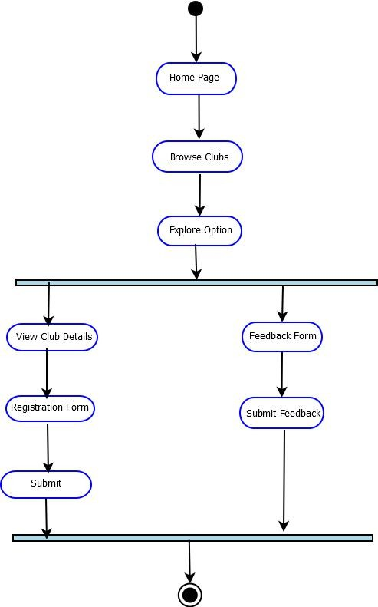

### Fig. 4.3.1 Activity Diagram

**Explanation:**

1. **Start:** The process begins when a user visits the college clubs website. They are directed

to the Home Page, where they see different navigation options.

1. **Home Page:** The home page presents the main features of the website. The user chooses to Browse Clubs from the navigation menu.
2. **Browse Clubs:** The user selects to view the list of clubs
3. **Explore Options**: The user views the details of a specific club.
4. **Registration Form**: The user fills out a form to join a club.
5. **Feedback Form**: The user provides feedback about the club or website.
6. **End:** The activity concludes when the user submits a form or exits.

## System Architecture

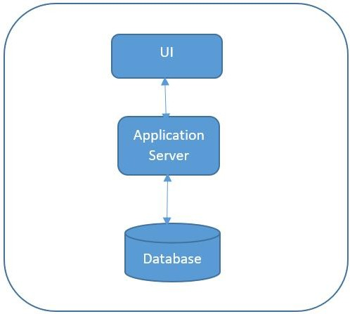

### Fig. 4.4.1 System Architecture

1. **UI (User Interface):**

**Role:** The User Interface (UI) is where users (students, faculty, and administrators) interact with the college club website.

### Interaction:

Users access the platform through a web browser or mobile app interface to browse

club events, view announcements, register for events, and interact with other club features.

### Key Functions:

Display events, announcements, and other club-related information. Allow event registration and participation.

feedback and communication options for users.

### Application Server:

**Role:** The Application Server hosts the backend of the college club website and processes user requests.

### Interaction:

It acts as a mediator between the User Interface and the Database, handling business logic and request processing.

### Key Functions:

Handle event registrations, feedback submissions, and other interactions from the UI. Update event status and send notifications to users.

Process data requests from the UI and fetch the appropriate data from the database.

### Database:

**Role:** The database stores all data related to users, events, registrations, and feedback.

### Interaction:

The Application Server communicates with the database to retrieve and store data, ensuring it is up-to-date and accurate for the users.

### Key Functions:

Host the application front-end (user interface).

Store event details, registration records, and user feedback. Manage users' participation and interaction history with the events.

Ensure data integrity, fast access to real-time data, and security for user and event data

### Communication Flow:

College club website, the communication flow is designed to ensure smooth interaction between users and the system. When a user (club member or visitor) accesses the **User Interface (UI)**, they can browse club events, view member details, or interact with various sections. The UI sends the user's request to the **Application Server**, which processes the request by accessing relevant data from the **Database**. The database stores information such as event schedules, member profiles, and past activities. After processing, the **Application Server** returns the data to the UI, which displays it in an

easy-to-read format for the user. This continuous flow of data ensures real-time updates.

# Implementation And Coding

## Algorithm

### Registration:

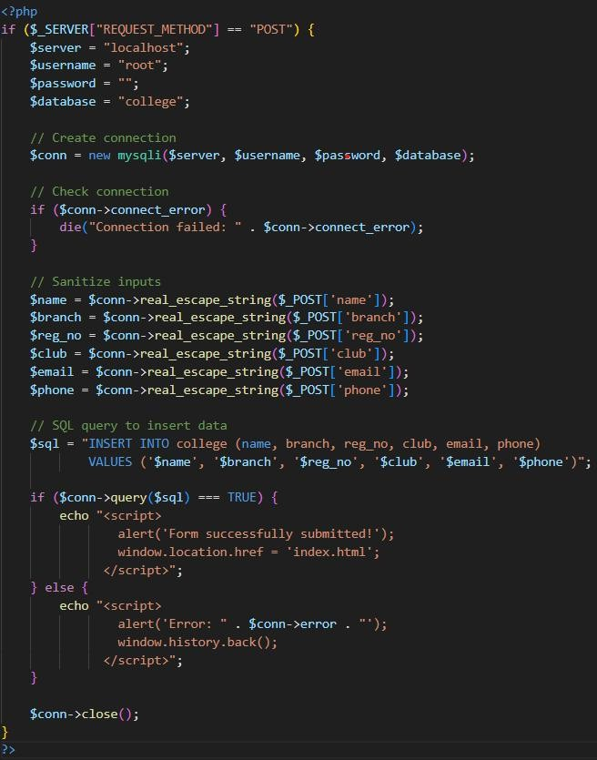

**Fig. 5.1.1 Student Registration**

Validate input fields (username, email, password, mobile number, address). Store user credentials in the database, including all details.

### Feedback:

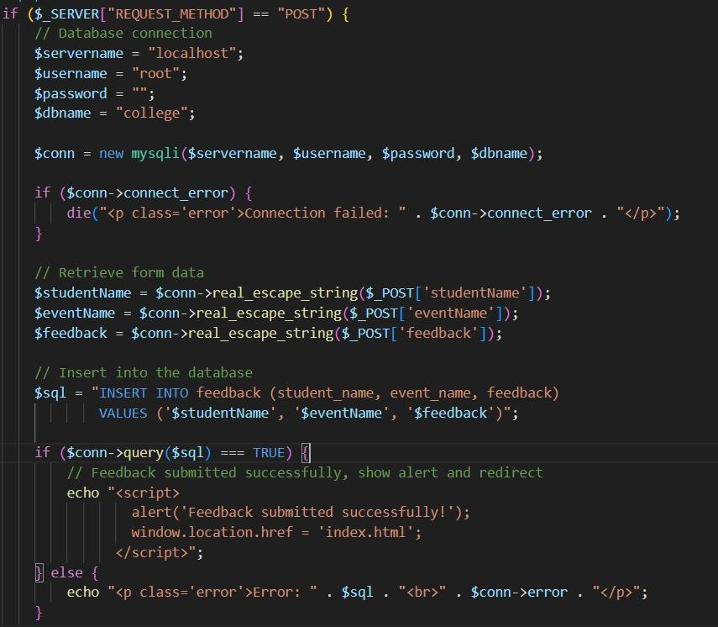

**Fig. 5.1.2 User login**

Students give the feedback about the past event. Feedback is get stored in database to analyse the event.

## Software Requirements

### Operating System :

Windows or Linux (Ubuntu), macOS (for Mac users)

### Web Development Technologies : Frontend -

HTML5: For structuring the web pages and content. CSS3: For styling and layout design.

JavaScript: For validation

### Backend -

PHP: For backend programming and advanced algorithms.

### Database Management System :

MySQL: Relational databases for storing Students registration data and feedback.

### Web Server :

XAMPP web server solution.

### Development Tools :

**IDE/Text Editor** -

Visual Studio Code or Sublime Text for writing the code.

### Version Control -

Git: For version control and collaboration.

GitHub or GitLab: To host the repository and manage codebase.

## Hardware Requirements

### Development Machines (for developers) Processor:

Intel Core i5 (or equivalent) or higher for smooth development and running of virtual environments.

**RAM**:

8 GB or higher to run IDEs, database servers, and other development tools efficiently.

### Storage:

SSD (Solid State Drive) with at least 100 GB of free space for fast storage and easy access to files.

### Network:

High-speed internet connection for downloading dependencies, hosting repositories, and managing deployments.

### Database Server (for live deployment) Processor:

Intel Xeon or AMD Ryzen processors with multi-core support for managing multiple database queries efficiently.

### RAM:

16 GB or higher, depending on the number of active users and the size of the database.

### Storage:

1 TB SSD (or more) for storing the user data, auction items, bids, and transaction history securely.

### Network:

A stable and secure network connection with low latency to ensure fast database access and real-time updates.

**Registration Page:**

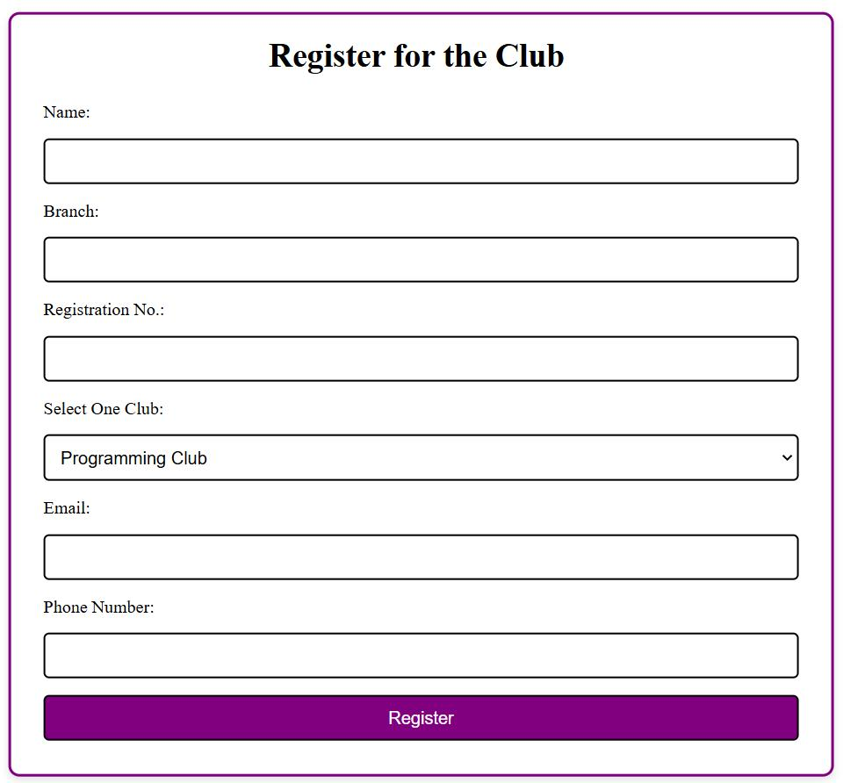

**Fig. 5.3.1 Registration page**

# Feedback Form:

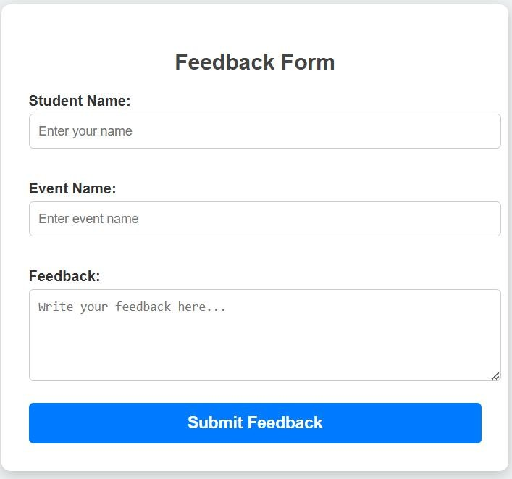

**Fig. 5.3.2 Feedback page**

# Home:

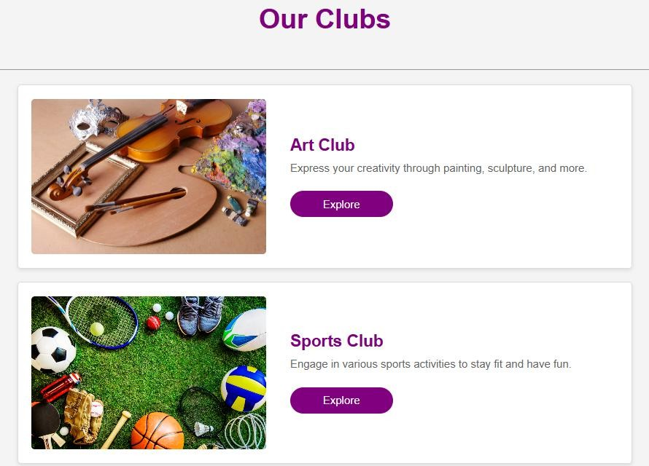

**Fig. 5.3.3 Home page**

# Conclusion

The college club website has been successfully developed with a strong emphasis on creating an easy-to-use platform for both students and administrators. Using PHP for server-side scripting and MySQL for database management, the website ensures smooth data handling, secure user registration, and efficient event management. The interface is designed to be simple and intuitive, allowing users to navigate the website effortlessly and access all necessary features without any complexity. From event registration to user management, each feature is carefully implemented to provide a seamless user experience.

On the back-end, secure practices like input validation and SQL injection prevention ensure the safety of user data and the reliability of the website. The admin panel provides a convenient way for administrators to manage content, monitor user registrations, and update website information as needed. By meeting both functional and non-functional requirements, the website serves as an efficient tool for the college club, fostering communication and engagement within the college community. This project not only streamlines event management but also lays a solid foundation for future development and scalability, making it a reliable and secure platform for managing club activities.

# References

1. **Kumar, R., & Sharma, P. (2020). Web Application Development:** Best Practices and Trends. Journal of Web Development, 12(4), 101-107. This paper discusses the latest trends in web application development, including user interface design and backend integration, offering valuable insights for creating a user-friendly and efficient website.
2. **Singh, A., & Mehta, R. (2019). Database Management Systems in Web Applications. International Journal of Computer Science & Engineering, 14(2), 50-57.** This article explores the role of database management systems, like MySQL, in web applications, emphasizing their importance in data storage, retrieval, and management.
3. **Patel, S., & Gupta, P. (2021). Enhancing User Experience in Web Development: Challenges and Solutions.** This research covers techniques and best practices to enhance user experience on websites, focusing on responsive design, navigation, and accessibility, which are crucial for your project.
4. **Sharma, R., & Saxena, N. (2022). Building Scalable Web Applications: Techniques and Tools. International Journal of Software Engineering, 28(7), 75-82.** This study Discusses the tools and frameworks for building scalable web applications, ensuring that the website can handle increasing traffic and user interaction as the college club grows.