**REPORT**

***6. a)***

**Sorter1 coverage:**

Statement coverage: 100%

Branch coverage: 100%

Covered instruction: 111

Missed instruction: 0

Total instruction: 111

**Sorter2 coverage:**

Statement coverage: 100%

Branch coverage: 100%

Covered instruction: 145

Missed instruction: 0

Total instruction: 145

**Screenshot:**

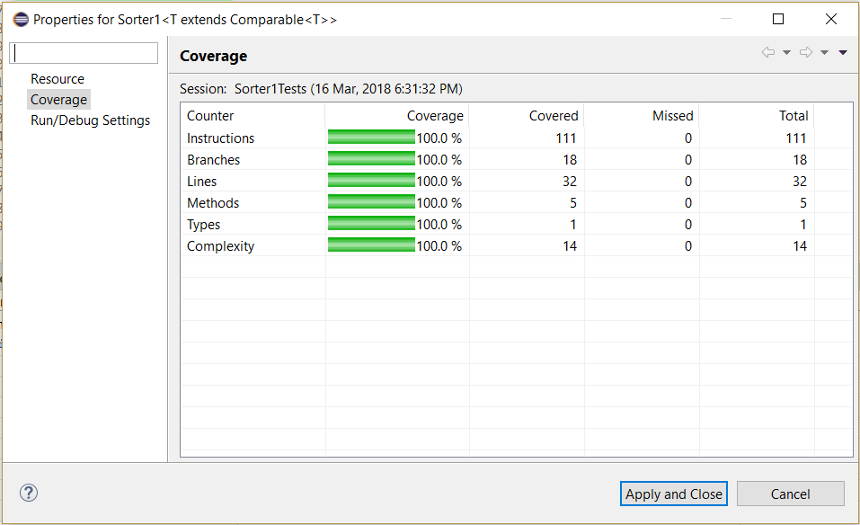

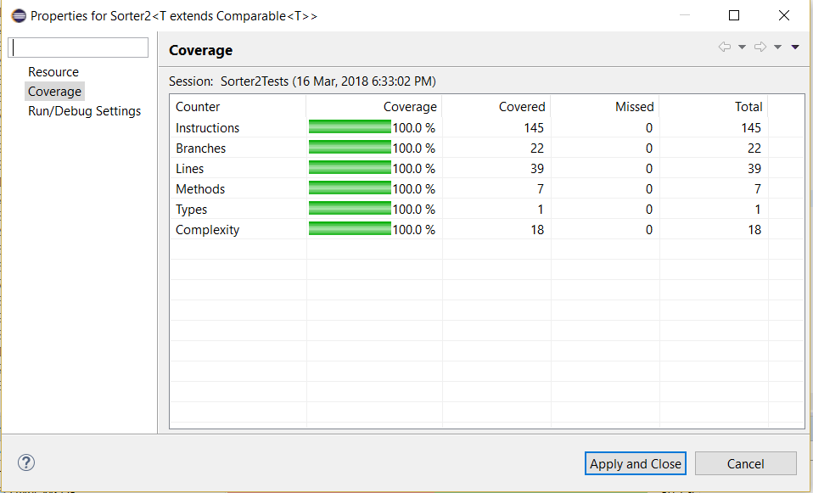

***6.b)***

**Sorter1 coverage for SampleTests:**

Statement coverage: 96.4% (Statements missed-4)

Branch coverage: 88.9%(Branches missed-2)

Covered instruction: 107

Missed instruction: 4

Total instruction: 111

**Sorter2 coverage for SampleTests:**

Statement coverage: 98.6% (Statements missed-2)

Branch coverage: 95.5% (Branches missed-1)

Covered instruction: 143

Missed instruction: 2

Total instruction: 145

**Screenshot:**

