**1 - click on correct combination**

a - byte int long short

b - float char

c - double float boolean

d - char and boolean

1. **Answer and Why? :** A byte is 1 byte, short is 2 byte, int is 4 byte and long is 8 bytes

**2 - Java save all object in which memory structure**

a - Heap

b - stack

c - queue

d - Graph

1. **Answer and Why? :** A because object sorting not specific.

**3 – write 2 ways to create infinite loop?**

**Answer and Why? :**

**For(int i=2; i>1; i++)**

**{**

**System.out.println(“infinite loop”);**

**}**

**A=1;**

**While(A)**

**{**

**System.out.println(“infinite loop”);**

**}**

**4 – Method Overloading is a kind of**

a – Compile Time Polymorphism

b – Runtime Polymorphism

c - Encapsulation

d – a and b both

**Answer and Why? :**

= a

**5 – What is the output?**

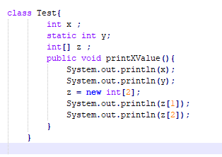

**Answer and Why? :**

Method printXValue not calling by class object.

**6 – Write Sequence to initialize blocks**

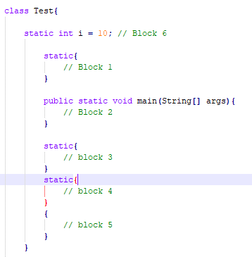

**Answer and Why? :**

Block1,block3,block4,block5,block2

**7 – Write Output of this Code**

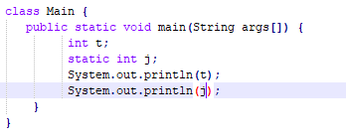

**Answer and Why? :**

Value of t and j. run without error.

**8 - Write difference between**

A - while, do…while and for loop.

**Answer and Why? :**

While : firstly condition check then statement executed.

Do while : once statement executed then statement is executed.

For : statement is excuted once the condition checked.

B – Encapsulation and Abstraction

Encapsulation is data binding means methods and parameters are bind together.

Abstraction is hide some details and only essential data gives to class/methods.

**Answer and Why? :**

C – JDK and JRE

**Answer and Why? :**

Jdk : java development kit is for develop java code

Jre : java runtime environment is used for execution of java programme. No need to source code only bytecode is needed for execution.

D – Logical AND and bitwise AND

Logical AND : denoted by && when both gates are true then only logical and return true otherwise it returns false.

Bitwise AND : denoted by & is used for when if first condition is true it returns true.

**Answer and Why? :**

**9 – What is result of below questions**

**X = 10**

**a –** Y = X++ + ++X + ++X + X++ + X++

**Answer and Why? :**

Y = 10 + 11 + 12 + 12 + 12 = 57

b – Y = X-- + --X + ++X +X++ + ++X

**Answer and Why? :**

B = 10+9+10+10+11 = 50

c – Y = X+++++X

**Answer and Why? :**

Y = 10+11 = 21

**10 – Result of Below Question**

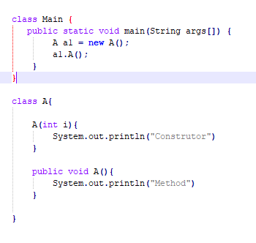

**Answer and Why? :**

o/p : Error because constructor is parametrized and it does not initialize memory to method A.