**1 - click on correct combination**

a - byte int long short

b - float char

c - double float boolean

d - char and boolean

**Answer and Why? : Because kind of value is integer for a. Others have different values (floating point and single character)**

**2 - Java save all object in which memory structure**

a - Heap

b - stack

c - queue

d - Graph

**Answer and Why? : Because in Heap memory will get allocated automatically.**

**3 – write 2 ways to create infinite loop?**

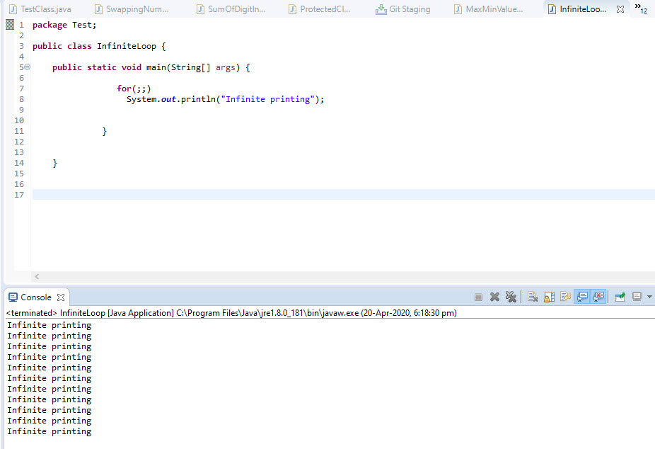

**Answer and Why? : If condition has no end point mentioned and that’s the reason why printing command has no break.**

**4 – Method Overloading is a kind of**

a – Compile Time Polymorphism

b – Runtime Polymorphism

c - Encapsulation

d – a and b both

**Answer and Why? : It checks at the time of compilation that’s why it os known as compile time polymorphism.**

**5 – What is the output?**

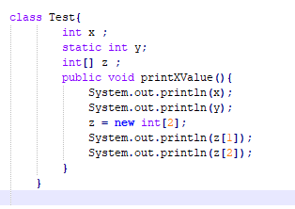

**Answer and Why? : It may give error because of main method is not present.**

**6 – Write Sequence to initialize blocks**

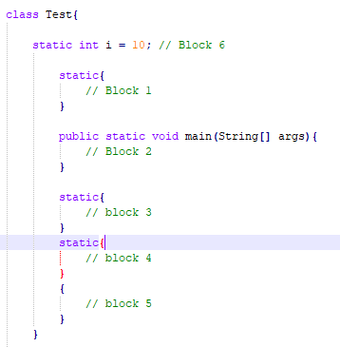

**Answer and Why? : 2,6,1,3,4,5**

**7 – Write Output of this Code**

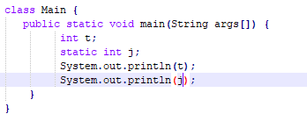

**Answer and Why? : It will give comilaton error because of static int j**

**8 - Write difference between**

A - while, do…while and for loop.

|  |  |  |
| --- | --- | --- |
| for loop | while loop | do while loop |
| The Java for loop is a control flow statement that iterates a part of the programs multiple times. | The Java while loop is a control flow statement that executes a part of the programs repeatedly on the basis of given boolean condition. | The Java do while loop is a control flow statement that executes a part of the programs at least once and the further execution depends upon the given boolean condition. |
| Can be used if the number of iteration is fixed. | Can be used if the number of iteration is not fixed. | Can be used if the number of iteration is not fixed and you must have to execute the loop at least once. |
|  |  |  |

B – Encapsulation and Abstraction

|  |  |
| --- | --- |
| Encapsulation | Abstraction |
| Works on design level | Work on application level |
| It is used to hide unnecessary data. | It is used to hide code and data together. |
| It focuses on outside viewing. | It focuses on internal working |

C – JDK and JRE

|  |  |
| --- | --- |
| JDK | JRE |
| Java development kit | Java runtime environment |
| provides the environment to develop and execute(run) the Java program | provides environment to onlyrun (notdevelop) the java program |
|  |  |

D – Logical AND and bitwise AND

|  |  |
| --- | --- |
| Logical Operators | Bitwise Operators |
| Logical operators take as input boolean values | Bitwise operators take as input integer values |
| Logicaloperatorsdealwithstatements***.*** | Bitwiseoperatorsdealwithbinaryrepresentationsofdata***.*** |
|  |  |

**9 – What is result of below questions**

**X = 10**

**a –** Y = X++ + ++X + ++X + X++ + X++

**Answer and Why? : 61**

b – Y = X-- + --X + ++X +X++ + ++X

**Answer and Why? : 51**

c – Y = X+++++X

**Answer and Why? : 22**

**10 – Result of Below Question**

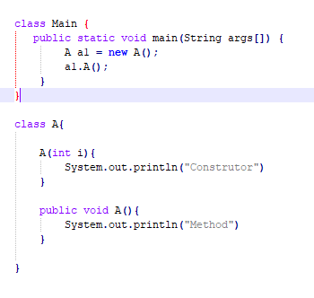

**Answer and Why? : Will solve later as time up for the test.**