**1 - click on correct combination**

a - byte int long short

b - float char

c - double float boolean

d - char and boolean

**Answer and Why? : a - byte int long short, because it is a Integer Data Type**

**2 - Java save all object in which memory structure**

a - Heap

b - stack

c - queue

d - Graph

**Answer and Why? : a - Heap, Java Heap space is used by java runtime to allocate memory to Objects**

**3 – write 2 ways to create infinite loop?**

**Answer and Why? :**

**Way 1:**

**Public void infinite()**

**{**

**while(true)**

**{**

**System.out.println(“inifinite loop”)**

**}**

**}**

**Way 2:**

**Public void infinite()**

**{**

**For(;;)**

**{**

**System.out.println(“inifinite loop”)**

**}**

**}**

**Why Ans: Because we are not assign the proper condition.**

**4 – Method Overloading is a kind of**

a – Compile Time Polymorphism

b – Runtime Polymorphism

c - Encapsulation

d – a and b both

**Answer and Why? : a – Compile Time Polymorphism, You have the multiple methods with same name and different parameters and compiler has to decide which method has to run based on the arg. at that time we use this.**

**5 – What is the output?**

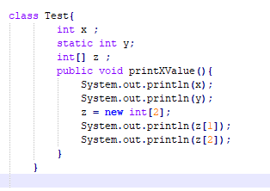

**Answer and Why? :**

**Compile time error, because static data type not accessible in non static method.**

**6 – Write Sequence to initialize blocks**

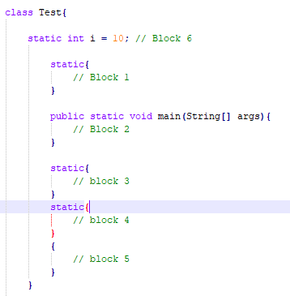

**Answer and Why? :**

**1**

**3**

**4**

**2**

**7 – Write Output of this Code**

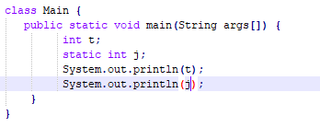

**Answer and Why? :**

**Compile time error,**

**8 - Write difference between**

A - while, do…while and for loop.

**Answer and Why? :**

**while :**

1. **While loop is known as entry controlled loop.**
2. **If the condition is not true first time than control will never enter in a loop.**

**do while:**

1. **do while loop is known as exit controlled loop.**
2. **Even if the condition is not true for the first time the control will enter in a loop.**

**for:**

1. **for loop is known as entry controlled loop**
2. **If the condition is not true first time than control will never enter in a loop**

B – Encapsulation and Abstraction

**Answer and Why? :**

**Abstraction:**

**Hiding internal details and showing functionality is known as abstraction**

**example: phone call**

**Encapsulation:**

**Wrapping code and data together into a single unit is known as encapsulation**

**example: capsule**

C – JDK and JRE

**Answer and Why? :**

**JVM is an environment for executing bytecode**

**JRE contains class libraries and other supporting files**

D – Logical AND and bitwise AND

**Answer and Why? :**

**Bitwise AND:**

**Bitwise operator works on binary digits of integer and return integer value.**

**It written: "&" and "|"**

**Logical AND:**

**Logical operator work on Boolean expression and return Boolean value (true or false).**

**It written: "&&" and "||"**

**9 – What is result of below questions**

**X = 10**

**a –** Y = X++ + ++X + ++X + X++ + X++

**Answer and Why? :**

**62**

b – Y = X-- + --X + ++X +X++ + ++X

**Answer and Why? :**

**47**

c – Y = X+++++X

**Answer and Why? :**

**Compile time error**

**10 – Result of Below Question**

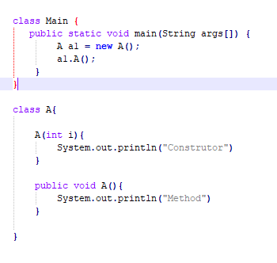

**Answer and Why? :**

**Compile time error, Constructor A is undefined**