**1 - click on correct combination**

a - byte int long short

b - float char

c - double float boolean

d - char and boolean

**Answer and Why? :**

**Correct combiniation is** a - byte int long short

**Because all these are Integer data types**

**2 - Java save all object in which memory structure**

a - Heap

b - stack

c - queue

d - Graph

**Answer and Why? :**

**Ans -** a - Heap

**In order to allocate memory and object retrieval process from memory in faster and effective way, objects are stored in heap memory structure.**

**In heap, memory is allocated in random manner to an object, using an Hash algorithm. And later those objects are retrieved faster using the reference of those object.**

**Whereas other memory structures like stack, queue, graph allocates memory in some specific order. And fetching those object takes time as it needs to retrieved from memory using that specific order.**

**3 – write 2 ways to create infinite loop?**

**Answer and Why? :**

1. **While loop**

**We can pass TRUE condition to while block and it will go into infinite loop because each time that condition will be satisfied**

**Ex-**

**While(true){**

**// some logic**

**}**

1. **For loop**

**We can achieve infinite loop using for loop, by setting empty initialization, condition and update statement**

**Ex.**

**For( ; ; ){**

**//some logic**

**}**

**4 – Method Overloading is a kind of**

a – Compile Time Polymorphism

b – Runtime Polymorphism

c - Encapsulation

d – a and b both

**Answer and Why? :**

**Ans -** a – Compile Time Polymorphism

**When we implement Overloading (i.e. same function names with different params), then compiler already checks the validity of the code. If we define same methods with same params and return type, then compiler detects the error even before interpreting the code.**

**5 – What is the output?**

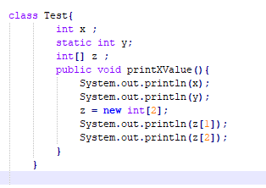

**Answer and Why? :**

**It will give error, because there is not main method defined in the class.**

**6 – Write Sequence to initialize blocks**

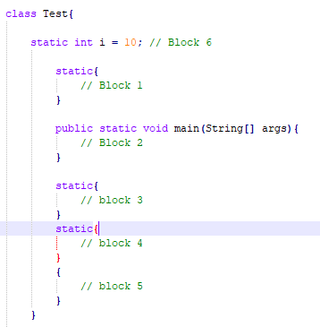

**Answer and Why? :**

**Sequence of blocks-**

* **Block 6**
* **Block 1**
* **Block 3**
* **Block 4**
* **Block 2**
* **Block 5**

**Because we can define all static blocks at beginning of class, which in turn will be executed at beginning of program execution.**

**7 – Write Output of this Code**

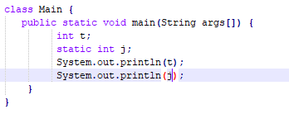

**Answer and Why? :**

**It will give error while printing variable t.**

**Because t is not declared static, hence is is not accessible in static main method.**

**8 - Write difference between**

A - while, do…while and for loop.

**Answer and Why? :**

**While loop: It executes if the provided condition is satisfied in the while statement. If goes on to execute in loop until the condition becomes false.**

**Do while loop: It is partially similar to while loop, but it must execute the block atleast once. For next iteration is checks if the particular condition is satisfied and executes the block accordingly in loop, until condition becomes false.**

**For loop: This loop executes by initializing variables and by checking if certain condition is true. If also has provision to increment/decrement variable during each iteration.**

B – Encapsulation and Abstraction

**Answer and Why? :**

Encapsulation is the property of OOP by which we can bind data and method of object together and hide from outer world.

Whereas abstraction is the property of OOP which hides and complex details from the users and just shows the details which are appropriate for user to understand

C – JDK and JRE

**Answer and Why? :**

**JDK – Java development kit has complete environment required for java execution including compliler, interpreter.**

**JRE – Whereas Java Runtime environment has interpreter part. It can not compile or create new program.**

D – Logical AND and bitwise AND

**Answer and Why? :**

**Logical AND (&&) performas logical operation to return Boolean value of the expression. Bitwise AND (&) returns integral value of the expression**

**9 – What is result of below questions**

**X = 10**

**a –** Y = X++ + ++X + ++X + X++ + X++

**Answer and Why? :**

**Y = 10 + 12 + 13 + 13 + 14**

**Y = 62**

b – Y = X-- + --X + ++X +X++ + ++X

**Answer and Why? :**

**Y = 10 + 8 + 9 + 9 + 11**

**Y = 47**

c – Y = X+++++X

**Answer and Why? :**

**It will give error because there is no space between increment operator (++) and addition operator (+)**

**10 – Result of Below Question**

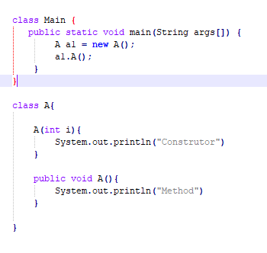

**Answer and Why? :**

**It will give error, because it will fail to create constructor of class A.**

**For creating object of class A, we need to pass an integer value while creating object.**