**1 - click on correct combination**

a - byte int long short

b - float char

c - double float boolean

d - char and boolean

**Answer and Why? : a - byte int long short**

All of them are Integer data types

**2 - Java save all object in which memory structure**

a - Heap

b - stack

c - queue

d - Graph

**Answer and Why? : a - Heap**

.To fetch object faster and allocate memory java uses heap memory allocation. Heap allows to remove and add data at ease as it gives reference ID to each object that passes through Hashing Algorithm. So allocation and deallocation occurs smoothly. Memory is allocated in any random order in heap using Hash algorithm so fetching objects is faster process using reference of object. Other memory structures allocate in specific manner and thus are not so time effective.

**3 – write 2 ways to create infinite loop?**

**Answer and Why? : While loop and For loop**

1. While loop

We can pass TRUE condition to while block and it will go into infinite loop because each time that condition will be satisfied

Ex-

While(true){

// some logic

}

2. For loop

We can get infinite loop using for loop, by setting empty initialization, condition and update statement

Ex.

For( ; ; ){

//some logic

}

**4 – Method Overloading is a kind of**

a – Compile Time Polymorphism

b – Runtime Polymorphism

c - Encapsulation

d – a and b both

**Answer and Why? : a – Compile Time Polymorphism**

Overloading (i.e. same function names with different params), then compiler already checks the validity of the code. If we define same methods with same params and return type, then compiler detects the error even before interpreting the code.

**5 – What is the output?**

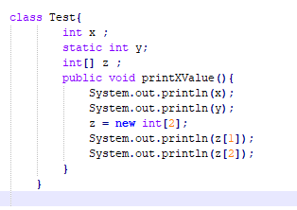

**Answer and Why? : It will give error, as there is no main method defined in the class.**

**6 – Write Sequence to initialize blocks**

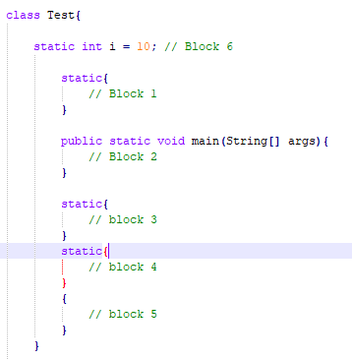

**Answer and Why? : Following will be sequence of blocks-**

**- Block 6**

**- Block 1**

**- Block 3**

**- Block 4**

**- Block 2**

**- Block 5**

As we can define all static blocks at beginning of class, which in turn will be executed at beginning of program execution.

**7 – Write Output of this Code**

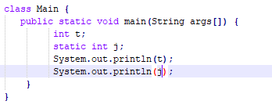

**Answer and Why? :** It will give error for static int j as it is declared static.

**8 - Write difference between**

A - while, do…while and for loop.

**Answer and Why? : Following is difference between while, do…while and for loop.**

**While loop**

1]Syntax: While(condition), { . Statements; . }

2] It is known as entry controlled loop.

3] If the condition is not true first time than control will never enter in a loop.

**Do while loop**

1] Syntax: Do { . Statements; } While(condition);

2] It is known as exit controlled loop.

3] Even if the condition is not true for the first time the control will enter in a loop.

**For loop**

1] Syntax: For(initialization; condition;updating), { . Statements; }

2] It is known as entry controlled loop

3] If the condition is not true first time than control will never enter in a loop

B – Encapsulation and Abstraction

**Answer and Why? :**

**Encapsulation** is a process of wrapping code and data together into a single unit and hide from outside world. For ex: Capsule.

**Abstraction** means displaying only essential details and hiding other data.

C – JDK and JRE

**Answer and Why? :**

**JDK –** Java development kit has entire environment required for java execution including compiler and interpreter.

**JRE –** Java Runtime environment has interpreter. It cannot create or compile a new program.

D – Logical AND and bitwise AND

**Answer and Why? :**

**Logical AND**

Logical AND is (&&) operator and operates on Boolean operands.

**Bitwise AND**

Bitwise AND (&) is a bitwise operator and compares each operand bitwise.

**9 – What is result of below questions**

**X = 10**

**a –** Y = X++ + ++X + ++X + X++ + X++

**Answer and Why? : Y = 10 + 12 + 13 + 13 + 14**

**Y = 62**

b – Y = X-- + --X + ++X +X++ + ++X

**Answer and Why? : Y = 10 + 8 + 9 + 9 + 11**

**Y = 47**

c – Y = X+++++X

**Answer and Why? : There is no space between addition operator and increment operator so it is error.**

**10 – Result of Below Question**

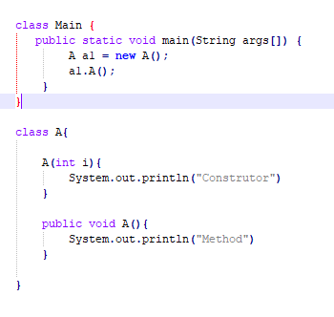

**Answer and Why? : It will give error because we have not defined constructor.**