**1 - click on correct combination**

a - byte int long short

b - float char

c - double float boolean

d - char and boolean

**Answer and Why? :**

1. **Byte int long short**

**Above combination is Integer Type. Whose stored a numbers without decimal.**

**2 - Java save all object in which memory structure**

a - Heap

b - stack

c - queue

d - Graph

**Answer and Why? :**

**Heap. Object is always created on heap. And references are stored on stack.**

**3 – write 2 ways to create infinite loop?**

**Answer and Why? :**

**For(;;)**

**while(i<=10)**

**{**

**system.out.println ("A");**

**}**

**4 – Method Overloading is a kind of**

a – Compile Time Polymorphism

b – Runtime Polymorphism

c - Encapsulation

d – a and b both

**Answer and Why? :**

1. **Compile time polymorphism**

**Overloading have more than one method having the same name with different data types of parameters.**

**If add() methods contains different parameters like:**

**Public add(int i, int j)**

**Public add(long i,int j)**

**Public add(int i, long j)**

**5 – What is the output?**

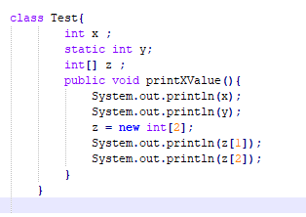

**Answer and Why? :**

**Error. Main method not found.**

**6 – Write Sequence to initialize blocks**

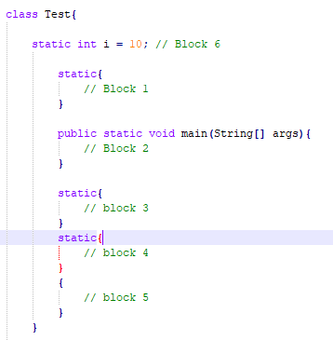

**Answer and Why? :**

**1,3,4,5,2**

**7 – Write Output of this Code**

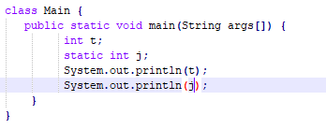

**Answer and Why? :**

**Compile time error.**

**Because on initialize the variable with value.**

**8 - Write difference between**

A - while, do…while and for loop.

**Answer and Why? :**

**While: checked the condition before iteration of the loop.**

**Do—while: First verifies the conditions after the execution of the statement inside the loop.**

**For : First initialization then check condition then increment/decrement.**

B – Encapsulation and Abstraction

**Answer and Why? :**

|  |
| --- |
| **Encapsulation** |
| **1.       Encapsulation is a process of wrapping code and related data together into a single class** |
| **1.       Encapsulation adds more security to data and protect it from outside world** |
| **2.       Example: Class** |
|  |
| **Abstraction** |
| **1.       Abstraction is a process of hiding the implementation details and showing only functionality to the user.** |
| **2. Abstraction allows user to see result rather than how it has been evaluated** |
| **3. Example: Interfaces** |

C – JDK and JRE

**Answer and Why? :**

**JDK: Java development Kit**

**JRE: Java Runtime Environment**

D – Logical AND and bitwise AND

**Answer and Why? :**

**Logical AND:**

1. **Logical AND represent as &&**
2. **Checked both conditions**

**Bitwisee AND:**

1. **Bitwise AND represent as &**
2. **If condition is FALSE then never checked second condition.**

**9 – What is result of below questions**

**X = 10**

**a –** Y = X++ + ++X + ++X + X++ + X++

**Answer and Why? :**

**= 10+12+13+13+14**

**= 62**

**Y= 15**

b – Y = X-- + --X + ++X +X++ + ++X

**Answer and Why? :**

**= 10+8+9+9+11**

**=47**

**Y= 11**

c – Y = X+++++X

**Answer and Why? :**

**=10+12**

**=22**

**Y=12**

**10 – Result of Below Question**

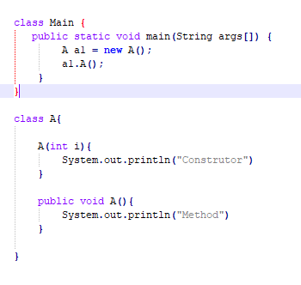

**Answer and Why? :**

Compile time error get occurred.

Because we created parameterized constructor.

We have to pass the value.