**1 - click on correct combination**

a - byte int long short

b - float char

c - double float boolean

d - char and boolean

**Answer and Why? :**

**2 - Java save all object in which memory structure**

a - Heap

b - stack

c - queue

d - Graph

**Answer and Why? : Heap because of dynamic memory allocation**

**3 – write 2 ways to create infinite loop?**

**Answer and Why? :**

**Int i = 1;**

**While (I < 2){**

**//Statement**

**}**

**4 – Method Overloading is a kind of**

a – Compile Time Polymorphism

b – Runtime Polymorphism

c - Encapsulation

d – a and b both

**Answer and Why? : Compile time Polymorphism because compiler has created class file (byte code) of methods already**

**5 – What is the output?**

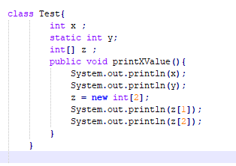

**Answer and Why? :** Error on this statement System.out.println(x);

Because x is not initialized

**6 – Write Sequence to initialize blocks**

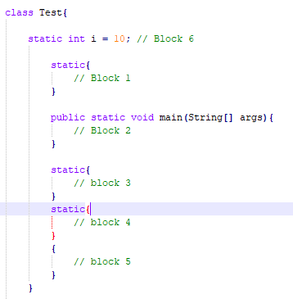

**Answer and Why? :**

**7 – Write Output of this Code**

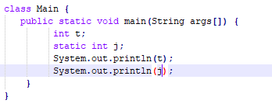

**Answer and Why? : error. Int t is not initialized.**

**8 - Write difference between**

A - while, do…while and for loop.

**Answer and Why? :**

While loop : Initialization has to be done outside the loop then condition has to be defined and at the end variable increments

Do While: Same as while loop except condition will be checked at the end of loop that means first interation of loop will be executed without check in condition

For loop : Initialization of variable, condition and increment of variable can be done in single statement.

B – Encapsulation and Abstraction

**Answer and Why? :**

Encapsulation is putting together code and data.

Abstraction is hiding internal details and showing functionality only.

C – JDK and JRE

**Answer and Why? :**

JDK : Java Development Kit to enable developer to write java code and compile into class file

JRE : Java Runtime Environment where java program runs on it.

D – Logical AND and bitwise AND

**Answer and Why? :**

**Logical AND : Logical operator process statement / condition**

**Bitwise AND : Process binary value of data**

**9 – What is result of below questions**

**X = 10**

**a –** Y = X++ + ++X + ++X + X++ + X++

**Answer and Why? : 63 = 10+12+13+13+15**

b – Y = X-- + --X + ++X +X++ + ++X

**Answer and Why? : 47=10+9+8+8+11**

c – Y = X+++++X

**Answer and Why? : 22=10+12**

**10 – Result of Below Question**

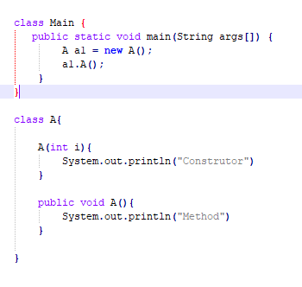

**Answer and Why? : Method**

**Because, constructor with int argument will not be called.**