**1 - click on correct combination**

a - byte int long short

b - float char

c - double float boolean

d - char and boolean

**Answer and Why? :**

1. a - byte int long short

**All are storing Integer type values**

**2 - Java save all object in which memory structure**

a - Heap

b - stack

c - queue

d - Graph

**Answer and Why? :**

1. a - Heap

**3 – write 2 ways to create infinite loop?**

**Answer and Why? :**

1. Initialization, Exit condition, Iteration nothing is specified

for(;;)

       System.out.println("Infinite Loop");

1. Since we are not incrementing value of “i”, it will never exceed 10. It will be always less than 10.

int i = 1;

while(i <= 10) {

System.out.println("Infinite Loop in while");

}

**4 – Method Overloading is a kind of**

a – Compile Time Polymorphism

b – Runtime Polymorphism

c - Encapsulation

d – a and b both

**Answer and Why? :**

a – Compile Time Polymorphism

At compile time, Java knows which method to invoke by checking the method signatures. So, this is called compile time polymorphism.

**5 – What is the output?**

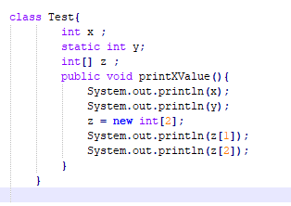

**Answer and Why? :**

**No output. There is no main method.**

**6 – Write Sequence to initialize blocks**

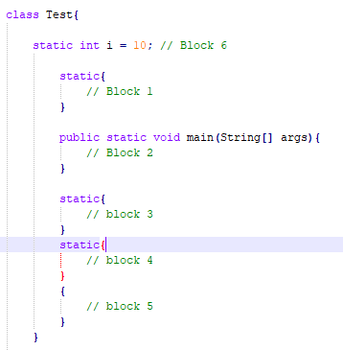

**Answer and Why? :**

**Block 1, 3, 4, 5, 2**

**7 – Write Output of this Code**

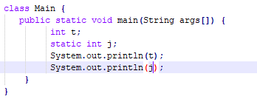

**Answer and Why? :**

**Answer : Error.**

**Static variable should be declared and initialized outside main method.**

**8 - Write difference between**

A - while, do…while and for loop.

**Answer and Why? :**

**Difference between While Loop and Do While Loop**

1.Main difference is that while loop check condition before iteration of the loop.

2. On the other hand, the do-while loop verifies the condition after the execution of the statements inside the loop.

3. while (condition) { statement(s); }

4. do { statement(s); } while (condition);

|  |  |
| --- | --- |
| **For Loop** | **Do While Loop** |
| Statement is executed once the condition is checked. | Condition is checked after the statement(s) is executed. |
| It might be that statements gets executed zero times. | Statement(s) is executed at least once. |
| for ( init ; condition ; iteration )  { statement (s); } | do { statement(s); }  while (condition); |

B – Encapsulation and Abstraction

**Answer and Why? :**

|  |  |
| --- | --- |
| **Encapsulation** | **Abstraction** |
| It is a process of hiding all the internal details of an object from the outside world. | It is defined as the process of representing the necessary features without showing the background details. |
| Encapsulation can be implemented by using access modifier i.e. private, protected and public. | We can implement abstraction using abstract class and interfaces. |

C – JDK and JRE

**Answer and Why? :**

**JRE is Java Virtual Machine where your Java programs run.**

**JDK is the software development kit for java**

D – Logical AND and bitwise AND

**Answer and Why? :**

|  |  |
| --- | --- |
| **Logical AND** | **bitwise AND** |
| It evaluates the first Boolean expression and, depending on its result and the operator used, may or may not evaluate the second | bitwise operator always evaluate both operands. |
|  |  |

**9 – What is result of below questions**

**X = 10**

**a –** Y = X++ + ++X + ++X + X++ + X++

**Answer and Why? :**

**10+12+13+13+14 = 62**

b – Y = X-- + --X + ++X +X++ + ++X

**Answer and Why? :**

**10+8+9+9+11 = 47**

c – Y = X+++++X

**Answer and Why? :**

**Error**

**If we mention as “Y = X++ + ++X” then 10 + 12 = 22**

**10 – Result of Below Question**

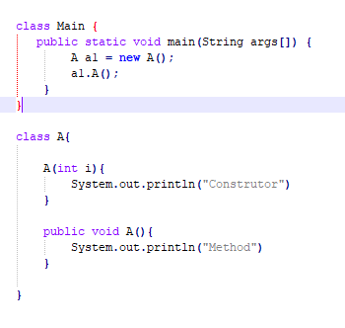

**Answer and Why? :**

**Answer : Method**

Constructor “A(int i)” has one parameter.

A al = new A() : here we are passing any parameter therefore Constructor “A(int i)” will not be called.

al.A() : will call method A.