**1 - click on correct combination**

a - byte int long short

b - float char

c - double float boolean

d - char and boolean

|  |  |
| --- | --- |
| **Answer** | **a** |
| **Why** | **all data types are for integer value.** |

**2 - Java save all object in which memory structure**

a - Heap

b – stack

c - queue

d - Graph

|  |  |
| --- | --- |
| **Answer** | **C** |
| **Why** |  |

**3 – write 2 ways to create infinite loop?**

**Answer and Why? :**

|  |  |
| --- | --- |
| **1** | **For (int I=1;i>=1;i=i++)**  **{**  **System.out.println(i);**  **}** |
| **2** | **Int i=1;**  **While (i>=1)**  **{**  **System.out.println(i);**  **i++;**  **}** |

**4 – Method Overloading is a kind of**

a – Compile Time Polymorphism

b – Runtime Polymorphism

c - Encapsulation

d – a and b both

**Answer and Why? : b**

**5 – What is the output?**

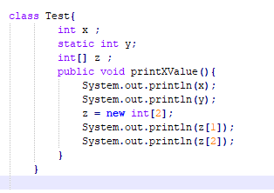

**Answer and Why? :**

|  |  |
| --- | --- |
| x | 0 |
| y | 0 |
| Z[1] | 0 |
| Z[2] | 0 |

**6 – Write Sequence to initialize blocks**

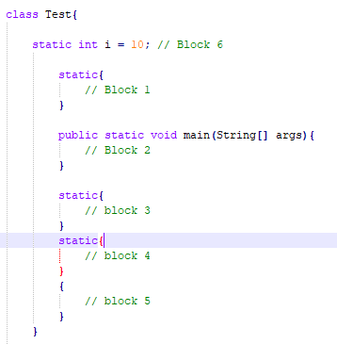

**Answer and Why? :**

|  |
| --- |
| **Block2** |

**7 – Write Output of this Code**

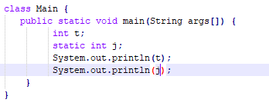

**Answer and Why? :**

|  |  |
| --- | --- |
| **t** | **0** |
| **j** | **0** |

**8 - Write difference between**

A - while, do…while and for loop.

**Answer and Why? :**

|  |  |  |
| --- | --- | --- |
| **For Loop** | **While Loop** | **Do….While Loop** |
| Code in the loop will be executed only when condition will be true. | Code in the loop will be executed only when condition will be true. | Code in the loop will be executed minimum once irrespective of condition is true or false. |
| No of iterations are known. | No of iterations are not known initially. | No of iterations are not known initially. |

B – Encapsulation and Abstraction

**Answer and Why? :** Abstraction

|  |  |
| --- | --- |
| **Encapsulation** | **Abstraction** |
| Binds variables and methods together. |  |
| Hides the content from outside access. | Only necessary data is accessible from outside the block. |

C – JDK and JRE

**Answer and Why? :**

|  |  |
| --- | --- |
| **JDK** | **JRE** |
| Java Development Kit | Java Runtime Environment |
| It provides development environment and has physical existence. | It contains java virtual machine |
| It contains Project Explorer, library files etc. | JRE is part of JDK |

D – Logical AND and bitwise AND

**Answer and Why? :**

|  |  |
| --- | --- |
| **Logical And** | **Bitwise And** |
| Symbol is && | Symbol is & |
| Result of the condition is Boolean value True or False | Result of the condition is a bit value 0 and 1 |

**9 – What is result of below questions**

**X = 10**

**a –** Y = X++ + ++X + ++X + X++ + X++

**Answer and Why? : 62**

b – Y = X-- + --X + ++X +X++ + ++X

**Answer and Why? : 47**

c – Y = X+++++X

**Answer and Why? : 22**

**10 – Result of Below Question**

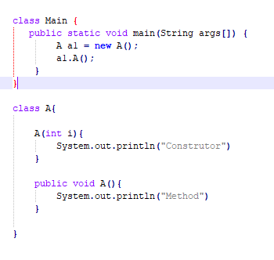

**Answer and Why? :**

|  |
| --- |
| Answer : “Method” |
|  |