**1 - click on correct combination**

a - byte int long short

b - float char

c - double float boolean

d - char and boolean

**Answer and Why? :**

**2 - Java save all object in which memory structure**

a - Heap

b - stack

c - queue

d - Graph

**Answer and Why? :**

**3 – write 2 ways to create infinite loop?**

**Answer and Why? :**

**4 – Method Overloading is a kind of**

a – Compile Time Polymorphism

b – Runtime Polymorphism

c - Encapsulation

d – a and b both

**Answer and Why? :**

**5 – What is the output?**

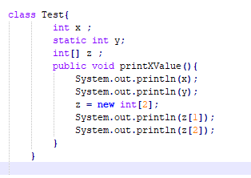

**Answer and Why? :**

**6 – Write Sequence to initialize blocks**

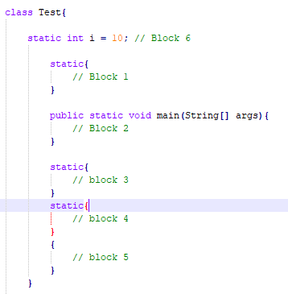

**Answer and Why? :**

**7 – Write Output of this Code**

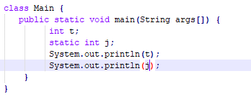

**Answer and Why? :**

**8 - Write difference between**

A - while, do…while and for loop.

**Answer and Why? :**

B – Encapsulation and Abstraction

**Answer and Why? :**

C – JDK and JRE

**Answer and Why? :**

D – Logical AND and bitwise AND

**Answer and Why? :**

**9 – What is result of below questions**

**X = 10**

**a –** Y = X++ + ++X + ++X + X++ + X++

**Answer and Why? :**

b – Y = X-- + --X + ++X +X++ + ++X

**Answer and Why? :**

c – Y = X+++++X

**Answer and Why? :**

**10 – Result of Below Question**

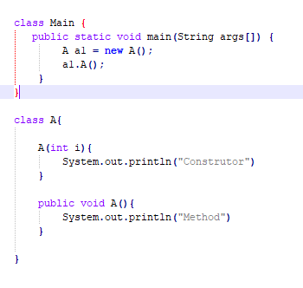

**Answer and Why? :**