**1 - click on correct combination**

a - byte int long short

b - float char

c - double float boolean

d - char and boolean

**Answer and Why? :**

**Ans - a** byte int long short **- these are all number datatypes, which can store number without decimal places.**

**2 - Java save all object in which memory structure**

a - Heap

b - stack

c - queue

d - Graph

**Answer and Why? :**

**Ans - a Heap , java stores all object data in heap and reference stores in stack**

**3 – write 2 ways to create infinite loop?**

**Answer and Why? :**

**For( ; ; )**

**{**

**}**

**Boolean count = true;**

**While(count)**

**{**

**}**

**4 – Method Overloading is a kind of**

a – Compile Time Polymorphism

b – Runtime Polymorphism

c - Encapsulation

d – a and b both

**Answer and Why? :**

**Ans - a Compile Time Polymorphism, java stores all object data in heap and reference stores in stack, because java decides which method to call at compile time.**

**5 – What is the output?**

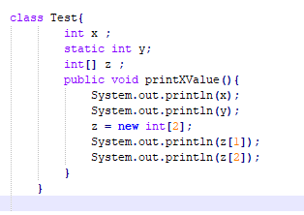

**Answer and Why? :**

**Ans –**

**System.out.println(x ) = 0;**

**System.out.println(y ) = 0;**

**System.out.println(z[1] ) = null pointer exeption**

**System.out.println(z[2] ) = ArrayIndexOutOfBoundsExpection**

**6 – Write Sequence to initialize blocks**

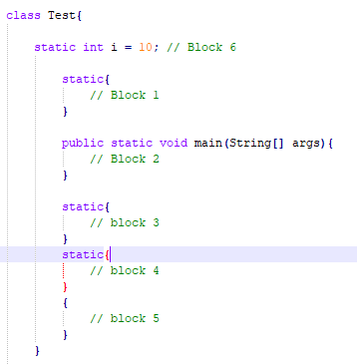

**Answer and Why? :**

**Ans : - Block 1 , Block 3, Block 4 , Block 2 and Block 6, Block 5**

**Static block run first and then static methods and instance blocks**

**7 – Write Output of this Code**

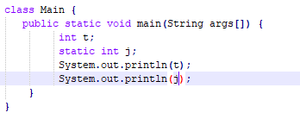

**Answer and Why? :**

**Ans : System.out.println(t) - compile time error – local variables must be initialize**

**System.out.println(j) - compile time error – local variables must be initialize**

**8 - Write difference between**

A - while, do…while and for loop.

**Answer and Why? :**

**Answer :**

**For () :when we know exact how many times ,loop is going to execute in advance we use for loop.**

**While: when we don’t know how many time loop is going to execute and it depends on condition we use while loop.**

**Do-while : when we want to execute loop atleast once whether condition is true or false ,so if condition is false initially still loop will get executes atleast once.**

B – Encapsulation and Abstraction

**Answer and Why? :**

**Ans:**

**Abstraction:**

**Hiding complexity from user and providing access to functionality is called abstraction , we implement abstraction with the help of interface , we just provide api, method so user can call implantation without getting into details .**

**Abstraction hides design level details from user.**

**Encapsulation : When we want hide implementation details from user, we use Encapsulation ,Encapsulation is process of wrapping data and code in form of object .so user don’t get direct access to data , they have to get those with public methods and our data is private .**

**As we are hiding internal detail implantation , we can change it later for ex in java HashMap implementation was done with linked list initially from Java 8 now they are using Binary tree ,but it doesn’t effect original working of code.**

C – JDK and JRE

**Answer and Why? :**

**And : JDK : JDK is java development kit , which is use to compile java programs , so if we want to complie java programs , we need to java JDK installed , most of system doesn’t come with JDK installed by default**

**JRE : JRE is java runtime environment which is use to run java programs , to run java programs system must have JRE installed , most of system comes with JRE installed now a days**

D – Logical AND and bitwise AND

**Answer and Why? :**

**Logical Operators ( && , ||) : logical operators are use perform logical operation like logical OR / Logical &&**

**In logical operator if first value gets false still second condition is check .**

**Bitwise Operator : ( & , | , ^) : Bitwise operator works on bit , if first condition gets falss it doesn’t check second condition.**

**9 – What is result of below questions**

**X = 10**

**a –** Y = X++ + ++X + ++X + X++ + X++ - 10 + 11 + 11 + 10 + 10

**Answer and Why? :**

**Ans: 52**

b – Y = X-- + --X + ++X +X++ + ++X = 10 + 9 + 11 + 10+ 11

**Answer and Why? :**

**Ans: 51**

c – Y = X+++++X = 10 + 11

**Answer and Why? :**

**Answer : 21**

**10 – Result of Below Question**

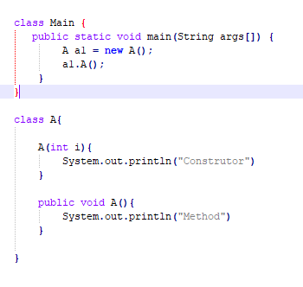

**Answer and Why? :**

**Above programs gives compile time error , as we have provided constructor with one argument then its user responsibility to provide constructor with no argument othersise java gives compile time error .**

**If we don’t have any use defined constructor then only java provided default constructor**