**1 - click on correct combination**

a - byte int long short

b - float char

c - double float boolean

d - char and Boolean

**Answer and Why? : byte int long short**

**2 - Java save all object in which memory structure**

a - Heap

b - stack

c - queue

d - Graph

**Answer and Why? : Heap**

**3 – write 2 ways to create infinite loop?**

**Answer and Why? :**

Write a for loop without any condition

For ( ; ; )

{

System.out.println(“Hello”);

}

Any loop you can run with no end condition or condition which will true always

**4 – Method Overloading is a kind of**

a – Compile Time Polymorphism

b – Runtime Polymorphism

c - Encapsulation

d – a and b both

**Answer and Why? :** Compile Time Polymorphism

**5 – What is the output?**

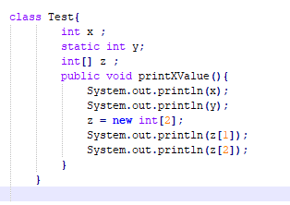

**Answer and Why? :**

No Output as there is no main method in the class

**6 – Write Sequence to initialize blocks**

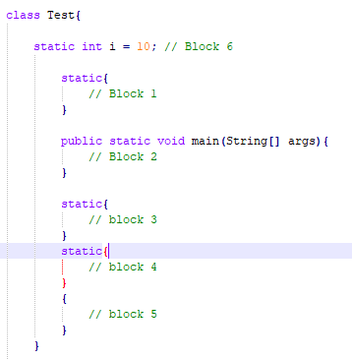

**Answer and Why? :**

Block 1

Block 3

Block 4

Block 6

Block 5

Block 2

**7 – Write Output of this Code**

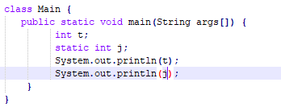

**Answer and Why? :**

Null

Null

As no value is assigned

**8 - Write difference between**

A - while, do…while and for loop.

**Answer and Why? :**

For Loop - when you are sure about the number of iterations you need to run something.

While loop - Use this when you are not sure about the number of iterations and the condition changes depending on what you do inside the loop.

Do While - Use this when you want to run something at-least once and based on the conditions run it further till the condition fails.

B – Encapsulation and Abstraction

**Answer and Why? :**

Encapsulation is defined as the wrapping up of data under a single unit. It is the mechanism that binds together code and the data it manipulates

Data Abstraction is the property in which only the essential details are displayed to the user. The trivial or the non-essentials units are not displayed to the user.

C – JDK and JRE

**Answer and Why? :**

Java Run time – required to run the program

JDK – to compile and run the program

D – Logical AND and bitwise AND

**Answer and Why?**

The logical and operator ‘&&’ expects its operands to be boolean expressions (either 1 or 0) and returns a boolean value.  
The bitwise and operator ‘&’ works on Integral (short, int, unsigned, char, bool, unsigned char, long) values and return Integral value

**9 – What is result of below questions**

**X = 10**

**a –** Y = X++ + ++X + ++X + X++ + X++

**Answer and Why? : 62**

b – Y = X-- + --X + ++X +X++ + ++X

**Answer and Why? : 59**

c – Y = X+++++X

**Answer and Why? : 22**

**10 – Result of Below Question**

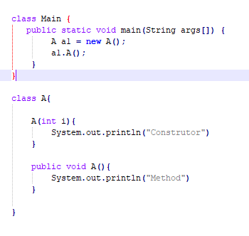

**Answer and Why? :**

Method

Method