**1 - click on correct combination**

a - byte int long short

b - float char

c - double float boolean

d - char and boolean

**Answer and Why? : a : Numerical data types**

**2 - Java save all object in which memory structure**

a - Heap

b - stack

c - queue

d - Graph

**Answer and Why? :** a - Heap

Java Heap space is used by java runtime to allocate memory to Objects

**3 – write 2 ways to create infinite loop?**

**Answer and Why? :**

**While(true){**

**}**

**For(;;){**

**}**

**4 – Method Overloading is a kind of**

a – Compile Time Polymorphism

b – Runtime Polymorphism

c - Encapsulation

d – a and b both

**Answer and Why? : a : decision of calling method is taken at compile time only**

**5 – What is the output?**

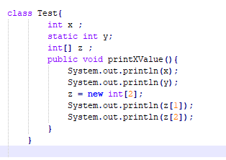

**Answer and Why? :**

0 0 Array index out of bound exception because of array size

**6 – Write Sequence to initialize blocks**

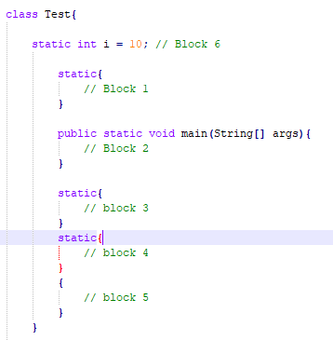

**Answer and Why? :**

1,3,4,5,2 Static blocks will executes first then not static block and then main method

**7 – Write Output of this Code**

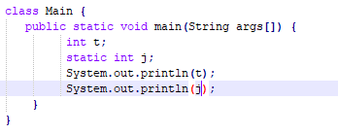

**Answer and Why? : compile time error**

**We cant declare static var inside method**

**8 - Write difference between**

A - while, do…while and for loop.

**Answer and Why? : While loop checks for the condition first. so it may not even enter into the loop, if the condition is false.**

**do while loop, execute the statements in the loop first before checks for the condition. At least one iteration takes places, even if the condition is false.**

**For loop is similar to while loop except the syntax**

B – Encapsulation and Abstraction

**Answer and Why? :**

Encapsulation: it means putting the things together

Abstraction means hiding the details

C – JDK and JRE

**Answer and Why? :**

JDK:  SDK for Java. Also it has JRE and some tools like javac and jdb etc;

JRE: provides environment to run program

D – Logical AND and bitwise AND

**Answer and Why? :**

**Logical AND: it returns Boolean value. It is used to verify 2 conditions**

**Bitwise AND: it performs bit by bit anding of binary digits. It returns digits only**

**9 – What is result of below questions**

**X = 10**

**a –** Y = X++ + ++X + ++X + X++ + X++

**Answer and Why? :**

62

b – Y = X-- + --X + ++X +X++ + ++X

**Answer and Why? :**

47

c – Y = X+++++X

**Answer and Why? :**

22

**10 – Result of Below Question**

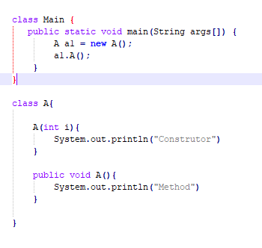

**Answer and Why? :**

Compile time error because as we are calling default constructor we need to declare it