**1 - click on correct combination**

a - byte int long short

b - float char

c - double float boolean

d - char and boolean

**Answer and Why? : a**Cause : All stores integer value with different range.

**2 - Java save all object in which memory structure**

a - Heap

b - stack

c - queue

d - Graph

**Answer and Why? : a**Cause :

**3 – write 2 ways to create infinite loop?**

**Answer and Why? : using while loop and do while loops**Cause : while loop first check the condition then execute the code,  
 in do while we can give while condition which executes infinitely.

**4 – Method Overloading is a kind of**

a – Compile Time Polymorphism

b – Runtime Polymorphism

c - Encapsulation

d – a and b both

**Answer and Why? : a**Cause : Compiler need to define which should call based on arguments.

**5 – What is the output?**

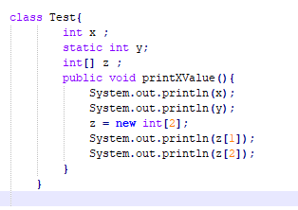

**Answer and Why? : Will get arrayindexoutofboundexception**Cause : Array have only one element (i.e index 0) and print statement have index 1 & 2

**6 – Write Sequence to initialize blocks**

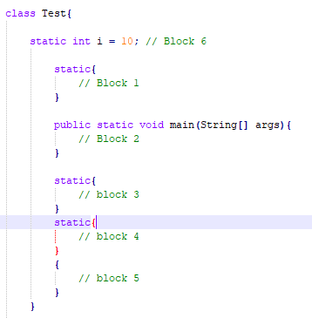

**Answer and Why? : block 2, block 5, block 3, block 4, block 1**Cause : main method executes first.

**7 – Write Output of this Code**

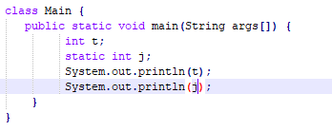

**Answer and Why? : Compile time error**Cause : variables are declared only not initialized

**8 - Write difference between**

A - while, do…while and for loop.

**Answer and Why? :**while loop check condition before first iteration  
do while loop check the condition at the end of loop  
for loop check condition in each iteration

B – Encapsulation and Abstraction

**Answer and Why? :**Wrapping of code is done in encapsulation while abstraction hide complex code and shows functionality only

C – JDK and JRE

**Answer and Why? :**JDK does compilation and execution   
JRE does execution only

D – Logical AND and bitwise AND

**Answer and Why? :   
Logical AND :** If both operands are true then condition become true  
**Bitwise AND :** It compares both operands

**9 – What is result of below questions**

**X = 10**

**a –** Y = X++ + ++X + ++X + X++ + X++

**Answer and Why? :**

b – Y = X-- + --X + ++X +X++ + ++X

**Answer and Why? :**

c – Y = X+++++X

**Answer and Why? :**

**10 – Result of Below Question**

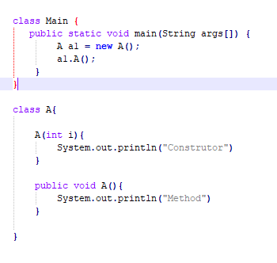

**Answer and Why? : Will get compile time error**Cause : parameter is passed to constructor, but there is no argument.