**1 - click on correct combination**

a - byte int long short

b - float char

c - double float boolean

d - char and boolean

**Answer and Why? :**

a - byte int long short is answer as all types stores whole numbers & can be converted from short autoconvert to long & int, Int to long etc(i.e. low size to high size) whenever needed.

**2 - Java save all object in which memory structure**

a - Heap

b - stack

c - queue

d - Graph

**Answer and Why? :** a – Heap is the answer. Heap memory structure follows the hash algorithm & using this algorithm it creates reference for addressing any object.

**3 – write 2 ways to create infinite loop?**

**Answer and Why? :**

1. **while(true){}- while condition is true it will execute infinitely till application or console close.**
2. **for(;; )- for (initialization; condition;updation)**

**all the 3 statement not mandatory in for loop  
as 1st initialisation statement is not mandatory – we just initialise variable**

**2nd condition is blank means it is by default true**

**3rd is updation of variable increment or decrement**

**4 – Method Overloading is a kind of**

a – Compile Time Polymorphism

b – Runtime Polymorphism

c - Encapsulation

d – a and b both

**Answer and Why? :** a – Compile Time Polymorphism

**If we overload any method with same no of parameter of the same datatype it will give compile time error.**

**5 – What is the output?**

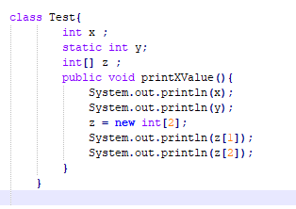

**Answer and Why? : No any output**

**As In this class there is no main method from which any appliction run.**

**6 – Write Sequence to initialize blocks**

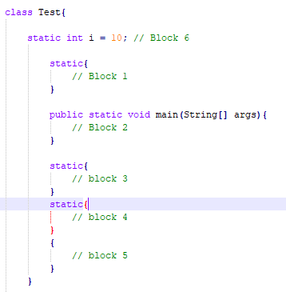

**Answer and Why? :**

1. **Block 6**
2. **Block 1**
3. **Block 2**
4. **Block 3**
5. **Block 4**

**7 – Write Output of this Code**

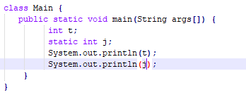

**Answer and Why? :**

**It will give compile time error to initialise variable for t & for j static variables declared outside method & within class.**

**8 - Write difference between**

A - while, do…while and for loop.

**Answer and Why? : while & for loops are entry controlled loop while do-while is exit controlled loop. Do while executes atleast once.**

B – Encapsulation and Abstraction

**Answer and Why? :**

C – JDK and JRE

**Answer and Why? :** JDK is useful for the compilation javac.exe

JRE is useful to run the application java.exe

**0.**

D – Logical AND and bitwise AND

**Answer and Why? :** Logical AND is && bitwise AND sign is &.

Logical is used for integral or Boolean operands as bitwise is only used for integral

**9 – What is result of below questions**

**X = 10**

**a –** Y = X++ + ++X + ++X + X++ + X++

**Answer and Why? : y=10+12+13+14+15=64**

b – Y = X-- + --X + ++X +X++ + ++X

**Answer and Why? : y=10+8+9+9+11=47**

c – Y = X+++++X

**Answer and Why? : y=10+11=21**

**10 – Result of Below Question**

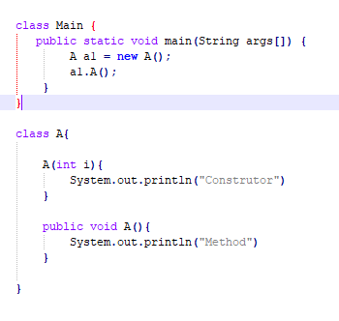

**Answer and Why? : Method is answer as default constructor not defined & parameterised constructor not called so only A() method of the class is called so it will print only ‘Method’ in the console**