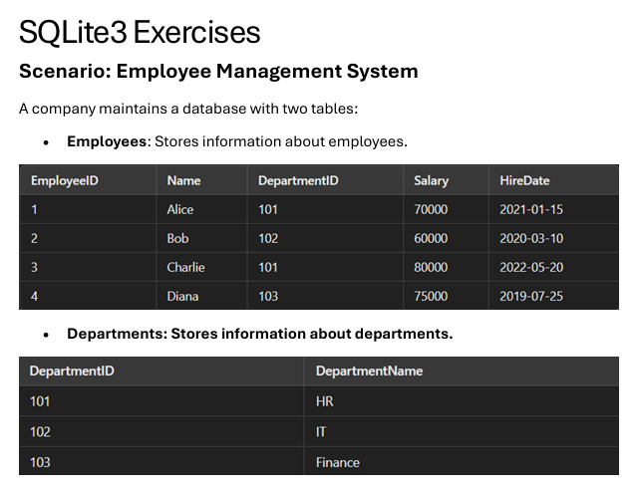

**Q1. Write a query to list the names of employees hired after January 1, 2021.**

SELECT Name, HireDate

FROM Employees

WHERE HireDate > '2021-01-01'

ORDER BY HireDate;

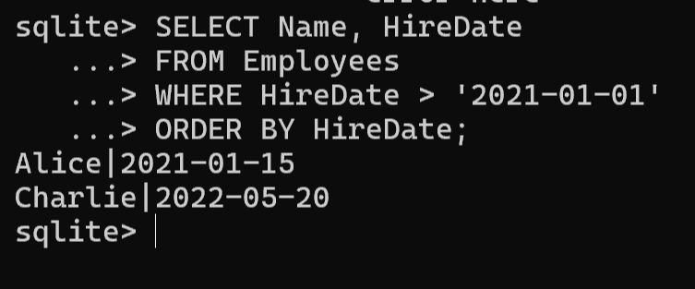

**Q2. Write a query to calculate the average salary of employees in each department.**

**SELECT**

**d.DepartmentName AS department_name,**

**ROUND(AVG(e.Salary), 2) AS average_salary**

**FROM Departments d**

**LEFT JOIN Employees e ON d.DepartmentID =**

**e.DepartmentID**

**GROUP BY d.DepartmentName**

**ORDER BY average_salary DESC;**

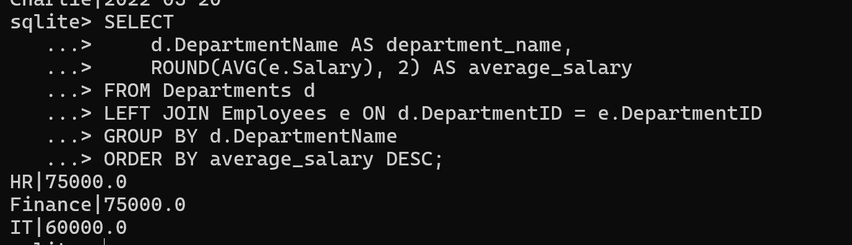

**Q3. Write a query to find the department name where the total salary is the highest.**

**SELECT**

**d.DepartmentName AS department_name,**

**SUM(e.Salary) AS total_salary**

**FROM Departments d**

**JOIN Employees e ON d.DepartmentID =**

**e.DepartmentID**

**GROUP BY d.DepartmentName**

**ORDER BY total_salary DESC**

**LIMIT 1**

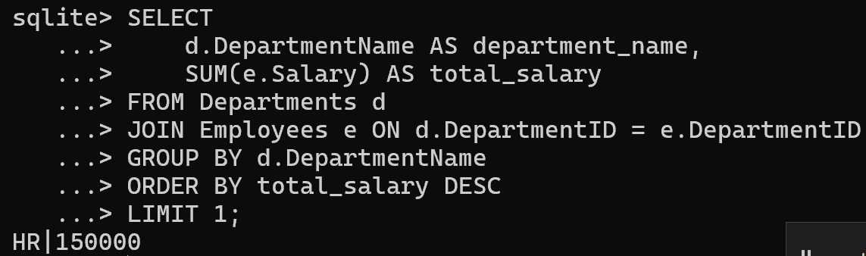

**Q4. Write a query to list all departments that currently have no employees assigned.**

SELECT

DepartmentName AS department_name

FROM Departments d

LEFT JOIN Employees e ON d.DepartmentID =

e.DepartmentID

WHERE e.EmployeeID IS NULL;

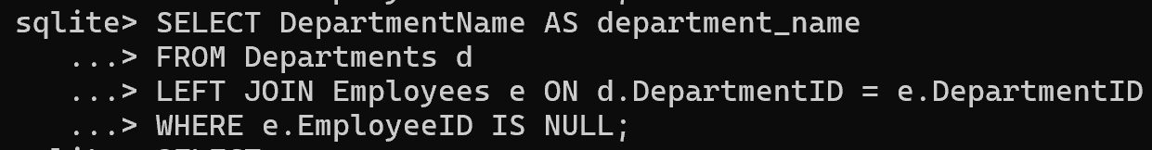

**Q5. Write a query to fetch all employee details along with their department names.**

**SELECT**

**e.EmployeeID AS employee_id,**

**e.Name AS name,**

**e.HireDate AS hire_date,**

**e.Salary AS salary,**

**d.DepartmentName AS department_name**

**FROM Employees e**

**JOIN Departments d ON e.DepartmentID = d.DepartmentID**

**ORDER BY e.EmployeeID;**

