MAINCRAFTS TECHNOLOGY
Cybersecurity & Ethical Hacking Internship
TASK 2: BUILD YOUR PERSONAL CYBERSECURITY LAB

Intern Name | Vaibhav Raj Singh Rathore
Intern ID | MT5902
Institution | University of Petroleum and Energy Studies (UPES), Dehradun
Program | BCA (AI/ML) — Semester III
Internship | Cybersecurity & Ethical Hacking — Maincrafts Technology
Duration | June – August 2026 (8 Weeks)
Task | Task 2 — Build Your Personal Cybersecurity Lab
Submission Date | July 5, 2026

1. Objective
The objective of this task is to build a safe and isolated cybersecurity practice environment on a personal computer. This hands-on lab serves as the foundation for all future tasks such as vulnerability assessment, web application testing, exploitation practice, and incident response.

The following were created as part of this lab:
• 1 Attacker Machine — Kali Linux 2026.1 (VirtualBox VM)
• 1 Vulnerable Target Application — OWASP Juice Shop (Docker on Ubuntu Server 24.04)
• Proper Network Segmentation — NAT (internet) + Host-Only (lab traffic)

2. Host System Specifications
Device | ASUS Vivobook Go E1504FA
Processor | AMD Ryzen 5 7520U with Radeon Graphics @ 2.80 GHz
Installed RAM | 16.0 GB (15.3 GB usable)
Storage | 477 GB (178 GB free)
OS | Windows 11 (64-bit)
Virtualization | Oracle VirtualBox 7.x

3. Lab Architecture
The lab uses a two-VM setup with isolated Host-Only networking for attack traffic and NAT for internet access during setup.

┌─────────────────────────────────────────┐
│ Host System (Windows 11) │
│ │
│ ┌─────────────┐ ┌────────────────┐ │
│ │ Kali Linux │ │ Ubuntu Server │ │
│ │ (Attacker) │ │ + Juice Shop │ │
│ │192.168.56.x │ │192.168.56.102 │ │
│ └──────┬──────┘ └───────┬────────┘ │
│ └────── eth1 ──────┘ │
│ Host-Only Network │
│ 192.168.56.0/24 │
│ NAT → Internet (for updates only) │
└─────────────────────────────────────────┘

4. Step-by-Step Implementation

Step 1: VirtualBox Installation & Network Setup
VirtualBox was installed on the Windows 11 host. A Host-Only network (vboxnet0) was created using VBoxManage CLI with subnet 192.168.56.0/24 to isolate lab traffic from the real network.

Step 2: Kali Linux VM Deployment
The pre-built Kali Linux 2026.1 VirtualBox image was downloaded, extracted using 7-Zip, and imported via File → Import Appliance. The VM was configured with 2 CPUs, 4 GB RAM, Adapter 1 as NAT, and Adapter 2 as Host-Only (vboxnet0).

Step 3: Ubuntu Server + Juice Shop Deployment
Ubuntu Server 24.04.4 LTS was installed on a second VM with 1 CPU, 2 GB RAM, and 15 GB disk. After installation, Docker was installed and OWASP Juice Shop was deployed using the following commands:
sudo apt update && sudo apt install -y docker.io
sudo docker run -d -p 3000:3000 --name juice bkimminich/juice-shop
sudo ip addr add 192.168.56.102/24 dev enp0s8

Target VM IP Configuration
The target VM was assigned IP 192.168.56.102 on the Host-Only interface (enp0s8) as shown below:
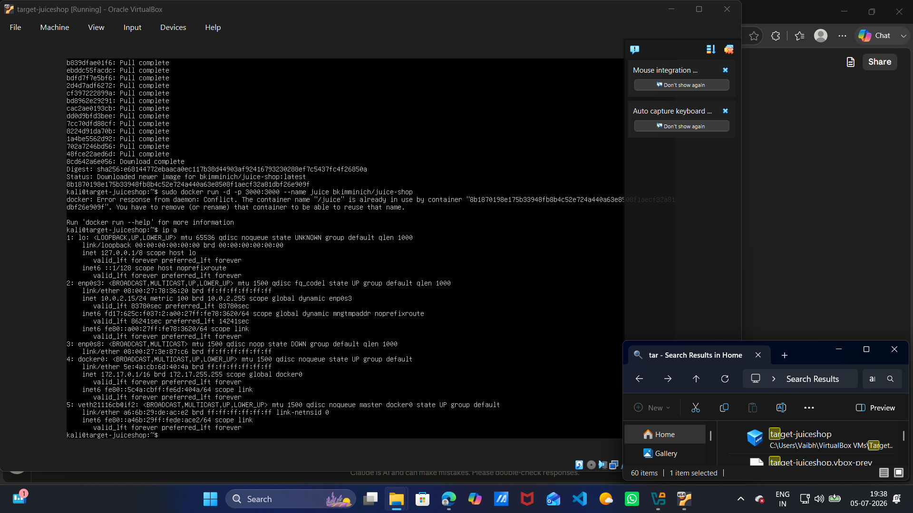
Screenshot 1: Target VM 'ip a' output showing 192.168.56.102 on enp0s8

5. Connectivity Verification

Ping & Nmap Scan from Kali
From the Kali attacker machine, connectivity to the target was verified using ping and Nmap port scan:
ping -c 4 192.168.56.102
nmap -p 3000 -sV 192.168.56.102

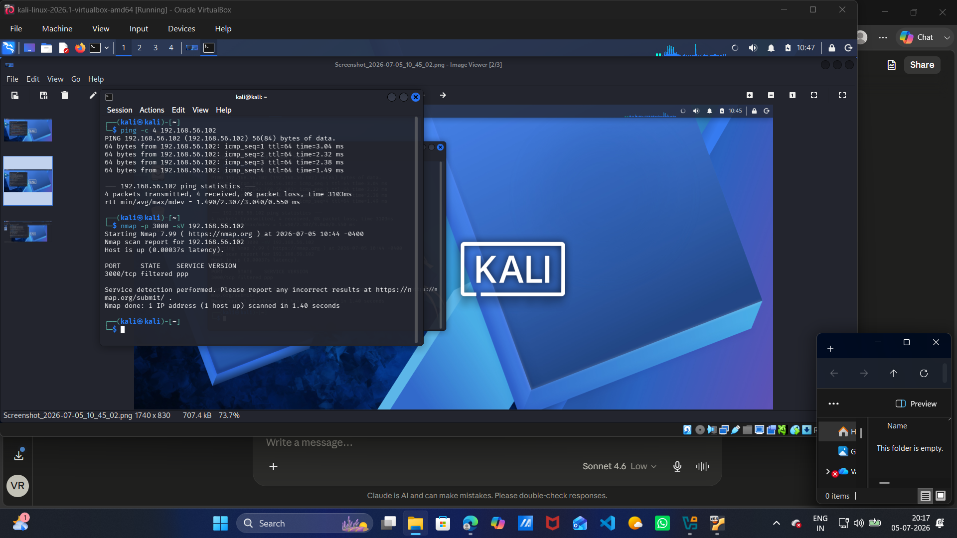
Screenshot 2: Ping showing 0% packet loss & Nmap confirming port 3000 open on target

6. OWASP Juice Shop Access
OWASP Juice Shop was successfully accessed from Kali's Firefox browser at http://192.168.56.102:3000, confirming the vulnerable web application is running and reachable from the attacker machine.

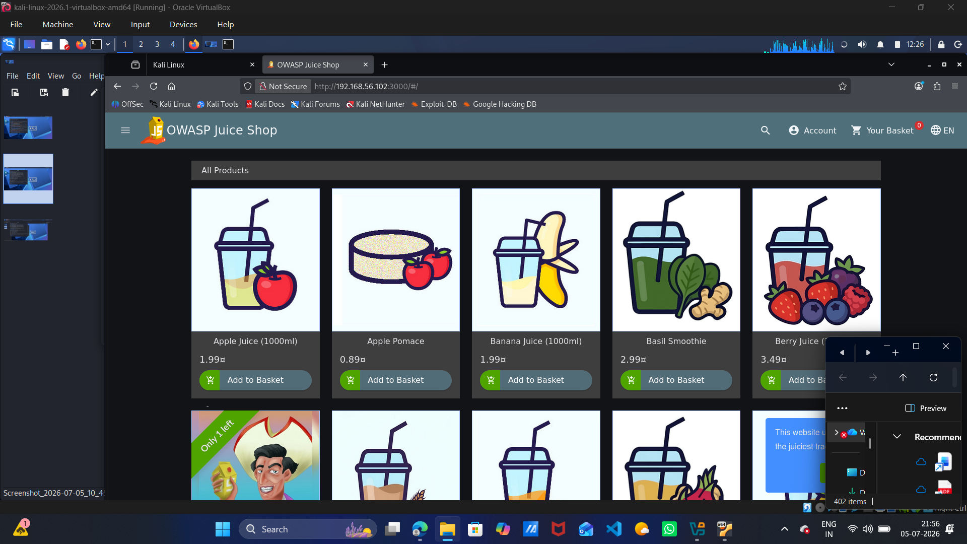
Screenshot 3: OWASP Juice Shop homepage loaded in Kali Firefox at http://192.168.56.102:3000

7. Tool Validation

Burp Suite — HTTP Traffic Interception
Burp Suite Community Edition was launched in Kali. Firefox was configured to proxy through 127.0.0.1:8080. HTTP requests to and from Juice Shop were successfully intercepted, demonstrating man-in-the-middle proxy capability.

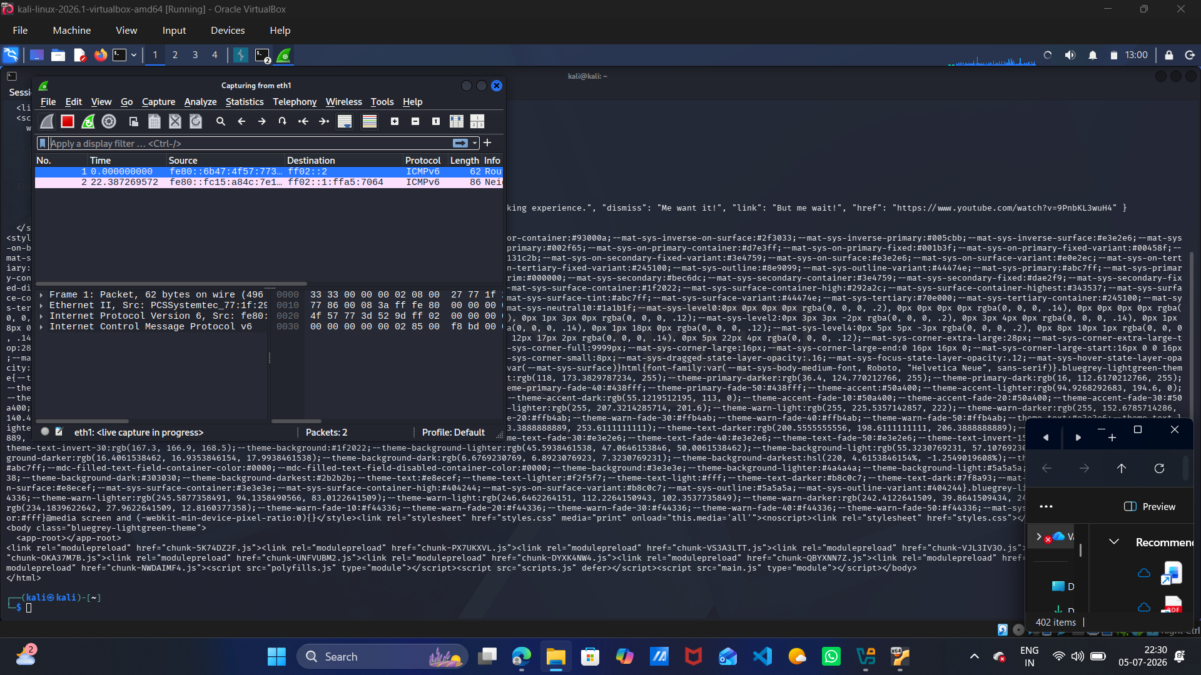
Screenshot 4: Burp Suite HTTP history showing intercepted requests to 192.168.56.102:3000

Wireshark — Packet Capture & Analysis
Wireshark was used to capture live network traffic on the eth0 interface. A curl request was sent to the Juice Shop target. Packets were filtered using ip.addr == 192.168.56.102, confirming bidirectional TCP/HTTP traffic between Kali and the target.

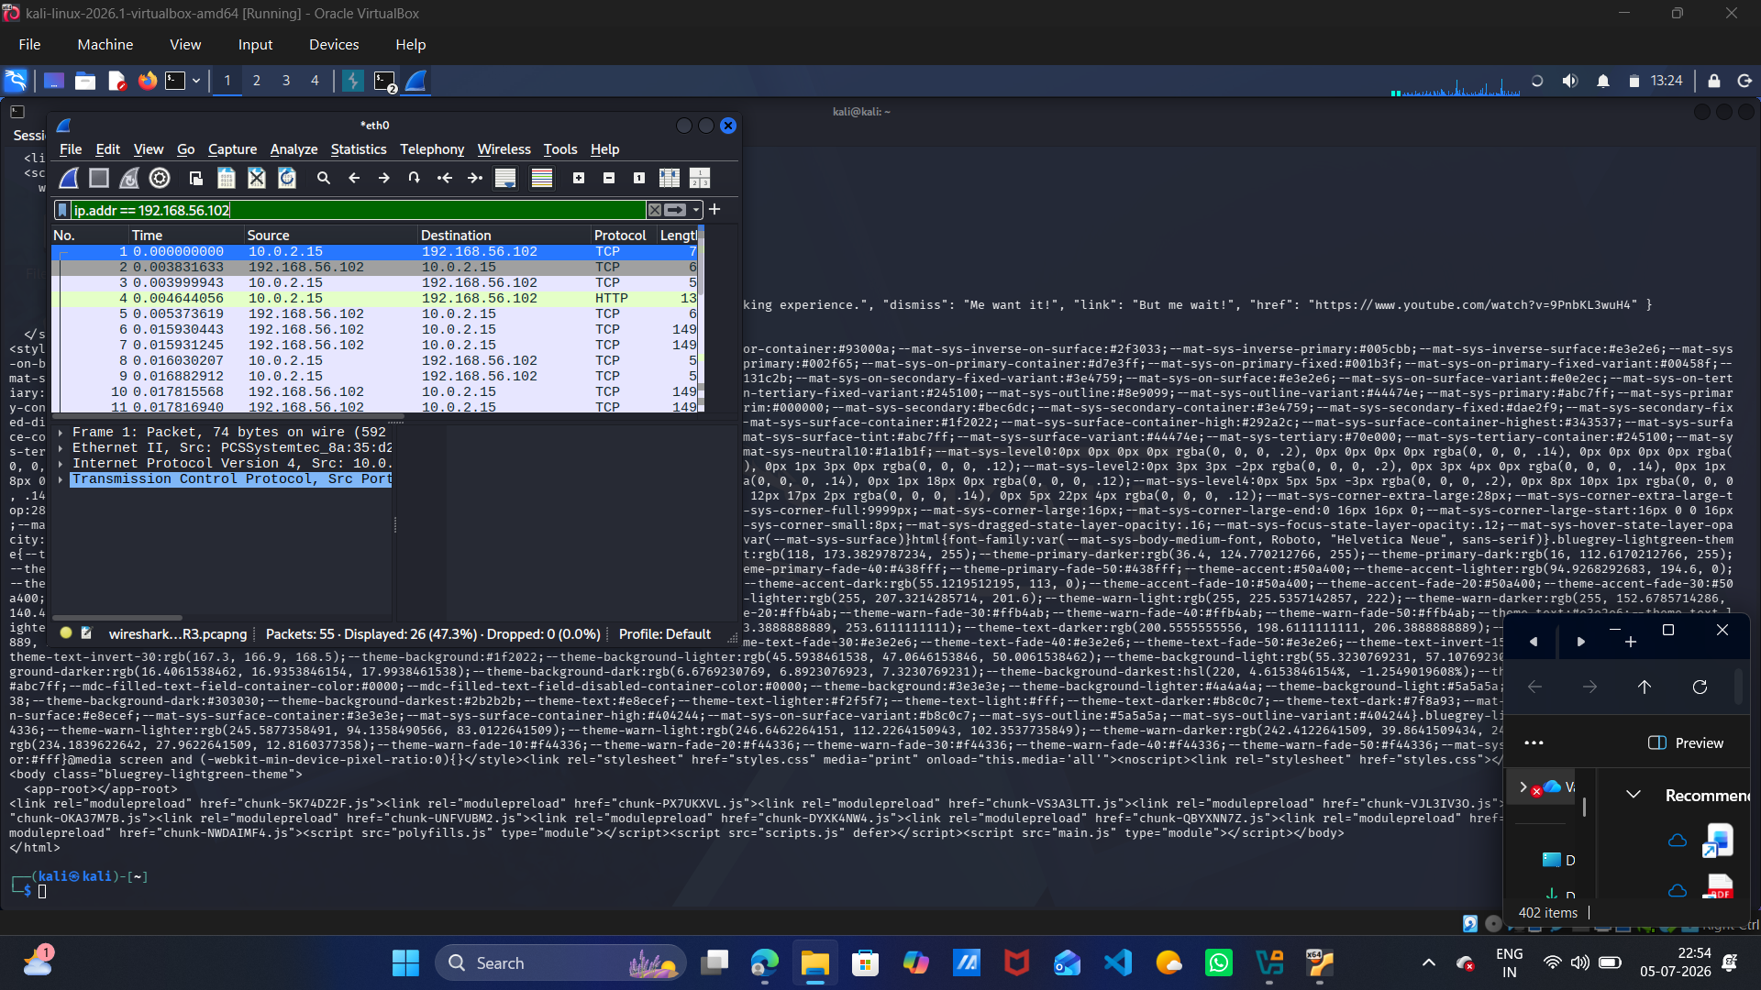
Screenshot 5: Wireshark filtered packet capture showing TCP/HTTP traffic to 192.168.56.102

8. Learning Outcomes
Virtualization | Successfully ran two isolated VMs simultaneously for pentesting
Lab Isolation | NAT + Host-Only networking prevented real-world exposure
Web Target Setup | Deployed OWASP Juice Shop via Docker on Ubuntu Server
Basic Networking | Configured NAT vs Host-Only, subnets, manual IP assignment
Tool Awareness | Validated Nmap, Burp Suite, and Wireshark in lab environment

9. Conclusion
The personal cybersecurity lab was successfully built and fully validated. The two-VM architecture with Kali Linux as the attacker and Ubuntu Server running OWASP Juice Shop as the target, connected via Host-Only networking, provides a safe and isolated environment for all future pentesting tasks. All required tools — Nmap, Burp Suite, Wireshark, Docker, and VirtualBox — were confirmed working. This lab will serve as the foundation for upcoming tasks including vulnerability assessment, web application exploitation, and incident response.

— End of Report —

