**Power BI Documentation**

POPULATION- 2020-2029

**1.IMPORT DATA INTO POWER BI**

**Open the Get Data Window**

In the Power BI Desktop application, navigate to the Home tab on the ribbon. In the Data section, click on Get Data. This will open a new window showing a list of common data sources.

Step 2: Select Your Data Source

Step 3: Choose the File and Connect

After selecting your data source type, a new dialog box will appear.

Select the file: A file explorer window will open. Navigate to the location of your file (e.g., an Excel workbook or a CSV file) and select it.

Click Connect: Once you have selected your file, click the Connect button.

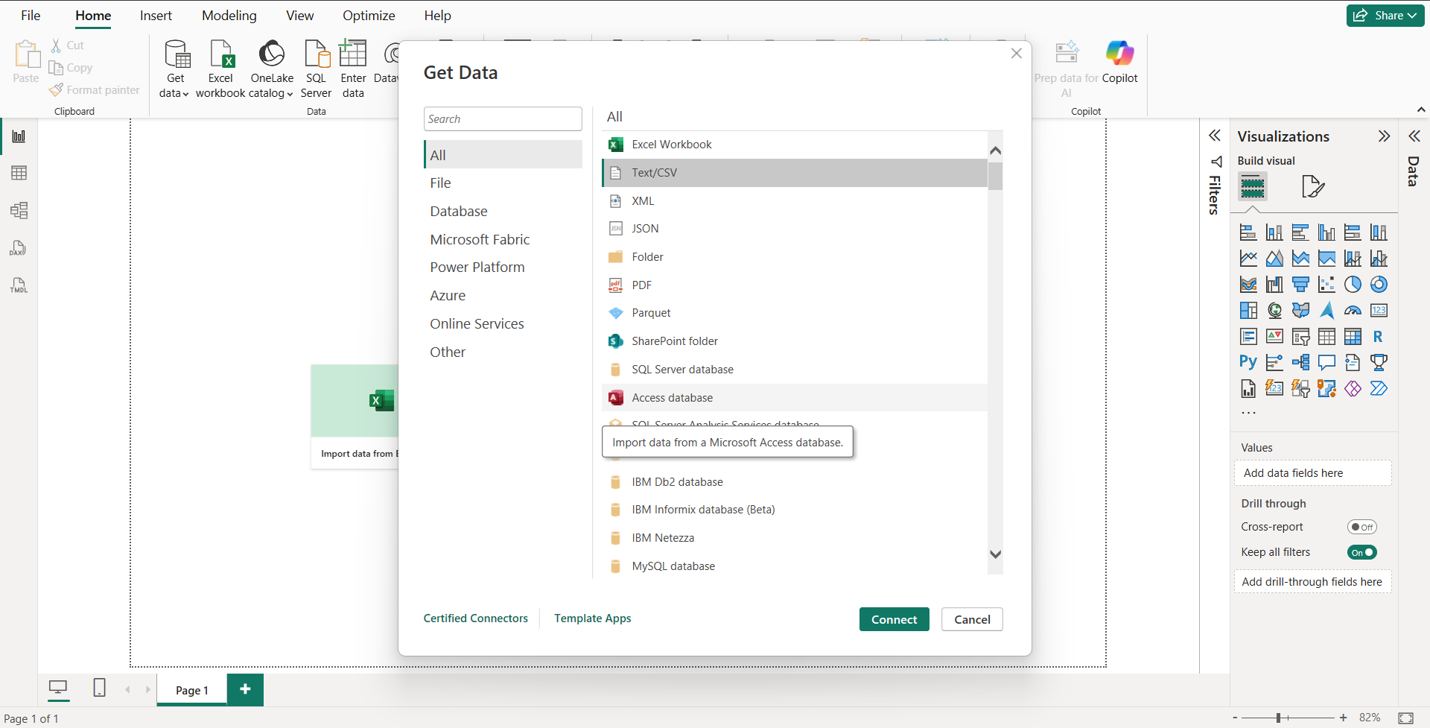

Step 4: Transform Data

After connecting to your data source, a Navigator window will appear. Here, you will see a preview of the data. You have two main options:

Transform Data: Click Transform Data to open the Power Query Editor. This is the recommended step for most cases, as it allows you to clean, shape, and transform your data before loading it into your report.

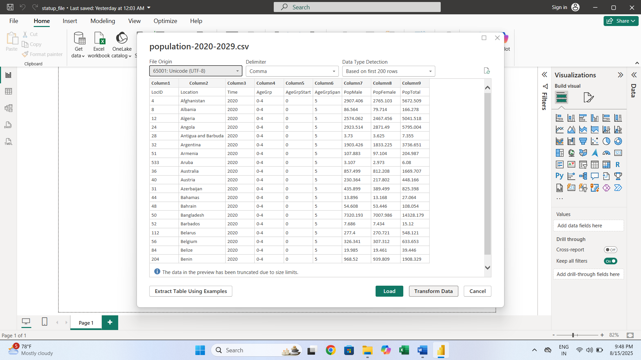

**2. REMOVE TOP ROW**

To remove the top row and use it as a header in Power Query, you can follow these steps:

1. Click the "Use First Row as Headers" button located in the "Home" tab. It is usually found within the "Transform" group.
2. The first row of your data will be promoted to become the column headers. The previous column headers (e.g., "Column1", "Column2", etc.) will be replaced.
3. Power Query will automatically add a step called "Promoted Headers" to your "APPLIED STEPS" pane.

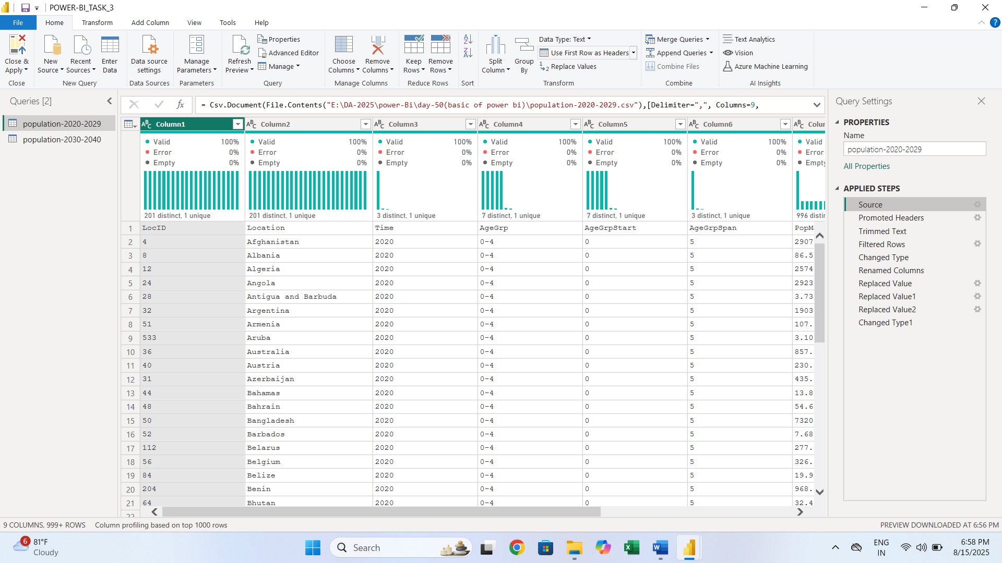

**3.Promoted Headers**

**How to Promote the First Row to Headers**

When you're in the **Power Query Editor**, you might see generic column names like **Column1**, **Column2**, and so on. To fix this, you'll want to use the first row of your data as the actual column headers.

On the **Home** tab, look for the **Transform** group and click on **Use First Row as Headers**. This action automatically promotes the first row of your data to become your column headers, making your data much easier to work with.

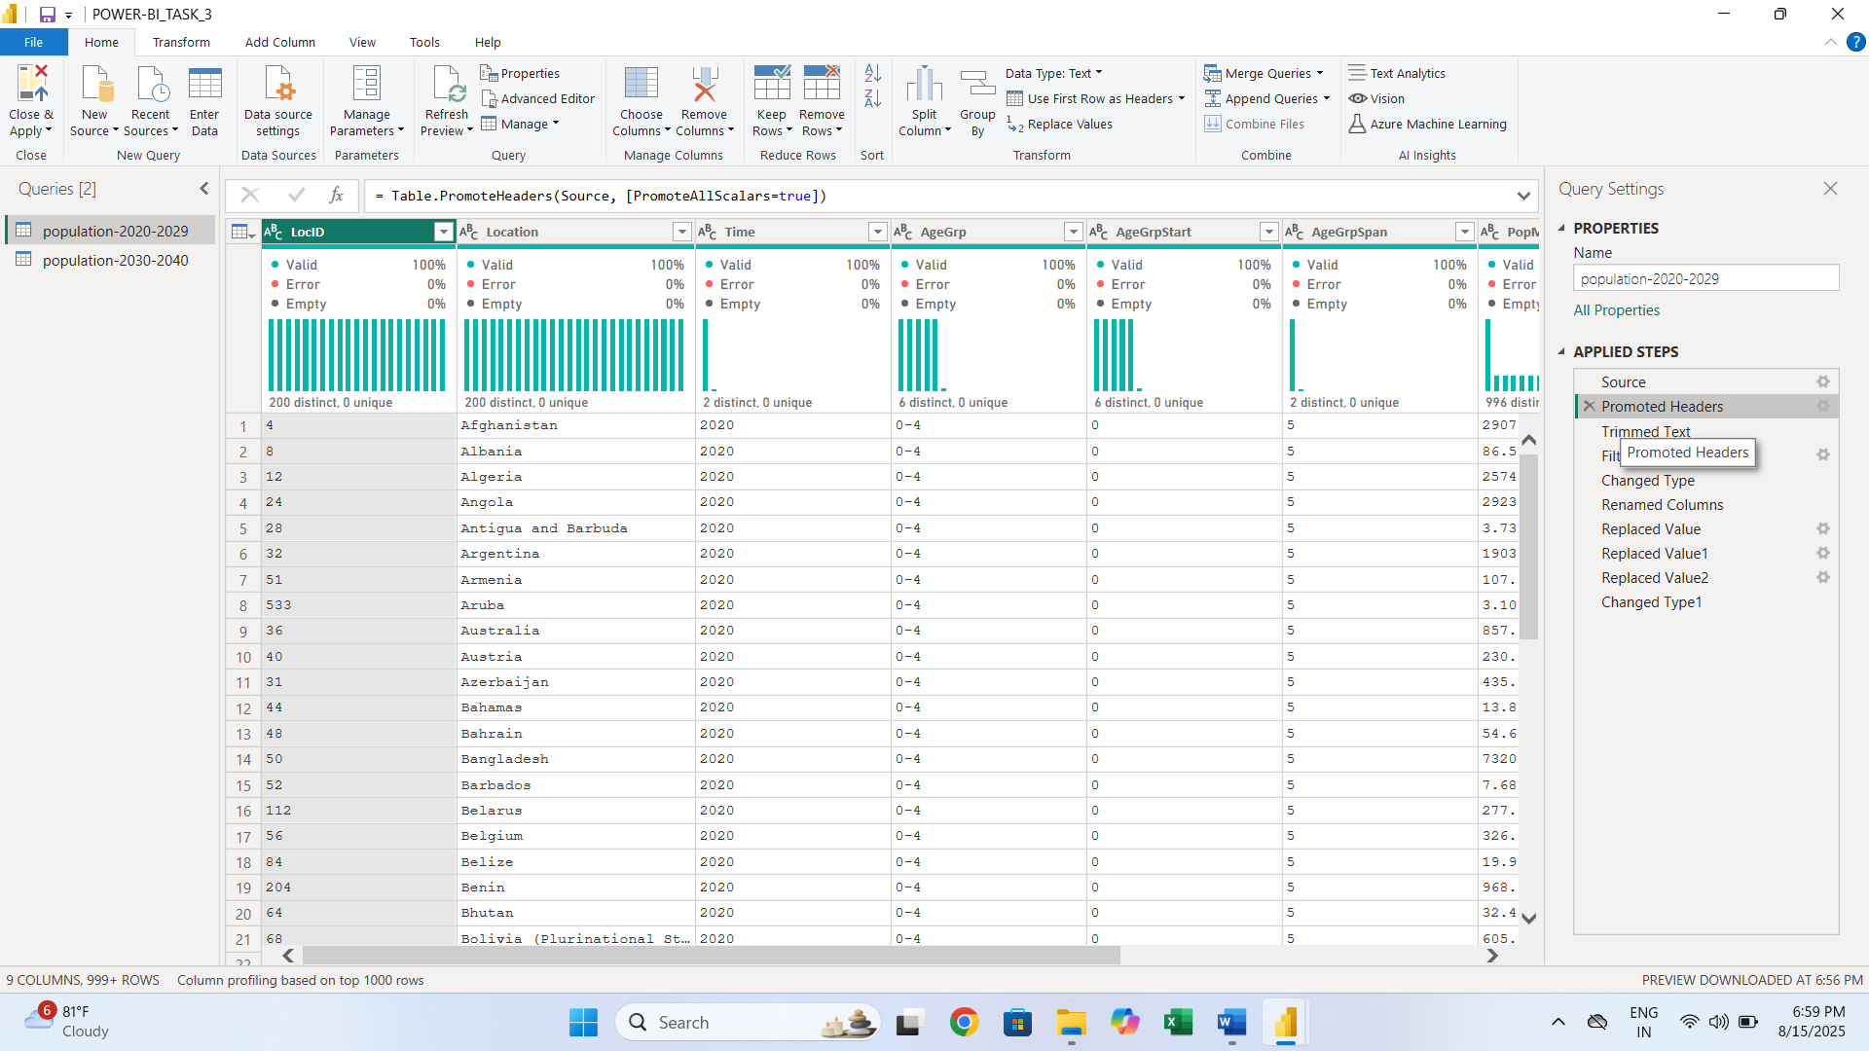

**4.TRIMMED TEXT**

* Select the Column: In the Power Query Editor, select the column that contains the text you want to trim.
* Trim the Text: Right-click the column header, navigate to Transform, and then select Trim. This will remove leading and trailing whitespace from all the values in that column

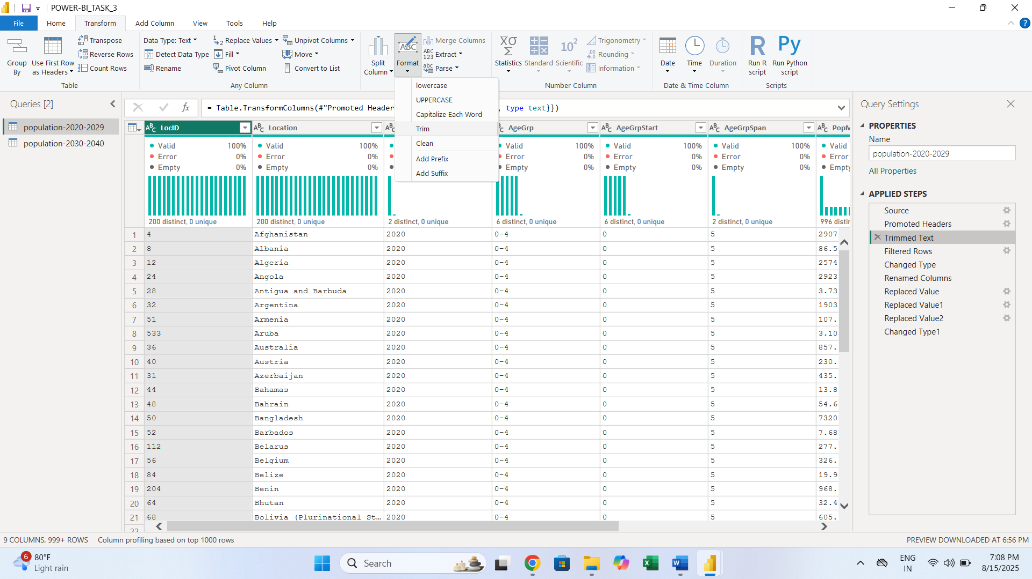

**5.Filtered Row**

* Clicking the small drop-down arrow on the header of the column you want to filter (in this case, "LocID").
* Selecting the Number Filters option.
* Choosing a specific condition.
* Entering the value you want to filter by (in this case, NO DATA).

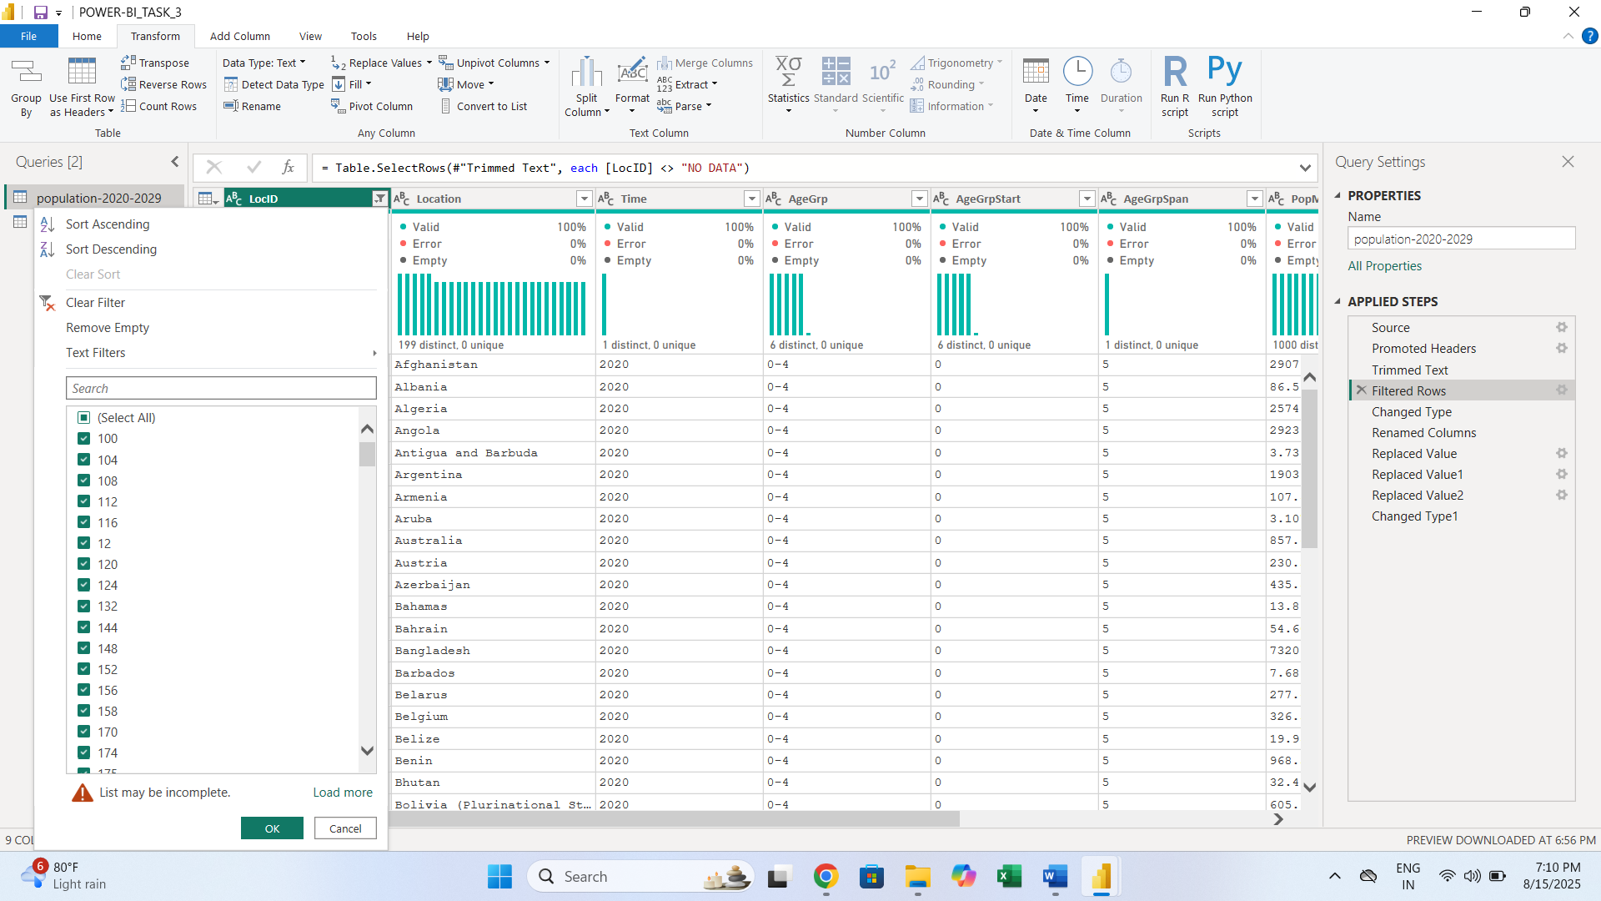

**6. Change Data Types**

To change a column's data type, you can:

1. Click the icon on the left side of the column header (e.g., the "123" for numbers, "ABC" for text).
2. Select the desired data type from the drop-down menu.

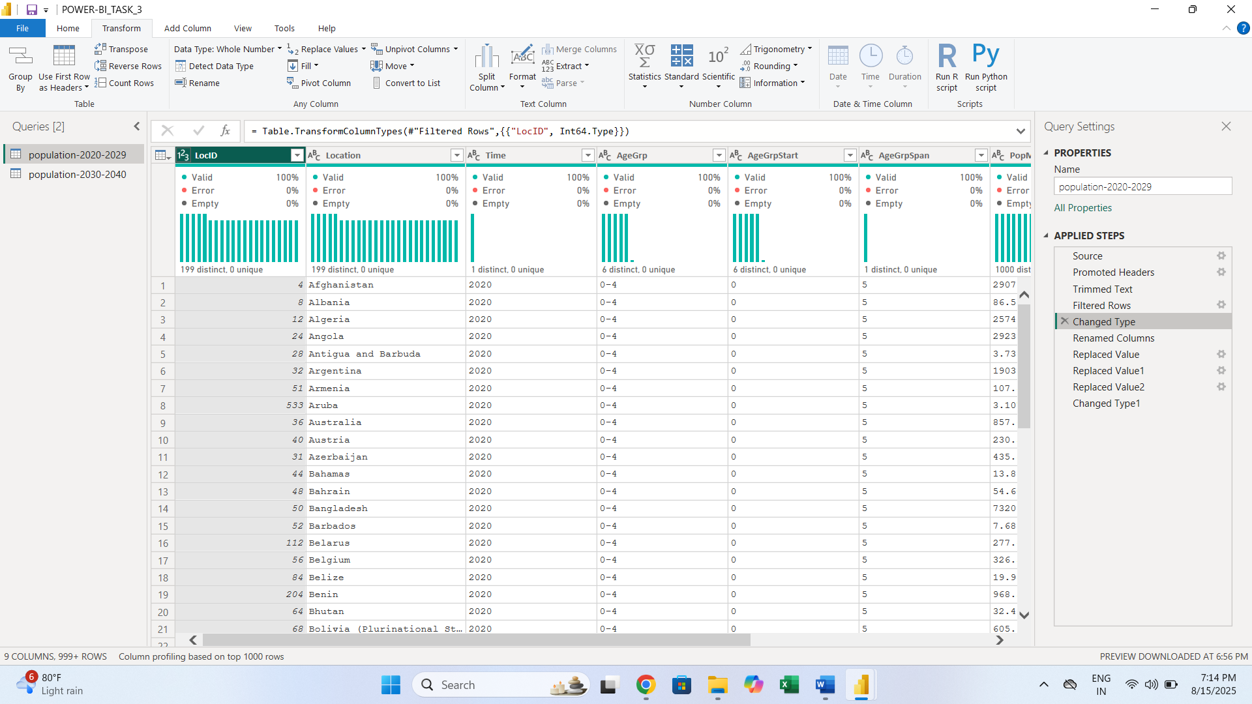

**7.RENAMED COLUMN**

* Double-click the column header and type the new name.
* I typed the column name 'year’

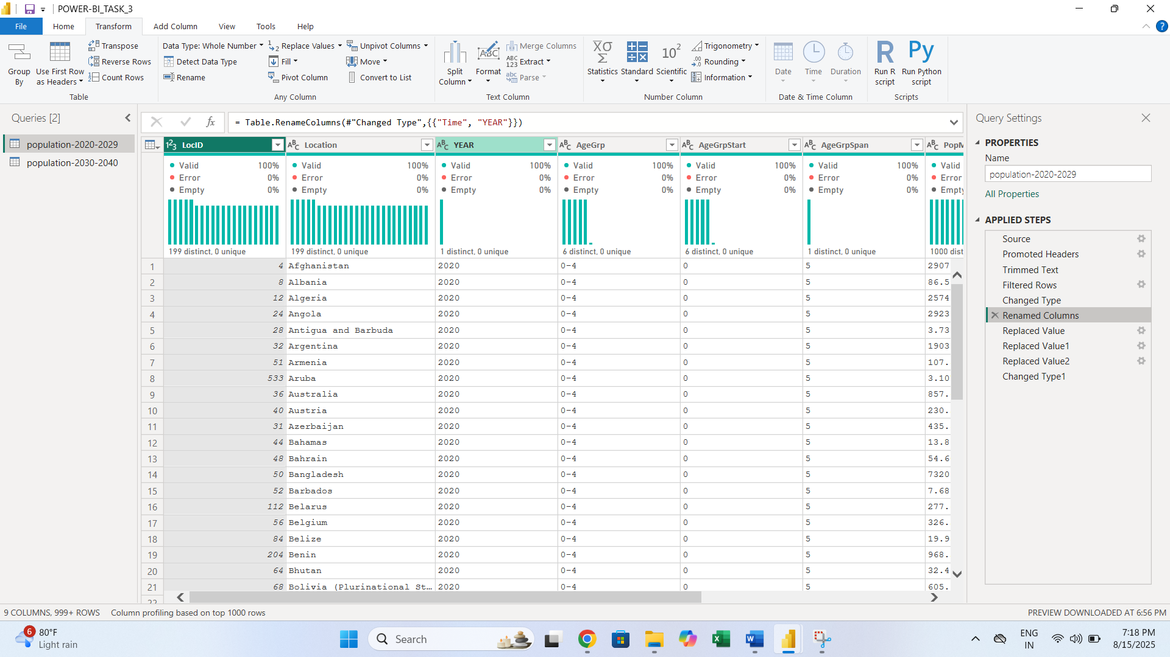

**8.REPLACED VALUE**

1 Select the Column:

* In the Power Query Editor window, locate and click on the header of the column where you want to replace values.

2 Use the "Replace Values" command:

* Right-click on the column header and choose Replace Values.
* You can also find this command in the Transform tab or the Home tab of the ribbon.

3 Enter the values:

* A dialog box will appear. In the "Value to Find" field, type the value you want to replace.
* In the "Replace With" field, type the new value you want to use.
* You can also use this feature to replace null values or errors.

4 Click "OK":

* After you click OK, the changes will be applied to the column

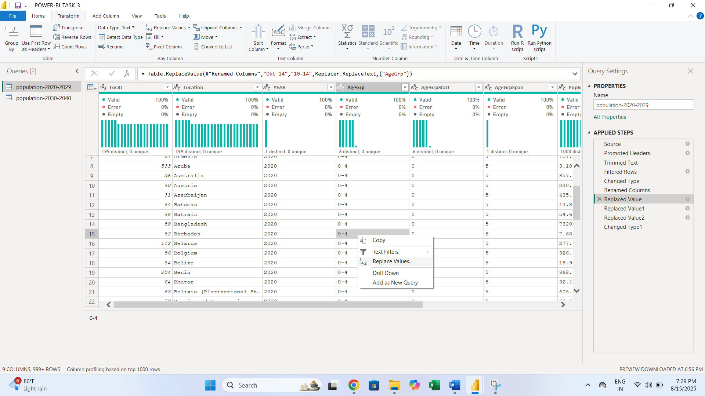

5 I replace 3 values in AgeGrp column

**9.Change Data Types**

To change a column's data type, you can:

1. Click the icon on the left side of the column header (e.g., the "123" for numbers, "ABC" for text).
2. Select the desired data type from the drop-down menu.

