**GRAPHIC ERA HILL UNIVERSITY**

Established by an act of the state legislature of Uttarakhand,

University under section 2(f) of UGC Act,1956

**Academic session: 2021-24**



**MINI PROJECT REPORT IN “SMART CITY APPLICATIONS”**

Submitted to thegraphic era hill universityin partial fulfillment of the requirements for the award of the Degree of

**Bachelor of Technology in Computer Science**

**Submitted by: VAIBHAV RAUTELA**

UNIV. ROLL NO- 2118023

SEMESTER: 3rd

ROLL NUMBER: 60

21011354

**ACKNOWLEDGMENT**

I would like to express our gratitude to the almighty, the most beneficent and the most merciful, for successful completion of mini project.

I wish to thank my parents for their continuing support and encouragement. I also wish to thank them for providing me. Thank you for providing me with the opportunity to reach this far in our studies.

I would also like thank external supervisor for his patience, support and encouragement.

I also acknowledge to my class coordinator and subject teacher MS Sonali mam...who helped me to understand the project.

At last but not the least, I greatly indebted to others who directly or indirectly helped me during this course.

VAIBHAV RAUTELA

B. TECH,

SEMISTER 3rd SECTION M

SESSION 2021- 2022

GEHU, DEHRADUN



* What’s in it for us?

|  |  |
| --- | --- |
| **PAGE NO.** | **INDEX** |
| **1.** | **Introduction** |
| **2.** | Objective & Aim of smart city! |
| **3.** | Component used |
| **4.** | Code |
| **5.** | Motivation of project |
| **6.** | Challenges faced |
| **7.** | Methodology of car parking system |
| **8.** | Conclusion |

* 1. **INTRODUCTION**

**What is smart city?**

A smart city uses information and communication technology (ICT) to improve operational efficiency, share information with the public and provide a better quality of government service and citizen welfare.

The main goal of a smart city is to optimise city functions and promote economic growth while also improving the quality of life for citizens by using smart technologies and data analysis. The value lies in how this technology is used rather than simply how much technology is available.

A smart city has the-

* Basic infrastructure
* Uses smart solution to make infrastructure and services better,
* Relies on area based development.

**2.1 Objective-**

The basic objective of smart city is:

* Provide basic infrastructure
* Quality of life
* Clean and sustainable environment
* Apply smart solution.
* Set examples to be replicated both within and outside the city and catalyze the creation of similar smart cities.

**2.2 AIM:**

To modernize the city design. by the infrastructure of parking system and lighting of lamp with the help of various IOT sensors and devices in order to solve the traffic congestion problem and to reduce the cost of lighting lamp.

In the approach to the Smart Cities Mission, the objective is to promote cities that provide core infrastructure and give a decent quality of life to its citizens, a clean and sustainable environment and application of 'Smart' Solutions.

**3.1 Component used :-**

Various Component’s used in parking system:

* Arduino UNO

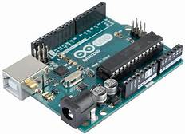

* IR Proximity Sensor

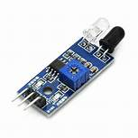

* Battery

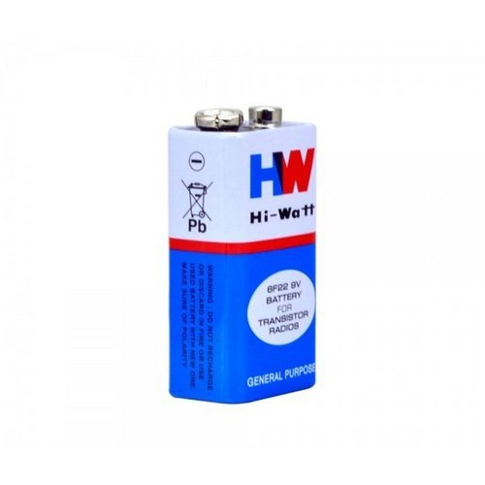

* Resistor

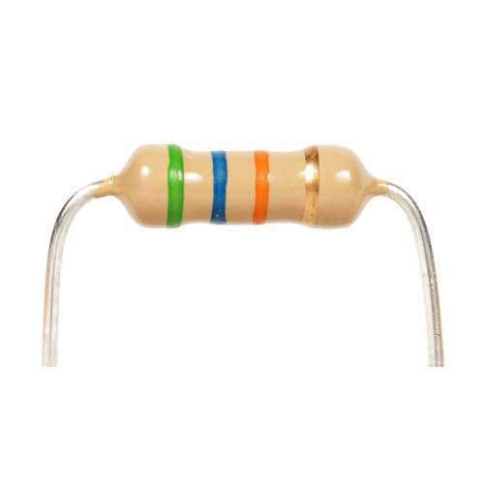

* Servo motor

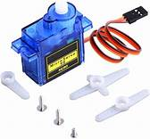

* Jumpers (both male & female)

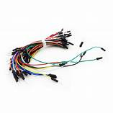

* Breadboard

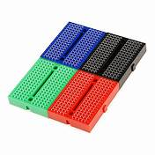

* Power adaptor(5v,2amp)

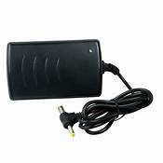

**4.1 MAIN CODE:-**

#include <Servo.h>

#include <Wire.h>

Servo tap_servo;

int sensor_pin1=2;

int sensor_pin2=4;

int ir_car1 =5;

int ir_car2 =6;

int ir_car3 =7;

int tap_servo_pin =3;

int S1=0, S2=0, S3=0;

int slot = 3;

int val1;

int val2;

void setup()

{

pinMode(sensor_pin1,INPUT);

pinMode(sensor_pin2,INPUT);

tap_servo.attach(tap_servo_pin);

pinMode(8,INPUT);

pinMode(9,INPUT);

pinMode(10,INPUT);

pinMode(11,OUTPUT);

pinMode(12,OUTPUT);

pinMode(13,OUTPUT);

}

void loop(){

val1 = digitalRead(sensor_pin1);

val2 = digitalRead(sensor_pin2);

Serial.begin(9600);

if(val1==0&&val2==0)

{

tap_servo.write(0);

}

else if(val1==1&&val2==0)

{

tap_servo.write(90);slot=slot+1;

}

else if(val1==0&&val2==1)

{

tap_servo.write(90);slot=slot-1;

}

else if(val1==1&&val2==1)

{

tap_servo.write(0);

}

{

if(digitalRead(8)==1&&digitalRead(9)==1&&digitalRead(10)==1)

{

digitalWrite(11,1);

digitalWrite(12,1);

digitalWrite(13,1);

}

else if(digitalRead(8)==1&&digitalRead(9)==1)

{

digitalWrite(11,1);

digitalWrite(12,1);

digitalWrite(13,0);

}

else if(digitalRead(9)==1&&digitalRead(10)==1)

{

digitalWrite(11,0);

digitalWrite(12,1);

digitalWrite(13,1);

}

else if(digitalRead(8)==1&&digitalRead(10)==1)

{

digitalWrite(11,1);

digitalWrite(12,0);

digitalWrite(13,1);

}

else if(digitalRead(8)==1)

{

digitalWrite(11,1);

digitalWrite(12,0);

digitalWrite(13,0);

}

else if(digitalRead(9)==1)

{

digitalWrite(11,0);

digitalWrite(12,1);

digitalWrite(13,0);

}

else if(digitalRead(10)==1)

{

digitalWrite(11,0);

digitalWrite(12,0);

digitalWrite(13,1);

}

else

{

digitalWrite(11,0);

digitalWrite(12,0);

digitalWrite(13,0);

}

}

Read_Sensor();

if(S1==1)

{

Serial.println("\nS1:Empty ");

}

else

{

Serial.println("\nS1:Fill");

}

if(S2==1)

{

Serial.print("\nS2:Fill");

}

else

{

Serial.print("\nS2:Empty");

}

if(S3==1){Serial.print("\nS3:Empty ");}

else

{

Serial.print("\nS3: Fill");

}

if(S3==0){

Serial.println(" Sorry Parking Full ");

}

delay(1500);

}

void Read_Sensor()

{

S1=0, S2=0, S3=0;

if(digitalRead(ir_car1) == 0){S1=1;}

if(digitalRead(ir_car2) == 0){S2=1;}

if(digitalRead(ir_car3) == 0){S3=1;}

}

**5.1 MOTIVATION FOR DOING THIS PROJECT**

Smart City projects can even be used to propel the economic development of a region, which is what the city of Nice, France sought to do within the Smart City sector starting in 2008. Its strategy was to build the sector through the creation of supporting infrastructure and by providing grants, encouraging sector-specific investments to establish an economic center of excellence. The ultimate goal is to facilitate the creation of 20,000 jobs within 20 years.

Besides the economic rationale to either save costs or increase revenues, other reasons why cities would like to become “smart” include environmental concerns, augmenting a city’s social inclusiveness, and increasing a city’s business attractiveness.

Whatever their motivations, the Smart City market will only continue to grow and how we classify them will evolve. How “Smart” will your city be in the future!

**6.1 CHALLENGES FACED-**

**Challenge #1: Infrastructure**

Smart Cities utilize sensor technology to gather and analyze information in an effort to improve the quality of life for residents. Sensors collect data on everything from rush hour stats to crime rates to overall air quality. Complicated and costly infrastructure is involved in installing and maintaining these sensors.

**Challenge #2: Security and Hackers**

As IoT and sensor technology use expands, so does the threat level to security. Recent discussion involving cyber-terror threats to vulnerable and outdated power grids has everyone a bit more concerned and skeptical about technology and security.

**Challenge #3: Privacy Concerns**

In any major city, there’s a balance between quality of life and invasion of privacy. While everyone wants to enjoy a more convenient, peaceful, and healthy environment, nobody wants to feel like they are constantly being monitored by “Big Brother.”

**Challenge #4: Being Socially Inclusive**

Smart transit programs that give riders real-time updates are a great idea for a bustling city. But what if half the population of that city can’t afford to take mass transit or Uber? What about a growing elderly population that doesn’t use mobile devices or apps? How will smart technology reach and benefit these groups of people!

**7.1** **Methodology of car parking system :-**

In this project we will be using IR (infrared) sensors to detect whether a vehicle is there in its range or not. If the vehicle is detected then a LED will show indicating that the slot is full and if there is no obstacle(vehicle) then led will glow indicating the slot is free(available).This availability of slots i.e. the output of the IR sensors, will be displayed in the LED.

Where as, we will be using the IR sensors to control the power and costing at the same time by appling sensor in the bulb. And will be analyze weather the person is in connection with the sensor and help too make our life comfortable.

Further we will be using two more IR sensors and servo motor to let the vehicles in and out of the parking area. One IR sensor will be placed just after the servo motor to detect the vehicles coming inside the parking area and the other IR sensor will be placed just before the servo motor to detect the vehicles going outside the parking area. When a vehicle is detected by first IR/second IR, then servo motor will rotate up to 90 degrees thus opening the barrier to let the vehicles in/out. However when the vehicles are detected by both the IR sensors at the same time, the servo motor will not rotate thus ensuring that both the vehicles might not collide

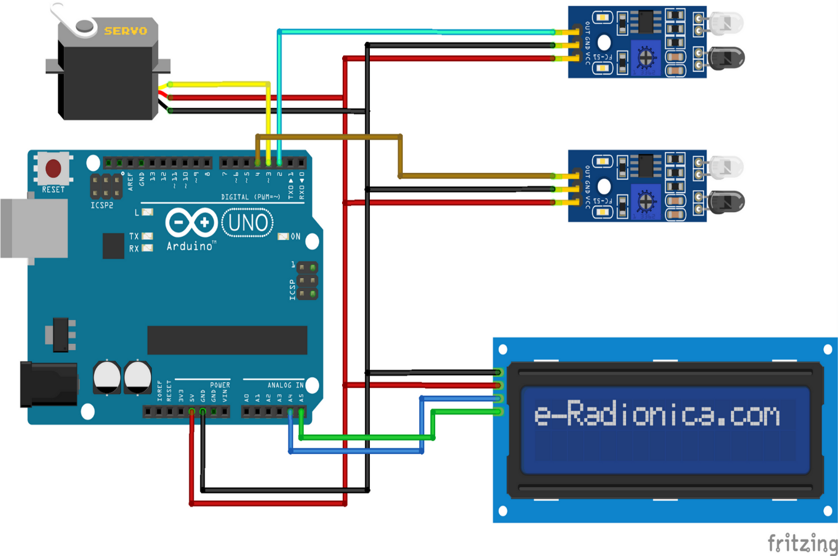

Fig 7.1- wires connections

**8.1** **CONCLUSION**

After doing study on smart city project. it is found that this system can be introduced in our country and it will be beneficiary in the context of our country. The main benefits are time and fuel saving. It can also provide sustainable parking management in an eco-friendly manner. There is less maintenance cost for this system so it helps the developer in cost saving. It provides the upgradation to the city. It reduces the hassle in parking grounds and traffic jam. It will also encourage Automation Engineering in our country which will make advancement in increasing usage of technology.

Therefore, we should implement this project and help to develop our city.