# BlogsAssignment

1.Login : For Login refer users from webconfig file other users are not valid.

2.configured your database connection in webconfig file.

3.for database schema check BlogDB.bak file.

below are the screenshots for blogs operations :

1.Login Form

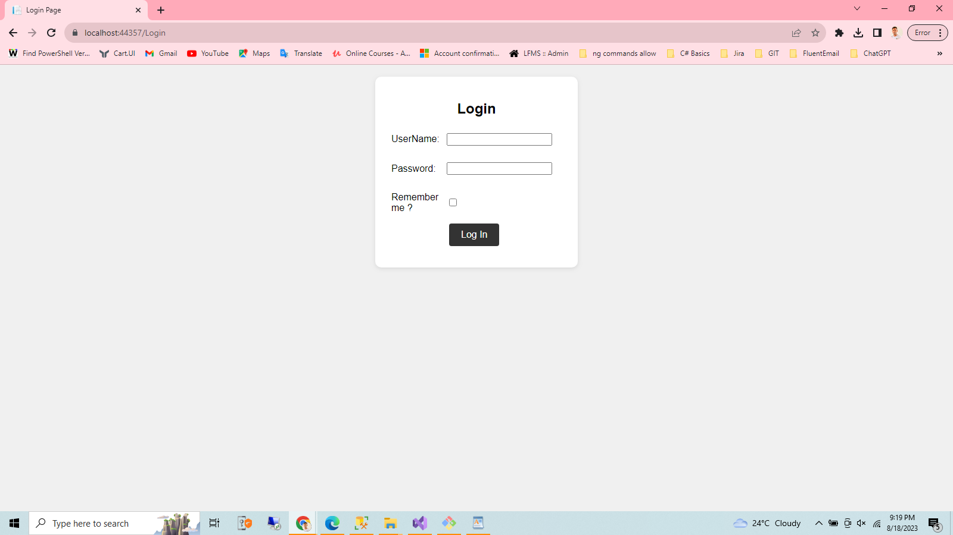

2.List Of Blogs

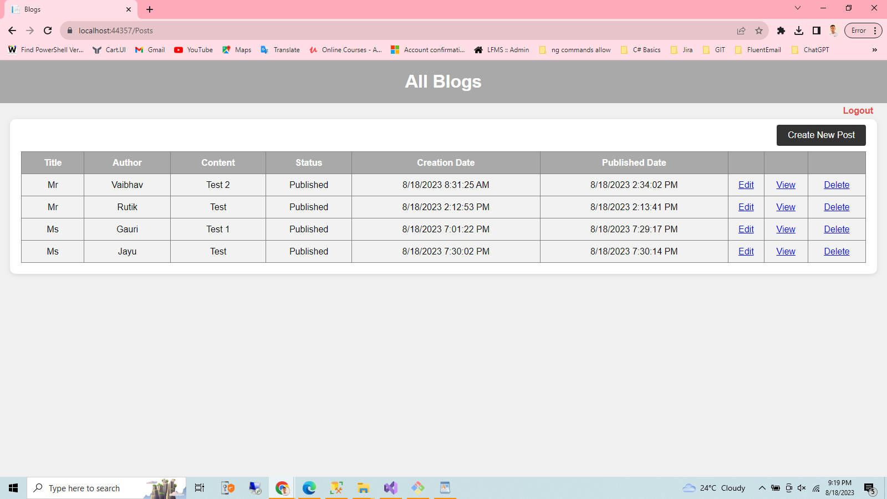

3.Create Blog

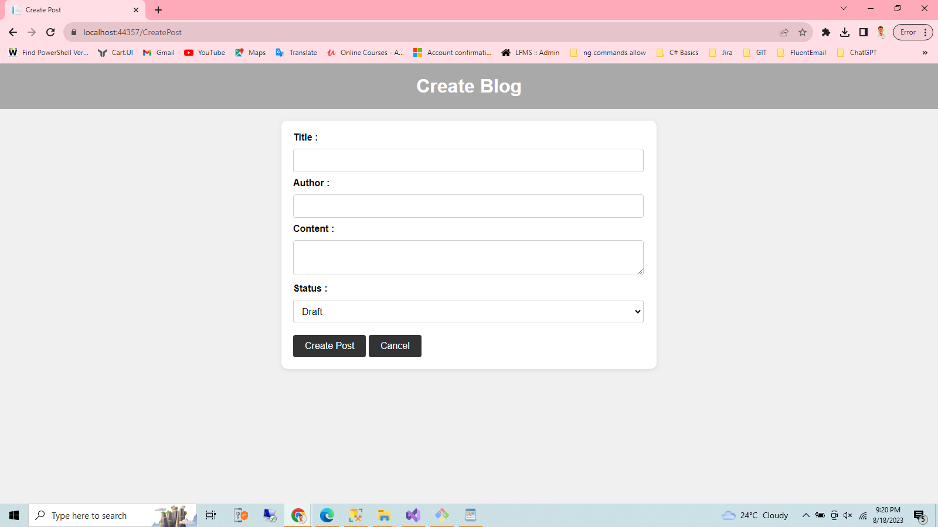

4.Update Blog

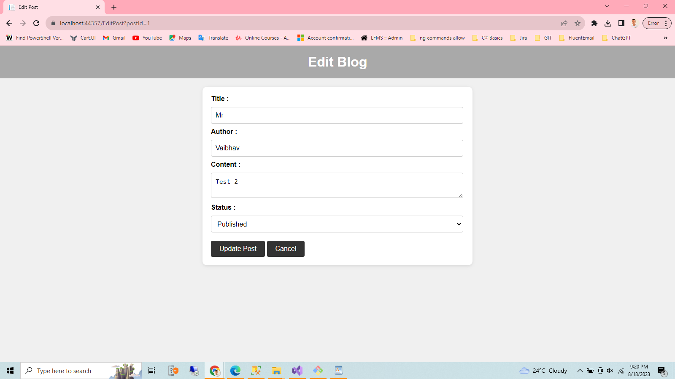

5.View Blog

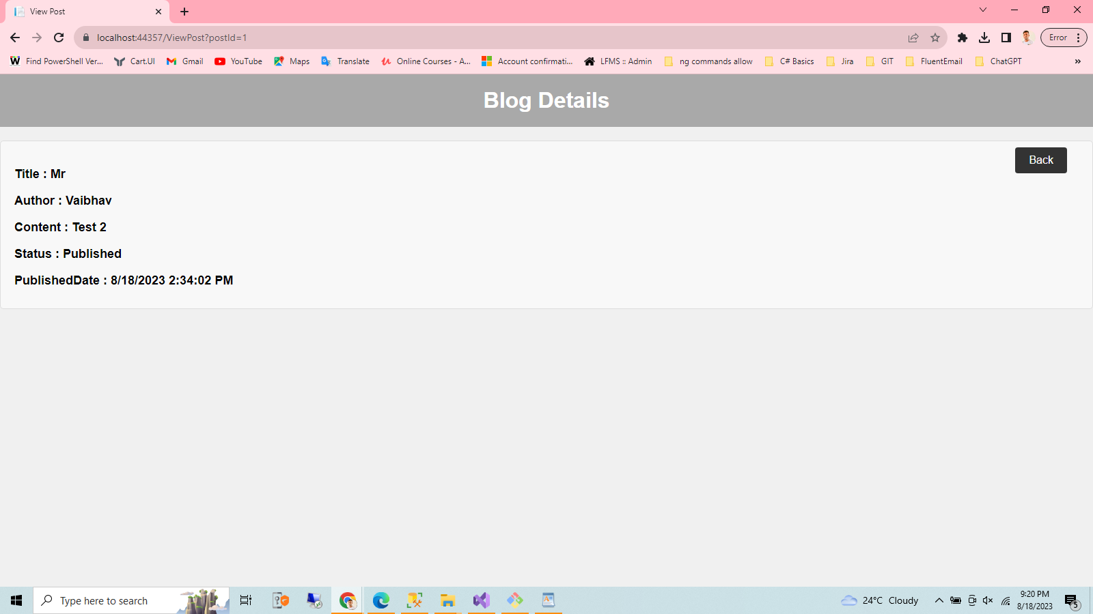

6.LogOut

