**PART A**

Code

%% A //----------//----------//----------//----------//----------//

a = 1;

b = 2;

b_values = [0.05*b, 1*b, 50*b];

figure;

for i = 1:length(b_values)

b = b_values(i);

G = tf(a, [1, b]);

% Calculate Bode plot

[m, p, w] = bode(G);

% Convert angular freq to freq

f = w/(2*pi);

% Plot magnitude response

subplot(2, 1, 1);

semilogx(f, 20*log10(squeeze(m)), 'DisplayName', ['b = ' num2str(b)], 'LineWidth', 2);

hold on;

% Plot phase response

subplot(2, 1, 2);

semilogx(f, squeeze(p), 'DisplayName', ['b = ' num2str(b)], 'LineWidth', 2);

hold on;

end

% Set labels and legends and show plot

subplot(2, 1, 1);

grid on;

title('Bode Plot - Magnitude Response');

xlabel('Frequency (Hz)'); ylabel('Magnitude (dB)');

legend('Location', 'Best');

subplot(2, 1, 2);

grid on;

title('Bode Plot - Phase Response');

xlabel('Frequency (Hz)'); ylabel('Phase (degrees)');

legend('Location', 'Best');

sgtitle('Bode Plots for Different Values of b');

Graphs

Observations

It is clear that the effect of the pole lasts longer as you move the position of the pole over from 0. Moving it over changes when the pole will lose its impact, which is seen in the Magnitude Response bode plot because instead of the signal dying out at 10^-2, it lasts until 10 when b=100. This is also seen in the phase response because the response chart just moves over but the actual response doesn’t change.

**PART B**

Code

%% B //----------//----------//----------//----------//----------//

a = 1;

b = 2;

b_values = [0.05*b, 1*b, 50*b];

figure;

for i = 1:length(b_values)

b = b_values(i);

G = tf(a, [1, b])

% Calculate the Bode plot

[m, p] = bode(G);

% Make into 1D array

m = m(1, :);

p = p(1, :);

% Convert to radians

polarplot((p*pi/180), m, 'DisplayName', ['b = ' num2str(b)], 'LineWidth', 2);

hold on;

end

legend('Location', 'Best');

Graphs

Observations

In this chart, increasing b will decrease the magnitude of the transfer function because it is increasing the denominator of the transfer function when evaluated at w=0. As a result, when b=100, it is almost impossible to see the polar plot of the function, but it is there.

**PART C**

Code

%% C //----------//----------//----------//----------//----------//

b = 2;

c_values = [0.1*b, 10*b];

% Magnitude and phase plots

figure;

for i = 1:length(c_values)

c = c_values(i);

G = tf([b, 1], [c, 1, 0, 0])

% Calculate the Bode plot

[m, p, w] = bode(G);

% Convert angular freq to freq

f = w/(2*pi);

% Plot magnitude response

subplot(2, 1, 1);

semilogx(f, 20*log10(squeeze(m)), 'DisplayName', ['c = ' num2str(c)], 'LineWidth', 2);

hold on;

% Plot phase response

subplot(2, 1, 2);

semilogx(f, squeeze(p), 'DisplayName', ['c = ' num2str(c)], 'LineWidth', 2);

hold on;

end

% Set labels and legends and show plot

subplot(2, 1, 1);

grid on;

title('Bode Plot - Magnitude Response');

xlabel('Frequency (Hz)'); ylabel('Magnitude (dB)');

legend('Location', 'Best');

subplot(2, 1, 2);

grid on;

title('Bode Plot - Phase Response');

xlabel('Frequency (Hz)'); ylabel('Phase (degrees)');

legend('Location', 'Best');

sgtitle('Bode Plots for Different Values of c');

% Polar plot

figure;

for i = 1:length(c_values)

c = c_values(i);

G = tf([b, 1], [c, 1, 0, 0]);

% Calculate the Bode plot

[m, p] = bode(G);

% Make into 1D array

m = m(1, :);

p = p(1, :);

% Generate the polar plot

polarplot((p* pi)/180, m, 'DisplayName', ['c = ' num2str(c)], 'LineWidth', 2);

hold on;

end

legend('Location', 'Best');

pax = gca;

rlim([0 50]); % set axis limits

Graphs

Observations

In this system, the system has 1 zero and 3 poles. For that reason, it is clear that the system will have a clear response at low frequencies thanks to the zero, while also then the zero being overcome by the poles to have a response at the high frequency as well.

**PART D**

Code

%% D //----------//----------//----------//----------//----------//

a = 1; b = 2; wn = b; zeta_values = [0.2, 0.5, 0.8];

% Magnitude and phase plots

figure;

for i = 1:length(zeta_values)

zeta = zeta_values(i);

G = tf((a * wn^2), [1, 2 * zeta * wn, wn^2])

% Calculate the Bode plot

[m, p, w] = bode(G);

% Convert angular frequency to regular frequency (Hz)

f = w/(2*pi);

% Plot magnitude response

subplot(2, 1, 1);

semilogx(f, 20*log10(squeeze(m)), 'DisplayName', ['ζ = ' num2str(zeta)], 'LineWidth', 2);

hold on;

% Plot phase response

subplot(2, 1, 2);

semilogx(f, squeeze(p), 'DisplayName', ['ζ = ' num2str(zeta)], 'LineWidth', 2);

hold on;

end

% Set labels and legends and show plot

subplot(2, 1, 1);

grid on;

title('Bode Plot - Magnitude Response');

xlabel('Frequency (Hz)'); ylabel('Magnitude (dB)');

legend('Location', 'Best');

subplot(2, 1, 2);

grid on;

title('Bode Plot - Phase Response');

xlabel('Frequency (Hz)'); ylabel('Phase (degrees)');

legend('Location', 'Best');

sgtitle('Bode Plots for Different Values of ζ');

% Polar plot

figure;

for i = 1:length(zeta_values)

zeta = zeta_values(i);

G = tf((a * wn^2), [1, 2 * zeta * wn, wn^2]);

% Calculate the Bode plot

[m, p] = bode(G);

% Make into 1D array

m = m(1, :);

p = p(1, :);

% Generate the polar plot

polarplot((p*pi)/180, m, 'DisplayName', ['ζ = ' num2str(zeta)], 'LineWidth', 2);

hold on;

end

legend('Location', 'Best');

pax = gca; % set axis limits

rlim([0 3]);

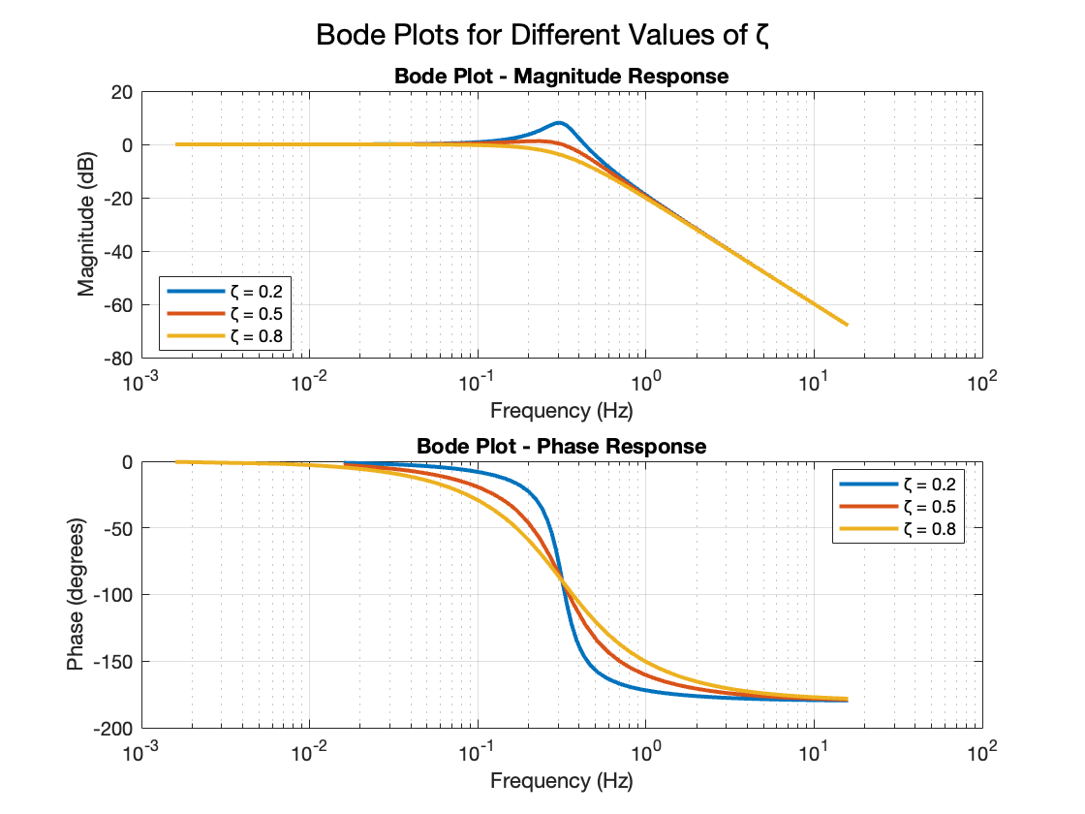Graphs

Observations

In this 2nd order transfer function, the response will have a resonant peak at wr. This is evident in the bode plots. What is more interesting is the polar plot, which will have a larger magnitude at smaller zeta. This is easily seen by what the transfer function will look like.

2 s + 1

-------------

0.2 s^3 + s^2

2 s + 1

------------

20 s^3 + s^2

Clearly, the magnitude will be decreased by having that larger denominator, and this is seen in the polar plot. Also in the polar plot, when w=0, the magnitude is at its maximum, and at high frequencies, the magnitude is very small, which shows why the graph curves down from 0, up, and back down to 0 at w=inf.