Vaibhav Shirole

EE 3331C, HW3

**RESULTS**

Lead compensation:

Lag compensation: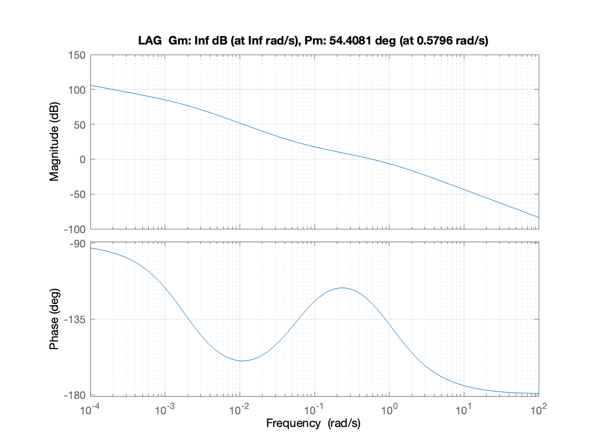

**CODE**

% A0271121X

% a = 1

%

% G(s) = 1/(s(s+a)), K(s) = K

% velocity error constant, Kv = 20

% phase margin of at least 50 deg

%% PART A - Lead compensator (see work in assignment)

D1 = tf([0.34, 1], [0.066, 1]); % +5 deg added to get >50 deg target

%% PART B - Design a lag compensator to meet the above specifications

D2 = tf([17.33, 1], [519.93, 1]); % +10 deg added to get >50 deg target

%% PART C - Simulate your results in Matlab and show the Bode plots

% Uncompensated system G(s)*K(s)

GK = tf(20, [1, 1, 0]); % numerator, denominator

figure;

h1 = bodeplot(GK);

grid on;

% Gain and phase margin analysis for G(s)*K(s)

[Gm, Pm, Wcg, Wcp] = margin(GK);

title(['{NONE} Gm: ', num2str(Gm), ' dB (at ',num2str(Wcg),' rad/s), Pm: ', ...

num2str(Pm), ' deg (at ',num2str(Wcp),' rad/s)']);

% Lead compensated system G(s)*D1(s)*K(s)

GD1K = GK*D1;

figure;

h2 = bodeplot(GD1K);

grid on;

% Gain and phase margin analysis for G(s)*D1(s)*K(s)

[Gm, Pm, Wcg, Wcp] = margin(GD1K);

title(['{LEAD} Gm: ', num2str(Gm), ' dB (at ',num2str(Wcg),' rad/s), Pm: ', ...

num2str(Pm), ' deg (at ',num2str(Wcp),' rad/s)']);

% Lag compensated system G(s)*D2(s)*K(s)

GD2K = GK*D2;

figure;

h3 = bodeplot(GD2K);

grid on;

% Gain and phase margin analysis for G(s)*D2(s)*K(s)

[Gm, Pm, Wcg, Wcp] = margin(GD2K);

title(['{LAG} Gm: ', num2str(Gm), ' dB (at ',num2str(Wcg),' rad/s), Pm: ', ...

num2str(Pm), ' deg (at ',num2str(Wcp),' rad/s)']);

**MATH**

