
Somaiya Vidyavihar University
K. J. Somaiya School of Engineering
Department of Electronics and Computer Engineering
Multimodal Deepfake Detection for Images, Video and Audio
A Hypothesis-Driven Study Under a Group-Disjoint Protocol
Submitted In Partial Fulfillment of Requirements
For the Degree Of
Bachelor of Technology
(Electronics and Computer Engineering)
By
Vaibhav Shiroorkar | Roll No: 16014024805
Shivansh Gupta | Roll No: 16014023052
Adithya Jithesh | Roll No: 16014024803
Guide
Dr. Tejashree Phatak
Assistant Professor
Somaiya Vidyavihar University
Vidyavihar, Mumbai - 400 077
2026-2027

Somaiya Vidyavihar University
K. J. Somaiya School of Engineering
Certificate
This is to certify that the project report entitled “Multimodal Deepfake Detection for Images, Video and Audio: A Hypothesis-Driven Study Under a Group-Disjoint Protocol” submitted by the following students at the end of Semester VII of LY B. Tech is a bona fide record for partial fulfillment of requirements for the degree of Bachelor of Technology (Electronics and Computer Engineering) of Somaiya Vidyavihar University.
Vaibhav Shiroorkar | (16014024805)
Shivansh Gupta | (16014023052)
Adithya Jithesh | (16014024803)

Guide  Dr. Tejashree Phatak | Head of the Department  Dr. Jagannath Nirmal
Examiner | Director
Date:
Place: Mumbai-77
Somaiya Vidyavihar University
K. J. Somaiya School of Engineering
Declaration
We declare that this written report submission represents the work done based on our and / or others’ ideas with adequately cited and referenced the original source. We also declare that we have adhered to all principles of intellectual property, academic honesty and integrity as we have not misinterpreted or fabricated or falsified any idea / data / fact / source / original work / matter in our submission.
We understand that any violation of the above will be cause for disciplinary action by the college and may evoke the penal action from the sources which have not been properly cited or from whom proper permission is not sought.
Signature of the Student  Vaibhav Shiroorkar  Roll No. 16014024805 | Signature of the Student  Shivansh Gupta  Roll No. 16014023052
Signature of the Student
Adithya Jithesh
Roll No. 16014024803
Date:
Place: Mumbai-77

Acknowledgement
We would like to express our sincere gratitude to our project guide, Dr. Tejashree Phatak, Assistant Professor, Department of Electronics and Computer Engineering, K. J. Somaiya School of Engineering, for her guidance, advice and encouragement throughout this project.
We thank Dr. Jagannath Nirmal, Head of the Department of Electronics and Computer Engineering, for the facilities that made the work possible, and the faculty and staff of K. J. Somaiya School of Engineering for their support.
We acknowledge the authors of the datasets used in this work, FaceForensics++, Celeb-DF, Celeb-DF++, DeepFakeDetection, ASVspoof 2019, In-the-Wild, LAV-DF and the ForenSynths generated-image sets, who made them available for research, and the developers of the open-source software on which the project is built, among them PyTorch, timm, Hugging Face Transformers, OpenCV and Flask.
Finally we thank our families and friends for their patience and support.

Abstract
Published deepfake detectors report high scores on the data they were developed against and markedly lower scores on data from other sources. This project builds, from zero, a system that takes an image, a video with its audio track, or a standalone audio clip and returns a score that the content is fake, calibrated on validation data only, together with a separate visual score and audio score so that the user can see which modality carries the evidence. It does not localise a manipulation in time.
The work follows a documented path. A working version uses a frozen pretrained encoder for each task and a linear head, with temperature scaling and a threshold that are fixed on validation data only. Seven further iterations follow, each starting from a written hypothesis, a success criterion and a failure criterion that precede the run; they cover fine-tuning depth, frame aggregation, loss and class weighting, augmentation and regularisation, combining encoders, late fusion with per-modality calibration and an experiment on the remote pulse signal (rPPG), followed by integration and freeze.
All data are split once and group-disjoint, where a group is the source video together with the person identity. A development slice of each cross-dataset source is used to rank candidates; the sealed test sets are touched once per frozen iteration through a guarded command that writes a ledger. Uncertainty is reported with group bootstrap intervals and several seeds, candidates are compared in a paired way, and a result is called comparable with a published detector only if it is non-inferior to a re-run of that detector on the same protocol.
The report describes the mathematical background, the evaluation harness and its acceptance test, the datasets and their licences, the shared preprocessing, the design of the encoder comparison, the working version, the iteration ladder with its measured results, the local web application, the test protocol and the sealed-test results. The results of the iterations are exploratory, on validation data and on development slices, and are reported with their intervals: fine-tuning the face encoder raises the development AUC from 0.6933 to 0.9096 (two further levers, augmentation with mixup and an average of three encoders, give 0.9315 and 0.9192 and do not enter the final system), three levers raise the speech AUC from 0.6100 to 0.8130, a pulse signal check fails (a positive control shows that the pipeline recovers an injected sinusoid of a relative green amplitude of 0.008 in 87 percent of the clips), and on LAV-DF a control shows that the fused result is driven by a production-pipeline cue of the visual head.
The sealed test sets were read once for each frozen iteration, and three tests were declared before the run. On the sealed Celeb-DF family set the final face-video system reaches an AUC of 0.8218 [0.8020, 0.8393] against 0.6238 [0.6015, 0.6486] for the working version (difference +0.1980 [+0.1688, +0.2242]), and on the sealed In-the-Wild set the final speech system reaches 0.9148 [0.8896, 0.9383] against 0.7516 [0.6802, 0.8035] (difference +0.1633 [+0.1177, +0.2266]); both are improvements by the declared rule and also at the 98.33 percent level. Against the re-run Xception baseline (0.8042 [0.7841, 0.8223]) the face-video system is superior at the 95 percent level (+0.0176 [+0.0025, +0.0327]), not at the 98.33 percent level, where the interval [−0.0011, +0.0355] contains zero, and non-inferior at both. Two predictions for speech failed upward, and every other sealed number is exploratory. The comparison rests on one baseline family at 224 pixels, 344 groups and 42 speakers.
After the freeze the detectors were wrapped in a modular analysis platform that reports one finding per module, each with its tested scope, and never a single overall score; it adds a lip-sync module (weak evidence), a Content Credentials check and an experimental generated-video module whose head is at chance on a held-out benchmark (AUC 0.4957). On the sealed half of FakeAVCeleb the frozen system ranks well (visual AUC 0.9552, audio 0.9263), but its thresholds do not transfer and the data set carries a codec shortcut.
Keywords: deepfake detection, multimodal, group-disjoint evaluation, frozen encoders, calibration, group bootstrap, non-inferiority, remote photoplethysmography.

Contents
Acknowledgement iii
Abstract iv
List of Figures ix
List of Tables xi
Nomenclature xiv
Chapter 1 Introduction 1
1.1 Background 1
1.2 Motivation 2
1.3 Problem Statement and Scope 2
1.4 Objectives 3
1.5 Approach and Constraints 4
1.6 Organisation of the Report and Outline of the Next Chapter 5
Chapter 2 Literature Survey 6
2.1 Face-video Datasets and Benchmarks 6
2.2 Visual Detectors and the Generalisation Problem 7
2.3 Detection of Fully Generated Images 8
2.4 Speech Anti-spoofing 9
2.5 Audio-visual Detection 9
2.6 Physiological Signals 10
2.7 Evaluation Methodology, Calibration and Adaptation 11
2.8 Research Gap and Objective of the Work 11
2.9 Summary and Outline of the Next Chapter 12
Chapter 3 Mathematical Background 13
3.1 Notation and Setting 13
3.2 Error Rates, the ROC Curve and the Area under It 13
3.3 Equal Error Rate 14
3.4 Precision, Accuracy and Balanced Accuracy 14
3.5 Probabilistic Metrics: Log Loss, Brier Score and Calibration Error 15
3.6 Platt Scaling and Temperature Scaling 16
3.7 Group Bootstrap Intervals 17
3.8 Paired Comparison of Two Models 17
3.9 Non-inferiority and the Tie Set 18
3.10 Which Quantity Sees What 18
3.11 Linear Probe, Binary Cross-Entropy and Class Weights 19
3.12 Fine-tuning Depth: Low-rank Adapters 20
3.13 Frame-to-video Aggregation 20
3.14 Loss Functions 21
3.15 Regularisation and Augmentation 21
3.16 Combining Encoders 22
3.17 Late Fusion of Audio and Visual Scores 22
3.18 The Pulse Signal and Its Signal-to-noise Ratio 23
3.19 Summary and Outline of the Next Chapter 24
Chapter 4 Implementation and Experimentation 25
4.1 Environment 25
4.2 Datasets, Splits and Licences 26
4.2.1 Group-disjoint splits 27
4.2.2 Celeb-DF++ and the balance of its sealed test set 29
4.2.3 Leakage check 30
4.3 Shared Preprocessing 30
4.4 Evaluation Harness and Its Acceptance Test 31
4.5 Design of the Encoder Comparison 33
4.5.1 Face video frames 37
4.5.2 Generated images 37
4.5.3 Speech audio 38
4.5.4 Checks of the audio result and of the image result 39
4.6 The Working Version (Iteration 0) 40
4.6.1 Results of the working version 42
4.6.2 Diagnostic battery of the working version 43
4.6.3 Candidate diagnoses 44
4.7 The Iteration Ladder 44
4.7.1 Fine-tuning budget of iteration I-1 46
4.7.2 The pulse experiment (iteration I-7) 47
4.7.3 Integration and freeze (iteration I-8) 48
4.8 Results of the Iterations 48
4.8.1 Iteration 1: fine-tuning depth on the face-video task 50
4.8.2 Iterations 1b and 1c: two further levers on the face-video task 51
4.8.3 Iterations 2 to 4: speech preprocessing, augmentation and combination 53
4.8.4 Iterations 5 and 6: LAV-DF, the pre-check and in-domain heads 54
4.8.5 Iteration 7: the pulse signal check 57
4.8.6 The re-run baseline and the margin of the comparison 58
4.9 The Web Application 59
4.10 The Analysis Platform 63
4.10.1 Module interface and coordinator 63
4.10.2 Report schema version 2 (extended in 2.1) 64
4.10.3 Modules that wrap the frozen detectors 65
4.10.4 Lip-sync module 66
4.10.5 Provenance: file metadata and Content Credentials 67
4.10.6 Generated-video module 68
4.10.7 Dashboard 68
4.10.8 Explanations from the stored result 70
4.10.9 Per-module verdicts and uncertainty 70
4.10.10 Evaluation Lab 71
4.11 Software Testing and Verification 73
4.12 The Staircase Test Protocol 74
4.13 Sealed-Test Results 76
4.13.1 The three confirmatory tests 76
4.13.2 The staircase on the sealed sets 78
4.13.3 LAV-DF on the sealed subset 79
4.13.4 Limits of these results 80
4.14 Experiments after the Freeze 81
4.14.1 The frozen system on the sealed half of FakeAVCeleb 81
4.14.2 Shortcut audits of the generated-video corpora 83
4.14.3 Generated-video candidates and their held-out test 83
4.14.4 Do real videos from other sources look generated to that head? 84
4.14.5 Training on the open generators of DF26 85
4.14.6 The generated-image model on modern generators 85
4.14.7 Retraining the generated-image head on recent generators 87
4.14.8 Comparison with published results 88
4.14.9 Validation of the lip-sync module 89
4.14.10 Limits of the later evidence and of its record 90
4.15 Summary and Outline of the Next Chapter 91
Chapter 5 Conclusions and Further Work 92
5.1 Conclusions 92
5.2 Further Work 96
References 98
Appendix A Fixed Settings of the Working Version 102
Appendix B Weights Recorded Before Use 103

List of Figures
Figure 1. Plan of the seven days to submission, 24 to 30 October 2026. An iteration not finished by the end of Wednesday is reported as not run. (schematic) 4
Figure 2. Group-disjoint splits and the access rules. The development slice and the sealed test set of a cross-dataset source share no group, identity or file content. (schematic) 28
Figure 3. Shortlist of the encoder comparison, with parameters and feature sizes read from the extraction records. 34
Figure 4. From a file to a calibrated score. The encoders are frozen, the temperature and the threshold are fixed on validation data, and the scores are calibrated on that data only. (schematic) 41
Figure 5. Iteration ladder. Each step from I-1 to I-6 starts from the diagnostic battery of the preceding step. (schematic) 45
Figure 6. Processing chain of the pulse signal check and its negative control. (schematic) 47
Figure 7. Measured ladder on the development slice: face video (top, with the re-run baseline and the two further iterations 1b and 1c) and speech (bottom), with 95 percent intervals. Sealed results are in a later section. (exploratory) 50
Figure 8. AUC of the visual and the audio head on the LAV-DF validation subset: against the real originals for each kind of fake, and within the produced videos only. (exploratory) 56
Figure 9. The local web page against the development stand-in: (a) result for an image, (b) result for a video. The banner is part of the design and the scores shown are not measurements. (screenshots against the stand-in) 61
Figure 10. The local web page with the real checkpoint: (a) result for an image, (b) result for a video with audio. The video shows its visual and audio score separately and the verdict undetermined. (screenshots of the real checkpoint on training items) 61
Figure 11. The local web page with the real checkpoint for an audio file, with the warning about the exploratory calibration of audio scores. (screenshot of the real checkpoint on a training item) 62
Figure 12. Structure of the analysis platform. The coordinator runs every registered module; each module appears once in the report, in one of three sections, with its status and, if it completed, its finding, tested scope and limitations. There is no global score. (schematic) 63
Figure 13. Top of a live report on the dashboard (demonstration input 3, a real LAV-DF training clip, 27 October 2026), taken before the per-module verdict labels described below were added: file description, counting summary without an overall score, and the first group of checks. A screenshot of the software, not a result. (screenshot) 69
Figure 14. Staircase test protocol. Verdicts on the development slice are exploratory; each frozen iteration is evaluated once on the sealed test sets and the pre-declared comparisons are the confirmatory claims. (schematic) 75

List of Tables
Table 1. Inputs, outputs and claims of the system. 3
Table 2. Published results quoted as context. Each row names the protocol under which it was measured; none is a result of this project and no two rows are comparable. 7
Table 3. What each quantity depends on. 19
Table 4. Environment of all experiments, as measured. 25
Table 5. Sizing probe: one training step of a trivial network, batch of 256 images of 3 by 224 by 224. 26
Table 6. Data sets in use, their roles and their licences or terms of use. All are for research use only. 27
Table 7. Development slices and sealed test sets of the cross-dataset sources (real / fake counts where both exist). 29
Table 8. Preprocessing of each input type. 30
Table 9. Face detector comparison (measurements; the machine was busy with 13 to 20 percent of the processor before each run, and the 200-video sample is warm in the file cache). 31
Table 10. Acceptance checks of the evaluation harness and the data tools. 33
Table 11. The three tasks of the comparison. 34
Table 12. Weights of the shortlisted encoders and their licence labels. 35
Table 13. Encoders on face video frames (exploratory, development slice). 37
Table 14. Encoders on generated images (exploratory, development slice, two groups). 38
Table 15. Encoders on speech audio (exploratory, development slice, 12 speakers; verdict inconclusive). 38
Table 16. Equal error rate and calibration on the development slice before and after temperature scaling (exploratory). 39
Table 17. AUC of single recording features used as the fake score (exploratory; a value below 0.5 means that fake clips have the smaller value). 40
Table 18. Working version: AUC with 95 percent group bootstrap interval, mean of three seeds (development slice values exploratory). 42
Table 19. Working version: expected calibration error before and after temperature scaling, Brier score and balanced accuracy at the validation threshold. 43
Table 20. Candidate lever, trigger, prediction and failure line of iterations I-1 to I-6 as planned before the runs. The predictions are hypotheses written before any run; the measured ladder is in the section on results. 46
Table 21. The iteration ladder as measured (exploratory; validation split and development slice). 49
Table 22. Fine-tuning of three encoders at three learning rates, one seed (validation and development slice AUC). 50
Table 23. Fine-tuned SigLIP base (three seeds) against the linear probe of the same encoder (exploratory). 51
Table 24. Iterations 1b and 1c against iteration 1 (three seeds each; paired difference with a 95 percent group bootstrap interval; exploratory). 52
Table 25. Speech task: the working version, the three levers and the members of the average (exploratory; slice of 12 speakers). 54
Table 26. Heads trained on LAV-DF, on its validation part (AUC with 95 percent group bootstrap interval; exploratory). 55
Table 27. Positive control of the pulse check: share of the 432 clips in which the injected 1.2 Hz sinusoid is recovered by the rule of the check (Wilson 95 percent interval; exploratory). 58
Table 28. Xception baseline at the first-pass rate and at the selected rate, against the fine-tuned SigLIP base, three seeds each (exploratory). 59
Table 29. Fields of the response of the inference library. 60
Table 30. Statuses of a module in the report. 65
Table 31. Findings allowed in each section of the report. None of them means that the media is genuine. 65
Table 32. Findings of the Content Credentials module. 67
Table 33. Verdict labels of each module. The label depends on whether the stored threshold comparison flags the file. 71
Table 34. Software tests and their recorded outcomes on 28 October 2026 (engineering verification, not detector accuracy). 74
Table 35. The three confirmatory tests on the sealed test sets (AUC and difference with 95 percent group bootstrap intervals; the last two columns give the robustness interval at the 98.33 percent level and the verdict). 77
Table 36. Sealed staircase for face video and generated images (AUC, three seeds, 95 percent group bootstrap interval; exploratory except the Celeb-DF family row, which carries tests T1 and T3). 78
Table 37. Sealed staircase for speech (AUC, three seeds, 95 percent group bootstrap interval; exploratory except the In-the-Wild values of the working version and of iteration 4, which carry test T2). 79
Table 38. Sealed LAV-DF subset (AUC, three seeds, 95 percent group bootstrap interval; exploratory). 79
Table 39. The frozen system on the sealed half of FakeAVCeleb (one run; 95 percent group bootstrap interval over 250 source identities, 2,000 resamples). 82
Table 40. Generated-video candidates: development (DeepAction, generator left out) and held-out test (DF26, once). AUC [95 percent cluster bootstrap interval]. 84
Table 41. DF26 open-generator training and the one counted look at the commercial generators. AUC [95 percent cluster bootstrap interval over source groups]. 85
Table 42. The frozen generated-image model on 11,550 images of 21 modern generators (AUC and rates with 95 percent bootstrap intervals over images, 2,000 resamples). 86
Table 43. The head retrained on 125 recent generators, scored once on the 11,550 evaluation images (seed mean over three seeds; 95 percent bootstrap intervals over images). 87
Table 44. Fixed settings of the working version. 102
Table 45. Weight files of the shortlisted encoders. 103

Nomenclature
Symbols
Symbol | Meaning
​$y_{i}$ | label of example i, 1 for fake and 0 for real
​$s_{i}, {\hat{p}}_{i}$ | score and predicted probability of fake
​$n_{0}, n_{1}, n, π$ | numbers of real and fake examples, their sum and the fake prevalence
​$t, t^{*}$ | decision threshold and the threshold at which the two error rates are equal
TPR, FPR, TNR, FNR | true positive, false positive, true negative and false negative rates
​$σ(u)$ | logistic function, 1 / (1 + exp(-u))
​$T$ | temperature of temperature scaling, or the number of frames of a video (context decides)
​$M, B_{m}$ | number of calibration bins and the examples in bin m
​$B, α$ | number of bootstrap resamples and the significance level
​$Δ, δ$ | difference of a metric between two models and the non-inferiority margin
​$r$ | rank of a low-rank adapter
​$ρ$ | correlation of the scores of frames or of encoders
​$l$ | logit, the log-odds of the fake class

Abbreviations
Abbreviation | Meaning
AUC | area under the ROC curve
AP | average precision
BA | balanced accuracy
ECE | expected calibration error
EER | equal error rate
ROC | receiver operating characteristic
GAN | generative adversarial network
rPPG | remote photoplethysmography, the pulse visible in skin colour
SNR | signal-to-noise ratio
POS | plane orthogonal to skin, a projection method for the pulse signal
LoRA | low-rank adaptation
FF++ | FaceForensics++
DFD | DeepFakeDetection data set
LAV-DF | localized audio visual deepfake data set
dev_x | development slice of a cross-dataset source
test_in, test_x | sealed in-dataset test and sealed cross-dataset test
I-0 to I-8 | working version, iterations 1 to 7 and the integration and freeze step
c23, c40 | FaceForensics++ compression levels
YuNet | face detector used by the preprocessing
C2PA | the content provenance standard behind Content Credentials
SyncNet | audio-visual synchronisation network used by the lip-sync module

Chapter 1
Introduction
This chapter presents the background and the motivation of the project, states the problem and its scope, lists the objectives, describes the way the work was organised and gives the outline of the report.

Background
Deepfakes are images, videos and audio clips that a learned model has generated or altered so that they show a person doing or saying something that did not happen, or show a scene that never existed. Five kinds of manipulation matter for this project: a face in a video replaced by another face (face swap); a face whose expression and head movement are driven by another person (re-enactment); a face animated from a still image and a speech signal (audio-driven talking face); a whole image produced by a generative network, either a generative adversarial network (GAN) or a diffusion model; and speech that is synthesised from text or converted from another speaker. A video can also be manipulated in its picture and in its sound separately, so that one modality is real and the other is not.
The research community has built benchmark data sets for each of these cases. FaceForensics++ holds 1,000 real videos and 4,000 videos manipulated with four methods at three compression levels [1]; Celeb-DF contains 590 real videos of 59 celebrities and 5,639 face-swap videos [2]; the DeepFake Detection Challenge data set adds over 100,000 clips of paid actors [3]; and for speech the ASVspoof 2019 database provides synthesised, converted and replayed attacks [4]. Detectors trained on these sets reach high scores on test data drawn from the same set.
The scores fall when the test data come from another source. In the DeepfakeBench benchmark, a plain Xception network trained on FaceForensics++ at the c23 compression level reaches a mean AUC of 94.5 over the six tests inside FaceForensics++ and 77.2 over eight other data sets (AUC in percent, frame level, the benchmark’s own protocol) [5]. For speech, one study that re-implemented twelve architectures under one protocol found a lowest equal error rate of about 1.2 percent on the evaluation split of ASVspoof 2019 and a lowest of about 33.9 percent on its separate In-the-Wild set, reached by a different model [6]. On the DeepFake Detection Challenge, the best models on content that was not made for the challenge reached an average precision of 75.3 and a ROC-AUC of 73.4 (percent) [3]. These numbers come from different protocols and are context only: they are never compared with the results of this project.

Motivation
Three observations from the literature shaped the project. First, reported numbers rarely share a protocol, so a table of published scores cannot show whether a new detector is better or worse than another; only a re-run of both under one protocol can. Second, binary face-forgery classifiers trained on FaceForensics++ learn information about the identity of the person in the picture [7], so a split that lets a person appear on both sides of the boundary measures memorisation of faces. Third, a full-text search of eight detector papers read for this survey found no mention of seeds, standard deviations or confidence intervals, although the seed-to-seed spread in audio detection reaches several points of equal error rate [6].
There is also a practical motivation. A person who receives a suspicious file needs a probability that is calibrated, so that 0.9 means what it says, and needs to know which modality carries the evidence: the picture, the sound or both. The system therefore returns a separate visual and audio score for a video instead of a single opaque number.
Finally, the project is a final-year project and its purpose is to show a documented path: a simple working version first, then at least seven iterations that each improve something for a stated reason, ending at results that can be compared with published detectors on a protocol that the project defines and runs itself. The goal is not the best model in the world. The report is written for a reader who asks “why this and not that”, so each choice is tied to a written decision and, where one exists, to an experiment.

Problem Statement and Scope
Given an image, a video with its audio track, or a standalone audio clip, the system returns the probability that the content is fake, and states which modality carries the evidence. Fake means a swapped, re-enacted or audio-driven face, a fully generated image (GAN or diffusion), synthesised or converted speech, or audio and video manipulated separately. Table 1 lists what is returned for each input.
Table 1. Inputs, outputs and claims of the system.
Input | What is returned | What is claimed
Still image | One visual score. A face crop is scored if a face is found, otherwise the whole image | A score calibrated on the validation data of its path (the face-crop path is not calibrated for still images); the path taken is reported
Video with an audio track | A visual score and an audio score, shown side by side | Each score for its own modality; no combined score is claimed until the combining rule is decided and tested
Video without audio | A visual score; the audio score is reported as unavailable, with the reason | A visual score only
Standalone audio file | One audio score | A score for fake speech with an exploratory calibration: a ranking score, not a reliable probability

The system does not locate a manipulation in time, because temporal labels are not available in every data set. It makes no claim about kinds of content that its training and test data do not cover. The frozen web page of the working version states, in a fixed sentence next to every score, that the score is a calibrated probability from a model fitted on the training data of this project, valid only for the kinds of content in that data, and that it is not proof. Calibrated here means that a temperature was fitted on the validation split of each task; on content unlike that split the number is a score, not a probability, which the later measurements on other sources show and the analysis platform states.
The analysis platform built after the freeze keeps these scores but presents each one as the finding of a module within its tested scope, adds modules for lip synchronisation, Content Credentials and generated video, and gives no single overall probability that the media is fake.

Objectives
The objectives of the project work are the following.
- Build the whole system from zero in one repository: data preparation, an evaluation harness, a detector for each of the three tasks (face video frames, generated images, speech audio), an inference library and a local web page.
- Define one evaluation protocol before any model exists, with group-disjoint splits, a development slice for ranking, sealed test sets and a guard that refuses test data unless a run is flagged as final.
- Compare candidate pretrained encoders under that protocol, with a rule that prefers the cheaper candidate when the evidence does not separate them.
- Develop the system in iterations, each starting from a written hypothesis, a success criterion and a failure criterion, and keep failed iterations in the record.
- Test remote photoplethysmography, the pulse visible in skin colour, as a candidate improvement and adopt it only if the evidence on the development slice supports it.
- State “comparable with published detectors” in a checkable way: non-inferior, on the same protocol, to a re-run of a published detector.
- Wrap the frozen detectors in an analysis platform that reports one finding per module with its tested scope and limitations, never a single overall probability that the media is fake, and add further modules (lip synchronisation, Content Credentials, generated video) only with the status that their evidence supports.
- Produce the software, an IEEE-format paper, this report and a presentation, all from the same logged evidence.

Approach and Constraints
The project runs over seven calendar days, from 24 to 30 October 2026, on one desktop machine with one NVIDIA GeForce RTX 5070 GPU of 12 GB. The schedule was organised so that every iteration is complete by itself: hypothesis, run, result, decision. An iteration that is not finished by the end of Wednesday is reported as not run, not as a result. Figure 1 shows the plan.
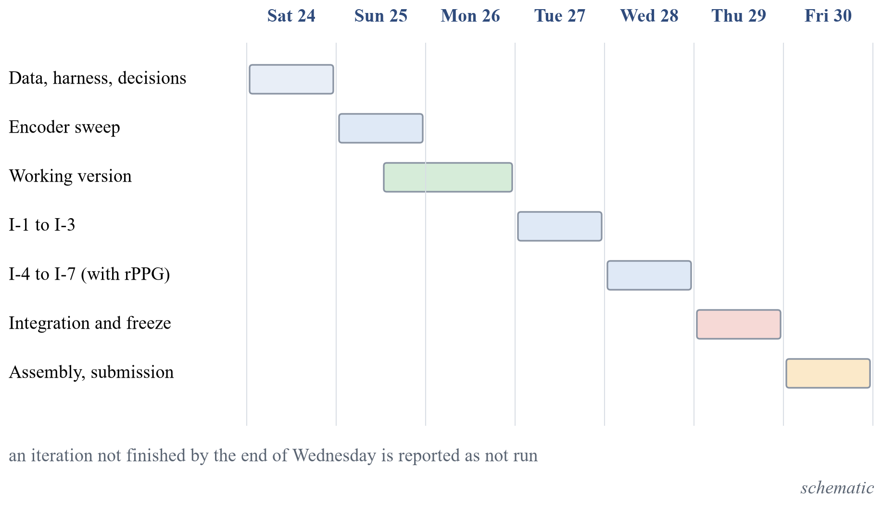
Figure 1. Plan of the seven days to submission, 24 to 30 October 2026. An iteration not finished by the end of Wednesday is reported as not run. (schematic)
Five working rules governed every step. Nothing unmeasured is written as a result: each number in a document comes from a logged experiment, and observations that are not measurements are labelled as such. The hypothesis, the success criterion and the failure criterion of every iteration and comparison are written before the run. The test data are never used for tuning: data are split once, by group, tuning uses only training and validation data, and the sealed test sets are touched once per frozen iteration. Candidates are compared on the same data, split, budget and metric, with several seeds, the mean, the standard deviation and a bootstrap interval; if the intervals of the difference include zero, the cheaper candidate is preferred and the report says so. Failed runs stay in the log.

Organisation of the Report and Outline of the Next Chapter
Chapter 2 surveys the literature and ends with the research gap that the objectives address. Chapter 3 gives the mathematical background: the metrics, the group bootstrap, the paired and non-inferiority comparisons and the argument behind each lever of the iteration ladder. Chapter 4 describes the implementation and the experimental design, from the environment and the data to the web application, the analysis platform, the software tests, the test protocol, the sealed-test results and the experiments after the freeze. Chapter 5 gives the conclusions and the further work. The references and two appendices follow.

Chapter 2
Literature Survey
This chapter presents the literature that the project builds on: the data sets and benchmarks, the visual, image, speech and audio-visual detectors, the evidence on the pulse signal, and the work on evaluation and adaptation. It ends with the research gap and the objective of the work.

Face-video Datasets and Benchmarks
FaceForensics++ is the standard training set for face forgery [1]. It contains 1,000 real videos and about 1.8 million fake images from 4,000 fake videos made with four methods (DeepFakes, Face2Face, FaceSwap and NeuralTextures) at three compression levels, raw, c23 and c40. Its fixed split uses 720, 140 and 140 videos for training, validation and test, and the faces are cropped with an enlargement factor of 1.3 before classification, a value that the preprocessing of this project reuses. With the in-dataset test videos, per-frame accuracy of an XceptionNet on cropped faces was 99.26, 95.73 and 81.00 percent at the three levels, which shows the sensitivity to compression.
Celeb-DF was built to be harder: 590 real videos of 59 celebrities and 5,639 face-swap videos made with an improved synthesis pipeline [2]. Nine existing detectors, run with their released models and without retraining, reached a frame-level AUC of 65.3 (Xception trained at c23) and lower for others, and Celeb-DF gave the lowest average AUC of the data sets compared. The DeepFake Detection Challenge data set contains over 100,000 clips of 3,426 paid and consenting actors, with a subject-disjoint public test set [3]; on content that was not made for the challenge the log loss of the best models was close to the value of a constant prediction.
Celeb-DF++ extends Celeb-DF with 22 recent generation methods, namely 8 face-swap methods including the original, 7 re-enactment methods and 7 talking-face methods, over the same 590 real videos of 59 identities, and defines three generalisation protocols [8]. A detector trained on FaceForensics++ lost on average 5.2 points of frame-level AUC on Celeb-DF++ compared with Celeb-DF. DeepfakeBench unifies 15 detectors, 9 data sets, one preprocessing pipeline and one set of metrics [5]; trained on FaceForensics++ c23, a plain Xception and an EfficientNet-B4 had the same mean cross-domain AUC (77.2) and were within one to two points of more elaborate detectors, which suggests that the backbone and the training recipe matter at least as much as the method name.
Table 2. Published results quoted as context. Each row names the protocol under which it was measured; none is a result of this project and no two rows are comparable.
Source | Protocol of the source | Quantity | Value
FaceForensics++ [1] | In-dataset, XceptionNet, c23, per frame | Accuracy (percent) | 95.73
Celeb-DF [2] | Released detectors, not retrained, Celeb-DF | Frame AUC of Xception-c23 (percent) | 65.3
DeepfakeBench [5] | Train FF++ c23; plain Xception | Mean AUC within FF++ / across 8 sets (percent) | 94.5 / 77.2
LipForensics [9] | Train FF++, cross-dataset, video level | AUC on Celeb-DF / DFDC (percent) | 82.4 / 73.5
Effort [10] | Train FF++ c23, video level, 7 data sets | Mean AUC (percent) | 91.7
Ojha et al. [11] | Train ProGAN, test unseen diffusion and autoregressive models | Mean AP, linear probe on CLIP / trained baseline | 95.00 / 75.51
AASIST [12] | ASVspoof 2019 LA evaluation | EER, best seed / mean of 3 seeds (percent) | 0.83 / 1.13
Muller et al. [6] | Train ASVspoof 2019, test In-the-Wild | Lowest EER over 12 models (percent) | about 33.9
FakeAVCeleb [13] | Own test set, three fake categories | Best audio-only AUC / video-only AUC (percent) | about 97.8 / 93.3
LAV-DF [14] | Own test split, identity-independent | Classification AUC of its multimodal method (percent) | 99.0

Visual Detectors and the Generalisation Problem
Face X-ray predicts the blending boundary between a pasted face and its background and is trained on self-made blended real images, so that no fake from any generator is needed [15]. Trained on blended images only it reached a cross-dataset AUC on Celeb-DF of 74.76, against 36.19 for an Xception trained on FaceForensics++ (percent). Self-blended images take the idea further: a real face is copied, augmented and blended back with a deformed mask, and an EfficientNet-B4 trained on such images from real FaceForensics++ videos only reached a video-level AUC of 93.18 on Celeb-DF v2 in its own paper [16]. The same paper states that the method fails on whole-image synthesis and reports one run per entry with no seeds or intervals.
LipForensics pretrains a network for lipreading and fine-tunes only its temporal part, with the feature extractor frozen [9]. In its ablation, the frozen extractor gave an accuracy of 87.5 and 90.4 percent on two unseen manipulation sets, against 83.2 and 84.6 when the whole network was fine-tuned; this is evidence that more trainable capacity does not always transfer better, which the fine-tuning iteration of this project tests directly. Dong et al. showed with a linear probe on frozen detector features that binary classifiers trained on FaceForensics++ encode identity [7], which is the reason why the splits of this project are disjoint in identity as well as in source video.
Adapting a large frozen vision-language encoder has recently given strong cross-dataset numbers. The Effort detector decomposes the attention weights of a CLIP ViT-L/14 by singular value decomposition, freezes the dominant part and trains a small residual with 0.19 million parameters, and reached a mean video-level AUC of 91.7 percent over seven data sets when trained on FaceForensics++ c23 [10]. The paper reports no seeds or intervals, and its ablations were run on the same test sets as its headline, so the number is context and not a target. Kornblith et al. compared 16 networks on 12 image data sets as fixed feature extractors and as fine-tuned models and found that ImageNet accuracy correlates with transfer accuracy for both, although some regularisers that raise ImageNet accuracy hurt the transfer of frozen features [17]. The study concerns natural images and not forensic detection, so it motivates the encoder comparison without answering it.

Detection of Fully Generated Images
A ResNet-50 trained on ProGAN images only, with blur and JPEG augmentation, detected images from unseen CNN generators with a mean average precision above 90 over eleven generators [18]. The paper also separates two ways of choosing the decision threshold: a threshold tuned on the test distribution (the “oracle”) gave an accuracy of 96.8 on StyleGAN images against 87.1 for the threshold fixed on training data, which is why the threshold of this project is chosen on validation data only. Ojha et al. replaced the trained network by a nearest-neighbour or a linear classifier in the frozen feature space of CLIP ViT-L/14 [11]. Trained on ProGAN, the linear probe reached a mean AP of 99.31 on GAN-family test sets and 95.00 on unseen diffusion and autoregressive models, against 94.19 and 75.51 for the best trained network; their training set was far larger than the one used here. Cozzolino et al. obtained robust results with a linear support vector machine on CLIP features trained on a few pairs of real and generated images [19].
Shortcuts are a risk in these data sets. In GenImage the real images are JPEG files of varied size while the fakes are PNG files of fixed size, so a detector can learn compression and size; after removing both biases the cross-generator accuracy of a ResNet-50 rose from 71.68 to 82.74 percent [20]. The generated-image path of this project therefore checks content duplicates across splits and states the class balance of every test set.

Speech Anti-spoofing
The ASVspoof 2019 database defines logical-access attacks (speech synthesis and voice conversion) and physical-access attacks (replay), with training, development and evaluation partitions that are disjoint in speakers and an evaluation set that contains attacks unseen in training [4]. AASIST applies graph attention to the raw waveform and reached 0.83 percent EER on the logical-access evaluation set in its best seed and 1.13 percent as the mean of three seeds; the authors note that the headline is the best of three seeds and that one baseline varied between 1.19 and 2.06 percent across seeds [12]. A RawNet2 front end was worse than a feature-based baseline when used alone and better in fusion with it [21].
Pretrained self-supervised encoders changed the picture. Replacing the front end of AASIST by wav2vec 2.0 lowered the EER on ASVspoof 2021 logical access from 11.47 to 6.15 percent (best seed) with nothing else changed [22]. The ASVspoof 2021 challenge showed the danger of a development partition: on the deepfake task the best EER fell to 0.10 percent in the progress phase and was 15.6 percent in the evaluation phase [23]. The In-the-Wild study re-implemented twelve architectures under one protocol, trained them on ASVspoof 2019 and tested them on 37.9 hours of public recordings of 58 speakers; many models were close to chance, and the standard deviation over three seeds reached 15 EER points [6]. The speech encoders in the shortlist of this project, wav2vec 2.0 [24], WavLM [25], HuBERT [26] and the Whisper encoder [27], are the pretrained models that this literature suggests, used here frozen.

Audio-visual Detection
FakeAVCeleb contains 500 real and 19,500 fake videos with synthesised, lip-synchronised audio [13]. Audio-only detectors reached an AUC of about 97.8 percent and video-only detectors about 93.3 percent on its test set, whereas ensembles of unimodal detectors were at best 82.8 and often near 50, and published multimodal models 53.3 to 68.8, so naive combination was not reliable. Chugh et al. computed a modality dissonance score between the audio and the video stream and reached a video-level AUC of 91.54 percent on a DFDC subset [28]. Zhou and Lim compared independently trained streams combined by an OR rule with joint training; on FaceForensics++ and DFDC the independent streams reached a whole-sequence accuracy of 95.83 and 89.36 percent and joint late fusion 94.25 and 89.15 percent, so joint fusion alone was no better [29].
LAV-DF contains 136,304 videos of 153 identities, in which words of the transcript are replaced and only the changed segments are regenerated in audio and in video; its four label types (real, video modified, audio modified, both) and its identity-independent split make it suitable for per-modality questions [14]. AV-Deepfake1M is larger, with 1,146,760 videos, and shows that in-dataset numbers of different data sets cannot be compared: the same Xception had an AUC of 83.58 on LAV-DF and 68.68 on AV-Deepfake1M [30]. In the audio-visual detectors read for this survey, none handled a missing modality inside the model, although a still image or a silent video needs it.

Physiological Signals
FakeCatcher extracts photoplethysmography-like signals from facial regions and classifies them with a support vector machine or a CNN, with in-dataset video accuracy of 96, 94.65, 91.50 and 91.07 percent on four sets [31]; a follow-up addressed source attribution with biological signals [32]. DeepFakesON-Phys fine-tuned a heart-rate estimation network as a detector and reached an in-dataset AUC of 99.9 percent on Celeb-DF v2 and 98.2 on DFDC Preview, with identity-disjoint development and test sets [33]. DeepRhythm reached an accuracy of 98.0 percent on FaceForensics++ but 64.1 percent when tested on DFDC Preview, and its ablation shows that without motion magnification the plain map scores near 50 percent, so the discriminative signal may be an amplified artefact and not a pulse [34].
Newer evidence is mixed. A study with ECG and photoplethysmography ground truth found that high-quality face swaps do carry a pulse: the heart-rate error was 1.80 beats per minute for genuine videos, 1.85 for autoencoder fakes and 3.24 for real-time DeepFaceLive fakes, and the pulse of a fake followed the driving video [35]. A reproduction of DeepFakesON-Phys on talking-face fakes of Celeb-DF++ scored an AUC of 62.2 percent against 99.9 in its original setting [36]; the authors of that preprint later describe their rPPG-derived signal as not shown to be cardiac and note that real and fake videos differ in frame rate [37]. On fakes built from data sets with contact-sensor ground truth, the heart-rate error grew from 3.13 beats per minute for real videos to 5.70 for face swap and 12.51 for motion transfer [38]. Pulse signals can also be forged on purpose [39]. The pulse extraction itself, the POS algorithm, was developed on uncompressed laboratory video, and its authors judged one compressed data set unsuitable because compression may remove or pollute the pulse [40]. These results motivate treating the pulse as an experiment with written thresholds and not as an adopted component.

Evaluation Methodology, Calibration and Adaptation
Guo et al. showed that modern networks are poorly calibrated and that temperature scaling, a single parameter fitted on a validation set, usually gives the best ECE among the calibration methods they compared; they define ECE with 15 equal-width bins [41]. The studies above show repeatedly that the threshold, the aggregation of frame scores and the number of seeds change the headline number, which is why the project fixes them in a protocol before any model exists.
Low-rank adaptation freezes the pretrained weights and trains a low-rank update, which reduced the trainable parameters of GPT-3 175B by about 10,000 times and the memory for training from 1.2 TB to 350 GB [42]; the study is on language models. In the Effort protocol (trained on ProGAN, mean accuracy at a fixed threshold), a linear probe scored 81.02, full fine-tuning 86.22 and low-rank variants 91.06 to 93.53 [10], although the rank was chosen on the test sets used for the headline. The encoders of the shortlist of this project are EfficientNet [43], Xception [44], DINOv2 [45], CLIP [46] and SigLIP [47] for images, and the four speech encoders named above; faces are found with the YuNet detector [48].

Research Gap and Objective of the Work
The survey leads to four observations. The numbers of published detectors come from protocols that differ in training data, splits, thresholds and aggregation, so they cannot stand in for a comparison. In the eight detector papers searched, uncertainty over groups and over seeds was not mentioned, while the measured seed spread of audio detectors is large. The identity of the person is a shortcut that a split must remove. The pulse signal has contradictory evidence on current generators. No complete path from a minimal working version to a documented improvement, with the hypothesis written before each run and every comparison paired, was found for the combination of images, video and audio.
The objective of the project work is therefore to build such a system and path: a multimodal detector for images, video and audio, developed from a working version through seven hypothesis-driven iterations, evaluated on group-disjoint splits with intervals over groups and seeds, and compared with a published detector family re-run under the same protocol, with “comparable” defined as non-inferior.

Summary and Outline of the Next Chapter
This chapter reviewed the data sets, detectors and evidence in the literature, quoted their results only with their own protocols, and stated the research gap and the objective. Chapter 3 now gives the mathematical background of the metrics, the uncertainty estimates and the levers of the iteration ladder.

Chapter 3
Mathematical Background
This chapter presents the definitions and the short derivations that the later chapters rely on: error rates, ranking and calibration metrics, the group bootstrap and the paired tests, and the argument behind each lever of the iteration ladder, with its assumption and the conditions under which it does not help.

Notation and Setting
Each example i has a label $y_{i}∈\{0,1\}$, where 1 means fake and is the positive class and 0 means real. A model gives a score $s_{i}∈R$; when the score is the probability of the fake class it is written ${\hat{p}}_{i}∈[0,1]$. The numbers of fake and real examples are $n_{1}$ and $n_{0}$, their sum is $n$, and the fake prevalence is
 | $$π=\frac{n_{1}}{n}, n=n_{0}+n_{1}$$ | (1)
A decision rule with threshold $t$ predicts fake when $s_{i}≥t$. At a threshold, $TP$, $FP$, $TN$ and $FN$ are the counts of true positives, false positives, true negatives and false negatives. Population statements use $S_{1}$ for the score of a randomly drawn fake and $S_{0}$ for the score of a randomly drawn real example. The unit that is resampled in the uncertainty estimates is the group, which is the source video together with the person identity (Chapter 4).

Error Rates, the ROC Curve and the Area under It
The true positive rate and the false positive rate at threshold $t$ are conditioned on the true class, so they do not depend on the prevalence $π$:
 | $$TPR(t)=\frac{TP}{TP+FN}=P(S≥t|Y=1), FPR(t)=\frac{FP}{FP+TN}=P(S≥t|Y=0)$$ | (2)
The false negative rate is $1-TPR$ and the true negative rate (specificity) is $1-FPR$. The ROC curve is the set of points $(FPR(t),TPR(t))$ traced as $t$ moves from $+∞$, which gives the point $(0,0)$, to $-∞$, which gives $(1,1)$. The area under it is
 | $$AUC=\int_{0}^{1}{TPR d(FPR)}$$ | (3)
The ranking interpretation follows from a change of variable. Let $F_{0}(t)=P(S_{0}≤t)$ for continuous score distributions. Then $FPR(t)=1-F_{0}(t)$ and $TPR(t)=P(S_{1}≥t)$, and substituting $u=1-F_{0}(t)$ gives $AUC=\int{P(S_{1}≥t) dF_{0}(t)}=P(S_{1}>S_{0})$. When ties are allowed the general form is
 | $$AUC=P(S_{1}>S_{0})+\frac{1}{2} P(S_{1}=S_{0})$$ | (4)
so the AUC is the probability that a random fake receives a higher score than a random real example. The empirical estimate is the Mann-Whitney form, where $U$ is the Mann-Whitney statistic:
 | $$\hat{AUC}=\frac{1}{n_{1}n_{0}}\sum_{i: y_{i}=1}{ \sum_{j: y_{j}=0}{\left[1(s_{i}>s_{j})+\frac{1}{2}1(s_{i}=s_{j})\right]}}=\frac{U}{n_{1}n_{0}}$$ | (5)
The AUC lies in $[0,1]$; $0.5$ means ranking no better than chance and $1$ means that every fake outranks every real example. It is unchanged by any strictly increasing transformation of the scores, so it does not see calibration or the threshold, and its population value does not depend on the prevalence. These properties are why it is the headline metric of the project: the test sets are unbalanced (the pooled Celeb-DF family test set is 90.3 percent fake, 9.7 percent real), and a metric that depended on the class ratio would change with the test set and not with the detector.

Equal Error Rate
The equal error rate is the common value of the two error rates at the threshold $t^{*}$ where they are equal:
 | $$FPR(t^{*})=FNR(t^{*}), EER=FPR(t^{*})$$ | (6)
On a finite sample the two rates are step functions and may not cross exactly. A common estimate takes the threshold that minimises the gap and averages the two rates there:
 | $$\hat{t}=\underset{t}{arg min}\left|FPR(t)-FNR(t)\right|, \hat{EER}=\frac{1}{2}\left(FPR(\hat{t})+FNR(\hat{t})\right)$$ | (7)
The threshold $t^{*}$ is a property of the data on which it is computed; a threshold taken from one data set and applied to another no longer gives equal errors. Like the AUC, the EER uses only the ranking of the scores. It is reported for standalone speech, where it is the usual metric of the anti-spoofing literature and allows comparison with published tables [4, 12].

Precision, Accuracy and Balanced Accuracy
Precision depends on the prevalence. By Bayes’ rule
 | $$Precision(t)=\frac{TP}{TP+FP}=\frac{π TPR(t)}{π TPR(t)+(1-π) FPR(t)}$$ | (8)
so the same detector has a different precision on a test set with a different real-to-fake ratio, although its true and false positive rates stay the same. Accuracy and balanced accuracy are
 | $$Acc(t)=π TPR(t)+(1-π) TNR(t), BA(t)=\frac{1}{2}\left(TPR(t)+TNR(t)\right)$$ | (9)
The two agree when $π=1/2$. Accuracy rewards predicting the majority class when the classes are unbalanced, whereas balanced accuracy weights the two classes equally whatever $π$ is. Both depend on the threshold. The threshold of the project is the one that maximises balanced accuracy on the validation split of the training data set, and accuracy at a fixed 0.5 is reported only as a reference.

Probabilistic Metrics: Log Loss, Brier Score and Calibration Error
Three metrics see the probabilities and not only their ranking. The logarithmic loss is the negative mean log likelihood of the labels under the predicted probabilities; the probabilities are clipped to $[{10}^{-7},1-{10}^{-7}]$ before it is computed:
 | $$LL=-\frac{1}{n}\sum_{i=1}^{n}{\left[y_{i} ln {\hat{p}}_{i}+(1-y_{i}) ln (1-{\hat{p}}_{i})\right]}$$ | (10)
The Brier score is the mean squared error of the probabilities, a proper scoring rule whose expected value is minimised only by reporting the true conditional probability. Always predicting 0.5 gives 0.25 and always predicting the prevalence gives $π(1-π)$:
 | $$BS=\frac{1}{n}\sum_{i=1}^{n}{({\hat{p}}_{i}-y_{i})^{2}}∈[0,1]$$ | (11)
If the forecasts take $K$ distinct values $p_{k}$, with $n_{k}$ cases having that value, ${\overline{o}}_{k}$ the observed fake fraction among them and $\overline{o}=π$ the overall fake fraction, the Murphy decomposition separates reliability, resolution and uncertainty:
 | $$BS=\underset{\text{reliability}}{\underbrace{\frac{1}{n}\sum_{k}{n_{k}(p_{k}-{\overline{o}}_{k})^{2}}}}-\underset{\text{resolution}}{\underbrace{\frac{1}{n}\sum_{k}{n_{k}({\overline{o}}_{k}-\overline{o})^{2}}}}+\underset{\text{uncertainty}}{\underbrace{\overline{o}(1-\overline{o})}}$$ | (12)
For continuous forecasts the sums are taken over bins and the identity then holds only approximately. The reliability term plays the role of a squared-error version of the calibration gap.
A classifier is perfectly calibrated when $P(Y=1|\hat{p}=p)=p$ for all $p∈[0,1]$. The expected calibration error (ECE) measures the departure by binning. Fix $M$ equal-width bins $I_{m}=(\frac{m-1}{M},\frac{m}{M}]$ and let $B_{m}=\{i:{\hat{p}}_{i}∈I_{m}\}$. The project uses the top-label version of Guo et al. [41]: the confidence of example $i$ is ${\hat{c}}_{i}=max({\hat{p}}_{i},1-{\hat{p}}_{i})$, its predicted label is ${\hat{y}}_{i}=1({\hat{p}}_{i}≥0.5)$, the examples are binned by confidence and
 | $$ECE=\sum_{m=1}^{M}{\frac{|B_{m}|}{n}\left|acc(B_{m})-conf(B_{m})\right|}$$ | (13)
where the accuracy and the mean confidence of a bin are
 | $$acc(B_{m})=\frac{1}{|B_{m}|}\sum_{i∈B_{m}}{1({\hat{y}}_{i}=y_{i})}, conf(B_{m})=\frac{1}{|B_{m}|}\sum_{i∈B_{m}}{{\hat{c}}_{i}}$$ | (14)
with $M=15$. A second version bins the fake probability itself and compares the mean label with the mean probability in each bin; it gives a different number for the same predictions, so the version is always stated. ECE depends on $M$ and on the binning rule, is zero for a perfectly calibrated model and is estimated with bias on small bins.

Platt Scaling and Temperature Scaling
Given a raw score, for example a logit $s_{i}$, Platt scaling maps it to a calibrated probability by a logistic function with two scalar parameters fitted on a held-out calibration set by minimising the negative log likelihood [41]:
 | $$q_{i}=σ(a s_{i}+b), σ(u)=\frac{1}{1+e^{-u}}$$ | (15)
 | $$(\hat{a},\hat{b})=\underset{a,b}{arg min} -\sum_{i}{\left[y_{i} ln q_{i}+(1-y_{i}) ln (1-q_{i})\right]}$$ | (16)
This is a logistic regression with one feature, so the objective is convex in $(a,b)$. If $\hat{a}>0$ the map is increasing, so the ranking, the AUC and the EER do not change; only the probabilities change. Temperature scaling is the special case $b=0$ and $a=1/T$ with the single parameter $T>0$ fitted on the validation set by the same objective:
 | $$q_{i}=σ\left(\frac{s_{i}}{T}\right), \hat{T}=\underset{T>0}{arg min} -\sum_{i}{\left[y_{i} ln q_{i}+(1-y_{i}) ln (1-q_{i})\right]}$$ | (17)
It does not change the predicted class. The calibration set must be separate from the training data and from the test data. The project fits $T$ on the validation split of the training data set and reports ECE and the Brier score before and after scaling. Temperature scaling cannot repair a shift between data sets, so a large ECE on a cross-dataset test set after scaling is a finding about the shift and not an error of the fit.

Group Bootstrap Intervals
The data consist of $N$ independent units, here the groups of the protocol, and each unit may contain many examples such as frames or clips. A metric $θ$ (AUC, EER, balanced accuracy, ECE, Brier score) is computed from all examples and gives $\hat{θ}$. Examples inside one group are dependent, so the group and not the example is resampled. For $b=1,…,B$ the procedure draws $N$ groups with replacement, keeping all examples of each drawn group, and computes ${\hat{θ}}^{*b}$ on the resample $D^{*b}$. The $(1-α)$ percentile interval is
 | $$\left[q_{α/2}, q_{1-α/2}\right], q_{u}=u\text{-quantile of }{\left\{{\hat{θ}}^{*b}\right\}}_{b=1}^{B}$$ | (18)
The project uses $B=2000$ resamples, $α=0.05$ and a fixed base random seed. A resample that contains only one class is drawn again, because the AUC and the EER do not exist for one class. For a small number of groups the percentile interval can cover less than its nominal level; this is why an exact paired sign-flip permutation test over groups is run as a sensitivity check beside the bootstrap on the small development slices.
When a candidate is trained with several seeds, the metric is computed for every seed on each resample and averaged over the $S$ seeds, and the interval is that of the seed-averaged value:
 | $${\overline{θ}}^{*b}=\frac{1}{S}\sum_{s=1}^{S}{θ_{s}\left(D^{*b}\right)}$$ | (19)
The standard deviation over seeds of the point estimate is reported next to it. The two sources of uncertainty are different: resampling groups measures the uncertainty due to which groups are in the test set, whereas the seeds measure the variation due to training. Neither covers the other.

Paired Comparison of Two Models
Let models $A$ and $B$ be scored on the same test groups. The quantity of interest is $Δ=θ_{A}-θ_{B}$. For each resample the same drawn groups are used for both models, and
 | $$Δ^{*b}=θ_{A}\left(D^{*b}\right)-θ_{B}\left(D^{*b}\right), p_{boot}=2min\left(\frac{\#\{b:Δ^{*b}≤0\}}{B},\frac{\#\{b:Δ^{*b}≥0\}}{B}\right)$$ | (20)
The percentile interval of $\{Δ^{*b}\}$ is the interval of the difference. If it contains zero the data do not separate the two models at that level. Pairing matters because
 | $$Var(\hat{Δ})=Var({\hat{θ}}_{A})+Var({\hat{θ}}_{B})-2 Cov({\hat{θ}}_{A},{\hat{θ}}_{B})$$ | (21)
and two models scored on the same groups have positively correlated errors, so the covariance term makes the paired interval narrower than a comparison of two separate intervals by eye.

Non-inferiority and the Tie Set
Published detectors report numbers under protocols of their own, so “comparable with a published detector” is defined as non-inferior to a re-run of that detector on the same data, split, budget and metric. Let $Δ^{*b}$ be the paired differences (ours minus the baseline) resampled over groups, and let $δ>0$ be a margin that is stated before the final comparison and chosen from the measured seed-to-seed spread of the baseline. Then
 | $$\text{non-inferior: }q_{0.025}\left(Δ^{*}\right)>-δ,\text{ superior: }q_{0.025}\left(Δ^{*}\right)>0$$ | (22)
An interval that only contains zero is reported as not distinguished, never as comparable. The same paired interval defines the tie set of the encoder comparison. If $l$ is the candidate with the highest mean AUC on the development slice, the tie set is
 | $$T=\left\{c: 0∈{CI}_{95}\left(θ_{l}-θ_{c}\right)\right\}$$ | (23)
and the cheapest member of $T$ wins, where cheaper means the lower end-to-end extraction time per 1,000 inputs and, if equal, fewer parameters. The rule follows from the comparison principle of the project: if the intervals of the difference include zero, the evidence does not separate the candidates, and the simpler or cheaper one is preferred.

Which Quantity Sees What
Table 3 summarises what each metric depends on. It is the reason for the choice of a ranking metric as the headline and of calibration metrics as secondary results.
Table 3. What each quantity depends on.
Quantity | Uses only ranking | Depends on a threshold | Depends on prevalence | Sees calibration
ROC curve, AUC | yes | no | no (population value) | no
EER | yes | defined at its own threshold | no | no
TPR, FPR, TNR, FNR | no | yes | no | no
Precision | no | yes | yes | no
Accuracy | no | yes | yes | no
Balanced accuracy | no | yes | no | no
ECE | no | no | indirectly | yes
Brier score | no | no | yes | yes, and ranking quality
Platt or temperature scaling | not a metric | fitted on a calibration set | via the calibration set | changes calibration only

Linear Probe, Binary Cross-Entropy and Class Weights
The working version places a linear head on frozen, standardised features $z_{i}∈R^{d}$. With $p_{i}=σ(w^{⊤}z_{i}+b)$ the binary cross-entropy is
 | $$L(w,b)=\frac{1}{n}\sum_{i=1}^{n}{\left[-y_{i} ln p_{i}-(1-y_{i}) ln (1-p_{i})\right]}$$ | (24)
Its gradient and Hessian are
 | $$∇_{w}L=\frac{1}{n}\sum_{i}{(p_{i}-y_{i}) z_{i}}, ∇_{w}^{2}L=\frac{1}{n}\sum_{i}{p_{i}(1-p_{i}) z_{i}z_{i}^{⊤}}⪰0$$ | (25)
so the problem is convex and its optimum does not depend on the initialisation; the seeds change only the order of the batches and the point at which early stopping fires. With class weights $w_{1}=\frac{n}{2n_{1}}$ and $w_{0}=\frac{n}{2n_{0}}$ the gradient becomes
 | $$∇_{w}L_{w}=\frac{1}{n}\sum_{i}{w_{y_{i}} (p_{i}-y_{i}) z_{i}}$$ | (26)
which is the gradient of the risk under a balanced prior $π=\frac{1}{2}$. This matters because the training sets are unbalanced: FaceForensics++ has four fake videos for every real video and ASVspoof 2019 has about nine spoofed utterances per bona fide utterance. The assumption is that the feature distribution of the training set is the one the head is applied to. The probe does not help when the features do not separate the classes, in which case the optimum is near chance whatever the weights, or when the shift between training and test data dominates.

Fine-tuning Depth: Low-rank Adapters
A frozen weight matrix $W∈R^{d×k}$ is replaced by a sum with a low-rank update [42]:
 | $$W'=W+\frac{α}{r} B A, B∈R^{d×r} (B=0\text{ at start}), A∈R^{r×k}, r≪min(d,k)$$ | (27)
With $G=∂L/∂W'$ the gradients are
 | $$\frac{∂L}{∂B}=\frac{α}{r} G A^{⊤}, \frac{∂L}{∂A}=\frac{α}{r} B^{⊤}G, \#\text{trainable}=r(d+k)\text{ instead of }dk$$ | (28)
Because $B=0$ at the start, $W'=W$ at step zero, so the frozen model is the starting point, and only $B$ receives a gradient in the first step. The update has rank at most $r$. The assumption is that the useful change of the representation is well approximated by a low-rank matrix. The lever does not help when the missing signal is not in the span of low-rank updates, when the training data are too few for the extra parameters, or when the gap is a distribution shift: more capacity then fits source-specific cues such as identity or compression, and the score on the development slice can fall while the validation score rises [7].

Frame-to-video Aggregation
Let the frame scores $s_{1},…,s_{T}$ of one video have a common variance $σ^{2}$ and a pairwise correlation $ρ$. The variance of their mean is
 | $$Var\left(\frac{1}{T}\sum_{t=1}^{T}{s_{t}}\right)=\frac{σ^{2}}{T}\left(1+(T-1)ρ\right) ⟶ ρ σ^{2} (T→∞)$$ | (29)
so averaging removes the independent part of the noise but not the shared part. If only $m$ of the $T$ frames carry the manipulation and each is shifted by $μ$, the mean is shifted by only $\frac{m}{T}μ$, so the signal is diluted, whereas the mean of the top $k=m$ scores keeps the shift $μ$ but adds selection bias. For $T$ independent $N(0,σ^{2})$ scores
 | $$E\left[\max_{t}s_{t}\right]≈σ\sqrt{2 ln T}$$ | (30)
which raises the score of real videos too and so raises false alarms. The clip score of the working version is the plain mean of the frame probabilities. The assumptions are equal variance and exchangeable frames. The alternatives do not help when $ρ≈1$, because the frames are then nearly identical and any aggregate is the same number, or when every frame is informative, because the mean is then near-optimal. That the rule matters in practice is shown by an audio-visual benchmark, where the video AUC of one model was 61.44 with the mean of the frame scores and 68.81 with the mean of the five highest [30].

Loss Functions
For a positive example with $p=σ(l)$ the focal loss is $L=-(1-p)^{γ} ln p$, and its derivative with respect to the logit is
 | $$\frac{dL}{dl}=-(1-p)^{γ}\left(1-p-γ p ln p\right)$$ | (31)
For $γ=0$ this is $p-1$, the gradient of the cross-entropy; for $γ>0$ the factor $(1-p)^{γ}$ shrinks the gradient of examples that are already well classified. Label smoothing replaces $y$ by $\tilde{y}=(1-ε)y+ε/2$; the gradient is $p-\tilde{y}$, and the minimiser of the expected loss has a finite logit instead of diverging on separable data:
 | $$l^{*}= ln \frac{1-ε/2}{ε/2}$$ | (32)
A pairwise surrogate of the AUC uses the logistic loss on score differences:
 | $$L=\frac{1}{n_{1}n_{0}}\sum_{i: y_{i}=1}{ \sum_{j: y_{j}=0}{ ln \left(1+e^{-(s_{i}-s_{j})}\right)}}$$ | (33)
Since $ln (1+e^{-m})≥ ln 2·1[m≤0]$, the quantity $L/ ln 2$ is a convex upper bound on $1-AUC$. The assumption is that the loss is the only change and the features are fixed. Because the AUC depends only on the ranking, all three change the AUC little for a linear head on fixed features; they matter for calibration, balanced accuracy and the behaviour on rare hard examples.

Regularisation and Augmentation
Ridge regularisation (weight decay) on a linear model with the singular value decomposition $X=UΣV^{⊤}$ gives
 | $${\hat{w}}_{λ}={\left(X^{⊤}X+nλI\right)}^{-1}X^{⊤}y, \text{component }j\text{ is scaled by }\frac{s_{j}^{2}}{s_{j}^{2}+nλ}$$ | (34)
relative to least squares, and its variance changes from $σ^{2}/s_{j}^{2}$ to $σ^{2}s_{j}^{2}/(s_{j}^{2}+nλ)^{2}$: the directions with small singular values, which are the noisy ones, are damped most, at the price of a bias. This is the maximum a posteriori estimate under a Gaussian prior on $w$ with variance $1/(nλ)$ per coordinate. Augmentation replaces empirical risk minimisation by
 | $$\min_{θ} E_{(x,y)} E_{t∼T} L\left(f_{θ}(t(x)),y\right)$$ | (35)
that is, empirical risk minimisation under the pushed-forward distribution; invariance is learned only to the transformations in $T$. Mixup trains on convex combinations of examples,
 | $$\tilde{x}=λx_{i}+(1-λ)x_{j}, \tilde{y}=λy_{i}+(1-λ)y_{j}, λ∼Beta(a,a)$$ | (36)
which penalises scores that change sharply between examples. The assumption is that the test perturbations (compression, blur, resize) are covered by $T$. The lever does not help when the shift is of a kind not in $T$, such as a new generator family, when the model is under-fitting so that the problem is bias and not variance, or when the regularisation strength is tuned on the same data it is judged on.

Combining Encoders
For $m$ scores with equal variance $σ^{2}$ and average pairwise correlation $\overline{ρ}$,
 | $$Var\left(\frac{1}{m}\sum_{j=1}^{m}{s_{j}}\right)=\frac{1}{m^{2}}\left(mσ^{2}+m(m-1)\overline{ρ}σ^{2}\right)=σ^{2}\left(\overline{ρ}+\frac{1-\overline{ρ}}{m}\right)$$ | (37)
The bias of the average is the average of the biases, so only the variance part falls. Concatenating the features raises the head size from $d_{j}$ to $\sum_{j}{d_{j}}$, which for a small training set can increase variance, whereas averaging the scores adds no parameters. The scores must be on a common scale, that is, logits after the same calibration, before averaging. The lever does not help when $\overline{ρ}→1$ because the encoders then make the same errors, when one member is much worse because the average inherits its bias, or when the cost or the licence restrictions of the extra encoders outweigh a gain smaller than the interval.

Late Fusion of Audio and Visual Scores
Let $x_{a}$ and $x_{v}$ be the audio and the visual input. If they are conditionally independent given the class,
 | $$ln \frac{P(y=1|x_{a},x_{v})}{P(y=0|x_{a},x_{v})}= ln \frac{π}{1-π}+ ln \frac{p(x_{a}|1)}{p(x_{a}|0)}+ ln \frac{p(x_{v}|1)}{p(x_{v}|0)}$$ | (38)
A calibrated unimodal model trained at prior $π$ gives $l_{m}= ln \frac{π}{1-π}+{LLR}_{m}$, where LLR is the log likelihood ratio of that modality, so the fused logit is
 | $$l_{\text{fused}}=l_{a}+l_{v}- ln \frac{π}{1-π}$$ | (39)
By the Neyman-Pearson lemma the likelihood-ratio test is the most powerful at every false positive rate, so its ROC curve dominates all others and its AUC is maximal among rules based on $(x_{a},x_{v})$. Temperature scaling fits one scalar $T$ per modality; it is monotone, so it leaves the AUC of each modality unchanged and only makes the sum meaningful. A logistic regression with three parameters is the alternative:
 | $$p(y=1|x_{a},x_{v})=σ\left(w_{0}+w_{a}l_{a}+w_{v}l_{v}\right)$$ | (40)
With dependent modalities the plain sum counts shared evidence twice, and the fitted weights $w_{a},w_{v}$ come out below 1. Fusion does not help when one modality is near chance, because it then adds noise and the fused AUC can fall below the better single modality; when the modalities are strongly dependent and the weights are not fitted; when the modality labels differ, because a video can be fake in the audio only, the picture only or both, so that the label of the fused question has to be defined first; or when the calibration is poor. A zero-shot audio-visual comparison supports this caution: joint late fusion was no better than independent detectors combined by an OR rule in a published study [29].

The Pulse Signal and Its Signal-to-noise Ratio
Let $c(t)=[R(t),G(t),B(t)]^{⊤}$ be the mean skin colour of the face region per frame. A projection-based pulse method [40] normalises $C_{n}=c/\overline{c}$ over a sliding window, forms two projections and combines them so that the common specular and motion component cancels:
 | $$S_{1}=G_{n}-B_{n}, S_{2}=-2R_{n}+G_{n}+B_{n}, h=S_{1}+\frac{σ(S_{1})}{σ(S_{2})} S_{2}$$ | (41)
where $σ$ is the standard deviation over the window. The pulse frequency is the peak of the power spectrum of $h$ in $[0.7,3]$ Hz, so the heart rate is $60f$ beats per minute. The signal-to-noise ratio is the power within a small band $δ$ around the peak, and around its second harmonic, divided by the remaining power in the band:
 | $$SNR=\frac{\sum_{f∈B_{δ}}{P(f)}}{\sum_{f∈[0.7,3]∖B_{δ}}{P(f)}}$$ | (42)
The negative control shuffles the frame order of each clip, which destroys the temporal structure and flattens the spectrum; the distribution of the SNR of the shuffled clips is the null against which the real clips are compared. The method assumes visible skin, stable illumination, small motion and enough frames at the native frame rate. It does not work when video compression removes the sub-percent colour fluctuation, when faces are too small or move too much, or when the frames are resampled so that the temporal sampling is lost, as in the 16-frame sampling of the working version, which is why the pulse experiment extracts contiguous frames separately.

Summary and Outline of the Next Chapter
This chapter defined the metrics that rank, threshold and calibrate a detector, the group bootstrap and the paired tests that attach an interval to every comparison, and the short argument for each lever of the iteration ladder together with the condition under which it does not help. Chapter 4 applies them: it describes the environment, the data and their licences, the preprocessing, the design of the encoder comparison, the working version, the iterations, the web application and the test protocol.

Chapter 4
Implementation and Experimentation
This chapter presents the environment, the data, the preprocessing, the evaluation harness, the encoder comparison, the working version, the iteration ladder, the web application, the analysis platform, the software tests, the test protocol, the sealed-test results and the later experiments. Development results are exploratory; of the sealed results only three declared tests are confirmatory.

Environment
All experiments run on one desktop computer. The hardware and the software were measured on the machine itself and not copied from its description; Table 4 lists them. The central processor is an AMD Ryzen 9 7900X, which is the measured model. About 1 GiB of the video memory is in use by desktop applications at idle, so about 11 GiB is usable.
Table 4. Environment of all experiments, as measured.
Item | Measured value
Operating system | Windows 10 Pro, version 10.0.19045, 64 bit
Processor | AMD Ryzen 9 7900X, 12 cores, 24 threads, maximum clock 4701 MHz, 64 MiB L3 cache
Memory | 2 x 16 GiB DDR5 configured at 5200 MT/s, 31.1 GiB usable
Graphics processor | NVIDIA GeForce RTX 5070, 12,227 MiB reported by the driver (11.94 GiB seen by PyTorch), compute capability 12.0 (sm_120)
Driver | NVIDIA 595.79 (WDDM), CUDA version reported by the driver 13.2
Python | CPython 3.13.15 managed by uv 0.12.12, virtual environment inside the repository
Deep learning | PyTorch 2.14.1 with CUDA 13.0 wheels (cuDNN 9.24.0), timm 1.0.30, transformers 5.20.2, safetensors 0.8.0, huggingface-hub 2.3.0
Numerics and tools | NumPy 2.5.4, SciPy 1.18.1, scikit-learn 1.9.1 (tests only), OpenCV 5.0.0.93 (headless), soundfile 0.14.0, Pillow 13.0.0
Web | Flask 3.1.3, Werkzeug 3.1.9
Media and version control | ffmpeg and ffprobe 9.0.1 (gyan.dev full build), git 2.51.1
Disk | Repository on drive D: (531 GB, 404 GB free when measured)

Python 3.13 was chosen over the newer system Python 3.14 because the machine-learning libraries support it better. The wheel index of PyTorch was queried directly: it offers builds of 2.14.1 for CUDA 12.6, 13.0 and 13.2, whereas the index for CUDA 12.8 stops at 2.11.0. The build for CUDA 13.0 was installed because the driver reports CUDA 13.2, which is newer, and because the build ships native kernels for sm_120.
The graphics processor was checked before any model work: PyTorch reports it, its list of architectures includes sm_120, a 4096 by 4096 float32 matrix product ran and differed from a float64 product on the processor by at most 6.0e-4 on the first eight rows, which is ordinary float32 rounding for sums of 4096 products, and a short training loop under bfloat16 and float16 autocast ran with finite loss. To size later plans, a deliberately trivial network was timed: three 3 by 3 convolution layers with 32, 64 and 128 channels, max pooling, global average pooling and a linear layer (93,506 parameters), on random tensors of 3 by 224 by 224 in batches of 256 with AdamW and the data already on the graphics processor. Table 5 gives the result. It is a throughput and memory probe and not a model proposal: it says nothing about the speed of a real backbone, and real data loading is the likely bottleneck.
Table 5. Sizing probe: one training step of a trivial network, batch of 256 images of 3 by 224 by 224.
Precision | Time per step | Images per second | Peak allocated memory
float32 | 134.5 ms | 1903 | 5771 MiB
bfloat16 autocast | 77.6 ms | 3300 | 3787 MiB
float16 autocast with gradient scaler | 83.4 ms | 3068 | 3787 MiB

Mixed precision cut the peak memory by about a third and the step time by about 42 percent for this network, so it is the default assumption when sizing. The memory here is dominated by activations at 224 by 224 resolution and not by parameters. Finally, the download speed was measured once: 4.09 MB/s on a single connection from one server, which is about 27 hours for 404 GB. This figure, from one server and one moment, is why the data plan puts the datasets that the working version needs first, and why the approval-gated data sets were fetched on a faster connection and transferred on a drive.

Datasets, Splits and Licences
Every data set serves a numbered requirement: training data for the working version and the comparison of candidates, cross-dataset test sets for the headline generalisation result, audio-visual data with labels for each modality, audio-only data, image data of two kinds (face-manipulated and fully generated) and data adequate for the pulse experiment. A data set is kept only if it serves one of them; easy availability is not a reason. Table 6 lists the data sets in use.
Table 6. Data sets in use, their roles and their licences or terms of use. All are for research use only.
Data set | Role | Content as obtained | Licence or terms
FaceForensics++ c23 | Training and validation of the video task; in-dataset test | 5,000 videos: 1,000 originals and 1,000 for each of four methods; no audio track | FaceForensics terms of use: non-commercial research and education
Celeb-DF v2 | Development slice and sealed cross-dataset test | 590 real, 300 YouTube real, 5,639 fake videos; 59 identities; no audio track | Request terms: non-commercial; no reproduction or publication of videos or of derived data
Celeb-DF++ | Sealed test with 21 newer generators | Test list: 178 real and 4,900 fake videos, 5,078 extracted | Own terms of use, provided as it is; derived data not published
DeepFakeDetection (DFD) | Sealed cross-dataset test | 363 original and 3,068 manipulated videos, 28 actors | Same terms as FaceForensics++
ASVspoof 2019 LA | Training, validation and in-dataset test of the audio task | 25,380 / 24,844 / 71,237 utterances; 20 / 20 / 67 speakers | Open Data Commons Attribution License
In-the-Wild | Development slice and sealed test of the audio task | 54 speakers in the metadata, 31,779 clips | CC BY-SA 4.0 on the dataset card
ProGAN validation and test sets | Training and validation (14 and 6 classes); in-dataset test | 8,000 images each, 20 LSUN classes, 200 real and 200 fake per class | CC BY-NC-SA 4.0 on the dataset card
CNN synthesis subset | Development slice and sealed test of the image task | 56,003 images from 8 generator folders | CC BY-NC-SA 4.0 on the dataset card
Diffusion test set | Sealed test of the image task | 10,000 images from unseen diffusion generators | Image licence not established; code under MIT
LAV-DF | Audio-visual iteration | 136,304 videos of 153 identities, all with an audio stream; splits of 78,703 / 31,501 / 26,100 videos | CC BY-NC 4.0; non-commercial research; VoxCeleb2 agreements apply

All of these data sets are for research use only. Celeb-DF, Celeb-DF++ and FakeAVCeleb forbid the publication of derived data, so no frame, crop or per-video score of them appears in any document of this project. Downloads were checked by file counts against the documentation and by archive CRC or SHA-256 checks, and the FaceForensics++ and LAV-DF videos were also checked by decoding every file with ffprobe. The LAV-DF archive of 25,607,198,720 bytes matched the published hash and all 136,304 videos have an audio stream; neither the FaceForensics++ videos (0 of 20 sampled) nor the Celeb-DF v2 videos (0 of 250 sampled) have one, so the audio inside videos is trained and tested on LAV-DF only. DFDC, FaceForensics++ at c40, DeepfakeTIMIT and UBFC-rPPG were deferred, and the other data sets considered were dropped because no requirement needs them.

Group-disjoint splits
A group is the source video together with the person identity where metadata exists; everything that shares a source or an identity shares a group. When identity metadata is missing the group falls back to the source video, and the manifest records that the identity is not known. Every sample belongs to exactly one of five splits, which Figure 2 shows: train; val, held out from the training data set and used for the threshold, the temperature and early stopping; dev_x, a development slice carved out of a cross-dataset source and used to rank candidates and choose hyperparameters; test_in, the in-dataset test; and test_x, a data set never used in training. The development slice is not a final split and may be evaluated repeatedly; the two test splits are sealed. A data set family, such as Celeb-DF v2 together with Celeb-DF++, counts as one source, so a family used in training is never a cross-dataset test.
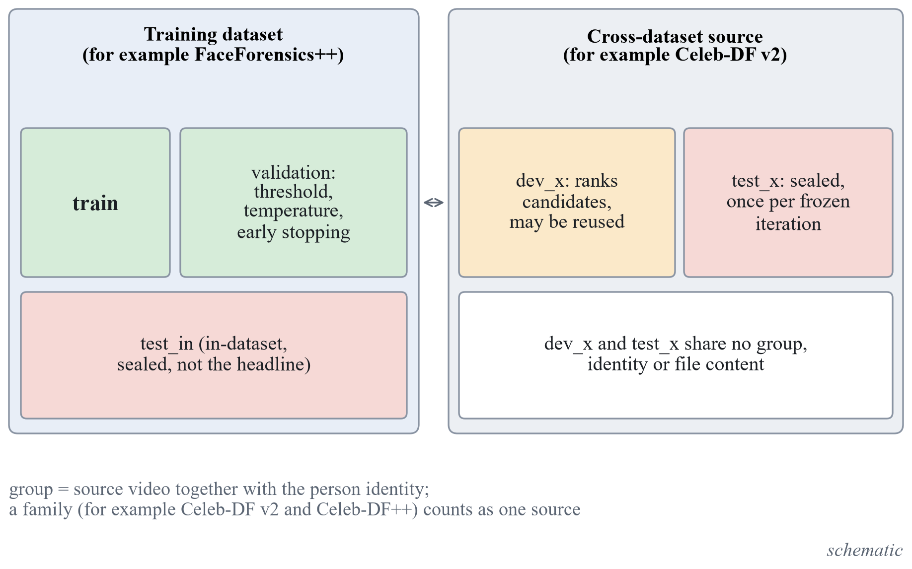
Figure 2. Group-disjoint splits and the access rules. The development slice and the sealed test set of a cross-dataset source share no group, identity or file content. (schematic)
The development slice is chosen by a seeded rule fixed before any extraction: the group names are sorted, a permutation is drawn with a fixed random seed and the first $k$ groups go to the slice, with every sample of a drawn group. Table 7 gives the slices that resulted. The slices are small, which makes intervals wide and ties likely; the cheaper-candidate rule exists for this reason.
Table 7. Development slices and sealed test sets of the cross-dataset sources (real / fake counts where both exist).
Source | Development slice | Sealed test set
Celeb-DF v2 | 15 of 59 identity groups: 1,728 videos (146 real, 1,582 fake) | 4,801 videos (744 real including 300 YouTube videos, 4,057 fake); 44 identity groups plus the YouTube videos
Celeb-DF++ | none; the 15 development identities are excluded | 2,849 fake videos, no real video; 44 identity groups
Family total (Celeb-DF v2 and ++) | 1,728 videos | 744 real and 6,906 fake videos; about 44 independent identity groups
In-the-Wild | 12 of 54 speakers | the other 42 speakers
CNN synthesis subset | 2 of 7 generator units: StarGAN (1,999 real, 1,999 fake) and Which-Face-Is-Real (1,000 real, 1,000 fake) | 48,805 images of the other 5 units after removing 1,200 duplicate real images
DFD | none | 28 actors, 3,431 videos

Celeb-DF++ and the balance of its sealed test set
Celeb-DF++ is built on Celeb-DF, shares its 59 identities and counts as one family with it. Its test list holds 4,900 fakes of the 21 newer generators and 178 real videos; 5,078 videos were extracted. Two exclusions keep any source video or identity of the development slice from being counted twice. First, 2,079 samples were excluded from the sealed test set because their target identity (1,477 samples) or only their celebrity source identity (602 samples) is one of the 15 development identities. Second, 150 real videos of Celeb-DF++ whose content is byte-identical to Celeb-DF v2 videos were dropped, and Celeb-DF v2 keeps them under its own group identifier, so that each source video has one group. The exclusion by celebrity source identity, and not by target identity alone, is required and not optional: in a face swap named by target and source identity the face that is visible is the source identity, so a rule on the target alone would leave faces of the development identities in the sealed test set.
The result is that Celeb-DF++ alone has 2,849 fake videos and no real video in its sealed test set, in 44 identity groups. Its AUC is therefore computed together with the Celeb-DF v2 real videos, which are the same real sources, and the pooled family test set holds 744 real and 6,906 fake videos. Real videos are 9.7 percent of that pool. The consequence for the statistics is that the bootstrap resamples identities, so the fakes of Celeb-DF++ add generator coverage but almost no new independent groups: intervals on a pooled or per-generator AUC are governed by about 44 identity groups, and the estimates per generator, from 200 to 300 clips each, are wide. Balanced accuracy and the threshold carry more noise than the AUC on such an unbalanced set.

Leakage check
A script proves that the splits are disjoint in group, identity and, for the image and the audio-visual sets, file content. With content hashing the check first failed on the image sets: real LSUN images occur byte for byte in the training set, the validation set and several test sets. The rule adopted is that any sample of a test set whose content hash equals the hash of a training or validation sample is excluded from the test set, and the exclusions are listed with the reason. After 1,200 samples of the CNN synthesis subset were excluded, the check passes on 80,803 image files, and it passes on 41,739 files of Celeb-DF, In-the-Wild and DFD together. The Celeb-DF family has one further pass after the exclusions above (9,378 files, no duplicate content in or across splits). The grouping of Celeb-DF fakes takes the first identity in the file name, assumed to be the target, as the resampling unit; the other identity is kept in the notes. The ProGAN validation set is split by LSUN class, 14 classes for training and 6 for validation, because a class is the coarsest source grouping available for images with no identity; the threshold and the temperature are therefore fitted on classes not seen in training.

Shared Preprocessing
One package prepares inputs for training, evaluation and inference, so that the same function runs in all three. The preprocessing parameters form a configuration whose hash is stored in every checkpoint, and inference refuses a checkpoint whose hash differs from the one in use. This turns a silent mismatch between training and use into an error.
Table 8. Preprocessing of each input type.
Input | Steps | Parameters
Video | Decode sequentially; take uniformly spaced frames; detect the faces with YuNet; crop the largest face enlarged by a factor; store as JPEG | 16 frames; factor 1.3; crop 224 by 224; JPEG quality 95; frames without a face left out and counted
Image | Face crop if a face is found, otherwise the whole image processed by the encoder’s own model-card rule | the path taken is reported in the response
Audio | First samples at 16 kHz, repeat-padded if shorter; the Whisper encoder receives its fixed 30 second window with the 4 seconds first and only those frames are pooled | 64,600 samples (about 4 seconds)

When several faces are found the largest is used and the warning that several faces were found is returned. A clip with no face at all returns the warning that no face was detected. Carrying the box of a neighbouring frame or using a centre crop for a frame without a face was rejected, because it invents a face position. Sequential decoding is used because seeking is about four times slower on FaceForensics++.
The face detector was chosen by measurement. YuNet [48], UltraFace and SCRFD were compared on 7,488 sampled FaceForensics++ frames and, separately, on 300 frames from 300 distinct FaceForensics++ validation videos and 300 frames from 300 distinct Celeb-DF development-slice videos (frames only, no labels or scores). All three found a face in every frame and never disagreed on whether a face exists; the largest boxes agree with a mean intersection over union of 0.887 to 0.923, and the eight frames of lowest agreement per set show the same face in every tile. The differences that matter are speed and licence (Table 9).
Table 9. Face detector comparison (measurements; the machine was busy with 13 to 20 percent of the processor before each run, and the 200-video sample is warm in the file cache).
Detector | Licence of the weights | ms per frame (FaceForensics++ / Celeb-DF) | Detections on 500 face-free images
YuNet 2023mar | MIT | 12.1 / 12.4 | 6.0 percent
UltraFace RFB-320 | not verified | 4.8 / 4.8 | 20.2 percent
SCRFD 500M | non-commercial research only | 29.7 / 30.9 | 4.6 percent

YuNet was chosen: it is small, MIT licensed, fast enough and runs on the processor through OpenCV; the other two were used only as benchmarks. The measurement does not include hard cases such as rotated or tiny faces, and the effect of a few percent of box shift on accuracy was not measured.
The throughput of the preparation was measured on 200 FaceForensics++ videos (16 frames, 224 pixels, JPEG 95, YuNet). Decoding takes about 73 percent of the time per video and detection about 24 percent. Decoding 16 frames took 0.74 s per video with OpenCV sequentially and with an ffmpeg pipe, and 2.88 s with seeking. The pipeline reached 1.25, 4.13, 5.91, 6.35 and 6.22 videos per second with 1, 4, 8, 16 and 24 worker processes; the growth stops after 8 workers and the cause was not found. This projects to about 13 minutes for the 5,000 FaceForensics++ videos at 16 workers, with 222,786 bytes of crops per video. ASVspoof FLAC files load in 4.76 ms each, about 582 s single-threaded for all 122,299 files. These timings are caveated by the busy machine and by warm reads; cold-disk reads were not measured.

Evaluation Harness and Its Acceptance Test
The evaluation protocol was fixed, and its harness built and tested, before any model existed. The harness implements the metrics of Chapter 3, the threshold chosen on validation data, temperature scaling, the group bootstrap with the paired and multi-seed forms, the guard for the sealed splits and the ledger. It reads score files only and never imports a model. A score file holds one row per clip with the run, iteration, seed, modality, data set, split, sample identifier, group identifier, label and the probability of fake.
Three rules define how a clip and a threshold are obtained. The clip score is the mean of the frame probabilities. The threshold maximises balanced accuracy on the validation split of the training data set, taking the midpoints between adjacent distinct validation scores and, among equal maxima, the one closest to 0.5; the chosen threshold is then fixed for every test set. Temperature scaling is fitted on the same split. Uncertainty uses 2,000 resamples, a 95 percent percentile interval and a fixed base seed, with the group as the resampling unit.
The guard refuses any evaluation that reads a sealed split unless the run is flagged final and carries an iteration tag. The ledger, a file under version control, records every final evaluation: the date, the iteration, the data set, the split, the run identifiers and the hash of the score file; a second final evaluation of the same iteration and data set is refused unless a reason is given, and the repeat is then listed as a correction. A paired comparison on a sealed split re-analyses logged scores only, needs the same flag, and refuses unless a regular final evaluation of that iteration and data set is already in the ledger, so it never gives a first look at a sealed split.
Table 10 lists the acceptance checks and what was logged for them.
Table 10. Acceptance checks of the evaluation harness and the data tools.
Check | What is tested | Logged result
Metrics | AUC, log loss and Brier score against scikit-learn on at least 20 random score sets; balanced accuracy, EER, precision, recall and ECE against hand-computed values | passed; on 5 further random sets of 2,000 samples with many tied scores the AUC equals scikit-learn’s to 10 decimals and log loss and Brier differ by at most 1.1e-16
Temperature scaling | recovers a known temperature on synthetic logits within 2 percent | passed
Bootstrap coverage | the group bootstrap interval covers the true AUC in at least 90 percent of 200 simulated data sets | 192 of 200 (96 percent)
Paired bootstrap | two identical runs give a difference of exactly zero with the interval [0, 0] | passed
Guard and ledger | refuses a sealed split without the final flag, refuses a second final evaluation without a reason, accepts a first one | passed
Leakage check | exits non-zero on a manufactured overlap and zero on clean splits, including across source families, with content hashing | passed (Section 4.2)
Manifests | documented counts for FaceForensics++ c23, ASVspoof 2019 LA, ProGAN validation and test, Celeb-DF v2 | 121,461 ASVspoof rows; 8,000 images per ProGAN set; 5,000 FaceForensics++ videos; 6,529 Celeb-DF v2 videos in 59 identity groups
Development slice | accepted by the score reader and not treated as final; leakage fails if a group or content is in both the slice and the sealed test | passed
End-to-end random scorer | AUC about 0.5 with an interval containing 0.5 | every interval contained 0.5 and every AUC was within 0.06 of 0.5; in a one-off run on 30 other synthetic files 117 of 120 intervals contained 0.5

A full pass of the command line on 10,000 validation and 50,000 test rows takes 9 s, and 2,000 resamples on 50,000 samples in 5,000 groups take 1.0 to 2.1 s. After the development slices were added, the test suites of the data tools and of the evaluation harness had 67 and 89 tests, all of which pass.

Design of the Encoder Comparison
The first iteration is a measured comparison of pretrained encoders under one protocol. The form of the working version is fixed: a frozen pretrained encoder and a linear head. Which encoder is the open question, and it is asked separately for three tasks: face video frames (the visual branch of a video), generated images and speech audio. Table 11 gives the data of each task.
Table 11. The three tasks of the comparison.
Task | Train | Validation | Development slice (ranking) | Input to the encoder
Face video frames | FaceForensics++ c23, official training split | FaceForensics++ official validation split | Celeb-DF v2, 15 identity groups | 16 face crops of 224 by 224 per video
Generated images | ProGAN validation set, 14 classes | the other 6 classes | 2 of 7 CNN-synthesis generator units | whole image, processed by the encoder’s own rule
Speech audio | ASVspoof 2019 LA train | ASVspoof 2019 LA dev | In-the-Wild, 12 speakers | first 4 seconds at 16 kHz

The shortlist was chosen by criteria stated first: the licence is verified from the weights’ own repository, the weights download and load offline, full inference fits in 12 GB, the feature tensor is stated exactly, and the families differ. DINOv3 was excluded on purpose, because its access gate is manual and its licence carries a duty to acknowledge it in publications. Figure 3 and Table 12 give the shortlist.
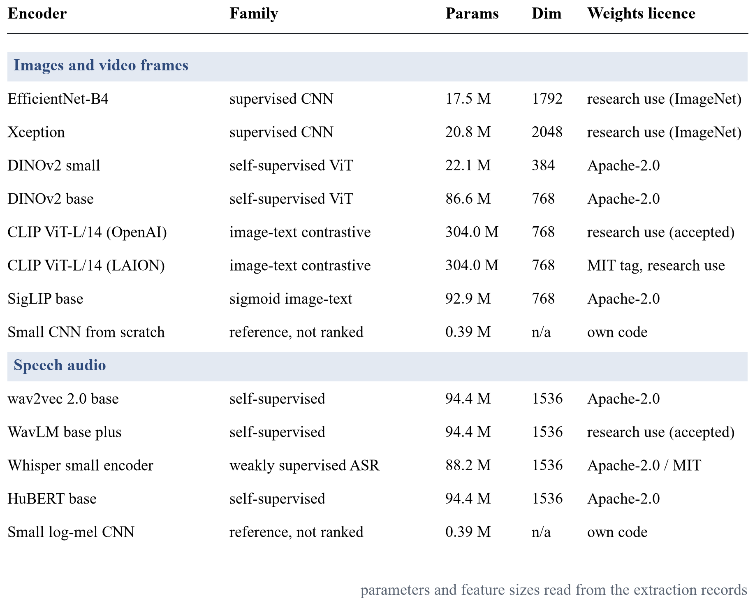
Figure 3. Shortlist of the encoder comparison, with parameters and feature sizes read from the extraction records.
Table 12. Weights of the shortlisted encoders and their licence labels.
Candidate | Checkpoint | Source | Label
EfficientNet-B4 [43] | timm efficientnet_b4.ra2_in1k | Hugging Face | Apache-2.0 tag; ImageNet-trained, research use
Xception [44] | timm legacy_xception (original architecture) | GitHub release of timm | Apache-2.0 declared by timm; upstream licence not retrieved; research use
DINOv2 small, base [45] | facebook/dinov2-small, facebook/dinov2-base | Hugging Face | Apache-2.0
CLIP ViT-L/14, OpenAI [46] | openai/clip-vit-large-patch14 | Hugging Face | no weights licence stated; card says research use; accepted as research-only
CLIP ViT-L/14, LAION | laion/CLIP-ViT-L-14-laion2B-s32B-b82K | Hugging Face | MIT tag; card says research use
SigLIP base [47] | google/siglip-base-patch16-224 | Hugging Face | Apache-2.0
wav2vec 2.0 base [24] | facebook/wav2vec2-base | Hugging Face | Apache-2.0
WavLM base plus [25] | microsoft/wavlm-base-plus | Hugging Face | no tag; upstream licence CC BY-SA 3.0; accepted as research-only
Whisper small encoder [27] | openai/whisper-small | Hugging Face | Apache-2.0 tag; MIT upstream
HuBERT base [26] | facebook/hubert-base-ls960 | Hugging Face | Apache-2.0
Small networks from scratch | own code | none | reference only, excluded from the selection

The licence of two weights is conditional. The OpenAI CLIP repository states no licence and its card says use is for research; the WavLM card has no licence tag and points to an upstream licence that is CC BY-SA 3.0. Both are accepted as research-only, and this is a limitation: results obtained with these weights make no claim of commercial usability. The ImageNet-trained weights are treated as research use as well, because the data set terms say so. The SHA-256 of every weight file was recorded before use, and the script that fetches the weights recomputes it locally and compares it.
Features are extracted once per candidate and task. The encoder runs in evaluation mode with mixed precision and the preprocessing of its own model card. The stored feature is the pooled embedding before any classifier: the global average of the final map for the convolutional networks, the class token for DINOv2, the projected image embedding for the CLIP encoders, the attention-pooled output for SigLIP, and the mean and standard deviation over time of the last hidden layer for the speech encoders. Features are stored as 16-bit floats with an index to the sample identifiers, and the same crops and split files serve every candidate.
The head is a single linear layer on features standardised with the training mean and standard deviation, trained with class-weighted binary cross-entropy, AdamW with a learning rate of ${10}^{-3}$ and a weight decay of ${10}^{-4}$, batches of 1,024 features, at most 200 epochs and early stopping on the validation AUC with a patience of 10. Three seeds, 0, 1 and 2, change the initialisation and the batch order. Nothing else is tuned in this iteration.
The ranking metric is the clip-level AUC on the development slice, averaged over the seeds, with the 2,000-resample paired group bootstrap. The leader is the candidate with the highest mean; the tie set is every candidate whose paired interval against the leader includes zero (Equation (23)); the cheapest member of the tie set wins. The from-scratch reference is trained on the same split for a fixed budget of 10 epochs with AdamW at ${10}^{-3}$ and no augmentation, is reported in the same table and is excluded from the selection. If the lower bound of the best candidate on the development slice is 0.55 or below, the sweep is declared inconclusive for that task. The exact sign-flip permutation test over groups is a sensitivity column beside the bootstrap, not a second rule. A cost record is kept for every candidate: parameters, floating-point operations of one forward pass, peak memory, and time per 1,000 inputs both for the model alone and end to end including decoding.
The hypotheses, success criteria and failure criteria were written before any feature extraction and are not edited afterwards. For face video frames, the hypothesis is that at least one self-supervised or vision-language encoder (the DINOv2 or CLIP families) reaches a higher development-slice AUC than the best supervised ImageNet network (EfficientNet or Xception); it is supported if the paired interval of that difference lies above zero and the lower bound of the best candidate is above 0.60, and it fails if the interval includes zero or if the lower bound is 0.55 or below. For generated images the hypothesis is that a CLIP-style frozen encoder beats every supervised network, with a lower bound above 0.65 as the success line. For speech the hypothesis is that wav2vec 2.0 or WavLM beats both the Whisper encoder and the from-scratch reference, with a lower bound above 0.60 as the success line. These are hypotheses and they have a direction that is uncertain by design: the literature also shows that face-forgery detectors learn identity cues [7] and that frozen features have been tested for generated images [11] and not for face forgery.
The comparison was run on 25 October 2026 and is final. All numbers in this section are exploratory, on the development slice: each is the mean of three head seeds, with the 95 percent group bootstrap interval of 2,000 resamples, and a verdict on this slice reports sign, size and interval and is never presented as confirmed performance. The verdicts are mechanical evaluations of criteria written before the run.

Face video frames
The slice has 1,728 clips (146 real, 1,582 fake) of 15 identity groups. Table 13 gives the ranking. The leader is the OpenAI CLIP ViT-L/14. The tie set, the candidates whose paired interval against the leader includes zero, holds five candidates: the two DINOv2 sizes, SigLIP base and the two CLIP models. The cheapest of them by end-to-end extraction time, 0.943 s per 1,000 inputs with 22.1 million parameters, is DINOv2 small, so the cost rule chooses it for the working version. The two supervised networks are outside the tie set by the bootstrap. The small network trained from scratch reaches 0.5166 [0.5033, 0.5324], which is close to chance, and is excluded from the selection.
Table 13. Encoders on face video frames (exploratory, development slice).
Candidate | AUC on the development slice [95 percent interval] | Validation AUC | Difference to the leader [95 percent interval] | Permutation p | In tie set
CLIP ViT-L/14, OpenAI | 0.7464 [0.6721, 0.8306] | 0.9046 | leader | n/a | yes
SigLIP base | 0.7396 [0.7031, 0.7832] | 0.8767 | −0.007 [−0.113, +0.091] | 0.930 | yes
CLIP ViT-L/14, LAION | 0.7331 [0.6764, 0.7966] | 0.8635 | −0.013 [−0.104, +0.082] | 0.795 | yes
DINOv2 small | 0.6933 [0.6639, 0.7314] | 0.7985 | −0.053 [−0.126, +0.010] | 0.220 | yes
DINOv2 base | 0.6745 [0.6323, 0.7239] | 0.8170 | −0.072 [−0.171, +0.017] | 0.202 | yes
EfficientNet-B4 | 0.6471 [0.5967, 0.6987] | 0.7478 | −0.099 [−0.172, −0.023] | 0.110 | no
Xception | 0.6162 [0.5744, 0.6633] | 0.7184 | −0.130 [−0.191, −0.071] | 0.007 | no
Small network from scratch (reference, excluded) | 0.5166 [0.5033, 0.5324] | not applicable | not applicable | n/a | excluded

The pre-declared criteria are both met. The highest candidate minus the highest supervised network is +0.0994 [+0.0228, +0.1723], an interval above zero, and the lower bound of the highest candidate, 0.6721, is above 0.60; the hypothesis is therefore supported on this slice. Two caveats stand with it. First, EfficientNet-B4 is outside the tie set by the bootstrap (difference −0.099 [−0.172, −0.023]) but its permutation p-value is 0.110, so it is borderline; the winner would not change if it were in the tie set, because DINOv2 small is cheaper end to end (0.943 against 1.732 s per 1,000 inputs). Second, every candidate loses between 0.10 and 0.16 AUC from the validation split to the development slice (for DINOv2 small 0.7985 against 0.6933), which is the generalisation gap that the hypothesis predicted. The three candidates that enter the fine-tuning iteration are DINOv2 small, SigLIP base and DINOv2 base; the two CLIP models do not fit the card.

Generated images
The slice has 5,998 images, 2,999 real and 2,999 fake, from two generator units. Table 14 gives the ranking. The OpenAI CLIP ViT-L/14 leads and its tie set contains only itself, so the cost rule is not needed. The two leading CLIP models reach 1.0000 on the validation split, which therefore cannot separate them, and on the development slice the leader (0.9935) is separated from every other candidate by the paired bootstrap, on only two generator units. The interval of its AUC, [0.9803, 0.9982], and all other intervals of this task must be read with a caveat: the slice has only two groups, so the bootstrap interval is not interpretable as a population interval, and the permutation test cannot reach 0.05 with fewer than six groups. The family comparison (+0.3247 [+0.2845, +0.3565]) and the lower bound above 0.65 meet the criteria, and the verdict is supported on this slice. The per-generator values are in the diagnostic discussion below.
Table 14. Encoders on generated images (exploratory, development slice, two groups).
Candidate | AUC on the development slice [95 percent interval] | Validation AUC | Difference to the leader [95 percent interval] | Permutation p | In tie set
CLIP ViT-L/14, OpenAI | 0.9935 [0.9803, 0.9982] | 1.0000 | leader | n/a | yes
CLIP ViT-L/14, LAION | 0.9563 [0.7760, 0.9975] | 1.0000 | −0.037 [−0.204, −0.001] | n/a | no
DINOv2 base | 0.9023 [0.8496, 0.9316] | 0.9899 | −0.091 [−0.131, −0.067] | n/a | no
SigLIP base | 0.8657 [0.7591, 0.9166] | 0.9975 | −0.128 [−0.221, −0.082] | n/a | no
DINOv2 small | 0.8340 [0.7401, 0.8823] | 0.9685 | −0.159 [−0.240, −0.116] | n/a | no
EfficientNet-B4 | 0.6688 [0.6238, 0.7137] | 0.8990 | −0.325 [−0.357, −0.285] | n/a | no
Xception | 0.6380 [0.4912, 0.7115] | 0.8140 | −0.355 [−0.489, −0.287] | n/a | no
Small network from scratch (reference, excluded) | 0.5500 [0.5080, 0.5735] | not applicable | −0.4435 [−0.4723, −0.4247] | n/a | excluded

Speech audio
The slice has 6,991 clips (3,804 real, 3,187 fake) of 12 speakers. Table 15 gives the ranking. The Whisper encoder leads, and three candidates are tied: Whisper, WavLM and HuBERT. HuBERT is the cheapest by end-to-end time and is chosen. All four encoders reach a validation AUC of 0.99 to 1.00 on the training corpus and fall to 0.50 to 0.64 on the development slice, a gap of 0.36 to 0.50. The verdict is inconclusive: the highest lower bound, 0.5338, is at or below the 0.55 line fixed before the run, so frozen speech features did not transfer reliably to In-the-Wild. The hypothesis that WavLM or wav2vec 2.0 beats Whisper is not met (WavLM minus Whisper −0.0046 [−0.0437, +0.0399]); the difference to the reference network is above zero, but that network is itself below 0.5.
Table 15. Encoders on speech audio (exploratory, development slice, 12 speakers; verdict inconclusive).
Candidate | AUC on the development slice [95 percent interval] | Validation AUC | Difference to the leader [95 percent interval] | Permutation p | In tie set
Whisper small encoder | 0.6380 [0.5338, 0.7700] | 0.9995 | leader | n/a | yes
WavLM base plus | 0.6334 [0.5291, 0.7714] | 0.9924 | −0.005 [−0.044, +0.040] | 0.894 | yes
HuBERT base | 0.6100 [0.5434, 0.7256] | 0.9942 | −0.028 [−0.107, +0.039] | 0.599 | yes
wav2vec 2.0 base | 0.4975 [0.3451, 0.7092] | 0.9965 | −0.140 [−0.238, −0.050] | 0.170 | no
Small log-mel network from scratch (reference, excluded) | 0.2458 [0.0706, 0.4404] | not applicable | −0.3922 [−0.6527, −0.1434] | n/a | excluded

Two further observations qualify the audio result. The score is not a calibrated probability on this slice: the expected calibration error rose after temperature scaling for every audio encoder (for HuBERT from 0.3293 to 0.4052), whereas it improved for the OpenAI CLIP on generated images (from 0.0462 to 0.0050). And the reference network is inverted: 0.2458 [0.0706, 0.4404] is below 0.5. Table 16 gives the other calibration measures of all candidates.
Table 16. Equal error rate and calibration on the development slice before and after temperature scaling (exploratory).
Task | Candidate | EER | ECE before / after | Brier score before / after
Face video | CLIP ViT-L/14, OpenAI | 0.3173 | 0.2845 / 0.2874 | 0.3458 / 0.3476
Face video | SigLIP base | 0.3356 | 0.0312 / 0.0430 | 0.2116 / 0.2122
Face video | CLIP ViT-L/14, LAION | 0.3270 | 0.1768 / 0.1958 | 0.2803 / 0.2883
Face video | DINOv2 small | 0.3582 | 0.2048 / 0.2217 | 0.2963 / 0.3050
Face video | DINOv2 base | 0.3788 | 0.1118 / 0.1401 | 0.2704 / 0.2815
Face video | EfficientNet-B4 | 0.4062 | 0.0636 / 0.0710 | 0.2199 / 0.2189
Face video | Xception | 0.4137 | 0.0492 / 0.0696 | 0.2396 / 0.2428
Generated images | CLIP ViT-L/14, OpenAI | 0.0401 | 0.0462 / 0.0050 | 0.0334 / 0.0299
Generated images | CLIP ViT-L/14, LAION | 0.1196 | 0.0222 / 0.0998 | 0.1074 / 0.1242
Generated images | DINOv2 base | 0.1803 | 0.1914 / 0.1534 | 0.2272 / 0.2103
Generated images | SigLIP base | 0.2147 | 0.2084 / 0.2345 | 0.2463 / 0.2620
Generated images | DINOv2 small | 0.2446 | 0.2074 / 0.1771 | 0.2592 / 0.2450
Generated images | EfficientNet-B4 | 0.3716 | 0.2880 / 0.2463 | 0.3284 / 0.3043
Generated images | Xception | 0.4069 | 0.2868 / 0.1728 | 0.3362 / 0.2785
Speech audio | Whisper small encoder | 0.4006 | 0.1819 / 0.2875 | 0.2796 / 0.3292
Speech audio | WavLM base plus | 0.3930 | 0.3700 / 0.4420 | 0.3893 / 0.4494
Speech audio | HuBERT base | 0.4183 | 0.3293 / 0.4052 | 0.3699 / 0.4247
Speech audio | wav2vec 2.0 base | 0.5020 | 0.3482 / 0.4165 | 0.3993 / 0.4418

Checks of the audio result and of the image result
Because an AUC below 0.5 can come from a labelling error, the mapping of labels was checked first, with the training and development data and the development slice only. The features of the development slice agree with the metadata of In-the-Wild on every label and speaker (6,991 items, no mismatch), and the features of the ASVspoof 2019 training and development sets agree with the protocol files (25,380 and 24,844 items, no mismatch). The network from scratch reaches an AUC of 0.99996 to 0.99997 in the training domain and 0.219 to 0.286 on the development slice for its three seeds. There is therefore no label inversion: values below 0.5 indicate a sign-flipped recording-condition shortcut learned from the training corpus, which is a property of the shift between the corpora and not a worse model.
A second check measured simple recording features as the fake score (Table 17). The sign of two of them reverses between the training corpus and In-the-Wild: the leading silence has an AUC of 0.375 on ASVspoof development and 0.719 on the slice, and the energy has 0.594 and 0.248. The energy value on the slice is of the same size as the network from scratch. With 12 speakers the intervals of these two include 0.5, so the sign supports the hypothesis that recording-condition cues of ASVspoof reverse in In-the-Wild, and the size does not establish it. Only the clip duration (0.622 [0.532, 0.670]) and the repeat-padded fraction (0.394 [0.348, 0.481]) exclude 0.5.
Table 17. AUC of single recording features used as the fake score (exploratory; a value below 0.5 means that fake clips have the smaller value).
Feature | ASVspoof training, 20 speakers | ASVspoof development, 20 speakers | In-the-Wild slice, 12 speakers
Leading silence | 0.416 [0.350, 0.488] | 0.375 [0.299, 0.453] | 0.719 [0.425, 0.933]
Clip duration | 0.479 [0.428, 0.531] | 0.467 [0.393, 0.540] | 0.622 [0.532, 0.670]
Energy (RMS) | 0.572 [0.525, 0.618] | 0.594 [0.537, 0.649] | 0.248 [0.073, 0.546]
Repeat-padded fraction | 0.530 [0.478, 0.581] | 0.543 [0.471, 0.614] | 0.394 [0.348, 0.481]

For the image task, the pooled AUC hides a difference between the two generator units of the slice. The OpenAI CLIP separates StarGAN almost perfectly (0.9988 [0.9983, 0.9992]) and reaches 0.9830 [0.9788, 0.9870] on the Which-Face-Is-Real unit; the LAION CLIP reaches 0.9978 and 0.7790 [0.7591, 0.8000]. The intervals of these per-unit values resample images inside one unit and are not population intervals. The file extension does not separate the classes in any split of this task.

The Working Version (Iteration 0)
The working version is not an improvement; it is the baseline that everything else is compared with. It counts as working when all of the following hold: a file goes in through the local web page; the encoder of each task is the winner of the comparison under the cheapest rule, frozen, with a linear head trained on the training split; the score is calibrated by temperature scaling fitted on validation and the checkpoint metadata is checked at load; metrics with three seeds, standard deviation and bootstrap interval exist on the validation split and on the development slice without any sealed split touched; the page shows a real result with its source marked real and the warnings for no face and several faces; the visual and the audio score of a video are shown separately; and the tests pass. Figure 4 shows the chain from a file to a calibrated score.
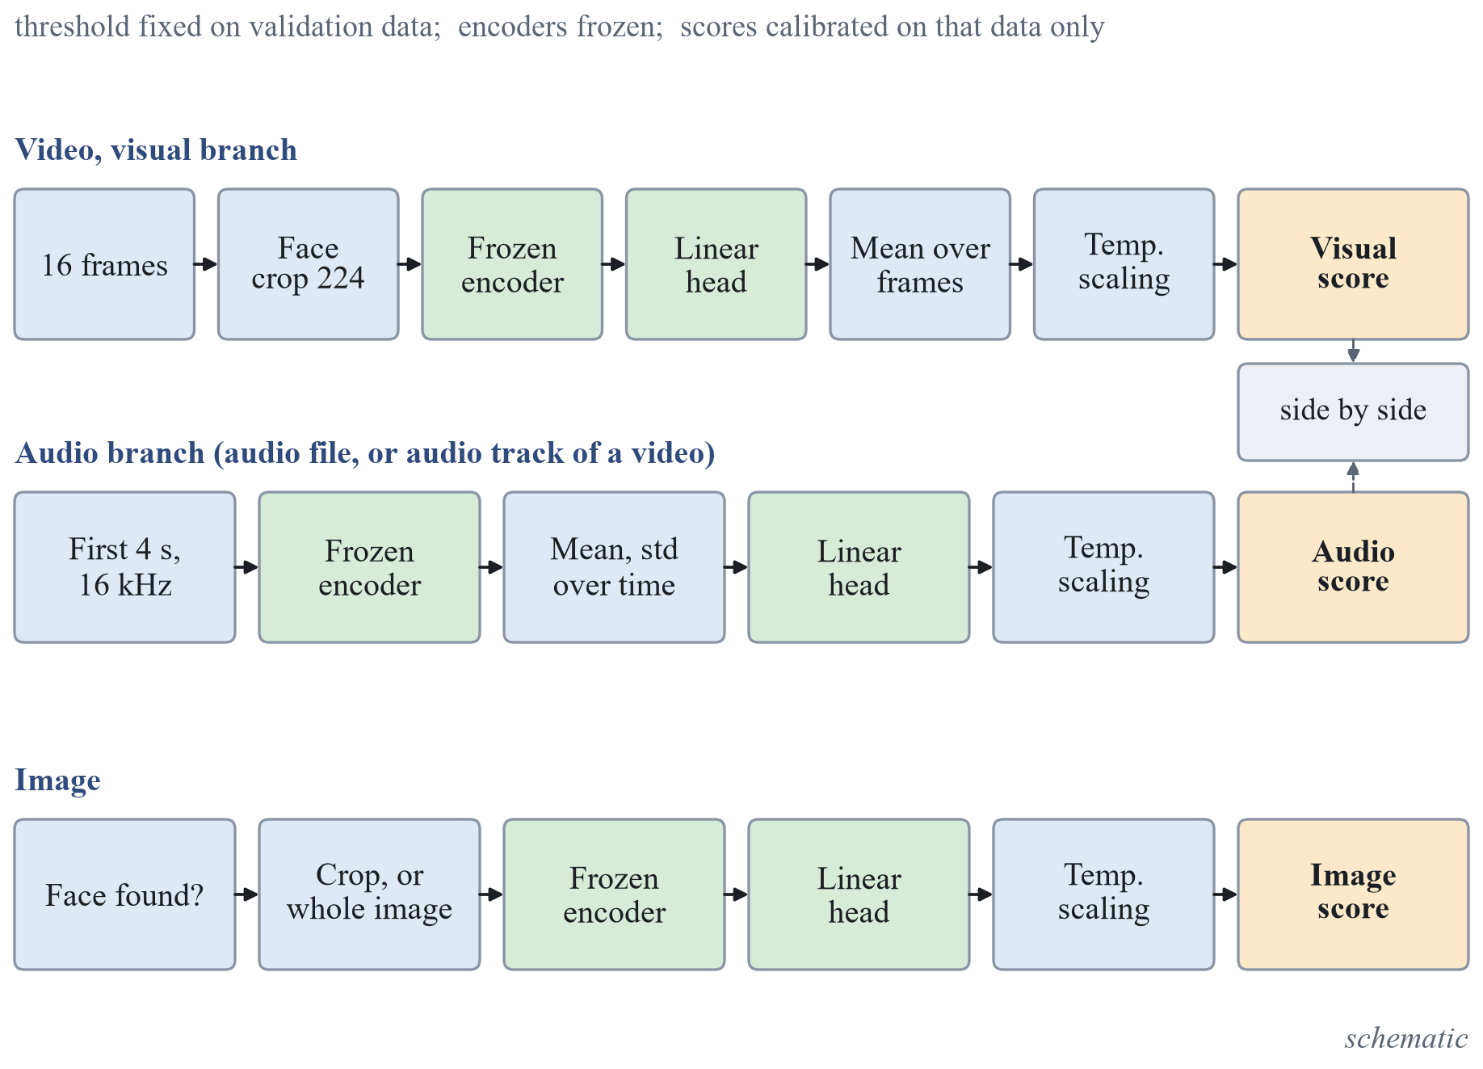
Figure 4. From a file to a calibrated score. The encoders are frozen, the temperature and the threshold are fixed on validation data, and the scores are calibrated on that data only. (schematic)
A checkpoint is a folder with one metadata file and one head file per task; no pickled object is used, because a pickle executes code when it is loaded. The metadata holds the checkpoint identifier, the iteration, the commit, the protocol, the seed, the library versions, the manifest and split identifiers and, per task, the encoder (name, revision, feature size, input size), the hash of the head file, the preprocessing hash and configuration, the calibration method with its temperature and the split it was fitted on, and the threshold with how it was chosen. The head file holds the mean and standard deviation of the standardisation and the weight vector and bias of the head. The loader refuses a folder without metadata, a folder with missing fields, a head file whose hash differs, a head whose width differs from the encoder’s and a preprocessing hash different from the one in use. The real adapter also checks that the encoder weights on disk are the hash-verified ones of the recorded revision, and a checkpoint without an audio head reports the audio modality as unavailable with the reason; no score is ever invented.
Scoring follows training exactly: 16 frames, the same detector, the same enlargement, a JPEG quality-95 round trip, the mean of the frame probabilities and temperature scaling. An image with a face goes through the video head and an image without a face through the generated-image head, with the path reported. Audio is scored from the first 64,600 samples at 16 kHz with the speech encoder’s own feature extractor, the mean and standard deviation over time, the audio head and temperature scaling. The code path was tested with a test double for the encoder and the detector and a made-up head; the acceptance run of the working version must score a training-split clip both ways to expose any mismatch between training-time and inference-time preprocessing.
After every iteration, including this one, the same diagnostic battery is run and its output fixes the order of what follows. It consists of: the AUC per data set and per generator or method with intervals; the gap between training and validation AUC, which separates bias (both low) from variance (a large gap); the gap between validation and the development slice, which indicates a distribution shift; the calibration curve with 15 bins, the ECE and the Brier score before and after temperature scaling; the score histograms of real and fake examples; the results split by compression level, face size and number of faces; the 20 worst errors, 10 false alarms and 10 misses, reviewed by eye and classified in writing; and the standard deviation over the three seeds next to the bootstrap half-width, which separates training noise from sampling noise. The diagnosis vocabulary is bias, variance, shift, calibration, aggregation and missing signal.

Results of the working version
The heads of the three winners were trained with three seeds and the checkpoint was built on 25 October 2026 from the head of seed 0, a choice fixed before the run so that no number of the development slice enters it. Temperature and threshold were fitted on the validation split of each task; the threshold is stored in the calibrated probability space. The temperatures are 0.907 (face video), 0.636 (generated images) and 0.486 (audio), and the thresholds 0.4774, 0.2073 and 0.1451. Table 18 gives the AUC and the equal error rate, and Table 19 the calibration; all development-slice values are exploratory and reproduce the comparison above.
Table 18. Working version: AUC with 95 percent group bootstrap interval, mean of three seeds (development slice values exploratory).
Task | Encoder | Training AUC | Validation AUC | Development slice AUC | Slice EER
Face video | DINOv2 small | 0.8367 [0.8267, 0.8475] | 0.7985 [0.7731, 0.8269] | 0.6933 [0.6639, 0.7314] | 0.3582
Generated images | CLIP ViT-L/14, OpenAI | 1.0000 [1.0000, 1.0000] | 1.0000 [1.0000, 1.0000] | 0.9935 [0.9803, 0.9982] | 0.0401
Speech audio | HuBERT base | 0.9997 [0.9996, 0.9999] | 0.9942 [0.9910, 0.9967] | 0.6100 [0.5434, 0.7256] | 0.4183

Table 19. Working version: expected calibration error before and after temperature scaling, Brier score and balanced accuracy at the validation threshold.
Task | ECE, validation | ECE, slice | Brier, slice | Balanced accuracy, validation / slice
Face video | 0.0325 / 0.0321 | 0.2048 / 0.2217 | 0.2963 / 0.3050 | 0.750 / 0.617
Generated images | 0.0050 / 0.0012 | 0.0462 / 0.0050 | 0.0334 / 0.0299 | 0.998 / 0.955
Speech audio | 0.0883 / 0.0078 | 0.3293 / 0.4052 | 0.3699 / 0.4247 | 0.971 / 0.529

The standard deviation over the three seeds on the development slice is 0.0107, 0.0006 and 0.0026 against bootstrap half-widths of 0.0338, 0.0089 and 0.0911, so it is the sampling of identities and speakers, not training noise, that limits the intervals. The interval of the image task rests on two units and that of the audio task on 12 speakers.
The checkpoint was tested in two ways. In a parity check, seven training items (one fake and one real video, two ProGAN images, three ASVspoof utterances) were scored from the stored features and by the real adapter from the raw file; the largest absolute difference of the calibrated score was 0.0019 (0.0002 for video, 0.0019 for images and 0.0005 for audio) against a tolerance of 0.02, so the two dependences named in advance, the JPEG round trip and the colour order, agree. In the page check, the local web page was started with the real adapter and the checkpoint, and in a real browser one image, one video with audio and one audio file, all training items, gave results with the source marked real, no stand-in banner and no page error; the video shows its visual and audio score separately with the verdict undetermined, and the upload folder was empty afterwards. These items are training data, so the check shows that the path works and says nothing about accuracy. The claim of the working version is limited to this: the path works, and metrics with intervals exist.

Diagnostic battery of the working version
The battery was run once, with the following observations (exploratory). Per method, the validation AUC of the face task is 0.884 for Deepfakes, 0.834 for Face2Face, 0.778 for FaceSwap and 0.697 for NeuralTextures, and the slice has one kind of fake, 0.693. For generated images all six validation classes score 1.000, and the slice units score 0.999 and 0.983. For speech the validation attacks score 0.984 to 0.997, and the slice per speaker has a minimum of 0.503, a median of 0.692 and a maximum of 0.990, with the pooled value 0.610 below the median.
The training minus validation AUC is +0.038 for face video, 0.000 for images and +0.006 for audio, and validation minus slice is +0.105, +0.007 and +0.384. Temperature scaling fitted on validation did not improve the calibration on the slice for face video or audio and did for images, and all three temperatures are below one, so the validation scores are sharpened and the slice scores are then over-confident. For face video the calibrated scores of real and fake clips overlap strongly (at the 50th percentile 0.304 for real and 0.434 for fake); for audio real In-the-Wild speech scores as fake (0.971 against 0.994 at the 50th percentile). Clips with two or more faces score 0.762 on the slice against 0.692 for one face, and the face-height tertiles score 0.689, 0.696 and 0.697, so face size and number show no effect that needs a lever; compression could not be split, because FaceForensics++ c23 is one level and the compression of Celeb-DF is not recorded. Aggregation does not help: on the slice the frame level scores 0.656, the clip mean 0.685, the median 0.688, the mean of the three highest 0.663 and the maximum 0.662.
The 20 worst errors on the slice were reviewed by eye from local contact sheets (face video and images) and from the audio features. The false alarms of the face task are sharp, well lit and near-frontal real faces with smooth skin, and six of ten misses come from one identity group; for images the false alarms are real StarGAN crops, several with stretched border pixels, and nine of ten misses are photorealistic StyleGAN faces; for audio both kinds of error are short clips (median 1.9 and 1.2 s) with a repeat-padded fraction of 0.52 and 0.70 and saturated scores. The contact sheets are not shown, because the licences of the data sets forbid publishing derived data.

Candidate diagnoses
The diagnoses below use the vocabulary of the battery and are candidates for the choice of the next lever; no lever is chosen here. For face video the first candidate is bias, since the training AUC is only 0.837 and the frozen feature separates even the training data moderately, followed by shift (0.105 from validation to slice) and calibration under shift; aggregation is not indicated. For generated images no bias or variance is visible and calibration is good, but a slice of two units cannot measure the shift to other generators. For audio the shift is dominant (0.384 at an in-domain AUC of 0.994), the checks above point to recording-condition cues that reverse in In-the-Wild, calibration worsens under shift, and the errors concentrate in short repeat-padded clips, so a window or padding effect is a candidate as a missing signal or a shortcut.

The Iteration Ladder
After the working version the project has seven experimental iterations, I-1 to I-7, and a last step, I-8, that integrates and freezes. I-1 to I-6 take their lever from one of six families, and the lever of each slot is chosen after the diagnostic battery of the preceding iteration, not in advance; the primary candidate in Table 20 is a starting guess for planning that is replaced without penalty when the battery points elsewhere. I-7 is the pulse experiment and I-8 runs no experiments. Figure 5 shows the ladder. The levers that were actually used and their results are given in the section on the results of the iterations. After the first pass over the ladder, two further iterations on the face-video task were added at the request of the project team, 1b (augmentation matched to the test perturbations, with mixup) and 1c (combining encoders), so the video task has the iterations 1, 1b and 1c.
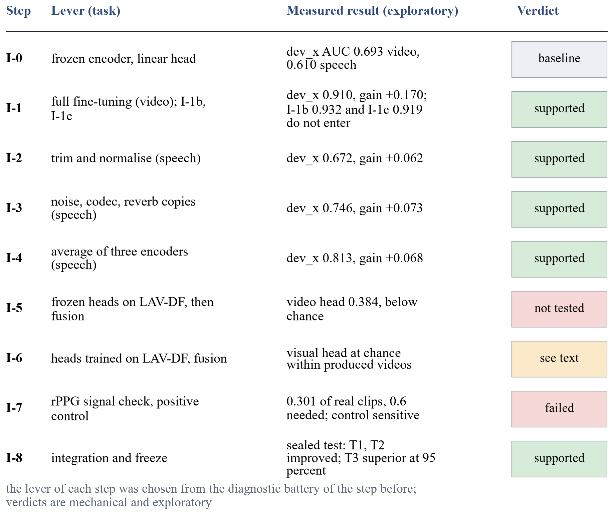
Figure 5. Iteration ladder. Each step from I-1 to I-6 starts from the diagnostic battery of the preceding step. (schematic)
Every slot is written in one template: observation (numbers from the battery), diagnosis, mathematical hypothesis, change, prediction with sign and rough size, result and verdict. The prediction lines are hypotheses, and each is judged against its failure line after the run. Verdicts on the development slice are exploratory.
Table 20. Candidate lever, trigger, prediction and failure line of iterations I-1 to I-6 as planned before the runs. The predictions are hypotheses written before any run; the measured ladder is in the section on results.
Slot | Lever | Triggered when | Prediction | Failure line
I-1 | Fine-tuning depth: linear probe to the last blocks, low-rank adapters or full fine-tuning | Bias: training and validation AUC both low or close (gap under 0.02, AUC under about 0.90) | Validation AUC up by about 0.02 to 0.05; development slice between slightly negative and +0.03 | Paired development interval includes zero or is below zero while validation AUC rises; or memory or time is outside the 12 GB budget
I-2 | Frame aggregation: mean to top-k mean, maximum or learned attention pooling | Frame-level AUC clearly above video-level AUC, a wide spread of frame scores, or many frames without a face | Video AUC change from 0 to +0.02 when few frames are informative; negative when frame noise dominates | Paired interval includes zero, or the real-video score histogram moves right (more false alarms)
I-3 | Loss and class weighting: class-weighted, focal, label smoothing or pairwise surrogate | Imbalance or saturation: balanced accuracy far below what the AUC implies, scores piled at 0 or 1, or ECE high after scaling | AUC change within about 0.01; balanced accuracy and ECE change more | AUC interval includes zero and the other two improve by less than their intervals
I-4 | Augmentation matched to the test perturbations; mixup; weight decay and dropout | Shift: validation AUC high, development slice or compression splits much lower (gap above about 0.10) | Development AUC up by about 0.01 to 0.04 for a compression or resolution shift; in-dataset flat or down by up to 0.01 | Development interval includes zero, or gains appear only on the perturbation types used in training
I-5 | Combining encoders: concatenate features or average scores | Ties in the comparison and complementary errors (low error correlation) | AUC +0.01 to +0.03 if the mean correlation is below 0.8; none as it tends to 1 | Interval includes zero: the cost in time, memory and licences is not justified
I-6 | Late fusion of audio and visual scores with per-modality calibration | Both unimodal heads above chance on LAV-DF and calibrated, with errors not strongly correlated | Fused AUC at or above the better single modality; gain of 0 to +0.05; learned weights below 1 if dependent | Fused lower bound below the better single modality, or the gain is within the interval

Two further elements complete the ladder. For I-6, the unimodal heads are the ones frozen in the earlier iterations, the visual head trained on FaceForensics++ and the audio head on ASVspoof 2019, each with its own temperature; only the fusion layer is fitted, on the LAV-DF training split, with the choice made on its validation split and per-modality temperatures also refitted on LAV-DF and reported both ways. A video is labelled fake for the fused question if either modality is fake, and the label of each modality from the metadata is reported as well, one AUC per modality label.

Fine-tuning budget of iteration I-1
The budget was derived from the measured time per step and not from a plan. Fine-tuning is done for the video task first. The top three encoders of the comparison that fit are fine-tuned at three learning rates, ${10}^{-5}$, $3×{10}^{-5}$ and ${10}^{-4}$, with one seed, and the best rate of the best encoder is then repeated with two further seeds. Every run has the same budget of 1,800 optimiser steps, which is one pass over the 57,600 training frames, an effective batch of 32, AdamW with a cosine schedule and 5 percent warm-up, weight decay 0.05, mixed precision and no augmentation. A run has a cap of 10 minutes of training and 15 minutes of wall time including evaluation. An encoder enters only if its peak memory at batch 32 is at most 10 GiB and one budget takes at most 10 minutes. By the step-time measurement this admits DINOv2 small and base, Xception and EfficientNet-B4; the two CLIP ViT-L/14 models do not fit, because their peak memory at batch 32 exceeds the 12 GB card and spills into shared system memory, which makes a step take seconds, and they stay frozen (a low-rank adapter variant is a later option). The claim “easiest to fine-tune” is made for the video task and for the encoders that fit only, and the step times are re-checked against a clean re-run before the first run. The generated-image and the speech tasks keep their frozen heads in I-1.

The pulse experiment (iteration I-7)
The pulse is a candidate improvement and not an adopted component. Its success and failure thresholds were written before any run and are not edited after the first run. A signal check, S-1, starts early on the processor, in parallel with I-1 to I-3. It extracts about 10 seconds of contiguous frames at the native frame rate, because the 16-frame sampling cannot carry a pulse, and computes the spectral peak in 0.7 to 3 Hz and its signal-to-noise ratio (Equation (42)) on real clips. The negative control is the same clips with time-shuffled frames, pooled across clips with at least ten shuffles per clip, and the 95th percentile of the pooled shuffled values is the reference. Figure 6 shows the chain.
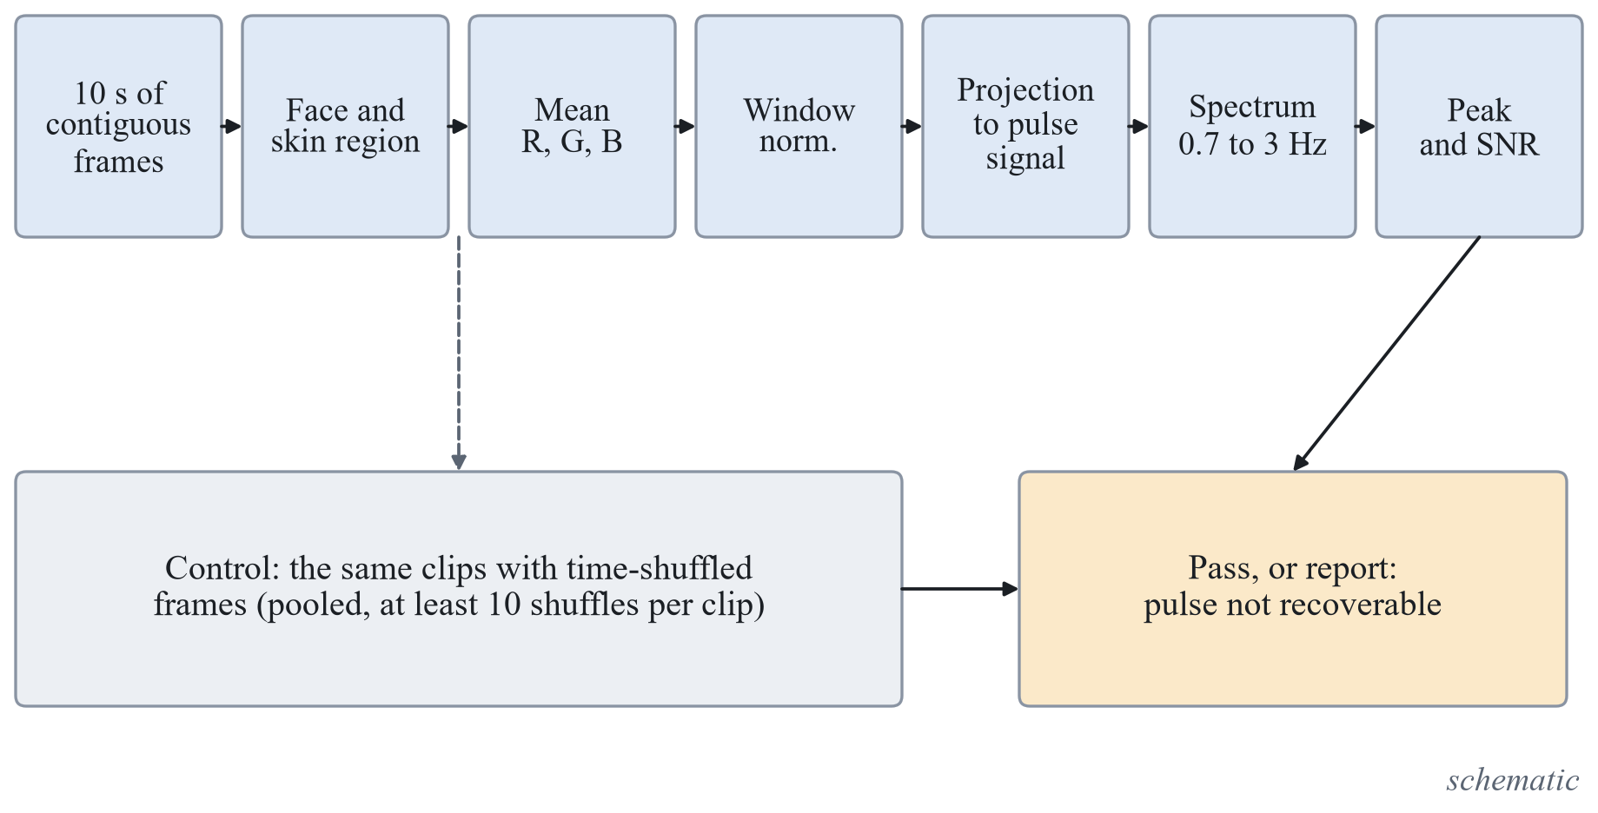
Figure 6. Processing chain of the pulse signal check and its negative control. (schematic)
S-1 passes when at least 60 percent of the real clips have a peak SNR above the 95th percentile of the shuffled control and, if a data set with pulse ground truth is obtained, the mean absolute heart-rate error is at most 8 beats per minute. If it does not pass, I-7 reports exactly that, “pulse not recoverable from these data”, with the numbers and the negative control, and no separation or fusion experiment is run; this is an honest result of the slot. If it passes, three further tests follow: the AUC of rPPG features on an identity-disjoint split for at least two generator families, with success if the lower bound is above 0.55 and failure if the interval includes 0.5; the added value of the fused model with the pulse over the model without it, a paired group bootstrap on the development slice with three seeds, adopted only if the whole interval is above zero; and negative controls with time-shuffled and identity-mismatched signals, whose AUC intervals must include 0.5, otherwise the separation is an artefact. The decision to adopt or not is made on the development slice and never on a sealed test set. The prior expectation, a hypothesis and not a result, was that most of the videos are compressed, which attenuates the pulse, so that S-1 would pass only partially. S-1 was run and failed (130 of 432 real clips above the control, 0.301 [0.260, 0.346], against the required 0.6), so none of the three further tests was run; the numbers are in the section on the results of the iterations.

Integration and freeze (iteration I-8)
I-8 runs no new experiments. It freezes the code, the preprocessing and the checkpoints, tags every frozen iteration in version control, evaluates each frozen iteration once on the sealed test sets under the final flag, runs the leakage check on the final splits, fills the paper, the report and the slides only from logged experiments, demonstrates the system end to end with the source set to real, and deletes the LAV-DF archive by hand. Anything not frozen before the sealed run is reported as not done. The sealed run was made on 25 October 2026 and each frozen iteration was evaluated once; its results are in the section on the sealed-test results. The local web page was run once with the checkpoint of the frozen system on three training files (an image, a video with audio and an audio file), with the source real and no banner, as a check of the page and not of accuracy; the analysis platform described below calls the frozen system for every file.

Results of the Iterations
All seven experimental iterations after the working version were run on 25 October 2026, each from a hypothesis, a success line and a failure line written before the run. Two further iterations on the face-video task, called 1b and 1c, were added the same evening at the request of the project team, after the first pass over the ladder. The lever of each slot was chosen from the diagnostic battery of the preceding step, so the order in which levers were used differs from the order of the candidate table above. Every number below is exploratory: it is measured on the validation split or on the development slice, is the mean of three seeds with a 95 percent group bootstrap interval, and every verdict is the mechanical evaluation of the criteria that were written before the run. None of the sealed test sets was read for these development results; the sealed evaluation follows in a later section. Table 21 summarises the ladder as it was measured.
Table 21. The iteration ladder as measured (exploratory; validation split and development slice).
Step | Lever and task | Validation AUC | Development slice AUC | Mechanical verdict
0 | Working version: frozen encoder and linear head (face video, generated images, speech) | 0.7985, 1.0000, 0.9942 | 0.6933, 0.9935, 0.6100 | baseline
1 | Full fine-tuning of the face-video encoder (SigLIP base) | 0.9899 [0.9809, 0.9967] | 0.9096 [0.8776, 0.9388] | supported
1b | Face video: augmentation matched to compression, blur and resize, plus mixup, on the fine-tuned encoder | 0.9705 [0.9618, 0.9795] | 0.9315 [0.9055, 0.9548] | trade-off: slice up, validation down; does not enter the final system
1c | Face video: mean of the logits of three fine-tuned encoders | 0.9903 [0.9823, 0.9968] | 0.9192 [0.8948, 0.9457] | interval includes zero; does not enter the final system
2 | Speech: trim silence and normalise the peak | 0.9889 [0.9831, 0.9933] | 0.6723 [0.6126, 0.7584] | supported
3 | Speech: augmentation of the training clips | 0.9869 [0.9818, 0.9911] | 0.7455 [0.7052, 0.8121] | supported
4 | Speech: average of three encoders | 0.9964 [0.9943, 0.9982] | 0.8130 [0.7523, 0.8808] | supported
5 | Frozen heads on LAV-DF, pre-check then fusion | visual 0.3838, audio 0.6476 (LAV-DF validation, own label) | not applicable | not tested: the visual head is below chance
6 | Heads trained on LAV-DF, late fusion; visual head on produced videos only | visual 0.7491, audio 0.8604, fused 0.9935 (LAV-DF validation) | not applicable | fusion supported, with the limit below; produced-only visual head not supported
7 | Pulse signal check | not applicable | not applicable | fails: signal not recoverable from these data

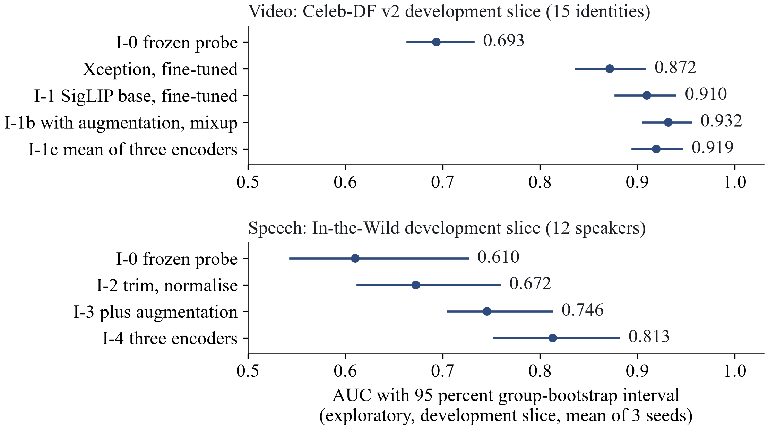
Figure 7. Measured ladder on the development slice: face video (top, with the re-run baseline and the two further iterations 1b and 1c) and speech (bottom), with 95 percent intervals. Sealed results are in a later section. (exploratory)

Iteration 1: fine-tuning depth on the face-video task
The diagnostic battery of the working version had pointed to bias for the face task: the training AUC of the frozen feature with a linear head was only 0.837. The lever was therefore the depth of fine-tuning, with the scope and budget fixed in advance: three encoders at three learning rates and one seed, selection on validation data only, then two further seeds for the selected encoder. The hypothesis was that the larger model class, which contains the probe, lowers the training risk and that the validation AUC rises by 0.02 to 0.05 and the development AUC changes between slightly negative and +0.03. Table 22 lists the nine runs of the first stage.
Table 22. Fine-tuning of three encoders at three learning rates, one seed (validation and development slice AUC).
Encoder | Learning rate 1e-5 | Learning rate 3e-5 | Learning rate 1e-4
DINOv2 small | 0.9869 / 0.9031 | 0.7056 / 0.6412 | 0.5871 / 0.5679
SigLIP base | 0.9893 / 0.9210 | 0.9814 / 0.8947 | 0.5186 / 0.5432
DINOv2 base | 0.9918 / 0.9036 | 0.5218 / 0.5379 | 0.5583 / 0.5667

The lowest rate was best for every encoder. At the two higher rates five of the six runs lost most of the signal (validation AUC between 0.52 and 0.71) and only SigLIP base at 3e-5 stayed high, so the learning-rate sensitivity is large, 0.40 to 0.47 in AUC between the best and the worst rate of an encoder; no non-finite loss or instability event was recorded, so these are training failures and not numerical ones. The selection on validation data (the cheaper candidate wins when the paired interval includes zero) gave the leader DINOv2 base (0.9918 [0.9847, 0.9974]), a tie set of DINOv2 base and SigLIP base (difference SigLIP minus leader −0.0025 [−0.0068, +0.0009]) and the winner SigLIP base at 1e-5 because its fine-tuning compute is smaller (203 against 238 seconds). One run (DINOv2 base at 1e-4) stopped when a data-loader worker died and was repeated once with the same configuration and seed; the error record is kept.
Table 23. Fine-tuned SigLIP base (three seeds) against the linear probe of the same encoder (exploratory).
Split | Fine-tuned | Linear probe | Difference [95 percent interval]
Training subset (900 clips) | 0.9994 [0.9986, 1.0000] | 0.9245 [0.9093, 0.9388] | +0.0749 [+0.0607, +0.0902]
Validation | 0.9899 [0.9809, 0.9967] | 0.8767 [0.8582, 0.8966] | +0.1132 [+0.0948, +0.1299]
Development slice | 0.9096 [0.8776, 0.9388] | 0.7396 [0.7031, 0.7832] | +0.1700 [+0.1228, +0.2114]

The seeds give a validation AUC of 0.9893, 0.9896 and 0.9908 and a development AUC of 0.9210, 0.9166 and 0.8912. The three criteria are met (lower bound of the validation gain above zero, training-subset AUC at least 0.90, lower bound of the development gain above zero) and the verdict is supported on this slice. The gains are larger than predicted: +0.1132 against +0.02 to +0.05 on validation and +0.1700 against at most +0.03 on the slice. The battery after the iteration shows no bias any more (training minus validation +0.0095) and a smaller shift (validation minus slice +0.0803 against +0.1052). On validation the AUC per manipulation is 1.000 (Deepfakes), 0.991 (Face2Face), 0.999 (FaceSwap) and 0.969 (NeuralTextures). Aggregation still does not help: the frame level scores 0.852 on the slice, the clip mean 0.921, and the median and the mean of the three highest 0.921 and 0.926. After temperature scaling the calibration error is 0.0174 on validation and 0.0331 on the slice, and the balanced accuracy at the validation threshold is 0.974 and 0.824. Of the 20 worst errors on the slice, 7 belong to one identity group. The slice has 15 identity groups and one kind of fake, so these numbers say nothing yet about other sources; they are the reason for the sealed test.

Iterations 1b and 1c: two further levers on the face-video task
After the first pass over the ladder, the project team asked for two more levers on the face-video task. Iteration 1b is the augmentation lever: the fine-tuned SigLIP base was trained with the same recipe as iteration 1 and, on the training stream only, Gaussian blur, a down-and-up resize and JPEG compression, each drawn independently with a probability and a range fixed before the run, followed by mixup of the examples of a batch. Its hypothesis was that the validation-to-slice gap of iteration 1 (0.0803) comes from a difference in compression, blur or resolution between the training and the slice videos, so that invariance to these perturbations transfers; if the gap comes from a different manipulation family it does not. The prediction was +0.01 to +0.04 on the slice and a change of at most −0.01 on validation. Iteration 1c averages the logits of three fine-tuned encoders (SigLIP base, DINOv2 base and DINOv2 small, three seeds each), on the hypothesis that the variance of the average falls with the correlation of its members; with a correlation of about 0.89 the formula allows a variance fall of only 7.6 percent. The prediction was a change within −0.01 to +0.01 on the slice and within ±0.003 on validation.
Both levers were run although the triggers written in the plan were not met to the letter: the gap of iteration 1 is 0.0803 against about 0.10 for the augmentation lever, and the score correlation of the three encoders is 0.89 to 0.91 against the value below 0.8 required for combining encoders. The mechanical rule for entering the final system was written before the runs: the lower bound of the paired slice difference to iteration 1 must be above zero and the paired validation difference must not fall by more than 0.0079, the half-width of the validation interval of iteration 1. Table 24 gives the result.
Table 24. Iterations 1b and 1c against iteration 1 (three seeds each; paired difference with a 95 percent group bootstrap interval; exploratory).
Split | Iteration 1b | Iteration 1c | Iteration 1 | 1b minus 1 | 1c minus 1
Validation | 0.9705 [0.9618, 0.9795] | 0.9903 [0.9823, 0.9968] | 0.9899 [0.9809, 0.9967] | −0.0194 [−0.0251, −0.0129] | +0.0004 [−0.0011, +0.0023]
Development slice | 0.9315 [0.9055, 0.9548] | 0.9192 [0.8948, 0.9457] | 0.9096 [0.8776, 0.9388] | +0.0219 [+0.0090, +0.0382] | +0.0096 [−0.0020, +0.0231]

Iteration 1b raised the slice AUC by +0.0219 [+0.0090, +0.0382], inside the predicted range, and lowered the validation AUC by 0.0194 [0.0129, 0.0251], more than the predicted 0.01. The first line is met and the second is not, so the mechanical verdict is that it does not enter the final system. The finding is a trade-off, higher on the slice and lower in the training data set, and not a failure of the augmentation to act: the training-subset AUC fell from 0.9994 to 0.9913, as expected from stronger regularisation, and the realised rates of the perturbations were checked on 2,000 training frames before the runs (blur 0.307, resize 0.4975 and JPEG 0.503 against the intended 0.3, 0.5 and 0.5). Two things are not separated: the effect of the perturbations from the effect of mixup, and the transfer to perturbation types that were not trained on, because no held-out perturbation slice exists. Iteration 1c reached 0.9192 [0.8948, 0.9457] on the slice, +0.0096 [−0.0020, +0.0231] over iteration 1; the lower bound is below zero, so it does not enter either. The three members are within 0.004 of each other on both splits (slice 0.9096, 0.9082 and 0.9057), so the average adds no accuracy that the interval can show, in line with the score correlation. A secondary variant, the mean of the two best members, has a slice lower bound of +0.0009; it was not the declared candidate, it is one of two variants looked at, and it does not change the verdict. The final system stays as defined before these two runs. Both results are exploratory, on the development slice and on validation only.

Iterations 2 to 4: speech preprocessing, augmentation and combination
The speech task kept its shift trigger after the first iteration: validation AUC 0.9942 and slice AUC 0.6100 (a gap of 0.38), with recording-condition cues that reverse in sign between ASVspoof 2019 and In-the-Wild. The first lever removed two of these cues by construction. Each clip is trimmed of leading and trailing silence (samples at most 0.005 of full scale) and divided by its peak before the window of 4 seconds is cut. The hypothesis was that a score that cannot use level and leading silence moves towards its content-based value out of domain, with a prediction of +0.05 to +0.15 on the slice and at most −0.01 on validation. A manipulation check was written into the criteria: after the change the single recording features must have intervals that include 0.5 on ASVspoof development, otherwise the hypothesis is not tested. It passed. The slice AUC rose from 0.6100 to 0.6723 [0.6126, 0.7584], a gain of +0.0623 [+0.0114, +0.1048], and the validation AUC fell by 0.0054 [−0.0115, −0.0006]; the verdict is supported. The energy of the clip, as a single feature, still has an AUC of 0.135 [0.054, 0.382] on In-the-Wild, so a level-related cue remains.
The second lever trained the head on the clean clips plus three augmented copies of each training clip, each copy with a random choice of additive noise (5 to 30 dB), a low-pass filter (cut-off 3,400 to 7,000 Hz), a synthetic room reverberation and an MP3 round trip (24 to 128 kbit/s); the ranges were fixed before the run and not tuned on the slice. The hypothesis was that a head fitted to the augmented distribution cannot rely on cues that the transformations destroy. A precondition was written: the augmentation must be a perturbation for the previous head, which it was (its AUC on an augmented validation copy was 0.6569 against 0.9889 on the clean one, while the new head scores 0.9436 against 0.9869). The slice AUC rose to 0.7455 [0.7052, 0.8121], +0.0732 [+0.0122, +0.1225] over the previous head and +0.1355 [+0.0515, +0.2088] over the working version, and the validation AUC changed by −0.0020 [−0.0043, +0.0006]; the verdict is supported.
The third lever averaged the logits of three tied speech encoders (HuBERT base, WavLM base plus and the Whisper small encoder), each with the pipeline of the second lever. The hypothesis was that the variance of the average falls with the correlation of the members. The mean pairwise correlation of the clip scores is 0.534 on the slice and 0.624 on validation. The average reaches 0.8130 [0.7523, 0.8808] on the slice, +0.0675 [+0.0300, +0.0929] over the HuBERT head alone, and 0.9964 [0.9943, 0.9982] on validation (+0.0095); the verdict is supported, and the gain is slightly larger than the predicted +0.02 to +0.06. The price is three encoder passes at inference: on the slice the end-to-end extraction runs at 237 clips per second for HuBERT, 210 for WavLM and 64 for Whisper. Table 25 gives the ladder of the speech task and the members.
Table 25. Speech task: the working version, the three levers and the members of the average (exploratory; slice of 12 speakers).
Head | Validation AUC | Development slice AUC | Change on the slice
Working version, HuBERT base | 0.9942 [0.9910, 0.9967] | 0.6100 [0.5434, 0.7256] | baseline
Trim and normalise (step 2) | 0.9889 [0.9831, 0.9933] | 0.6723 [0.6126, 0.7584] | +0.0623 [+0.0114, +0.1048]
Plus augmentation (step 3) | 0.9869 [0.9818, 0.9911] | 0.7455 [0.7052, 0.8121] | +0.0732 [+0.0122, +0.1225]
Average of three encoders (step 4) | 0.9964 [0.9943, 0.9982] | 0.8130 [0.7523, 0.8808] | +0.0675 [+0.0300, +0.0929]
Member: HuBERT base | 0.9869 [0.9818, 0.9911] | 0.7455 [0.7052, 0.8121] | same as step 3
Member: WavLM base plus | 0.9699 [0.9595, 0.9786] | 0.7823 [0.7172, 0.8436] | not applicable
Member: Whisper small encoder | 0.9951 [0.9924, 0.9973] | 0.7526 [0.6851, 0.8406] | not applicable

Two limits stand with these three results. The slice has 12 speakers, so its intervals are wide and a true gain below about +0.09 cannot be shown by a single step; the steps are supported because their gains exceed this width. And the calibration error on the slice is still high after temperature scaling (0.1670 for the average), so the audio score remains a ranking score, and the page keeps its warning.

Iterations 5 and 6: LAV-DF, the pre-check and in-domain heads
LAV-DF is the only data set on the machine in which video and audio are manipulated independently and every video has an audio stream. A fixed subset was drawn from its official splits: 500 videos for each of four cells (real, video fake only, audio fake only, both fake) in each of the training, validation and test splits, with the source video as the group, so each split has 2,000 videos. Only the training part (used to fit the fusion layer) and the validation part were scored for the development results; the test part was sealed and was scored once at the freeze. The label for the fused question is fake if either modality is fake, and the label of each modality comes from the metadata.
The first step was the pre-check written in advance: the frozen visual head (trained on FaceForensics++) and the frozen speech average are scored without any fitting, and a head whose lower bound against its own label is at or below 0.55 is declared near chance. The visual head failed, and failed below chance: its AUC against the video label is 0.3838 [0.3599, 0.4079] and against the fused label 0.2786 [0.2534, 0.3042]. It also scores the videos whose frames are untouched (audio fakes) as more real than the real originals (AUC 0.2876 for that cell), so the reversed sign is not a response to a visual manipulation. The code path was checked against the earlier validation scores on FaceForensics++ (largest difference 0.00012). The speech average gives 0.6476 [0.6244, 0.6701] against the audio label. The fusion was therefore not tested. A logistic regression fitted on the training part reached 0.7536 on validation only by giving the visual head a negative weight; this exploits a data-set-specific inversion and is recorded but not used.
The next step trained both heads in the domain: the visual encoder was fine-tuned with the recipe of iteration 1, unchanged, on 10,000 LAV-DF training videos (disjoint in source video from the fusion-fit and validation parts), and linear heads for the three speech encoders were fitted on the audio of the same videos; the temperature of each modality was fitted on the fusion-fit part. Table 26 shows the result and the cell-wise values.
Table 26. Heads trained on LAV-DF, on its validation part (AUC with 95 percent group bootstrap interval; exploratory).
Score | Fused label | Own modality label | Video-only fakes against real | Audio-only fakes against real
Visual head | 0.9913 [0.9871, 0.9949] | 0.7491 [0.7280, 0.7697] | 0.9905 [0.9857, 0.9945] | 0.9912 [0.9864, 0.9951]
Speech average | 0.7480 [0.7260, 0.7689] | 0.8604 [0.8435, 0.8769] | 0.5175 [0.4836, 0.5532] | 0.8711 [0.8474, 0.8920]
Sum of log-odds | 0.9795 [0.9726, 0.9857] | not applicable | not applicable | not applicable
Logistic regression | 0.9935 [0.9905, 0.9962] | not applicable | not applicable | not applicable

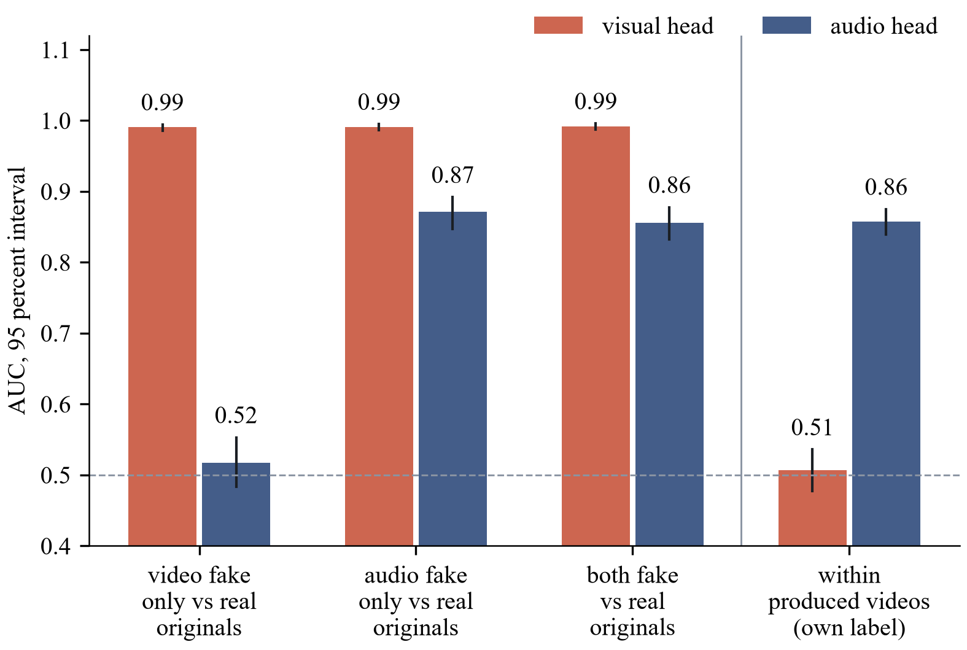
Figure 8. AUC of the visual and the audio head on the LAV-DF validation subset: against the real originals for each kind of fake, and within the produced videos only. (exploratory)
Both heads pass the pre-check (0.7491 and 0.8604 against their own labels, lower bounds above 0.55), the logistic-regression fusion exceeds the better single head by +0.0023 [+0.0009, +0.0040] on the fused label, and the mechanical verdict of the step is supported. The table and Figure 8 show what this number means. The visual head scores the audio-only fakes, whose frames are the original frames, as high as the video fakes (0.9912 against 0.9905 when each is compared with the real originals). A post-hoc control, labelled as such, keeps only the produced videos, that is, those that went through the data set's own pipeline: the visual head's AUC against the video label is then 0.5070 [0.4771, 0.5361], which is chance, while the speech average reaches 0.8574 [0.8394, 0.8752] against the audio label. The visual head has therefore learned to separate the original videos from the produced ones, and the fused AUC of 0.9935 is an in-data-set result that this cue drives. The part of the system that detects a manipulation on LAV-DF is the audio head.
One follow-up tested whether a visual signal exists at all. The visual head was trained on the produced videos only, with the audio fakes as the negatives, so that the pipeline cue is constant. Its AUC within the produced videos is 0.5169 [0.4945, 0.5392], the difference to the previous head is +0.0100 [−0.0159, +0.0372], and the verdict is not supported: this recipe, on this subset and with 16 face crops per video, does not recover a visual manipulation signal. The report therefore makes no claim of audio-visual deepfake detection from these results. The audio-visual mode of the system shows the visual and the audio score of a video side by side, with a warning, and no fused verdict.

Iteration 7: the pulse signal check
The signal check S-1 ran on the processor on 432 real clips (up to 150 per data set: FaceForensics++ original sequences, real Celeb-DF v2 videos and real LAV-DF videos), each represented by 10 seconds of contiguous frames at the native frame rate. The spectral peak in 0.7 to 3 Hz and its signal-to-noise ratio were computed, and a time-shuffled control with at least ten shuffles per clip was pooled; its 95th percentile, 1.118 dB, is the reference. The rule written in advance required 60 percent of the real clips above the reference. The share is 130 of 432, that is 0.301 [0.260, 0.346]; per data set it is 0.280 for FaceForensics++, 0.288 for Celeb-DF v2 and 0.333 for LAV-DF, and the median signal-to-noise ratio of the real clips is −0.222 dB. The check fails, and the iteration reports exactly this: the pulse signal is not recoverable from these data. No separation or fusion experiment was run. The check has no ground-truth pulse, so it says that this extractor does not recover a pulse from these compressed videos, not that no pulse exists; another extractor or uncompressed video could differ.
A positive control, run afterwards on the processor, asks whether this extractor would have recovered a pulse that was there. The exact pipeline of the check was run again on the same 432 clips, after a known sinusoid of 1.2 Hz had been added to the skin pixels of every frame at seven relative amplitudes of the green channel (0.0005 to 0.032, doubling each step; the table starts at 0.001, the 0.0005 row is the same as the control, 0.303), with a phase drawn per clip; the channel weights of the injected signature are the implementer's choice, and a green-only signature was run as a sensitivity check. With no injection the control reproduces the first check (0.301; the largest difference of the signal-to-noise ratio is 5 millionths of a decibel). Table 27 gives the share of clips recovered. With the primary signature, the smallest tested amplitude recovered in at least 60 percent of the clips is 0.008 (377 of 432, 0.873 [0.838, 0.901]; at 0.004 the share is 0.546), and with green only it is 0.004 (0.789). An amplitude of 0.008 in the green channel is about one grey level at a skin value near 130.
Table 27. Positive control of the pulse check: share of the 432 clips in which the injected 1.2 Hz sinusoid is recovered by the rule of the check (Wilson 95 percent interval; exploratory).
Relative green amplitude | Primary signature | Green only
0 (control) | 0.301 [0.260, 0.346] | 0.301 [0.260, 0.346]
0.001 | 0.303 [0.262, 0.348] | 0.319 [0.277, 0.365]
0.002 | 0.343 [0.299, 0.389] | 0.410 [0.364, 0.457]
0.004 | 0.546 [0.499, 0.593] | 0.789 [0.748, 0.825]
0.008 | 0.873 [0.838, 0.901] | 0.958 [0.935, 0.973]
0.016 | 0.972 [0.952, 0.984] | 0.975 [0.955, 0.986]
0.032 | 0.981 [0.964, 0.991] | 0.986 [0.970, 0.994]

This shows that the pipeline, with its face track, skin mask, projection, spectral rule and shuffled null, is sensitive to a clean sinusoid of that size, so the failure of the check is not caused by an insensitive pipeline for a modulation of that size and form. It does not show that a real pulse exists in these videos, nor what its amplitude, form and spectrum are (the amplitude of a real pulse in these videos was not measured, and no source on typical amplitudes was read); it does not show that a pulse survives H.264 compression, because the injection is made after decoding and is not re-encoded; and it says nothing about forged videos. The injected sinusoid is constant in frequency and amplitude, which is easier than a real pulse. The verdict of the check (0.301 against 0.6) and the conclusion of the iteration are unchanged.

The re-run baseline and the margin of the comparison
The comparison with a published detector is made against a family that is re-run on the same data, split, budget and metric. The family is Xception with ImageNet weights, fine-tuned on the same FaceForensics++ frames with the recipe and budget of iteration 1; the learning rate was chosen on validation data and three seeds were run. In the first pass the grid was 1e-5, 3e-5 and 1e-4, and the selected rate, 1e-4, was the highest of the grid (validation AUC 0.9646, 0.9809 and 0.9883), so a better rate outside the grid could not be excluded, which would have favoured the system in the comparison. The grid was therefore extended by one step, 3e-4, before any sealed evaluation. At seed 0 it gave a validation AUC of 0.9909 against 0.9883, so by the same rule 3e-4 was selected, and two further seeds were run at it. The first pass stays reported as the first pass. Table 28 gives both.
Table 28. Xception baseline at the first-pass rate and at the selected rate, against the fine-tuned SigLIP base, three seeds each (exploratory).
Split | Xception, 1e-4 (first pass) | Xception, 3e-4 (selected) | SigLIP base fine-tuned | SigLIP minus Xception at 3e-4 [95 percent interval]
Validation | 0.9872 [0.9784, 0.9942] | 0.9912 [0.9849, 0.9963] | 0.9899 [0.9809, 0.9967] | −0.0013 [−0.0063, +0.0033]
Development slice | 0.8750 [0.8435, 0.9089] | 0.8716 [0.8364, 0.9076] | 0.9096 [0.8776, 0.9388] | +0.0380 [+0.0172, +0.0592]

The rate of 3e-4 moved the validation AUC of the baseline by +0.0040 [+0.0009, +0.0077] and the slice AUC by −0.0034 [−0.0167, +0.0094] against the first pass. The seed standard deviation of the selected baseline is 0.0003 on validation and 0.0020 on the slice (0.0010 and 0.0072 in the first pass). On the slice the fine-tuned system is higher than the selected baseline by +0.0380 [+0.0172, +0.0592], and the hypothesis that it is higher (lower bound above zero) is supported as an exploratory result. The selected baseline also gains +0.1783 [+0.1296, +0.2140] on the slice over the working version, so most of the gain of iteration 1 comes from fine-tuning and not from the particular encoder. The margin of the non-inferiority comparison was fixed before any sealed evaluation by the rule that the margin is twice the larger of the two seed standard deviations, with a floor of 0.01, computed from the unrounded standard deviations. For the first pass the rule gave $δ$ = 0.0143; for the selected baseline both standard deviations are small, the floor applies and $δ$ = 0.0100, which is the margin used. Since 3e-4 is again the best rate of the grid, the edge of the grid is stated as a limit of the baseline, and no further rate was added.

The Web Application
The software form is a local web page: the user uploads an image, a video or an audio file in a browser and sees the response of the inference library. It was chosen over a command line, which was not adopted as a second form. The page is served by Flask, chosen against FastAPI, the standard library server, Streamlit and Gradio, Bottle, by six criteria written before the choice: it installs on Python 3.13 without a compiled build, runs as one process with no database or separate front-end build, handles uploads of several hundred megabytes without code that has to be tested separately, gives plain HTML, CSS and a little JavaScript that can be restyled without a build step, adds few packages (four, on top of those already present), and returns the response structure unchanged as JSON. A job runs in a worker thread and the page polls a status route, which gives progress by stage without a second service.
Three safeguards were added and tested. The server binds to 127.0.0.1 only and has no option to change this. Uploads are limited to 512 MB, and an oversized upload returns an error in the response format. Uploaded files are deleted after every request, also after an aborted upload, and leftovers are removed at start.
The inference library takes a file and returns one structured response, so that the library and the page can be built in parallel and a development stand-in can never be mistaken for a result. Table 29 lists its fields.
Table 29. Fields of the response of the inference library.
Field | Content
Schema version and request identifier | version of the response format and a unique identifier of the request
Input | file name, media type (image, video or audio), MIME type, size, SHA-256, duration (none for images) and number of frames used (none for audio)
Inference source | always present: real or mock
Model block | checkpoint, configuration hash, preprocessing hash, commit, iteration, protocol version, calibration (method, temperature, split) and the threshold with how it was chosen; empty when the source is mock
Result | the fused score in [0, 1] with a decision (fake, real or undetermined); for an image the visual score, for audio the audio score; for a video the combining rule is not decided, so the decision is undetermined; per modality: availability with a reason, score and number of units used
Score meaning | the fixed sentence: calibrated probability that this content is fake, from a model fitted on the training data of this project, valid only for the kinds of content in that data, not proof
Status | ok, partial or failed, the processing time and the list of stages (validate, decode, detect, score, calibrate, fuse) with their times
Warnings and errors | warnings such as no face detected, several faces, short audio, low resolution; errors such as unsupported media type or unreadable file, in which case the status is failed and there is no result

A development stand-in is allowed under strict rules. It lives in a module whose name contains “mock”, always sets the source to mock and leaves the model block empty, and its scores are deterministic from the file hash so that tests are repeatable, but they carry no meaning. Every interface shows a visible banner whenever the source is not real, a test checks this, the evaluation harness refuses any run whose metadata says mock, and the document builds fail if a number cites a mock run. The real adapter refuses to run without a checkpoint whose metadata and preprocessing hash match. Figure 9 shows the page, with screenshots taken against the development stand-in; the banner and the undetermined decision for a video are part of the design and the scores shown mean nothing.
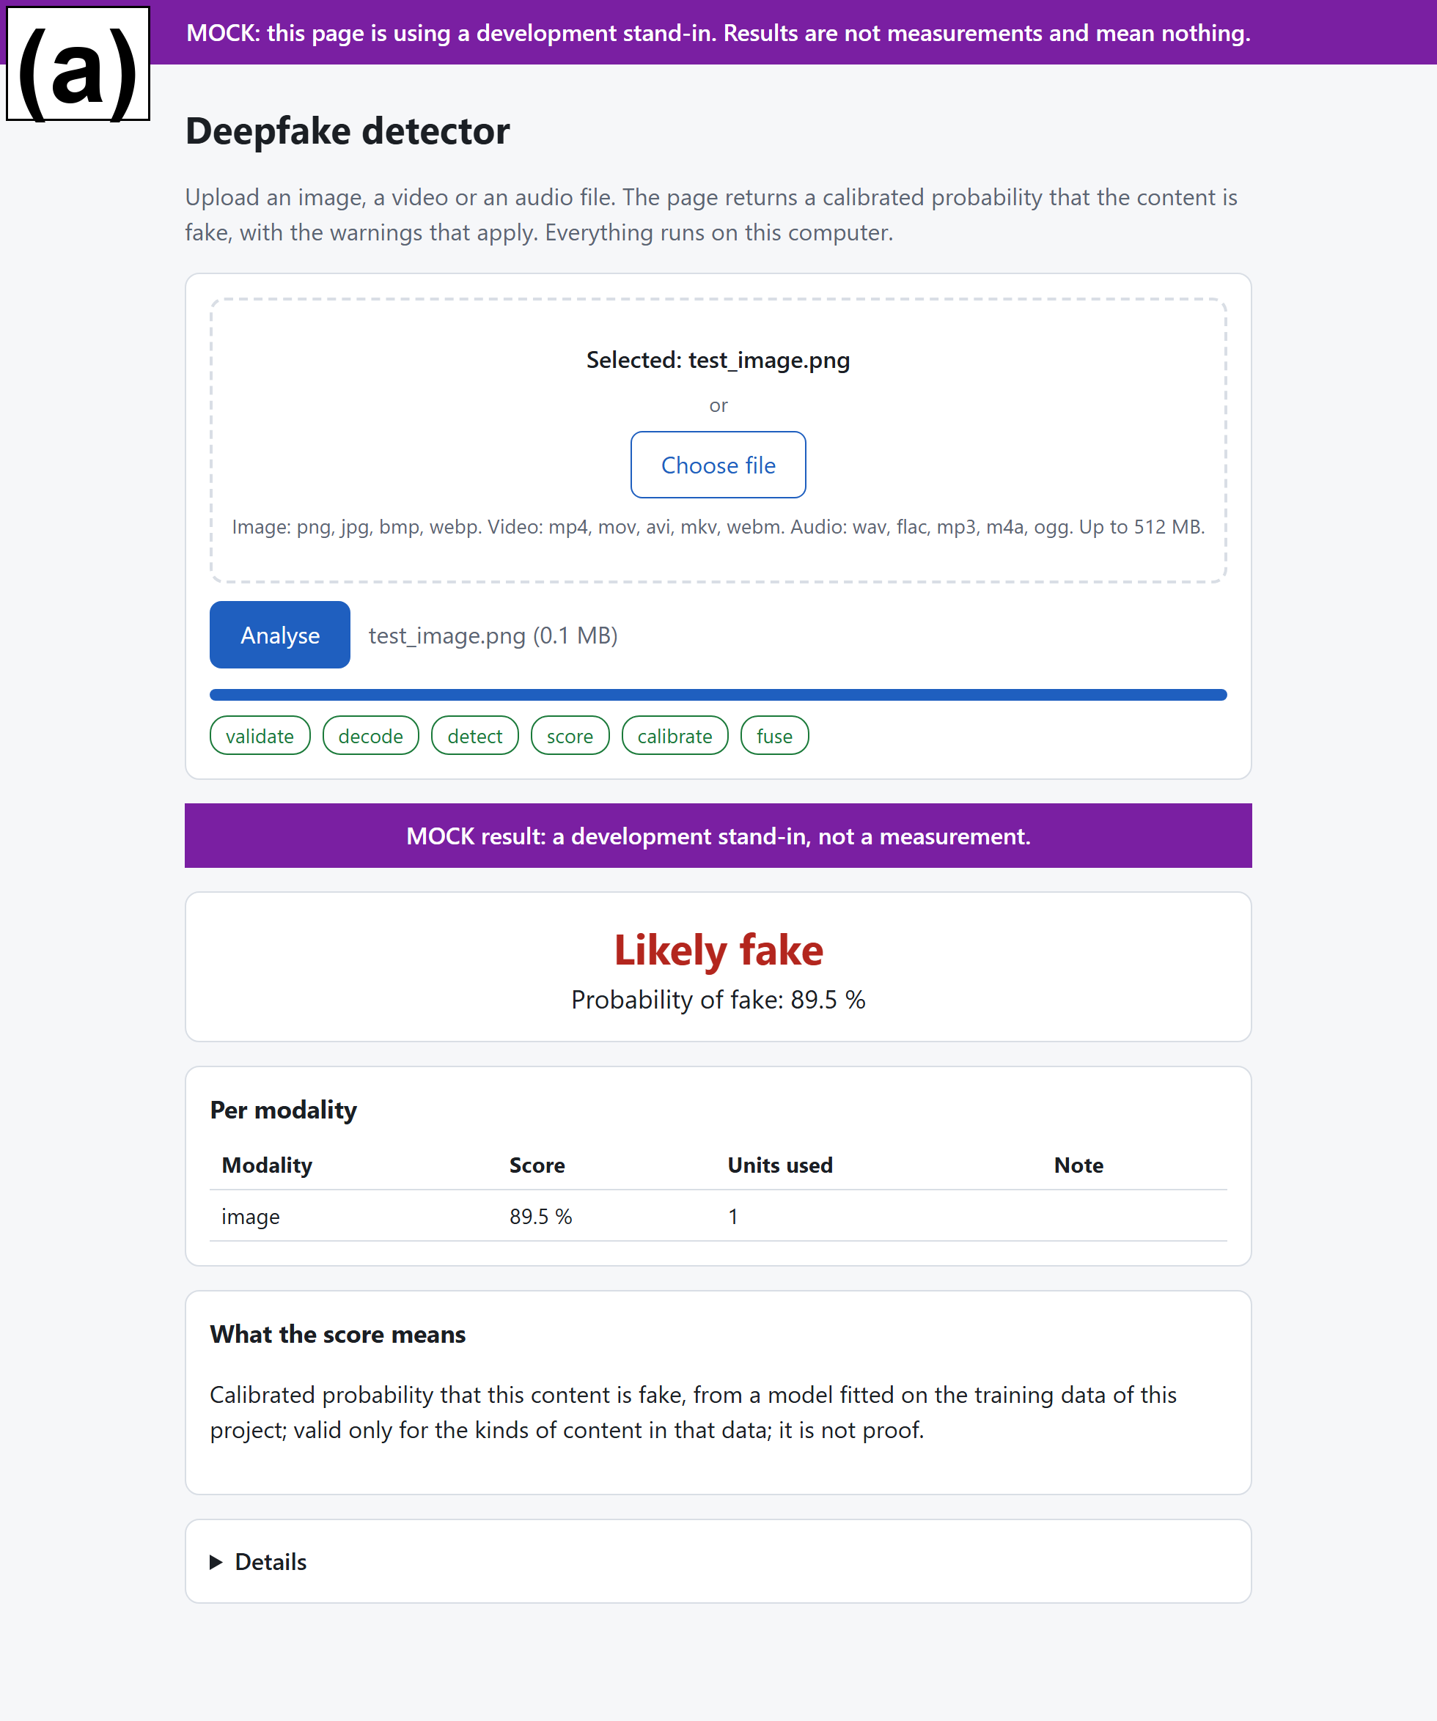 | 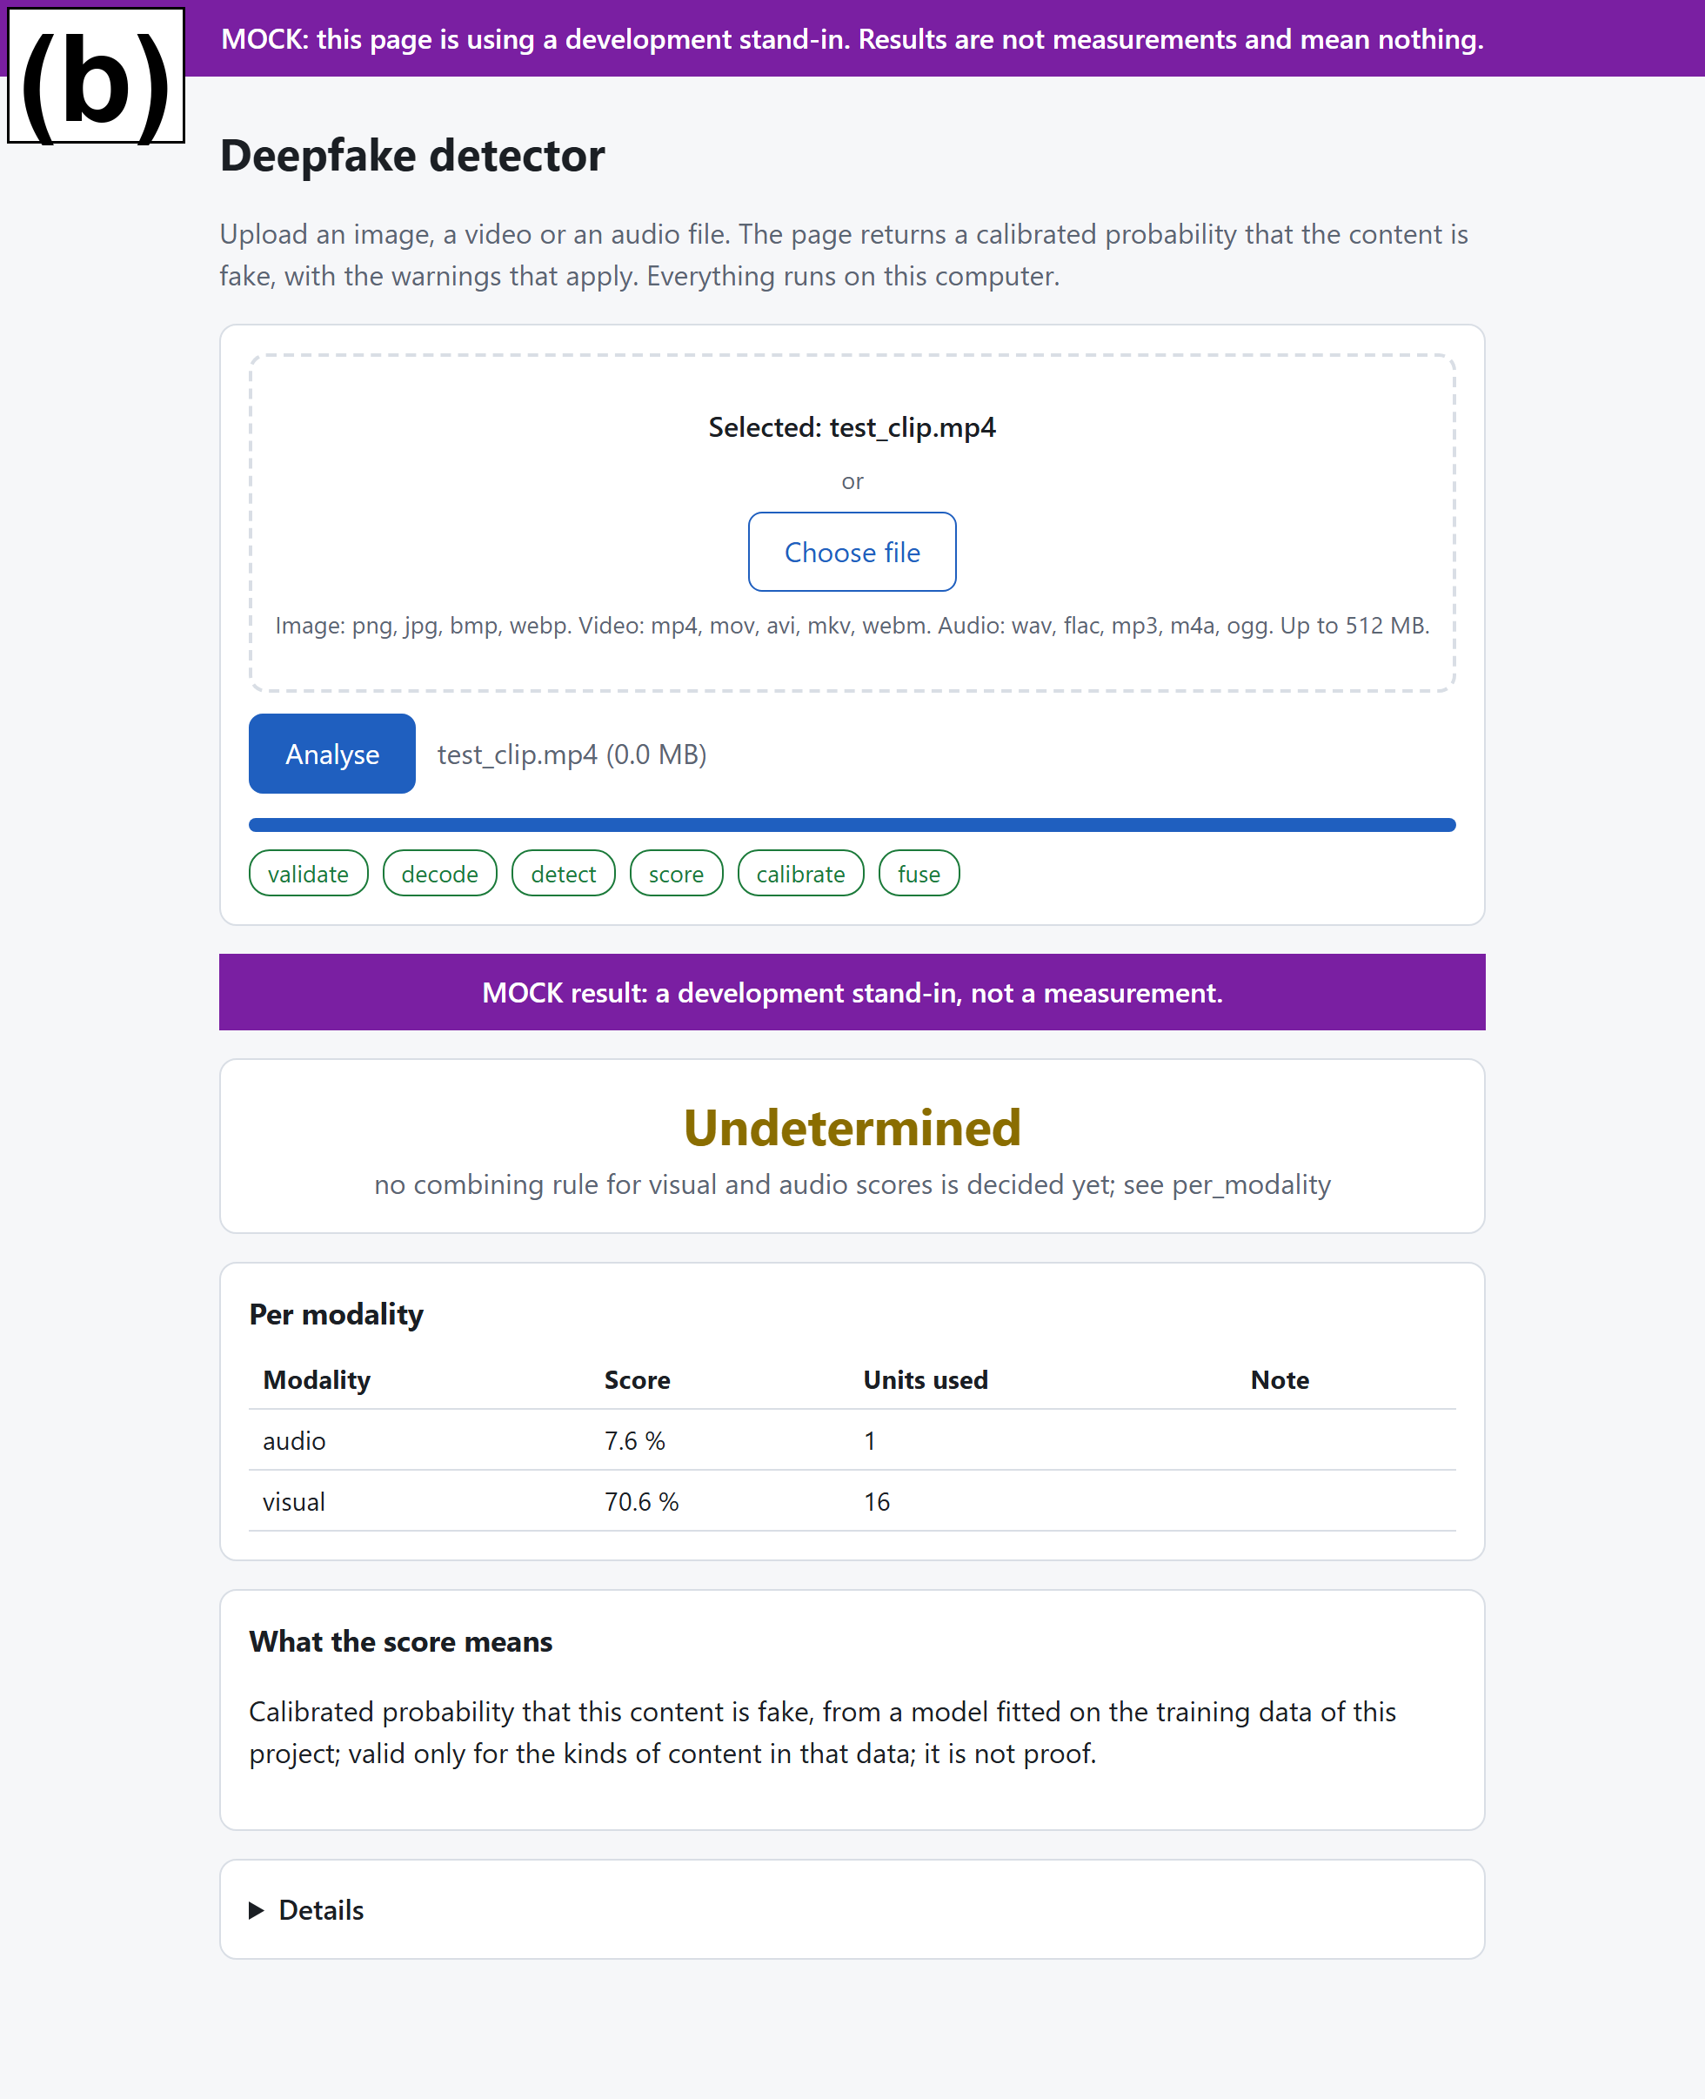
Figure 9. The local web page against the development stand-in: (a) result for an image, (b) result for a video. The banner is part of the design and the scores shown are not measurements. (screenshots against the stand-in)
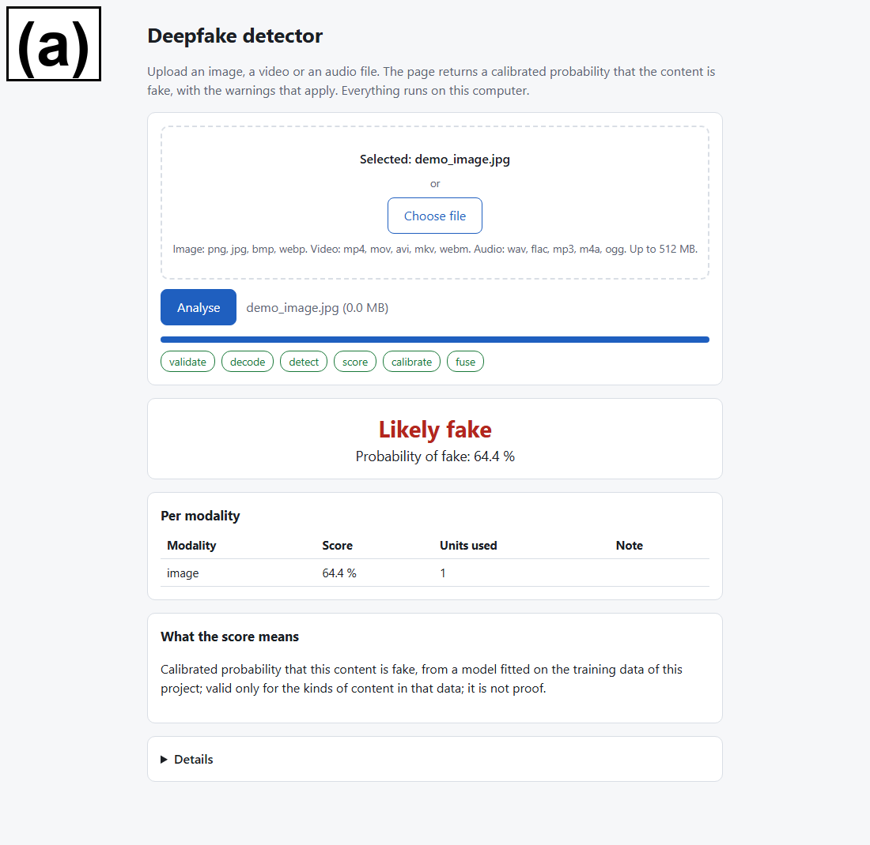 | 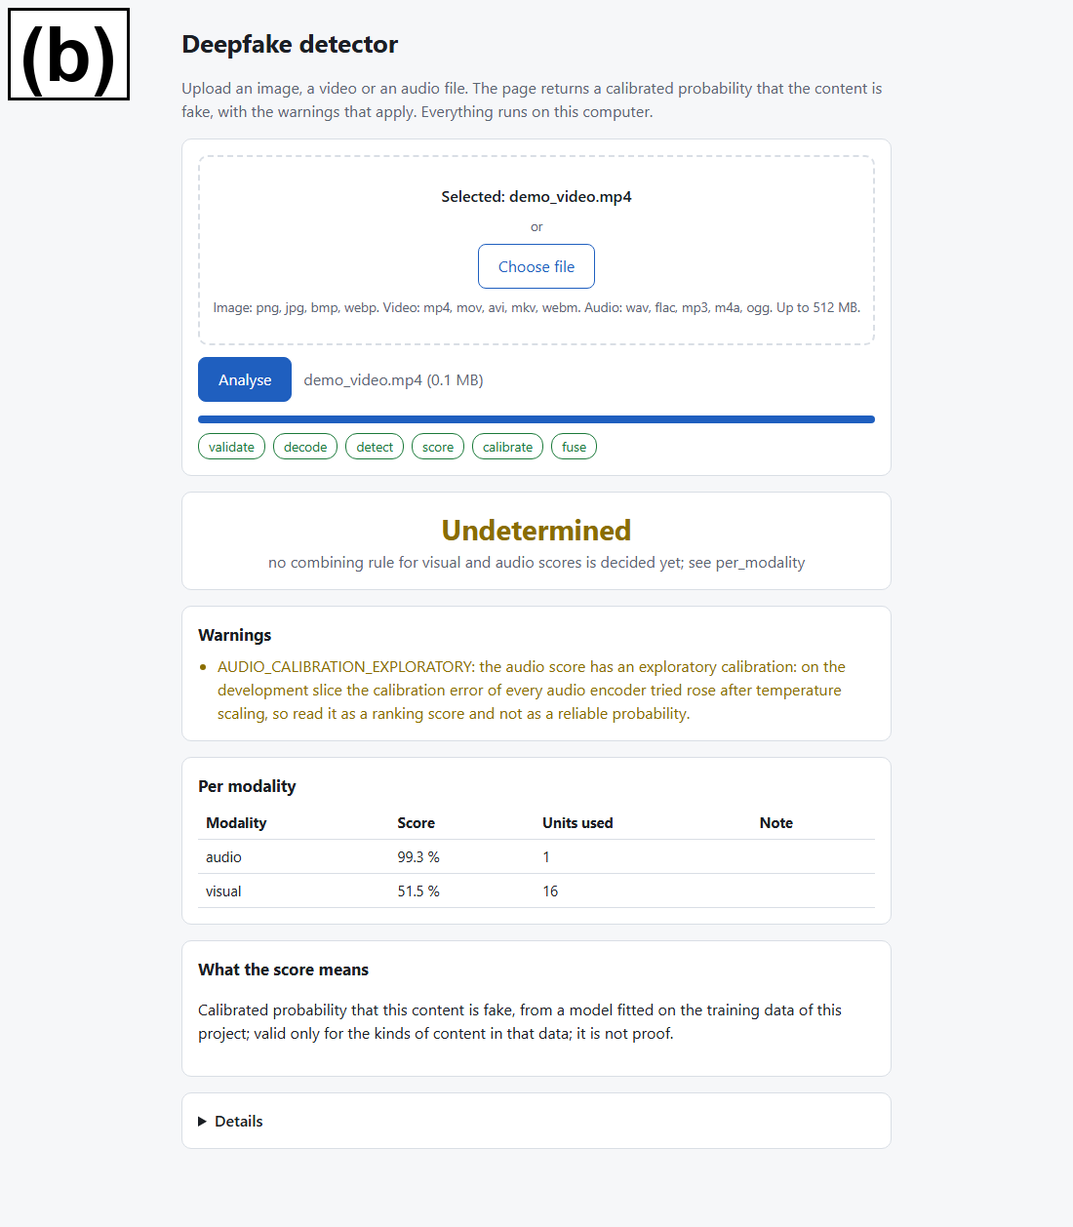
Figure 10. The local web page with the real checkpoint: (a) result for an image, (b) result for a video with audio. The video shows its visual and audio score separately and the verdict undetermined. (screenshots of the real checkpoint on training items)
Figure 10 and Figure 11 show the page with the real checkpoint, on training items, so they show that the path works and not how accurate it is. For an audio score the page adds a warning to the result: it says that on the development slice the calibration error of every audio encoder tried rose after temperature scaling, so the audio score is to be read as a ranking score and not as a reliable probability. The verdict for an audio file above the threshold still appears next to this warning.
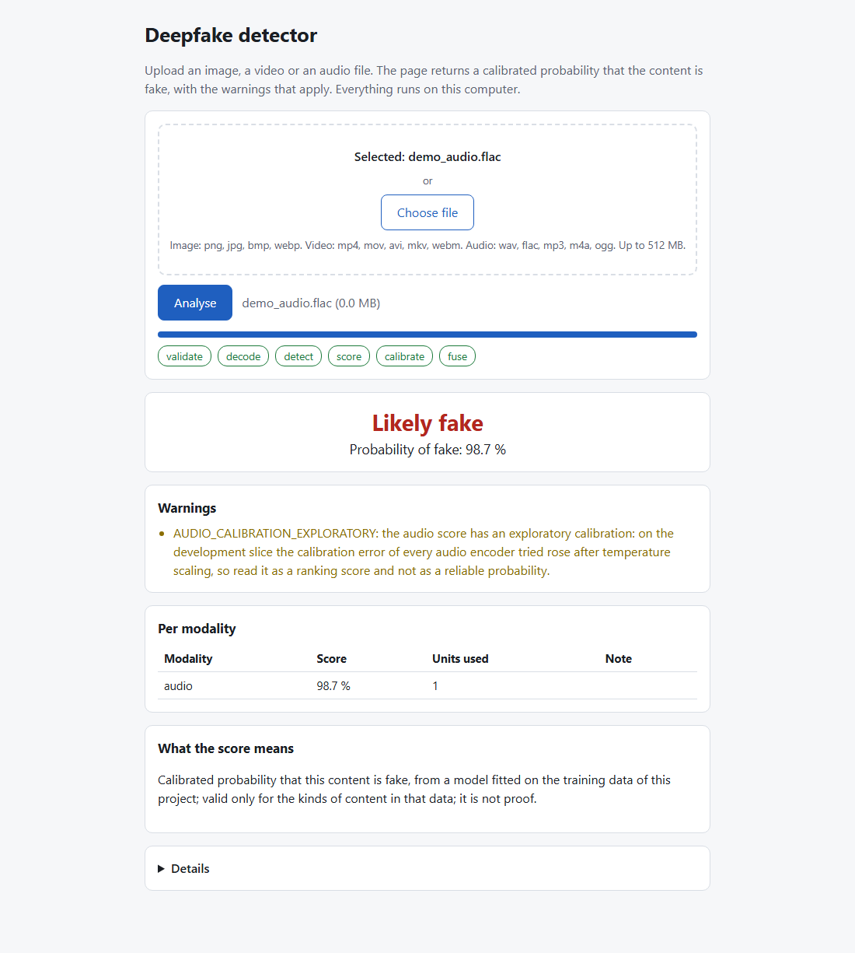
Figure 11. The local web page with the real checkpoint for an audio file, with the warning about the exploratory calibration of audio scores. (screenshot of the real checkpoint on a training item)
Tests with synthetic media cover the response contract, the stand-in and its banner, the real adapter stub, the web routes and, in a real browser, the page itself against the stand-in.
The inference library was extended for the frozen system. A second checkpoint format records, per task, how the score is made (a linear probe on frozen features, a fine-tuned encoder, or the mean logit of an ensemble of heads), keeps the hash of every file, and checks the preprocessing identifier against the configuration recorded in the checkpoint; the audio preprocessing now includes the trimming and normalisation, so it has a new identifier, and the checkpoint of the working version still loads and is scored with its own rule. The format and its refusals are covered by 304 unit tests, which pass. A candidate checkpoint of the frozen system was built, and a parity check on the graphics processor passed: 11 training or validation items (6 FaceForensics++ videos, 3 ASVspoof files and 2 ProGAN images) were scored from the stored scores and by the real adapter from the raw files, and the largest absolute difference of the calibrated score was 0.0019 against a tolerance of 0.02. The local web page was later run once with the checkpoint of the frozen system on three training files and passed its page check (source real, no banner); its screenshots in this report show the working-version checkpoint.

The Analysis Platform
After the freeze the frozen detectors were placed inside a modular analysis platform. The inference library of the working version returns one score per modality, which is the right form for the three tasks that were measured, but it has no place for evidence of other kinds, such as the agreement between the lips and the speech, or a signed statement of where a file came from, and it invites a reader to treat a high score as a verdict on the whole file. The platform keeps the frozen detectors unchanged and adds a second layer around them: each capability is a module, each module reports what it found within its own tested scope, and no number is ever combined into one overall probability that the media is fake. Emotion and expression analysis was removed from the scope at this point; lip synchronisation stayed. The platform is a separate package, so the frozen inference library and its web page were not changed. Figure 12 shows the structure.
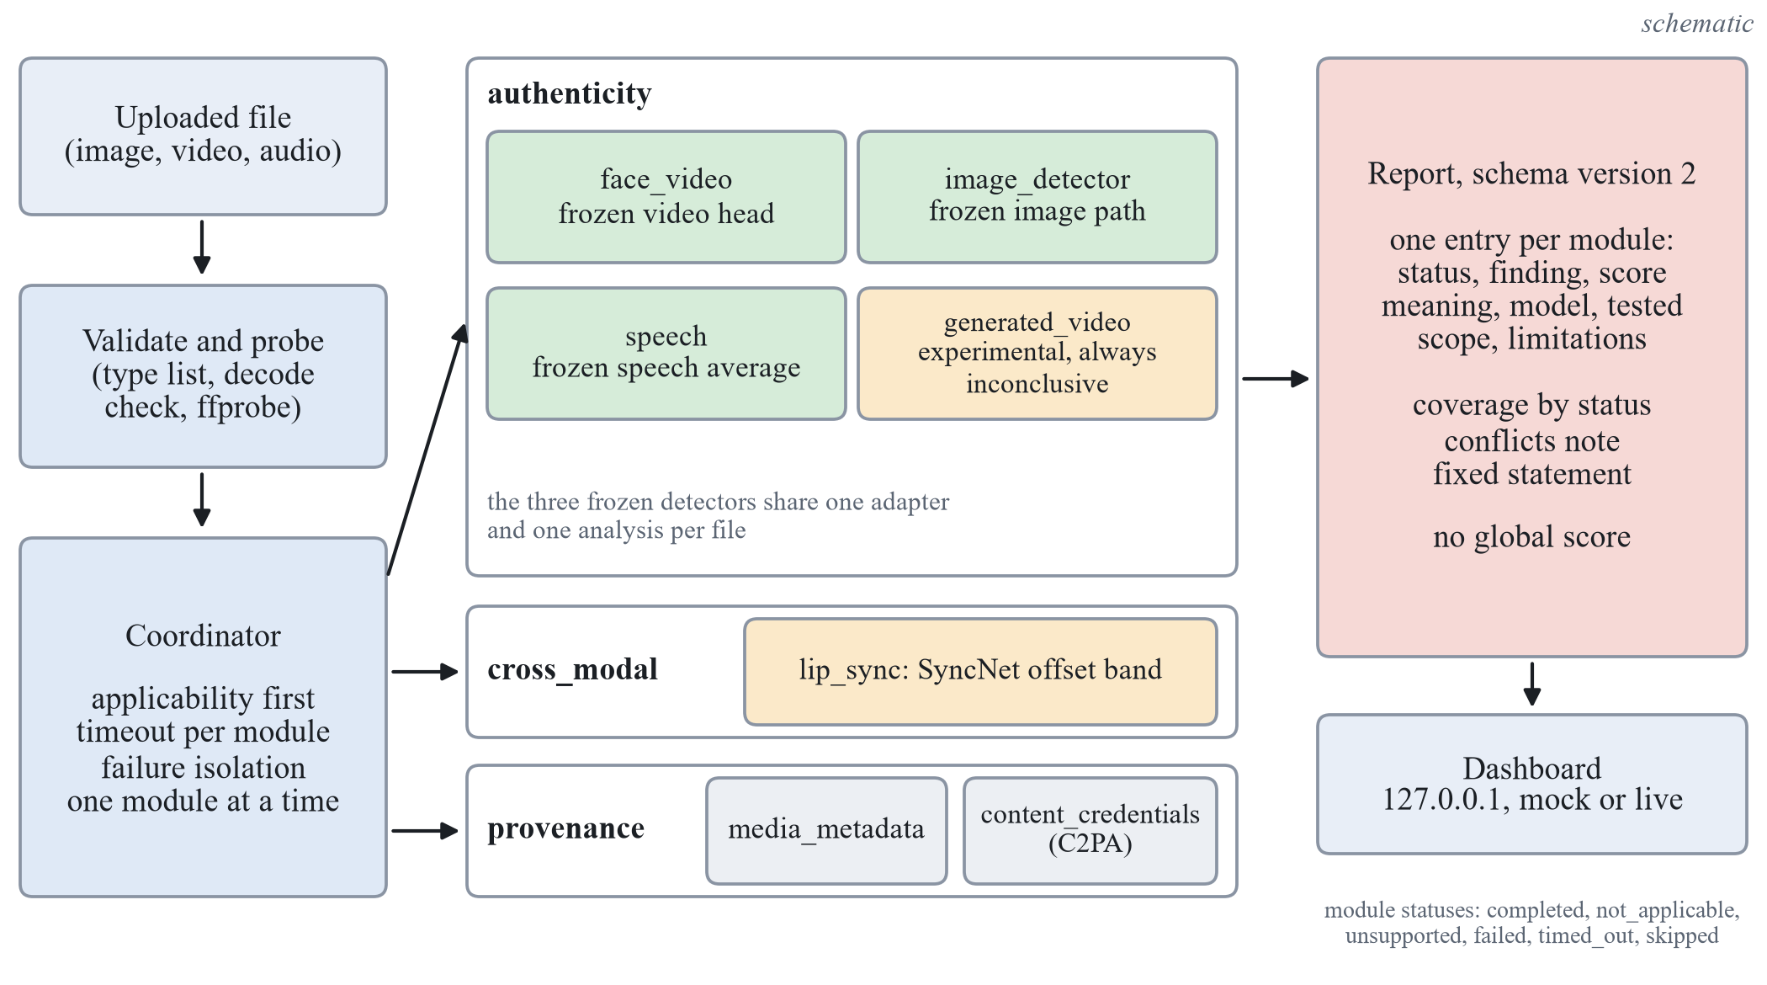
Figure 12. Structure of the analysis platform. The coordinator runs every registered module; each module appears once in the report, in one of three sections, with its status and, if it completed, its finding, tested scope and limitations. There is no global score. (schematic)

Module interface and coordinator
A module declares a module identifier, a version, its section and a time limit, and it implements two functions. The first, applicability, receives a probe of the file (media type, duration, whether a video and an audio stream exist, size, hash) and answers applicable, not applicable (the input lacks what the module needs, for example a still image for a speech module) or unsupported (the capability is not available here, for example because a weights file is not installed). A field of the probe that is not known is left empty and never read as absent. The second function, run, does the work and returns a module result; it may still return not applicable when the answer needs the decoded media, for example when no face is found.
The coordinator runs the registered modules one at a time, because the graphics processor is shared, and gives each its own time limit. Nothing a module does can break the report: an exception becomes a failed entry with the exception type, a module that does not answer in time becomes timed out, and a result that does not satisfy the report contract is replaced by a failed entry that names the broken rule. Python cannot stop a thread, so a timed-out module is abandoned: the coordinator sets a cancellation flag that the module may poll, discards any late result or exception, and gives every module a view of the shared cache that ignores writes once the module is cancelled, so a late thread cannot change the report or what other modules read. While an abandoned module that uses the graphics processor is still running, a second such module is not started and is reported as skipped with the reason; a total time limit for the whole analysis turns modules that were not started into skipped entries as well. Every registered module appears in the report exactly once.

Report schema version 2 (extended in 2.1)
The report lists one entry per module with its status, its finding, an optional score with a sentence that says what the number is, whether it is calibrated and the threshold used, the model block (name, version, weight hash, licence and the evaluation it rests on), the tested scope, the limitations, warnings, errors and observations, and the processing time. Table 30 gives the six statuses and Table 31 the findings that each section allows.
Three rules keep the report from saying more than the evidence. There is no global score: the contract checker rejects a report that carries a fused score, an overall probability or a verdict field, and no section has a finding that means genuine; the strongest negative finding is no indication within the tested scope. Every report ends with one fixed statement: “This report lists what each module found within its tested scope. A module that found nothing, did not run, was unsupported or was inconclusive does not show that the media is authentic. No single probability that the media is fake is given.” And the state of the report is failed when no module completed, partial when any module failed, timed out, was unsupported or was skipped by the coordinator, and ok otherwise, so a report in which nothing was analysed is never ok. When authenticity modules disagree, the report adds a note that the modules cover different kinds of manipulation, so the disagreement is not necessarily a contradiction. A development stand-in result carries no model block and no calibrated score, as in the inference library.
Table 30. Statuses of a module in the report.
Status | Meaning | Finding and score
completed | the module ran and returned a valid result | a finding of its section; a score only with its meaning
not_applicable | the input lacks what the module needs (no face, no audio stream, a still image for a video module) | none; a reason is required
unsupported | the capability is not available here (weights or trained head not installed, incompatible head) | none; a reason is required
failed | an exception, a failed applicability check or a result that breaks the contract | none; an error entry is required
timed_out | no result within the time limit of the module | none; an error entry is required
skipped | not started: total time limit reached, or a timed-out module still holds the graphics processor | none; a reason is required

Table 31. Findings allowed in each section of the report. None of them means that the media is genuine.
Section | Findings | Modules
authenticity | indicates_manipulation; no_indication_within_tested_scope; inconclusive | face_video, image_detector, speech, generated_video
cross_modal | consistent; potential_mismatch; inconclusive | lip_sync
provenance | credentials_valid; credentials_invalid; no_credentials_found; inconclusive | media_metadata, content_credentials

Modules that wrap the frozen detectors
Three modules wrap the frozen system without changing it. One adapter is built per process from the frozen checkpoint, the file is analysed once and the result is cached under the hash of the file, so the three modules never score a file twice; a missing checkpoint is an error and never falls back to a stand-in. The face_video module reports the calibrated score of the fine-tuned SigLIP base head on the largest face in up to 16 frames, with the threshold of the checkpoint. The image_detector module reports the path taken: a face crop goes through the same video-trained head, and its score is marked as not calibrated for still images, because that head was never evaluated on still face-swapped photos; a whole image without a face goes through the frozen CLIP head of the generated-image task. The speech module reports the mean logit of the three speech heads on the first window of about 4 seconds, marked as not calibrated, because the calibration of the audio scores stayed exploratory. Each module states its tested scope, quotes the sealed results of its detector in its evaluation field and lists its limitations, among them the sealed AUC below 0.5 of the face head on LAV-DF. A parity check compared the three wrapped modules with the stored scores of the freeze parity check on 11 non-sealed files: the largest difference was 0.0019 against a tolerance of 0.02. One limitation was found in the demonstration run and documented, not changed: the speech module has no speech check of its own, so a synthetic 440 Hz tone receives a speech finding (no indication within the tested scope, score 0.0) although such input lies outside what the speech detector was trained on; the lip-sync module reports the same audio as not speech-like. A speech gate was not added, because it would change the decision of a frozen detector with a heuristic that was not evaluated for it.
The routing of still images left a gap: an image in which a face is found goes only to the face-swap head, so a fully generated portrait was never shown to the generated-image model. An additional module, generated_image, closes the gap for display without changing the frozen path. When, and only when, the image analysis took the face-crop path, it passes the whole image to the frozen generated-image head through the adapter's own whole-image function, the one used for images without a face, so the number is the score the frozen model gives that image. The module is experimental: it never makes a finding, applies no decision line, and its score is never the key figure of its card, because the generated-image head missed most generated faces when it was measured on images that contain a face (see the later subsection on modern generators). On the demonstration still image the image analysis result was unchanged (0.999983 on the face crop) and the new module reported a low score without a finding.

Lip-sync module
The lip_sync module measures the temporal agreement between the speech and the lips of one tracked face. The network and the offset search are ports of the public SyncNet reference code (MIT licence); the weights file comes from the same source, which states no licence for it, so its use is limited to this academic prototype. The steps are: the audio at 16 kHz, at most the first 30 s; at least 2 s of audio; enough audible audio; a cheap speech-likelihood heuristic from spectral flatness and loudness variation, named a heuristic and not a speech detector; a YuNet face track at 25 frames per second; and the offset in frames, within 15 frames either way, that minimises the embedding distance, together with its confidence. The decision rule is: inconclusive when the clip is too short, the audio is silent or not speech-like, two or more faces share the frames (the speaker is not established), the confidence is below 3.0, or the offset lies at the edge of the search range; otherwise consistent when the offset lies in the band of −6 to +2 frames, and potential_mismatch outside it; not applicable without an audio stream or without a face; unsupported when the weights file is not installed.
The band and the confidence minimum were set by experiments described in the section on the experiments after the freeze. The module is weak evidence by design: its vocabulary has no finding that says manipulated, a mismatch can come from dubbing, bad muxing or a variable frame rate, and a fake that was generated to be synchronised passes. Its score is the confidence rescaled for display and is not a probability.

Provenance: file metadata and Content Credentials
Two modules form the provenance section; neither is a detector and neither has a model. The media_metadata module lists container, stream and tag properties read with ffprobe and a few descriptive flags (for example a missing creation time, or the name of the tool that last wrote the file), and its finding is always inconclusive, because metadata can be stripped, rewritten or copied. The content_credentials module checks C2PA Content Credentials. When the optional c2pa-python package is installed (version 0.38.0 was used) the manifest is validated by the library, which checks the claim signature and the assertion and data hashes; remote manifest fetching and certificate revocation checks are off. Table 32 gives the mapping from what the library reports to the finding.
Table 32. Findings of the Content Credentials module.
Situation | Finding
c2pa-python not installed | byte scan for C2PA marker bytes only: inconclusive if markers occur, no_credentials_found otherwise; nothing is verified
Manifest valid, signer not on a configured trust list (the default: no list is bundled) | inconclusive, with the observation that integrity was checked and the signer is not established
Manifest valid and the signer chains to a trust anchor configured by the operator | credentials_valid, relative to that configuration
File or manifest changed after signing | credentials_invalid
No manifest | no_credentials_found
Unsupported file type or unreadable manifest | inconclusive, with a warning naming the reason

A valid credential attests to claims that the signer made about the file at signing time; it does not prove that the content is authentic, and a self-made certificate can sign anything, which is why an untrusted signer is inconclusive. Absence of credentials proves nothing, because many editing and sharing paths remove them; credentials held in a separate file or a cloud store, and invisible watermarks, are not checked. A declared generative source in a manifest is reported as a statement of the signer, not as a detection.

Generated-video module
The generated_video module looks at the whole picture, independent of faces, for video produced by a text-to-video or image-to-video generator. The clip is re-encoded by one fixed recipe (the first 2.0 s, 7 frames per second, a 224 by 224 centre crop, fixed keyframe and B-frame structure, no metadata and no audio), 8 frames go through the frozen DINOv2 small encoder [45], and a logistic regression on the mean class-token embedding scores the clip. This head was selected by a rule fixed before its experiment; it is an appearance baseline and not the ReStraV method [49], whose temporal-geometry features were tried as another candidate and were at chance in the same experiment.
The head did not generalise to a held-out benchmark (the section on the experiments after the freeze gives the numbers), so the module is experimental and its finding is always inconclusive. A gate in the code enforces this: a definitive finding needs the boolean validation flag in the head file, the SHA-256 of the exact head file in a table of approved heads that only a reviewed code change can extend, a finite score and threshold, and evaluation and limitation texts that do not contradict validation. The table is empty, so every head, including the installed one, gives inconclusive with the warning that the capability is experimental and unvalidated; the score is shown for inspection only and no threshold is shown. The gate hashes the same bytes that it loads. A missing head, a head with another feature size or a head trained under another preprocessing protocol makes the module unsupported, and non-finite features or scores make it fail.

Dashboard
A local dashboard, served by Flask on 127.0.0.1 only, presents the report to a reader who need not know how the models work. In live mode it opens on an upload panel (drag and drop or a file picker, the accepted types and the 512 MB limit read from the inspector of the frozen library, and a preview played in the browser); nothing is analysed and no report of any kind is shown until the user presses Analyse. The result opens with a description of the file, then a sentence that only counts the checks by what they found, what is known about faces and speech, and the statement that no overall score is given. The checks follow in groups by meaning: merits attention, nothing found within the tested scope, inconclusive, file information, experimental, did not apply, not available and did not complete. Each check shows a plain headline, what it checks, at most one rounded number and what the result does not establish; the explanation and the technical details (identifiers, raw scores and thresholds, model, hashes and evaluation lines) open on request. The experimental generated-video check is shown in its own group with an EXPERIMENTAL badge and its score only as an experimental signal. Invented scenarios stay available on request under a hatched MOCK banner. The colours follow a fixed palette in which no green stands for nothing found; every text colour pair meets the WCAG AA contrast ratio in light and dark mode, which a test computes. Figure 13 shows the top of a live report. In live mode the server accepts uploads into a single worker, refuses a new one while 4 analyses are queued or running, and deletes every uploaded file when the analysis returns. The frozen web page of the working version stays as it was.

Figure 13. Top of a live report on the dashboard (demonstration input 3, a real LAV-DF training clip, 27 October 2026), taken before the per-module verdict labels described below were added: file description, counting summary without an overall score, and the first group of checks. A screenshot of the software, not a result. (screenshot)

Explanations from the stored result
Report schema version 2.1 adds three optional parts: an explanation for each module, a summary of the report, and evidence that a module has already computed. The explanation is written on the server by fixed templates, one per module and outcome, from the fields of the module's own result; it says what was checked, what was observed, what it means, what it does not establish and the main limitations, and every sentence lists the fields it was built from. A validator rejects a sentence whose numbers are not in its cited fields, a cited field that does not exist, a sentence of model output on a module that did not run, wording such as authentic or proves, an experimental score shown as a headline number and an unmarked stand-in result; the summary must equal its recomputation from the module results. The evidence is display only: the lip-sync module returns the 31 distances of its offset search, which it computed before and discarded, and the generated-video module returns the 8 frames its encoder received. Faces and speech, which the probe cannot know before the modules run, are reported from module results with their source, or as not established; speech is never inferred from the presence of an audio stream. When the lip-sync check finds the audio unlike speech, the speech explanation says so, while the speech result itself is unchanged. These explanations describe the stored result faithfully; they are not an account of how a network reached its score, and no language model writes them.

Per-module verdicts and uncertainty
Each completed module result carries an additive assessment: a verdict label, a tier (detector, limited, experimental, provenance or context), the basis, the raw score with its kind (model output or ranking score), a calibration statement, an uncertainty level with a sentence of text, and evidence entries tied to stored result files, each of which a unit test checks against its file. There is no report-level verdict and no fused score: the schema still rejects keys such as an overall score or a probability of fake, and the report keeps only counts of checks per group. A label is offered only where the stored evidence justifies it, as Table 33 shows. The reason for the face-video label is a measurement: on the sealed half of FakeAVCeleb the frozen video threshold had specificity 0.996 but sensitivity 0.480, so a flag is rarely a false alarm there but about half of the fake videos are missed, and the absence of a flag is therefore reported with high uncertainty. That specificity belongs to one sealed set: computed afterwards from the stored sealed scores, with no model run, the same threshold flagged about 0.11 of the real videos of the Celeb-DF family and 0.14 of those of DFD. A flag is therefore labelled Possible manipulation, with high uncertainty, as a possible sign and not a determination, and the check is not described as reliable on the strength of one set. For the same reason a low score from the whole-image model is not reassuring: on modern generated images it missed 0.7395 at its threshold (macro AUC 0.7039).
Table 33. Verdict labels of each module. The label depends on whether the stored threshold comparison flags the file.
Module | Flag | No flag | Uncertainty without a flag
Face video | Possible manipulation | No strong evidence of manipulation detected | high
Image, face crop | Possible manipulation (weak evidence) | Inconclusive | stated in the card
Image, whole image | Possible AI-generation (weak evidence) | Inconclusive | stated in the card
Speech | Possible manipulation (weak evidence) | No strong evidence | moderate
Lip sync | Possible audio-visual mismatch (weak evidence) | No audio-visual mismatch found | stated in the card
Experimental modules | Experimental signal observed, no reliable verdict available | same label at every score | not applicable

The scores of the face-video, image and speech detectors are temperature-scaled on each detector's validation split, so they behave like probabilities only for data like that split; the later sealed and modern-generator measurements show that they do not elsewhere. The platform therefore says score, not calibrated probability, and shows the raw value only under technical details, labelled model output or ranking score and never as a percentage. The experimental heads give uncalibrated ranking scores with no threshold applied. They cannot create a finding for two reasons: no experimental head passed its own acceptance test, and the approval table of the generated-video module is empty, so the code refuses a finding from any head file whose hash is not in it. The label Likely AI-generated exists in the vocabulary, but no rule can reach it, and a test pins this. The layer fails closed: it recomputes the comparison of score and threshold itself, and a missing, non-finite or out-of-range score, a missing threshold, or a stored finding that disagrees with the comparison gives Inconclusive with the reason, never a guess. A failed, timed-out or skipped module gives Analysis failed, and an unsupported input gives Unsupported input. On the dashboard a card shows the label, the headline, supporting signals and evidence, model and modality, limitations and uncertainty, in that order; experimental cards use a separate dashed style with no detector colour.

Evaluation Lab
The Evaluation Lab is a separate page of the local dashboard, next to the page for analysing a file, with an interface under /api/evallab. It re-analyses recorded score files (run, iteration, seed, modality, dataset, split, sample, group, label and score). It runs no model, trains nothing, writes no checkpoint, never reads or writes the approval table or any threshold, and writes nothing to the evaluation ledger, so a good result in the lab is not a product approval. The workflow has five steps: choose a score file and a block (a dataset and split shown with its role: training, validation, development slice or final held-out); review the settings (model iteration, runs and seeds, threshold source, purpose, sample counts and class balance); run, with progress and failures shown; read the results (AUC, equal error rate, accuracy, balanced accuracy, precision, recall, specificity and the two error rates, with group-bootstrap intervals, a confusion matrix, an ROC curve, an optional breakdown, warnings and skipped rows); and compare with a baseline run and export JSON or Markdown.
- Provenance and frozen configuration. The SHA-256 of the score file, its row count and the git state go into every run record, and the configuration and its SHA-256 are frozen into the record before any metric is computed, so identical configurations give identical metrics.
- Test-set isolation. A final held-out split runs only as a re-analysis of an evaluation already in the ledger, only with the purpose final re-analysis, and only if the SHA-256 of the score file equals the hash recorded in that ledger entry, so an edited copy cannot pass. The lab never makes a first look at sealed data.
- Thresholds. A threshold is fitted only on the validation rows of the same runs (maximum balanced accuracy, the project's rule) or given with its provenance; it is never fitted on the evaluated rows.
- Leakage checks. Before computing, the lab looks for a group shared between the evaluated block and the training or validation rows (refused for a final split, warned otherwise), duplicate sample identifiers, and duplicate file hashes across splits when the file records them.
- Comparisons. Only on identical samples, by a paired group bootstrap; otherwise the lab reports that the comparison is unavailable and why.
The known limit is stated in every run record: when a score file does not record its training data, the lab cannot prove that the training data excluded the evaluated items. On 28 October 2026 an engineering check exercised the safeguards. Re-analysis of the frozen final system on the sealed Celeb-DF family reproduced the logged AUC of 0.8218; a first look at a sealed split labelled as development was refused; and the ledger file was byte-identical afterwards. This is a record of software behaviour, not a new detection result.

Software Testing and Verification
Testing of the software is kept apart from the experimental evaluation. A test establishes that the code behaves as specified on constructed inputs or that the application runs end to end; it says nothing about how well a detector separates real from fake media, which only an experiment on held-out data can show. The current record was made on 28 October 2026, after the per-module verdict layer and the Evaluation Lab were added, in the project environment (Python 3.13.15, synced from the lock file with the C2PA extra) on the development machine, with every count taken from a saved log. Table 34 summarises it; results of earlier runs that were not repeated on the final state of the code are marked as earlier records.
- Unit and contract tests. Data loaders and split guards, the frozen inference library and web page, the report contract (including the rejection of a global score), the coordinator (exceptions, timeouts, invalid results, late results of abandoned modules, the total time limit), the three wrappers with test doubles for the adapter, the lip-sync decision rule and missing weights, the generated-video gate (an unapproved head stays inconclusive at every score, metadata cannot authorise a finding, non-finite values fail), the Content Credentials module with a test certificate authority created for the test and without the package, the metadata module, the explanation layer (numbers from cited fields, wording by status, tampered explanations that must be caught), the verdict layer (labels by rule, fail-closed cases, evidence entries checked against stored files) and the Evaluation Lab (frozen configuration, test-set isolation, leakage checks), the contrast of the palette, and the dashboard in a real browser (upload-first opening, grouping, the explanation on screen equal to the stored one, keyboard reach). The suite (710 passed, 2 skipped) ran with the graphics processor hidden; 13 data-dependent tests that read the real dataset inventories were deselected and are not verified in this record.
- Opt-in tests on the graphics processor. A parity test of the three wrapped detectors against the stored scores of the freeze parity check on 11 non-sealed files (largest difference 0.0019, tolerance 0.02), and a live test of the face path.
- Application run. The dashboard was started in live mode and given the 8 inputs of the demonstration (six media files of every kind and two error cases) by driving the page in the Edge browser; every report that came back was checked against the schema and every number shown against the stored score.
- Documentation and dependency checks. The documentation check of the three deliverables and the check that the lock file matches the declared dependencies.
Table 34. Software tests and their recorded outcomes on 28 October 2026 (engineering verification, not detector accuracy).
Level | What was run | Recorded outcome
Safe suite | all unit and contract tests, graphics processor hidden; the 13 data-dependent tests deselected | 710 passed, 2 skipped (the two opt-in tests)
Opt-in, graphics processor (record of 27 October 2026) | parity of the wrapped detectors on 11 non-sealed files, and the live face path | 5 passed; largest parity difference 0.0019 against 0.02
Live dashboard, 8 demonstration inputs | the page driven in a browser; each report checked against the schema and each number shown against the stored score | all 8 behaved as specified, 0 page errors (on 27 October 2026: 6 media files with all seven modules reported, every report valid; 2 error cases failed with UNSUPPORTED_MEDIA_TYPE and UNREADABLE_FILE)
Documentation check | the check of the paper, report and slides, in the project environment | 71 pass, 0 fail (before the verdict and Evaluation Lab text was added)
Lock file | lock file against the declared dependencies | consistent, exit 0
Earlier records, not re-run on this state | live checks of all modules; Content Credentials cases; generated-video reproducibility; full suite with the graphics processor visible; clean installation from the lock file | 60 checks, 0 failed; 5 of 5 cases; 16 of 16 frames identical; 508 passed, 2 skipped; 495 passed, 2 skipped
Earlier records, 26 and 27 October 2026 | safe suite before the redesign, and after it | 497 passed, 2 skipped; 551 passed, 2 skipped

One defect was found and fixed during the application run. In live mode, after a failed or refused analysis (an unsupported file type or an unreadable file), the stand-in scenario shown when the page loads, tagged MOCK, stayed on screen next to the failure message. The page now hides any report before a new analysis starts; a regression test covers it, and in the browser the two error cases now show the error and no report.
The limits of this evidence are stated with it. The tests ran on the development machine, which also holds the large files that version control does not track; a fresh clone without those files was not run end to end, and the data-dependent tests were not run. The application run and the browser tests examine structure and integration (every module appears, statuses and reasons are right, the page renders warnings and errors), not accuracy.

The Staircase Test Protocol
Rankings, hyperparameter choices and iteration verdicts made on the development slice and on the validation split are exploratory: they report sign, size and interval, and they choose the next step; they are never presented as confirmed performance. At the freeze each frozen iteration is evaluated once on the sealed test sets under the final flag, which gives a staircase of test scores, one per iteration, each touched once and recorded in the ledger. Figure 14 shows the protocol.
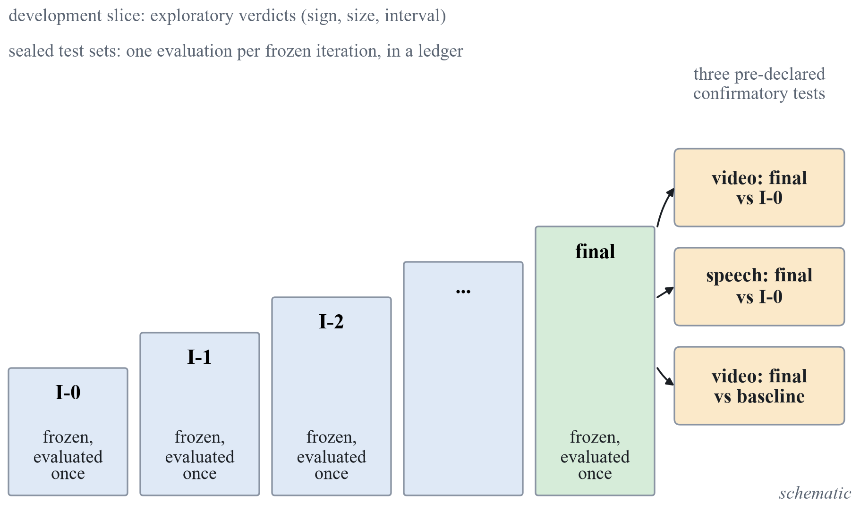
Figure 14. Staircase test protocol. Verdicts on the development slice are exploratory; each frozen iteration is evaluated once on the sealed test sets and the pre-declared comparisons are the confirmatory claims. (schematic)
The confirmatory claims are three tests, declared before any final run, all as paired group bootstrap comparisons on the sealed data under the comparison rules: the final system against the working version, and the final system against a re-run published baseline, where the second is the non-inferiority test of Equation (22). The first comparison is made on two sealed sets, face video on the Celeb-DF family and speech on In-the-Wild, which with the baseline comparison makes the three tests; a Bonferroni interval at the 98.33 percent level is printed beside each as a robustness line. The margin $δ$ is stated before the comparison and chosen from the measured seed-to-seed spread of the baseline, so the baseline had to be trained before $δ$ existed; it was trained (Xception, three seeds, first at three learning rates and then with one more, 3e-4, that was selected) and $δ$ is 0.0100, the floor of the rule; the first pass gave 0.0143. Every other comparison in the report is labelled exploratory.
The standing limitations of this protocol are stated with it. The development slices have 15 identities, 12 speakers and 2 generator units, so intervals are wide and ties are likely; the sealed Celeb-DF family tests have about 44 independent identity groups; the threshold is chosen on validation data from the training distribution, which may be too easy, so it can transfer badly across data sets, and that would appear as a gap between the in-dataset and the cross-dataset balanced accuracy and be reported; and temperature scaling does not repair a shift between data sets.
The definition of the final system and the comparisons were also fixed before any sealed evaluation. The final system is the configuration after the last supported lever of each task: the fine-tuned SigLIP base for face video, the frozen OpenAI CLIP head for generated images, and the average of the three speech encoders with trimming, normalisation and augmentation for speech. Neither iteration 1b nor iteration 1c entered it, and the audio-visual fusion on LAV-DF is not part of it. The confirmatory comparisons are three tests. The first is the final system against the working version on the sealed Celeb-DF family test for face video, and the second is the same comparison on the sealed In-the-Wild test for speech; the image head is the same in both versions, so there is nothing to compare. Each is called an improvement if the lower bound of the paired 95 percent interval is above zero. The third is the final face-video system against the Xception baseline at its selected rate on the sealed Celeb-DF family test: superior if the lower bound is above zero, non-inferior if it is above −0.0100, and, if the interval contains zero but not −0.0100, worded as not distinguished and non-inferior by the rule. For each of the three, a robustness line is printed beside the declared verdict: the interval at the 98.33 percent level, which is the Bonferroni correction for three tests, computed from the same bootstrap resamples. It does not replace the declared rule; a verdict that the corrected interval does not support is reported as not robust to the Bonferroni level. All other sealed numbers are exploratory. The sealed run was made on 25 October 2026, and its results are given in the section on the sealed-test results.

Sealed-Test Results
The sealed run was made on 25 October 2026, after the code, the preprocessing and the checkpoints had been frozen. Each frozen iteration was evaluated once on each sealed test set under the final flag, and the ledger holds 74 entries. Every value is for three seeds (0 to 2), at the level of the clip or the image, with the 95 percent group bootstrap interval of 2,000 resamples. Only the three tests declared before the run are confirmatory; every other sealed number in this section is exploratory and says so.

The three confirmatory tests
Table 35 gives the three tests. In the first two, the final system is compared with the working version on the same sealed set, in a paired group bootstrap: the lower bound of the 95 percent interval decides, and the interval at the 98.33 percent level is printed beside it as a robustness line. In the third, the final face-video system is compared with the re-run Xception baseline at the selected rate of 3e-4, with the margin 0.0100.
Table 35. The three confirmatory tests on the sealed test sets (AUC and difference with 95 percent group bootstrap intervals; the last two columns give the robustness interval at the 98.33 percent level and the verdict).
Test | Sealed set | Final system | Compared with | Difference, 95 percent | 98.33 percent interval | Verdict
Face video, final system against working version | Celeb-DF family, 7,650 videos, 344 groups | 0.8218  [0.8020, 0.8393] | 0.6238  [0.6015, 0.6486] | +0.1980  [+0.1688, +0.2242] | [+0.1627, +0.2303] | improved; robust
Speech, final system against working version | In-the-Wild, 24,788 clips, 42 speakers | 0.9148  [0.8896, 0.9383] | 0.7516  [0.6802, 0.8035] | +0.1633  [+0.1177, +0.2266] | [+0.1085, +0.2481] | improved; robust
Face video, final system against Xception baseline (margin 0.0100) | Celeb-DF family, 7,650 videos, 344 groups | 0.8218  [0.8020, 0.8393] | 0.8042  [0.7841, 0.8223] | +0.0176  [+0.0025, +0.0327] | [−0.0011, +0.0355] | superior at 95 percent; not robust at 98.33 percent; non-inferior at both

For face video the final system reaches an AUC of 0.8218 [0.8020, 0.8393] against 0.6238 [0.6015, 0.6486] for the working version, a difference of +0.1980 [+0.1688, +0.2242]. The lower bound is above zero, so the verdict under the declared rule is improved, and the interval at the 98.33 percent level, [+0.1627, +0.2303], is also above zero. For speech the final system reaches 0.9148 [0.8896, 0.9383] against 0.7516 [0.6802, 0.8035], a difference of +0.1633 [+0.1177, +0.2266] and, at the 98.33 percent level, [+0.1085, +0.2481]: improved, and robust to the correction. The speech intervals are wide, because the 42 speakers of the sealed set are the resampling unit.
For the comparison with the baseline, the difference is +0.0176 [+0.0025, +0.0327]. The lower bound is above zero, so by the declared 95 percent rule the final face-video system is superior to the re-run Xception baseline on this set. The robustness interval, [−0.0011, +0.0355], contains zero, so the superiority is not robust to the Bonferroni level. The lower bound is above −0.0100 at both levels, so the system is non-inferior at both. The wording that the data support is therefore: superior at the 95 percent level, not robust to the 98.33 percent level, non-inferior at both. The result concerns one baseline family at 224 pixels and one sealed set, and it supports no claim beyond this.
The predictions written before the run held for the video task, including the range for the difference to the baseline. Two predictions for speech failed, both upward: the final speech system was predicted at 0.60 to 0.85 and reached 0.9148, and the working version was predicted at 0.50 to 0.70 and reached 0.7516. The sealed video value is below the development value of the same system (0.8218 against 0.9096), and the sealed speech value is above it (0.9148 against 0.8130). The sets differ in identities and speakers, so these are different measurements and not a fall or a rise of one quantity, but for speech the direction is the opposite of what the small development slice suggested.

The staircase on the sealed sets
Each frozen iteration was also scored once on every sealed set. Apart from the Celeb-DF family row of Table 36 and the working-version and iteration 4 values of the In-the-Wild row of Table 37, which carry the tests above, every number in this section is exploratory. Table 36 gives the video and image tasks. The face-video model is the same in iterations 1 to 4, because the later levers act on speech, so one column stands for the four, and the image head is unchanged in all iterations, so its three rows are the same everywhere. The Celeb-DF++ videos have no real videos of their own, so Celeb-DF++ alone has one class and no AUC; its row uses the Celeb-DF v2 real videos, and the family set mixes the Celeb-DF v2 test videos and the Celeb-DF++ fakes against those reals.
Table 36. Sealed staircase for face video and generated images (AUC, three seeds, 95 percent group bootstrap interval; exploratory except the Celeb-DF family row, which carries tests T1 and T3).
Sealed set | Items (groups) | Working version | Iterations 1 to 4 | Xception, 3e-4
Celeb-DF family | 7,650 (344) | 0.6238  [0.6015, 0.6486] | 0.8218  [0.8020, 0.8393] | 0.8042  [0.7841, 0.8223]
Celeb-DF v2 test alone | 4,801 (344) | 0.6322  [0.6018, 0.6658] | 0.8999  [0.8759, 0.9210] | 0.8527  [0.8237, 0.8777]
Celeb-DF++ fakes with the v2 reals | 3,593 (344) | 0.6119  [0.5821, 0.6427] | 0.7105  [0.6877, 0.7331] | 0.7351  [0.7083, 0.7599]
DeepFakeDetection | 3,431 (28) | 0.5927  [0.5629, 0.6258] | 0.8797  [0.8566, 0.9041] | 0.8847  [0.8655, 0.9052]
FaceForensics++ test (in-dataset) | 700 (70) | 0.7946  [0.7667, 0.8243] | 0.9899  [0.9826, 0.9959] | 0.9895  [0.9823, 0.9952]
ProGAN test (in-dataset images) | 8,000 (20) | 1.0000  [0.9999, 1.0000] | same | not applicable
CNN synthesis subset (images) | 48,805 (16) | 0.9316  [0.8933, 0.9694] | same | not applicable
Diffusion test set (images) | 10,000 (10) | 0.9354  [0.8967, 0.9665] | same | not applicable

On the Celeb-DF v2 test videos alone the fine-tuned model reaches 0.8999 [0.8759, 0.9210], and on DeepFakeDetection 0.8797 [0.8566, 0.9041] against 0.5927 [0.5629, 0.6258] for the working version; on the in-dataset test of the training data set it reaches 0.9899 [0.9826, 0.9959]. The Xception baseline is not lower than the final system on every set: on DeepFakeDetection and on the Celeb-DF++ fakes with the v2 reals its values, 0.8847 and 0.7351, are above those of the final system, 0.8797 and 0.7105, with overlapping intervals. No paired test was declared for these sets, so they are descriptive and not a finding in either direction. The pooled family value of 0.8218 is lower than the value on the Celeb-DF v2 test videos alone because the Celeb-DF++ fakes with the v2 reals are at 0.7105; the cause of that lower value, for example the newer generators of Celeb-DF++, was not tested here.
Table 37 gives the speech task. The working version and iteration 1 are the same on audio. On In-the-Wild the AUC rises in each step, 0.7516, 0.8125, 0.8672 and 0.9148, in the order of the lever that trims and normalises the clip, the augmentation, and the average of three encoders. In the training corpus the order is not monotone: the AUC on the in-dataset test is 0.9684 for the working version, falls to 0.9632 and 0.9541 for the first two levers and is 0.9835 for the final system, as the validation AUC did in the development runs.
Table 37. Sealed staircase for speech (AUC, three seeds, 95 percent group bootstrap interval; exploratory except the In-the-Wild values of the working version and of iteration 4, which carry test T2).
Sealed set | Clips (groups) | Working version | Iteration 2 | Iteration 3 | Iteration 4
In-the-Wild | 24,788 (42) | 0.7516  [0.6802, 0.8035] | 0.8125  [0.7361, 0.8560] | 0.8672  [0.8320, 0.8989] | 0.9148  [0.8896, 0.9383]
ASVspoof 2019 LA test (in-dataset) | 71,237 (67) | 0.9684  [0.9564, 0.9777] | 0.9632  [0.9535, 0.9717] | 0.9541  [0.9452, 0.9626] | 0.9835  [0.9798, 0.9872]

LAV-DF on the sealed subset
The sealed subset of LAV-DF has 2,000 videos from 1,736 source groups, and its subset of produced videos has 1,500 videos from 1,335 groups. Table 38 gives the heads of the audio-visual iterations. The pattern of the development runs repeats. The frozen visual head is below chance (0.3226 [0.2953, 0.3490]). The head trained on LAV-DF reaches 0.9921 [0.9880, 0.9956] on the whole subset and the fusion 0.9945 [0.9917, 0.9969]. Within the produced videos, where the cue that separates original videos from produced ones is constant, the visual head is at 0.5032 [0.4746, 0.5320] and the head trained on the produced videos only at 0.5203 [0.4973, 0.5429], while the audio head is at 0.8480 [0.8281, 0.8670]. The sealed numbers therefore support no claim of audio-visual deepfake detection, and the system still shows the two scores side by side without a fused verdict.
Table 38. Sealed LAV-DF subset (AUC, three seeds, 95 percent group bootstrap interval; exploratory).
Head | Videos scored | Label | AUC [95 percent interval]
Frozen visual head | 2,000 (all) | fake if either modality is fake | 0.3226 [0.2953, 0.3490]
Frozen speech average | 2,000 (all) | fake if either modality is fake | 0.6462 [0.6188, 0.6723]
Visual head trained on LAV-DF | 2,000 (all) | fake if either modality is fake | 0.9921 [0.9880, 0.9956]
Speech heads trained on LAV-DF | 2,000 (all) | fake if either modality is fake | 0.7344 [0.7133, 0.7549]
Fusion of the two | 2,000 (all) | fake if either modality is fake | 0.9945 [0.9917, 0.9969]
Visual head, produced-videos-only recipe | 2,000 (all) | fake if either modality is fake | 0.5216 [0.5007, 0.5428]
Visual head trained on LAV-DF | 1,500 (produced) | video label | 0.5032 [0.4746, 0.5320]
Speech heads trained on LAV-DF | 1,500 (produced) | audio label | 0.8480 [0.8281, 0.8670]
Visual head, produced-videos-only recipe | 1,500 (produced) | video label | 0.5203 [0.4973, 0.5429]

Limits of these results
- Every development verdict above rests on the validation split or on a development slice and is exploratory. The slices are small: 15 identity groups for face video, two generator units for generated images and 12 speakers for speech, so the intervals are wide and a gain below about +0.09 cannot be shown on the speech slice.
- The development slice of the face task has one kind of fake, so the gain from fine-tuning is not shown to hold on other manipulations by the slice alone; the sealed sets add other manipulations.
- The baseline learning rate, 3e-4, is the highest of its grid, which was extended by one step and then closed, so a better rate outside the grid cannot be excluded; one run was repeated after a data-loader error, and three seeds give only a rough standard deviation for the margin.
- Iterations 1b and 1c were run although their triggers were not met to the letter; iteration 1b is a trade-off (slice up, validation down) in which the perturbations and mixup are not separated, and the transfer to perturbation types that were not trained on could not be tested.
- The positive control of the pulse check uses an injected sinusoid of constant frequency, made after decoding and not re-encoded, with channel weights chosen by the implementer, so it measures the sensitivity of the pipeline to that signal and not the presence or the amplitude of a real pulse.
- The LAV-DF subset has 2,000 videos per split, the identities of LAV-DF are not in its metadata, and the early-stopping epoch of its audio heads was chosen on its validation part, so the audio values there are slightly optimistic.
- The pulse check has no ground-truth pulse, and the image task has two generator units, so its intervals are not population intervals.
- The sealed numbers are one run of each frozen iteration, with three seeds; they show the spread over seeds and over resampled groups, not the spread over repeated freezes.
- The baseline is one family, Xception at 224 pixels, re-run on the same data, so the superiority at the 95 percent level says nothing about other published detectors or other input sizes; and the superiority is not robust to the 98.33 percent level.
- The sealed Celeb-DF family set rests on 344 groups, of which 300 are single YouTube videos, so the identity variation of its fakes is that of 44 identities; the sealed In-the-Wild set has 42 speakers, and its intervals are wide.
- The margin of 0.0100 comes from three seeds of the baseline and a floor, so it is a rough value.
- Iterations 1b and 1c were not tested on the sealed sets, because they are not part of the final system; the sealed staircase, other than the three declared tests, is exploratory.
- The two speech predictions failed upward and the sealed video value is below its development value; these differences between development slices and sealed sets were not explained by an experiment.
- The sealed LAV-DF subset repeats the development pattern and supports no claim of audio-visual detection.
- The web page was checked with the checkpoint of the frozen system on three training files only; that check shows the page works and says nothing about accuracy.

Experiments after the Freeze
Four groups of experiments followed the sealed run: the frozen system on a further sealed set, FakeAVCeleb, with two follow-ups on its development half; audits of technical shortcuts in two generated-video corpora; three candidate generated-video detectors; and the validation of the lip-sync module. Each was registered with its hypothesis, success line and failure line before its run (the limits of that record are stated at the end of this section). None of them changed the frozen system, its thresholds or its calibration.

The frozen system on the sealed half of FakeAVCeleb
FakeAVCeleb [13] arrived after the freeze. Its identities were split into two halves inside each race and gender cell by a salted hash fixed before any split was computed, and a clip was kept only if its source and target identities fall on the same side; the development half and the sealed half each have 250 identities and share none. The sealed half (5,013 clips) was scored once by the frozen system under the final flag, with the predictions written before the labels were read. Each modality was judged by its own label, and two controls asked whether a module responds to the other modality. Table 39 gives the results.
Table 39. The frozen system on the sealed half of FakeAVCeleb (one run; 95 percent group bootstrap interval over 250 source identities, 2,000 resamples).
Question | Comparison | AUC [95 percent interval] | Pre-stated rule
Visual transfer | real video (500 clips) against fake video (4,513 clips) | 0.9552 [0.9442, 0.9657] | supported (lower bound above 0.70)
Audio transfer | real audio (2,725 clips) against fake audio (2,288 clips) | 0.9263 [0.9149, 0.9366] | supported
Independence, visual | visual score, same real video with real against fake audio | 0.5613 [0.5428, 0.5816] | supported (inside 0.40 to 0.60)
Independence, audio | audio score, same real audio with real against fake video | 0.5011 [0.4801, 0.5243] | supported

All four criteria were met, but three findings limit what this means. First, the frozen thresholds did not transfer: at them the visual sensitivity is 0.480 (0.231 for the Wav2Lip clips) at a specificity of 0.996, and the audio specificity is 0.637 at a sensitivity of 0.962, so the frozen decision rule would miss about half of the fake videos and flag about a third of the real audio. Second, the real audio is interview speech while the fake audio is clean synthesis, a channel difference that the experiment cannot separate from the manipulation. Third, the visual score separates two clips with identical real video slightly (0.5613), which pointed to a re-encoding effect. The prediction written before the run for the visual AUC (0.55 to 0.80) was wrong. Two follow-ups on the development half examined the third point; the sealed half was not opened again.
The first follow-up found that the gap between the two identical real videos is present on the development half, 0.5517 [0.5325, 0.5729], and disappears after one common re-encode, 0.5012 [0.4806, 0.5213], while nearly every pair differs in encoder tag, bit rate and frame count. It also found a large technical shortcut in the data set: the video codec alone separates real from fake video (a metadata model reaches 0.9985), because the real videos use the h264 codec and almost all fake videos the mpeg4 codec (the exceptions are face-swap clips), and cheap pixel statistics without any face reach 0.9585. On the same 1,000 development clips the frozen visual score falls from 0.9732 [0.9642, 0.9816] to 0.8772 [0.8562, 0.8981] after a common re-encode (paired change −0.0960 [−0.1127, −0.0803]), and on the Wav2Lip clips from 0.9548 to 0.7944, with the fake scores falling and the real ones unchanged.
The second follow-up gave the real clips an MPEG-4 generation at a bit rate that brackets that of the fakes before the common re-encode. The separation did not fall: 0.8856 [0.8643, 0.9056] against 0.8763 [0.8548, 0.8963] without the matching, a change of +0.0092 [+0.0006, +0.0180]; by the pre-stated rule the outcome is that manipulation evidence remains. The prediction (0.70 to 0.85) was wrong again. The reverse control, an extra MPEG-4 generation for the fakes, lowered the separation by −0.0430 [−0.0528, −0.0339], so the score of the fakes depends partly on their compression. This control cannot settle the question: in the development half of FakeAVCeleb the codec and the method coincide completely (every h264 fake video is a face swap, every FSGAN or Wav2Lip fake is mpeg4), so a difference between them cannot be assigned to codec rather than method or content. Whether the sealed AUC of 0.9552 is inflated by a data set artefact, and by how much, is not estimated and not claimed.

Shortcut audits of the generated-video corpora
Before any content-based generated-video experiment, the metadata of DeepAction [50] (2,605 clips, 100 real stock clips against clips from six generators) was audited with models that see only container and stream headers. They separated real from generated clips perfectly (AUC 1.0000, also for every generator left out), through the encoder tag, the colour tags, the creation time, the resolution and the frame rate. Every clip of DeepAction and of DF26 [51] was therefore re-encoded by one recipe. The first recipe copied two colour tags from the source, which left a perfect shortcut; the second set them and failed the pre-stated acceptance rule by a small margin (an upper bound of 0.6048 against the line of 0.60, carried by the keyframe and B-frame structure); the third fixed that structure, made every header field constant and passed. The pass is true by construction and holds for the headers only: it is the third recipe tried on the same data, and seven cheap pixel statistics still separate the classes on DeepAction with an AUC of 0.773 [0.729, 0.817] by logistic regression and 0.787 [0.743, 0.827] by gradient boosting. The re-encoded clips are therefore not free of shortcuts, and every content-based result on them is reported next to that pixel-statistics baseline.

Generated-video candidates and their held-out test
Three candidates were trained on the re-encoded DeepAction clips with features of the frozen DINOv2 small encoder: a temporal-geometry classifier in the style of ReStraV [49], a logistic regression on the mean class-token embedding (an appearance baseline), and the pixel-statistics control, which is never deployed. The development metric was the mean over the six generators of the AUC with each generator left out of training, and the selection rule, fixed before the run, required a lower bound above 0.70 and a paired advantage over the control. The heads were frozen and hashed before the held-out benchmark DF26 (2,691 talking-head clips, 271 real and 2,420 generated by ten generators) was read; DF26 is licensed for evaluation only and was used for nothing else. Table 40 gives the results.
Table 40. Generated-video candidates: development (DeepAction, generator left out) and held-out test (DF26, once). AUC [95 percent cluster bootstrap interval].
Candidate | DeepAction, development | DF26, all clips | Outcome
Temporal geometry, ReStraV-style classifier | 0.5073 [0.4608, 0.5542] | 0.5077 [0.4723, 0.5424] | at chance on both
Mean class-token embedding, logistic regression | 0.8281 [0.7908, 0.8662] | 0.4957 [0.4755, 0.5168] | selected; did not transfer
Seven pixel statistics (control) | 0.7613 [0.7182, 0.8033] | 0.5604 [0.5361, 0.5852] | control, not deployed

Only the appearance baseline met the selection rule (its advantage over the control was 0.0668 [0.0147, 0.1209]). On the pre-registered primary question, the closed-generator subset of DF26, it reached 0.4880 [0.4534, 0.5204], so the hypothesis that it transfers is not supported; at its development threshold the sensitivity is 0.3165 and the specificity 0.6568. The likely reading, a hypothesis that was not tested, is that on DeepAction the head recognised stock footage against generated action content rather than generation itself. This is why the installed head is experimental and its finding is always inconclusive. The result does not show that the method cannot work; it shows that this head, trained on this corpus, does not generalise to talking-head video from other generators.

Do real videos from other sources look generated to that head?
The reading above was tested on 27 October 2026 in a pre-registered diagnostic that fits nothing. First, the development result of the appearance baseline was recomputed from the stored features with the original code and matched the record (0.8281). Then the installed head scored unmodified real videos from two other sources through the same preprocessing as the live module: all 140 original videos of the FaceForensics++ validation split and 300 real clips drawn at random from the official LAV-DF training set (neither was used to train the head; no sealed split and no DF26 clip was read). At the head's own threshold, 338 of the 440 real clips, 0.7682 [0.7265, 0.8052], were scored as generated-like, against 19 of 100, 0.19 [0.1251, 0.2778], for DeepAction's own real clips scored out of fold; FaceForensics++ originals 72 of 140, LAV-DF clips 266 of 300. The pre-registered hypothesis of a source confound is therefore supported: on DeepAction the head separates that library's stock footage from everything else far more than it detects generation. Which property drives it (source, content, framing, resolution or compression) is not identified, because the other sources differ from the stock clips in all of them at once. The module now states this result in its limitations; its finding stays inconclusive.

Training on the open generators of DF26
The licence of DF26 allows detector training on its six open generators (HunyuanVideo 1.5, LTX 2.3 and Wan 2.2, each image-to-video and text-to-video) under a leave-one-generator-out protocol, and keeps its four commercial generators for evaluation only. A pre-registered experiment used this route on 27 October 2026. Real clips were grouped by source video and split into five folds so that no source appears on both sides; each of the three open families was held out in turn, because the two variants of one family share their backbone. Eight candidates were declared in advance (four frozen image encoders, each with the mean embedding of 8 frames or with temporal statistics over 14 frames), with the pixel statistics and the installed head as controls and three fold seeds. Table 41 gives the main results.
Table 41. DF26 open-generator training and the one counted look at the commercial generators. AUC [95 percent cluster bootstrap interval over source groups].
Quantity | Result
Chosen head (CLIP ViT-L/14, mean of 8 frames, logistic regression), open families held out | 0.7453 [0.7174, 0.7710]
Seven pixel statistics, same protocol (control) | 0.4921 [0.4682, 0.5119]
Installed head of the earlier experiment, not refitted (control) | 0.4995 [0.4819, 0.5168]
Temporal features minus pooled appearance (14 frames) | -0.0404 [-0.0650, -0.0165]
Commercial generators, 794 clips against 200 scenario-matched reals (one look) | 0.7548 [0.7189, 0.7885]
Weakest and strongest commercial generator | Kling 3.0 0.6483; Wan 2.6 0.8758
Real FF++ and LAV-DF clips flagged at the balanced threshold | 0.8023 [0.7625, 0.8368]

In-domain training changed the held-out picture: the commercial generators, on which the earlier head was at chance (0.4880), were separated with AUC 0.7548, and the pre-registered success line was met. Two results limit the reading. Temporal features did not add to the averaged appearance, so the head compares how frames look, not how they move. And the source confound of the earlier head remains: at its balanced threshold the deployable head flags 80 percent of unmodified real clips from FaceForensics++ and LAV-DF, against 28 percent of DF26's own real clips, and inside DF26 it flags YouTube-sourced real clips far more often than the TalkingCelebs clips. The real side of the commercial look is the same 271 real clips seen in development, and this was the second look at that subset. The head is therefore not installed; a head that is to make findings needs real training clips from many sources and must pass the same source-confound control.

The generated-image model on modern generators
The generated-image model of the product is a linear probe on frozen CLIP ViT-L/14 features, trained on ProGAN images. Before the experiment below the project had no measurement of it on contemporary generators or on portraits, so on 27 October 2026 the frozen model was scored, without any change, on a test-only subset of Community Forensics-Eval [52]: 11,550 images (5,759 generated by 21 generators, 5,791 real), chosen by a written rule that prefers the cheapest shards and that was fixed before any image was seen. The generators are commercial services (DALL-E 2 and 3, Firefly, FLUX, Ideogram, Imagen 3, Midjourney), latent and pixel diffusion models and two GANs; eight of them share one pooled set of 121 RAISE photographs as real images. The experiment was registered with its hypothesis and with the lines for adequate and inadequate before the first image was decoded; the ordering record is a hash file written by the script (no commit was authorised), which is weaker evidence than a commit. Table 42 gives the results.
Table 42. The frozen generated-image model on 11,550 images of 21 modern generators (AUC and rates with 95 percent bootstrap intervals over images, 2,000 resamples).
Quantity | Result
Macro AUC over the 21 generators | 0.7039 [0.6855, 0.7229]
Pooled AUC / generated images missed at the frozen threshold / real images flagged | 0.7973 / 0.7395 [0.7300, 0.7500] / 0.0418
AUC, two GANs | 0.9580 [0.9475, 0.9674]
AUC, pixel diffusion (Hourglass) | 0.8410 [0.8221, 0.8595]
AUC, commercial generators (share missed 0.8839) | 0.7351 [0.7239, 0.7467]
AUC, latent diffusion against RAISE reals | 0.5808 [0.5337, 0.6322]
AUC of a format-only score (1 for PNG), pooled | 0.9222
Model AUC on PNG real against PNG generated images | 0.6123 [0.5908, 0.6353]
Change of pooled AUC after JPEG re-encoding of 380 generated PNG images | -0.059 [-0.067, -0.051]
Images with a face (3,119): whole-image model / face-swap path of the product | 0.7859 [0.7717, 0.7995] / 0.6020 [0.5836, 0.6202]
Paired difference, whole-image model minus face-swap path | +0.1839 [+0.1596, +0.2074]

By the line written in advance the model is inadequate as a check for modern generators: the upper bound of its macro AUC, 0.7229, is below 0.75, and it misses about three quarters of the generated images at its threshold, 71 to 95 percent for every commercial generator, because the threshold was chosen on ProGAN validation images. It ranks GAN images well, is at chance on one latent diffusion model (0.4951) and below chance on another (0.4145, both against the RAISE photographs). Part of what it separates is the file format: 92.8 percent of the generated images are PNG and 88.1 percent of the real ones are JPEG, a score that only reads the format reaches 0.9222, the model's AUC on PNG against PNG falls to 0.6123, and recompressing generated PNG files as JPEG lowers its AUC. The observed macro AUC of 0.7039 was just above the range written beforehand (0.50 to 0.70). For still images with a face, which the product sends to the face-swap model only, the whole-image model separates the generated faces better (paired difference +0.1839, interval above zero), but it still misses 80.6 percent of them, so neither is usable on modern generated faces. This is the evidence behind the experimental whole-image check: images with a face also receive a whole-image score, shown as experimental, without a finding. Limits: a subset chosen by cost, one pooled real set for eight generators, reals and generated images that differ in format and size, and no image that was edited or shared through a social network.

Retraining the generated-image head on recent generators
To ask whether the weakness of the generated-image model is its training data, the same kind of head (frozen CLIP ViT-L/14 features and one linear layer) was retrained on 27 October 2026 on images of many recent generators, using the training part of Community Forensics-Small: 23,807 training images (14,000 generated by 125 generators, 9,807 real) and 5,333 validation images from 31 other generators and other real images, so that no generator and no real image is on both sides. Three seeds were trained for each of two encoders; the temperature, the threshold and the choice of encoder used the validation images only, and the six heads were frozen and hashed before the evaluation images were scored. The evaluation was the same 11,550 images as above, scored once. The registration was written before any feature was extracted; an amendment, also written before any feature existed, stopped the per-source cap from discarding real images. Table 43 gives the results.
Table 43. The head retrained on 125 recent generators, scored once on the 11,550 evaluation images (seed mean over three seeds; 95 percent bootstrap intervals over images).
Quantity | Result
Validation AUC on held-out generators (chosen encoder) | 0.9823 [0.9662, 0.9969]
Macro AUC over the 21 evaluation generators | 0.8839 [0.8732, 0.8942] (seeds 0.8863, 0.8832, 0.8823)
Paired gain over the installed head (macro AUC) | +0.1800 [+0.1643, +0.1959]; each seed above zero
Paired gain, generators without a related model in training (18) | +0.1675 [+0.1540, +0.1803]
Paired gain by type: latent diffusion / commercial / pixel diffusion | +0.32 / +0.12 / -0.01 [-0.03, +0.01]
AUC on PNG real against PNG generated images only (installed head 0.6123) | 0.8365
Change of pooled AUC after JPEG re-encoding of 380 generated PNG images | -0.0729 [-0.0827, -0.0643]
Real images flagged at the head's validation threshold (frozen candidate) | 0.5213 [0.5091, 0.5339]
Real images flagged: LAION photographs / COCO photographs | 0.5885 / 0.0328
Generated images missed at that threshold | 0.0545 [0.0495, 0.0596]

The hypothesis of improvement is supported: on 21 generators that are not in its training data, the retrained head ranks generated against real images clearly better than the installed one, in all three seeds, most on latent-diffusion generators, and the gain is still present when only generators without a related model in training are counted and when real and generated images are restricted to one file format. It is not a usable detector as it stands. The threshold was chosen on validation real images from two sources (COCO and FFHQ), and on real photographs from other sources it flags about half of them (more than half of the LAION photographs, which are 82 percent of the real evaluation images). The preregistered line for a candidate product check required a false-positive rate of at most 0.10, and the JPEG control lowered the pixel-diffusion AUC by more than 0.10, so the heads stay research artefacts and nothing is installed. The encoder that validation ranked lower reached a higher macro AUC on the evaluation images (0.9142); the rule fixed in advance was applied as written and was not changed after the result. Three written predictions failed (the smallest gain was not on the commercial generators, JPEG-compressed fakes were not missed, and the two encoders were not equal on validation). Limits: a subset of the training set, validation real images from two sources, and no evaluation of edited images or of images shared through social networks.

Comparison with published results
A published number is set against ours only when task, data, protocol and metric match; otherwise it is reported as context and no difference is computed. The full table with 32 verified papers is kept in the repository. Most rows are partially comparable, because our test subsets differ from the official ones or because the metric differs (image papers report average precision, speech papers report equal error rate). To match the speech metric, the equal error rate was computed afterwards from the stored sealed scores of the frozen speech system, with no model run and nothing selected. On the official ASVspoof 2019 LA evaluation set, with the official training data, it is 6.94 percent [5.95, 7.82] against 1.13 percent for AASIST [12], 5.81 points worse: a system of three frozen general speech encoders built to transfer pays for that in-corpus. On the 42 sealed In-the-Wild speakers it is 15.8 percent [12.7, 18.8]; published values on the full set, 33.9 percent for the best model of [6] and 7.2 percent for a frozen encoder of 2 billion parameters [53], use more speakers, so no gap is computed. On DF26 without DF26 training, our earlier head (0.4957) lies within the range the DF26 authors report for detectors trained on FaceForensics++ (pooled AUROC 44.0 to 69.7 percent, without intervals) [51].
Each row of the full table carries one of four comparability classes. Class A is directly comparable: same data, test items, metric, aggregation and declared training protocol, and only these rows receive a difference. Class B is the same dataset under a different protocol, class C is cross-dataset or out-of-distribution, and class D is contextual only. The class A rows are the speech rows above, with a third: RawNet2 under the protocol of Pascu et al. reaches 5.9 percent, so our point estimate is slightly higher but the sign of the difference is not established; the zero-shot generated-video row on DF26 (our head 0.4957, at chance, against 44.0 to 69.7 for nine published detectors trained on FaceForensics++); and our own re-run Xception baseline against the final video system on the same sealed tests (final system 0.8218 on the Celeb-DF family). The In-the-Wild speech row is class B. No class A row exists for the face-video task against any published detector, because published results use other subsets, frame counts and training compression and give no intervals; the DFDC dataset was never used.
The experimental heads remain unapproved for a stated reason: each failed its own acceptance line, on real clips from other sources (a source confound) or on false positives. The installed generated-image model has a macro AUC of 0.7039 on 21 modern generators and misses 0.7395 of generated images, which is inadequate. The retrained image heads gain 0.1800 in ranking (macro AUC 0.8839) but flag 0.5213 of real evaluation images at the validation threshold, so they are not installed. The generated-video head trained on the DF26 open generators reaches 0.7548 on unseen closed generators but flags 0.8023 of unmodified real clips from two other sources. The approval table stays empty, and promotion would need a new preregistered test with a false-positive line on sources not used for calibration.

Validation of the lip-sync module
The lip-sync module was checked in three steps on development clips only. The first step ran constructed cases on 40 LAV-DF training clips (shifted audio, non-speech audio, unsuitable inputs) and exposed two problems, spurious offsets for shifts beyond the search range and confident results on non-speech audio; the confidence minimum of 3.0 and the speech heuristic were chosen on those same clips, so that step is exploratory. The second step froze the module and measured it on fresh clips with lines fixed in advance: shifts of 120 to 480 ms were recovered within 2 frames or flagged in 97.8 percent [94.4, 99.1] of the files, every shift of 1000 ms and every synthetic non-speech track was inconclusive, and every unsuitable input was not applicable or inconclusive. It failed on real speech: with the placeholder tolerance of 2 frames, 15.0 percent [8.1, 26.1] of 60 LAV-DF clips and 13.3 percent [6.9, 24.2] of 60 FakeAVCeleb clips were flagged, against a line of 10 percent. Wav2Lip clips were flagged in 85 to 93 percent, almost all at an offset of exactly −3 frames, against the written prediction.
The third step fitted a band to the natural spread of real clips and validated it on disjoint clips. On 230 calibration clips (150 LAV-DF and 80 FakeAVCeleb) the rule fixed in advance gave the band of −6 to +2 frames, which holds 98.2 percent of the confident offsets. On 230 other real clips the band flagged 3, that is 1.3 percent [0.4, 3.8], against 27 of 230 (11.7 percent) under the old rule, which passed the line. The cost is measured as well: the Wav2Lip fakes, which sit at −3 or −2 frames, were flagged in 0 of 160 cases, and real audio shifts of 120 ms were flagged in 14 of 28 clips in one direction and 2 of 28 in the other. The earlier separation of the Wav2Lip clips was therefore carried by a one-frame margin that also covers about one real clip in ten. The module keeps the band, reports the offset and confidence as observations, and remains weak evidence, not a detector of lip-sync fakes.

Limits of the later evidence and of its record
- Order of registration. The registration texts of the generated-video and lip-sync experiments and of the two FakeAVCeleb follow-ups first appear in version control in one commit, together with the scripts that ran them. Each text states that it was written before its run, and file times are consistent with that, but version control cannot show it. This is a gap in the record, not evidence that the order was different; the record is not rewritten to close it, and every later experiment is to commit its registration on its own before the run. The diagnostic of 27 October 2026 could not follow that rule, because no commit was authorised before it ran; its script wrote the hash of its registration text and the time to a file before the first clip was read, which is weaker evidence than a commit.
- The re-encoding recipe that passed the header audit is the third one tried on the same data, and the pass holds for the headers only; pixel statistics still separate the classes at about 0.77 to 0.79, so the re-encoded clips are not shortcut-free.
- Inside FakeAVCeleb the codec and the manipulation method coincide completely, so no analysis of its development half can say whether the residual separation is manipulation evidence or another artefact; the sealed AUC is read as ranking quality on a data set with a codec shortcut.
- The LAV-DF half of the lip-sync calibration and validation pools was split by file, because its metadata has no speaker field; the same speaker can occur in both, so the 1.3 percent is not evidence of speaker-independent behaviour, and both sources derive from VoxCeleb2.
- Licences: the SyncNet weights have no stated licence, and the terms of the FakeAVCeleb request form are not recorded in the project; neither blocks internal academic use, both block any redistribution of weights or derived data. DF26 is used for evaluation only, as its licence requires.
- The frozen checkpoints and most result files are not tracked by version control; for them, only the hashes recorded in their own metadata and in the ledger exist, not an independent hash list made before they were used.
- The speech module has no speech check of its own: a pure tone receives a speech finding (score 0.0), so its finding on non-speech audio means nothing.
- The test counts above are engineering records of the code on the development machine; they are not measurements of detection accuracy.

Summary and Outline of the Next Chapter
This chapter described what was built, how it is tested and what the iterations found. The data, the group-disjoint splits, the shared preprocessing, the evaluation harness with its acceptance test, the design of the encoder comparison, the working version, the iteration ladder, the web application and the staircase test protocol exist and are documented. The encoder comparison, the seven iterations, the two further face-video iterations 1b and 1c, the pulse positive control and the re-run baseline have exploratory results on the development slice and on validation data, with their intervals and mechanical verdicts. The sealed run was made once for each frozen iteration: the final face-video and speech systems are improved over the working version at the 95 percent level and at the 98.33 percent level, and the final face-video system is superior to the re-run baseline at the 95 percent level, not at the 98.33 percent level, and non-inferior at both. After the freeze the detectors were wrapped in an analysis platform that reports one finding per module and no overall score, with a lip-sync module, a Content Credentials check and an experimental generated-video module; the software was tested at five levels, kept apart from the experiments. The later experiments found that the frozen system ranks the sealed half of FakeAVCeleb well while its thresholds do not transfer and the data set carries a codec shortcut, that the generated-video head does not generalise to DF26, and that the lip-sync module is weak evidence. Chapter 5 states the conclusions that the evidence supports and the further work.

Chapter 5
Conclusions and Further Work
This chapter presents the conclusions that the evidence of the project supports at this stage, with the important points in list form, and the further work that completes the work that remains after the sealed-test evaluation and the later experiments.

Conclusions
The project built, from zero and in one repository, the foundations of a multimodal deepfake detector and the protocol under which it is judged. A group-disjoint evaluation harness exists, with a development slice for ranking, sealed test sets behind a guard and a ledger, bootstrap intervals over groups and seeds, paired and non-inferiority comparisons, and an acceptance test that the harness passes. The data sets were obtained, verified and split, with their licences recorded, and the Celeb-DF family test set was corrected so that no source video is counted twice. A shared preprocessing package, a measured choice of face detector, a checkpoint format that refuses a mismatch, an inference library and a local web page exist. Eleven pretrained encoders were compared on the development slice under one rule, hypotheses, success criteria and failure criteria having been written before any run, and the first working checkpoint was built from the three winners and tested end to end.
The results are exploratory, on validation data and on development slices. On face video, frozen DINOv2 small separated clips of unseen identities with an AUC of 0.6933 [0.6639, 0.7314], and full fine-tuning of SigLIP base raised the slice AUC to 0.9096 [0.8776, 0.9388] (validation 0.9899); a re-run Xception baseline with the same recipe, at the learning rate selected on validation data, reaches 0.8716 [0.8364, 0.9076], and the difference on the slice is +0.0380 [+0.0172, +0.0592]. Two further levers on the face task did not enter the final system: augmentation matched to compression, blur and resize with mixup gave 0.9315 [0.9055, 0.9548] on the slice and lowered the validation AUC to 0.9705 [0.9618, 0.9795], a trade-off, and the average of three fine-tuned encoders gave 0.9192 [0.8948, 0.9457], not distinguished from the single encoder. On speech, frozen encoders did not transfer reliably to In-the-Wild (the best lower bound, 0.5338, was below the line fixed in advance, so that comparison was inconclusive), and three levers took the slice AUC from 0.6100 [0.5434, 0.7256] to 0.8130 [0.7523, 0.8808]: trimming and normalising the clip, augmenting the training clips, and averaging three encoders. On generated images the OpenAI CLIP head separates the two generator units of the slice with 0.9935. On LAV-DF the frozen face head was below chance (0.3838), and a head trained on LAV-DF reached a fused AUC of 0.9935 that a control shows is driven by a cue that separates original videos from produced ones, not by a visual manipulation signal (0.5070 within the produced videos); the audio head, at 0.8574 within the produced videos, is the part that detects a manipulation there. The pulse signal was not recoverable from the data (0.301 against the required 0.6); a positive control showed that the same pipeline recovers an injected 1.2 Hz sinusoid of a relative green amplitude of 0.008 in 377 of 432 clips, which shows its sensitivity to a clean signal of that size and does not show that a real pulse exists in these videos or survives compression.
The sealed run was made on 25 October 2026, once for each frozen iteration, and the three confirmatory tests declared before it give the following. On the sealed Celeb-DF family set (7,650 videos, 344 groups) the final face-video system reaches an AUC of 0.8218 [0.8020, 0.8393] against 0.6238 [0.6015, 0.6486] for the working version, a difference of +0.1980 [+0.1688, +0.2242], which is improved under the declared rule and also at the 98.33 percent level ([+0.1627, +0.2303]). On the sealed In-the-Wild set (24,788 clips, 42 speakers) the final speech system reaches 0.9148 [0.8896, 0.9383] against 0.7516 [0.6802, 0.8035], a difference of +0.1633 [+0.1177, +0.2266], improved, and robust at the 98.33 percent level ([+0.1085, +0.2481]). Against the re-run Xception baseline (0.8042 [0.7841, 0.8223]) the final face-video system is higher by +0.0176 [+0.0025, +0.0327]: superior at the 95 percent level, not robust to the 98.33 percent level, whose interval [−0.0011, +0.0355] contains zero, and non-inferior at both levels. The report claims nothing beyond this wording.
What these results do not show is stated with them. The comparison with a published detector rests on one baseline family at 224 pixels and one sealed set. The sealed Celeb-DF family has 344 groups, and its fakes vary over 44 identities; the sealed In-the-Wild set has 42 speakers. The margin of 0.0100 comes from three seeds and a floor. Iterations 1b and 1c were not tested on the sealed sets. The sealed numbers are one run of each frozen iteration. Two predictions for speech failed upward, since the final speech system and the working version reached 0.9148 and 0.7516 against the predicted ranges 0.60 to 0.85 and 0.50 to 0.70, and the sealed video value is below its development value (0.8218 against 0.9096). Every sealed number outside the three tests is exploratory. On the sealed LAV-DF subset the development pattern repeats, and the report makes no claim of audio-visual detection. Where numbers of other papers are quoted, they are quoted with their own protocol and as context.
After the freeze the frozen detectors were placed in an analysis platform. Each capability is a module with an applicability check, a time limit and a fixed place in one of three report sections; a coordinator isolates failures and timeouts, every module appears once with its status, and the report carries no overall score and no finding that means genuine. The later experiments add evidence and limits rather than new claims. On the sealed half of FakeAVCeleb the frozen system ranks fake from real well (visual AUC 0.9552 [0.9442, 0.9657], audio 0.9263 [0.9149, 0.9366]), but its thresholds do not transfer (visual sensitivity 0.480), and the development half shows a codec shortcut that is confounded with the manipulation method, so the sealed number is read as ranking quality on that data set. The generated-video head that met its development rule (0.8281 on DeepAction with each generator left out) is at chance on DF26 (0.4957 [0.4755, 0.5168]), so the module stays experimental and always inconclusive. The lip-sync band of −6 to +2 frames keeps false alarms on disjoint real clips at 1.3 percent [0.4, 3.8], and at that setting it flags none of the 160 Wav2Lip fakes, so the module is weak evidence and not a detector. The software was tested at five levels, from contract tests to a clean installation, and these tests are kept apart from the measurements of accuracy.
The important points are the following.
- The protocol is fixed before any model: the headline metric is the ROC-AUC on a data set never used in training with a 95 percent group bootstrap interval, the threshold and the temperature are fitted on validation data only, and the sealed test sets are touched once per frozen iteration.
- The splits are group-disjoint, the group being the source video together with the person identity; the leakage check passes on 80,803 image files and on 41,739 files of Celeb-DF, In-the-Wild and DFD, and the Celeb-DF family test set of 744 real and 6,906 fake videos has about 44 independent identity groups, so its intervals are wide.
- The evaluation harness passes its acceptance checks, including a bootstrap coverage of 192 of 200 simulated data sets against a requirement of 90 percent.
- Eleven pretrained encoders, seven for images and four for speech, plus two small networks trained from scratch as references, are compared under one rule that prefers the cheaper candidate when the paired interval includes zero.
- The working version is defined by seven checkable conditions and meets them: its checkpoint scores a file through the local web page with the source marked real, the parity between stored features and the raw-file path is within 0.0019, and a visible banner keeps a development stand-in from being mistaken for a result.
- Fine-tuning the face encoder removed the bias seen in the working version (training AUC 0.837 to 0.9994) and raised the development AUC by +0.1700 [+0.1228, +0.2114] over the probe of the same encoder; most of that gain comes from fine-tuning, since the Xception baseline gains +0.1783 [+0.1296, +0.2140] over the working version as well.
- The speech task is the weakest: three levers raised the slice AUC to 0.8130, the slice has only 12 speakers, and the calibration error stays high, so the audio score is a ranking score.
- The audio-visual result on LAV-DF is an in-data-set result that a production-pipeline cue of the visual head drives; the visual head has no demonstrated ability to detect a visual manipulation there, and the audio head does. The system therefore shows the two scores side by side with a warning and no fused verdict.
- The pulse experiment has its thresholds written before any run, and it reported a negative outcome as an outcome: the pulse signal is not recoverable from these data. A positive control with an injected sinusoid shows that the pipeline is sensitive to a clean signal of relative amplitude 0.008 and leaves open whether a real pulse exists.
- A version-2 checkpoint of the frozen system exists, is covered by 304 unit tests, and passed a parity check on the graphics processor (largest difference 0.0019); the web page passed a page check with it on three training files.
- The sealed run gave two improvements over the working version (face video and speech) at both levels, and a superiority over the re-run Xception baseline that holds at the 95 percent level, is not robust to the 98.33 percent level and is non-inferior at both; every other sealed number is exploratory.
- The analysis platform reports one finding per module, each with its tested scope and limitations, and no global score; the coordinator turns exceptions and timeouts into reported statuses, and the safe test suite (497 passed, 2 opt-in tests skipped, graphics processor hidden), the opt-in tests (5 passed) and a live run of the dashboard on the 8 demonstration inputs verify this behaviour of the software, not detector accuracy.
- On the sealed half of FakeAVCeleb all four pre-stated criteria were met, but the frozen thresholds do not transfer and the codec of the data set is confounded with its manipulation methods; whether the sealed AUC is inflated is not estimated.
- The generated-video head is at chance on DF26, and a gate in the code keeps every installed head inconclusive until a head passes an independent pre-registered validation.
- The lip-sync module, with a band fitted on one pool of real clips and validated on another, has a low false-alarm rate on that kind of clip and does not separate the Wav2Lip fakes; it is weak evidence.
- The registration texts of the later experiments entered version control in one commit with their scripts, so the order of text and run rests on the project's own statements; the record says so and is not rewritten.
- Limitations are stated with the results: small development slices, one baseline family at 224 pixels, 344 groups and 42 speakers in the sealed sets, a margin from three seeds, a baseline learning rate that is the highest of its grid, two extra face-video iterations that were run although their triggers were not met to the letter, and weights of two encoders that are research-only.

Further Work
The remaining work follows the plan of the iteration ladder and the notes of the decisions.
- Make the analysis platform the single interface, and run the full test suite from a fresh clone without the files that version control does not track.
- Validate a generated-video head on data that played no part in its training or selection, with a registration committed before the run, before any head may give a finding; DF26 may not be used to train or select it.
- Measure the lip-sync band on other media, with speaker-disjoint pools, and test the speech heuristic on natural music, singing and speech over noise.
- Test the FakeAVCeleb question on a data set in which codec and manipulation method are not confounded, and configure a C2PA trust list if credentials are to be reported as valid.
- Commit each future registration on its own before its run, record a hash list of the frozen files, and settle the licence questions of the SyncNet weights and the FakeAVCeleb terms before any redistribution.
- Repeat the comparison with further families of published detectors and at other input sizes, with more seeds for the margin, because the present superiority rests on one baseline family at 224 pixels and is not robust to the 98.33 percent level.
- Test on sealed sets with more independent identities and speakers than the 44 identities and 42 speakers of the present sets, and explain by an experiment why the speech predictions failed upward and the sealed video value is below its development value.
- Evaluate iterations 1b and 1c on a sealed set if they are to enter a later system.
- Look for a visual manipulation signal on LAV-DF with a recipe that does not rely on the production pipeline, for example more frames per video or a temporal model, before any audio-visual claim is made.
- Extend the baseline grid beyond the learning rate of 3e-4 if the comparison is to be repeated, and fine-tune the generated-image task if time remains.
- Separate the perturbations from mixup in the augmentation lever, and test it on a held-out perturbation slice, before any claim of robustness to compression is made.
- Test the pulse pipeline with an injected signal that varies in frequency and is re-encoded with H.264, and measure the amplitude of a real pulse on data with ground truth, before concluding anything about a pulse in compressed video.
- Treat the audio calibration as open: the calibration error on the slice stays high after temperature scaling.
- Add DINOv3 as an iteration if its access gate is accepted, add WildDeepfake as a further test when obtained, and add UBFC-rPPG only if a pulse experiment is repeated with ground truth.
- Treat the JPEG quality of the stored crops as a candidate preprocessing iteration, and revisit the identity exclusion of Celeb-DF++ with a narrower rule (target identity only) if that is preferred.
- Extend the output with temporal localisation, which was excluded from the first version because temporal labels are not available in every data set.

References
[1] A. Rössler, D. Cozzolino, L. Verdoliva, C. Riess, J. Thies and M. Nießner, “FaceForensics++: Learning to detect manipulated facial images,” in Proc. IEEE/CVF International Conference on Computer Vision (ICCV), 2019.
[2] Y. Li, X. Yang, P. Sun, H. Qi and S. Lyu, “Celeb-DF: A large-scale challenging dataset for DeepFake forensics,” in Proc. IEEE/CVF Conference on Computer Vision and Pattern Recognition (CVPR), 2020.
[3] B. Dolhansky, J. Bitton, B. Pflaum, J. Lu, R. Howes, M. Wang and C. Canton Ferrer, “The DeepFake Detection Challenge (DFDC) dataset,” arXiv:2006.07397v4, 2020.
[4] X. Wang, J. Yamagishi, M. Todisco, H. Delgado, A. Nautsch, N. Evans et al., “ASVspoof 2019: A large-scale public database of synthesized, converted and replayed speech,” Computer Speech and Language, 2020, doi: 10.1016/j.csl.2020.101114.
[5] Z. Yan, Y. Zhang, X. Yuan, S. Lyu and B. Wu, “DeepfakeBench: A comprehensive benchmark of deepfake detection,” in Advances in Neural Information Processing Systems (NeurIPS), Datasets and Benchmarks Track, 2023.
[6] N. M. Müller, P. Czempin, F. Dieckmann, A. Froghyar and K. Böttinger, “Does audio deepfake detection generalize?,” in Proc. Interspeech, 2022.
[7] S. Dong, J. Wang, R. Ji, J. Liang, H. Fan and Z. Ge, “Implicit identity leakage: The stumbling block to improving deepfake detection generalization,” in Proc. IEEE/CVF Conference on Computer Vision and Pattern Recognition (CVPR), 2023.
[8] Y. Li, D. Zhu, X. Cui and S. Lyu, “Celeb-DF++: A large-scale challenging video DeepFake benchmark for generalizable forensics,” arXiv:2507.18015v1, 2025.
[9] A. Haliassos, K. Vougioukas, S. Petridis and M. Pantic, “Lips don’t lie: A generalisable and robust approach to face forgery detection,” in Proc. IEEE/CVF Conference on Computer Vision and Pattern Recognition (CVPR), 2021.
[10] Z. Yan, J. Wang, P. Jin, K.-Y. Zhang, C. Liu, S. Chen, T. Yao, S. Ding, B. Wu and L. Yuan, “Orthogonal subspace decomposition for generalizable AI-generated image detection,” in Proc. 42nd International Conference on Machine Learning (ICML), PMLR 267, 2025.
[11] U. Ojha, Y. Li and Y. J. Lee, “Towards universal fake image detectors that generalize across generative models,” in Proc. IEEE/CVF Conference on Computer Vision and Pattern Recognition (CVPR), 2023.
[12] J. Jung, H. Heo, H. Tak, H. Shim, J. S. Chung, B. Lee, H. Yu and N. Evans, “AASIST: Audio anti-spoofing using integrated spectro-temporal graph attention networks,” in Proc. IEEE International Conference on Acoustics, Speech and Signal Processing (ICASSP), 2022.
[13] H. Khalid, S. Tariq, M. Kim and S. S. Woo, “FakeAVCeleb: A novel audio-video multimodal deepfake dataset,” in Advances in Neural Information Processing Systems (NeurIPS), Datasets and Benchmarks Track, 2021.
[14] Z. Cai, K. Stefanov, A. Dhall and M. Hayat, “Do you really mean that? Content driven audio-visual deepfake dataset and multimodal method for temporal forgery localization,” in Proc. International Conference on Digital Image Computing: Techniques and Applications (DICTA), 2022.
[15] L. Li, J. Bao, T. Zhang, H. Yang, D. Chen, F. Wen and B. Guo, “Face X-ray for more general face forgery detection,” in Proc. IEEE/CVF Conference on Computer Vision and Pattern Recognition (CVPR), 2020.
[16] K. Shiohara and T. Yamasaki, “Detecting deepfakes with self-blended images,” in Proc. IEEE/CVF Conference on Computer Vision and Pattern Recognition (CVPR), 2022.
[17] S. Kornblith, J. Shlens and Q. V. Le, “Do better ImageNet models transfer better?,” in Proc. IEEE/CVF Conference on Computer Vision and Pattern Recognition (CVPR), 2019.
[18] S.-Y. Wang, O. Wang, R. Zhang, A. Owens and A. A. Efros, “CNN-generated images are surprisingly easy to spot... for now,” in Proc. IEEE/CVF Conference on Computer Vision and Pattern Recognition (CVPR), 2020.
[19] D. Cozzolino, G. Poggi, R. Corvi, M. Nießner and L. Verdoliva, “Raising the bar of AI-generated image detection with CLIP,” in Proc. IEEE/CVF Conference on Computer Vision and Pattern Recognition Workshops (CVPRW), 2024.
[20] P. Grommelt, L. Weiss, F.-J. Pfreundt and J. Keuper, “Fake or JPEG? Revealing common biases in generated image detection datasets,” in Computer Vision, ECCV 2024 Workshops, Lecture Notes in Computer Science, Springer, 2025.
[21] H. Tak, J. Patino, M. Todisco, A. Nautsch, N. Evans and A. Larcher, “End-to-end anti-spoofing with RawNet2,” in Proc. IEEE International Conference on Acoustics, Speech and Signal Processing (ICASSP), 2021.
[22] H. Tak, M. Todisco, X. Wang, J. Jung, J. Yamagishi and N. Evans, “Automatic speaker verification spoofing and deepfake detection using wav2vec 2.0 and data augmentation,” in Proc. Speaker and Language Recognition Workshop (Odyssey), 2022.
[23] J. Yamagishi, X. Wang, M. Todisco, M. Sahidullah, J. Patino, A. Nautsch, X. Liu, K. A. Lee, T. Kinnunen, N. Evans and H. Delgado, “ASVspoof 2021: Accelerating progress in spoofed and deepfake speech detection,” in Proc. ASVspoof 2021 Workshop, 2021.
[24] A. Baevski, Y. Zhou, A. Mohamed and M. Auli, “wav2vec 2.0: A framework for self-supervised learning of speech representations,” in Advances in Neural Information Processing Systems (NeurIPS), vol. 33, 2020.
[25] S. Chen, C. Wang, Z. Chen, Y. Wu, S. Liu, Z. Chen et al., “WavLM: Large-scale self-supervised pre-training for full stack speech processing,” IEEE Journal of Selected Topics in Signal Processing, vol. 16, no. 6, pp. 1505-1518, 2022.
[26] W.-N. Hsu, B. Bolte, Y.-H. H. Tsai, K. Lakhotia, R. Salakhutdinov and A. Mohamed, “HuBERT: Self-supervised speech representation learning by masked prediction of hidden units,” IEEE/ACM Transactions on Audio, Speech, and Language Processing, vol. 29, pp. 3451-3460, 2021.
[27] A. Radford, J. W. Kim, T. Xu, G. Brockman, C. McLeavey and I. Sutskever, “Robust speech recognition via large-scale weak supervision,” in Proc. 40th International Conference on Machine Learning (ICML), PMLR 202, 2023.
[28] K. Chugh, P. Gupta, A. Dhall and R. Subramanian, “Not made for each other: Audio-visual dissonance-based deepfake detection and localization,” in Proc. 28th ACM International Conference on Multimedia, 2020.
[29] Y. Zhou and S.-N. Lim, “Joint audio-visual deepfake detection,” in Proc. IEEE/CVF International Conference on Computer Vision (ICCV), 2021, doi: 10.1109/ICCV48922.2021.01453.
[30] Z. Cai, S. Ghosh, A. P. Adatia, M. Hayat, A. Dhall, T. Gedeon and K. Stefanov, “AV-Deepfake1M: A large-scale LLM-driven audio-visual deepfake dataset,” in Proc. 32nd ACM International Conference on Multimedia, 2024, doi: 10.1145/3664647.3680795.
[31] U. A. Ciftci, I. Demir and L. Yin, “FakeCatcher: Detection of synthetic portrait videos using biological signals,” IEEE Transactions on Pattern Analysis and Machine Intelligence, 2020, doi: 10.1109/TPAMI.2020.3009287.
[32] U. A. Ciftci, I. Demir and L. Yin, “How do the hearts of deep fakes beat? Deep fake source detection via interpreting residuals with biological signals,” in Proc. IEEE International Joint Conference on Biometrics (IJCB), 2020.
[33] J. Hernandez-Ortega, R. Tolosana, J. Fierrez and A. Morales, “DeepFakesON-Phys: DeepFakes detection based on heart rate estimation,” arXiv:2010.00400v3, 2020.
[34] H. Qi, Q. Guo, F. Juefei-Xu, X. Xie, L. Ma, W. Feng, Y. Liu and J. Zhao, “DeepRhythm: Exposing DeepFakes with attentional visual heartbeat rhythms,” in Proc. 28th ACM International Conference on Multimedia, 2020.
[35] C. Seibold, E. L. Wisotzky, A. Beckmann, B. Kossack, A. Hilsmann and P. Eisert, “High-quality deepfakes have a heart!,” Frontiers in Imaging, vol. 4, 2025, doi: 10.3389/fimag.2025.1504551.
[36] O. Harraq and T. Aldwairi, “Physiological signals as a forensic modality for talking-face deepfake detection,” arXiv:2607.21776v1, 2026 (preprint).
[37] O. Harraq and T. Aldwairi, “Complementary rPPG-derived and lip-region frequency cues for talking-face deepfake detection,” arXiv:2609.22284v1, 2026 (preprint).
[38] C. Yang, Y. Ouzar and L. Boubchir, “Beyond ambiguous visual cues: Studying physiological disruptions and cross-modal inconsistencies in deepfake videos,” arXiv:2609.12668v1, 2026 (preprint).
[39] Y. Lin, E. Maiorana, B. Li and P. Campisi, “Detection of photoplethysmography manipulation in video forgery,” in Proc. European Signal Processing Conference (EUSIPCO), 2023.
[40] W. Wang, A. C. den Brinker, S. Stuijk and G. de Haan, “Algorithmic principles of remote PPG,” IEEE Transactions on Biomedical Engineering, vol. 64, no. 7, pp. 1479-1491, 2017.
[41] C. Guo, G. Pleiss, Y. Sun and K. Q. Weinberger, “On calibration of modern neural networks,” in Proc. 34th International Conference on Machine Learning (ICML), PMLR 70, 2017.
[42] E. J. Hu, Y. Shen, P. Wallis, Z. Allen-Zhu, Y. Li, S. Wang, L. Wang and W. Chen, “LoRA: Low-rank adaptation of large language models,” in Proc. International Conference on Learning Representations (ICLR), 2022.
[43] M. Tan and Q. V. Le, “EfficientNet: Rethinking model scaling for convolutional neural networks,” in Proc. 36th International Conference on Machine Learning (ICML), PMLR 97, 2019.
[44] F. Chollet, “Xception: Deep learning with depthwise separable convolutions,” in Proc. IEEE Conference on Computer Vision and Pattern Recognition (CVPR), 2017.
[45] M. Oquab, T. Darcet, T. Moutakanni, H. Vo, M. Szafraniec, V. Khalidov, P. Fernandez et al., “DINOv2: Learning robust visual features without supervision,” Transactions on Machine Learning Research, 2024.
[46] A. Radford, J. W. Kim, C. Hallacy, A. Ramesh, G. Goh, S. Agarwal, G. Sastry et al., “Learning transferable visual models from natural language supervision,” in Proc. 38th International Conference on Machine Learning (ICML), PMLR 139, 2021.
[47] X. Zhai, B. Mustafa, A. Kolesnikov and L. Beyer, “Sigmoid loss for language image pre-training,” in Proc. IEEE/CVF International Conference on Computer Vision (ICCV), 2023.
[48] W. Wu, H. Peng and S. Yu, “YuNet: A tiny millisecond-level face detector,” Machine Intelligence Research, vol. 20, no. 5, pp. 656-665, 2023, doi: 10.1007/s11633-023-1423-y.
[49] C. Internò, R. Geirhos, M. Olhofer, S. Liu, B. Hammer and D. Klindt, “AI-generated video detection via perceptual straightening,” in Advances in Neural Information Processing Systems (NeurIPS), 2025, arXiv:2507.00583.
[50] M. Bohacek and H. Farid, “Human action CLIPs: Detecting AI-generated human motion,” in Workshop on Deepfake Detection, Localization and Interpretability at IJCAI 2025, arXiv:2412.00526.
[51] S. Shykula, A. Yermakov, I. Samarskyi, D. Mishkin, J. Cech and A. Mishchuk, “DF26: We cannot tell fake from real anymore,” arXiv:2609.07369v1, 2026 (preprint).
[52] J. Park and A. Owens, “Community Forensics: Using thousands of generators to train fake image detectors,” arXiv:2411.04125v2, 2025 (preprint).
[53] O. Pascu, A. Stan, D. Oneata, E. Oneata and H. Cucu, “Towards generalisable and calibrated audio deepfake detection with self-supervised representations,” in Proc. Interspeech, 2024, pp. 4828-4832, doi: 10.21437/Interspeech.2024-1302.

Appendix A
Fixed Settings of the Working Version
Table 44 lists the settings that are fixed for the working version. Changing any preprocessing setting gives a new preprocessing hash and is recorded as a parameter change.
Table 44. Fixed settings of the working version.
Item | Value
Frames per video | 16, uniformly spaced
Face detector and crop | YuNet 2023mar; largest face; enlargement factor 1.3; 224 by 224
Stored crop | JPEG, quality 95
Audio window | first 64,600 samples at 16 kHz, repeat-padded
Features | stored once as 16-bit floats; standardised with the training mean and standard deviation
Head | one linear layer; class-weighted binary cross-entropy
Optimiser | AdamW, learning rate 1e-3, weight decay 1e-4
Batch and epochs | 1,024 features; at most 200 epochs; early stopping on validation AUC with patience 10
Seeds | 0, 1 and 2 for the head of every candidate
Clip score | mean of the frame probabilities
Threshold | maximises balanced accuracy on validation; midpoints of adjacent distinct validation scores; fixed for all test sets
Calibration | temperature scaling fitted on validation; ECE with 15 equal-width bins, top-label version
Probability clipping | to [1e-7, 1 - 1e-7] before log loss
Bootstrap | 2,000 resamples, 95 percent percentile interval, fixed base seed 20261024, resampling unit the group, one-class resamples redrawn

Appendix B
Weights Recorded Before Use
The weight files of the shortlisted encoders were recorded with their size, SHA-256 and repository revision before use. Table 45 gives the size, the first 16 hexadecimal digits of the hash and the first 12 characters of the revision.
Table 45. Weight files of the shortlisted encoders.
Encoder | File | Size in bytes | SHA-256, first 16 digits | Revision, first 12
EfficientNet-B4 | model.safetensors | 77,933,206 | 8030f9c929ed71a0 | 442c00e15609
Xception | xception-43020ad28.pth | 91,675,053 | 43020ad2812c333d | release v0.1
DINOv2 small | model.safetensors | 88,249,960 | ae1e99fcefd534ed | ed25f3a31f01
DINOv2 base | model.safetensors | 346,345,912 | d73036b56966966d | f9e44c814b77
CLIP ViT-L/14, OpenAI | model.safetensors | 1,710,540,580 | a2bf730a0c7debf1 | 32bd64288804
CLIP ViT-L/14, LAION | model.safetensors | 1,710,540,580 | 0fce40ac684817a1 | 162703219714
SigLIP base | model.safetensors | 812,672,320 | 2c63cb7d1f2e95ba | 7fd15f0689c7
wav2vec 2.0 base | pytorch_model.bin | 380,267,417 | 3249fe98bfc62fcb | 0b5b8e868dd8
WavLM base plus | pytorch_model.bin | 377,617,425 | 3bb273a6ace99408 | 4c66d4806a42
Whisper small | model.safetensors | 966,995,080 | 1d7734884874f1a1 | 973afd24965f
HuBERT base | pytorch_model.bin | 377,569,754 | 062249fffb353eab | dba3bb02fda4

