Somaiya Vidyavihar University
K. J. Somaiya School of Engineering
Department of Electronics and Computer Engineering
Task 29: Proof of Publication and Contribution Statement
Multimodal Deepfake Detection for Images, Video and Audio
1. Publication details
Item | Detail
Title | Multimodal Deepfake Detection for Images, Video and Audio
Authors | Shivansh Gupta, Vaibhav Shiroorkar, Adithya Jithesh
Guide | Dr. Tejashree Phatak, Assistant Professor
Repository | Zenodo (preprint, open access)
Published | October 30, 2026, Version v2
Record link | https://zenodo.org/records/23813523
DOI of this version (v2) | 10.5281/zenodo.23813523
DOI of version v1 (earlier, October 23, 2026) | 10.5281/zenodo.23594605
DOI for all versions (always resolves to the latest) | 10.5281/zenodo.23594604
File uploaded | IEEE_Research_Paper_SUBMIT.pdf (9 pages, IEEE conference format)
Page statistics at capture | 12 views, 11 downloads

2. Proof: screenshot of the Zenodo record
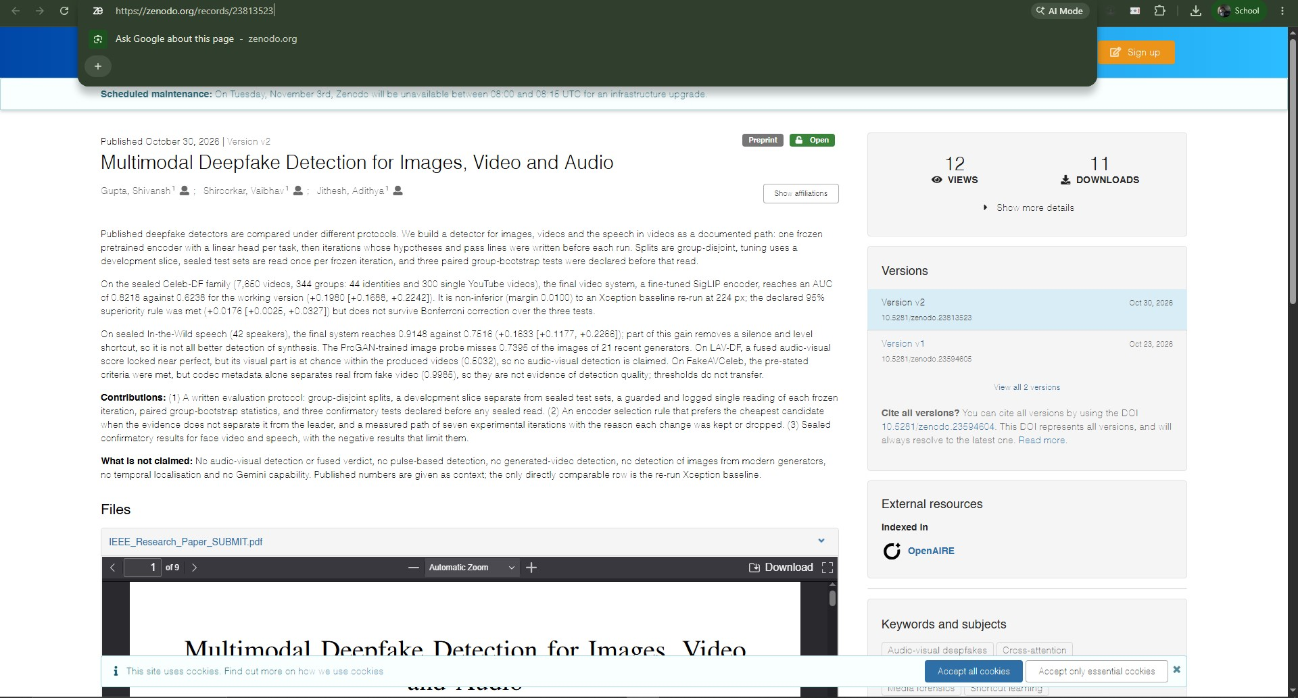
Figure 1. Zenodo record 23813523, Version v2, published October 30, 2026, with the file IEEE_Research_Paper_SUBMIT.pdf attached.

3. Contribution of each team member to the Task 29 research paper
The three authors contributed equally to this paper. Each author is responsible for the sections below.
Member | Contribution to this paper
Shivansh Gupta  (16014023052) | Abstract; Introduction (Section I); preprocessing, head, calibration and threshold (Section III-B); sealed tests, metrics and statistics (Section IV-B); results after the freeze (Section V-D); Conclusion (Section VIII).
Vaibhav Shiroorkar  (16014024805) | Data and group-disjoint splits (Section IV-A); confirmatory tests (Section IV-C); sealed results and confirmatory tests (Section V-B); thresholds and false alarms (Section V-C); Limitations (Section VII).
Adithya Jithesh  (16014024803) | Related Work (Section II); tasks and score semantics (Section III-A); encoder sweep and cost rule (Section III-C); from the working version to the frozen system (Section V-A); comparison with published results (Section V-E); Discussion (Section VI).

