
Somaiya Vidyavihar University
K. J. Somaiya School of Engineering
Department of Electronics and Computer Engineering
Multimodal Deepfake Detection for Images, Video and Audio
A Hypothesis-Driven Study Under a Source-Disjoint Protocol
Submitted In Partial Fulfillment of Requirements
For the Degree Of
Bachelor of Technology
(Electronics and Computer Engineering)
By
Vaibhav Shiroorkar | Roll No: 16014024805
Shivansh Gupta | Roll No: 16014023052
Adithya Jithesh | Roll No: 16014024803
Guide
Dr. Tejashree Phatak
Assistant Professor
Somaiya Vidyavihar University
Vidyavihar, Mumbai - 400 077
2026-2027

Somaiya Vidyavihar University
K. J. Somaiya School of Engineering
Certificate
This is to certify that the project report entitled “Multimodal Deepfake Detection for Images, Video and Audio” submitted by the following students at the end of Semester VII of LY B. Tech is a bona fide record for partial fulfillment of requirements for the degree of Bachelor of Technology (Electronics and Computer Engineering) of Somaiya Vidyavihar University.
Vaibhav Shiroorkar | (16014024805)
Shivansh Gupta | (16014023052)
Adithya Jithesh | (16014024803)

Guide  Dr. Tejashree Phatak | Head of the Department  Dr. Jagannath Nirmal
Examiner | Director
Date:
Place: Mumbai-77
Somaiya Vidyavihar University
K. J. Somaiya School of Engineering
Declaration
We declare that this written report submission represents the work done based on our and / or others’ ideas with adequately cited and referenced the original source. We also declare that we have adhered to all principles of intellectual property, academic honesty and integrity as we have not misinterpreted or fabricated or falsified any idea / data / fact / source / original work / matter in our submission.
We understand that any violation of the above will be cause for disciplinary action by the college and may evoke the penal action from the sources which have not been properly cited or from whom proper permission is not sought.
Signature of the Student  Vaibhav Shiroorkar  Roll No. 16014024805 | Signature of the Student  Shivansh Gupta  Roll No. 16014023052
Signature of the Student
Adithya Jithesh
Roll No. 16014024803
Date:
Place: Mumbai-77

Acknowledgement
We would like to express our sincere gratitude to our project guide, Dr. Tejashree Phatak, Assistant Professor, Department of Electronics and Computer Engineering, K. J. Somaiya School of Engineering, for her guidance, advice and encouragement throughout this project.
We thank Dr. Jagannath Nirmal, Head of the Department of Electronics and Computer Engineering, for the facilities that made the work possible, and the faculty and staff of K. J. Somaiya School of Engineering for their support.
We acknowledge the authors of the datasets used in this work, FaceForensics++, Celeb-DF, Celeb-DF++, DeepFakeDetection, ASVspoof 2019, In-the-Wild, LAV-DF and the ForenSynths generated-image sets, who made them available for research, and the developers of the open-source software on which the project is built, among them PyTorch, timm, Hugging Face Transformers, OpenCV and Flask.
Finally we thank our families and friends for their patience and support.

Abstract
Published deepfake detectors report high scores on the data they were developed against and markedly lower scores on data from other sources. This project builds, from zero, a system that takes an image, a video with its audio track, or a standalone audio clip and returns a calibrated probability that the content is fake, together with a separate visual score and audio score so that the user can see which modality carries the evidence. It does not localise a manipulation in time.
The work follows a documented path. A working version uses a frozen pretrained encoder for each task and a linear head, with temperature scaling and a threshold that are fixed on validation data only. Seven further iterations follow, each starting from a written hypothesis, a success criterion and a failure criterion that precede the run; they cover fine-tuning depth, frame aggregation, loss and class weighting, augmentation and regularisation, combining encoders, late fusion with per-modality calibration and an experiment on the remote pulse signal (rPPG), followed by integration and freeze.
All data are split once and group-disjoint, where a group is the source video together with the person identity. A development slice of each cross-dataset source is used to rank candidates; the sealed test sets are touched once per frozen iteration through a guarded command that writes a ledger. Uncertainty is reported with group bootstrap intervals and several seeds, candidates are compared in a paired way, and a result is called comparable with a published detector only if it is non-inferior to a re-run of that detector on the same protocol.
The report describes the mathematical background, the evaluation harness and its acceptance test, the datasets and their licences, the shared preprocessing, the design of the encoder comparison, the working version, the iteration ladder, the local web application and the test protocol. Measured results of the encoder comparison and of the iterations are marked as pending until their runs are frozen.
Keywords: deepfake detection, multimodal, group-disjoint evaluation, frozen encoders, calibration, group bootstrap, non-inferiority, remote photoplethysmography.

Contents
Acknowledgement iii
Abstract iv
List of Figures vii
List of Tables viii
Nomenclature ix
Chapter 1 Introduction 1
1.1 Background 1
1.2 Motivation 2
1.3 Problem Statement and Scope 2
1.4 Objectives 3
1.5 Approach and Constraints 4
1.6 Organisation of the Report and Outline of the Next Chapter 4
Chapter 2 Literature Survey 5
2.1 Face-video Datasets and Benchmarks 5
2.2 Visual Detectors and the Generalisation Problem 6
2.3 Detection of Fully Generated Images 7
2.4 Speech Anti-spoofing 7
2.5 Audio-visual Detection 8
2.6 Physiological Signals 9
2.7 Evaluation Methodology, Calibration and Adaptation 9
2.8 Research Gap and Objective of the Work 10
2.9 Summary and Outline of the Next Chapter 10
Chapter 3 Mathematical Background 11
3.1 Notation and Setting 11
3.2 Error Rates, the ROC Curve and the Area under It 11
3.3 Equal Error Rate 12
3.4 Precision, Accuracy and Balanced Accuracy 12
3.5 Probabilistic Metrics: Log Loss, Brier Score and Calibration Error 13
3.6 Platt Scaling and Temperature Scaling 14
3.7 Group Bootstrap Intervals 15
3.8 Paired Comparison of Two Models 15
3.9 Non-inferiority and the Tie Set 16
3.10 Which Quantity Sees What 16
3.11 Linear Probe, Binary Cross-Entropy and Class Weights 17
3.12 Fine-tuning Depth: Low-rank Adapters 18
3.13 Frame-to-video Aggregation 18
3.14 Loss Functions 19
3.15 Regularisation and Augmentation 19
3.16 Combining Encoders 20
3.17 Late Fusion of Audio and Visual Scores 20
3.18 The Pulse Signal and Its Signal-to-noise Ratio 21
3.19 Summary and Outline of the Next Chapter 22
Chapter 4 Implementation and Experimentation 23
4.1 Environment 23
4.2 Datasets, Splits and Licences 24
4.2.1 Group-disjoint splits 25
4.2.2 Celeb-DF++ and the balance of its sealed test set 26
4.2.3 Leakage check 27
4.3 Shared Preprocessing 27
4.4 Evaluation Harness and Its Acceptance Test 29
4.5 Design of the Encoder Comparison 30
4.6 The Working Version (Iteration 0) 33
4.7 The Iteration Ladder 35
4.7.1 Fine-tuning budget of iteration I-1 37
4.7.2 The pulse experiment (iteration I-7) 37
4.7.3 Integration and freeze (iteration I-8) 38
4.8 The Web Application 39
4.9 The Staircase Test Protocol 41
4.10 Summary and Outline of the Next Chapter 42
Chapter 5 Conclusions and Further Work 44
5.1 Conclusions 44
5.2 Further Work 45
References 47
Appendix A Fixed Settings of the Working Version 51
Appendix B Weights Recorded Before Use 52

List of Figures
Figure 1. Plan of the seven days to submission, 24 to 30 October 2026. An iteration not finished by the end of Wednesday is reported as not run. (schematic) 4
Figure 2. Group-disjoint splits and the access rules. The development slice and the sealed test set of a cross-dataset source share no group, identity or file content. (schematic) 26
Figure 3. Shortlist of the encoder comparison. Entries marked pending are filled from the extraction records when they are final. 31
Figure 4. From a file to a calibrated score. The encoders are frozen, the temperature and the threshold are fixed on validation data, and the scores are probabilities of fake. (schematic) 34
Figure 5. Iteration ladder. Each step from I-1 to I-6 starts from the diagnostic battery of the preceding step. (schematic) 36
Figure 6. Processing chain of the pulse signal check and its negative control. (schematic) 38
Figure 7. The local web page against the development stand-in: (a) result for an image, (b) result for a video. The banner is part of the design and the scores shown are not measurements. (screenshots against the stand-in) 41
Figure 8. Staircase test protocol. Verdicts on the development slice are exploratory; each frozen iteration is evaluated once on the sealed test sets and the two pre-declared comparisons are the confirmatory claims. (schematic) 42

List of Tables
Table 1. Inputs, outputs and claims of the system. 3
Table 2. Published results quoted as context. Each row names the protocol under which it was measured; none is a result of this project and no two rows are comparable. 6
Table 3. What each quantity depends on. 17
Table 4. Environment of all experiments, as measured. 23
Table 5. Sizing probe: one training step of a trivial network, batch of 256 images of 3 by 224 by 224. 24
Table 6. Data sets in use, their roles and their licences or terms of use. All are for research use only. 24
Table 7. Development slices and sealed test sets of the cross-dataset sources (real / fake counts where both exist). 26
Table 8. Preprocessing of each input type. 28
Table 9. Face detector comparison (measurements; the machine was busy with 13 to 20 percent of the processor before each run, and the 200-video sample is warm in the file cache). 28
Table 10. Acceptance checks of the evaluation harness and the data tools. 30
Table 11. The three tasks of the comparison. 30
Table 12. Weights of the shortlisted encoders and their licence labels. 31
Table 13. Outcome of the encoder comparison per task, on the development slice (exploratory). 33
Table 14. Primary candidate lever, trigger, prediction and failure line of iterations I-1 to I-6. The predictions are hypotheses written before any run. 36
Table 15. Fields of the response of the inference library. 40
Table 16. Fixed settings of the working version. 51
Table 17. Weight files of the shortlisted encoders. 52

Nomenclature
Symbols
Symbol | Meaning
​$y_{i}$ | label of example i, 1 for fake and 0 for real
​$s_{i}, {\hat{p}}_{i}$ | score and predicted probability of fake
​$n_{0}, n_{1}, n, π$ | numbers of real and fake examples, their sum and the fake prevalence
​$t, t^{*}$ | decision threshold and the threshold at which the two error rates are equal
TPR, FPR, TNR, FNR | true positive, false positive, true negative and false negative rates
​$σ(u)$ | logistic function, 1 / (1 + exp(-u))
​$T$ | temperature of temperature scaling, or the number of frames of a video (context decides)
​$M, B_{m}$ | number of calibration bins and the examples in bin m
​$B, α$ | number of bootstrap resamples and the significance level
​$Δ, δ$ | difference of a metric between two models and the non-inferiority margin
​$r$ | rank of a low-rank adapter
​$ρ$ | correlation of the scores of frames or of encoders
​$l$ | logit, the log-odds of the fake class

Abbreviations
Abbreviation | Meaning
AUC | area under the ROC curve
AP | average precision
BA | balanced accuracy
ECE | expected calibration error
EER | equal error rate
ROC | receiver operating characteristic
GAN | generative adversarial network
rPPG | remote photoplethysmography, the pulse visible in skin colour
SNR | signal-to-noise ratio
POS | plane orthogonal to skin, a projection method for the pulse signal
LoRA | low-rank adaptation
FF++ | FaceForensics++
DFD | DeepFakeDetection data set
LAV-DF | localized audio visual deepfake data set
dev_x | development slice of a cross-dataset source
test_in, test_x | sealed in-dataset test and sealed cross-dataset test
I-0 to I-8 | working version, iterations 1 to 7 and the integration and freeze step
c23, c40 | FaceForensics++ compression levels
YuNet | face detector used by the preprocessing

Chapter 1
Introduction
This chapter presents the background and the motivation of the project, states the problem and its scope, lists the objectives, describes the way the work was organised and gives the outline of the report.

Background
Deepfakes are images, videos and audio clips that a learned model has generated or altered so that they show a person doing or saying something that did not happen, or show a scene that never existed. Five kinds of manipulation matter for this project: a face in a video replaced by another face (face swap); a face whose expression and head movement are driven by another person (re-enactment); a face animated from a still image and a speech signal (audio-driven talking face); a whole image produced by a generative network, either a generative adversarial network (GAN) or a diffusion model; and speech that is synthesised from text or converted from another speaker. A video can also be manipulated in its picture and in its sound separately, so that one modality is real and the other is not.
The research community has built benchmark data sets for each of these cases. FaceForensics++ holds 1,000 real videos and 4,000 videos manipulated with four methods at three compression levels [1]; Celeb-DF contains 590 real videos of 59 celebrities and 5,639 face-swap videos [2]; the DeepFake Detection Challenge data set adds over 100,000 clips of paid actors [3]; and for speech the ASVspoof 2019 database provides synthesised, converted and replayed attacks [4]. Detectors trained on these sets reach high scores on test data drawn from the same set.
The scores fall when the test data come from another source. In the DeepfakeBench benchmark, a plain Xception network trained on FaceForensics++ at the c23 compression level reaches a mean AUC of 94.5 over the six tests inside FaceForensics++ and 77.2 over eight other data sets (AUC in percent, frame level, the benchmark’s own protocol) [5]. For speech, one study that re-implemented twelve architectures under one protocol found a lowest equal error rate of about 1.2 percent on the evaluation split of ASVspoof 2019 and a lowest of about 33.9 percent on its separate In-the-Wild set, reached by a different model [6]. On the DeepFake Detection Challenge, the best models on content that was not made for the challenge reached an average precision of 75.3 and a ROC-AUC of 73.4 (percent) [3]. These numbers come from different protocols and are context only: they are never compared with the results of this project.

Motivation
Three observations from the literature shaped the project. First, reported numbers rarely share a protocol, so a table of published scores cannot show whether a new detector is better or worse than another; only a re-run of both under one protocol can. Second, binary face-forgery classifiers trained on FaceForensics++ learn information about the identity of the person in the picture [7], so a split that lets a person appear on both sides of the boundary measures memorisation of faces. Third, a full-text search of eight detector papers read for this survey found no mention of seeds, standard deviations or confidence intervals, although the seed-to-seed spread in audio detection reaches several points of equal error rate [6].
There is also a practical motivation. A person who receives a suspicious file needs a probability that is calibrated, so that 0.9 means what it says, and needs to know which modality carries the evidence: the picture, the sound or both. The system therefore returns a separate visual and audio score for a video instead of a single opaque number.
Finally, the project is a final-year project and its purpose is to show a documented path: a simple working version first, then at least seven iterations that each improve something for a stated reason, ending at results that can be compared with published detectors on a protocol that the project defines and runs itself. The goal is not the best model in the world. The report is written for a reader who asks “why this and not that”, so each choice is tied to a written decision and, where one exists, to an experiment.

Problem Statement and Scope
Given an image, a video with its audio track, or a standalone audio clip, the system returns the probability that the content is fake, and states which modality carries the evidence. Fake means a swapped, re-enacted or audio-driven face, a fully generated image (GAN or diffusion), synthesised or converted speech, or audio and video manipulated separately. Table 1 lists what is returned for each input.
Table 1. Inputs, outputs and claims of the system.
Input | What is returned | What is claimed
Still image | One visual score. A face crop is scored if a face is found, otherwise the whole image | A calibrated probability of fake for that kind of image; the path taken is reported
Video with an audio track | A visual score and an audio score, shown side by side | Each score for its own modality; no combined score is claimed until the combining rule is decided and tested
Video without audio | A visual score; the audio score is reported as unavailable, with the reason | A visual probability only
Standalone audio file | One audio score | A calibrated probability of fake speech

The system does not locate a manipulation in time, because temporal labels are not available in every data set. It makes no claim about kinds of content that its training and test data do not cover, and it states, in a fixed sentence next to every score, that the score is a calibrated probability from a model fitted on the training data of this project, valid only for the kinds of content in that data, and that it is not proof.

Objectives
The objectives of the project work are the following.
- Build the whole system from zero in one repository: data preparation, an evaluation harness, a detector for each of the three tasks (face video frames, generated images, speech audio), an inference library and a local web page.
- Define one evaluation protocol before any model exists, with group-disjoint splits, a development slice for ranking, sealed test sets and a guard that refuses test data unless a run is flagged as final.
- Compare candidate pretrained encoders under that protocol, with a rule that prefers the cheaper candidate when the evidence does not separate them.
- Develop the system in iterations, each starting from a written hypothesis, a success criterion and a failure criterion, and keep failed iterations in the record.
- Test remote photoplethysmography, the pulse visible in skin colour, as a candidate improvement and adopt it only if the evidence on the development slice supports it.
- State “comparable with published detectors” in a checkable way: non-inferior, on the same protocol, to a re-run of a published detector.
- Produce the software, an IEEE-format paper, this report and a presentation, all from the same logged evidence.

Approach and Constraints
The project runs over seven calendar days, from 24 to 30 October 2026, on one desktop machine with one NVIDIA GeForce RTX 5070 GPU of 12 GB. The schedule was organised so that every iteration is complete by itself: hypothesis, run, result, decision. An iteration that is not finished by the end of Wednesday is reported as not run, not as a result. Figure 1 shows the plan.
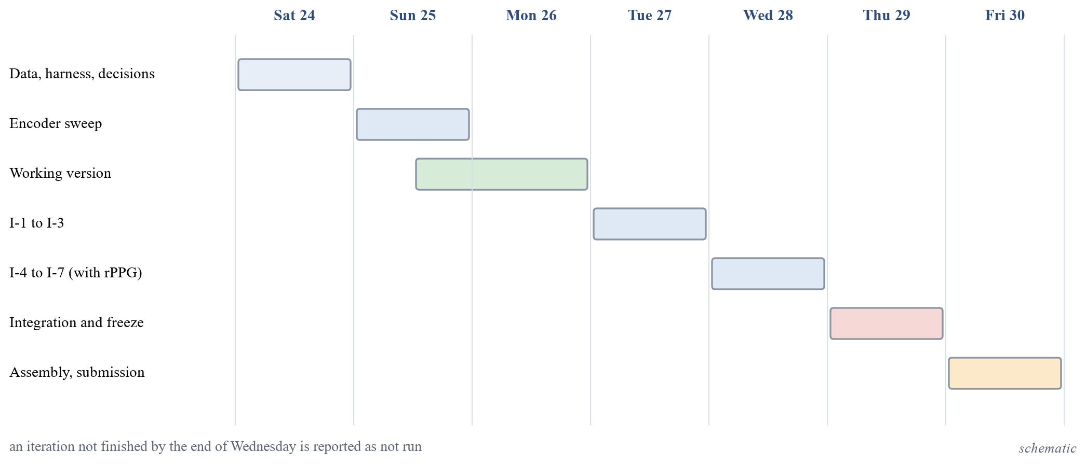
Figure 1. Plan of the seven days to submission, 24 to 30 October 2026. An iteration not finished by the end of Wednesday is reported as not run. (schematic)
Five working rules governed every step. Nothing unmeasured is written as a result: each number in a document comes from a logged experiment, and observations that are not measurements are labelled as such. The hypothesis, the success criterion and the failure criterion of every iteration and comparison are written before the run. The test data are never used for tuning: data are split once, by group, tuning uses only training and validation data, and the sealed test sets are touched once per frozen iteration. Candidates are compared on the same data, split, budget and metric, with several seeds, the mean, the standard deviation and a bootstrap interval; if the intervals of the difference include zero, the cheaper candidate is preferred and the report says so. Failed runs stay in the log.

Organisation of the Report and Outline of the Next Chapter
Chapter 2 surveys the literature and ends with the research gap that the objectives address. Chapter 3 gives the mathematical background: the metrics, the group bootstrap, the paired and non-inferiority comparisons and the argument behind each lever of the iteration ladder. Chapter 4 describes the implementation and the experimental design, from the environment and the data to the web application and the test protocol. Chapter 5 gives the conclusions and the further work. The references and two appendices follow.

Chapter 2
Literature Survey
This chapter presents the literature that the project builds on: the data sets and benchmarks, the visual, image, speech and audio-visual detectors, the evidence on the pulse signal, and the work on evaluation and adaptation. It ends with the research gap and the objective of the work.

Face-video Datasets and Benchmarks
FaceForensics++ is the standard training set for face forgery [1]. It contains 1,000 real videos and about 1.8 million fake images from 4,000 fake videos made with four methods (DeepFakes, Face2Face, FaceSwap and NeuralTextures) at three compression levels, raw, c23 and c40. Its fixed split uses 720, 140 and 140 videos for training, validation and test, and the faces are cropped with an enlargement factor of 1.3 before classification, a value that the preprocessing of this project reuses. With the in-dataset test videos, per-frame accuracy of an XceptionNet on cropped faces was 99.26, 95.73 and 81.00 percent at the three levels, which shows the sensitivity to compression.
Celeb-DF was built to be harder: 590 real videos of 59 celebrities and 5,639 face-swap videos made with an improved synthesis pipeline [2]. Nine existing detectors, run with their released models and without retraining, reached a frame-level AUC of 65.3 (Xception trained at c23) and lower for others, and Celeb-DF gave the lowest average AUC of the data sets compared. The DeepFake Detection Challenge data set contains over 100,000 clips of 3,426 paid and consenting actors, with a subject-disjoint public test set [3]; on content that was not made for the challenge the log loss of the best models was close to the value of a constant prediction.
Celeb-DF++ extends Celeb-DF with 22 recent generation methods, namely 8 face-swap methods including the original, 7 re-enactment methods and 7 talking-face methods, over the same 590 real videos of 59 identities, and defines three generalisation protocols [8]. A detector trained on FaceForensics++ lost on average 5.2 points of frame-level AUC on Celeb-DF++ compared with Celeb-DF. DeepfakeBench unifies 15 detectors, 9 data sets, one preprocessing pipeline and one set of metrics [5]; trained on FaceForensics++ c23, a plain Xception and an EfficientNet-B4 had the same mean cross-domain AUC (77.2) and were within one to two points of more elaborate detectors, which suggests that the backbone and the training recipe matter at least as much as the method name.
Table 2. Published results quoted as context. Each row names the protocol under which it was measured; none is a result of this project and no two rows are comparable.
Source | Protocol of the source | Quantity | Value
FaceForensics++ [1] | In-dataset, XceptionNet, c23, per frame | Accuracy (percent) | 95.73
Celeb-DF [2] | Released detectors, not retrained, Celeb-DF | Frame AUC of Xception-c23 (percent) | 65.3
DeepfakeBench [5] | Train FF++ c23; plain Xception | Mean AUC within FF++ / across 8 sets (percent) | 94.5 / 77.2
LipForensics [9] | Train FF++, cross-dataset, video level | AUC on Celeb-DF / DFDC (percent) | 82.4 / 73.5
Effort [10] | Train FF++ c23, video level, 7 data sets | Mean AUC (percent) | 91.7
Ojha et al. [11] | Train ProGAN, test unseen diffusion and autoregressive models | Mean AP, linear probe on CLIP / trained baseline | 95.00 / 75.51
AASIST [12] | ASVspoof 2019 LA evaluation | EER, best seed / mean of 3 seeds (percent) | 0.83 / 1.13
Muller et al. [6] | Train ASVspoof 2019, test In-the-Wild | Lowest EER over 12 models (percent) | about 33.9
FakeAVCeleb [13] | Own test set, three fake categories | Best audio-only AUC / video-only AUC (percent) | about 97.8 / 93.3
LAV-DF [14] | Own test split, identity-independent | Classification AUC of its multimodal method (percent) | 99.0

Visual Detectors and the Generalisation Problem
Face X-ray predicts the blending boundary between a pasted face and its background and is trained on self-made blended real images, so that no fake from any generator is needed [15]. Trained on blended images only it reached a cross-dataset AUC on Celeb-DF of 74.76, against 36.19 for an Xception trained on FaceForensics++ (percent). Self-blended images take the idea further: a real face is copied, augmented and blended back with a deformed mask, and an EfficientNet-B4 trained on such images from real FaceForensics++ videos only reached a video-level AUC of 93.18 on Celeb-DF v2 in its own paper [16]. The same paper states that the method fails on whole-image synthesis and reports one run per entry with no seeds or intervals.
LipForensics pretrains a network for lipreading and fine-tunes only its temporal part, with the feature extractor frozen [9]. In its ablation, the frozen extractor gave an accuracy of 87.5 and 90.4 percent on two unseen manipulation sets, against 83.2 and 84.6 when the whole network was fine-tuned; this is evidence that more trainable capacity does not always transfer better, which the fine-tuning iteration of this project tests directly. Dong et al. showed with a linear probe on frozen detector features that binary classifiers trained on FaceForensics++ encode identity [7], which is the reason why the splits of this project are disjoint in identity as well as in source video.
Adapting a large frozen vision-language encoder has recently given strong cross-dataset numbers. The Effort detector decomposes the attention weights of a CLIP ViT-L/14 by singular value decomposition, freezes the dominant part and trains a small residual with 0.19 million parameters, and reached a mean video-level AUC of 91.7 percent over seven data sets when trained on FaceForensics++ c23 [10]. The paper reports no seeds or intervals, and its ablations were run on the same test sets as its headline, so the number is context and not a target. Kornblith et al. compared 16 networks on 12 image data sets as fixed feature extractors and as fine-tuned models and found that ImageNet accuracy correlates with transfer accuracy for both, although some regularisers that raise ImageNet accuracy hurt the transfer of frozen features [17]. The study concerns natural images and not forensic detection, so it motivates the encoder comparison without answering it.

Detection of Fully Generated Images
A ResNet-50 trained on ProGAN images only, with blur and JPEG augmentation, detected images from unseen CNN generators with a mean average precision above 90 over eleven generators [18]. The paper also separates two ways of choosing the decision threshold: a threshold tuned on the test distribution (the “oracle”) gave an accuracy of 96.8 on StyleGAN images against 87.1 for the threshold fixed on training data, which is why the threshold of this project is chosen on validation data only. Ojha et al. replaced the trained network by a nearest-neighbour or a linear classifier in the frozen feature space of CLIP ViT-L/14 [11]. Trained on ProGAN, the linear probe reached a mean AP of 99.31 on GAN-family test sets and 95.00 on unseen diffusion and autoregressive models, against 94.19 and 75.51 for the best trained network; their training set was far larger than the one used here. Cozzolino et al. obtained robust results with a linear support vector machine on CLIP features trained on a few pairs of real and generated images [19].
Shortcuts are a risk in these data sets. In GenImage the real images are JPEG files of varied size while the fakes are PNG files of fixed size, so a detector can learn compression and size; after removing both biases the cross-generator accuracy of a ResNet-50 rose from 71.68 to 82.74 percent [20]. The generated-image path of this project therefore checks content duplicates across splits and states the class balance of every test set.

Speech Anti-spoofing
The ASVspoof 2019 database defines logical-access attacks (speech synthesis and voice conversion) and physical-access attacks (replay), with training, development and evaluation partitions that are disjoint in speakers and an evaluation set that contains attacks unseen in training [4]. AASIST applies graph attention to the raw waveform and reached 0.83 percent EER on the logical-access evaluation set in its best seed and 1.13 percent as the mean of three seeds; the authors note that the headline is the best of three seeds and that one baseline varied between 1.19 and 2.06 percent across seeds [12]. A RawNet2 front end was worse than a feature-based baseline when used alone and better in fusion with it [21].
Pretrained self-supervised encoders changed the picture. Replacing the front end of AASIST by wav2vec 2.0 lowered the EER on ASVspoof 2021 logical access from 11.47 to 6.15 percent (best seed) with nothing else changed [22]. The ASVspoof 2021 challenge showed the danger of a development partition: on the deepfake task the best EER fell to 0.10 percent in the progress phase and was 15.6 percent in the evaluation phase [23]. The In-the-Wild study re-implemented twelve architectures under one protocol, trained them on ASVspoof 2019 and tested them on 37.9 hours of public recordings of 58 speakers; many models were close to chance, and the standard deviation over three seeds reached 15 EER points [6]. The speech encoders in the shortlist of this project, wav2vec 2.0 [24], WavLM [25], HuBERT [26] and the Whisper encoder [27], are the pretrained models that this literature suggests, used here frozen.

Audio-visual Detection
FakeAVCeleb contains 500 real and 19,500 fake videos with synthesised, lip-synchronised audio [13]. Audio-only detectors reached an AUC of about 97.8 percent and video-only detectors about 93.3 percent on its test set, whereas ensembles of unimodal detectors were at best 82.8 and often near 50, and published multimodal models 53.3 to 68.8, so naive combination was not reliable. Chugh et al. computed a modality dissonance score between the audio and the video stream and reached a video-level AUC of 91.54 percent on a DFDC subset [28]. Zhou and Lim compared independently trained streams combined by an OR rule with joint training; on FaceForensics++ and DFDC the independent streams reached a whole-sequence accuracy of 95.83 and 89.36 percent and joint late fusion 94.25 and 89.15 percent, so joint fusion alone was no better [29].
LAV-DF contains 136,304 videos of 153 identities, in which words of the transcript are replaced and only the changed segments are regenerated in audio and in video; its four label types (real, video modified, audio modified, both) and its identity-independent split make it suitable for per-modality questions [14]. AV-Deepfake1M is larger, with 1,146,760 videos, and shows that in-dataset numbers of different data sets cannot be compared: the same Xception had an AUC of 83.58 on LAV-DF and 68.68 on AV-Deepfake1M [30]. In the audio-visual detectors read for this survey, none handled a missing modality inside the model, although a still image or a silent video needs it.

Physiological Signals
FakeCatcher extracts photoplethysmography-like signals from facial regions and classifies them with a support vector machine or a CNN, with in-dataset video accuracy of 96, 94.65, 91.50 and 91.07 percent on four sets [31]; a follow-up addressed source attribution with biological signals [32]. DeepFakesON-Phys fine-tuned a heart-rate estimation network as a detector and reached an in-dataset AUC of 99.9 percent on Celeb-DF v2 and 98.2 on DFDC Preview, with identity-disjoint development and test sets [33]. DeepRhythm reached an accuracy of 98.0 percent on FaceForensics++ but 64.1 percent when tested on DFDC Preview, and its ablation shows that without motion magnification the plain map scores near 50 percent, so the discriminative signal may be an amplified artefact and not a pulse [34].
Newer evidence is mixed. A study with ECG and photoplethysmography ground truth found that high-quality face swaps do carry a pulse: the heart-rate error was 1.80 beats per minute for genuine videos, 1.85 for autoencoder fakes and 3.24 for real-time DeepFaceLive fakes, and the pulse of a fake followed the driving video [35]. A reproduction of DeepFakesON-Phys on talking-face fakes of Celeb-DF++ scored an AUC of 62.2 percent against 99.9 in its original setting [36]; the authors of that preprint later describe their rPPG-derived signal as not shown to be cardiac and note that real and fake videos differ in frame rate [37]. On fakes built from data sets with contact-sensor ground truth, the heart-rate error grew from 3.13 beats per minute for real videos to 5.70 for face swap and 12.51 for motion transfer [38]. Pulse signals can also be forged on purpose [39]. The pulse extraction itself, the POS algorithm, was developed on uncompressed laboratory video, and its authors judged one compressed data set unsuitable because compression may remove or pollute the pulse [40]. These results motivate treating the pulse as an experiment with written thresholds and not as an adopted component.

Evaluation Methodology, Calibration and Adaptation
Guo et al. showed that modern networks are poorly calibrated and that temperature scaling, a single parameter fitted on a validation set, usually gives the best ECE among the calibration methods they compared; they define ECE with 15 equal-width bins [41]. The studies above show repeatedly that the threshold, the aggregation of frame scores and the number of seeds change the headline number, which is why the project fixes them in a protocol before any model exists.
Low-rank adaptation freezes the pretrained weights and trains a low-rank update, which reduced the trainable parameters of GPT-3 175B by about 10,000 times and the memory for training from 1.2 TB to 350 GB [42]; the study is on language models. In the Effort protocol (trained on ProGAN, mean accuracy at a fixed threshold), a linear probe scored 81.02, full fine-tuning 86.22 and low-rank variants 91.06 to 93.53 [10], although the rank was chosen on the test sets used for the headline. The encoders of the shortlist of this project are EfficientNet [43], Xception [44], DINOv2 [45], CLIP [46] and SigLIP [47] for images, and the four speech encoders named above; faces are found with the YuNet detector [48].

Research Gap and Objective of the Work
The survey leads to four observations. The numbers of published detectors come from protocols that differ in training data, splits, thresholds and aggregation, so they cannot stand in for a comparison. In the eight detector papers searched, uncertainty over groups and over seeds was not mentioned, while the measured seed spread of audio detectors is large. The identity of the person is a shortcut that a split must remove. The pulse signal has contradictory evidence on current generators. No complete path from a minimal working version to a documented improvement, with the hypothesis written before each run and every comparison paired, was found for the combination of images, video and audio.
The objective of the project work is therefore to build such a system and path: a multimodal detector for images, video and audio, developed from a working version through seven hypothesis-driven iterations, evaluated on group-disjoint splits with intervals over groups and seeds, and compared with a published detector family re-run under the same protocol, with “comparable” defined as non-inferior.

Summary and Outline of the Next Chapter
This chapter reviewed the data sets, detectors and evidence in the literature, quoted their results only with their own protocols, and stated the research gap and the objective. Chapter 3 now gives the mathematical background of the metrics, the uncertainty estimates and the levers of the iteration ladder.

Chapter 3
Mathematical Background
This chapter presents the definitions and the short derivations that the later chapters rely on: error rates, ranking and calibration metrics, the group bootstrap and the paired tests, and the argument behind each lever of the iteration ladder, with its assumption and the conditions under which it does not help.

Notation and Setting
Each example i has a label $y_{i}∈\{0,1\}$, where 1 means fake and is the positive class and 0 means real. A model gives a score $s_{i}∈R$; when the score is the probability of the fake class it is written ${\hat{p}}_{i}∈[0,1]$. The numbers of fake and real examples are $n_{1}$ and $n_{0}$, their sum is $n$, and the fake prevalence is
 | $$π=\frac{n_{1}}{n}, n=n_{0}+n_{1}$$ | (1)
A decision rule with threshold $t$ predicts fake when $s_{i}≥t$. At a threshold, $TP$, $FP$, $TN$ and $FN$ are the counts of true positives, false positives, true negatives and false negatives. Population statements use $S_{1}$ for the score of a randomly drawn fake and $S_{0}$ for the score of a randomly drawn real example. The unit that is resampled in the uncertainty estimates is the group, which is the source video together with the person identity (Chapter 4).

Error Rates, the ROC Curve and the Area under It
The true positive rate and the false positive rate at threshold $t$ are conditioned on the true class, so they do not depend on the prevalence $π$:
 | $$TPR(t)=\frac{TP}{TP+FN}=P(S≥t|Y=1), FPR(t)=\frac{FP}{FP+TN}=P(S≥t|Y=0)$$ | (2)
The false negative rate is $1-TPR$ and the true negative rate (specificity) is $1-FPR$. The ROC curve is the set of points $(FPR(t),TPR(t))$ traced as $t$ moves from $+∞$, which gives the point $(0,0)$, to $-∞$, which gives $(1,1)$. The area under it is
 | $$AUC=\int_{0}^{1}{TPR d(FPR)}$$ | (3)
The ranking interpretation follows from a change of variable. Let $F_{0}(t)=P(S_{0}≤t)$ for continuous score distributions. Then $FPR(t)=1-F_{0}(t)$ and $TPR(t)=P(S_{1}≥t)$, and substituting $u=1-F_{0}(t)$ gives $AUC=\int{P(S_{1}≥t) dF_{0}(t)}=P(S_{1}>S_{0})$. When ties are allowed the general form is
 | $$AUC=P(S_{1}>S_{0})+\frac{1}{2} P(S_{1}=S_{0})$$ | (4)
so the AUC is the probability that a random fake receives a higher score than a random real example. The empirical estimate is the Mann-Whitney form, where $U$ is the Mann-Whitney statistic:
 | $$\hat{AUC}=\frac{1}{n_{1}n_{0}}\sum_{i: y_{i}=1}{ \sum_{j: y_{j}=0}{\left[1(s_{i}>s_{j})+\frac{1}{2}1(s_{i}=s_{j})\right]}}=\frac{U}{n_{1}n_{0}}$$ | (5)
The AUC lies in $[0,1]$; $0.5$ means ranking no better than chance and $1$ means that every fake outranks every real example. It is unchanged by any strictly increasing transformation of the scores, so it does not see calibration or the threshold, and its population value does not depend on the prevalence. These properties are why it is the headline metric of the project: the test sets are unbalanced (the pooled Celeb-DF family test set is 89 percent fake), and a metric that depended on the class ratio would change with the test set and not with the detector.

Equal Error Rate
The equal error rate is the common value of the two error rates at the threshold $t^{*}$ where they are equal:
 | $$FPR(t^{*})=FNR(t^{*}), EER=FPR(t^{*})$$ | (6)
On a finite sample the two rates are step functions and may not cross exactly. A common estimate takes the threshold that minimises the gap and averages the two rates there:
 | $$\hat{t}=\underset{t}{arg min}\left|FPR(t)-FNR(t)\right|, \hat{EER}=\frac{1}{2}\left(FPR(\hat{t})+FNR(\hat{t})\right)$$ | (7)
The threshold $t^{*}$ is a property of the data on which it is computed; a threshold taken from one data set and applied to another no longer gives equal errors. Like the AUC, the EER uses only the ranking of the scores. It is reported for standalone speech, where it is the usual metric of the anti-spoofing literature and allows comparison with published tables [4, 12].

Precision, Accuracy and Balanced Accuracy
Precision depends on the prevalence. By Bayes’ rule
 | $$Precision(t)=\frac{TP}{TP+FP}=\frac{π TPR(t)}{π TPR(t)+(1-π) FPR(t)}$$ | (8)
so the same detector has a different precision on a test set with a different real-to-fake ratio, although its true and false positive rates stay the same. Accuracy and balanced accuracy are
 | $$Acc(t)=π TPR(t)+(1-π) TNR(t), BA(t)=\frac{1}{2}\left(TPR(t)+TNR(t)\right)$$ | (9)
The two agree when $π=1/2$. Accuracy rewards predicting the majority class when the classes are unbalanced, whereas balanced accuracy weights the two classes equally whatever $π$ is. Both depend on the threshold. The threshold of the project is the one that maximises balanced accuracy on the validation split of the training data set, and accuracy at a fixed 0.5 is reported only as a reference.

Probabilistic Metrics: Log Loss, Brier Score and Calibration Error
Three metrics see the probabilities and not only their ranking. The logarithmic loss is the negative mean log likelihood of the labels under the predicted probabilities; the probabilities are clipped to $[{10}^{-7},1-{10}^{-7}]$ before it is computed:
 | $$LL=-\frac{1}{n}\sum_{i=1}^{n}{\left[y_{i} ln {\hat{p}}_{i}+(1-y_{i}) ln (1-{\hat{p}}_{i})\right]}$$ | (10)
The Brier score is the mean squared error of the probabilities, a proper scoring rule whose expected value is minimised only by reporting the true conditional probability. Always predicting 0.5 gives 0.25 and always predicting the prevalence gives $π(1-π)$:
 | $$BS=\frac{1}{n}\sum_{i=1}^{n}{({\hat{p}}_{i}-y_{i})^{2}}∈[0,1]$$ | (11)
If the forecasts take $K$ distinct values $p_{k}$, with $n_{k}$ cases having that value, ${\overline{o}}_{k}$ the observed fake fraction among them and $\overline{o}=π$ the overall fake fraction, the Murphy decomposition separates reliability, resolution and uncertainty:
 | $$BS=\underset{\text{reliability}}{\underbrace{\frac{1}{n}\sum_{k}{n_{k}(p_{k}-{\overline{o}}_{k})^{2}}}}-\underset{\text{resolution}}{\underbrace{\frac{1}{n}\sum_{k}{n_{k}({\overline{o}}_{k}-\overline{o})^{2}}}}+\underset{\text{uncertainty}}{\underbrace{\overline{o}(1-\overline{o})}}$$ | (12)
For continuous forecasts the sums are taken over bins and the identity then holds only approximately. The reliability term plays the role of a squared-error version of the calibration gap.
A classifier is perfectly calibrated when $P(Y=1|\hat{p}=p)=p$ for all $p∈[0,1]$. The expected calibration error (ECE) measures the departure by binning. Fix $M$ equal-width bins $I_{m}=(\frac{m-1}{M},\frac{m}{M}]$ and let $B_{m}=\{i:{\hat{p}}_{i}∈I_{m}\}$. The project uses the top-label version of Guo et al. [41]: the confidence of example $i$ is ${\hat{c}}_{i}=max({\hat{p}}_{i},1-{\hat{p}}_{i})$, its predicted label is ${\hat{y}}_{i}=1({\hat{p}}_{i}≥0.5)$, the examples are binned by confidence and
 | $$ECE=\sum_{m=1}^{M}{\frac{|B_{m}|}{n}\left|acc(B_{m})-conf(B_{m})\right|}$$ | (13)
where the accuracy and the mean confidence of a bin are
 | $$acc(B_{m})=\frac{1}{|B_{m}|}\sum_{i∈B_{m}}{1({\hat{y}}_{i}=y_{i})}, conf(B_{m})=\frac{1}{|B_{m}|}\sum_{i∈B_{m}}{{\hat{c}}_{i}}$$ | (14)
with $M=15$. A second version bins the fake probability itself and compares the mean label with the mean probability in each bin; it gives a different number for the same predictions, so the version is always stated. ECE depends on $M$ and on the binning rule, is zero for a perfectly calibrated model and is estimated with bias on small bins.

Platt Scaling and Temperature Scaling
Given a raw score, for example a logit $s_{i}$, Platt scaling maps it to a calibrated probability by a logistic function with two scalar parameters fitted on a held-out calibration set by minimising the negative log likelihood [41]:
 | $$q_{i}=σ(a s_{i}+b), σ(u)=\frac{1}{1+e^{-u}}$$ | (15)
 | $$(\hat{a},\hat{b})=\underset{a,b}{arg min} -\sum_{i}{\left[y_{i} ln q_{i}+(1-y_{i}) ln (1-q_{i})\right]}$$ | (16)
This is a logistic regression with one feature, so the objective is convex in $(a,b)$. If $\hat{a}>0$ the map is increasing, so the ranking, the AUC and the EER do not change; only the probabilities change. Temperature scaling is the special case $b=0$ and $a=1/T$ with the single parameter $T>0$ fitted on the validation set by the same objective:
 | $$q_{i}=σ\left(\frac{s_{i}}{T}\right), \hat{T}=\underset{T>0}{arg min} -\sum_{i}{\left[y_{i} ln q_{i}+(1-y_{i}) ln (1-q_{i})\right]}$$ | (17)
It does not change the predicted class. The calibration set must be separate from the training data and from the test data. The project fits $T$ on the validation split of the training data set and reports ECE and the Brier score before and after scaling. Temperature scaling cannot repair a shift between data sets, so a large ECE on a cross-dataset test set after scaling is a finding about the shift and not an error of the fit.

Group Bootstrap Intervals
The data consist of $N$ independent units, here the groups of the protocol, and each unit may contain many examples such as frames or clips. A metric $θ$ (AUC, EER, balanced accuracy, ECE, Brier score) is computed from all examples and gives $\hat{θ}$. Examples inside one group are dependent, so the group and not the example is resampled. For $b=1,…,B$ the procedure draws $N$ groups with replacement, keeping all examples of each drawn group, and computes ${\hat{θ}}^{*b}$ on the resample $D^{*b}$. The $(1-α)$ percentile interval is
 | $$\left[q_{α/2}, q_{1-α/2}\right], q_{u}=u\text{-quantile of }{\left\{{\hat{θ}}^{*b}\right\}}_{b=1}^{B}$$ | (18)
The project uses $B=2000$ resamples, $α=0.05$ and a fixed base random seed. A resample that contains only one class is drawn again, because the AUC and the EER do not exist for one class. For a small number of groups the percentile interval can cover less than its nominal level; this is why an exact paired sign-flip permutation test over groups is run as a sensitivity check beside the bootstrap on the small development slices.
When a candidate is trained with several seeds, the metric is computed for every seed on each resample and averaged over the $S$ seeds, and the interval is that of the seed-averaged value:
 | $${\overline{θ}}^{*b}=\frac{1}{S}\sum_{s=1}^{S}{θ_{s}\left(D^{*b}\right)}$$ | (19)
The standard deviation over seeds of the point estimate is reported next to it. The two sources of uncertainty are different: resampling groups measures the uncertainty due to which groups are in the test set, whereas the seeds measure the variation due to training. Neither covers the other.

Paired Comparison of Two Models
Let models $A$ and $B$ be scored on the same test groups. The quantity of interest is $Δ=θ_{A}-θ_{B}$. For each resample the same drawn groups are used for both models, and
 | $$Δ^{*b}=θ_{A}\left(D^{*b}\right)-θ_{B}\left(D^{*b}\right), p_{boot}=2min\left(\frac{\#\{b:Δ^{*b}≤0\}}{B},\frac{\#\{b:Δ^{*b}≥0\}}{B}\right)$$ | (20)
The percentile interval of $\{Δ^{*b}\}$ is the interval of the difference. If it contains zero the data do not separate the two models at that level. Pairing matters because
 | $$Var(\hat{Δ})=Var({\hat{θ}}_{A})+Var({\hat{θ}}_{B})-2 Cov({\hat{θ}}_{A},{\hat{θ}}_{B})$$ | (21)
and two models scored on the same groups have positively correlated errors, so the covariance term makes the paired interval narrower than a comparison of two separate intervals by eye.

Non-inferiority and the Tie Set
Published detectors report numbers under protocols of their own, so “comparable with a published detector” is defined as non-inferior to a re-run of that detector on the same data, split, budget and metric. Let $Δ^{*b}$ be the paired differences (ours minus the baseline) resampled over groups, and let $δ>0$ be a margin that is stated before the final comparison and chosen from the measured seed-to-seed spread of the baseline. Then
 | $$\text{non-inferior: }q_{0.025}\left(Δ^{*}\right)>-δ,\text{ superior: }q_{0.025}\left(Δ^{*}\right)>0$$ | (22)
An interval that only contains zero is reported as not distinguished, never as comparable. The same paired interval defines the tie set of the encoder comparison. If $l$ is the candidate with the highest mean AUC on the development slice, the tie set is
 | $$T=\left\{c: 0∈{CI}_{95}\left(θ_{l}-θ_{c}\right)\right\}$$ | (23)
and the cheapest member of $T$ wins, where cheaper means the lower end-to-end extraction time per 1,000 inputs and, if equal, fewer parameters. The rule follows from the comparison principle of the project: if the intervals of the difference include zero, the evidence does not separate the candidates, and the simpler or cheaper one is preferred.

Which Quantity Sees What
Table 3 summarises what each metric depends on. It is the reason for the choice of a ranking metric as the headline and of calibration metrics as secondary results.
Table 3. What each quantity depends on.
Quantity | Uses only ranking | Depends on a threshold | Depends on prevalence | Sees calibration
ROC curve, AUC | yes | no | no (population value) | no
EER | yes | defined at its own threshold | no | no
TPR, FPR, TNR, FNR | no | yes | no | no
Precision | no | yes | yes | no
Accuracy | no | yes | yes | no
Balanced accuracy | no | yes | no | no
ECE | no | no | indirectly | yes
Brier score | no | no | yes | yes, and ranking quality
Platt or temperature scaling | not a metric | fitted on a calibration set | via the calibration set | changes calibration only

Linear Probe, Binary Cross-Entropy and Class Weights
The working version places a linear head on frozen, standardised features $z_{i}∈R^{d}$. With $p_{i}=σ(w^{⊤}z_{i}+b)$ the binary cross-entropy is
 | $$L(w,b)=\frac{1}{n}\sum_{i=1}^{n}{\left[-y_{i} ln p_{i}-(1-y_{i}) ln (1-p_{i})\right]}$$ | (24)
Its gradient and Hessian are
 | $$∇_{w}L=\frac{1}{n}\sum_{i}{(p_{i}-y_{i}) z_{i}}, ∇_{w}^{2}L=\frac{1}{n}\sum_{i}{p_{i}(1-p_{i}) z_{i}z_{i}^{⊤}}⪰0$$ | (25)
so the problem is convex and its optimum does not depend on the initialisation; the seeds change only the order of the batches and the point at which early stopping fires. With class weights $w_{1}=\frac{n}{2n_{1}}$ and $w_{0}=\frac{n}{2n_{0}}$ the gradient becomes
 | $$∇_{w}L_{w}=\frac{1}{n}\sum_{i}{w_{y_{i}} (p_{i}-y_{i}) z_{i}}$$ | (26)
which is the gradient of the risk under a balanced prior $π=\frac{12}{}$. This matters because the training sets are unbalanced: FaceForensics++ has four fake videos for every real video and ASVspoof 2019 has about nine spoofed utterances per bona fide utterance. The assumption is that the feature distribution of the training set is the one the head is applied to. The probe does not help when the features do not separate the classes, in which case the optimum is near chance whatever the weights, or when the shift between training and test data dominates.

Fine-tuning Depth: Low-rank Adapters
A frozen weight matrix $W∈R^{d×k}$ is replaced by a sum with a low-rank update [42]:
 | $$W'=W+\frac{α}{r} B A, B∈R^{d×r} (B=0\text{ at start}), A∈R^{r×k}, r≪min(d,k)$$ | (27)
With $G=∂L/∂W'$ the gradients are
 | $$\frac{∂L}{∂B}=\frac{α}{r} G A^{⊤}, \frac{∂L}{∂A}=\frac{α}{r} B^{⊤}G, \#\text{trainable}=r(d+k)\text{ instead of }dk$$ | (28)
Because $B=0$ at the start, $W'=W$ at step zero, so the frozen model is the starting point, and only $B$ receives a gradient in the first step. The update has rank at most $r$. The assumption is that the useful change of the representation is well approximated by a low-rank matrix. The lever does not help when the missing signal is not in the span of low-rank updates, when the training data are too few for the extra parameters, or when the gap is a distribution shift: more capacity then fits source-specific cues such as identity or compression, and the score on the development slice can fall while the validation score rises [7].

Frame-to-video Aggregation
Let the frame scores $s_{1},…,s_{T}$ of one video have a common variance $σ^{2}$ and a pairwise correlation $ρ$. The variance of their mean is
 | $$Var\left(\frac{1}{T}\sum_{t=1}^{T}{s_{t}}\right)=\frac{σ^{2}}{T}\left(1+(T-1)ρ\right) ⟶ ρ σ^{2} (T→∞)$$ | (29)
so averaging removes the independent part of the noise but not the shared part. If only $m$ of the $T$ frames carry the manipulation and each is shifted by $μ$, the mean is shifted by only $\frac{m}{T}μ$, so the signal is diluted, whereas the mean of the top $k=m$ scores keeps the shift $μ$ but adds selection bias. For $T$ independent $N(0,σ^{2})$ scores
 | $$E\left[\max_{t}s_{t}\right]≈σ\sqrt{2 ln T}$$ | (30)
which raises the score of real videos too and so raises false alarms. The clip score of the working version is the plain mean of the frame probabilities. The assumptions are equal variance and exchangeable frames. The alternatives do not help when $ρ≈1$, because the frames are then nearly identical and any aggregate is the same number, or when every frame is informative, because the mean is then near-optimal. That the rule matters in practice is shown by an audio-visual benchmark, where the video AUC of one model was 61.44 with the mean of the frame scores and 68.81 with the mean of the five highest [30].

Loss Functions
For a positive example with $p=σ(l)$ the focal loss is $L=-(1-p)^{γ} ln p$, and its derivative with respect to the logit is
 | $$\frac{dL}{dl}=-(1-p)^{γ}\left(1-p-γ p ln p\right)$$ | (31)
For $γ=0$ this is $p-1$, the gradient of the cross-entropy; for $γ>0$ the factor $(1-p)^{γ}$ shrinks the gradient of examples that are already well classified. Label smoothing replaces $y$ by $\tilde{y}=(1-ε)y+ε/2$; the gradient is $p-\tilde{y}$, and the minimiser of the expected loss has a finite logit instead of diverging on separable data:
 | $$l^{*}= ln \frac{1-ε/2}{ε/2}$$ | (32)
A pairwise surrogate of the AUC uses the logistic loss on score differences:
 | $$L=\frac{1}{n_{1}n_{0}}\sum_{i: y_{i}=1}{ \sum_{j: y_{j}=0}{ ln \left(1+e^{-(s_{i}-s_{j})}\right)}}$$ | (33)
Since $ln (1+e^{-m})≥ ln 2·1[m≤0]$, the quantity $L/ ln 2$ is a convex upper bound on $1-AUC$. The assumption is that the loss is the only change and the features are fixed. Because the AUC depends only on the ranking, all three change the AUC little for a linear head on fixed features; they matter for calibration, balanced accuracy and the behaviour on rare hard examples.

Regularisation and Augmentation
Ridge regularisation (weight decay) on a linear model with the singular value decomposition $X=UΣV^{⊤}$ gives
 | $${\hat{w}}_{λ}={\left(X^{⊤}X+nλI\right)}^{-1}X^{⊤}y, \text{component }j\text{ is scaled by }\frac{s_{j}^{2}}{s_{j}^{2}+nλ}$$ | (34)
relative to least squares, and its variance changes from $σ^{2}/s_{j}^{2}$ to $σ^{2}s_{j}^{2}/(s_{j}^{2}+nλ)^{2}$: the directions with small singular values, which are the noisy ones, are damped most, at the price of a bias. This is the maximum a posteriori estimate under a Gaussian prior on $w$ with variance $1/(nλ)$ per coordinate. Augmentation replaces empirical risk minimisation by
 | $$\min_{θ} E_{(x,y)} E_{t∼T} L\left(f_{θ}(t(x)),y\right)$$ | (35)
that is, empirical risk minimisation under the pushed-forward distribution; invariance is learned only to the transformations in $T$. Mixup trains on convex combinations of examples,
 | $$\tilde{x}=λx_{i}+(1-λ)x_{j}, \tilde{y}=λy_{i}+(1-λ)y_{j}, λ∼Beta(a,a)$$ | (36)
which penalises scores that change sharply between examples. The assumption is that the test perturbations (compression, blur, resize) are covered by $T$. The lever does not help when the shift is of a kind not in $T$, such as a new generator family, when the model is under-fitting so that the problem is bias and not variance, or when the regularisation strength is tuned on the same data it is judged on.

Combining Encoders
For $m$ scores with equal variance $σ^{2}$ and average pairwise correlation $\overline{ρ}$,
 | $$Var\left(\frac{1}{m}\sum_{j=1}^{m}{s_{j}}\right)=\frac{1}{m^{2}}\left(mσ^{2}+m(m-1)\overline{ρ}σ^{2}\right)=σ^{2}\left(\overline{ρ}+\frac{1-\overline{ρ}}{m}\right)$$ | (37)
The bias of the average is the average of the biases, so only the variance part falls. Concatenating the features raises the head size from $d_{j}$ to $\sum_{j}{d_{j}}$, which for a small training set can increase variance, whereas averaging the scores adds no parameters. The scores must be on a common scale, that is, logits after the same calibration, before averaging. The lever does not help when $\overline{ρ}→1$ because the encoders then make the same errors, when one member is much worse because the average inherits its bias, or when the cost or the licence restrictions of the extra encoders outweigh a gain smaller than the interval.

Late Fusion of Audio and Visual Scores
Let $x_{a}$ and $x_{v}$ be the audio and the visual input. If they are conditionally independent given the class,
 | $$ln \frac{P(y=1|x_{a},x_{v})}{P(y=0|x_{a},x_{v})}= ln \frac{π}{1-π}+ ln \frac{p(x_{a}|1)}{p(x_{a}|0)}+ ln \frac{p(x_{v}|1)}{p(x_{v}|0)}$$ | (38)
A calibrated unimodal model trained at prior $π$ gives $l_{m}= ln \frac{π}{1-π}+{LLR}_{m}$, where LLR is the log likelihood ratio of that modality, so the fused logit is
 | $$l_{\text{fused}}=l_{a}+l_{v}- ln \frac{π}{1-π}$$ | (39)
By the Neyman-Pearson lemma the likelihood-ratio test is the most powerful at every false positive rate, so its ROC curve dominates all others and its AUC is maximal among rules based on $(x_{a},x_{v})$. Temperature scaling fits one scalar $T$ per modality; it is monotone, so it leaves the AUC of each modality unchanged and only makes the sum meaningful. A logistic regression with three parameters is the alternative:
 | $$p(y=1|x_{a},x_{v})=σ\left(w_{0}+w_{a}l_{a}+w_{v}l_{v}\right)$$ | (40)
With dependent modalities the plain sum counts shared evidence twice, and the fitted weights $w_{a},w_{v}$ come out below 1. Fusion does not help when one modality is near chance, because it then adds noise and the fused AUC can fall below the better single modality; when the modalities are strongly dependent and the weights are not fitted; when the modality labels differ, because a video can be fake in the audio only, the picture only or both, so that the label of the fused question has to be defined first; or when the calibration is poor. A zero-shot audio-visual comparison supports this caution: joint late fusion was no better than independent detectors combined by an OR rule in a published study [29].

The Pulse Signal and Its Signal-to-noise Ratio
Let $c(t)=[R(t),G(t),B(t)]^{⊤}$ be the mean skin colour of the face region per frame. A projection-based pulse method [40] normalises $C_{n}=c/\overline{c}$ over a sliding window, forms two projections and combines them so that the common specular and motion component cancels:
 | $$S_{1}=G_{n}-B_{n}, S_{2}=-2R_{n}+G_{n}+B_{n}, h=S_{1}+\frac{σ(S_{1})}{σ(S_{2})} S_{2}$$ | (41)
where $σ$ is the standard deviation over the window. The pulse frequency is the peak of the power spectrum of $h$ in $[0.7,3]$ Hz, so the heart rate is $60f$ beats per minute. The signal-to-noise ratio is the power within a small band $δ$ around the peak, and around its second harmonic, divided by the remaining power in the band:
 | $$SNR=\frac{\sum_{f∈B_{δ}}{P(f)}}{\sum_{f∈[0.7,3]∖B_{δ}}{P(f)}}$$ | (42)
The negative control shuffles the frame order of each clip, which destroys the temporal structure and flattens the spectrum; the distribution of the SNR of the shuffled clips is the null against which the real clips are compared. The method assumes visible skin, stable illumination, small motion and enough frames at the native frame rate. It does not work when video compression removes the sub-percent colour fluctuation, when faces are too small or move too much, or when the frames are resampled so that the temporal sampling is lost, as in the 16-frame sampling of the working version, which is why the pulse experiment extracts contiguous frames separately.

Summary and Outline of the Next Chapter
This chapter defined the metrics that rank, threshold and calibrate a detector, the group bootstrap and the paired tests that attach an interval to every comparison, and the short argument for each lever of the iteration ladder together with the condition under which it does not help. Chapter 4 applies them: it describes the environment, the data and their licences, the preprocessing, the design of the encoder comparison, the working version, the iterations, the web application and the test protocol.

Chapter 4
Implementation and Experimentation
This chapter presents the implementation and the experimental design: the environment, the data and their licences, the shared preprocessing, the evaluation harness, the encoder comparison, the working version, the iteration ladder, the web application and the test protocol. Results that are not final are marked as pending.

Environment
All experiments run on one desktop computer. The hardware and the software were measured on the machine itself and not copied from its description; Table 4 lists them. The central processor is an AMD Ryzen 9 7900X, which is the measured model. About 1 GiB of the video memory is in use by desktop applications at idle, so about 11 GiB is usable.
Table 4. Environment of all experiments, as measured.
Item | Measured value
Operating system | Windows 10 Pro, version 10.0.19045, 64 bit
Processor | AMD Ryzen 9 7900X, 12 cores, 24 threads, maximum clock 4701 MHz, 64 MiB L3 cache
Memory | 2 x 16 GiB DDR5 configured at 5200 MT/s, 31.1 GiB usable
Graphics processor | NVIDIA GeForce RTX 5070, 12,227 MiB reported by the driver (11.94 GiB seen by PyTorch), compute capability 12.0 (sm_120)
Driver | NVIDIA 595.79 (WDDM), CUDA version reported by the driver 13.2
Python | CPython 3.13.15 managed by uv 0.12.12, virtual environment inside the repository
Deep learning | PyTorch 2.14.1 with CUDA 13.0 wheels (cuDNN 9.24.0), timm 1.0.30, transformers 5.20.2, safetensors 0.8.0, huggingface-hub 2.3.0
Numerics and tools | NumPy 2.5.4, SciPy 1.18.1, scikit-learn 1.9.1 (tests only), OpenCV 5.0.0.93 (headless), soundfile 0.14.0, Pillow 13.0.0
Web | Flask 3.1.3, Werkzeug 3.1.9
Media and version control | ffmpeg and ffprobe 9.0.1 (gyan.dev full build), git 2.51.1
Disk | Repository on drive D: (531 GB, 404 GB free when measured)

Python 3.13 was chosen over the newer system Python 3.14 because the machine-learning libraries support it better. The wheel index of PyTorch was queried directly: it offers builds of 2.14.1 for CUDA 12.6, 13.0 and 13.2, whereas the index for CUDA 12.8 stops at 2.11.0. The build for CUDA 13.0 was installed because the driver reports CUDA 13.2, which is newer, and because the build ships native kernels for sm_120.
The graphics processor was checked before any model work: PyTorch reports it, its list of architectures includes sm_120, a 4096 by 4096 float32 matrix product ran and differed from a float64 product on the processor by at most 6.0e-4 on the first eight rows, which is ordinary float32 rounding for sums of 4096 products, and a short training loop under bfloat16 and float16 autocast ran with finite loss. To size later plans, a deliberately trivial network was timed: three 3 by 3 convolution layers with 32, 64 and 128 channels, max pooling, global average pooling and a linear layer (93,506 parameters), on random tensors of 3 by 224 by 224 in batches of 256 with AdamW and the data already on the graphics processor. Table 5 gives the result. It is a throughput and memory probe and not a model proposal: it says nothing about the speed of a real backbone, and real data loading is the likely bottleneck.
Table 5. Sizing probe: one training step of a trivial network, batch of 256 images of 3 by 224 by 224.
Precision | Time per step | Images per second | Peak allocated memory
float32 | 134.5 ms | 1903 | 5771 MiB
bfloat16 autocast | 77.6 ms | 3300 | 3787 MiB
float16 autocast with gradient scaler | 83.4 ms | 3068 | 3787 MiB

Mixed precision cut the peak memory by about a third and the step time by about 42 percent for this network, so it is the default assumption when sizing. The memory here is dominated by activations at 224 by 224 resolution and not by parameters. Finally, the download speed was measured once: 4.09 MB/s on a single connection from one server, which is about 27 hours for 404 GB. This figure, from one server and one moment, is why the data plan puts the datasets that the working version needs first, and why the approval-gated data sets were fetched on a faster connection and transferred on a drive.

Datasets, Splits and Licences
Every data set serves a numbered requirement: training data for the working version and the comparison of candidates, cross-dataset test sets for the headline generalisation result, audio-visual data with labels for each modality, audio-only data, image data of two kinds (face-manipulated and fully generated) and data adequate for the pulse experiment. A data set is kept only if it serves one of them; easy availability is not a reason. Table 6 lists the data sets in use.
Table 6. Data sets in use, their roles and their licences or terms of use. All are for research use only.
Data set | Role | Content as obtained | Licence or terms
FaceForensics++ c23 | Training and validation of the video task; in-dataset test | 5,000 videos: 1,000 originals and 1,000 for each of four methods; no audio track | FaceForensics terms of use: non-commercial research and education
Celeb-DF v2 | Development slice and sealed cross-dataset test | 590 real, 300 YouTube real, 5,639 fake videos; 59 identities; no audio track | Request terms: non-commercial; no reproduction or publication of videos or of derived data
Celeb-DF++ | Sealed test with 21 newer generators | Test list: 178 real and 4,900 fake videos, 5,078 extracted | Own terms of use, provided as it is; derived data not published
DeepFakeDetection (DFD) | Sealed cross-dataset test | 363 original and 3,068 manipulated videos, 28 actors | Same terms as FaceForensics++
ASVspoof 2019 LA | Training, validation and in-dataset test of the audio task | 25,380 / 24,844 / 71,237 utterances; 20 / 20 / 67 speakers | Open Data Commons Attribution License
In-the-Wild | Development slice and sealed test of the audio task | 54 speakers in the metadata, 31,779 clips | CC BY-SA 4.0 on the dataset card
ProGAN validation and test sets | Training and validation (14 and 6 classes); in-dataset test | 8,000 images each, 20 LSUN classes, 200 real and 200 fake per class | CC BY-NC-SA 4.0 on the dataset card
CNN synthesis subset | Development slice and sealed test of the image task | 56,003 images from 8 generator folders | CC BY-NC-SA 4.0 on the dataset card
Diffusion test set | Sealed test of the image task | 10,000 images from unseen diffusion generators | Image licence not established; code under MIT
LAV-DF | Audio-visual iteration | 136,304 videos of 153 identities, all with an audio stream; splits of 78,703 / 31,501 / 26,100 videos | CC BY-NC 4.0; non-commercial research; VoxCeleb2 agreements apply

All of these data sets are for research use only. Celeb-DF, Celeb-DF++ and FakeAVCeleb forbid the publication of derived data, so no frame, crop or per-video score of them appears in any document of this project. Downloads were checked by file counts against the documentation and by archive CRC or SHA-256 checks, and the FaceForensics++ and LAV-DF videos were also checked by decoding every file with ffprobe. The LAV-DF archive of 25,607,198,720 bytes matched the published hash and all 136,304 videos have an audio stream; neither the FaceForensics++ videos (0 of 20 sampled) nor the Celeb-DF v2 videos (0 of 250 sampled) have one, so the audio inside videos is trained and tested on LAV-DF only. DFDC, FaceForensics++ at c40, DeepfakeTIMIT and UBFC-rPPG were deferred, and the other data sets considered were dropped because no requirement needs them.

Group-disjoint splits
A group is the source video together with the person identity where metadata exists; everything that shares a source or an identity shares a group. When identity metadata is missing the group falls back to the source video, and the manifest records that the identity is not known. Every sample belongs to exactly one of five splits, which Figure 2 shows: train; val, held out from the training data set and used for the threshold, the temperature and early stopping; dev_x, a development slice carved out of a cross-dataset source and used to rank candidates and choose hyperparameters; test_in, the in-dataset test; and test_x, a data set never used in training. The development slice is not a final split and may be evaluated repeatedly; the two test splits are sealed. A data set family, such as Celeb-DF v2 together with Celeb-DF++, counts as one source, so a family used in training is never a cross-dataset test.
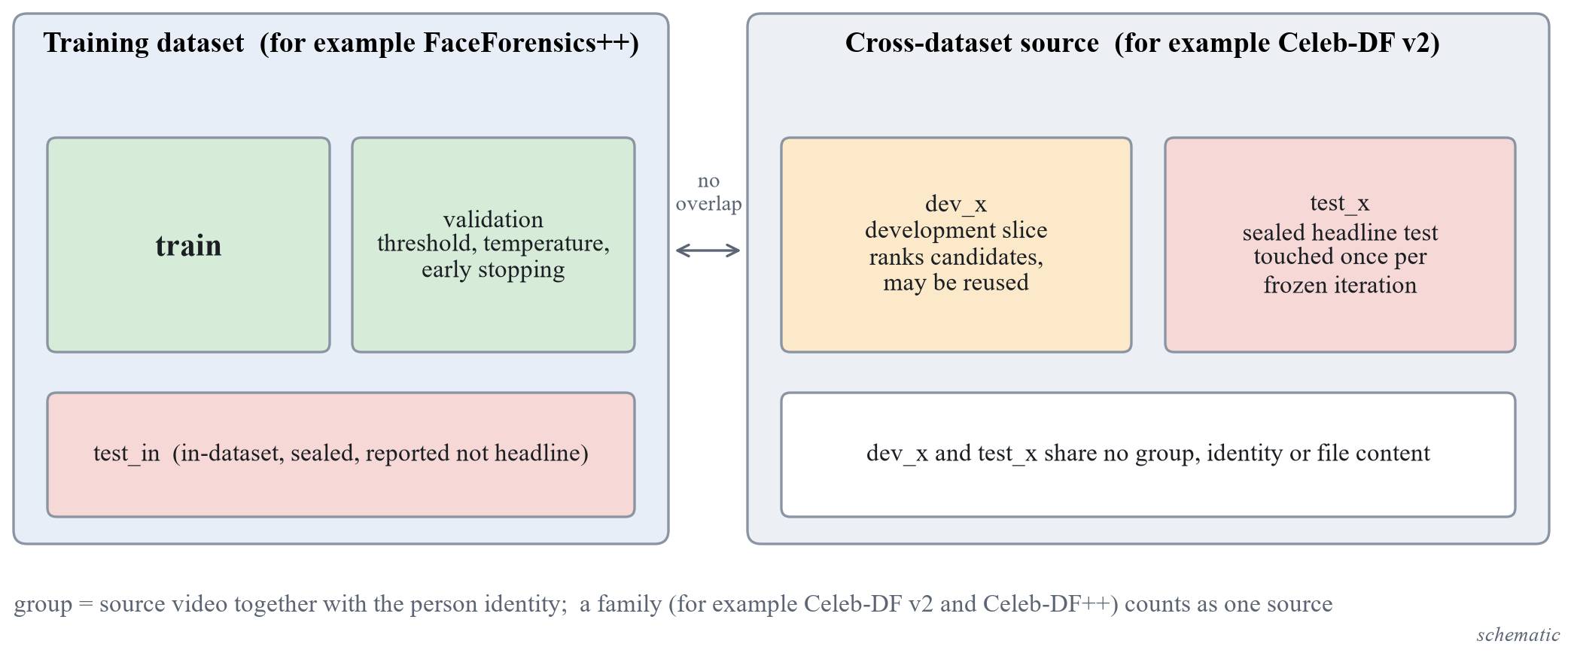
Figure 2. Group-disjoint splits and the access rules. The development slice and the sealed test set of a cross-dataset source share no group, identity or file content. (schematic)
The development slice is chosen by a seeded rule fixed before any extraction: the group names are sorted, a permutation is drawn with a fixed random seed and the first $k$ groups go to the slice, with every sample of a drawn group. Table 7 gives the slices that resulted. The slices are small, which makes intervals wide and ties likely; the cheaper-candidate rule exists for this reason.
Table 7. Development slices and sealed test sets of the cross-dataset sources (real / fake counts where both exist).
Source | Development slice | Sealed test set
Celeb-DF v2 | 15 of 59 identity groups: 1,728 videos (146 real, 1,582 fake) | 4,801 videos (744 real including 300 YouTube videos, 4,057 fake); 44 identity groups plus the YouTube videos
Celeb-DF++ | none; the 15 development identities are excluded | 2,849 fake videos, no real video; 44 identity groups
Family total (Celeb-DF v2 and ++) | 1,728 videos | 744 real and 6,906 fake videos; about 44 independent identity groups
In-the-Wild | 12 of 54 speakers | the other 42 speakers
CNN synthesis subset | 2 of 7 generator units: StarGAN (1,999 real, 1,999 fake) and Which-Face-Is-Real (1,000 real, 1,000 fake) | 48,805 images of the other 5 units after removing 1,200 duplicate real images
DFD | none | 28 actors, 3,431 videos

Celeb-DF++ and the balance of its sealed test set
Celeb-DF++ is built on Celeb-DF, shares its 59 identities and counts as one family with it. Its test list holds 4,900 fakes of the 21 newer generators and 178 real videos; 5,078 videos were extracted. Two exclusions keep any source video or identity of the development slice from being counted twice. First, 2,079 samples were excluded from the sealed test set because their target identity (1,477 samples) or only their celebrity source identity (602 samples) is one of the 15 development identities. Second, 150 real videos of Celeb-DF++ whose content is byte-identical to Celeb-DF v2 videos were dropped, and Celeb-DF v2 keeps them under its own group identifier, so that each source video has one group.
The result is that Celeb-DF++ alone has 2,849 fake videos and no real video in its sealed test set, in 44 identity groups. Its AUC is therefore computed together with the Celeb-DF v2 real videos, which are the same real sources, and the pooled family test set holds 744 real and 6,906 fake videos. Real videos are 10.8 percent of that pool. The consequence for the statistics is that the bootstrap resamples identities, so the fakes of Celeb-DF++ add generator coverage but almost no new independent groups: intervals on a pooled or per-generator AUC are governed by about 44 identity groups, and the estimates per generator, from 200 to 300 clips each, are wide. Balanced accuracy and the threshold carry more noise than the AUC on such an unbalanced set.

Leakage check
A script proves that the splits are disjoint in group, identity and, for the image and the audio-visual sets, file content. With content hashing the check first failed on the image sets: real LSUN images occur byte for byte in the training set, the validation set and several test sets. The rule adopted is that any sample of a test set whose content hash equals the hash of a training or validation sample is excluded from the test set, and the exclusions are listed with the reason. After 1,200 samples of the CNN synthesis subset were excluded, the check passes on 80,803 image files, and it passes on 41,739 files of Celeb-DF, In-the-Wild and DFD together. The Celeb-DF family has one further pass after the exclusions above (9,378 files, no duplicate content in or across splits). The grouping of Celeb-DF fakes takes the first identity in the file name, assumed to be the target, as the resampling unit; the other identity is kept in the notes. The ProGAN validation set is split by LSUN class, 14 classes for training and 6 for validation, because a class is the coarsest source grouping available for images with no identity; the threshold and the temperature are therefore fitted on classes not seen in training.

Shared Preprocessing
One package prepares inputs for training, evaluation and inference, so that the same function runs in all three. The preprocessing parameters form a configuration whose hash is stored in every checkpoint, and inference refuses a checkpoint whose hash differs from the one in use. This turns a silent mismatch between training and use into an error.
Table 8. Preprocessing of each input type.
Input | Steps | Parameters
Video | Decode sequentially; take uniformly spaced frames; detect the faces with YuNet; crop the largest face enlarged by a factor; store as JPEG | 16 frames; factor 1.3; crop 224 by 224; JPEG quality 95; frames without a face left out and counted
Image | Face crop if a face is found, otherwise the whole image processed by the encoder’s own model-card rule | the path taken is reported in the response
Audio | First samples at 16 kHz, repeat-padded if shorter; the Whisper encoder receives its fixed 30 second window with the 4 seconds first and only those frames are pooled | 64,600 samples (about 4 seconds)

When several faces are found the largest is used and the warning that several faces were found is returned. A clip with no face at all returns the warning that no face was detected. Carrying the box of a neighbouring frame or using a centre crop for a frame without a face was rejected, because it invents a face position. Sequential decoding is used because seeking is about four times slower on FaceForensics++.
The face detector was chosen by measurement. YuNet [48], UltraFace and SCRFD were compared on 7,488 sampled FaceForensics++ frames and, separately, on 300 frames from 300 distinct FaceForensics++ validation videos and 300 frames from 300 distinct Celeb-DF development-slice videos (frames only, no labels or scores). All three found a face in every frame and never disagreed on whether a face exists; the largest boxes agree with a mean intersection over union of 0.887 to 0.923, and the eight frames of lowest agreement per set show the same face in every tile. The differences that matter are speed and licence (Table 9).
Table 9. Face detector comparison (measurements; the machine was busy with 13 to 20 percent of the processor before each run, and the 200-video sample is warm in the file cache).
Detector | Licence of the weights | ms per frame (FaceForensics++ / Celeb-DF) | Detections on 500 face-free images
YuNet 2023mar | MIT | 12.1 / 12.4 | 6.0 percent
UltraFace RFB-320 | not verified | 4.8 / 4.8 | 20.2 percent
SCRFD 500M | non-commercial research only | 29.7 / 30.9 | 4.6 percent

YuNet was chosen: it is small, MIT licensed, fast enough and runs on the processor through OpenCV; the other two were used only as benchmarks. The measurement does not include hard cases such as rotated or tiny faces, and the effect of a few percent of box shift on accuracy was not measured.
The throughput of the preparation was measured on 200 FaceForensics++ videos (16 frames, 224 pixels, JPEG 95, YuNet). Decoding takes about 73 percent of the time per video and detection about 24 percent. Decoding 16 frames took 0.74 s per video with OpenCV sequentially and with an ffmpeg pipe, and 2.88 s with seeking. The pipeline reached 1.25, 4.13, 5.91, 6.35 and 6.22 videos per second with 1, 4, 8, 16 and 24 worker processes; the growth stops after 8 workers and the cause was not found. This projects to about 13 minutes for the 5,000 FaceForensics++ videos at 16 workers, with 222,786 bytes of crops per video. ASVspoof FLAC files load in 4.76 ms each, about 582 s single-threaded for all 122,299 files. These timings are caveated by the busy machine and by warm reads; cold-disk reads were not measured.

Evaluation Harness and Its Acceptance Test
The evaluation protocol was fixed, and its harness built and tested, before any model existed. The harness implements the metrics of Chapter 3, the threshold chosen on validation data, temperature scaling, the group bootstrap with the paired and multi-seed forms, the guard for the sealed splits and the ledger. It reads score files only and never imports a model. A score file holds one row per clip with the run, iteration, seed, modality, data set, split, sample identifier, group identifier, label and the probability of fake.
Three rules define how a clip and a threshold are obtained. The clip score is the mean of the frame probabilities. The threshold maximises balanced accuracy on the validation split of the training data set, taking the midpoints between adjacent distinct validation scores and, among equal maxima, the one closest to 0.5; the chosen threshold is then fixed for every test set. Temperature scaling is fitted on the same split. Uncertainty uses 2,000 resamples, a 95 percent percentile interval and a fixed base seed, with the group as the resampling unit.
The guard refuses any evaluation that reads a sealed split unless the run is flagged final and carries an iteration tag. The ledger, a file under version control, records every final evaluation: the date, the iteration, the data set, the split, the run identifiers and the hash of the score file; a second final evaluation of the same iteration and data set is refused unless a reason is given, and the repeat is then listed as a correction. A paired comparison on a sealed split re-analyses logged scores only, needs the same flag, and refuses unless a regular final evaluation of that iteration and data set is already in the ledger, so it never gives a first look at a sealed split.
Table 10 lists the acceptance checks and what was logged for them.
Table 10. Acceptance checks of the evaluation harness and the data tools.
Check | What is tested | Logged result
Metrics | AUC, log loss and Brier score against scikit-learn on at least 20 random score sets; balanced accuracy, EER, precision, recall and ECE against hand-computed values | passed; on 5 further random sets of 2,000 samples with many tied scores the AUC equals scikit-learn’s to 10 decimals and log loss and Brier differ by at most 1.1e-16
Temperature scaling | recovers a known temperature on synthetic logits within 2 percent | passed
Bootstrap coverage | the group bootstrap interval covers the true AUC in at least 90 percent of 200 simulated data sets | 192 of 200 (96 percent)
Paired bootstrap | two identical runs give a difference of exactly zero with the interval [0, 0] | passed
Guard and ledger | refuses a sealed split without the final flag, refuses a second final evaluation without a reason, accepts a first one | passed
Leakage check | exits non-zero on a manufactured overlap and zero on clean splits, including across source families, with content hashing | passed (Section 4.2)
Manifests | documented counts for FaceForensics++ c23, ASVspoof 2019 LA, ProGAN validation and test, Celeb-DF v2 | 121,461 ASVspoof rows; 8,000 images per ProGAN set; 5,000 FaceForensics++ videos; 6,529 Celeb-DF v2 videos in 59 identity groups
Development slice | accepted by the score reader and not treated as final; leakage fails if a group or content is in both the slice and the sealed test | passed
End-to-end random scorer | AUC about 0.5 with an interval containing 0.5 | every interval contained 0.5 and every AUC was within 0.06 of 0.5; in a one-off run on 30 other synthetic files 117 of 120 intervals contained 0.5

A full pass of the command line on 10,000 validation and 50,000 test rows takes 9 s, and 2,000 resamples on 50,000 samples in 5,000 groups take 1.0 to 2.1 s. After the development slices were added, the test suites of the data tools and of the evaluation harness had 67 and 89 tests, all of which pass.

Design of the Encoder Comparison
The first iteration is a measured comparison of pretrained encoders under one protocol. The form of the working version is fixed: a frozen pretrained encoder and a linear head. Which encoder is the open question, and it is asked separately for three tasks: face video frames (the visual branch of a video), generated images and speech audio. Table 11 gives the data of each task.
Table 11. The three tasks of the comparison.
Task | Train | Validation | Development slice (ranking) | Input to the encoder
Face video frames | FaceForensics++ c23, official training split | FaceForensics++ official validation split | Celeb-DF v2, 15 identity groups | 16 face crops of 224 by 224 per video
Generated images | ProGAN validation set, 14 classes | the other 6 classes | 2 of 7 CNN-synthesis generator units | whole image, processed by the encoder’s own rule
Speech audio | ASVspoof 2019 LA train | ASVspoof 2019 LA dev | In-the-Wild, 12 speakers | first 4 seconds at 16 kHz

The shortlist was chosen by criteria stated first: the licence is verified from the weights’ own repository, the weights download and load offline, full inference fits in 12 GB, the feature tensor is stated exactly, and the families differ. DINOv3 was excluded on purpose, because its access gate is manual and its licence carries a duty to acknowledge it in publications. Figure 3 and Table 12 give the shortlist.
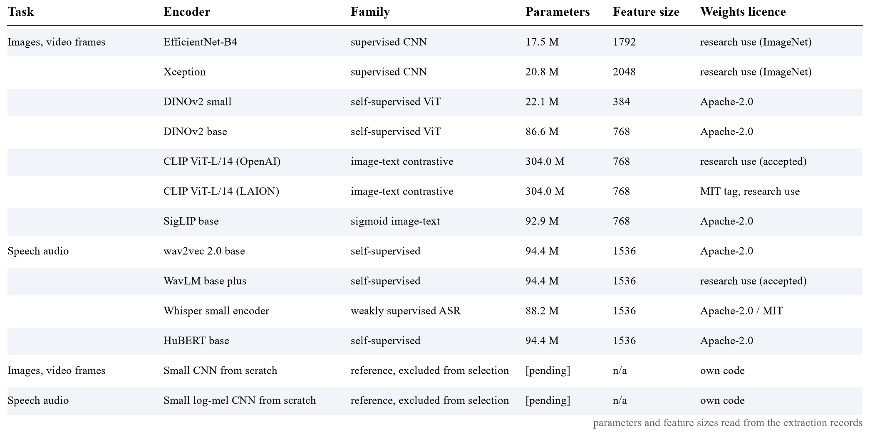
Figure 3. Shortlist of the encoder comparison. Entries marked pending are filled from the extraction records when they are final.
Table 12. Weights of the shortlisted encoders and their licence labels.
Candidate | Checkpoint | Source | Label
EfficientNet-B4 [43] | timm efficientnet_b4.ra2_in1k | Hugging Face | Apache-2.0 tag; ImageNet-trained, research use
Xception [44] | timm legacy_xception (original architecture) | GitHub release of timm | Apache-2.0 declared by timm; upstream licence not retrieved; research use
DINOv2 small, base [45] | facebook/dinov2-small, facebook/dinov2-base | Hugging Face | Apache-2.0
CLIP ViT-L/14, OpenAI [46] | openai/clip-vit-large-patch14 | Hugging Face | no weights licence stated; card says research use; accepted as research-only
CLIP ViT-L/14, LAION | laion/CLIP-ViT-L-14-laion2B-s32B-b82K | Hugging Face | MIT tag; card says research use
SigLIP base [47] | google/siglip-base-patch16-224 | Hugging Face | Apache-2.0
wav2vec 2.0 base [24] | facebook/wav2vec2-base | Hugging Face | Apache-2.0
WavLM base plus [25] | microsoft/wavlm-base-plus | Hugging Face | no tag; upstream licence CC BY-SA 3.0; accepted as research-only
Whisper small encoder [27] | openai/whisper-small | Hugging Face | Apache-2.0 tag; MIT upstream
HuBERT base [26] | facebook/hubert-base-ls960 | Hugging Face | Apache-2.0
Small networks from scratch | own code | none | reference only, excluded from the selection

The licence of two weights is conditional. The OpenAI CLIP repository states no licence and its card says use is for research; the WavLM card has no licence tag and points to an upstream licence that is CC BY-SA 3.0. Both are accepted as research-only, and this is a limitation: results obtained with these weights make no claim of commercial usability. The ImageNet-trained weights are treated as research use as well, because the data set terms say so. The SHA-256 of every weight file was recorded before use, and the script that fetches the weights recomputes it locally and compares it.
Features are extracted once per candidate and task. The encoder runs in evaluation mode with mixed precision and the preprocessing of its own model card. The stored feature is the pooled embedding before any classifier: the global average of the final map for the convolutional networks, the class token for DINOv2, the projected image embedding for the CLIP encoders, the attention-pooled output for SigLIP, and the mean and standard deviation over time of the last hidden layer for the speech encoders. Features are stored as 16-bit floats with an index to the sample identifiers, and the same crops and split files serve every candidate.
The head is a single linear layer on features standardised with the training mean and standard deviation, trained with class-weighted binary cross-entropy, AdamW with a learning rate of ${10}^{-3}$ and a weight decay of ${10}^{-4}$, batches of 1,024 features, at most 200 epochs and early stopping on the validation AUC with a patience of 10. Three seeds, 0, 1 and 2, change the initialisation and the batch order. Nothing else is tuned in this iteration.
The ranking metric is the clip-level AUC on the development slice, averaged over the seeds, with the 2,000-resample paired group bootstrap. The leader is the candidate with the highest mean; the tie set is every candidate whose paired interval against the leader includes zero (Equation (23)); the cheapest member of the tie set wins. The from-scratch reference is trained on the same split for a fixed budget of 10 epochs with AdamW at ${10}^{-3}$ and no augmentation, is reported in the same table and is excluded from the selection. If the lower bound of the best candidate on the development slice is 0.55 or below, the sweep is declared inconclusive for that task. The exact sign-flip permutation test over groups is a sensitivity column beside the bootstrap, not a second rule. A cost record is kept for every candidate: parameters, floating-point operations of one forward pass, peak memory, and time per 1,000 inputs both for the model alone and end to end including decoding.
The hypotheses, success criteria and failure criteria were written before any feature extraction and are not edited afterwards. For face video frames, the hypothesis is that at least one self-supervised or vision-language encoder (the DINOv2 or CLIP families) reaches a higher development-slice AUC than the best supervised ImageNet network (EfficientNet or Xception); it is supported if the paired interval of that difference lies above zero and the lower bound of the best candidate is above 0.60, and it fails if the interval includes zero or if the lower bound is 0.55 or below. For generated images the hypothesis is that a CLIP-style frozen encoder beats every supervised network, with a lower bound above 0.65 as the success line. For speech the hypothesis is that wav2vec 2.0 or WavLM beats both the Whisper encoder and the from-scratch reference, with a lower bound above 0.60 as the success line. These are hypotheses and they have a direction that is uncertain by design: the literature also shows that face-forgery detectors learn identity cues [7] and that frozen features have been tested for generated images [11] and not for face forgery.
Table 13 holds the outcome of the comparison. The ranking is exploratory, a verdict on the development slice with sign, size and interval, and it is re-run when the extraction of all tasks is complete, so every cell is marked until the run is frozen.
Table 13. Outcome of the encoder comparison per task, on the development slice (exploratory).
Task | Leader | Tie set | Winner by the cheapest rule | Lower bound of the best candidate
Face video frames | [pending] | [pending] | [pending] | [pending]
Generated images | [pending] | [pending] | [pending] | [pending]
Speech audio | [pending] | [pending] | [pending] | [pending]

The Working Version (Iteration 0)
The working version is not an improvement; it is the baseline that everything else is compared with. It counts as working when all of the following hold: a file goes in through the local web page; the encoder of each task is the winner of the comparison under the cheapest rule, frozen, with a linear head trained on the training split; the score is calibrated by temperature scaling fitted on validation and the checkpoint metadata is checked at load; metrics with three seeds, standard deviation and bootstrap interval exist on the validation split and on the development slice without any sealed split touched; the page shows a real result with its source marked real and the warnings for no face and several faces; the visual and the audio score of a video are shown separately; and the tests pass. Figure 4 shows the chain from a file to a calibrated score.
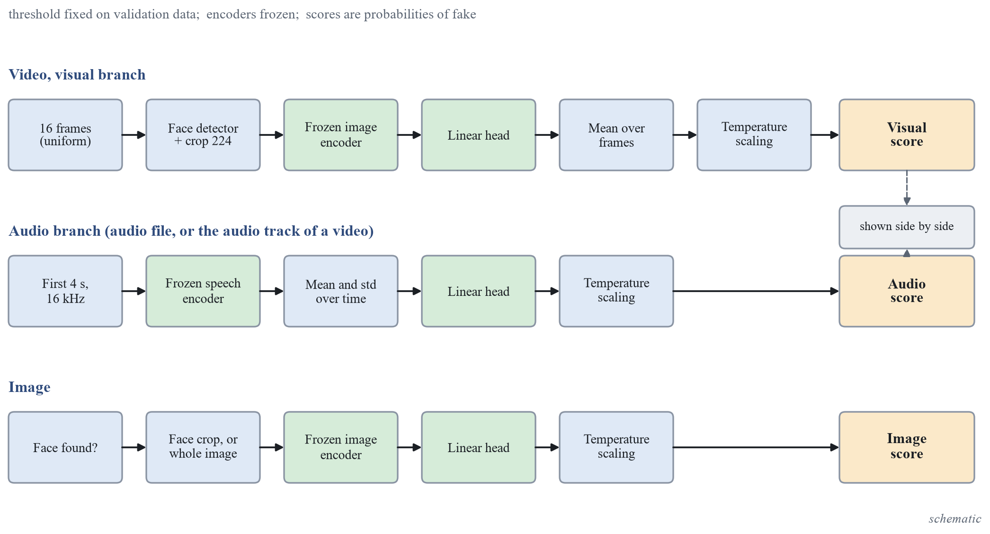
Figure 4. From a file to a calibrated score. The encoders are frozen, the temperature and the threshold are fixed on validation data, and the scores are probabilities of fake. (schematic)
A checkpoint is a folder with one metadata file and one head file per task; no pickled object is used, because a pickle executes code when it is loaded. The metadata holds the checkpoint identifier, the iteration, the commit, the protocol, the seed, the library versions, the manifest and split identifiers and, per task, the encoder (name, revision, feature size, input size), the hash of the head file, the preprocessing hash and configuration, the calibration method with its temperature and the split it was fitted on, and the threshold with how it was chosen. The head file holds the mean and standard deviation of the standardisation and the weight vector and bias of the head. The loader refuses a folder without metadata, a folder with missing fields, a head file whose hash differs, a head whose width differs from the encoder’s and a preprocessing hash different from the one in use. The real adapter also checks that the encoder weights on disk are the hash-verified ones of the recorded revision, and a checkpoint without an audio head reports the audio modality as unavailable with the reason; no score is ever invented.
Scoring follows training exactly: 16 frames, the same detector, the same enlargement, a JPEG quality-95 round trip, the mean of the frame probabilities and temperature scaling. An image with a face goes through the video head and an image without a face through the generated-image head, with the path reported. Audio is scored from the first 64,600 samples at 16 kHz with the speech encoder’s own feature extractor, the mean and standard deviation over time, the audio head and temperature scaling. The code path was tested with a test double for the encoder and the detector and a made-up head; the acceptance run of the working version must score a training-split clip both ways to expose any mismatch between training-time and inference-time preprocessing.
After every iteration, including this one, the same diagnostic battery is run and its output fixes the order of what follows. It consists of: the AUC per data set and per generator or method with intervals; the gap between training and validation AUC, which separates bias (both low) from variance (a large gap); the gap between validation and the development slice, which indicates a distribution shift; the calibration curve with 15 bins, the ECE and the Brier score before and after temperature scaling; the score histograms of real and fake examples; the results split by compression level, face size and number of faces; the 20 worst errors, 10 false alarms and 10 misses, reviewed by eye and classified in writing; and the standard deviation over the three seeds next to the bootstrap half-width, which separates training noise from sampling noise. The diagnosis vocabulary is bias, variance, shift, calibration, aggregation and missing signal.
The AUC of the working version on the validation split and on the development slice, for the video, image and audio tasks, is [pending], [pending] and [pending] until the heads of the winning encoders are fitted and frozen.

The Iteration Ladder
After the working version the project has seven experimental iterations, I-1 to I-7, and a last step, I-8, that integrates and freezes. I-1 to I-6 take their lever from one of six families, and the lever of each slot is chosen after the diagnostic battery of the preceding iteration, not in advance; the primary candidate in Table 14 is a starting guess for planning that is replaced without penalty when the battery points elsewhere. I-7 is the pulse experiment and I-8 runs no experiments. Figure 5 shows the ladder.
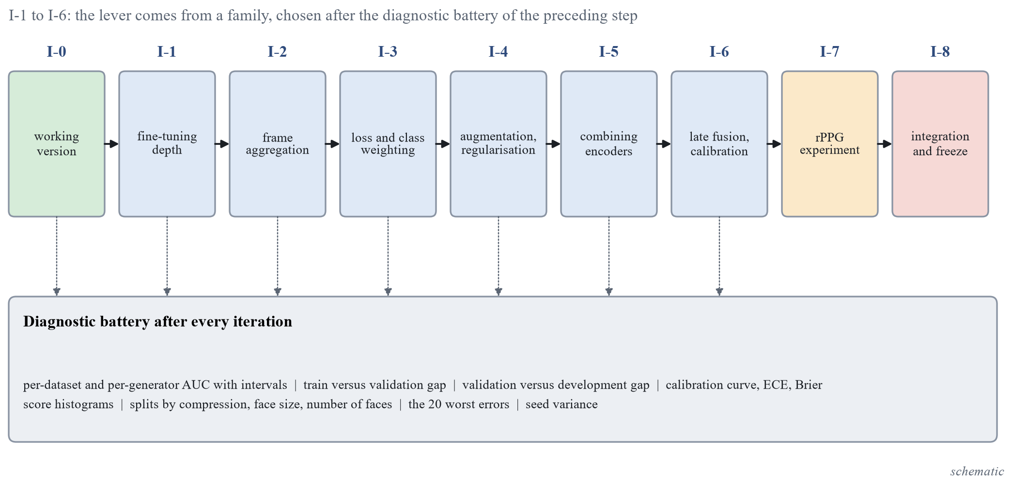
Figure 5. Iteration ladder. Each step from I-1 to I-6 starts from the diagnostic battery of the preceding step. (schematic)
Every slot is written in one template: observation (numbers from the battery), diagnosis, mathematical hypothesis, change, prediction with sign and rough size, result and verdict. The prediction lines are hypotheses, and each is judged against its failure line after the run. Verdicts on the development slice are exploratory.
Table 14. Primary candidate lever, trigger, prediction and failure line of iterations I-1 to I-6. The predictions are hypotheses written before any run.
Slot | Lever | Triggered when | Prediction | Failure line
I-1 | Fine-tuning depth: linear probe to the last blocks, low-rank adapters or full fine-tuning | Bias: training and validation AUC both low or close (gap under 0.02, AUC under about 0.90) | Validation AUC up by about 0.02 to 0.05; development slice between slightly negative and +0.03 | Paired development interval includes zero or is below zero while validation AUC rises; or memory or time is outside the 12 GB budget
I-2 | Frame aggregation: mean to top-k mean, maximum or learned attention pooling | Frame-level AUC clearly above video-level AUC, a wide spread of frame scores, or many frames without a face | Video AUC change from 0 to +0.02 when few frames are informative; negative when frame noise dominates | Paired interval includes zero, or the real-video score histogram moves right (more false alarms)
I-3 | Loss and class weighting: class-weighted, focal, label smoothing or pairwise surrogate | Imbalance or saturation: balanced accuracy far below what the AUC implies, scores piled at 0 or 1, or ECE high after scaling | AUC change within about 0.01; balanced accuracy and ECE change more | AUC interval includes zero and the other two improve by less than their intervals
I-4 | Augmentation matched to the test perturbations; mixup; weight decay and dropout | Shift: validation AUC high, development slice or compression splits much lower (gap above about 0.10) | Development AUC up by about 0.01 to 0.04 for a compression or resolution shift; in-dataset flat or down by up to 0.01 | Development interval includes zero, or gains appear only on the perturbation types used in training
I-5 | Combining encoders: concatenate features or average scores | Ties in the comparison and complementary errors (low error correlation) | AUC +0.01 to +0.03 if the mean correlation is below 0.8; none as it tends to 1 | Interval includes zero: the cost in time, memory and licences is not justified
I-6 | Late fusion of audio and visual scores with per-modality calibration | Both unimodal heads above chance on LAV-DF and calibrated, with errors not strongly correlated | Fused AUC at or above the better single modality; gain of 0 to +0.05; learned weights below 1 if dependent | Fused lower bound below the better single modality, or the gain is within the interval

Two further elements complete the ladder. For I-6, the unimodal heads are the ones frozen in the earlier iterations, the visual head trained on FaceForensics++ and the audio head on ASVspoof 2019, each with its own temperature; only the fusion layer is fitted, on the LAV-DF training split, with the choice made on its validation split and per-modality temperatures also refitted on LAV-DF and reported both ways. A video is labelled fake for the fused question if either modality is fake, and the label of each modality from the metadata is reported as well, one AUC per modality label.

Fine-tuning budget of iteration I-1
The budget was derived from the measured time per step and not from a plan. Fine-tuning is done for the video task first. The top three encoders of the comparison that fit are fine-tuned at three learning rates, ${10}^{-5}$, $3×{10}^{-5}$ and ${10}^{-4}$, with one seed, and the best rate of the best encoder is then repeated with two further seeds. Every run has the same budget of 1,800 optimiser steps, which is one pass over the 57,600 training frames, an effective batch of 32, AdamW with a cosine schedule and 5 percent warm-up, weight decay 0.05, mixed precision and no augmentation. A run has a cap of 10 minutes of training and 15 minutes of wall time including evaluation. An encoder enters only if its peak memory at batch 32 is at most 10 GiB and one budget takes at most 10 minutes. By the step-time measurement this admits DINOv2 small and base, Xception and EfficientNet-B4; the two CLIP ViT-L/14 models do not fit, because their peak memory at batch 32 exceeds the 12 GB card and spills into shared system memory, which makes a step take seconds, and they stay frozen (a low-rank adapter variant is a later option). The claim “easiest to fine-tune” is made for the video task and for the encoders that fit only, and the step times are re-checked against a clean re-run before the first run. The generated-image and the speech tasks keep their frozen heads in I-1.

The pulse experiment (iteration I-7)
The pulse is a candidate improvement and not an adopted component. Its success and failure thresholds were written before any run and are not edited after the first run. A signal check, S-1, starts early on the processor, in parallel with I-1 to I-3. It extracts about 10 seconds of contiguous frames at the native frame rate, because the 16-frame sampling cannot carry a pulse, and computes the spectral peak in 0.7 to 3 Hz and its signal-to-noise ratio (Equation (42)) on real clips. The negative control is the same clips with time-shuffled frames, pooled across clips with at least ten shuffles per clip, and the 95th percentile of the pooled shuffled values is the reference. Figure 6 shows the chain.
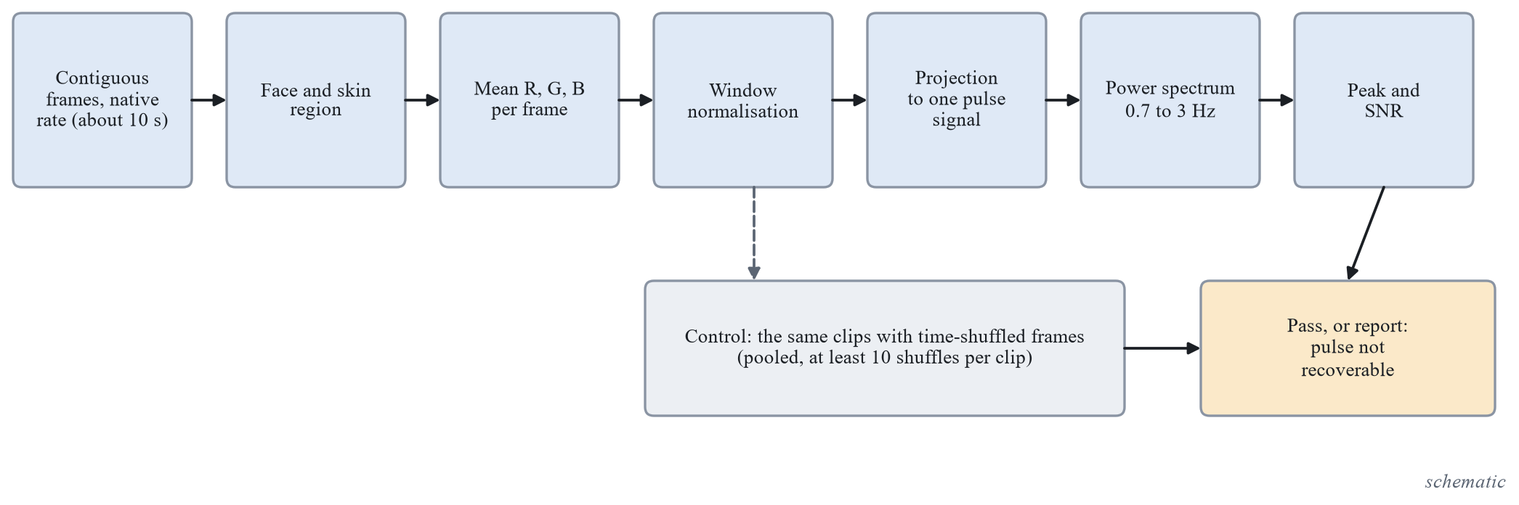
Figure 6. Processing chain of the pulse signal check and its negative control. (schematic)
S-1 passes when at least 60 percent of the real clips have a peak SNR above the 95th percentile of the shuffled control and, if a data set with pulse ground truth is obtained, the mean absolute heart-rate error is at most 8 beats per minute. If it does not pass, I-7 reports exactly that, “pulse not recoverable from these data”, with the numbers and the negative control, and no separation or fusion experiment is run; this is an honest result of the slot. If it passes, three further tests follow: the AUC of rPPG features on an identity-disjoint split for at least two generator families, with success if the lower bound is above 0.55 and failure if the interval includes 0.5; the added value of the fused model with the pulse over the model without it, a paired group bootstrap on the development slice with three seeds, adopted only if the whole interval is above zero; and negative controls with time-shuffled and identity-mismatched signals, whose AUC intervals must include 0.5, otherwise the separation is an artefact. The decision to adopt or not is made on the development slice and never on a sealed test set. The prior expectation, a hypothesis and not a result, is that most of the videos are compressed, which attenuates the pulse, so S-1 is expected to pass only partially.

Integration and freeze (iteration I-8)
I-8 runs no new experiments. It freezes the code, the preprocessing and the checkpoints, tags every frozen iteration in version control, evaluates each frozen iteration once on the sealed test sets under the final flag, runs the leakage check on the final splits, fills the paper, the report and the slides only from logged experiments, demonstrates the system end to end with the source set to real, and deletes the LAV-DF archive by hand. Anything not frozen by Thursday 29 October is reported as not done.

The Web Application
The software form is a local web page: the user uploads an image, a video or an audio file in a browser and sees the response of the inference library. It was chosen over a command line, which was not adopted as a second form. The page is served by Flask, chosen against FastAPI, the standard library server, Streamlit and Gradio, Bottle, by six criteria written before the choice: it installs on Python 3.13 without a compiled build, runs as one process with no database or separate front-end build, handles uploads of several hundred megabytes without code that has to be tested separately, gives plain HTML, CSS and a little JavaScript that can be restyled without a build step, adds few packages (four, on top of those already present), and returns the response structure unchanged as JSON. A job runs in a worker thread and the page polls a status route, which gives progress by stage without a second service.
Three safeguards were added and tested. The server binds to 127.0.0.1 only and has no option to change this. Uploads are limited to 512 MB, and an oversized upload returns an error in the response format. Uploaded files are deleted after every request, also after an aborted upload, and leftovers are removed at start.
The inference library takes a file and returns one structured response, so that the library and the page can be built in parallel and a development stand-in can never be mistaken for a result. Table 15 lists its fields.
Table 15. Fields of the response of the inference library.
Field | Content
Schema version and request identifier | version of the response format and a unique identifier of the request
Input | file name, media type (image, video or audio), MIME type, size, SHA-256, duration (none for images) and number of frames used (none for audio)
Inference source | always present: real or mock
Model block | checkpoint, configuration hash, preprocessing hash, commit, iteration, protocol version, calibration (method, temperature, split) and the threshold with how it was chosen; empty when the source is mock
Result | the fused score in [0, 1] with a decision (fake, real or undetermined); for an image the visual score, for audio the audio score; for a video the combining rule is not decided, so the decision is undetermined; per modality: availability with a reason, score and number of units used
Score meaning | the fixed sentence: calibrated probability that this content is fake, from a model fitted on the training data of this project, valid only for the kinds of content in that data, not proof
Status | ok, partial or failed, the processing time and the list of stages (validate, decode, detect, score, calibrate, fuse) with their times
Warnings and errors | warnings such as no face detected, several faces, short audio, low resolution; errors such as unsupported media type or unreadable file, in which case the status is failed and there is no result

A development stand-in is allowed under strict rules. It lives in a module whose name contains “mock”, always sets the source to mock and leaves the model block empty, and its scores are deterministic from the file hash so that tests are repeatable, but they carry no meaning. Every interface shows a visible banner whenever the source is not real, a test checks this, the evaluation harness refuses any run whose metadata says mock, and the document builds fail if a number cites a mock run. The real adapter refuses to run without a checkpoint whose metadata and preprocessing hash match. Figure 7 shows the page, with screenshots taken against the development stand-in; the banner and the undetermined decision for a video are part of the design and the scores shown mean nothing.
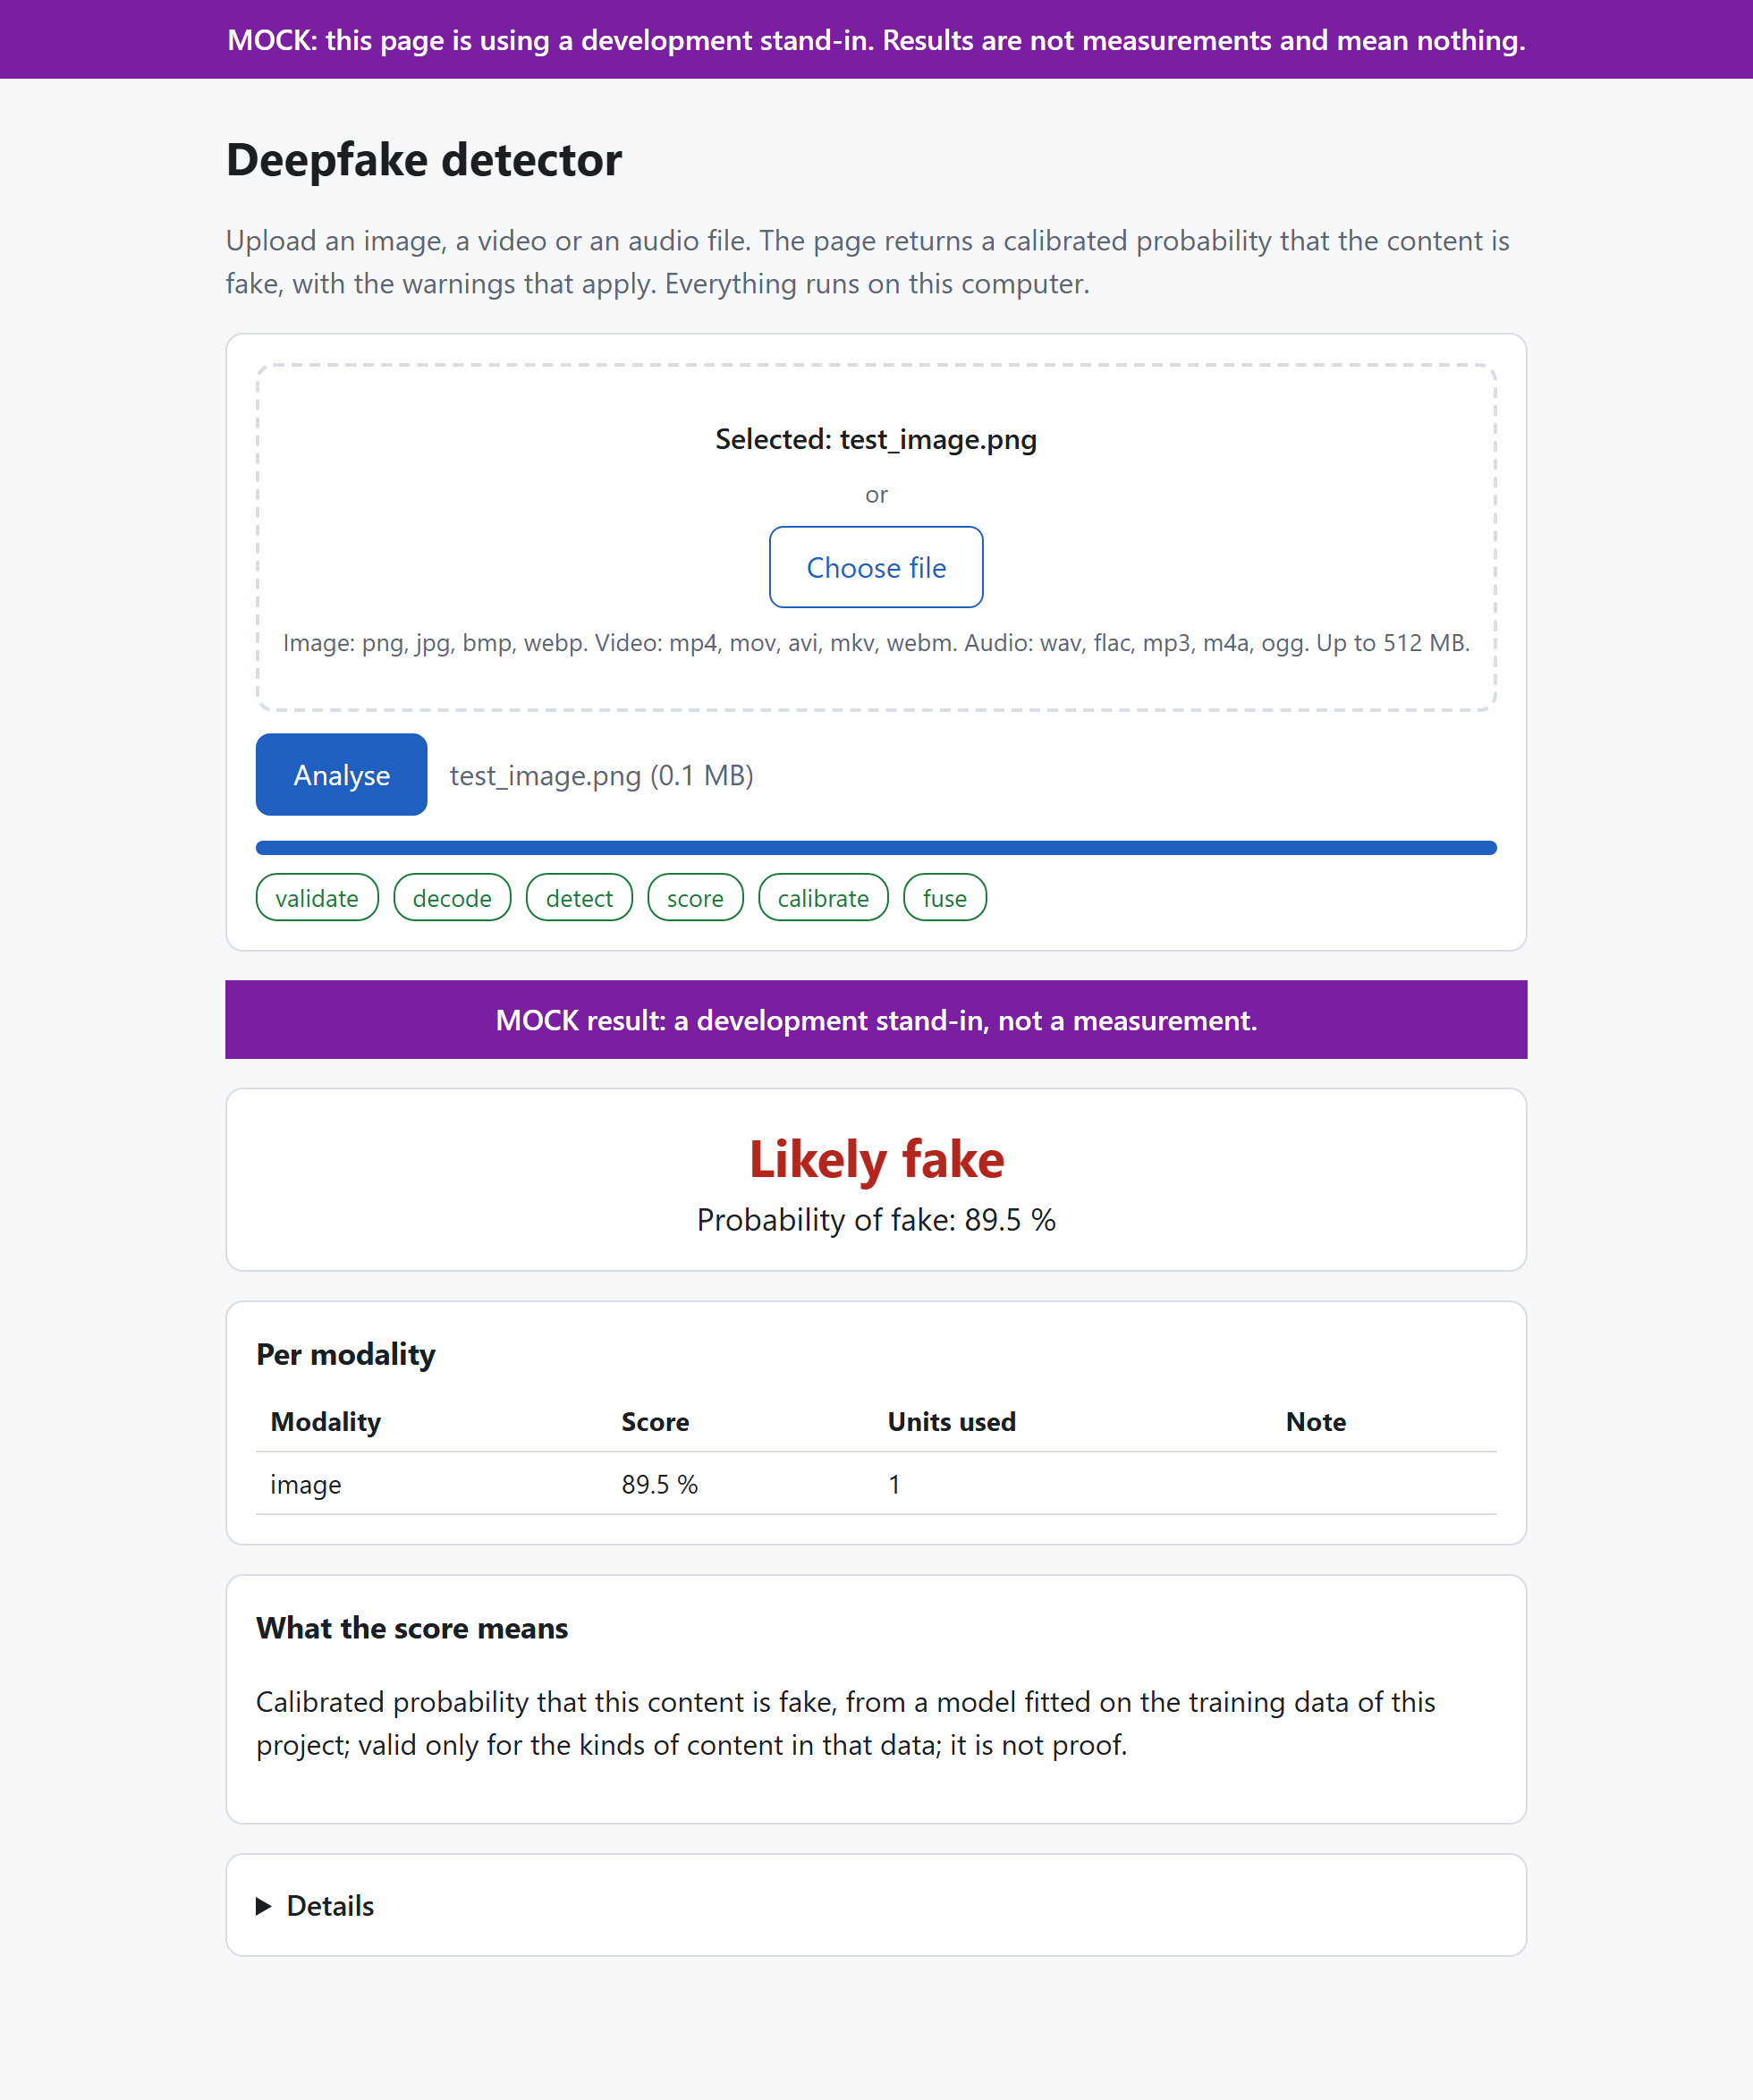 | 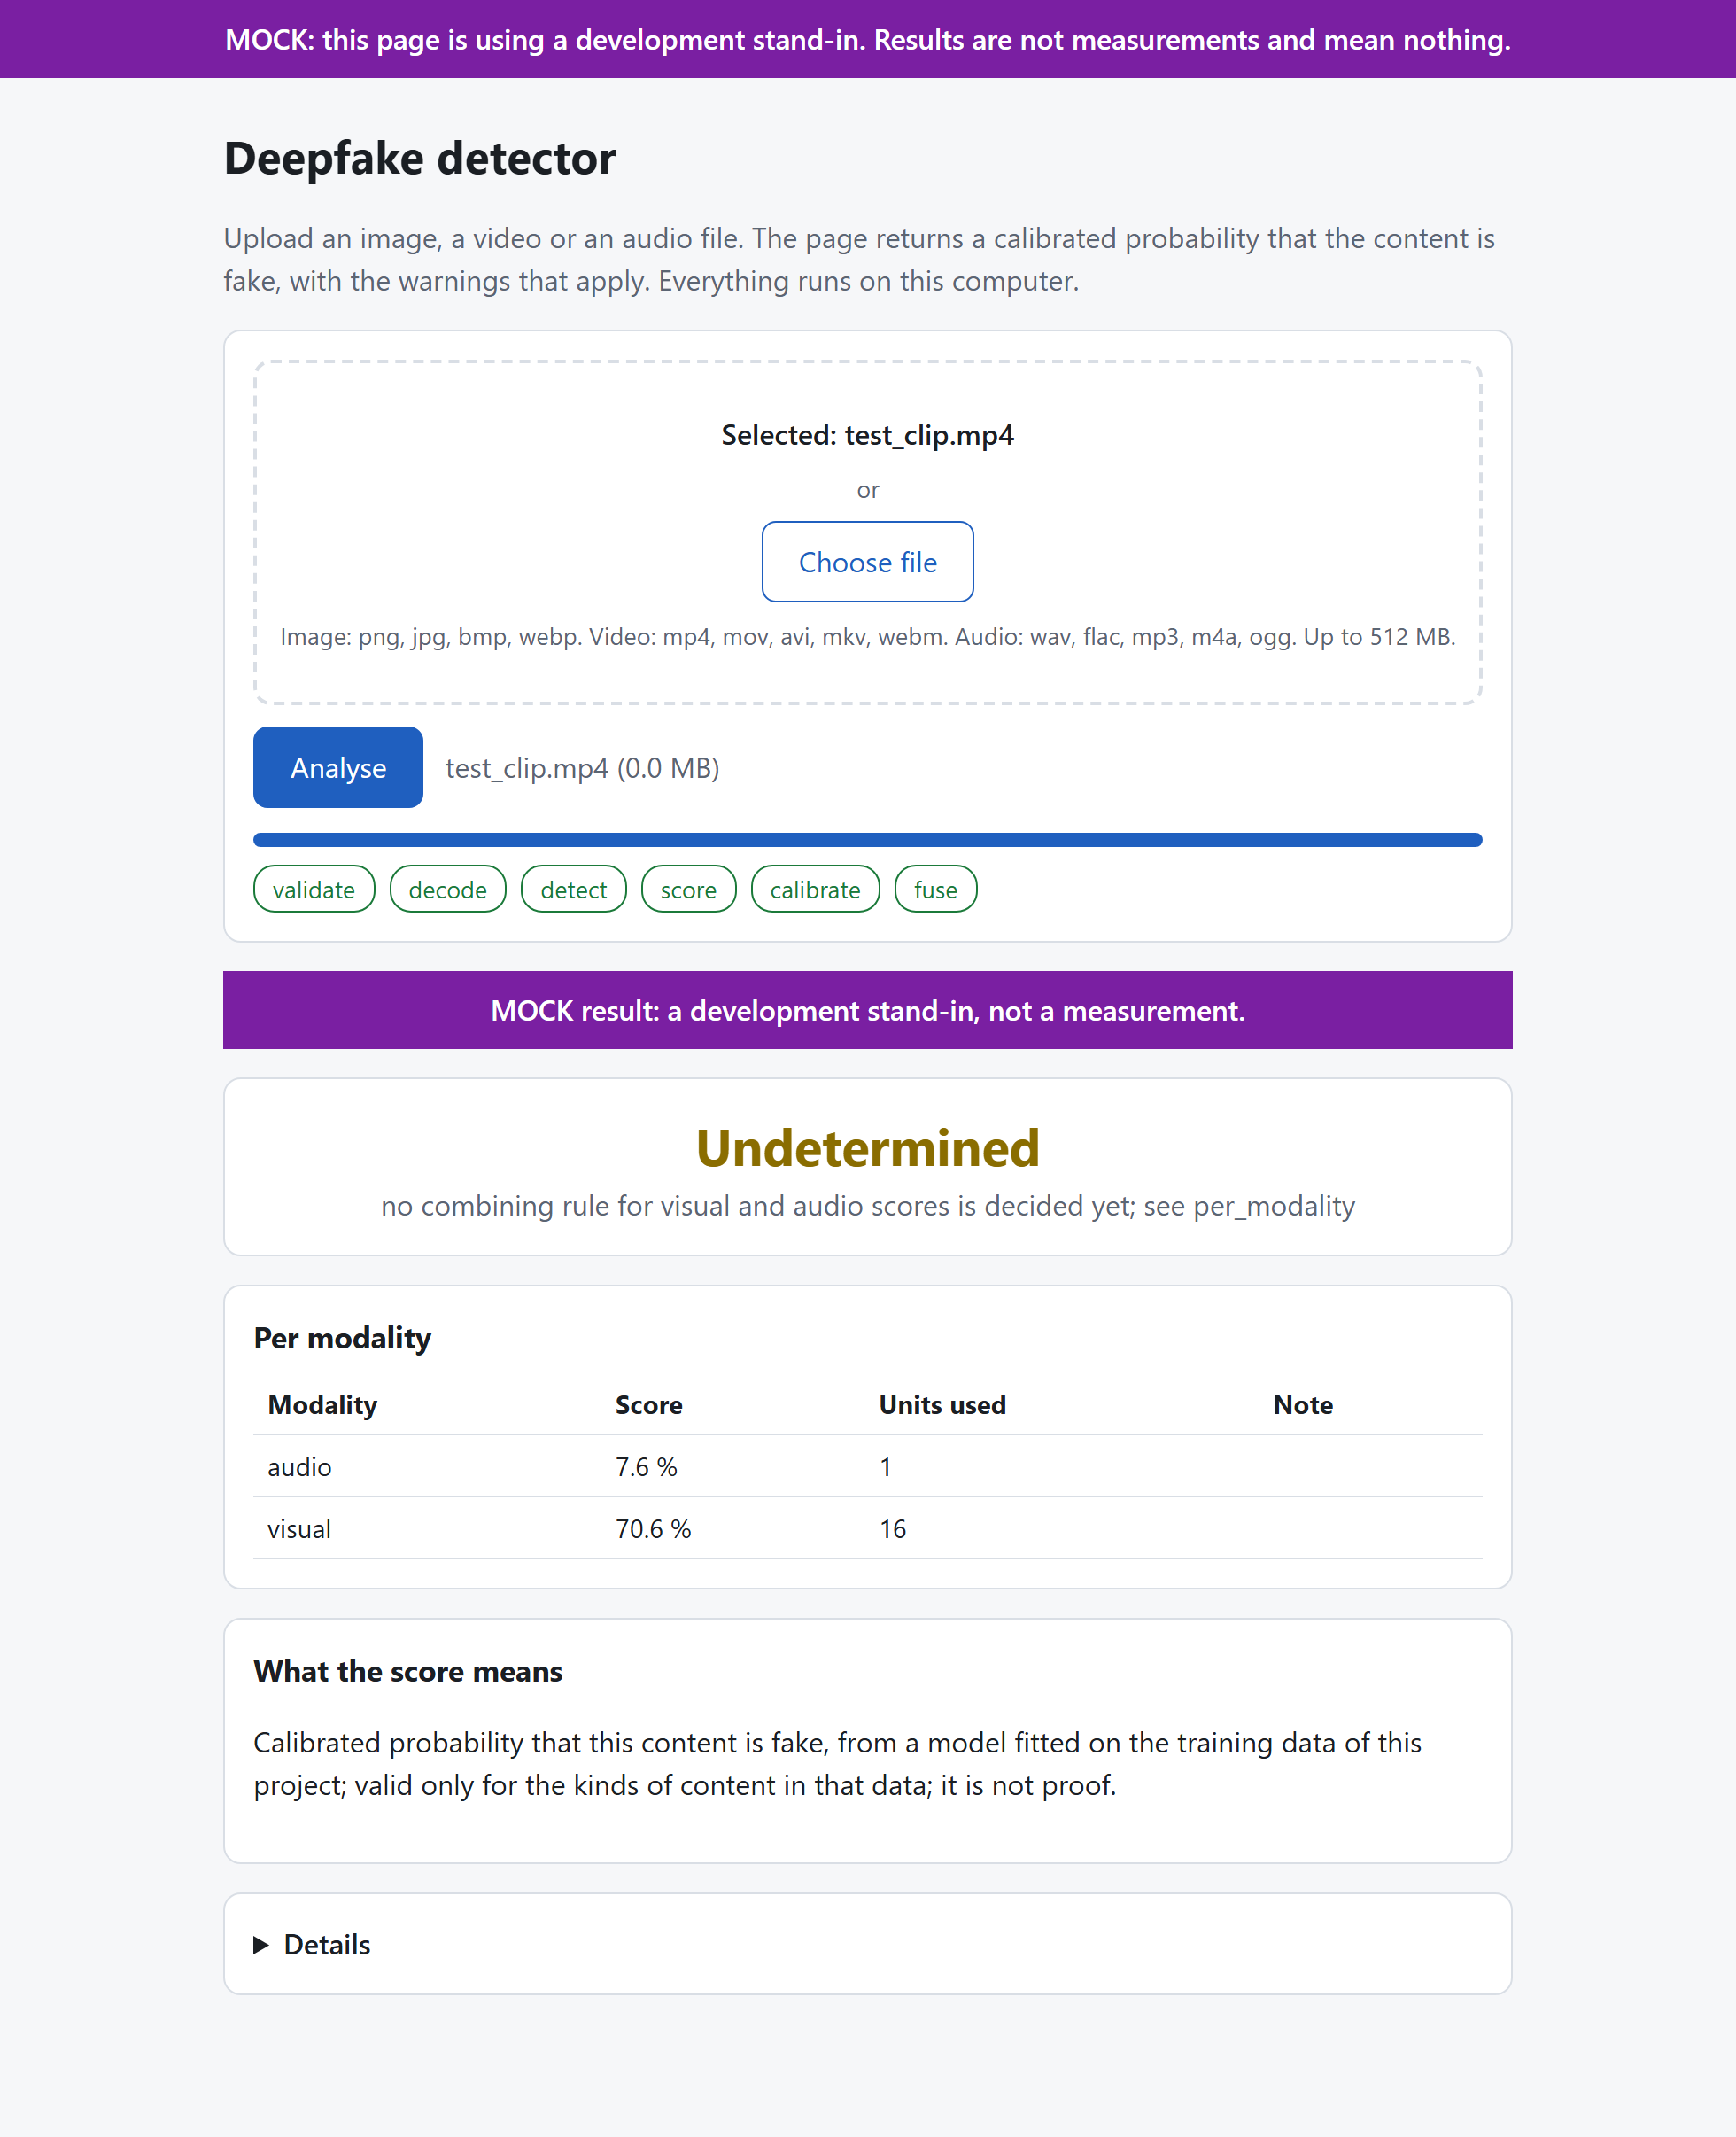
Figure 7. The local web page against the development stand-in: (a) result for an image, (b) result for a video. The banner is part of the design and the scores shown are not measurements. (screenshots against the stand-in)
Tests with synthetic media cover the response contract, the stand-in and its banner, the real adapter stub, the web routes and, in a real browser, the page itself against the stand-in.

The Staircase Test Protocol
Rankings, hyperparameter choices and iteration verdicts made on the development slice and on the validation split are exploratory: they report sign, size and interval, and they choose the next step; they are never presented as confirmed performance. At the freeze each frozen iteration is evaluated once on the sealed test sets under the final flag, which gives a staircase of test scores, one per iteration, each touched once and recorded in the ledger. Figure 8 shows the protocol.
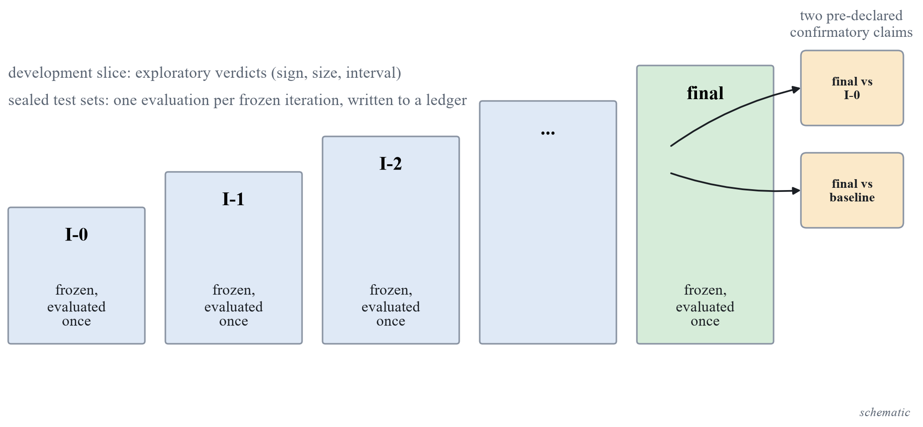
Figure 8. Staircase test protocol. Verdicts on the development slice are exploratory; each frozen iteration is evaluated once on the sealed test sets and the two pre-declared comparisons are the confirmatory claims. (schematic)
The confirmatory claims are exactly two, declared before any final run, both as paired group bootstrap comparisons on the sealed data under the comparison rules: the final system against the working version, and the final system against a re-run published baseline, where the second is the non-inferiority test of Equation (22). The margin $δ$ is stated before the comparison and chosen from the measured seed-to-seed spread of the baseline, so the baseline must be trained before $δ$ exists; if it cannot be trained within the time budget, the word comparable would have to be weakened and the report would say so. Every other comparison in the report is labelled exploratory.
The standing limitations of this protocol are stated with it. The development slices have 15 identities, 12 speakers and 2 generator units, so intervals are wide and ties are likely; the sealed Celeb-DF family tests have about 44 independent identity groups; the threshold is chosen on validation data from the training distribution, which may be too easy, so it can transfer badly across data sets, and that would appear as a gap between the in-dataset and the cross-dataset balanced accuracy and be reported; and temperature scaling does not repair a shift between data sets.

Summary and Outline of the Next Chapter
This chapter described what was built and how it is tested. The data, the group-disjoint splits, the shared preprocessing, the evaluation harness with its acceptance test, the design of the encoder comparison, the working version, the iteration ladder, the web application and the staircase test protocol exist and are documented; the measured results of the encoder comparison and of the iterations are marked as pending until their runs are frozen. Chapter 5 states the conclusions that the present evidence supports and the further work.

Chapter 5
Conclusions and Further Work
This chapter presents the conclusions that the evidence of the project supports at this stage, with the important points in list form, and the further work that completes the planned path from the working version to the frozen system.

Conclusions
The project built, from zero and in one repository, the foundations of a multimodal deepfake detector and the protocol under which it is judged. A group-disjoint evaluation harness exists, with a development slice for ranking, sealed test sets behind a guard and a ledger, bootstrap intervals over groups and seeds, paired and non-inferiority comparisons, and an acceptance test that the harness passes. The data sets were obtained, verified and split, with their licences recorded, and the Celeb-DF family test set was corrected so that no source video is counted twice. A shared preprocessing package, a measured choice of face detector, a checkpoint format that refuses a mismatch, an inference library and a local web page exist. The comparison of eleven pretrained encoders and the iteration ladder were designed with hypotheses, success criteria and failure criteria written before any run.
What the project does not yet have is a final measured performance. The ranking of the encoders, the metrics of the working version and the verdicts of the iterations are marked as pending in this report because their runs are not frozen, and the report makes no claim about detection accuracy, calibration or comparability with a published detector. Where numbers of other papers are quoted, they are quoted with their own protocol and as context.
The important points are the following.
- The protocol is fixed before any model: the headline metric is the ROC-AUC on a data set never used in training with a 95 percent group bootstrap interval, the threshold and the temperature are fitted on validation data only, and the sealed test sets are touched once per frozen iteration.
- The splits are group-disjoint, the group being the source video together with the person identity; the leakage check passes on 80,803 image files and on 41,739 files of Celeb-DF, In-the-Wild and DFD, and the Celeb-DF family test set of 744 real and 6,906 fake videos has about 44 independent identity groups, so its intervals are wide.
- The evaluation harness passes its acceptance checks, including a bootstrap coverage of 192 of 200 simulated data sets against a requirement of 90 percent.
- Eleven pretrained encoders, seven for images and four for speech, plus two small networks trained from scratch as references, are compared under one rule that prefers the cheaper candidate when the paired interval includes zero.
- The working version is defined by seven checkable conditions, and its code path, checkpoint format and web page exist; a visible banner keeps a development stand-in from being mistaken for a result.
- The pulse experiment has its thresholds written before any run, and it reports a negative outcome as an outcome.
- Two limitations are stated with the design: small development slices, and weights of two encoders that are research-only.

Further Work
The remaining work follows the plan of the iteration ladder and the notes of the decisions.
- Freeze the encoder comparison for the three tasks and fit the heads of the winners, which completes the working version and its diagnostic battery.
- Run iterations I-1 to I-7, each with its lever chosen from the diagnostic battery of the preceding iteration, and report an iteration that is not finished as not run.
- Evaluate every frozen iteration once on the sealed test sets and run the two confirmatory comparisons, which needs the published baseline to be named and re-run, and the margin $δ$ to be fixed from its seed spread.
- Fine-tune the generated-image and the speech tasks if time remains, and consider a low-rank adapter variant of the two CLIP ViT-L/14 models, which do not fit the card for full fine-tuning.
- Decide the combining rule for the visual and audio scores of a video once both unimodal heads are calibrated on LAV-DF.
- Add DINOv3 as an iteration if its access gate is accepted, add FakeAVCeleb and WildDeepfake as further tests when obtained, and add UBFC-rPPG only if the pulse experiment needs ground truth.
- Treat the JPEG quality of the stored crops as a candidate preprocessing iteration, and revisit the identity exclusion of Celeb-DF++ with a narrower rule (target identity only) if that is preferred.
- Extend the output with temporal localisation, which was excluded from the first version because temporal labels are not available in every data set.

References
[1] A. Rössler, D. Cozzolino, L. Verdoliva, C. Riess, J. Thies and M. Nießner, “FaceForensics++: Learning to detect manipulated facial images,” in Proc. IEEE/CVF International Conference on Computer Vision (ICCV), 2019.
[2] Y. Li, X. Yang, P. Sun, H. Qi and S. Lyu, “Celeb-DF: A large-scale challenging dataset for DeepFake forensics,” in Proc. IEEE/CVF Conference on Computer Vision and Pattern Recognition (CVPR), 2020.
[3] B. Dolhansky, J. Bitton, B. Pflaum, J. Lu, R. Howes, M. Wang and C. Canton Ferrer, “The DeepFake Detection Challenge (DFDC) dataset,” arXiv:2006.07397v4, 2020.
[4] X. Wang, J. Yamagishi, M. Todisco, H. Delgado, A. Nautsch, N. Evans et al., “ASVspoof 2019: A large-scale public database of synthesized, converted and replayed speech,” Computer Speech and Language, 2020, doi: 10.1016/j.csl.2020.101114.
[5] Z. Yan, Y. Zhang, X. Yuan, S. Lyu and B. Wu, “DeepfakeBench: A comprehensive benchmark of deepfake detection,” in Advances in Neural Information Processing Systems (NeurIPS), Datasets and Benchmarks Track, 2023.
[6] N. M. Müller, P. Czempin, F. Dieckmann, A. Froghyar and K. Böttinger, “Does audio deepfake detection generalize?,” in Proc. Interspeech, 2022.
[7] S. Dong, J. Wang, R. Ji, J. Liang, H. Fan and Z. Ge, “Implicit identity leakage: The stumbling block to improving deepfake detection generalization,” in Proc. IEEE/CVF Conference on Computer Vision and Pattern Recognition (CVPR), 2023.
[8] Y. Li, D. Zhu, X. Cui and S. Lyu, “Celeb-DF++: A large-scale challenging video DeepFake benchmark for generalizable forensics,” arXiv:2507.18015v1, 2025.
[9] A. Haliassos, K. Vougioukas, S. Petridis and M. Pantic, “Lips don’t lie: A generalisable and robust approach to face forgery detection,” in Proc. IEEE/CVF Conference on Computer Vision and Pattern Recognition (CVPR), 2021.
[10] Z. Yan, J. Wang, P. Jin, K.-Y. Zhang, C. Liu, S. Chen, T. Yao, S. Ding, B. Wu and L. Yuan, “Orthogonal subspace decomposition for generalizable AI-generated image detection,” in Proc. 42nd International Conference on Machine Learning (ICML), PMLR 267, 2025.
[11] U. Ojha, Y. Li and Y. J. Lee, “Towards universal fake image detectors that generalize across generative models,” in Proc. IEEE/CVF Conference on Computer Vision and Pattern Recognition (CVPR), 2023.
[12] J. Jung, H. Heo, H. Tak, H. Shim, J. S. Chung, B. Lee, H. Yu and N. Evans, “AASIST: Audio anti-spoofing using integrated spectro-temporal graph attention networks,” in Proc. IEEE International Conference on Acoustics, Speech and Signal Processing (ICASSP), 2022.
[13] H. Khalid, S. Tariq, M. Kim and S. S. Woo, “FakeAVCeleb: A novel audio-video multimodal deepfake dataset,” in Advances in Neural Information Processing Systems (NeurIPS), Datasets and Benchmarks Track, 2021.
[14] Z. Cai, K. Stefanov, A. Dhall and M. Hayat, “Do you really mean that? Content driven audio-visual deepfake dataset and multimodal method for temporal forgery localization,” in Proc. International Conference on Digital Image Computing: Techniques and Applications (DICTA), 2022.
[15] L. Li, J. Bao, T. Zhang, H. Yang, D. Chen, F. Wen and B. Guo, “Face X-ray for more general face forgery detection,” in Proc. IEEE/CVF Conference on Computer Vision and Pattern Recognition (CVPR), 2020.
[16] K. Shiohara and T. Yamasaki, “Detecting deepfakes with self-blended images,” in Proc. IEEE/CVF Conference on Computer Vision and Pattern Recognition (CVPR), 2022.
[17] S. Kornblith, J. Shlens and Q. V. Le, “Do better ImageNet models transfer better?,” in Proc. IEEE/CVF Conference on Computer Vision and Pattern Recognition (CVPR), 2019.
[18] S.-Y. Wang, O. Wang, R. Zhang, A. Owens and A. A. Efros, “CNN-generated images are surprisingly easy to spot... for now,” in Proc. IEEE/CVF Conference on Computer Vision and Pattern Recognition (CVPR), 2020.
[19] D. Cozzolino, G. Poggi, R. Corvi, M. Nießner and L. Verdoliva, “Raising the bar of AI-generated image detection with CLIP,” in Proc. IEEE/CVF Conference on Computer Vision and Pattern Recognition Workshops (CVPRW), 2024.
[20] P. Grommelt, L. Weiss, F.-J. Pfreundt and J. Keuper, “Fake or JPEG? Revealing common biases in generated image detection datasets,” in Computer Vision, ECCV 2024 Workshops, Lecture Notes in Computer Science, Springer, 2025.
[21] H. Tak, J. Patino, M. Todisco, A. Nautsch, N. Evans and A. Larcher, “End-to-end anti-spoofing with RawNet2,” in Proc. IEEE International Conference on Acoustics, Speech and Signal Processing (ICASSP), 2021.
[22] H. Tak, M. Todisco, X. Wang, J. Jung, J. Yamagishi and N. Evans, “Automatic speaker verification spoofing and deepfake detection using wav2vec 2.0 and data augmentation,” in Proc. Speaker and Language Recognition Workshop (Odyssey), 2022.
[23] J. Yamagishi, X. Wang, M. Todisco, M. Sahidullah, J. Patino, A. Nautsch, X. Liu, K. A. Lee, T. Kinnunen, N. Evans and H. Delgado, “ASVspoof 2021: Accelerating progress in spoofed and deepfake speech detection,” in Proc. ASVspoof 2021 Workshop, 2021.
[24] A. Baevski, Y. Zhou, A. Mohamed and M. Auli, “wav2vec 2.0: A framework for self-supervised learning of speech representations,” in Advances in Neural Information Processing Systems (NeurIPS), vol. 33, 2020.
[25] S. Chen, C. Wang, Z. Chen, Y. Wu, S. Liu, Z. Chen et al., “WavLM: Large-scale self-supervised pre-training for full stack speech processing,” IEEE Journal of Selected Topics in Signal Processing, vol. 16, no. 6, pp. 1505-1518, 2022.
[26] W.-N. Hsu, B. Bolte, Y.-H. H. Tsai, K. Lakhotia, R. Salakhutdinov and A. Mohamed, “HuBERT: Self-supervised speech representation learning by masked prediction of hidden units,” IEEE/ACM Transactions on Audio, Speech, and Language Processing, vol. 29, pp. 3451-3460, 2021.
[27] A. Radford, J. W. Kim, T. Xu, G. Brockman, C. McLeavey and I. Sutskever, “Robust speech recognition via large-scale weak supervision,” in Proc. 40th International Conference on Machine Learning (ICML), PMLR 202, 2023.
[28] K. Chugh, P. Gupta, A. Dhall and R. Subramanian, “Not made for each other: Audio-visual dissonance-based deepfake detection and localization,” in Proc. 28th ACM International Conference on Multimedia, 2020.
[29] Y. Zhou and S.-N. Lim, “Joint audio-visual deepfake detection,” in Proc. IEEE/CVF International Conference on Computer Vision (ICCV), 2021, doi: 10.1109/ICCV48922.2021.01453.
[30] Z. Cai, S. Ghosh, A. P. Adatia, M. Hayat, A. Dhall, T. Gedeon and K. Stefanov, “AV-Deepfake1M: A large-scale LLM-driven audio-visual deepfake dataset,” in Proc. 32nd ACM International Conference on Multimedia, 2024, doi: 10.1145/3664647.3680795.
[31] U. A. Ciftci, I. Demir and L. Yin, “FakeCatcher: Detection of synthetic portrait videos using biological signals,” IEEE Transactions on Pattern Analysis and Machine Intelligence, 2020, doi: 10.1109/TPAMI.2020.3009287.
[32] U. A. Ciftci, I. Demir and L. Yin, “How do the hearts of deep fakes beat? Deep fake source detection via interpreting residuals with biological signals,” in Proc. IEEE International Joint Conference on Biometrics (IJCB), 2020.
[33] J. Hernandez-Ortega, R. Tolosana, J. Fierrez and A. Morales, “DeepFakesON-Phys: DeepFakes detection based on heart rate estimation,” arXiv:2010.00400v3, 2020.
[34] H. Qi, Q. Guo, F. Juefei-Xu, X. Xie, L. Ma, W. Feng, Y. Liu and J. Zhao, “DeepRhythm: Exposing DeepFakes with attentional visual heartbeat rhythms,” in Proc. 28th ACM International Conference on Multimedia, 2020.
[35] C. Seibold, E. L. Wisotzky, A. Beckmann, B. Kossack, A. Hilsmann and P. Eisert, “High-quality deepfakes have a heart!,” Frontiers in Imaging, vol. 4, 2025, doi: 10.3389/fimag.2025.1504551.
[36] O. Harraq and T. Aldwairi, “Physiological signals as a forensic modality for talking-face deepfake detection,” arXiv:2607.21776v1, 2026 (preprint).
[37] O. Harraq and T. Aldwairi, “Complementary rPPG-derived and lip-region frequency cues for talking-face deepfake detection,” arXiv:2609.22284v1, 2026 (preprint).
[38] C. Yang, Y. Ouzar and L. Boubchir, “Beyond ambiguous visual cues: Studying physiological disruptions and cross-modal inconsistencies in deepfake videos,” arXiv:2609.12668v1, 2026 (preprint).
[39] Y. Lin, E. Maiorana, B. Li and P. Campisi, “Detection of photoplethysmography manipulation in video forgery,” in Proc. European Signal Processing Conference (EUSIPCO), 2023.
[40] W. Wang, A. C. den Brinker, S. Stuijk and G. de Haan, “Algorithmic principles of remote PPG,” IEEE Transactions on Biomedical Engineering, vol. 64, no. 7, pp. 1479-1491, 2017.
[41] C. Guo, G. Pleiss, Y. Sun and K. Q. Weinberger, “On calibration of modern neural networks,” in Proc. 34th International Conference on Machine Learning (ICML), PMLR 70, 2017.
[42] E. J. Hu, Y. Shen, P. Wallis, Z. Allen-Zhu, Y. Li, S. Wang, L. Wang and W. Chen, “LoRA: Low-rank adaptation of large language models,” in Proc. International Conference on Learning Representations (ICLR), 2022.
[43] M. Tan and Q. V. Le, “EfficientNet: Rethinking model scaling for convolutional neural networks,” in Proc. 36th International Conference on Machine Learning (ICML), PMLR 97, 2019.
[44] F. Chollet, “Xception: Deep learning with depthwise separable convolutions,” in Proc. IEEE Conference on Computer Vision and Pattern Recognition (CVPR), 2017.
[45] M. Oquab, T. Darcet, T. Moutakanni, H. Vo, M. Szafraniec, V. Khalidov, P. Fernandez et al., “DINOv2: Learning robust visual features without supervision,” Transactions on Machine Learning Research, 2024.
[46] A. Radford, J. W. Kim, C. Hallacy, A. Ramesh, G. Goh, S. Agarwal, G. Sastry et al., “Learning transferable visual models from natural language supervision,” in Proc. 38th International Conference on Machine Learning (ICML), PMLR 139, 2021.
[47] X. Zhai, B. Mustafa, A. Kolesnikov and L. Beyer, “Sigmoid loss for language image pre-training,” in Proc. IEEE/CVF International Conference on Computer Vision (ICCV), 2023.
[48] W. Wu, H. Peng and S. Yu, “YuNet: A tiny millisecond-level face detector,” Machine Intelligence Research, vol. 20, no. 5, pp. 656-665, 2023, doi: 10.1007/s11633-023-1423-y.

Appendix A
Fixed Settings of the Working Version
Table 16 lists the settings that are fixed for the working version. Changing any preprocessing setting gives a new preprocessing hash and is recorded as a parameter change.
Table 16. Fixed settings of the working version.
Item | Value
Frames per video | 16, uniformly spaced
Face detector and crop | YuNet 2023mar; largest face; enlargement factor 1.3; 224 by 224
Stored crop | JPEG, quality 95
Audio window | first 64,600 samples at 16 kHz, repeat-padded
Features | stored once as 16-bit floats; standardised with the training mean and standard deviation
Head | one linear layer; class-weighted binary cross-entropy
Optimiser | AdamW, learning rate 1e-3, weight decay 1e-4
Batch and epochs | 1,024 features; at most 200 epochs; early stopping on validation AUC with patience 10
Seeds | 0, 1 and 2 for the head of every candidate
Clip score | mean of the frame probabilities
Threshold | maximises balanced accuracy on validation; midpoints of adjacent distinct validation scores; fixed for all test sets
Calibration | temperature scaling fitted on validation; ECE with 15 equal-width bins, top-label version
Probability clipping | to [1e-7, 1 - 1e-7] before log loss
Bootstrap | 2,000 resamples, 95 percent percentile interval, fixed base seed 20261024, resampling unit the group, one-class resamples redrawn

Appendix B
Weights Recorded Before Use
The weight files of the shortlisted encoders were recorded with their size, SHA-256 and repository revision before use. Table 17 gives the size, the first 16 hexadecimal digits of the hash and the first 12 characters of the revision.
Table 17. Weight files of the shortlisted encoders.
Encoder | File | Size in bytes | SHA-256, first 16 digits | Revision, first 12
EfficientNet-B4 | model.safetensors | 77,933,206 | 8030f9c929ed71a0 | 442c00e15609
Xception | xception-43020ad28.pth | 91,675,053 | 43020ad2812c333d | release v0.1
DINOv2 small | model.safetensors | 88,249,960 | ae1e99fcefd534ed | ed25f3a31f01
DINOv2 base | model.safetensors | 346,345,912 | d73036b56966966d | f9e44c814b77
CLIP ViT-L/14, OpenAI | model.safetensors | 1,710,540,580 | a2bf730a0c7debf1 | 32bd64288804
CLIP ViT-L/14, LAION | model.safetensors | 1,710,540,580 | 0fce40ac684817a1 | 162703219714
SigLIP base | model.safetensors | 812,672,320 | 2c63cb7d1f2e95ba | 7fd15f0689c7
wav2vec 2.0 base | pytorch_model.bin | 380,267,417 | 3249fe98bfc62fcb | 0b5b8e868dd8
WavLM base plus | pytorch_model.bin | 377,617,425 | 3bb273a6ace99408 | 4c66d4806a42
Whisper small | model.safetensors | 966,995,080 | 1d7734884874f1a1 | 973afd24965f
HuBERT base | pytorch_model.bin | 377,569,754 | 062249fffb353eab | dba3bb02fda4

