Date: 16-Nov-2021

Person Present: - Shri Gautam Kumar, Shri Navab Singh

Ornate: Amit

Meeting Points

Test URL as <http://43.224.139.117/>

1. Under First Page

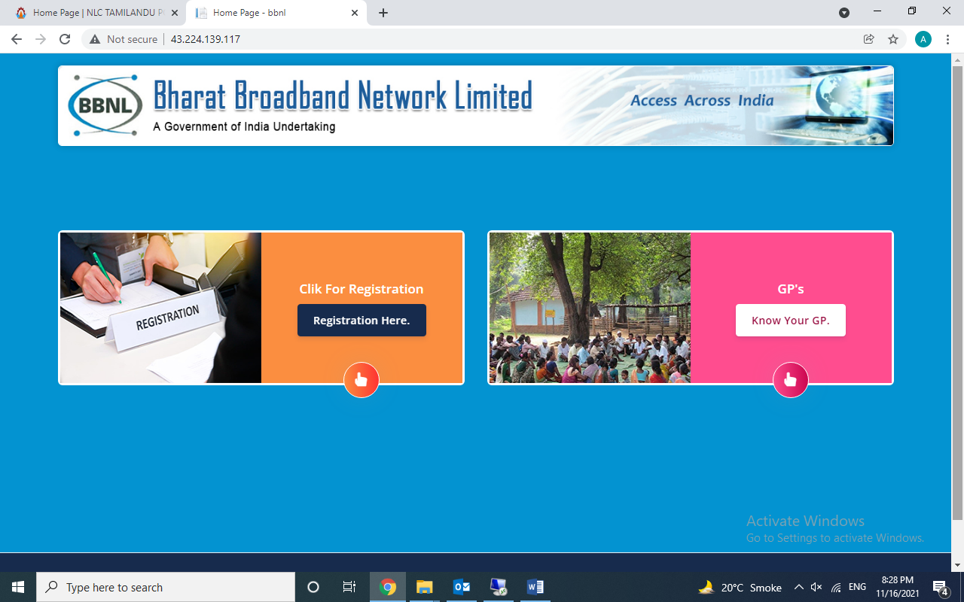

1. Spelling Click For Registration
2. Registration Here and Login Here with Blink or eye catching.
3. Thump icon on Registered Here not in bottom in both.
4. Know Your GP

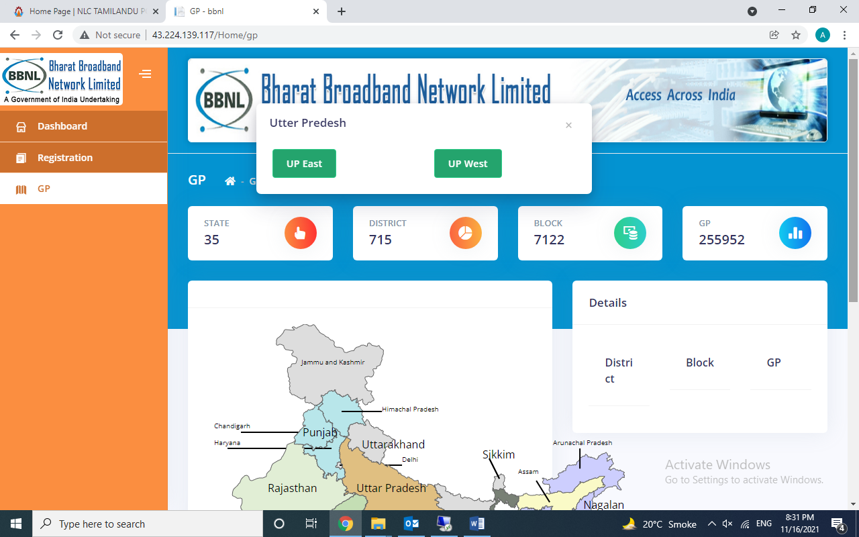

* 1. Click on UP state or states which represent two box shows on top. It should show on middle of Maps so that user saw it clearly.

1. Registration Here Form
   1. Under Type of Company add Other
   2. Add these with Textbox or browse file option
      1. PAN (Text box & Browse)
      2. GST No (Text box & Browse)
      3. TAN No (Text box)
      4. DoT/I&B/LCO Licence No (Browse)
      5. AoA/MoA (Browse)
      6. Any Agreement (Browse)
   3. Change the text Authorized Signatory Name to Name of Authorized Signatory
   4. Aadhaar Number of Authorized Signatory.
   5. Change the text Address 1 and Address to Address Line 1 and Address Line 2
2. No any PSU please change the heading/text to PMU.
3. Once Registration done than a confirmation message with Userid and Password sent to User for further action.
4. User Login with Userid and Password it show the service required
   1. Under service required
      1. Bandwidth
         1. Asymantec (Traiff plan given by BBNL)
         2. Symantec (Traiff plan given by BBNL)
      2. Dark Fiber (Traiff plan given by BBNL)
      3. Please check the attached image of Form for Requirement of Bandwidth under point no. 3
      4. These point no. 3 details forwarded to PMU which are belongs.
      5. Once PMU Received the details than make a demand note and note sent to User.
      6. After than User Pay the Online Payment.
      7. Online Payment received by PMU and check the status than it forwarded to NOC – Network Operating Center (Shastri Park)
      8. NOC works on it and than sent to Billing department.

Point no v, vi, vii, viii are discussed later one above points are done. Meeting on NOC Shastri Park for other developments and points.

**A complete tariff plan and billing work done under this software tariff wise.**

Total Users

1. Admin
2. Registered User
3. PMU User (State wise)
4. Accounts BBNL for billing purpose.

