Smart Factory Equipment Anomaly Alert Agent
Pegatron ML Engineer Assignment — Assignment 3
Vaibhav Kumar Sunkaria · Built end-to-end with free AI tools · https://github.com/vaibhavsunkaria97/smart-factory-agent

1. Task Description & Objective
An AI agent that monitors smart-factory equipment sensor data, detects anomalies automatically, and delivers actionable real-time alerts. The pipeline generates a dummy sensor dataset (temperature, pressure, vibration), cleans it, scores every reading with two independent detectors, explains each anomaly through an LLM, and emits a prioritised alert table plus a machine-readable JSON log for downstream MES integration.
Design constraint taken from the brief. Because the assignment rewards a low usage barrier, the system runs with one command and no API key: python run_all.py regenerates the data, alerts, metrics, figures and test results. LLM reasoning is used when available and degrades gracefully to a deterministic expert reasoner when it is not.

2. Development Workflow (AI-driven)
The project was built with an agentic coding loop: Aider driving a free-tier frontier model, reading the repository, writing files and committing to git. Manual effort was limited to specifying constraints, verifying every output by execution, and taking over where the agent stalled. Full prompts and the defect log are in docs/AI_LOG.md.

3. Method & Model Details

3.1 Data generation and preprocessing
300 rows at one-minute intervals, ~11% abnormal, with 1–3 channels corrupted per abnormal row. Missing values and duplicate timestamps are injected deliberately so cleaning is not a no-op. A generator-side assertion guarantees every row labelled abnormal breaches at least one threshold. Preprocessing de-duplicates, imputes with time-aware interpolation, and produces a separate z-scored copy for the ML detector — physical units are kept apart from scaled values so alerts stay human-readable.

3.2 Detection ensemble
A rule detector applies the brief's physical thresholds (temp >52/<43 °C, pressure >1.08/<0.97 bar, vibration >0.07 g) — fast, explainable, no training. An IsolationForest (200 trees) learns the normal multivariate envelope unsupervised and catches patterns no single threshold expresses. Scores are fused as an OR-of-evidence (score = max(rule, ML)), favouring recall because a missed fault costs more than a false alarm. Severity follows from breach count and score.

3.3 Reasoning layer
Each anomaly is turned into a diagnosis and recommended action by the best available free backend — local Ollama, free-tier Groq, or a deterministic knowledge base keyed on (signal, direction). The LLM never alters a detection; it only phrases the explanation, so correctness remains deterministic and unit-tested.

4. System Architecture
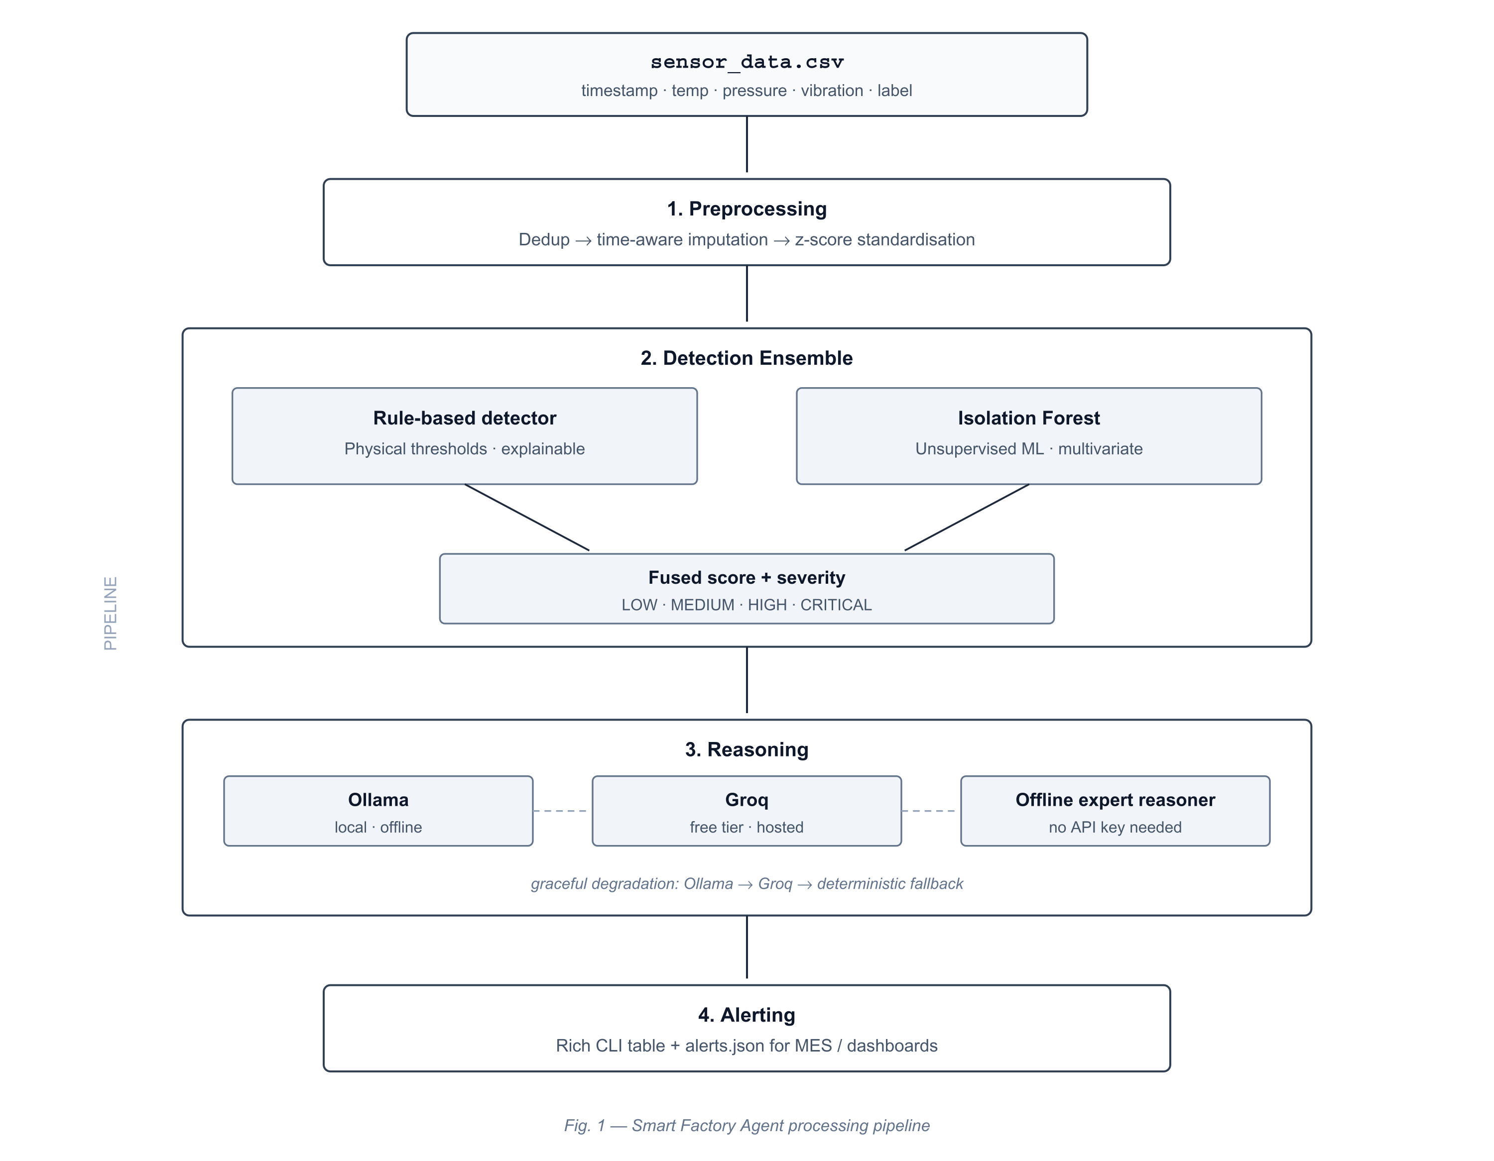
Figure 1 — Four-stage pipeline with graceful degradation at the reasoning layer.

5. Evaluation
Four configurations were compared against ground-truth labels (300 readings, 33 true anomalies). F2 is reported alongside F1 because β=2 weights recall four times more than precision, which is the right emphasis for equipment safety. Accuracy is deliberately omitted: with ~11% positives, predicting 'all normal' would already score ~89%.
Detector | Precision | Recall | F1 | F2 | Flagged
Rule-based only | 0.943 | 1.000 | 0.971 | 0.988 | 35
IsolationForest only | 0.917 | 1.000 | 0.957 | 0.982 | 36
Gaussian Mixture (K=2) | 0.917 | 1.000 | 0.957 | 0.982 | 36
Rule + IF ensemble (shipped) | 0.917 | 1.000 | 0.957 | 0.982 | 36
Table 1 — Detector comparison. All configurations achieve perfect recall.
An honest finding: preprocessing manufactured two anomalies. Precision is below 1.0 for every detector, and investigation showed why. Two rows with a missing vibration reading sat between high-vibration neighbours; time-interpolation filled them with 0.080 and 0.088, both above the 0.07 limit. Those rows are labelled normal but breach after cleaning, so they count as false positives. The detectors behaved correctly — the imputed value never occurred. Cleaning is not a neutral step. In production the fix is causal forward-fill (which the streaming path requires anyway) plus flagging imputed values in the alert so an operator knows the reading was inferred rather than measured.
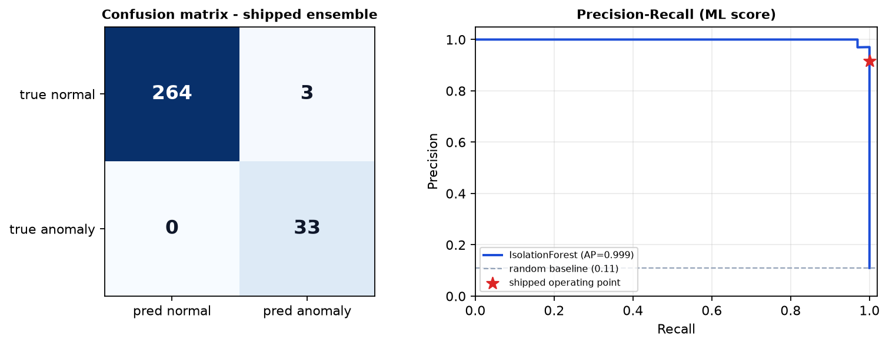
Figure 2 — Confusion matrix and precision–recall curve with the shipped operating point.

6. Demo
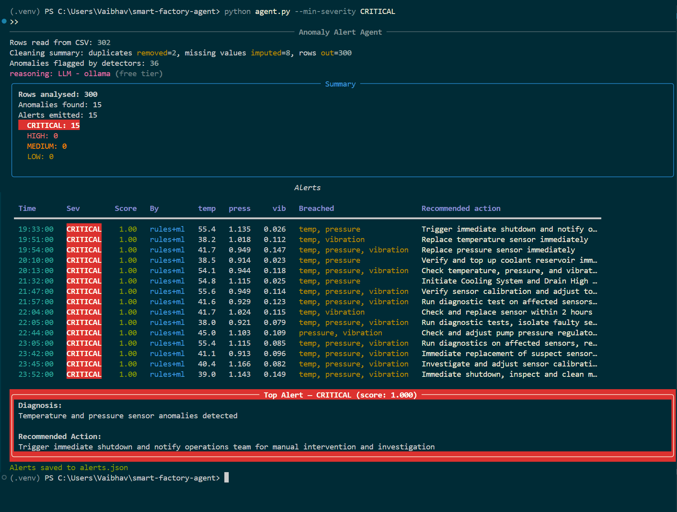
Figure 3 — CRITICAL alerts with live Ollama reasoning: cleaning summary, prioritised table, and top-priority alert card.
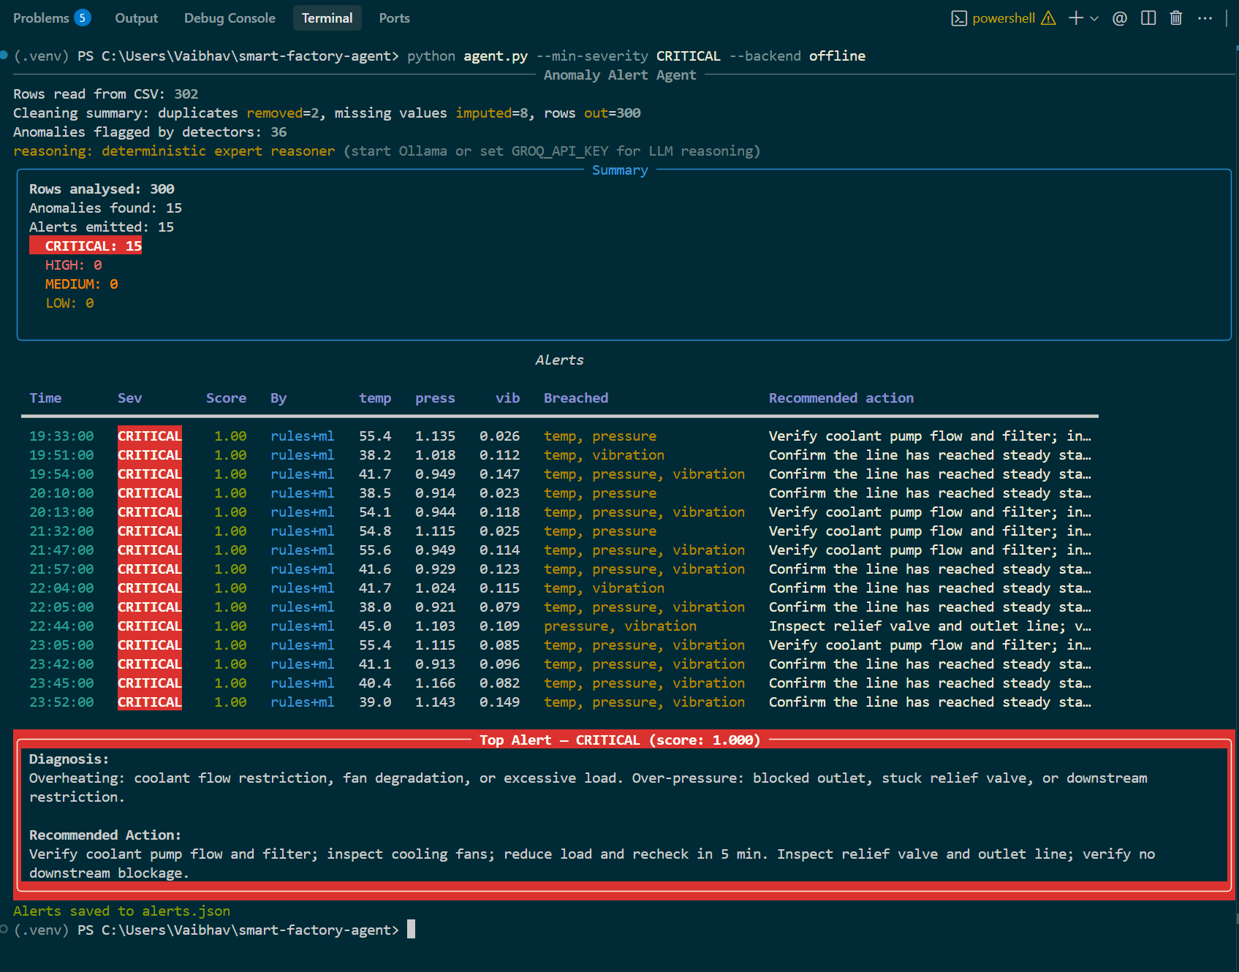
Figure 4 — Offline fallback execution with deterministic expert reasoner output when no LLM backend is active.

7. Use of AI Tools
Only free tiers were used. AI appears in two distinct roles: tools that built the system, and an LLM embedded inside the delivered product as its reasoning layer.
Free AI tool | Type | Contribution
Aider + free-tier frontier model | Build-time | Agentic loop: read repo, planned changes, wrote modules and tests, committed to git.
Claude (free tier) | Build-time | Requirement analysis, architecture decisions, debugging, report generation.
Ollama / llama3.2 (local) | Runtime | LLM inside the product writing each alert's diagnosis — free, offline, air-gap friendly.
Groq (free tier) | Runtime | Hosted alternative reasoning backend.

7.1 AI as reviewer, not only generator
Every AI output was verified by execution, and verification caught defects that reading the code did not: mislabelled rows where 8 of 41 'abnormal' readings breached no threshold; a syntax error from a duplicated loop header; a runtime TypeError from interpolating a string column; a scale-dependent bug where 100-row datasets received zero missing values; and — most instructive — an LLM backend that reported success while every call silently failed, because it posted to the wrong endpoint and a bare except: pass hid it. The status line said 'ollama' while zero LLM calls had succeeded. Report observed state, never intended state.
Measured limits of the local model. On multi-breach rows llama3.2 frequently names only one fault, occasionally inverts the direction (recommending 'increase temperature' for a low-temperature fault), and has hallucinated non-existent hardware ('Replace sensor 3'). The deterministic knowledge base never does. This is the empirical basis for keeping detection deterministic and confining the LLM to phrasing.

8. Limitations & Next Steps
The system detects point anomalies only; contextual and collective (subsequence) faults would need windowed or sequence models — deliberately not attempted here because the synthetic data contains independent point anomalies with no temporal structure for a sequence model to learn. Batch imputation is non-causal and unsuitable for streaming. Severity cutoffs are a heuristic rather than a derivation. Next steps: Kafka ingestion in place of CSV, per-equipment learned thresholds, drift detection with retraining, an operator confirm/dismiss feedback loop to build real labels, retrieval-grounded maintenance actions, and MES integration so a CRITICAL alert opens a work order.

