EXPT. NO. 1

# %Program to Generate Gaussian distribution function for different

pkg load statistics

x=-5:0.5:5;

y=normpdf(x,0,1) subplot(1,3,1) plot(x,y)

axis([-5 5 0 1]) title('mean=0, std dev=1') y=-5:0.5:5;

y=normpdf(x,0,0.5) subplot(1,3,2) plot(x,y)

axis([-5 5 0 1]) title('mean=0, std dev=.5') x=-5:0.5:5;

y=normpdf(x,1,1) subplot(1,3,3) plot(x,y)

axis([-5 5 0 1]) title('mean=1, std dev=1')

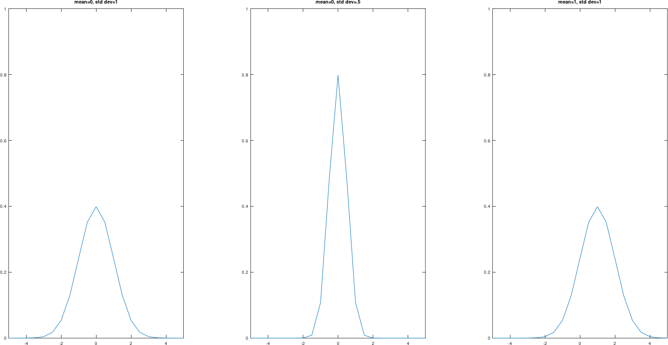

# % Program to plot PSD and Autocorrelation of Random Process

y=normrnd(0,1,1,200);

Gy=periodogram(y);

Ry=abs(ifft(Gy,256));

Ry=[Ry(130:256)' Ry(1:129)']

t=-127:1:128;

subplot(1,2,1)

plot(Gy)

xlabel('frequencysamples');

title('PSD')

subplot(1,2,2)

plot(t,Ry)

xlabel('time shift')

title('autocorrelation')

