Indian Legal AI Platform
Exhaustive technical documentation generated from the repository source tree (application code only; dependencies such as node_modules and .venv are excluded).

Table of Contents
- Section 1 — Project Overview
- Section 2 — Technology Stack
- Section 3 — RAG Deep Dive
- Section 4 — Python Concepts Used
- Section 5 — Complete Code Walkthrough
- Section 6 — API / Endpoints
- Section 7 — Data Flow Diagram
- Section 8 — Setup & Configuration
- Section 9 — Master Interview Preparation
- Section 10 — MongoDB Collections & Fields (reference)
- Section 11 — Beginner Concepts (Python, HTTP, JWT, async explained)
- Section 12 — RAG Alternatives & Design Trade-offs
- Section 13 — Security, Privacy & Limitations
- Section 14 — Glossary
Note: In Microsoft Word, you can replace this list with Insert → Table of Contents if you apply Heading styles consistently (this document does).

Visual diagrams (system, RAG, authentication)
These figures are rendered automatically when matplotlib is installed. If you only install python-docx, the textual ASCII diagrams elsewhere still explain the flows.

Figure 1 — Retrieval-augmented chat ends to end.
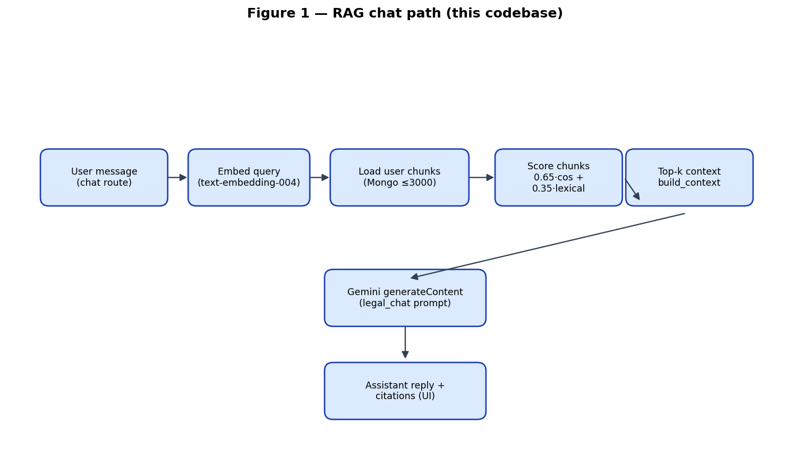

Figure 2 — Services and persistence.
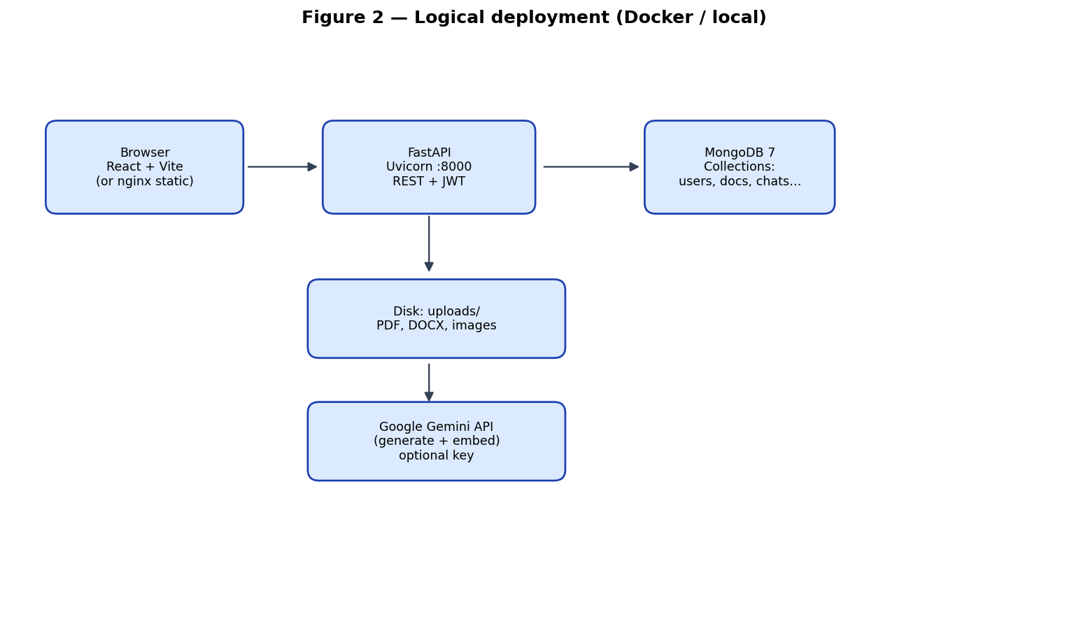

Figure 3 — Authentication and Bearer usage.
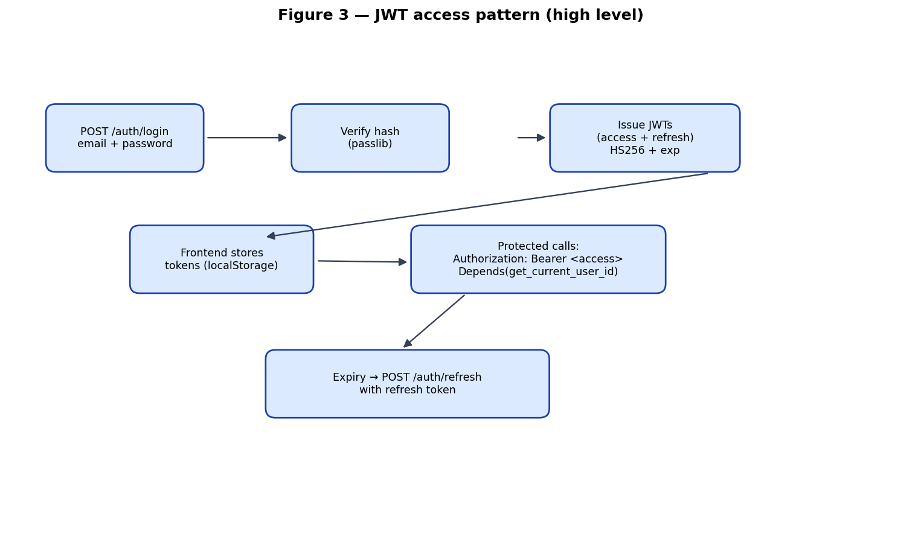

Section 1: Project Overview

What this project does
This repository implements an Indian-law-focused legal assistant web application. Users register and log in with email and password. They upload contracts (PDF, DOCX, or images), and the backend extracts text, stores documents in MongoDB, and optionally chunks text for retrieval-augmented generation (RAG) using Google Gemini embeddings and cosine similarity, with lexical token overlap as a secondary signal. Chat lets users ask legal-style questions; the backend retrieves relevant chunks, builds a context string, and calls Gemini for an answer (or falls back to rule-based text when no API key is set). A separate “analysis” endpoint scans contract text with keyword and regex heuristics to produce extracted clause snippets, risk flags, and a simple summary. The frontend is a React + TypeScript single-page app styled with Tailwind CSS, offering dashboard, upload, documents with analysis views, chat, profile, and settings including global search and notifications.

Who would use it and why
Legal teams, founders, or procurement staff who need a lightweight MVP to organize contracts, get heuristic risk highlights, and ask questions grounded (when embeddings work) in uploaded text. It is framed as educational guidance, not a substitute for professional legal advice.

High-level architecture (ASCII)
+------------------+
| Web Browser |
| React + Vite |
+--------+---------+
| HTTPS / REST (axios)
v
+------------------+ +------------------+ +------------------+
| Nginx (Docker) | | FastAPI (Python) | | MongoDB 7 |
| serves static | ---> | JWT auth | ---> | users, documents |
| frontend build | | document upload | | clauses, risks, |
+------------------+ | RAG + Gemini | | chats, chunks, |
+------------------+ | notifications |
| +------------------+
v
Google Gemini API
(generateContent + embedContent)

Complete folder structure (project files only)
Legal_AI/
README.md # Run instructions (Docker + local)
docker-compose.yml # mongo + backend + frontend services
backend/
Dockerfile
requirements.txt
.env.example # Backend configuration template
app/
main.py # FastAPI app, CORS, routers, lifespan
core/
config.py # Pydantic Settings (env)
deps.py # get_db, JWT dependency
security.py # hash/verify password, JWT create/decode
db/
mongo.py # Motor async Mongo client
indexes.py # Collection indexes
modules/
auth/routes.py # Register, login, refresh, /me, PATCH /users/me
documents/routes.py # Upload, list, get, delete, analyze
analysis/routes.py # Clauses, risks, summary, explain
chat/routes.py # Chat sessions and messages (RAG + AI)
search/routes.py # Regex search across entities
notifications/routes.py
schemas/
common.py # User and auth DTOs
legal.py # Legal domain response models
services/
ai_service.py # Gemini HTTP + heuristics / fallbacks
rag_service.py # Chunking, embedding, hybrid retrieval
document_service.py # Save uploads, extract PDF/DOCX/image stub
tests/
test_health.py # Health endpoint smoke test
uploads/ # Stored uploaded files (runtime)
frontend/
Dockerfile # Multi-stage: npm build + nginx
package.json
vite.config.ts
index.html
.env.example
src/
main.tsx # React root, router, react-query, toaster
App.tsx # Routes and auth guard
lib/api.ts # Axios instance + refresh helper
lib/types.ts # Shared TS types
lib/utils.ts # cn() class merge
hooks/use-auth.tsx # Auth context
pages/ # Landing, auth, workspace pages
components/ # UI shell, chat, upload, marketing
shared/contracts/legal.ts # Shared clause type unions (TS)
Excluded from documentation scope: backend/.venv, frontend/node_modules, frontend/dist build artifacts (except noting they exist), and binary uploads under backend/uploads/.

Section 2: Technology Stack
Below, each major dependency is explained for readers new to Python or web development, with project-specific usage and interview-style practice.

FastAPI
What is it? A modern Python web framework that builds REST APIs using standard Python type hints. It automatically validates request bodies with Pydantic and generates OpenAPI documentation.
Why / how in this project: Defines HTTP routes in app.main and app.modules.*.routes, wires routers, and applies CORS.
Analogy: Like a restaurant counter: each endpoint is a menu item; FastAPI checks orders (requests) and plates responses.
Term | Meaning
Router | Groups related endpoints under a prefix
Dependency injection | Depends() injects DB and current user
OpenAPI | Interactive docs at /docs

Interview questions — FastAPI
- How does FastAPI know the shape of JSON bodies?
Through Pydantic models used as parameters or response_model.
- What is the difference between sync and async route functions?
Async routes can await I/O (DB, HTTP); sync routes block the worker thread.
- Where is CORS configured in this project?
CORSMiddleware in app/main.py allows all origins for development.
- How are routes organized?
Separate modules under app/modules/<area>/routes.py included in main.
- What generates API docs?
FastAPI builds OpenAPI schema; Swagger UI is at /docs.

Uvicorn
What is it? An ASGI server that runs async Python web apps such as FastAPI.
Why / how in this project: Docker CMD and local README use uvicorn app.main:app to serve the API.
Analogy: Like an engine that runs the FastAPI application process and listens on a port.
Term | Meaning
ASGI | Async Server Gateway Interface for Python web apps
Workers | Can scale with multiple processes in production

Interview questions — Uvicorn
- What is ASGI?
A standard interface between async Python apps and servers like Uvicorn.
- Why uvicorn for FastAPI?
FastAPI is an ASGI app; uvicorn is a common production server.
- How is the app object referenced?
app.main:app means module path app.main, variable app.
- What port does Docker expose?
8000 inside the container per Dockerfile.

Motor + MongoDB
What is it? Motor is the official async Python driver for MongoDB. MongoDB is a document database storing JSON-like documents.
Why / how in this project: connect_to_mongo uses AsyncIOMotorClient; routes query collections like db.users, db.documents.
Analogy: MongoDB is like filing cabinets with flexible folders; Motor is the async librarian fetching papers.
Term | Meaning
Collection | Analogous to a SQL table but schema-flexible
Index | Speeds lookups; unique index on users.email

Interview questions — Motor + MongoDB
- Why Motor instead of PyMongo directly?
Native async/await integration with FastAPI routes.
- How is the database selected?
client[settings.mongo_db_name] in mongo.py.
- What indexes are created?
See db/indexes.py for users, documents, clauses, risks, chats, chunks.

Pydantic & pydantic-settings
What is it? Pydantic validates Python data classes; pydantic-settings loads configuration from environment variables and .env files.
Why / how in this project: Settings in core/config.py defines app_name, mongo_uri, jwt_secret, gemini keys, etc.
Analogy: Settings are a checklist that refuses to serve the app with inconsistent types—like forms that validate before submit.
Term | Meaning
BaseSettings | Loads fields from environment with optional .env file
Field validation | EmailStr, min_length on passwords in schemas

Interview questions — Pydantic & pydantic-settings
- Where is .env loaded?
SettingsConfigDict(env_file='.env') in Settings.
- Why separate schemas/common.py and legal.py?
Auth models vs legal domain models.

PyJWT & passlib
What is it? PyJWT creates and verifies JSON Web Tokens. Passlib hashes passwords (here pbkdf2_sha256).
Why / how in this project: Login returns access and refresh tokens; get_current_user_id decodes access tokens.
Analogy: JWT is a stamped ticket showing identity; hashing prevents storing raw passwords.
Term | Meaning
Access vs refresh | Access for API calls; refresh to obtain new access tokens
HS256 | Symmetric signing with jwt_secret

Interview questions — PyJWT & passlib
- Why not store plaintext passwords?
If the DB leaks, attackers still lack passwords.
- What claim distinguishes token types?
Custom 'type' field: access or refresh.

httpx
What is it? Async-capable HTTP client for Python used to call external REST APIs.
Why / how in this project: AIService and RAGService use httpx.AsyncClient to call Google Gemini generateContent and embedContent.
Analogy: Like requests but fits async FastAPI routes without blocking.
Term | Meaning
AsyncClient | Use with await for non-blocking I/O

Interview questions — httpx
- How are Gemini failures handled?
Retry once on some HTTP errors; else fallback logic.

python-docx & pypdf & Pillow
What is it? python-docx reads Word files; pypdf reads PDF pages; Pillow is imported indirectly for image pipeline readiness.
Why / how in this project: document_service.extract_text uses PdfReader and Docx paragraphs; images return a placeholder string.
Analogy: Like printers in reverse: turning files back into plain text the AI pipeline can read.

Interview questions — python-docx & pypdf & Pillow
- What happens for scanned PDFs?
Text extraction may be empty unless OCR is added; images use placeholder text.

React 19 + TypeScript + Vite
What is it? React builds UI as components; TypeScript adds static types; Vite bundles for dev and production builds.
Why / how in this project: src/App.tsx routes pages; workspace-pages.tsx contains dashboard, chat, documents, etc.
Analogy: React is LEGO bricks for UI; Vite is a fast factory assembling them.
Term | Meaning
Hooks | useState, useEffect, useMemo, useContext in this codebase
react-router-dom | BrowserRouter, Routes, Navigate for SPA navigation

Interview questions — React 19 + TypeScript + Vite
- Why axios interceptor?
Attaches Bearer token from localStorage to each request.

Tailwind CSS 4
What is it? Utility-first CSS: classes like flex, p-4, bg-slate-900 compose layouts without writing separate CSS files for each rule.
Why / how in this project: index.css and components use Tailwind classes for the dark legal workspace theme.
Analogy: Like naming every paint chip instead of mixing paint from scratch each time.

Interview questions — Tailwind CSS 4
- What is cn() in lib/utils.ts?
Merges class names with tailwind-merge to resolve conflicts.

TanStack React Query
What is it? A data-fetching library for caching and refreshing server state (used here via QueryClientProvider).
Why / how in this project: QueryClient created in main.tsx; many pages still call axios directly—both can coexist.
Analogy: Like a smart clipboard that remembers server answers for a short time.

Interview questions — TanStack React Query
- Is every screen using useQuery?
Not necessarily; many components call api.get in useEffect.

Google Gemini (REST)
What is it? Gemini is Google's multimodal model family accessed via HTTP from this project (not the Python SDK).
Why / how in this project: ai_service calls generateContent; rag_service calls text-embedding-004 embedContent.
Analogy: Two booths: one writes answers, one turns text into vectors for similarity.
Term | Meaning
Model name | settings.gemini_model default gemini-1.5-flash
Embedding model | text-embedding-004 in rag_service._embed_text

Interview questions — Google Gemini (REST)
- What happens if GEMINI_API_KEY is empty?
LLM and embeddings return None; fallbacks and lexical-only retrieval apply.

Section 3: RAG (Retrieval-Augmented Generation) — Deep Dive
RAG augments a language model with retrieved passages from your own documents so answers cite private material instead of only memorized training data.

Why RAG exists
Large models may hallucinate or lack up-to-date private facts. Retrieval grounds answers in snippets the user actually uploaded.

RAG flow (boxes)
User question
|
v
+-------------+ +------------------+ +------------------+
| Embed query | --> | Score all chunks | --> | Top-k chunks |
| (optional) | | vector + lexical | | build_context() |
+-------------+ +------------------+ +---------+--------+
|
v
+---------------------+
| Prompt = context + |
| question -> Gemini |
+---------------------+
|
v
Assistant reply + citations

Pipeline mapped to this project
1) Document loading: upload saves bytes; document_service.extract_text produces a single string. 2) Chunking: rag_service.chunk_text splits normalized whitespace text into overlapping windows (default size 900 chars, overlap 180). 3) Embedding: _embed_text posts each chunk to Gemini text-embedding-004; vectors stored in MongoDB document_chunks.embedding. 4) Vector store: MongoDB collection document_chunks (not a dedicated vector DB). 5) Retrieval: retrieve loads user chunks, scores 0.65 * cosine + 0.35 * token overlap. 6) LLM: legal_chat sends prompt with context slice to Gemini generateContent. 7) Response: ChatMessageResponse returns assistant text and citations built from chunk excerpts.

Embeddings explained
An embedding is a list of numbers (e.g., hundreds of floats) representing semantic meaning. Similar meanings yield vectors that point in similar directions; cosine similarity measures the angle between vectors.

Vector database and similarity
Dedicated vector databases optimize approximate nearest neighbor search. Here, vectors live in MongoDB documents and retrieval loops all user chunks (up to 3000), computing cosine in Python. This is simple but may be slower at large scale.

Chunks: size trade-offs
Too-large chunks dilute relevance and waste context window; too-small chunks lose surrounding legal meaning. Overlap helps preserve continuity across boundaries.

Code walkthrough — RAG functions
Step | File / symbol | Role
Chunking | rag_service.chunk_text | Regex normalize whitespace; sliding windows with overlap
Embed chunk | rag_service._embed_text | POST embedContent; returns None without API key
Index | rag_service.index_document_chunks | Deletes prior chunks for doc; insert_many with embedding and token_set
Retrieve | rag_service.retrieve | Hybrid vector + lexical score; sort descending
Context | rag_service.build_context | Concatenate labeled chunks up to max_chars
Citations | rag_service.build_citations | File name + chunk index + excerpt
Use in chat | chat/routes.send_message | Calls retrieve, build_context, ai_service.legal_chat

RAG interview Q&A (10+)
- What is the retrieval scoring formula in this codebase?
score = 0.65 * cosine_similarity(embedding) + 0.35 * (intersection of query/chunk tokens / query token count).
- What embedding model is used?
Google Gemini text-embedding-004 via embedContent REST endpoint.
- Is LangChain used?
No. Retrieval and prompting are implemented directly in Python services.
- What happens if embeddings are unavailable?
vector term is 0; lexical token overlap can still rank chunks; if no chunks, context is empty.
- Why store token_set in MongoDB?
To speed lexical overlap using pre-tokenized words of length >= 3 characters.
- How are citations produced?
build_citations lists file_name and first ~220 characters of each retrieved chunk.
- When are chunks (re)indexed?
On upload after extract_text, and again after analyze completes to refresh text-derived chunks.
- Does this use pgvector or Chroma?
No. Embeddings are stored as arrays on MongoDB documents; similarity is computed in application code.
- What limits retrieval fan-out?
retrieve fetches up to 3000 chunk documents for the user from MongoDB.
- How does the prompt instruct the model?
legal_chat prepends Indian-law assistant instructions and includes trimmed context up to ~4000 chars.
- What ethical caveat appears in prompts?
The prompt states educational guidance, not legal advice.

Section 4: Python Concepts Used

Type hints (PEP 484)
Concept: Annotate variables and returns like user_id: str for readability and tooling.
In this project: deps.py: async def get_current_user_id(...) -> str
- Why use | None?
Union types express optional values clearly in Python 3.10+.
- Do hints enforce at runtime?
Not by default; Pydantic validates API layers.

async / await
Concept: Allows non-blocking I/O in asynchronous functions.
In this project: All Mongo operations use await; httpx AsyncClient in AI calls.
- What runs the event loop?
Uvicorn drives ASGI apps; await yields control while waiting on I/O.

Dependency injection with FastAPI Depends
Concept: Reusable dependencies injected into route parameters.
In this project: get_current_user_id and get_db pattern on routes.
- Benefit?
Centralizes auth and DB access, fewer duplicated lines.

Comprehensions and generators
Concept: Compact loops building lists or dicts.
In this project: List comprehensions when mapping Mongo docs to Pydantic responses.
- Example?
[_map_doc(d) for d in docs] in documents routes.

Pathlib
Concept: Object-oriented filesystem paths.
In this project: document_service uses Path(settings.upload_dir) / file_id.
- Why Path over strings?
Cross-platform joins and readability.

Regular expressions (re)
Concept: Pattern matching on strings for risk detection and tokenization.
In this project: rag_service._tokenize and AIService.detect_risks patterns.
- Flag used?
Case-insensitive search uses lowered text or inline patterns.

Classes and singleton service instances
Concept: AIService class instantiated once as ai_service module global.
In this project: Shared stateless service object reused across requests.
- Is this thread-safe?
For this MVP, yes—no mutable shared fields beyond logger.

Section 5: Complete Code Walkthrough
This section walks repository Python modules and summarizes each function. Frontend TSX files follow.

backend/app/main.py
Symbol | Inputs | Behavior | Returns
startup | None | await connect_to_mongo(); ensure_indexes | None
shutdown | None | close Mongo client | None
health | None | JSON status ok | dict

backend/app/core/config.py
Symbol | Inputs | Behavior | Returns
Settings | env vars | Loads configuration via pydantic-settings | settings singleton

backend/app/core/deps.py
Symbol | Inputs | Behavior | Returns
get_db | None | Returns AsyncIOMotorDatabase | database
get_current_user_id | Bearer token | Validates access JWT, returns sub | str user id

backend/app/core/security.py
Symbol | Inputs | Behavior | Returns
hash_password | plain password | pbkdf2_sha256 hash | str
verify_password | plain, hash | boolean verify | bool
create_token | subject, type, minutes | JWT encode with exp | str jwt
decode_token | jwt string | decode with secret | payload dict

backend/app/db/mongo.py
Symbol | Inputs | Behavior | Returns
connect_to_mongo | None | Initializes global client/db | None
close_mongo_connection | None | Closes client | None
get_database | None | Returns db or raises | AsyncIOMotorDatabase

backend/app/db/indexes.py
Symbol | Inputs | Behavior | Returns
ensure_indexes | db | create_index on collections | None

backend/app/modules/auth/routes.py
Symbol | Inputs | Behavior | Returns
register | UserCreate | Insert user if email free | UserResponse
login | UserLogin | Verify password; issue tokens | TokenResponse
refresh_token | dict with refresh_token | Validate refresh type; new tokens | TokenResponse
me | Authorization | Fetch user by id | UserResponse
update_me | UserUpdate | PATCH name | UserResponse

backend/app/modules/documents/routes.py
Symbol | Inputs | Behavior | Returns
upload_document | UploadFile | Save file, extract text, insert doc, index chunks, notify | DocumentResponse
list_documents | auth | List user docs desc | list DocumentResponse
get_document | id | Single doc | DocumentResponse
delete_document | id | Cascade delete related rows | ok flag
analyze_document | id | Heuristic clauses/risks/summary; update risk_score | {"ok": true}

backend/app/modules/analysis/routes.py
Symbol | Inputs | Behavior | Returns
list_clauses | document_id | Requires ownership | ClauseResponse list
list_risks | document_id | Requires ownership | RiskResponse list
get_summary | document_id | Summary record | SummaryResponse
explain_clause | ClauseExplainRequest | Calls ai_service.explain_clause | dict

backend/app/modules/chat/routes.py
Symbol | Inputs | Behavior | Returns
create_chat_session | ChatCreate | Insert chat shell | id + title
list_sessions | auth | Recent chats | list metadata
get_session | session_id | Messages array | dict
send_message | ChatMessageRequest | RAG retrieve + legal_chat; persist messages | ChatMessageResponse

backend/app/modules/search/routes.py
Symbol | Inputs | Behavior | Returns
search_all | query string q | Regex searches across filenames, titles, clauses, risks | JSON buckets

backend/app/modules/notifications/routes.py
Symbol | Inputs | Behavior | Returns
list_notifications | auth | Recent notifications | list dict

backend/app/services/document_service.py
Symbol | Inputs | Behavior | Returns
save_upload | UploadFile | Write bytes to uploads/uuid.ext | path, ext
extract_text | path, ext | PDF/DOCX text or image placeholder | str

backend/app/services/rag_service.py
Symbol | Inputs | Behavior | Returns
chunk_text | text, sizes | Whitespace normalize + overlap slicing | list[str]
_tokenize | text | Word tokens length>=3 | set[str]
_embed_text | text | Gemini embed | list[float]|None
_cosine | vectors | Cosine similarity | float
index_document_chunks | db + ids + text | Replace chunks for doc | int count
retrieve | db + user + query | Hybrid score top_k | list[dict]
build_context | chunks | Join with labels | str
build_citations | chunks | Citation dicts | list[dict]

backend/app/services/ai_service.py
Symbol | Inputs | Behavior | Returns
_call_gemini | prompt | POST generateContent | str|None
extract_clauses | full text | Keyword buckets -> pseudo clauses | list[dict]
detect_risks | clauses + text | Regex library across corpus | list[dict]
summarize_contract | text | First sentences heuristics | dict
legal_chat | question, context | Gemini or fallback answer + citations structure | dict
explain_clause | type, content | Static explanatory template | dict

backend/tests/test_health.py
Symbol | Inputs | Behavior | Returns
test_health | uses TestClient | GET /health returns ok | asserts

Schemas (Pydantic)
File | Models | Purpose
schemas/common.py | UserCreate, UserLogin, TokenResponse, UserResponse, UserUpdate, Message | Auth and user DTOs
schemas/legal.py | DocumentResponse, ClauseResponse, RiskResponse, SummaryResponse, ClauseExplainRequest, ChatCreate, ChatMessageRequest, Citation, ChatMessageResponse | Legal/chat API contracts with Literal clause types

Frontend (TypeScript / React) file-by-file
Path | Role
src/main.tsx | Bootstraps React with StrictMode, QueryClientProvider, BrowserRouter, Toaster.
src/App.tsx | AuthProvider; routes /, /login, /register, /app/* with ProtectedRoutes guarding workspace.
src/lib/api.ts | Axios instance with VITE_API_BASE_URL; attaches Bearer; refreshAccessToken posts /auth/refresh.
src/lib/types.ts | User, DocumentItem, risk and analysis status unions.
src/lib/utils.ts | cn() merges Tailwind classes via clsx + tailwind-merge.
src/hooks/use-auth.tsx | AuthContext with user, loading, setUser, logout; boot fetch /auth/me with refresh retry.
src/pages/auth-pages.tsx | LoginPage and RegisterPage forms posting to /auth/*; stores tokens; navigates to /app/dashboard.
src/pages/workspace-pages.tsx | Dashboard, Chat (sessions, upload-in-chat, messages), Upload, Documents (clauses/risks/summary), Analysis stub, Profile, Settings.
src/pages/landing-page.tsx | Marketing landing with animated feature carousel, how-it-works, use cases, testimonials, FAQ, pricing CTA.
src/components/app-sidebar.tsx | LexSaarthi-branded nav links to workspace routes using useLocation active styles.
src/components/chat-bubble.tsx | User vs assistant layout; ReactMarkdown body; citations block; copy button.
src/components/upload-zone.tsx | Drag/drop or pick file UI used by UploadPage.
src/components/feature-card.tsx | Reusable marketing card if referenced from landing.
src/components/marketing-navbar.tsx | Top nav for landing linking sections and auth.
src/components/risk-badge.tsx | Visual severity badge for numeric or categorical risk.
src/components/ui/button.tsx, card.tsx, input.tsx, skeleton.tsx | Styled primitives (likely shadcn-style) for consistent UI.
src/index.css, App.css | Global and app-level styles; Tailwind layer.
public/, index.html | Static favicon/icons and Vite HTML shell.
Shared folder: shared/contracts/legal.ts exports clauseTypes array and ClauseType union mirroring backend literals.

Design decisions
- Mongo stores chat messages inline arrays for MVP simplicity (not a separate messages collection). - Risk scoring sums severities with caps at 100. - Auth tokens in login use literal 30 minutes and 7 days rather than reading settings.access_token_exp_minutes—an inconsistency to fix in production hardening. - CORS allow_origins=['*'] is permissive for development only. - Image uploads do not perform real OCR yet; placeholder text reminds integrators to add vision/OCR. - explain_clause is template-based, not LLM-driven, keeping latency and cost low.

Section 6: API / Endpoints
Method | Path | Auth | Description
GET | /health | No | Liveness check
POST | /auth/register | No | Create user
POST | /auth/login | No | Issue JWT pair
POST | /auth/refresh | No | Refresh tokens (body.refresh_token)
GET | /auth/me | Bearer | Current profile
PATCH | /users/me | Bearer | Update profile name
POST | /documents/upload | Bearer multipart | Upload + index chunks
GET | /documents | Bearer | List documents
GET | /documents/{id} | Bearer | Get metadata
DELETE | /documents/{id} | Bearer | Delete doc + dependent records
POST | /documents/{id}/analyze | Bearer | Run heuristics analysis
GET | /documents/{id}/clauses | Bearer | List clauses
GET | /documents/{id}/risks | Bearer | List risks
GET | /documents/{id}/summary | Bearer | Summary
POST | /documents/{id}/clauses/explain | Bearer JSON | Explain clause
POST | /chat/sessions | Bearer | Create chat
GET | /chat/sessions | Bearer | List chats
GET | /chat/sessions/{id} | Bearer | Fetch messages
POST | /chat/sessions/{id}/messages | Bearer | Send user message (RAG)
GET | /search?q= | Bearer | Regex search
GET | /notifications | Bearer | Notifications

Example requests / responses
POST /auth/login
Request JSON: {"email":"user@example.com","password":"********"}
Response: {"access_token":"...","refresh_token":"...","token_type":"bearer"}
POST /documents/upload
Headers: Authorization: Bearer <access>
Body: multipart/form-data file=@contract.pdf
Response: {"id":"...","file_name":"contract.pdf","file_type":"pdf","analysis_status":"uploaded",...}
POST /chat/sessions/{id}/messages
Request: {"content":"What are termination rights?"}
Response: {"session_id":"...","user_message":"...","assistant_message":"...","citations":[{"source":"...","excerpt":"..."}]}

REST / FastAPI interview Q&A
- Why separate routers with prefixes?
Namespaces endpoints (/auth vs /documents) and attaches shared tags for docs.
- How is authentication enforced?
Depends(get_current_user_id) ensures Bearer JWT with type access.
- What status codes are used for auth failures?
401 for invalid token/credentials, 404 when documents missing.

Section 7: Data Flow Diagram
- 1. User opens React app; AuthProvider calls GET /auth/me with stored access token.
- 2. Login posts credentials; tokens saved to localStorage; axios interceptor attaches Authorization header.
- 3. Upload: browser sends multipart to POST /documents/upload; backend saves file, extracts text, inserts Mongo document row, calls rag_service.index_document_chunks, inserts notification.
- 4. Analyze: POST /documents/{id}/analyze loads extracted text, runs ai_service heuristics, writes clauses/risks/summaries, updates analysis_status and risk_score, reindexes chunks, notifies user.
- 5. Chat message: POST /chat/sessions/{id}/messages loads session, rag_service.retrieve scores chunks, build_context, ai_service.legal_chat calls Gemini or fallback, persists user+assistant messages.
- 6. Search: GET /search applies Mongo $regex queries across permitted collections scoped to user.

Section 8: Setup & Configuration

Install and run from zero
Docker: docker compose up --build — launches mongo:7, backend image (uvicorn), frontend image (nginx static).
Local backend: python -m venv .venv; activate; pip install -r requirements.txt; copy .env.example to .env; run uvicorn app.main:app --reload inside backend/.
Local frontend: npm install; npm run dev; set frontend/.env VITE_API_BASE_URL to backend URL.

Environment variables
Variable | Purpose
APP_NAME | FastAPI title / branding
ENVIRONMENT | Deployment stage string
MONGO_URI | Mongo connection URI (docker-compose uses mongodb://mongo:27017)
MONGO_DB_NAME | Database name (default legal_ai)
JWT_SECRET | Signing key for HS256 tokens—must be strong in production
JWT_ALGORITHM | Usually HS256
ACCESS_TOKEN_EXP_MINUTES | Intended access token lifetime (note: code may still use literals in auth routes)
REFRESH_TOKEN_EXP_MINUTES | Refresh lifetime
UPLOAD_DIR | Directory for stored uploads
GEMINI_API_KEY | Google AI Studio key for LLM + embeddings
GEMINI_MODEL | Model id for generateContent (default gemini-1.5-flash)
VITE_API_BASE_URL | Frontend axios base URL

Common errors
- Mongo connection refused
Ensure Mongo is running and MONGO_URI matches host/port; docker service name is mongo.
- 401 on protected routes
Token expired—use refresh flow or login again; check Authorization header.
- Empty PDF text
Scanned PDFs need OCR; pipeline returns little text so analysis may be sparse.
- Gemini errors
Verify GEMINI_API_KEY; watch rate limits—service retries once on some HTTP errors.

Section 9: Master Interview Preparation

Python Basics
- What is the difference between a list and a tuple?
Lists are mutable; tuples immutable—use tuples for fixed records.
- What does async def accomplish in FastAPI?
Declares a coroutine route that can await I/O without blocking other requests.
- How are dictionaries used when returning Mongo documents?
Keys like _id map to fields; ObjectId may be converted to str for JSON.
- What is Pydantic?
Data validation layer—defines schemas for request/response models.
- Explain try/except around password hashing in register.
Turns low-level hashing errors into HTTP 400 with safe messaging.
- What is a list comprehension?
Compact syntax [f(x) for x in items if cond]—used mapping Mongo docs.
- What does Pathlib provide?
OO path operations—used when saving uploads.
- What is a module-level singleton?
ai_service = AIService() reused across imports.
- Why datetime timezone.utc?
Store timestamps timezone-aware to avoid DST ambiguity.
- What is ObjectId in Mongo?
BSON type for primary keys; converted to str for API responses.
- Why use Field(min_length=8) on passwords?
Enforces minimum complexity at validation layer.
- What is * and ** unpacking?
Not heavily used here, but dict payloads use explicit keys for Mongo updates.

RAG & LLMs
- Define retrieval-augmented generation.
Fetch relevant texts first, then condition the LLM prompt on them.
- Why cosine similarity?
Measures directional alignment of embedding vectors independent of magnitude scaling when norms considered.
- What is a chunk overlap?
Characters repeated between consecutive chunks to preserve cross-boundary context.
- How does this app ground answers?
Inserts top chunks into the Gemini prompt via legal_chat.
- Fallback when LLM absent?
Rule-based messages in _fallback_legal_chat_answer.
- Why include lexical scoring?
Captures keyword overlap when embeddings missing or weak.
- Prompt injection concern?
Untrusted documents included in prompts—sanitize or isolate untrusted content.
- Temperature not shown—why?
Gemini REST payload here only sets text parts; tuning omitted.
- Context truncation at 4000 chars—why?
Balances prompt size vs latency/cost.
- What is a fallback path?
Code path when external LLM is unavailable to keep UX working.
- Why label chunks with file_name?
Citations remain human-readable in the UI.
- Why cap context to 5000 chars in build_context?
Prevents overlong prompts and controls cost.

Vector Databases
- Why might MongoDB + Python cosine be a bottleneck?
Linear scan over user chunks; specialized ANN indexes scale better.
- What is ANN?
Approximate nearest neighbor search trading accuracy for speed.
- Does this project normalize embeddings before cosine?
Cosine function divides by norms of both vectors (implicit normalization effect).
- Difference between exact and approximate search?
Exact checks all pairs; approximate uses indexes/graphs for speed.
- Embedding dimensionality?
Defined by model—values list length must match for cosine.
- What is metadata filtering?
Restricting vector search by user_id before distance calc—done here by query filter.
- Why store embeddings in-app vs recompute?
Trade storage for latency; recomputing each time would be slower and costlier.

API Development
- How does FastAPI validate an email field?
EmailStr from Pydantic in UserCreate.
- Why use response_model?
Filters output fields and documents schema for clients.
- How to secure cookies vs tokens here?
Bearer tokens in headers—cookies not used in this MVP.
- What is multipart upload?
HTTP encoding for files—FastAPI UploadFile handles streams.
- Why HTTPBearer?
Standard Authorization: Bearer header parsing.
- How to document multipart endpoints?
FastAPI infers file parameters; appears in OpenAPI as multipart.
- What is idempotency?
Repeating a request has same effect; DELETE is idempotent; analyze POST is not strictly idempotent.
- Why return 404 vs 403?
This MVP hides existence of other users' docs by 404 on mismatch.
- What is OpenAPI tag?
Groups endpoints in docs—see tags in APIRouter declarations.

System Design
- How would you shard chat history at scale?
Move messages to their own collection with indexed session_id.
- How to improve OCR?
Integrate Gemini vision or Tesseract; preprocess PDF images.
- How to harden auth?
Align token TTL with settings, rotate secrets, narrow CORS, rate limit login.
- How to scale retrieval?
Use a vector database with ANN; pre-filter by user_id metadata.
- Caching strategies for dashboard counts?
Redis or memoized queries with ttl.
- How to version API?
Prefix routes /v1 and maintain backward compatible schemas.
- Zero-downtime deploy?
Blue/green behind load balancer; migrate Mongo with compatible schema.
- Backpressure on Gemini?
Queue analyze jobs; limit concurrent httpx calls.
- How to audit AI outputs?
Log prompts, model version, and outputs with user id for compliance.
- Data residency considerations?
Host Mongo and call regional Gemini endpoints as required.

Improvements
- Add integration tests for auth and RAG.
Use TestClient with seeded Mongo or mongomock.
- Add structured logging/trace ids.
Observability across Gemini and Mongo calls.
- Add file virus scanning.
ClamAV or cloud malware API before saving uploads.
- Implement background jobs for analyze.
Celery/RQ so HTTP returns quickly.
- Internationalization on frontend.
i18n framework with extracted strings.
- Role-based access control.
Tenant or role claims inside JWT for team workspaces.
- Add LLM-based clause extraction.
Replace keyword method with structured JSON outputs validated by Pydantic.
- Per-tenant encryption.
KMS-managed keys for documents at rest.
- Add pytest coverage for RAG scoring.
Golden vectors with known cosine outcomes.
- Feature flags for Gemini.
Toggle LLM per tenant in settings.
- Add contract templates library.
Pre-seed chunk store with standard clauses for comparison.
Total curated Q&A items in this section: 61.

Section 10: MongoDB Collections & Fields
MongoDB groups records into collections (like flexible tables). The app infers schemas from Python dictionaries inserted at runtime; indexed fields accelerate common queries (see backend/app/db/indexes.py).
Collection | Purpose | Representative fields (from routes/services)
users | Registered accounts. | email (unique), password_hash (passlib), name, _id.
documents | One row per uploaded file. | user_id, file_name, file_type, storage_path, extracted_text, analysis_status, risk_score (0–100 cap), created_at.
clauses | Heuristic clause snippets after analyze. | document_id, clause_type, content, explanation, risk_level, created_at.
risks | Regex/heuristic flags tied to clauses. | document_id, clause_id?, clause_type, severity (high/medium/low), issue, risky_text, why_risky, recommendation, created_at.
summaries | summary dict from summarize_contract. | document_id, plain_summary, obligations[], deadlines[], payment_terms[], termination_conditions[], key_risks[], created_at.
document_chunks | RAG store per user/document. | user_id, document_id, file_name, chunk_index, content, token_set[], embedding[] (Gemini dims) | null, created_at.
chats | Chat threads; messages nested array. | _id as session id, user_id, title?, messages[{role, content, citations?, created_at}], updated_at.
notifications | Toast-style events. | user_id, title, message, created_at.

Cascade & consistency notes
Deleting a document (DELETE /documents/{id}) removes related clauses, risks, summaries, and document_chunks for that document_id. Analyze replaces prior clauses/risks/summary for the document.

Risk score calculation (interview)
In analyze_document, each risk increments risk_score by 80 if severity is high, 50 if medium, 20 if low; final score stored as min(sum, 100). This is a simple additive heuristic.

Section 11: Beginner Concepts (read this first if new to Python or web backends)

How software in this repo fits together
Your browser loads JavaScript bundles built from the React frontend. When you submit a form or click Chat, the frontend sends an HTTP request to the backend URL (often http://localhost:8000 during development). FastAPI inspects headers and JSON or multipart bodies, validates them with Pydantic models, then runs Python functions that query MongoDB (via Motor) or call Gemini (via httpx). The response travels back as JSON and React redraws components.
Idea | Plain explanation | Where you see it here
Python module | A .py file you import elsewhere. | app.services.rag_service imported as rag_service.
Virtual environment (.venv) | Isolated dependency folder so pip packages do not clash. | Recommended in README before pip install.
async def / await | Pauses only the current request while waiting on network/database. | Nearly every Mongo call uses await.
JSON | Structured text exchanged over HTTP ({"key":"value"}). | Auth and chat payloads.
Environment variables | Config outside Git; Production secrets. | .env copied from .env.example.
REST resource | A URL noun like /documents with verbs GET/POST/DELETE. | routers prefixed /documents.
JWT split | Access token proves identity for minutes; refresh token renews quietly. | /auth/login + /auth/refresh.

What “embedding” and “dimension” mean (no math prerequisites)
Think of embedding as turning a paragraph into hundreds of sliders (numbers); similar paragraphs yield similar slider positions. Cosine similarity compares two sliders’ angles: 1 means very aligned, 0 means unrelated.

Section 12: Comparing Ways to Teach the Model About Your Documents
Approach | How it works | Pros | Cons | This repo
Naive long prompt | Paste entire contract into Gemini each time. | Simple mental model. | Hits token limits quickly; pricey; brittle. | Legal chat trims context (~4000 chars) + top chunks—not whole doc blindly.
Fine-tuning | Train new weights with domain data. | Learns stylistic quirks. | Expensive pipelines; staleness unless retrained. | Not used.
Classic RAG (this codebase) | Chunk, embed/stash, retrieve, answer with citations-ish snippets. | Updates when user uploads docs; grounding. | Retriever quality bottleneck; hallucination risk if chunks wrong. | Yes—Gemini embeddings + lexical hybrid.
External vector DB (Pinecone, etc.) | Same as RAG but ANN indexing. | Faster retrieval at billions of vectors. | Extra infra complexity. | Not yet—vectors live in Mongo + Python cosine.

Interview framing
Be ready to say: embeddings give semantic fuzziness, lexical fallback keeps keyword-heavy legal terms relevant when API keys fail, Mongo gives flexible schema plus single DB story, drawbacks are brute-force scoring (3000 chunks). Production would add ANN and background workers.

Section 13: Security, Privacy & Limitations
Topic | Current behavior | Hardening idea
CORS | allow_origins=['*'] in backend/app/main.py (dev convenience). | Restrict to frontend origin.
Tokens | Bearer stored in browser localStorage (common MVP). | Consider httpOnly cookie + CSRF defenses.
Prompt injection | Uploaded doc text appended to Gemini prompt. | Strip instructions, classify untrusted blobs.
OCR gaps | Image uploads return placeholder string only. | Add vision API or OCR service.
Legal disclaimer | Prompt says guidance not advice. | Add UI banner + jurisdiction-specific copy.
Secrets | JWT secret env driven but default weak in dev. | Rotate keys; KMS in prod.
Rate limiting | Not implemented on auth routes. | Add slowapi or API gateway quotas.
File malware | No AV scan. | Hook ClamAV or cloud scanner.

Section 14: Glossary
- API: Application Programming Interface: how programs talk over HTTP with structured requests and responses.
- ASGI: Asynchronous Server Gateway Interface for Python web servers and apps.
- Bearer token: Authorization scheme where the secret token is placed after the word Bearer in the header.
- BSON: Binary JSON-like encoding MongoDB uses internally for documents.
- Chunk: A slice of document text used for retrieval and embedding.
- Collection: MongoDB grouping of documents, similar to a table but schema-flexible.
- Context window: Maximum prompt size a language model can consider at once.
- Cosine similarity: Similarity measure between two vectors based on the cosine of the angle between them.
- CORS: Cross-Origin Resource Sharing: browser security rules for calling APIs from different domains.
- Dependency injection: Supplying shared objects like database connections automatically to route handlers.
- Docker Compose: Tool to run multi-container applications from a YAML file.
- Embedding: Numeric vector representing text semantics for similarity comparisons.
- Environment variable: Configuration value provided outside source code, often via .env.
- FastAPI: Python framework for building APIs quickly with type hints and validation.
- Gemini: Google’s generative model family used here via REST for chat and embeddings.
- Heuristic: Rule-based approximation rather than full semantic reasoning.
- HS256: HMAC SHA-256 algorithm for signing JWTs with a shared secret.
- HTTPX: Python HTTP client supporting sync and async requests.
- Index: Database structure speeding queries—unique on email, compound on user_id + created_at, etc.
- JWT: JSON Web Token: compact signed claims for authentication.
- Lexical scoring: Scoring using overlapping words between query and passage.
- LLM: Large Language Model trained to predict and generate human-like text.
- Motor: Async Python driver for MongoDB.
- MongoDB: Document-oriented database storing BSON documents.
- Multimodal: Models handling more than text—Gemini family supports this broadly.
- MVP: Minimum viable product focusing on core features.
- ObjectId: MongoDB’s default unique document identifier type.
- OCR: Optical Character Recognition: turning images of text into text data.
- OpenAPI: Specification describing REST APIs; FastAPI generates it automatically.
- Passlib: Password hashing library—project uses pbkdf2_sha256.
- PDF: Portable Document Format; text extraction depends on whether text is embedded or scanned.
- Pydantic: Data validation using Python type annotations.
- PyJWT: Library to encode and decode JWT tokens.
- RAG: Retrieval-Augmented Generation combining search with language generation.
- React: JavaScript library for building component-based user interfaces.
- Regex: Regular expression pattern matching on strings.
- Refresh token: Longer-lived token used to obtain new access tokens.
- REST: Representational State Transfer style of HTTP APIs using resources and verbs.
- Similarity search: Finding nearest embedding vectors to a query vector.
- SPA: Single-page application where navigation occurs client-side without full page reloads.
- Tailwind CSS: Utility-first styling framework using composable class names.
- Token (JWT claim): Typed claim distinguishing access vs refresh in custom payload field.
- Token (text): A word or subword unit used in lexical overlap scoring.
- Type hints: Optional annotations in Python showing intended data types.
- TypeScript: JavaScript with static typing for safer front-end code.
- UploadFile: FastAPI class representing an uploaded multipart file stream.
- Uvicorn: ASGI server that runs FastAPI applications.
- Vector: List of numbers; embedding vectors live in Mongo documents.
- Vite: Fast front-end build tool and dev server used by this React project.
Glossary entries: 49.

