STATIC ROUTING

BASIC TOPOLOGY

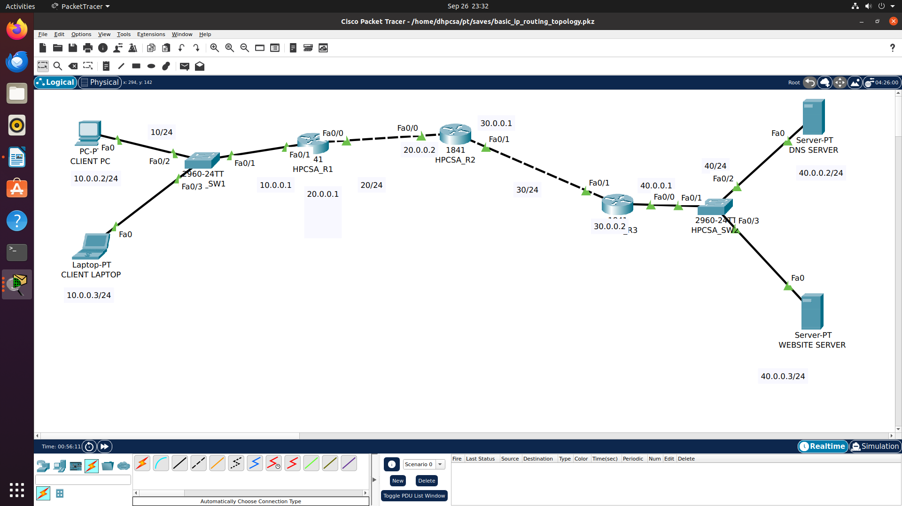
Router R1 COMMANDS (IP ADDRESSES)
Router>en
Router#
Router#configure terminal
Router(config)#
Router(config)#hostname HPCSA_R1
HPCSA_R1(config)#

HPCSA_R1(config)#interface fastEthernet 0/0
HPCSA_R1(config-if)#ip address 20.0.0.1 255.255.255.0
HPCSA_R1(config-if)#no shutdown

HPCSA_R1(config)#interface fastEthernet 0/1
HPCSA_R1(config-if)#ip address 10.0.0.1 255.255.255.0
HPCSA_R1(config-if)#no shutdown

to up

Router R2 COMMANDS (IP ADDRESSES)
R2(config)#interface FastEthernet0/0
R2(config-if)#ip address 20.0.0.2 255.255.255.0
R2(config-if)#no shutdown
R2(config)#interface FastEthernet0/1
R2(config-if)#ip address 30.0.0.1 255.255.255.0
R2(config-if)#no shutdown

Router R3 COMMANDS (IP ADDRESSES)
R3(config)#interface FastEthernet0/1
R3(config-if)#ip address 30.0.0.2 255.255.255.0
R3(config-if)#no shutdown
R3(config)#interface FastEthernet0/1
R3(config-if)#ip address 40.0.0.1 255.255.255.0
R3(config-if)#no shutdown

save all

R1#WRITE
R2#WRITE
R3#WRITE

HPCSA_R1#sh ip route
(to get routing table)
Codes: C - connected, S - static, I - IGRP, R - RIP, M - mobile, B - BGP
D - EIGRP, EX - EIGRP external, O - OSPF, IA - OSPF inter area
N1 - OSPF NSSA external type 1, N2 - OSPF NSSA external type 2
E1 - OSPF external type 1, E2 - OSPF external type 2, E - EGP
i - IS-IS, L1 - IS-IS level-1, L2 - IS-IS level-2, ia - IS-IS inter area
* - candidate default, U - per-user static route, o - ODR
P - periodic downloaded static route

Gateway of last resort is not set

10.0.0.0/24 is subnetted, 1 subnets
C 10.0.0.0 is directly connected, FastEthernet0/1
20.0.0.0/24 is subnetted, 1 subnets
C 20.0.0.0 is directly connected, FastEthernet0/0

CONFIGURE STATIC ROUTING

HPCSA_R1(config)#ip route <destination_missing_network_address> <destination_subnet_mask> <next_hop_router_ip_address>

Router R1 STATIC ROUTING
HPCSA_R1(config)#ip route 30.0.0.0 255.255.255.0 20.0.0.2
HPCSA_R1(config)#ip route 40.0.0.0 255.255.255.0 20.0.0.2

Router R2 STATIC ROUTING
HPCSA_R2(config)#ip route 10.0.0.0 255.255.255.0 20.0.0.1
HPCSA_R2(config)#ip route 40.0.0.0 255.255.255.0 30.0.0.2

Router R3 STATIC ROUTING
HPCSA_R3(config)#ip route 10.0.0.0 255.255.255.0 30.0.0.1
HPCSA_R3(config)#ip route 20.0.0.0 255.255.255.0 30.0.0.1

HPCSA_R1#show ip route
Codes: C - connected, S - static, I - IGRP, R - RIP, M - mobile, B - BGP
D - EIGRP, EX - EIGRP external, O - OSPF, IA - OSPF inter area
N1 - OSPF NSSA external type 1, N2 - OSPF NSSA external type 2
E1 - OSPF external type 1, E2 - OSPF external type 2, E - EGP
i - IS-IS, L1 - IS-IS level-1, L2 - IS-IS level-2, ia - IS-IS inter area
* - candidate default, U - per-user static route, o - ODR
P - periodic downloaded static route

Gateway of last resort is not set

10.0.0.0/24 is subnetted, 1 subnets
C 10.0.0.0 is directly connected, FastEthernet0/1
20.0.0.0/24 is subnetted, 1 subnets
C 20.0.0.0 is directly connected, FastEthernet0/0
30.0.0.0/24 is subnetted, 1 subnets
S 30.0.0.0 [1/0] via 20.0.0.2
40.0.0.0/24 is subnetted, 1 subnets
S 40.0.0.0 [1/0] via 20.0.0.2

HPCSA_R2#sh ip route
Codes: C - connected, S - static, I - IGRP, R - RIP, M - mobile, B - BGP
D - EIGRP, EX - EIGRP external, O - OSPF, IA - OSPF inter area
N1 - OSPF NSSA external type 1, N2 - OSPF NSSA external type 2
E1 - OSPF external type 1, E2 - OSPF external type 2, E - EGP
i - IS-IS, L1 - IS-IS level-1, L2 - IS-IS level-2, ia - IS-IS inter area
* - candidate default, U - per-user static route, o - ODR
P - periodic downloaded static route

Gateway of last resort is not set

10.0.0.0/24 is subnetted, 1 subnets
S 10.0.0.0 [1/0] via 20.0.0.1
20.0.0.0/24 is subnetted, 1 subnets
C 20.0.0.0 is directly connected, FastEthernet0/0
30.0.0.0/24 is subnetted, 1 subnets
C 30.0.0.0 is directly connected, FastEthernet0/1
40.0.0.0/24 is subnetted, 1 subnets
S 40.0.0.0 [1/0] via 30.0.0.2

HPCSA_R3#sh ip route
Codes: C - connected, S - static, I - IGRP, R - RIP, M - mobile, B - BGP
D - EIGRP, EX - EIGRP external, O - OSPF, IA - OSPF inter area
N1 - OSPF NSSA external type 1, N2 - OSPF NSSA external type 2
E1 - OSPF external type 1, E2 - OSPF external type 2, E - EGP
i - IS-IS, L1 - IS-IS level-1, L2 - IS-IS level-2, ia - IS-IS inter area
* - candidate default, U - per-user static route, o - ODR
P - periodic downloaded static route

Gateway of last resort is not set

10.0.0.0/24 is subnetted, 1 subnets
S 10.0.0.0 [1/0] via 30.0.0.1
20.0.0.0/24 is subnetted, 1 subnets
S 20.0.0.0 [1/0] via 30.0.0.1
30.0.0.0/24 is subnetted, 1 subnets
C 30.0.0.0 is directly connected, FastEthernet0/1
40.0.0.0/24 is subnetted, 1 subnets
C 40.0.0.0 is directly connected, FastEthernet0/0

C:\>tracert 40.0.0.3

Tracing route to 40.0.0.3 over a maximum of 30 hops:

1 0 ms 0 ms 0 ms 10.0.0.1
2 0 ms 1 ms 0 ms 20.0.0.2
3 0 ms 0 ms 0 ms 30.0.0.2
4 0 ms 0 ms 0 ms 40.0.0.3

Trace complete.

