Purpose: This Doc describes the Use Case Diagram and detailed description of HELP-DESK .

HELP-DESK :

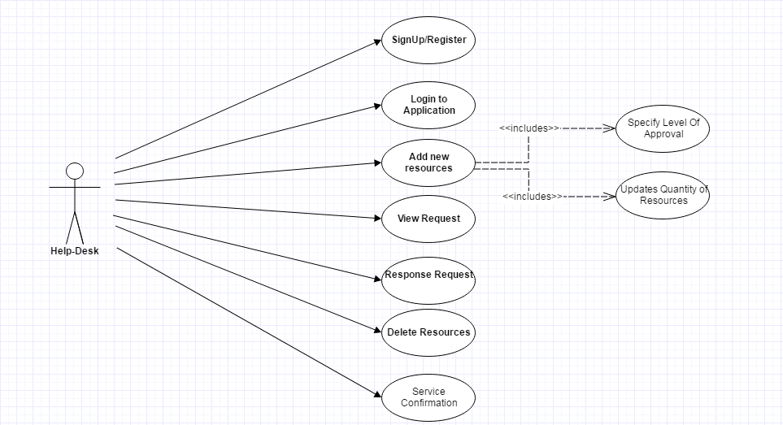
Detailed Description :

- Sign-Up/Register:
Module to log-in for help-desk.

- Log-In to Application :
helpdesk like others can log-into the application via custom login or social login.

- Add new Resources :
Helpdesk can add new IT resources if required. This will include :

a) level of approval for each resource should be given.
b) Can update quatity of resource equipment available.

- View Request :
Helpdesk can view requests but can not update its priority.

- Response to Request :
helpdesk can response to a request positive or negative ie can delay a request based on availability of requested resource.

- Delete Resources :
Helpdesk can delete a resource.

- Service Confirmation :
After providing requested resource to corresponding employee helpdesk have to confirm it. Although a request will be confirmed by manager only when it is confirmed by both requester and helpdesk.

