**AI Powered News Search App**

***Summary :***

The web is home to massive amounts of data, with more being created every day. Organizations can harness this constant stream of information to gain understanding, plan strategies, and find opportunities. Enriched news data can help your application make dynamic connections across current events faster.

In this project, you’ll start with the basics and build your own news mining web application using Node-RED / Python Web App and the IBM Watson Discovery Service.

To do this, you’ll:

* Build a Server Side Application using Node-RED
* Use the pre-built Watson Discovery News collection
* Access the Watson Discovery Service through the Discovery API

Optionally, you can choose to:

* Use a Slack interface to query the data
* Push news alerts out to web notification
* Deploy the app on IBM Cloud

***Flow :***

* The user interacts with the app UI(Built with Node-Red or Cloud or Local) to

request relevant news content.

* The app sends user requests to Watson Discovery News.
* The Watson Discovery Service is continually crawling the web to update its Discovery News collection.
* The Watson Discovery Service responds to Slack search requests.

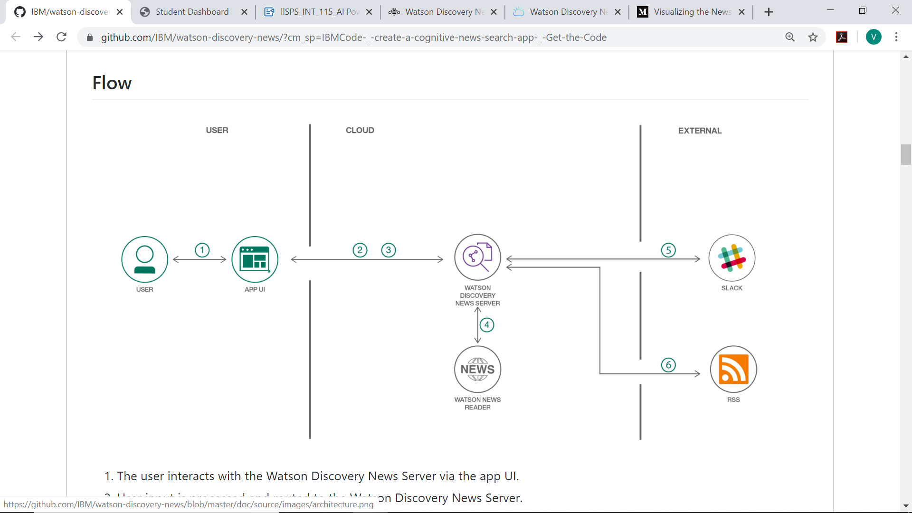

***Input :***

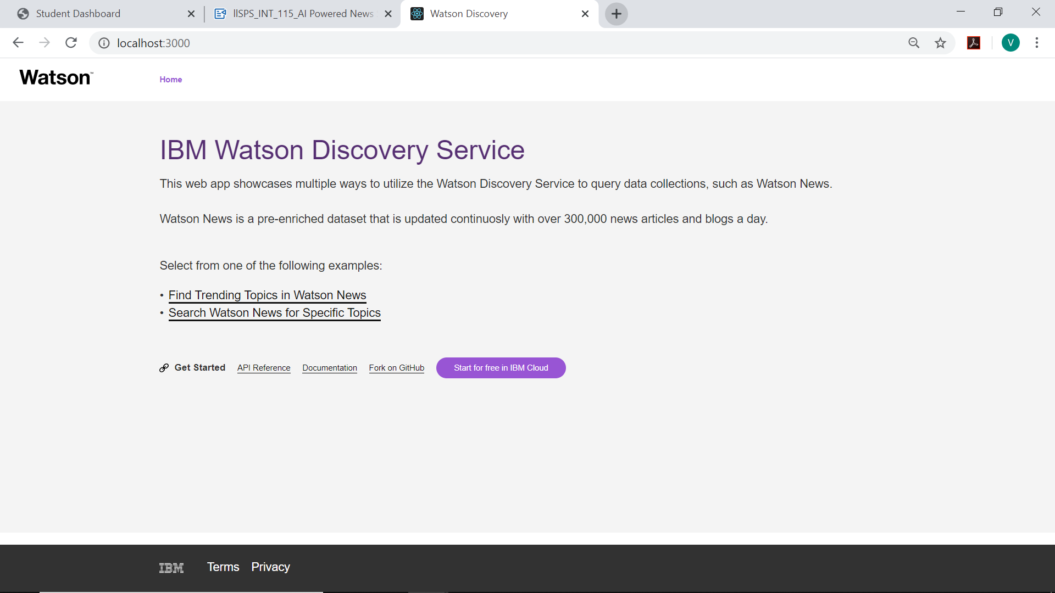

Query Page -

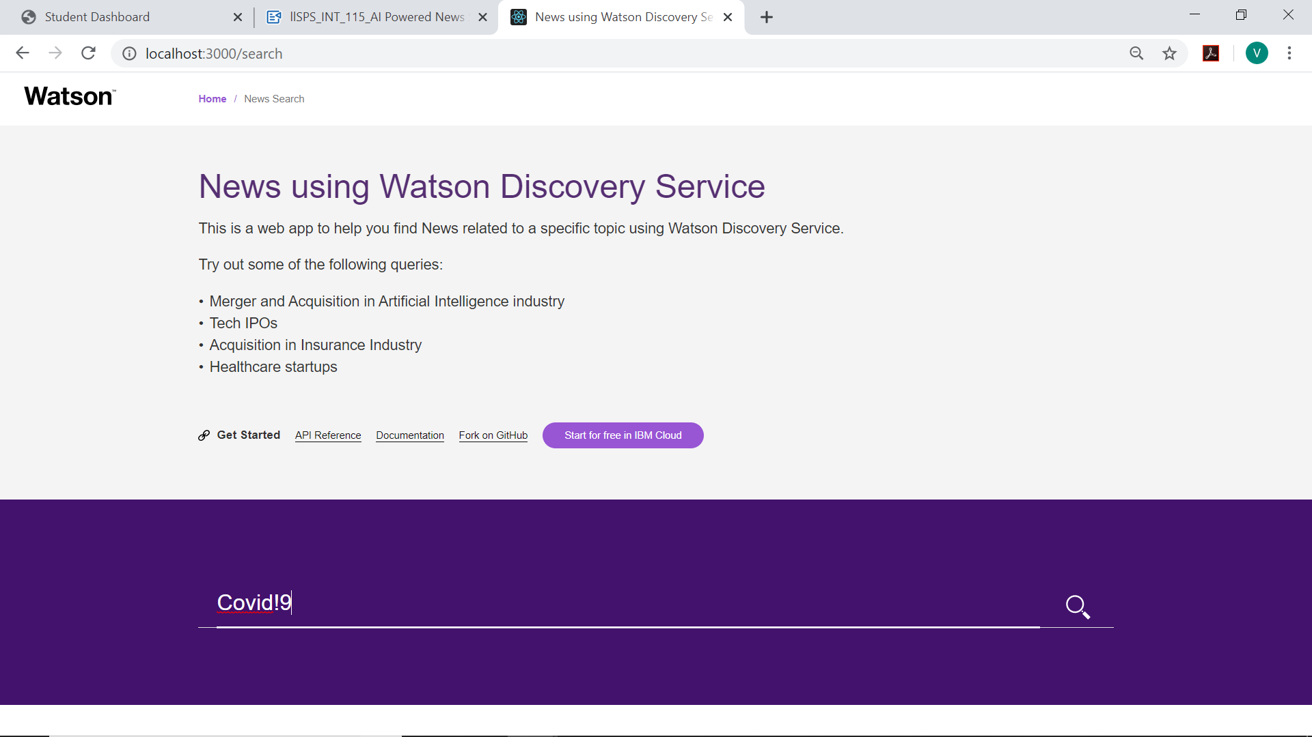

***Output -***

Top News -

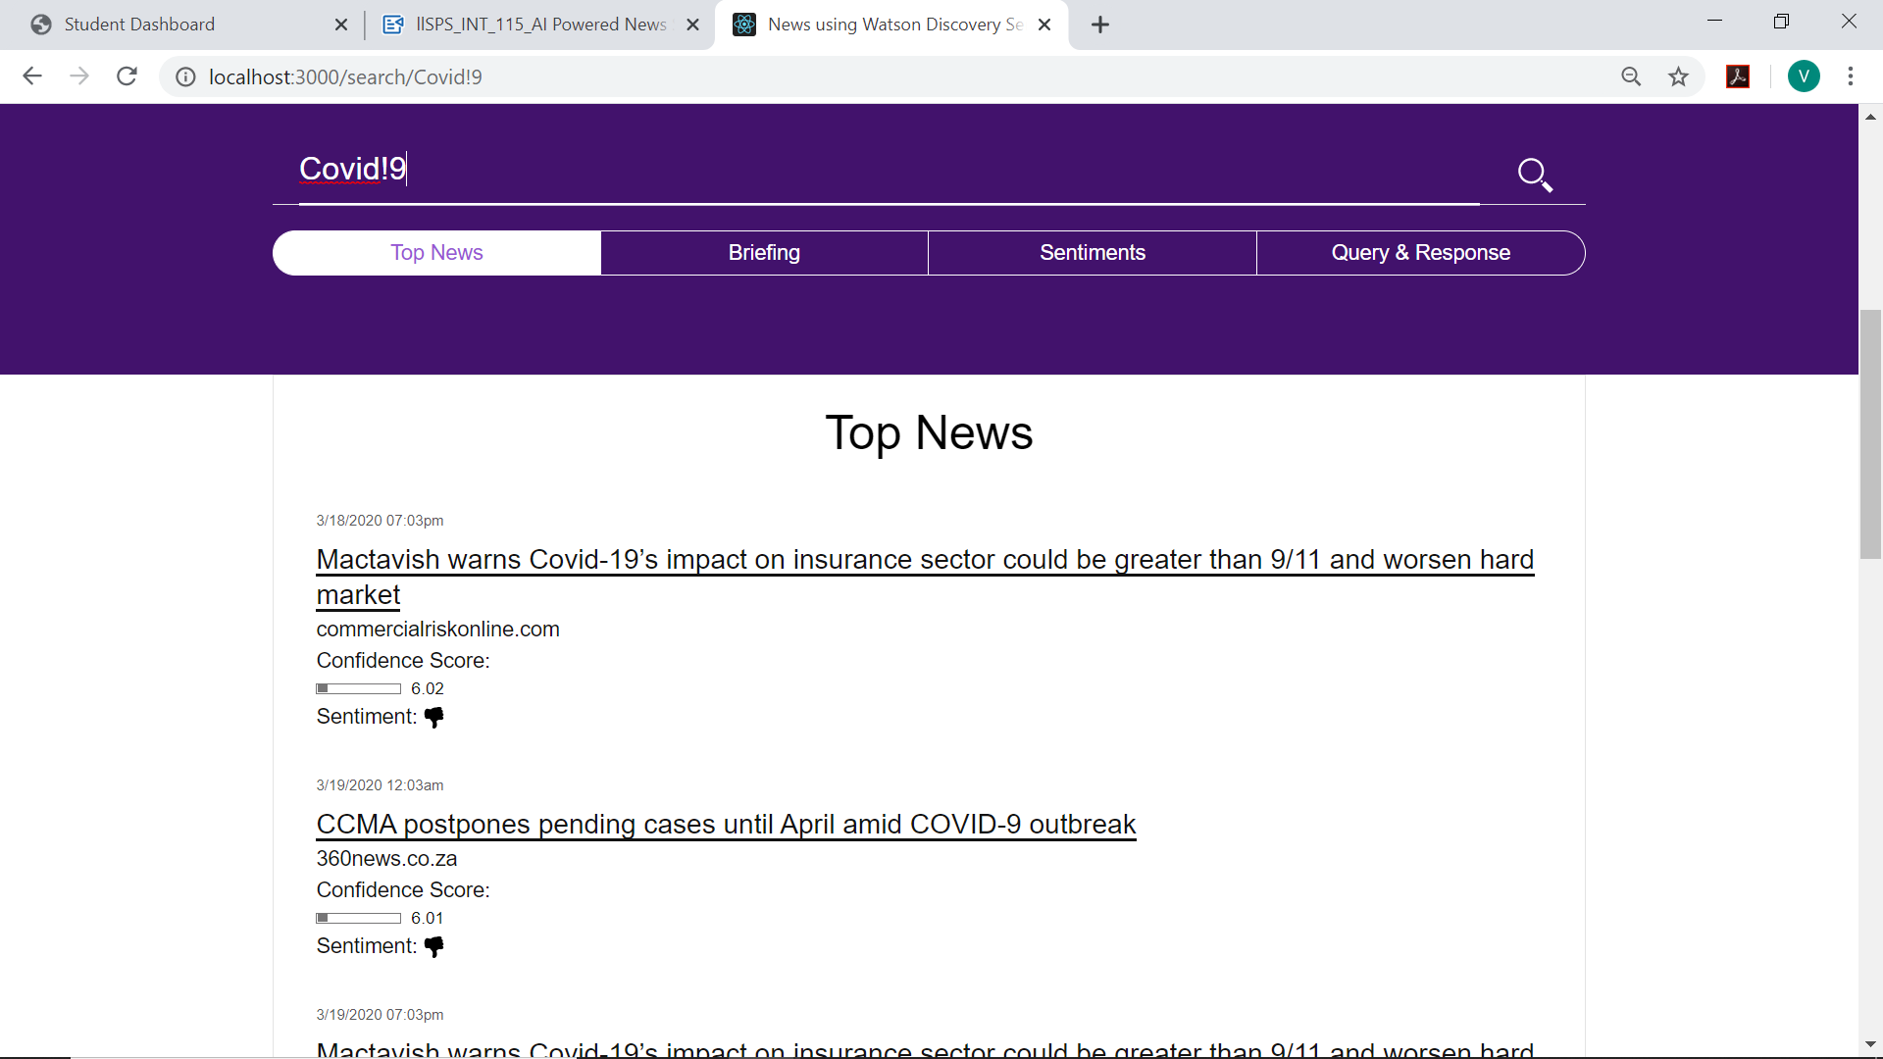

Sentiment Analysis –

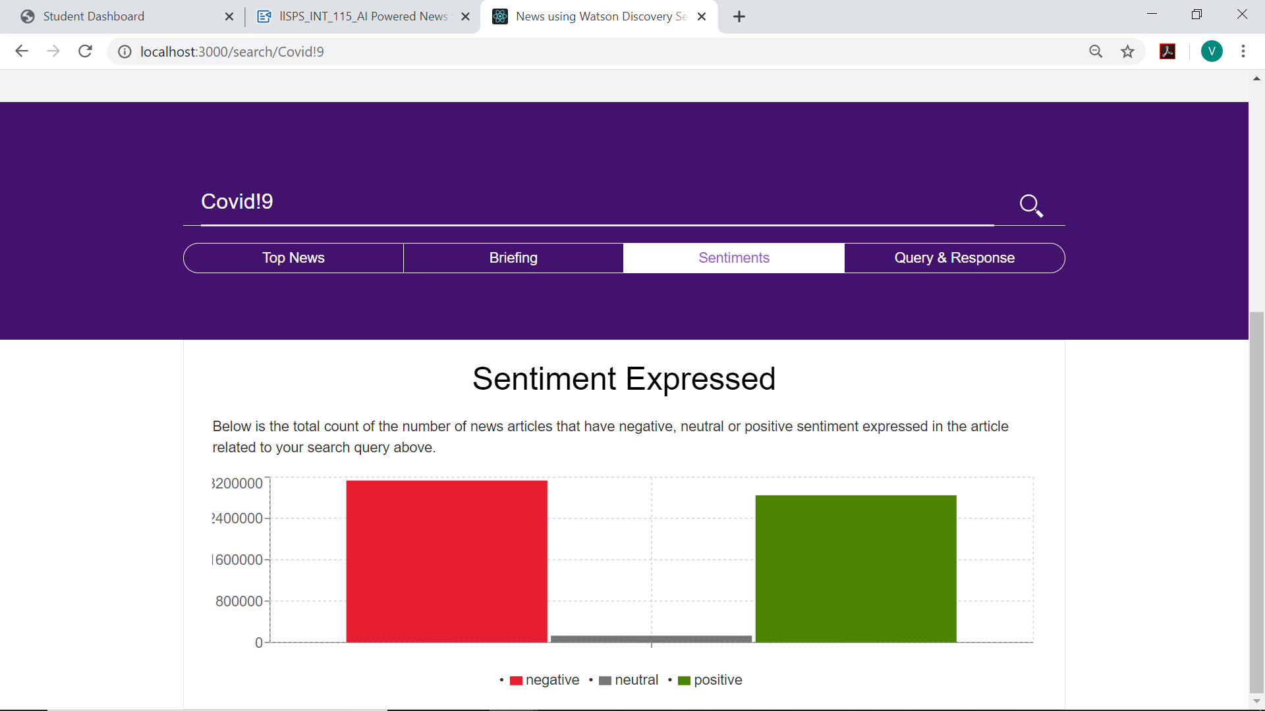

Query & Response -

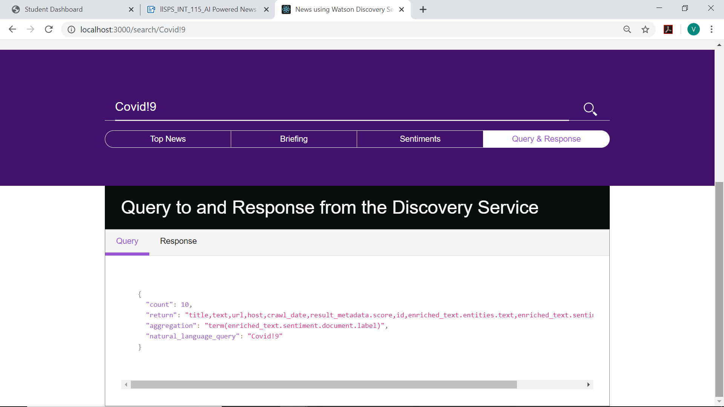

Briefing –

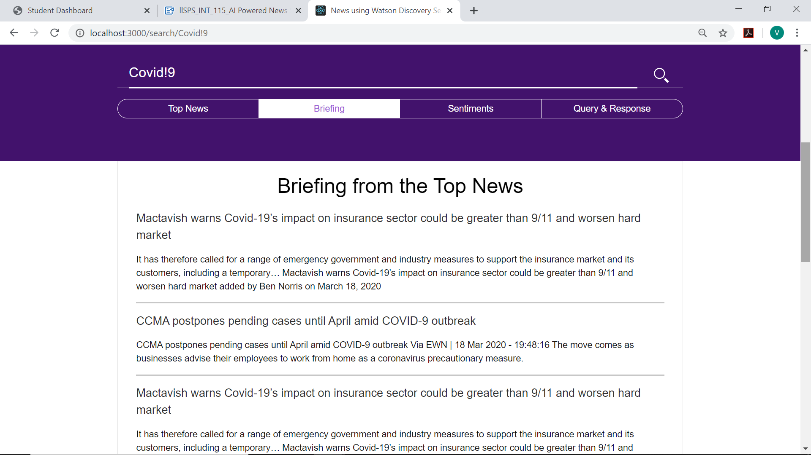

***Slack Input -***

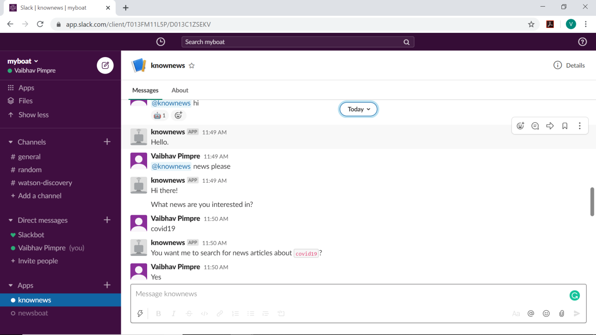

***Slack Output –***

