Title of the invention:
AI-Based Garbage Detection and Automated Geo-Mapping System

Abstract

This invention provides an AI-powered automated system for detecting garbage, waste dumps, or dead animals in urban areas using image or video input. The system analyzes captured images using an artificial intelligence model to determine whether garbage is present. If detected, the system extracts the geolocation (GPS coordinates) from the image metadata or from the capturing device. The coordinates are then plotted on an interactive digital map for municipal authorities. This enables faster action, improved urban hygiene, and an automated monitoring infrastructure suitable for smart cities. The invention integrates AI vision models, geolocation extraction modules, and interactive mapping interfaces into a unified waste-monitoring platform.

PROPOSED METHODOLOGY
- Image Acquisition
• Images or video frames are captured using city-surveillance cameras, mobile devices, or drones.
• Images may contain embedded EXIF GPS metadata.
- AI-Based Garbage Detection
• The image is processed through an AI model (Gemini AI/YOLO).
• The model classifies whether the image contains garbage, waste piles, or dead animals.
• Confidence scores help refine detection accuracy.
- Location Extraction
• The system extracts GPS metadata (latitude, longitude) from the image.
• If metadata is unavailable, real-time device geolocation or API-based estimation is used.
- Geo-Mapping
• Detected waste locations are automatically plotted as markers on an interactive Leaflet.js map.
• The marker displays details such as type of waste, detection time, and image reference.
- Alert and Reporting System
• Municipal authorities receive automated alerts for each detection.
• A dashboard shows all active waste points pending cleaning.
- Action Tracking
• Once cleaned, staff can update the status on the dashboard.
• The system logs historical waste data for analytics and trend prediction.
- Scalability & Smart City Integration
• Supports integration with drones, IoT smart bins, and cloud-based AI pipelines.
• Suitable for large-scale urban deployment.

Display image/Diagram
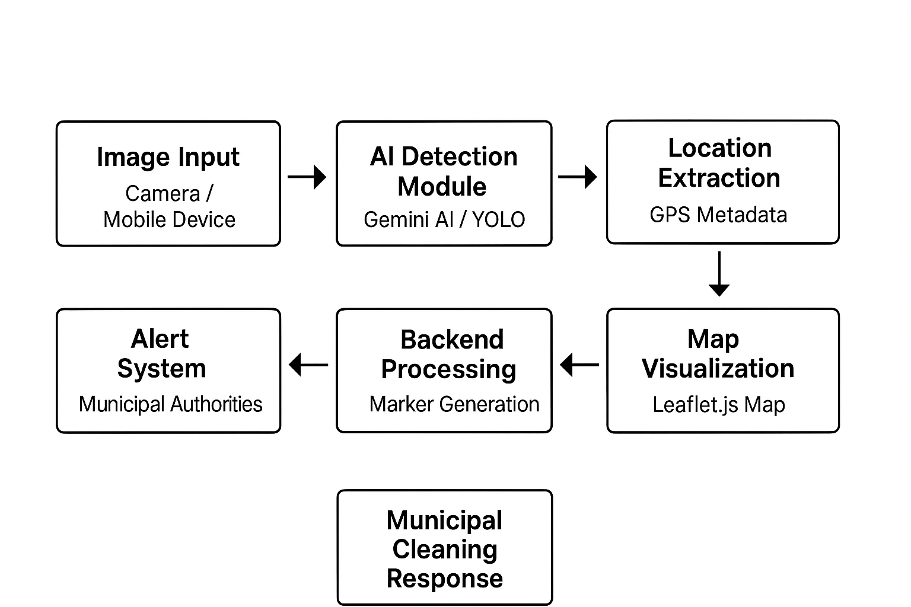

Name of Applicant:
- Mr. Vaibhav Gupta
Address of Applicant: Student, B-Tech (3rd Year), CSE-AI, Greater Noida Institute of Technology (Engg. Institute), Greater Noida, Uttar Pradesh-201310
- Ms. Zoya Rahman
Address of Applicant: Student, B-Tech (3rd Year), CSE-AI, Greater Noida Institute of Technology (Engg. Institute), Greater Noida, Uttar Pradesh-201310
- Mr. Shivam Raj
Address of Applicant: Student, B-Tech (3rd Year), CSE-AI, Greater Noida Institute of Technology (Engg. Institute), Greater Noida, Uttar Pradesh-201310
- Ms. Shreya Jaiswal
Address of Applicant: Student, B-Tech (3rd Year), CSE-AI, Greater Noida Institute of Technology (Engg. Institute), Greater Noida, Uttar Pradesh-201310
- Mr. Shubham Vishwakarma
Address of Applicant: Student, B-Tech (3rd Year), CSE-AI, Greater Noida Institute of Technology (Engg. Institute), Greater Noida, Uttar Pradesh-201310
- Ms. Somya
Address of Applicant: Student, B-Tech (3rd Year), CSE-AI, Greater Noida Institute of Technology (Engg. Institute), Greater Noida, Uttar Pradesh-201310
- Mr. Sumer
Address of Applicant: Student, B-Tech (3rd Year), CSE-AI, Greater Noida Institute of Technology (Engg. Institute), Greater Noida, Uttar Pradesh-201310
- Ms. Tanisha Verma
Address of Applicant: Student, B-Tech (3rd Year), CSE-AI, Greater Noida Institute of Technology (Engg. Institute), Greater Noida, Uttar Pradesh-201310
- Mr. Yash Kapoor
Address of Applicant: Student, B-Tech (3rd Year), CSE-AI, Greater Noida Institute of Technology (Engg. Institute), Greater Noida, Uttar Pradesh-201310

Name of Inventor:
- Mr. Vaibhav Gupta
Address of Applicant: Student, B-Tech (3rd Year), CSE-AI, Greater Noida Institute of Technology (Engg. Institute), Greater Noida, Uttar Pradesh-201310
- Ms. Zoya Rahman
Address of Applicant: Student, B-Tech (3rd Year), CSE-AI, Greater Noida Institute of Technology (Engg. Institute), Greater Noida, Uttar Pradesh-201310
- Mr. Shivam Raj
Address of Applicant: Student, B-Tech (3rd Year), CSE-AI, Greater Noida Institute of Technology (Engg. Institute), Greater Noida, Uttar Pradesh-201310
- Ms. Shreya Jaiswal
Address of Applicant: Student, B-Tech (3rd Year), CSE-AI, Greater Noida Institute of Technology (Engg. Institute), Greater Noida, Uttar Pradesh-201310
- Mr. Shubham Vishwakarma
Address of Applicant: Student, B-Tech (3rd Year), CSE-AI, Greater Noida Institute of Technology (Engg. Institute), Greater Noida, Uttar Pradesh-201310
- Ms. Somya
Address of Applicant: Student, B-Tech (3rd Year), CSE-AI, Greater Noida Institute of Technology (Engg. Institute), Greater Noida, Uttar Pradesh-201310
- Mr. Sumer
Address of Applicant: Student, B-Tech (3rd Year), CSE-AI, Greater Noida Institute of Technology (Engg. Institute), Greater Noida, Uttar Pradesh-201310
- Ms. Tanisha Verma
Address of Applicant: Student, B-Tech (3rd Year), CSE-AI, Greater Noida Institute of Technology (Engg. Institute), Greater Noida, Uttar Pradesh-201310
- Mr. Yash Kapoor
Address of Applicant: Student, B-Tech (3rd Year), CSE-AI, Greater Noida Institute of Technology (Engg. Institute), Greater Noida, Uttar Pradesh-201310

