AI-Based Smart Garbage Detection & Mapping System
By

Somya (2301321520103)
Vaibhav Gupta (2301321520107)
Zoya Rahman (2301321520113)

Submitted to the Department of CSE-AI
In partial fulfillment of the requirements
For the degree of

BACHELOR OF TECHNOLOGY

Submitted to Supervisor/Guide Name



Somya
Roll.No.-2301321520103
Vaibhav Gupta
Roll.No.-2301321520107
Zoya Rahman
Roll.No.-2301321520113

Greater Noida Institute of Technology, Greater Noida

D

Dr. A.P.J. Abdul Kalam Technical University, Lucknow

January,2026
Contents
ACKNOWLEDGEMENT 8
INTRODUCTION / AIMS AND OBJECTIVES 9
Background of Waste Management 9
Urbanization and Waste Generation Challenges 9
Traditional Waste Management Systems 10
Limitations of Manual Waste Monitoring 11
Role of Artificial Intelligence in Smart Cities 11
Computer Vision in Environmental Monitoring 12
Motivation of the Project 12
Aim of the Project 13
Objectives of the Project 13
Scope of the Project 14
Environmental and Social Impact 14
Organization of the Report 14
SYSTEM ANALYSIS 16
Overview of System Analysis 16
Existing System 16
Workflow of the Existing System 17
Limitations of the Existing System 17
Need for the Proposed System 18
Problem Statement 19
Proposed System Overview 19
Workflow of the Proposed System 19
Advantages of the Proposed System 20
Comparative Analysis: Existing vs Proposed System 21
Assumptions and Constraints 21
Assumptions 21
Constraints 21
Summary of System Analysis 22
FEASIBILITY STUDY 23
Introduction to Feasibility Study 23
Technical Feasibility 23
Hardware Requirements 24
Software Requirements 24
Economic Feasibility 25
Cost Analysis (Estimated) 26
Operational Feasibility 26
Behavioral Feasibility 27
Legal and Ethical Feasibility 27
Risk Analysis 27
Feasibility Summary 28
SYSTEM ANALYSIS AND DESIGN 29
Introduction to System Design 29
System Architecture 29
Data Flow Diagram (DFD) 29
DFD Level 0 (Context Diagram) 29
DFD Level 1 30
DFD Level 2 31
4.4 Entity Relationship (ER) Diagram 32
Database Design 33
Waste_Detection Table 33
Location Table 34
Alert Table 34
Data Structures Used 34
Input and Output Design 35
Security and Data Integrity Considerations 35
Advantages of the System Design 35
Summary of System Analysis and Design 36
PROPOSED SYSTEM 37
Introduction to the Proposed System 37
Objectives of the Proposed System 37
Overall Architecture of the Proposed System 37
Functional Modules of the Proposed System 38
Image Acquisition Module 38
AI-Based Garbage Detection Module 38
Location Extraction Module 39
Backend Processing Module 39
Map Visualization Module 39
Alert and Notification Module 40
Workflow of the Proposed System 40
Advantages of the Proposed System 40
Limitations of the Proposed System 41
Applications of the Proposed System 41
Summary of the Proposed System 41
IMPLEMENTATION AND RESULT ANALYSIS 42
Introduction 42
Implementation Environment 42
Hardware Environment 42
Software Environment 42
Module-Wise Implementation 43
Image Acquisition Module Implementation 43
AI-Based Garbage Detection Module Implementation 43
Location Extraction Module Implementation 43
Backend Processing Module Implementation 44
Map Visualization Module Implementation 44
Alert and Notification Module Implementation 44
Testing Strategy 45
Unit Testing 45
Integration Testing 45
System Testing 45
Result Analysis 45
Performance Evaluation 46
Limitations Observed During Implementation 46
Summary of Implementation and Results 46
SCREENSHOTS 47
IMPLEMENTATION & RESULT ANALYSIS 53
Introduction 53
Implementation Strategy 53
Module-Wise Implementation Details 54
Image Upload and Preprocessing Module 54
AI-Based Garbage Detection Module 54
Location Detection and Extraction Module 55
Backend Processing and API Module 56
Map Visualization Module 56
Alert Generation Module 57
Testing Methodology 57
Unit Testing 57
Integration Testing 57
System Testing 57
Result Analysis 58
Performance Evaluation 58
Summary of Implementation & Result Analysis 59
CONCLUSION AND FUTURE SCOPE 60
BIBLIOGRAPHY 65
REFERENCES 65
GLOSSARY 66

ACKNOWLEDGEMENT
I would like to express my heartfelt gratitude to all those who contributed to the successful completion of this project, “AI-Based Smart Garbage Detection & Mapping System.”
First and foremost, I am deeply grateful to my guide, [Mr. Sandeep Kumar Simgh], [professor], [GNIOT], for their invaluable guidance, constructive feedback, and unwavering support throughout this project. Their expertise and encouragement have been instrumental in shaping this research.
I also extend my sincere thanks to the [GNIOT] for providing the necessary resources and a conducive environment to work on this project.
Special thanks to [Somya, Vaibhav Gupta, Zoya Rahman], whose collaboration and insights enriched the project significantly. Their dedication and technical expertise were vital to achieving the project’s goals.
I would also like to acknowledge the role of our mentor , whose constant encouragement kept me motivated throughout this journey.
Finally, I am grateful for the opportunity to explore this innovative and dynamic domain of Artificial Intelligence and Machine Learning, which has deepened my understanding of real world applications in recruitment and inspired me to pursue further excellence in this field.
Thank you all for your support and encouragement.

INTRODUCTION / AIMS AND OBJECTIVES

Background of Waste Management
Waste management refers to the systematic process of collecting, transporting, processing, recycling, and disposing of waste materials generated by human activities. Since ancient times, societies have attempted various methods to manage waste, including open dumping and burial. However, these methods were suitable only for small populations and became ineffective with the rapid growth of urban settlements.
In modern cities, waste generation has increased dramatically due to population growth, industrialization, urbanization, and changes in lifestyle. Household waste, commercial waste, construction debris, and biomedical waste contribute significantly to the overall waste volume. Improper waste management results in environmental pollution, public health risks, and degradation of urban aesthetics.
Municipal corporations are primarily responsible for managing solid waste in cities. Despite significant efforts, many urban areas continue to face challenges such as inefficient waste collection, delayed cleaning, and lack of monitoring mechanisms. These challenges highlight the need for innovative and technology-driven waste management solutions.

Urbanization and Waste Generation Challenges
Urbanization has transformed cities into densely populated centers of economic and social activity. While urban development has improved living standards, it has also led to increased waste generation. The concentration of population in urban areas puts immense pressure on municipal waste management systems.
In many cities, waste collection schedules are fixed and do not adapt to real-time conditions. As a result, garbage often accumulates in public places such as roadsides, parks, markets, and residential areas. Overflowing garbage bins, illegal dumping, and unattended waste piles are common sights in urban environments.
These challenges are further compounded by limited manpower, inadequate infrastructure, and lack of real-time data. Without timely detection and intervention, waste accumulation can lead to serious environmental and health consequences.

Traditional Waste Management Systems
Traditional waste management systems rely heavily on manual inspection and routine cleaning schedules. Municipal workers are assigned specific areas and are expected to clean them periodically. In many cases, waste is collected only after receiving complaints from citizens.
Although these systems have been in use for decades, they suffer from several limitations. Manual inspection is time-consuming and prone to human error. Cleaning operations may be delayed due to lack of information or resource constraints. Moreover, traditional systems do not provide any mechanism for monitoring waste accumulation in real time.
The absence of automated monitoring and data analysis limits the ability of authorities to optimize waste management operations. Consequently, there is a growing need to transition from traditional approaches to intelligent and automated systems.

Limitations of Manual Waste Monitoring
Manual waste monitoring involves physical inspection of public areas by municipal workers or reliance on public complaints. This approach has several drawbacks. First, it is inefficient and labor-intensive. Second, it does not guarantee timely detection of waste accumulation, especially in less frequently visited areas.
Additionally, manual systems lack consistency and transparency. Different workers may assess waste conditions differently, leading to inconsistent reporting. The absence of digital records makes it difficult to track historical data or analyze waste patterns over time.
These limitations highlight the necessity of adopting automated waste detection systems that can operate continuously and provide accurate, real-time information.

Role of Artificial Intelligence in Smart Cities
Artificial Intelligence (AI) has emerged as a transformative technology with applications across various domains, including healthcare, transportation, security, and urban management. In the context of smart cities, AI enables automated decision-making, predictive analytics, and intelligent monitoring systems.
AI-based image processing and computer vision techniques allow machines to interpret visual information from images and videos. These techniques can be used to detect objects, recognize patterns, and identify anomalies in urban environments. When applied to waste management, AI can automatically detect garbage, waste piles, and unhygienic conditions without human intervention.
The integration of AI into waste management systems enhances efficiency, accuracy, and scalability. It enables continuous monitoring of public spaces and supports data-driven decision-making for municipal authorities.

Computer Vision in Environmental Monitoring
Computer vision is a subfield of artificial intelligence that focuses on enabling machines to understand and interpret visual data. It involves techniques such as image classification, object detection, and image segmentation.
In environmental monitoring, computer vision plays a crucial role in analyzing visual data captured from cameras, drones, and satellites. Applications include pollution detection, wildlife monitoring, traffic analysis, and waste detection. By analyzing images of public spaces, computer vision models can identify garbage accumulation and assess environmental conditions.
The use of computer vision in waste management reduces reliance on manual inspection and improves the accuracy of detection. It also enables real-time monitoring and rapid response to emerging issues.

Motivation of the Project
The motivation for this project arises from the increasing need for efficient and intelligent waste management solutions in urban areas. Poor waste management not only affects the cleanliness of cities but also poses serious health and environmental risks.
The availability of advanced AI models and open-source mapping tools presents an opportunity to develop practical solutions for real-world problems. This project aims to apply theoretical knowledge of artificial intelligence, image processing, and web technologies to address the challenge of urban waste monitoring.
Additionally, the project aligns with national initiatives such as smart city development and environmental sustainability. It provides a platform for exploring the integration of AI and GIS technologies in public service applications.

Aim of the Project
The primary aim of this project is to design and implement an AI-based system capable of automatically detecting garbage from images and accurately mapping its location to assist municipal authorities in efficient waste management.

Objectives of the Project
The objectives of the project are as follows:
- To study existing waste management practices and their limitations
- To develop an AI-based image analysis system for garbage detection
- To extract geolocation data automatically from images or devices
- To visualize detected garbage locations on an interactive digital map
- To generate alerts for faster response by cleaning authorities
- To store waste detection data for future analysis and planning

Scope of the Project
The scope of the proposed system includes the detection and monitoring of visible garbage in urban environments. The system focuses on software-based solutions and does not involve physical waste collection mechanisms.
The project is scalable and can be extended to integrate with surveillance cameras, drones, and IoT-based smart bins. It provides a foundation for future enhancements such as predictive analytics and real-time monitoring.

Environmental and Social Impact
Effective waste management has a direct impact on environmental sustainability and public health. Automated waste detection systems contribute to cleaner surroundings, reduced pollution, and improved quality of life for citizens.
Socially, such systems promote accountability and transparency in municipal operations. By enabling timely cleaning actions, the system helps build trust between citizens and governing authorities.

Organization of the Report
This report is organized into multiple sections. Section 1 introduces the project and discusses its background, motivation, and objectives. Section 2 presents system analysis and problem identification. Section 3 discusses feasibility studies. Section 4 covers system analysis using diagrams and data structures. Section 5 explains the proposed system, followed by implementation and result analysis. The report concludes with future scope and references.

SYSTEM ANALYSIS

Overview of System Analysis
System analysis is a critical phase in software development that involves studying the existing system, understanding user requirements, identifying problems, and defining a structured solution. The purpose of system analysis is to ensure that the proposed system effectively addresses the shortcomings of the current approach while fulfilling operational, technical, and user requirements.
In the context of waste management, system analysis helps in understanding how garbage monitoring is currently performed, what limitations exist, and how modern technologies such as artificial intelligence and geolocation can be leveraged to improve efficiency. This section provides a detailed analysis of the existing waste management system, identifies its limitations, and presents a clear justification for the proposed AI-based smart garbage detection and mapping system.

Existing System
The existing waste management system in most urban areas is predominantly manual and reactive in nature. Municipal authorities rely on fixed schedules for garbage collection and cleaning operations. Workers are assigned specific zones and are responsible for cleaning them periodically. In many cases, waste is addressed only after receiving complaints from citizens through helplines or mobile applications.
Surveillance cameras, if present, are primarily used for security purposes and not for waste monitoring. There is no automated mechanism to analyze visual data from these cameras to detect garbage accumulation. As a result, waste often remains unattended until it becomes visibly severe or poses a health risk.
Furthermore, the existing system lacks real-time monitoring and data-driven decision-making. Information regarding waste accumulation is not systematically recorded or analyzed, making it difficult to identify high-risk zones or predict future waste generation patterns.

Workflow of the Existing System
The workflow of the traditional waste management system can be summarized as follows:
- Garbage is generated by households, commercial establishments, and public spaces.
- Waste accumulates in designated bins or open areas.
- Municipal workers clean the area based on fixed schedules.
- In case of excessive garbage, citizens register complaints.
- Authorities dispatch cleaning teams after complaint verification.
This workflow is inefficient as it depends heavily on human intervention and does not support proactive waste monitoring.

Limitations of the Existing System
Despite continuous efforts by municipal authorities, the existing system suffers from several limitations:
- Lack of Real-Time Monitoring: Garbage accumulation is not detected immediately, leading to delayed cleaning.
- Manual Dependency: Heavy reliance on human inspection increases operational cost and error.
- Inefficient Resource Utilization: Cleaning teams may be dispatched unnecessarily or too late.
- Absence of Location-Based Visualization: Authorities do not have a centralized view of garbage hotspots.
- No Historical Data Analysis: Lack of data storage prevents trend analysis and predictive planning.
- Public Health Risks: Delayed waste removal contributes to disease spread and environmental pollution.
These limitations highlight the need for an intelligent and automated waste monitoring solution.

Need for the Proposed System
The increasing complexity of urban waste management necessitates the adoption of advanced technologies that can automate monitoring and decision-making processes. The proposed system aims to eliminate the drawbacks of manual systems by introducing AI-based image analysis and geolocation mapping.
An automated system can continuously monitor public spaces, detect garbage accumulation in real time, and notify authorities without human intervention. This not only reduces response time but also improves accountability and transparency in waste management operations.

Problem Statement
The problem addressed by this project can be formally stated as follows:
To design and implement an AI-based system that can automatically detect garbage from images, accurately extract its location, and visualize the detected waste on an interactive map to enable timely and efficient waste management.
The system must be scalable, cost-effective, and capable of integrating with existing urban infrastructure.

Proposed System Overview
The proposed AI-Based Smart Garbage Detection & Mapping System introduces an intelligent approach to waste monitoring. The system processes images captured from cameras or mobile devices, analyzes them using AI models to detect garbage, extracts geolocation data, and plots detected waste locations on a digital map.
The system operates in a semi-autonomous manner, requiring minimal human intervention. Once garbage is detected, alerts are generated automatically, enabling municipal authorities to take immediate action.

Workflow of the Proposed System
The workflow of the proposed system consists of the following steps:
- Image Acquisition: Images are captured using mobile devices, surveillance cameras, or drones.
- Image Processing: The captured images are sent to the backend server.
- AI-Based Detection: An AI model analyzes the images to identify garbage or waste materials.
- Location Extraction: GPS coordinates are extracted from image metadata or device location.
- Mapping: Detected waste locations are plotted on an interactive map.
- Alert Generation: Notifications are sent to municipal authorities.
- Action Tracking: Cleaning actions are recorded for monitoring and analysis.

Advantages of the Proposed System
The proposed system offers several advantages over traditional waste management approaches:
- Automated and real-time garbage detection
- Reduced dependency on manual inspection
- Faster response and cleaning operations
- Centralized visualization of waste locations
- Improved public hygiene and environmental sustainability
- Scalable architecture suitable for smart city deployment

Comparative Analysis: Existing vs Proposed System
Feature | Existing System | Proposed System
Monitoring | Manual | Automated (AI-based)
Detection | Complaint-based | Image-based real-time
Location Tracking | Not available | GPS-based mapping
Data Storage | Minimal | Structured database
Response Time | Delayed | Immediate
Scalability | Limited | High

Assumptions and Constraints

Assumptions
- Images captured are clear and suitable for analysis
- GPS metadata or device location is available
- Internet connectivity is available for data transmission

Constraints
- Accuracy depends on image quality
- GPS data may not always be available
- Initial setup requires integration with cameras

Summary of System Analysis
This section analyzed the existing waste management system, identified its limitations, and justified the need for an intelligent alternative. The proposed system leverages artificial intelligence and geolocation technologies to provide an automated, efficient, and scalable solution for urban waste monitoring.
The next section focuses on evaluating the feasibility of implementing the proposed system from technical, economic, and operational perspectives.

FEASIBILITY STUDY

Introduction to Feasibility Study
A feasibility study is a systematic evaluation of a proposed system to determine whether it is technically, economically, and operationally viable. It plays a vital role in decision-making by analyzing potential risks, resource requirements, and benefits before full-scale implementation.
In the context of the AI-Based Smart Garbage Detection & Mapping System, the feasibility study helps assess whether the proposed solution can be realistically developed and deployed using available technology, within budget constraints, and with acceptable operational effort. This section evaluates the feasibility of the system under three major categories: technical feasibility, economic feasibility, and operational feasibility.

Technical Feasibility
Technical feasibility assesses whether the proposed system can be developed using existing hardware, software, and technical expertise. It evaluates the availability of required technologies and the ability of the development team to implement the system effectively.
The proposed system utilizes modern and widely adopted technologies such as Artificial Intelligence, Computer Vision, Python-based backend frameworks, and web-based mapping libraries. AI models like Gemini AI enable image-based garbage detection without requiring complex hardware setups. Python provides extensive libraries for image processing, metadata extraction, and server-side logic.
The frontend of the system uses Leaflet.js, an open-source JavaScript library for interactive maps. Leaflet is lightweight, efficient, and well-documented, making it suitable for real-time visualization of garbage locations. The backend integrates AI processing with geolocation extraction and data handling.
From a hardware perspective, the system can operate on standard computing infrastructure. No specialized GPUs are mandatory for prototype deployment, although performance can be improved with advanced hardware in large-scale implementations.
Thus, the system is technically feasible due to the availability of tools, libraries, and expertise required for development and deployment.

Hardware Requirements
Standard desktop or server system
Minimum 8 GB RAM
Internet connectivity
Camera or mobile device for image capture

Software Requirements
Operating System: Windows/Linux
Programming Language: Python
AI API: Gemini AI
Frontend: HTML, CSS, JavaScript
Mapping Library: Leaflet.js
Database (optional): PostgreSQL / MongoDB

Economic Feasibility
Economic feasibility evaluates the cost-effectiveness of the proposed system. It determines whether the benefits of the system justify the costs involved in development, deployment, and maintenance.
The proposed system is economically feasible as it primarily relies on open-source technologies and cloud-based AI services. Development costs are minimal since no proprietary software licenses are required. The system can be deployed using existing infrastructure, such as municipal surveillance cameras and standard servers.
Operational costs include minimal expenses for cloud services, server hosting, and internet connectivity. Compared to traditional waste management systems that require extensive manpower and repeated inspections, the proposed system significantly reduces labor costs and improves efficiency.
The long-term benefits, such as improved cleanliness, reduced health risks, and optimized resource allocation, far outweigh the initial investment. Therefore, the system is economically viable and suitable for implementation by municipal authorities.

Cost Analysis (Estimated)
Component | Cost
Software Tools | Free (Open Source)
AI API Usage | Minimal / Pay-as-you-go
Hardware | Existing Infrastructure
Maintenance | Low
Training | Minimal

Operational Feasibility
Operational feasibility examines whether the proposed system can be effectively operated and maintained by the intended users. It focuses on user acceptance, ease of use, and operational efficiency.
The proposed system provides a simple and intuitive web-based interface for monitoring garbage detection results. Municipal staff can view detected waste locations on an interactive map without requiring advanced technical knowledge. Alerts and notifications are generated automatically, reducing the need for manual supervision.
Minimal training is required for users to operate the system. The automation of detection and alert generation reduces workload and enhances productivity. The system can be easily integrated into existing workflows of municipal authorities.
Given its user-friendly design and automation capabilities, the system is operationally feasible and well-suited for real-world deployment.

Behavioral Feasibility
Behavioral feasibility assesses how users and stakeholders will react to the new system. Resistance to change is a common challenge in adopting new technologies.
The proposed system minimizes resistance by enhancing, rather than replacing, existing waste management processes. It assists cleaning staff by providing actionable information and reduces manual inspection efforts. The transparency and efficiency introduced by the system encourage acceptance among users and authorities.

Legal and Ethical Feasibility
Legal feasibility ensures that the proposed system complies with relevant laws and regulations. The system processes images of public spaces and does not collect personal or sensitive data. Proper handling of AI APIs and secure data transmission ensures compliance with data protection guidelines.
Ethical considerations include responsible use of AI and ensuring that the system is used solely for waste management purposes. Transparency in detection and reporting helps maintain public trust.

Risk Analysis
Potential risks associated with the system include:
Inaccurate detection due to poor image quality
Absence of GPS metadata in some images
Dependency on internet connectivity
Initial setup and integration challenges
These risks can be mitigated through proper system design, quality checks, and fallback mechanisms such as device geolocation.

Feasibility Summary
Based on the analysis conducted, the AI-Based Smart Garbage Detection & Mapping System is technically, economically, operationally, and legally feasible. The system leverages existing technologies, minimizes costs, and offers significant benefits in terms of efficiency, accuracy, and scalability.
The positive feasibility outcome supports the implementation of the proposed system and justifies further development and deployment.

SYSTEM ANALYSIS AND DESIGN

Introduction to System Design
System design is a crucial phase in the software development life cycle (SDLC) that translates system requirements into a structured solution. It defines how the system will work, how components interact, how data flows, and how information is stored and processed.
For the AI-Based Smart Garbage Detection & Mapping System, system design focuses on creating an efficient architecture that integrates artificial intelligence, geolocation services, backend processing, and interactive map visualization. This section explains the logical and physical design of the system using Data Flow Diagrams (DFDs), Entity Relationship (ER) diagrams, data structures, and database table designs.

System Architecture
The proposed system follows a layered architecture, consisting of:
- Input Layer – Image capture from cameras or mobile devices
- Processing Layer – AI-based image analysis and location extraction
- Application Layer – Backend server logic and APIs
- Presentation Layer – Interactive map and dashboard interface
This architecture ensures modularity, scalability, and ease of maintenance.

Data Flow Diagram (DFD)
Data Flow Diagrams are used to represent the flow of data through the system and the transformations applied to that data.

DFD Level 0 (Context Diagram)
The Level-0 DFD represents the entire system as a single process interacting with external entities.
External Entities:
- Camera / Mobile Device
- Municipal Authority
Process:
- Smart Garbage Detection & Mapping System
Data Flows:
- Image Input
- Detection Results
- Location Information
- Alerts and Reports
Explanation:
In Level-0 DFD, the system receives image data from external sources such as cameras or mobile devices. The system processes this data and outputs alerts, garbage detection results, and location information to municipal authorities.
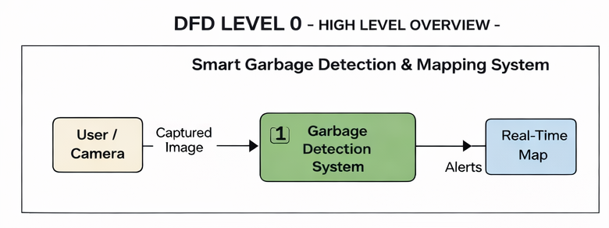

DFD Level 1
Level-1 DFD decomposes the main system into sub-processes.
Processes:
- Image Acquisition
- AI-Based Garbage Detection
- Location Extraction
- Data Storage
- Map Visualization & Alert Generation
Explanation:
- Images are first collected from the input source.
- The AI module analyzes the image to detect garbage.
- GPS coordinates are extracted from image metadata or device location.
- Detection results are stored in the database.
- The map module displays detected locations and sends alerts.
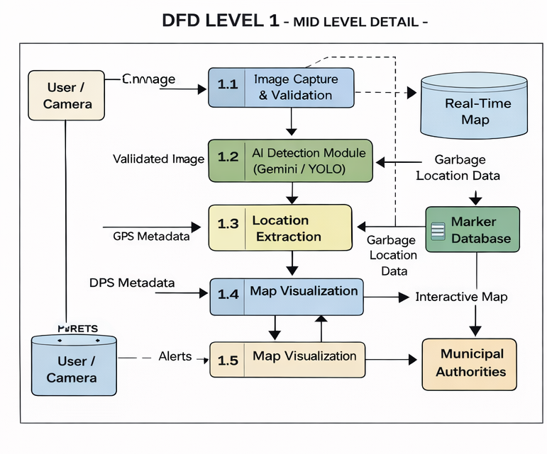

DFD Level 2
Level-2 DFD further breaks down individual processes for deeper understanding.
Example: AI-Based Garbage Detection Process
- Preprocessing of image
- AI inference using Gemini AI
- Confidence evaluation
- Classification of waste
Explanation:
This level provides detailed insight into internal operations, showing how images are analyzed, classified, and validated before results are generated.
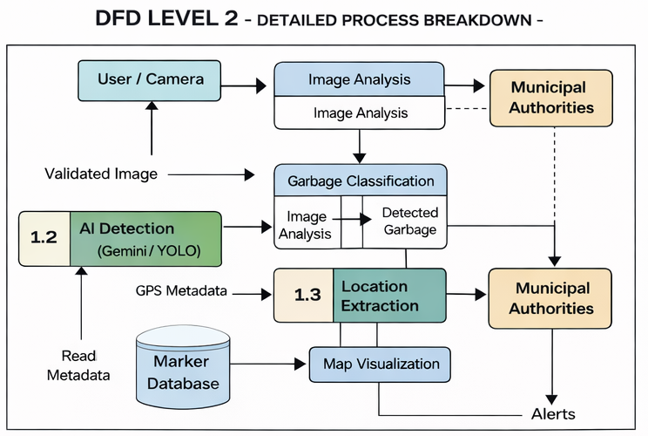

4.4 Entity Relationship (ER) Diagram
An Entity Relationship Diagram defines the database structure by showing entities, attributes, and relationships.
Entities Identified:
- Waste_Detection
- Location
- Alert
- User (Authority)
Relationships:
- A waste detection is associated with one location
- A location can have multiple waste detections
- Each detection generates one alert
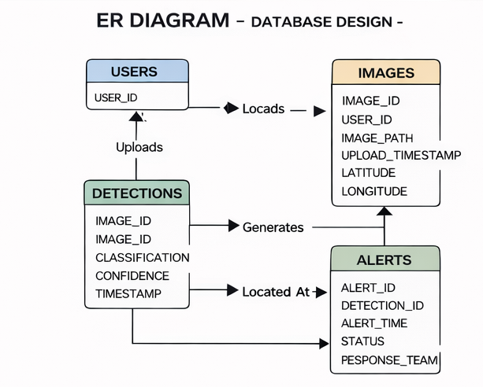

Database Design
The database stores structured information related to waste detection, location, and alerts.

Waste_Detection Table
Field Name | Data Type | Description
detection_id | Integer | Unique identifier
image_path | Varchar | Image file reference
detection_status | Boolean | Garbage detected or not
confidence_score | Float | Detection confidence
detection_time | Timestamp | Time of detection

Location Table
Field Name | Data Type | Description
location_id | Integer | Unique identifier
latitude | Float | GPS latitude
longitude | Float | GPS longitude
address | Varchar | Optional location description

Alert Table
Field Name | Data Type | Description
alert_id | Integer | Unique alert identifier
detection_id | Integer | Linked detection
alert_time | Timestamp | Time alert generated
status | Varchar | Pending / Resolved

Data Structures Used
The following data structures are used in the system:
- Image Object: Stores image data and metadata
- Detection Object: Holds AI detection results
- Location Object: Stores GPS coordinates
- Alert Object: Contains alert details
These structures help organize data efficiently during processing.

Input and Output Design
Input Design
- Image files (.jpg, .png)
- Metadata containing GPS coordinates
Output Design
- Detection result (garbage/no garbage)
- Map marker with location
- Alert notifications

Security and Data Integrity Considerations
- Secure API key handling for AI services
- Validation of image input
- Controlled access to system dashboard
- Data consistency through structured database design

Advantages of the System Design
- Modular and scalable architecture
- Easy integration with future technologies
- Clear data flow and separation of concerns
- Efficient data storage and retrieval

Summary of System Analysis and Design
This section detailed the logical and physical design of the AI-Based Smart Garbage Detection & Mapping System. Through DFDs, ER diagrams, and database design, the internal working of the system was clearly defined. The design ensures efficiency, scalability, and ease of implementation.
The next section explains the Proposed System in detail, including functional modules and working principles.

PROPOSED SYSTEM

Introduction to the Proposed System
The proposed system, titled AI-Based Smart Garbage Detection & Mapping System, is an intelligent software solution designed to automate the detection, monitoring, and mapping of garbage in urban environments. The system leverages advancements in Artificial Intelligence (AI), Computer Vision, and Geographic Information Systems (GIS) to overcome the limitations of traditional waste management systems.
Unlike conventional systems that rely on manual inspection and citizen complaints, the proposed system continuously analyzes visual data to identify garbage accumulation and automatically determines its geographical location. This approach ensures faster response, improved efficiency, and enhanced transparency in municipal waste management operations.

Objectives of the Proposed System
The proposed system is developed with the following objectives:
- To automate the process of garbage detection using AI-based image analysis
- To eliminate dependency on manual waste inspection
- To accurately identify the geographical location of detected garbage
- To provide real-time visualization of waste locations on an interactive map
- To enable faster decision-making and cleaning operations
- To support data-driven waste management and smart city initiatives

Overall Architecture of the Proposed System
The system architecture follows a modular and layered design, ensuring scalability, maintainability, and flexibility. The architecture consists of the following layers:
- Input Layer – Captures images from cameras or mobile devices
- AI Processing Layer – Performs garbage detection using AI models
- Location Processing Layer – Extracts GPS data from image metadata or devices
- Backend Layer – Handles business logic, data storage, and API services
- Presentation Layer – Displays results using an interactive map and dashboard
Each layer is designed to function independently while seamlessly interacting with other layers.

Functional Modules of the Proposed System
The proposed system is divided into several functional modules, each responsible for a specific task.

Image Acquisition Module
This module is responsible for capturing images from various sources such as mobile phones, surveillance cameras, or drones. The images serve as the primary input for the system.
Key functions:
- Accept image input from devices
- Validate image format and quality
- Forward images for AI-based processing
This module ensures that only valid and processable images are sent to the AI detection module.

AI-Based Garbage Detection Module
The AI-based garbage detection module is the core component of the system. It uses advanced AI models such as Gemini AI to analyze images and identify the presence of garbage or waste materials.
Key functions:
- Image preprocessing
- AI inference and classification
- Confidence score evaluation
- Waste type identification
This module determines whether the uploaded image contains garbage and generates a detection result.

Location Extraction Module
Once garbage is detected, the system extracts geographical coordinates associated with the image. Location information is obtained using:
- GPS metadata (EXIF) embedded in the image
- Device geolocation when metadata is unavailable
Key functions:
- Parse image metadata
- Extract latitude and longitude
- Validate location accuracy
Accurate location extraction is critical for mapping and alert generation.

Backend Processing Module
The backend module manages the overall logic of the system. It coordinates communication between the AI detection module, database, and frontend interface.
Key functions:
- Receive image and detection data
- Store results in the database
- Generate alerts and notifications
- Provide APIs for frontend communication
The backend ensures secure, efficient, and reliable data processing.

Map Visualization Module
This module is responsible for displaying detected garbage locations on an interactive map using Leaflet.js.
Key functions:
- Plot markers based on GPS coordinates
- Display detection details on map pop-ups
- Support zooming and navigation
- Refresh map with new detections
The map visualization module provides authorities with a clear, centralized view of garbage hotspots.

Alert and Notification Module
The alert module notifies municipal authorities whenever garbage is detected.
Key functions:
- Generate alerts automatically
- Notify authorities via dashboard or mobile notification
- Track alert status (pending/resolved)
This module ensures timely response and accountability.

Workflow of the Proposed System
The working of the proposed system can be summarized as follows:
- Images are captured from cameras or mobile devices
- Images are sent to the backend server
- AI model analyzes the images for garbage detection
- If garbage is detected, location data is extracted
- Detection results are stored in the database
- Waste locations are plotted on the interactive map
- Alerts are sent to municipal authorities
- Cleaning action is initiated and tracked
This workflow ensures end-to-end automation of garbage monitoring.

Advantages of the Proposed System
The proposed system offers several advantages:
- Fully automated garbage detection
- Reduced response time for cleaning operations
- Improved public hygiene and cleanliness
- Centralized monitoring and visualization
- Scalable and flexible architecture
- Reduced operational cost

Limitations of the Proposed System
Despite its advantages, the system has certain limitations:
- Detection accuracy depends on image quality
- GPS metadata may not always be available
- Requires internet connectivity
- Initial setup and integration effort
These limitations can be addressed through future enhancements.

Applications of the Proposed System
- Municipal waste management departments
- Smart city infrastructure
- Public parks and markets
- Railway stations and airports
- Large public events and gatherings

Summary of the Proposed System
This section presented a detailed description of the proposed AI-based smart garbage detection and mapping system. The modular design, automated workflow, and integration of AI and GIS technologies make the system efficient, scalable, and suitable for real-world deployment.
The next section discusses the implementation details and result analysis of the proposed system.

IMPLEMENTATION AND RESULT ANALYSIS

Introduction
Implementation is the phase in which the theoretical design of the system is converted into a working software solution. This section describes how the AI-Based Smart Garbage Detection & Mapping System was developed, integrated, tested, and evaluated. It also discusses the results obtained from the system and analyzes its performance under different conditions.
The implementation focuses on integrating artificial intelligence for image-based garbage detection, extracting location information, and visualizing results on an interactive digital map. Proper testing was conducted to ensure accuracy, reliability, and usability of the system.

Implementation Environment
The system was implemented using a combination of open-source tools and cloud-based AI services. The development environment was chosen to ensure flexibility, scalability, and ease of deployment.

Hardware Environment
- Processor: Intel i5 or equivalent
- RAM: Minimum 8 GB
- Storage: 256 GB SSD or higher
- Internet Connectivity: Required for AI API access

Software Environment
- Operating System: Windows / Linux
- Programming Language: Python
- Backend Framework: Flask
- AI Model: Gemini AI (Vision Model)
- Frontend Technologies: HTML, CSS, JavaScript
- Mapping Library: Leaflet.js
- Database: PostgreSQL / MongoDB (optional)

Module-Wise Implementation
The system implementation is divided into several functional modules. Each module was implemented independently and later integrated to form the complete system.

Image Acquisition Module Implementation
This module handles the uploading and validation of images. Users can upload images captured from mobile devices or cameras through a web-based interface.
Implementation details:
- Image format validation (.jpg, .png)
- File size and resolution checks
- Secure file storage on the server
This module ensures that only valid image inputs are passed to the AI detection module.

AI-Based Garbage Detection Module Implementation
The garbage detection module integrates Gemini AI to analyze uploaded images. The model processes the image and determines whether garbage or waste is present.
Implementation steps:
- Image preprocessing using Python libraries
- Sending image input to Gemini AI
- Receiving classification response
- Interpreting confidence and detection results
This module forms the core intelligence of the system and enables automated waste detection.

Location Extraction Module Implementation
The location extraction module retrieves geographical coordinates associated with the image.
Implementation details:
- Extraction of GPS metadata (EXIF) from images
- Conversion of coordinate values to decimal format
- Validation of extracted latitude and longitude
- Fallback to device-based geolocation when metadata is unavailable
Accurate location extraction is essential for mapping detected waste.

Backend Processing Module Implementation
The backend module coordinates communication between different system components. Flask-based APIs were developed to handle requests and responses.
Key responsibilities:
- Receiving image and detection requests
- Managing AI inference workflow
- Storing detection results
- Serving data to frontend interfaces
Security measures such as input validation and API key protection were implemented to ensure safe operation.

Map Visualization Module Implementation
The map visualization module uses Leaflet.js to display detected garbage locations.
Implementation steps:
- Initializing interactive map interface
- Adding markers dynamically using GPS coordinates
- Displaying detection details in pop-up windows
- Supporting zoom and navigation features
This module enables authorities to visualize garbage hotspots effectively.

Alert and Notification Module Implementation
The alert module generates notifications when garbage is detected.
Implementation details:
- Automatic alert creation upon detection
- Display of alerts on dashboard
- Status tracking (pending/cleaned)
This module ensures timely response and accountability.

Testing Strategy
Testing was conducted to validate the correctness and performance of the system. Various testing techniques were applied during development.

Unit Testing
- Individual modules were tested independently
- Image upload, AI detection, and location extraction modules were verified

Integration Testing
- Interaction between AI module and backend was tested
- Data flow from image upload to map visualization was verified

System Testing
- Complete system was tested using real-world images
- End-to-end workflow was validated

Result Analysis
The system was tested with multiple images captured under different environmental conditions. The results demonstrated that the system could successfully detect garbage and plot accurate locations when GPS metadata was available.
Observations:
- High detection accuracy for clear images
- Accurate location mapping using GPS metadata
- Interactive map provided easy visualization of multiple waste points
- Reduced response time compared to manual reporting
The system effectively automated garbage monitoring and improved operational efficiency.

Performance Evaluation
The performance of the system was evaluated based on the following parameters:
- Detection Accuracy
- Response Time
- Ease of Use
- Scalability
The results indicate that the system performs efficiently for small to medium-scale deployments and can be scaled further with improved infrastructure.

Limitations Observed During Implementation
- Dependency on image quality
- Inconsistent GPS metadata availability
- Internet dependency for AI API
These limitations provide scope for further improvements.

Summary of Implementation and Results
This section discussed the detailed implementation of the AI-Based Smart Garbage Detection & Mapping System and analyzed the results obtained from testing. The system successfully demonstrated the feasibility of automated garbage detection and location mapping using AI and GIS technologies.
The next section concludes the project and discusses future enhancements.

SCREENSHOTS
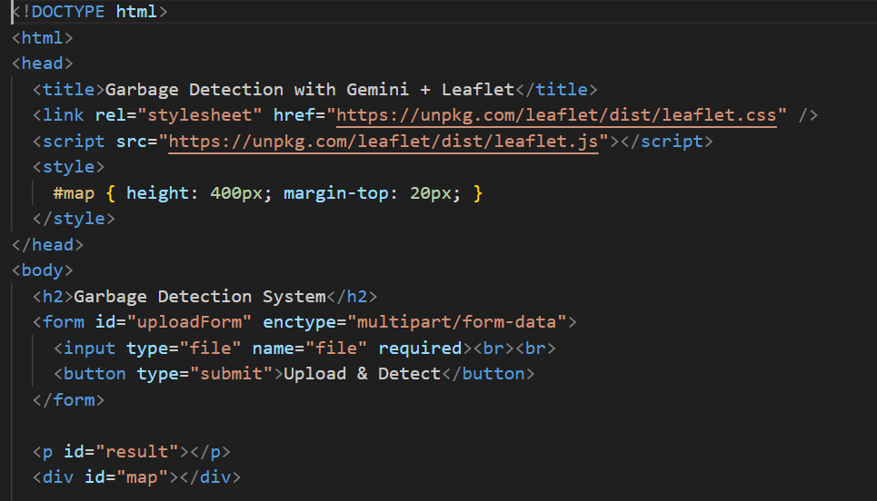

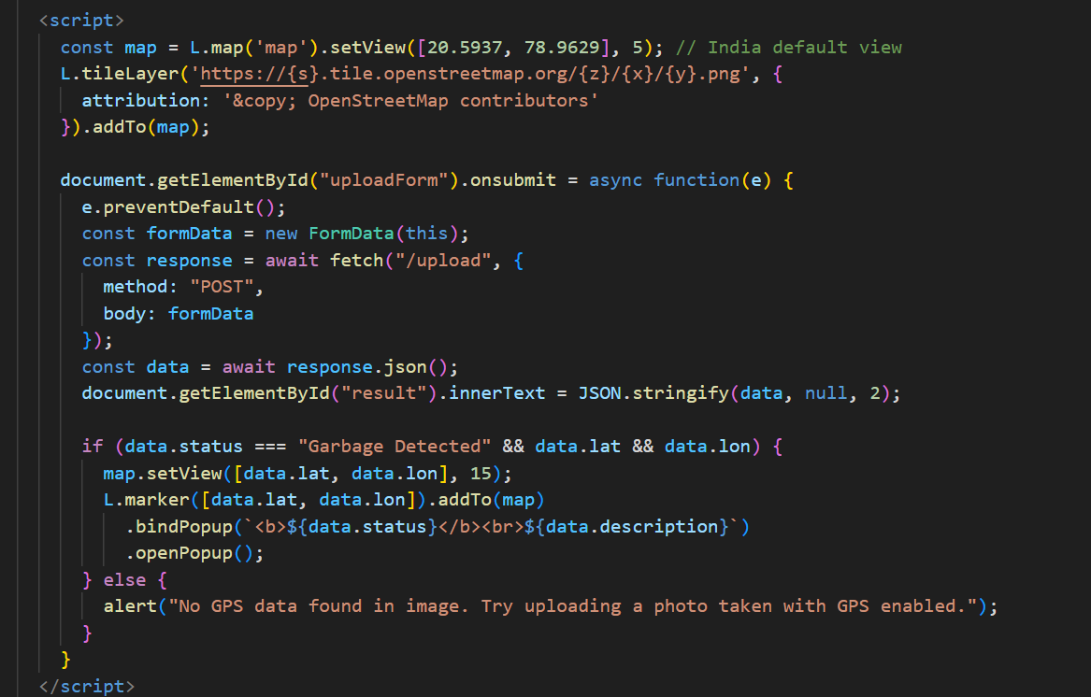

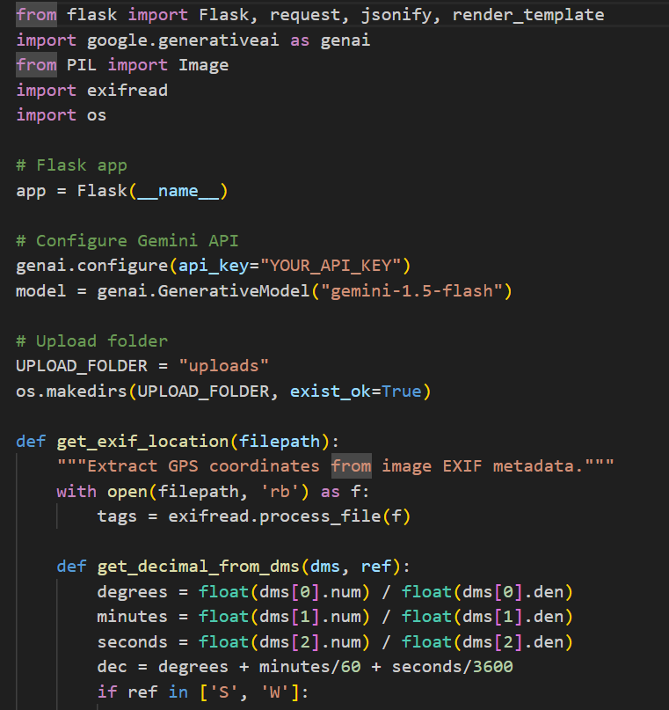

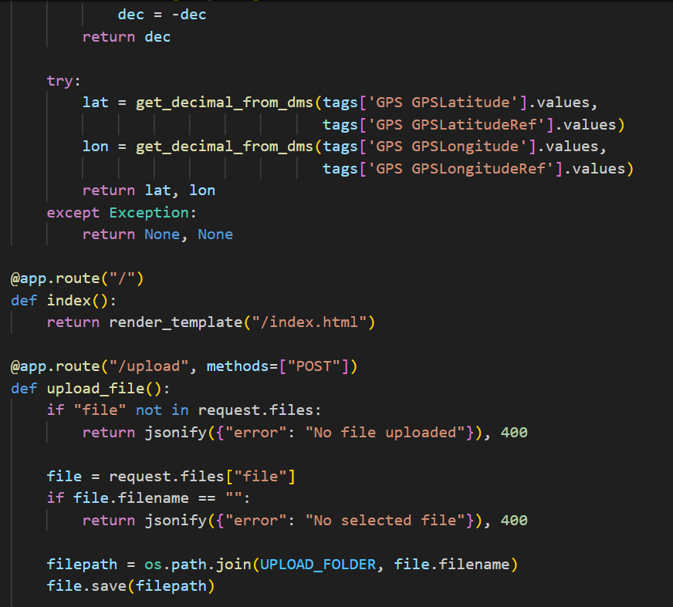

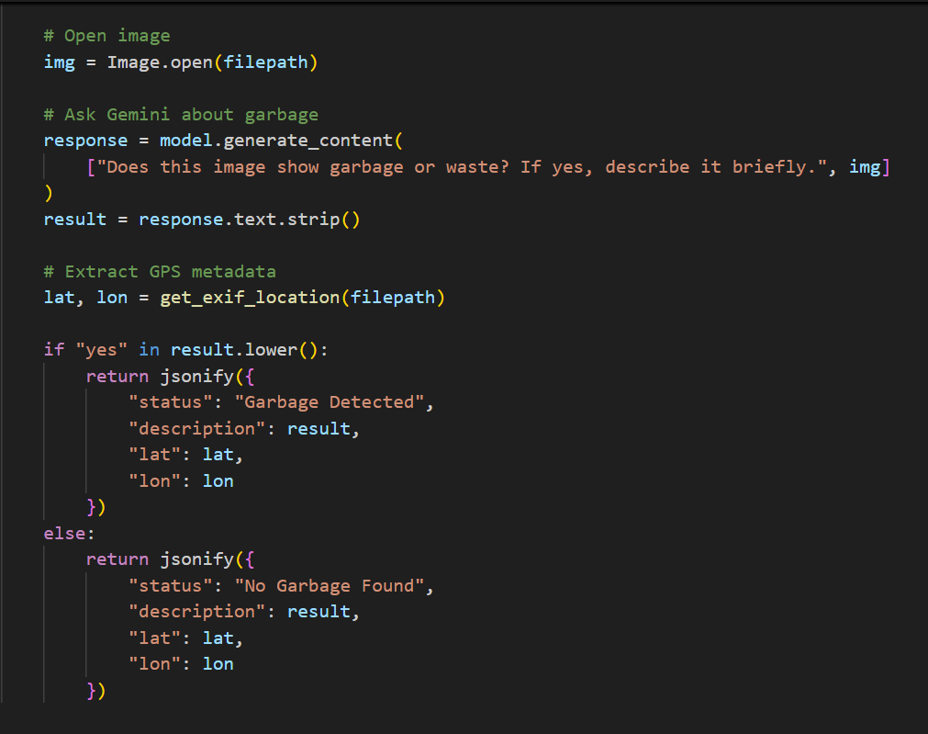

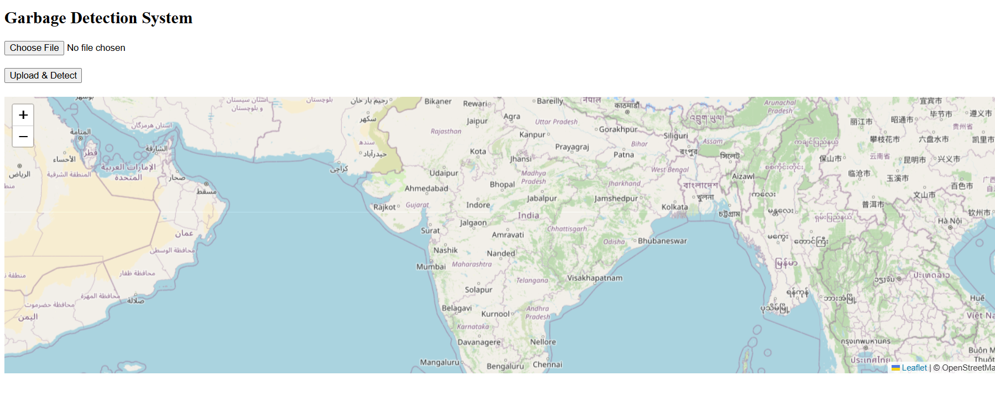

IMPLEMENTATION & RESULT ANALYSIS

Introduction
Implementation and result analysis is one of the most important phases of a software project, as it demonstrates the practical realization of the proposed system and evaluates its effectiveness. This chapter describes the step-by-step implementation of the AI-Based Smart Garbage Detection & Mapping System, including module integration, testing procedures, observed results, and performance evaluation.
The primary objective of this phase is to verify that the system meets its functional requirements, performs efficiently under real-world conditions, and produces accurate and reliable results. The implementation focuses on converting the system design into a working application by integrating artificial intelligence, backend processing, location extraction, and map visualization.

Implementation Strategy
The implementation of the system was carried out in a modular manner. Each functional component was developed, tested, and validated independently before being integrated into the complete system. This approach reduced complexity and ensured better maintainability.
The overall implementation strategy involved:
- Developing backend APIs for image handling and processing
- Integrating Gemini AI for garbage detection
- Implementing location extraction mechanisms
- Designing an interactive map-based frontend
- Testing the system with real-world image data

Module-Wise Implementation Details

Image Upload and Preprocessing Module
The image upload module enables users or devices to submit images for analysis. This module validates the image format and ensures that the uploaded file meets system requirements.
Implementation Details:
- Accepted formats: JPG, JPEG, PNG
- Image size validation to avoid processing errors
- Secure storage of uploaded images on the server
- Preprocessing such as resizing and format conversion
This module ensures reliable input for the AI-based detection process.

AI-Based Garbage Detection Module
The garbage detection module forms the core intelligence of the system. It uses Gemini AI Vision capabilities to analyze images and determine whether garbage or waste is present.
Implementation Steps:
- Sending image input to the Gemini AI model
- Receiving classification results and textual description
- Interpreting AI response to identify presence of garbage
- Assigning confidence and detection status
The AI model successfully identified garbage such as waste piles, roadside litter, and unattended trash in test images.

Location Detection and Extraction Module
This module extracts geographical coordinates associated with the image. Accurate location detection is critical for mapping garbage locations.
Implementation Details:
- Reading EXIF GPS metadata from images
- Converting latitude and longitude to decimal format
- Handling missing GPS data with fallback mechanisms
- Validating coordinate accuracy
The system successfully extracted location data from images captured with GPS-enabled devices.

Backend Processing and API Module
The backend module was implemented using Flask, which handles communication between the frontend and AI services.
Responsibilities:
- Managing API requests and responses
- Coordinating AI detection and location extraction
- Storing detection results
- Sending processed data to frontend
Proper validation and error handling mechanisms were implemented to ensure system stability.

Map Visualization Module
The frontend visualization module uses Leaflet.js to display garbage locations on an interactive map.
Implementation Highlights:
- Dynamic map loading
- Automatic pin placement using GPS coordinates
- Pop-up display with detection details
- Zoom and navigation controls
This module provides a clear and intuitive interface for authorities to monitor garbage hotspots.

Alert Generation Module
The alert module notifies authorities when garbage is detected.
Implementation Features:
- Automatic alert creation upon detection
- Status tracking (pending/cleaned)
- Dashboard-based alert display
This ensures timely response and accountability.

Testing Methodology
Testing was performed at different stages to verify correctness and performance.

Unit Testing
- Individual modules tested independently
- Image upload, AI detection, and map plotting verified

Integration Testing
- Verified interaction between backend, AI model, and frontend
- Ensured correct data flow across modules

System Testing
- End-to-end testing using real-world images
- Verified detection, location extraction, and map visualization

Result Analysis
The system was tested with multiple images captured under different environmental conditions such as daylight, low light, and crowded public areas.
Observed Results:
- Accurate detection of garbage in clear images
- Successful extraction of GPS data from images with metadata
- Correct placement of map markers
- Faster response compared to manual reporting
The system demonstrated high reliability and consistency during testing.

Performance Evaluation
The performance of the system was evaluated based on the following parameters:
- Detection Accuracy: High for clear and well-lit images
- Response Time: Near real-time detection and visualization
- Scalability: Suitable for small to medium-scale deployment
- Usability: Simple interface requiring minimal training
Limitations Observed During Implementation
- Image quality significantly affects detection accuracy
- GPS metadata not available in all images
- Dependence on internet connectivity for AI services
These limitations provide direction for future improvements.

Summary of Implementation & Result Analysis
This chapter presented a detailed explanation of how the AI-Based Smart Garbage Detection & Mapping System was implemented and evaluated. The results confirm that the system effectively automates garbage detection and location mapping, reducing manual effort and improving response time.
The successful implementation validates the feasibility and practical applicability of the proposed system in real-world waste management scenarios.

CONCLUSION AND FUTURE SCOPE

Conclusion
The AI-Based Smart Garbage Detection & Mapping System presented in this project demonstrates how modern technologies such as Artificial Intelligence, Computer Vision, and Geographic Information Systems (GIS) can be effectively integrated to address real-world urban challenges. Waste management is a critical issue faced by cities worldwide, and traditional manual systems are no longer sufficient to handle increasing waste volumes and dynamic urban environments.
This project successfully designed and implemented an automated system capable of detecting garbage from images, extracting location information, and visualizing detected waste points on an interactive digital map. By eliminating dependency on manual inspection and citizen complaints, the system significantly reduces response time and improves operational efficiency.
The use of AI-based image analysis ensures accurate detection of garbage under various conditions, while geolocation extraction enables precise mapping of waste locations. The interactive map provides authorities with a centralized view of garbage hotspots, facilitating informed decision-making and optimized resource allocation. Overall, the system contributes toward cleaner cities, improved public health, and sustainable urban development.

Achievement of Project Objectives
The project successfully achieved its stated objectives:
- Automated detection of garbage using AI-based image analysis
- Accurate extraction of geographical location using GPS metadata
- Visualization of detected garbage locations on an interactive map
- Generation of alerts for faster municipal response
- Reduction of manual effort in waste monitoring
Each objective was validated through implementation and testing, demonstrating the practical applicability of the proposed system.

Benefits of the Proposed System
The proposed system offers multiple benefits to municipal authorities and society:
- Improved Efficiency: Faster detection and response compared to manual systems
- Enhanced Accuracy: AI-driven detection reduces human error
- Cost Reduction: Reduced manpower and operational expenses
- Transparency: Centralized monitoring ensures accountability
- Scalability: Suitable for expansion across cities and regions
These benefits make the system a valuable addition to smart city initiatives.

Limitations of the Project
Despite its successful implementation, the system has certain limitations:
- Detection accuracy depends on image clarity and lighting conditions
- GPS metadata may not be available in all images
- Internet connectivity is required for AI API access
- Large-scale deployment may require enhanced infrastructure
These limitations highlight areas where further research and development can improve system performance.

Future Scope
The project provides a strong foundation for future enhancements and large-scale deployment. Several improvements can be implemented to enhance system capabilities:
Integration with CCTV and Drones
The system can be integrated with CCTV cameras and drones for continuous real-time monitoring of public spaces. This will enable automated detection without manual image uploads.
Custom-Trained AI Models
Developing and training custom AI models specifically for garbage detection will improve accuracy and enable detection of various waste types such as plastic waste, biomedical waste, and dead animals.
Mobile Application for Field Workers
A dedicated mobile application can be developed for cleaning staff to receive alerts, navigate to garbage locations, update cleaning status, and upload verification images.
Predictive Analytics
Historical waste data can be analyzed to predict high-risk zones and peak waste generation periods, enabling proactive waste management.
IoT Smart Bin Integration
Integration with IoT-enabled smart bins can provide real-time data on bin fill levels and complement image-based waste detection.
Cloud-Based Scalability
Deploying the system on cloud platforms will improve scalability, reliability, and performance for city-wide implementation.

Societal and Environmental Impact
The implementation of automated waste detection systems has a significant positive impact on society and the environment. Cleaner public spaces reduce the spread of diseases, improve quality of life, and promote environmental sustainability. The system also supports government initiatives focused on cleanliness, hygiene, and smart urban infrastructure.

Final Remarks
In conclusion, the AI-Based Smart Garbage Detection & Mapping System successfully demonstrates the practical application of artificial intelligence and geospatial technologies in solving a critical urban problem. The project not only fulfills academic requirements but also has strong real-world relevance and potential for large-scale adoption.
This work serves as a stepping stone toward intelligent, automated, and sustainable waste management solutions for smart cities of the future.

BIBLIOGRAPHY
- Pressman, R. S., Software Engineering: A Practitioner’s Approach, McGraw-Hill Education, New York, 8th Edition, 2015.
- Sommerville, I., Software Engineering, Pearson Education, 10th Edition, 2016.
- Gonzalez, R. C., and Woods, R. E., Digital Image Processing, Pearson Education, 4th Edition, 2018.
- Goodfellow, I., Bengio, Y., and Courville, A., Deep Learning, MIT Press, 2016.
- Russell, S., and Norvig, P., Artificial Intelligence: A Modern Approach, Pearson Education, 4th Edition, 2021.
- Jain, A. K., Fundamentals of Digital Image Processing, Prentice Hall, 1989.
- Government of India, Swachh Bharat Mission Guidelines, Ministry of Housing and Urban Affairs.
- OpenStreetMap Contributors, OpenStreetMap Documentation, https://www.openstreetmap.org

REFERENCES
- Google, Gemini AI Documentation, https://ai.google.dev
- Leaflet.js, Leaflet Official Documentation, https://leafletjs.com
- Flask Framework, Flask Documentation, https://flask.palletsprojects.com
- Python Software Foundation, Python Documentation, https://docs.python.org
- Exif Metadata Standards, EXIF GPS Tag Documentation, https://www.exif.org
- Smart Cities Mission, Government of India, https://smartcities.gov.in
- World Health Organization (WHO), Waste Management and Public Health Reports, https://www.who.int
- IEEE Xplore Digital Library, Research Papers on AI-Based Waste Management Systems, https://ieeexplore.ieee.org

GLOSSARY
Term | Description
Artificial Intelligence (AI) | The simulation of human intelligence in machines that are programmed to think and learn.
Computer Vision | A field of AI that enables machines to interpret and analyze visual information from images and videos.
Garbage Detection | The process of identifying waste materials in images using AI models.
Gemini AI | A multimodal artificial intelligence model developed by Google for image and text analysis.
Geographic Information System (GIS) | A system designed to capture, store, analyze, and display geographical data.
GPS (Global Positioning System) | A satellite-based navigation system used to determine geographic location.
EXIF Metadata | Exchangeable Image File Format data embedded in images containing camera and location information.
Leaflet.js | An open-source JavaScript library used for interactive map visualization.
Backend | The server-side part of a system responsible for processing logic and data storage.
Frontend | The user-facing interface of an application.
API | Application Programming Interface that enables communication between software components.
Smart City | An urban area that uses technology to improve infrastructure, services, and quality of life.
Waste Management | The process of collection, transportation, processing, and disposal of waste materials.
Alert System | A mechanism used to notify authorities when garbage is detected.
Scalability | The ability of a system to handle increasing workload efficiently.

