INTERNSHIP PROJECT REPORT
on
THE TIFFIN DISPATCH: A FOOD ORDERING SYSTEM
Submitted in partial fulfillment of the requirement for the degree of
Bachelor of Technology (Computer Science & Engg.)
by
VAIBHAV GUPTA
(Roll Number: 2301321520107)

Department of Computer Science & Engineering (Artificial Intelligence)
Greater Noida Institute of Technology, Greater Noida
October 2026

CERTIFICATE
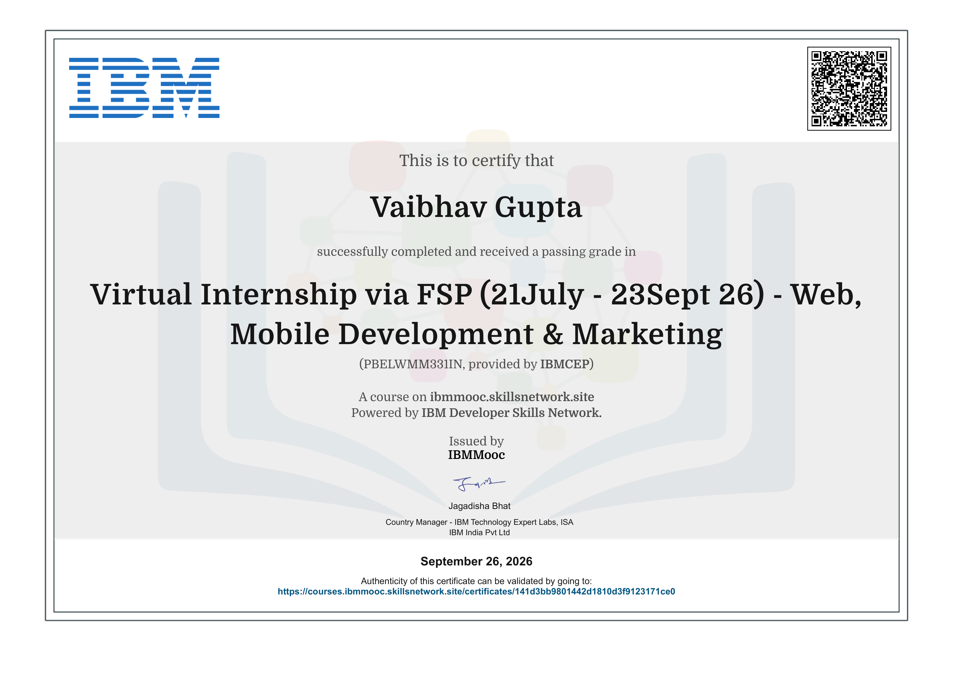
Certificate of completion issued by IBMMooc (IBM Developer Skills Network) for the Virtual Internship via FSP (21 July - 23 September 2026) - Web, Mobile Development & Marketing, course code PBELWMM331IN, provided by IBMCEP. Date of issue: 26 September 2026.

ABSTRACT
Online food ordering is one of the most familiar consumer web patterns, and it combines several skills that a front-end developer is expected to have: fetching and presenting remote data, filtering and searching it, holding shared state such as a cart across screens, and delivering a checkout flow that is clear to a first-time user. This report documents the design, development and deployment of The Tiffin Dispatch, a food ordering web application built during the IBM Collaborative Project-Based Experiential Learning (PBEL) Virtual Internship in Web, Mobile Development and Marketing (21 July - 23 September 2026), delivered through FutureSkills Prime (FSP).
The Tiffin Dispatch is a single-page application built with React (Hooks, Context API and React Router), TailwindCSS and Vite, with menu data supplied by the TheMealDB public API. It offers category tabs, keyword search, price and dietary filters, a favourites list, a cart drawer with a floating cart bar, a pickup or delivery choice with an estimated time, and a checkout that ends in an order number and a printable receipt. The application is localised for an Indian audience, with beef and pork items excluded, prices in rupees and a Greater Noida placeholder address, and it uses a vintage typewriter and dispatch-slip visual theme. It is deployed on Vercel at https://thetiffindispatch.vaibhv19.dev/ and was submitted as the final PBEL project.
The work shows that a front-end-only application with a clear scope, shared state held in a Context provider and a public API as the data source can deliver a complete, deployable ordering experience within an internship. The main limitations are the absence of a back end, real payment processing and automated tests; these are identified as the first recommended extensions. The repositories of the other programme projects are listed in Appendix B for reference.
Keywords: Food Ordering System, React.js, Context API, React Router, TailwindCSS, Vite, TheMealDB API, Single-Page Application, IBM PBEL.

ACKNOWLEDGEMENT
I express my sincere gratitude to IBM and the IBM Developer Skills Network for providing the Collaborative Project-Based Experiential Learning (PBEL) programme, and to the FutureSkills Prime (FSP) platform and the AICTE for making the Virtual Internship accessible to students across the country.
I am thankful to my Mentor, Dr. Kumari Pragya Prayesi, and to the Head of the Department of Computer Science & Engineering (Artificial Intelligence), Dr. Deepak Kr Singh, Greater Noida Institute of Technology, Greater Noida, for their guidance, encouragement and for approving this work as part of my degree requirements.
I also thank the maintainers of the open-source tools and public API used in this project, namely React, React Router, TailwindCSS, Vite and TheMealDB, whose documentation and free tiers made hands-on learning possible. Finally, I thank my family and friends for their constant support during the internship period.
Vaibhav Gupta
TABLE OF CONTENTS
Title Page No.
CERTIFICATE i
ABSTRACT ii
ACKNOWLEDGEMENT iii
LIST OF SYMBOLS, ABBREVIATIONS AND NOMENCLATURE v
1. INTRODUCTION 1
1.1 Background of the Internship 1
1.2 Statement of the Problem 1
1.3 Importance of the Work 1
1.4 Related Work and Technologies 1
1.5 Scope of the Project 2
1.6 Organisation of the Report 2
2. OBJECTIVES 3
3. METHODOLOGY 4
3.1 Overall Approach 4
3.2 Development Workflow 4
3.3 Technology Stack 4
3.4 Application Architecture and Data Flow 4
3.5 Menu Browsing, Search and Filters 5
3.6 Cart and Checkout 5
3.7 Visual Design and Localisation 5
3.8 Deployment 5
3.9 Programme Requirements 6
3.10 Mapping of the Syllabus to the Project 6
4. RESULTS AND DISCUSSION 7
4.1 Deliverables 7
4.2 Application Walkthrough 7
4.3 Discussion of Findings 9
4.4 Programme Outcomes 10
5. RESOURCES AND LIMITATIONS 11
5.1 Resources Used 11
5.2 Limitations 11
6. CONCLUSIONS AND RECOMMENDATIONS 12
6.1 Conclusions 12
6.2 Recommendations and Future Work 12
APPENDICES 13
Appendix A: Certificate of Completion 13
Appendix B: Repositories and Live Link 13
REFERENCES 14

LIST OF SYMBOLS, ABBREVIATIONS AND NOMENCLATURE
Abbreviation | Expansion
AICTE | All India Council for Technical Education
AKTU | Dr. A.P.J. Abdul Kalam Technical University
API | Application Programming Interface
CSS | Cascading Style Sheets
DOM | Document Object Model
EDA | Exploratory Data Analysis
FSP | FutureSkills Prime
HTML | HyperText Markup Language
HTTP | HyperText Transfer Protocol
JSON | JavaScript Object Notation
PBEL | Project-Based Experiential Learning
REST | Representational State Transfer
SEO | Search Engine Optimisation
SPA | Single-Page Application
UI / UX | User Interface / User Experience
URL | Uniform Resource Locator

1. INTRODUCTION

1.1 Background of the Internship
The IBM Collaborative Project-Based Experiential Learning (PBEL) programme is an industry-aligned initiative offered through the FutureSkills Prime (FSP) portal. This report covers the Virtual Internship "Web, Mobile Development & Marketing" (course code PBELWMM331IN, provided by IBMCEP), which ran from 21 July 2026 to 23 September 2026. The certificate of completion was issued by IBMMooc on 26 September 2026 (Appendix A). The track followed is Full Stack Web Development with JavaScript, and under AICTE and AKTU norms the programme is treated as equivalent to a 60-hour internship experience. The syllabus comprises six modules totalling 50 hours plus 10 hours of project work [8].

1.2 Statement of the Problem
Many beginner food ordering interfaces are generic: they show a list of dishes and a button, with little thought for search, filtering, localisation or a checkout that feels complete. The problem addressed here is how to build, within the internship window, a food ordering web application that gives a customer a realistic path from browsing to a confirmed order, that holds its state reliably across screens, and that is deployed so that it can be used and evaluated through a public link.

1.3 Importance of the Work
Browsing a catalogue, narrowing it with search and filters, adding items to a cart and confirming an order are steps that recur in nearly every commercial web application. Building them end to end exercises the central skills of modern front-end development: component design, shared state, client-side routing, consumption of a remote API, responsive styling and deployment.

1.4 Related Work and Technologies
Commercial food ordering platforms share a recognisable pattern of category browsing, search, filters, a persistent cart and a short checkout. Component-based libraries such as React make this pattern practical to build from small reusable units with predictable state flow [1]. Client-side routing is provided by React Router [2], utility-first styling by TailwindCSS [3], and fast development and production builds by Vite [4]. Menu data comes from the free TheMealDB API [5], which is read in the browser using the standard Fetch API [7]. The finished application is hosted on Vercel [6]. Texts on JavaScript, TailwindCSS and React projects listed in the syllabus [9][10][11] supported the learning along the way.

1.5 Scope of the Project
The project is a front-end single-page application named The Tiffin Dispatch. It covers menu browsing, search and filtering, favourites, a cart, a pickup or delivery choice, checkout, and a printable receipt. It does not include a database, user accounts, real payment processing or a restaurant-side order management screen; the application states plainly at checkout that the order flow is a simulation prepared for evaluation. Other programme projects built during the internship are kept in their own repositories and are listed in Appendix B for reference only.

1.6 Organisation of the Report
Chapter 2 states the objectives. Chapter 3 describes the methodology and the design of the application. Chapter 4 presents the results, with screenshots, and discusses the findings. Chapter 5 lists the resources used and the limitations. Chapter 6 gives conclusions and recommendations. The certificate and the repository and live links appear in the appendices, followed by the references.

2. OBJECTIVES
The objectives of the project follow the course objectives of the IBM Full Stack Web Development with JavaScript syllabus [8] and were as follows:
- To build an interactive front end for a food ordering system using React, React Router and TailwindCSS (syllabus Modules I and IV).
- To integrate a public REST API as the data source and present its data through categories, search and filters.
- To manage shared state, namely the cart and favourites, with the Context API so that every screen stays consistent.
- To provide a complete ordering flow with a pickup or delivery choice, a checkout form, an order number and a printable receipt.
- To adapt the application for an Indian audience through content filtering, rupee prices and local placeholder details.
- To apply good practice in code organisation and documentation, and to deploy the application to a public URL (syllabus Module V).
- To complete the mandatory Exploratory Data Analysis course and the programme submission requirements on the FSP portal.

3. METHODOLOGY

3.1 Overall Approach
The project began as a simple flow: browse a menu, add items to a cart and view a checkout, using a free public food API and no back end. It was built in React rather than plain JavaScript so that cart state and routing could be handled with the library features taught in Module IV of the syllabus. After a first working version, the design was judged too generic in appearance, content and features, and a deeper overhaul was carried out before deployment. The overhaul gave the application its name, The Tiffin Dispatch, and its present visual identity and feature set.

3.2 Development Workflow
Work was divided into small tasks, with one commit per completed task made directly to the main branch of the project repository, since there was a single contributor. Antigravity was used as a development tool during scaffolding and iteration, and its output was reviewed, run and adjusted by the author before being committed. The repository carries a README describing the purpose, tech stack and usage of the application.

3.3 Technology Stack
Table 3.1: Technology stack of The Tiffin Dispatch
Layer | Technology | Purpose
User interface | React.js (functional components, Hooks) | Component-based screens and local state
Shared state | React Context API | Cart, favourites and order mode shared across screens
Routing | React Router | Separate menu and checkout views with their own URLs
Styling | TailwindCSS | Utility-first, responsive layout and theme
Build tool | Vite | Development server and production bundle
Data source | TheMealDB API | Dish names, categories, images and descriptions
Hosting | Vercel with custom subdomain | Public deployment at thetiffindispatch.vaibhv19.dev

3.4 Application Architecture and Data Flow
The application runs entirely in the browser. When the menu view loads, the application requests dish data from TheMealDB, groups it by category and renders it as cards. A single Context provider wraps the application and holds the cart, the favourites list and the selected dispatch mode, so that the menu, the cart drawer, the floating cart bar and the checkout read and update the same data. React Router separates the menu view from the checkout view, which has its own URL, and the checkout leads to a confirmation view showing the order number and receipt. There is no server of its own and no data is submitted anywhere.

3.5 Menu Browsing, Search and Filters
The menu is organised into category tabs (for example Chicken, Dessert, Lamb, Pasta, Seafood, Starter, Vegan and Vegetarian). Above the cards, a search field filters dishes by keyword, price bands (under Rs. 300, Rs. 300 to Rs. 500 and over Rs. 500) narrow the list by cost, and dietary toggles show vegetarian-only or vegan-only dishes. Each dish card carries a running item number, a favourite toggle and an add button, and selecting a card opens a larger detail view. The names and categories supplied by the API were kept as they are; the customisation was done as a presentation and filtering layer on top of the API data.

3.6 Cart and Checkout
Added items appear in a cart drawer styled as a kitchen slip, where quantities can be changed or items removed and the subtotal and total are shown. A floating cart bar summarises the item count and total and stays visible while the user scrolls, so that the user does not have to return to the top of the page after adding an item. The checkout view, styled as a final guest check, collects the customer name, a pickup or delivery choice with an estimated time for each, a table or station number and an optional special request, and shows the bill ticket alongside. Confirming the order produces an order number and a printable receipt. A notice at the foot of the form states that the flow is a simulation for evaluation, with no database submission and no financial charge.

3.7 Visual Design and Localisation
The interface follows a vintage typewriter and courier-dispatch theme: monospaced type, ticket and slip metaphors, a stamped banner, and a tagline of freshly dispatched tiffins. To suit an Indian audience, beef and pork items are excluded from the menu, prices are shown in rupees, and the placeholder address and phone details use Indian formats with a location near Greater Noida. Because the source API does not carry prices, the displayed prices are defined by the application.

3.8 Deployment
The application is built with Vite and deployed on Vercel, one of the deployment options named in Module V of the syllabus. It is served from a custom subdomain, https://thetiffindispatch.vaibhv19.dev/, and the source code is available at https://github.com/vaibhv19/Food-Ordering-System.

3.9 Programme Requirements
Alongside development, the programme process required portal registration on FutureSkills Prime, authentication through DigiLocker, project submission and confirmation of the Government of India incentive. The project submission, consisting of a presentation and a demonstration link, was completed successfully. The Exploratory Data Analysis course was a mandatory component; its certificate was issued on 25 July 2026 and the assessment was cleared on 5 August 2026 in the Gold Category with a score of 75%. Supporting screenshots and documents are kept in the programme repository.

3.10 Mapping of the Syllabus to the Project
Table 3.2: Syllabus modules and where they were applied
Module | Hours | Applied in
I. Frontend basics | 6 | HTML, TailwindCSS styling, DOM events and responsive layout of the interface
II. Node.js and Express.js | 10 | Studied as coursework; used in other programme projects (Appendix B)
III. Database and API development | 10 | Studied as coursework; REST consumption applied here through the TheMealDB API
IV. Advanced frontend with React.js | 10 | Components, Hooks, React Router, Context API and REST API integration
V. Full-stack project and deployment | 8 | Complete application, code organisation and deployment on Vercel
VI. Website launch and SEO | 6 | Studied as coursework; not built as a separate project
Projects | 10 | Food ordering website (frontend) submitted as the final project

4. RESULTS AND DISCUSSION

4.1 Deliverables
The Tiffin Dispatch was completed, deployed and submitted as the final PBEL project. Its source code is at https://github.com/vaibhv19/Food-Ordering-System and the live application is at https://thetiffindispatch.vaibhv19.dev/. Table 4.1 summarises the features delivered.
Table 4.1: Summary of features delivered
Area | Features
Browsing | Category tabs, dish cards with item numbers, detail view
Search and filters | Keyword search, three price bands, vegetarian and vegan filters
Favourites | Favourite toggle on each dish card and a saved list
Cart | Cart drawer with quantity controls, subtotal and total, floating cart bar
Checkout | Customer details, pickup or delivery with estimated time, special request, bill ticket
Confirmation | Order number and printable receipt
Localisation | Beef and pork excluded, rupee prices, Indian-format placeholder address and phone
Delivery | Deployed on Vercel at a custom subdomain

4.2 Application Walkthrough
Figure 4.1 shows the home view, with the navigation (menu, ticket, checkout), the stamped banner carrying the location and opening hours, the category tabs and the search field.
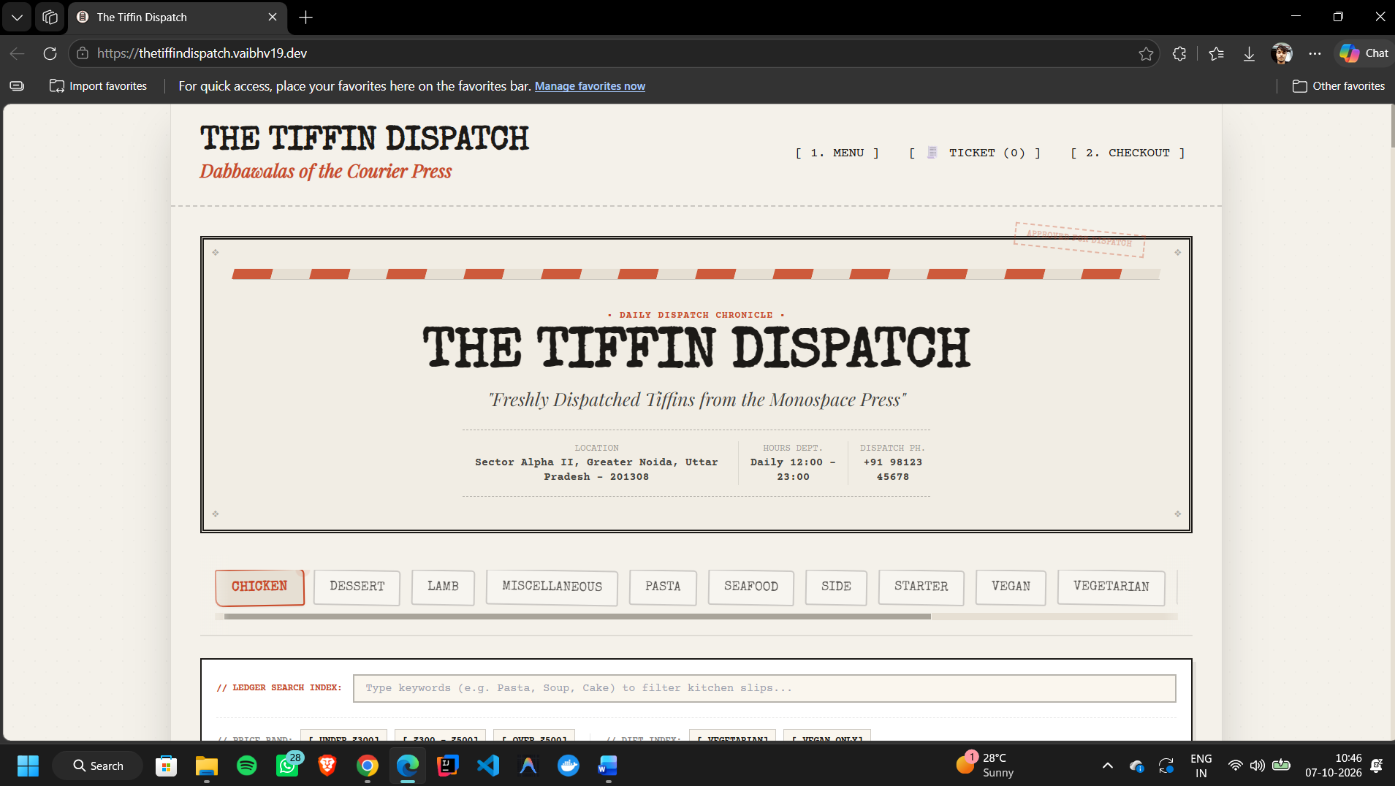
Fig. 4.1: Home view with banner, category tabs and search
Figure 4.2 shows the menu cards with the keyword search, the price bands and the dietary filters, and a selected dish opened in a larger detail card.
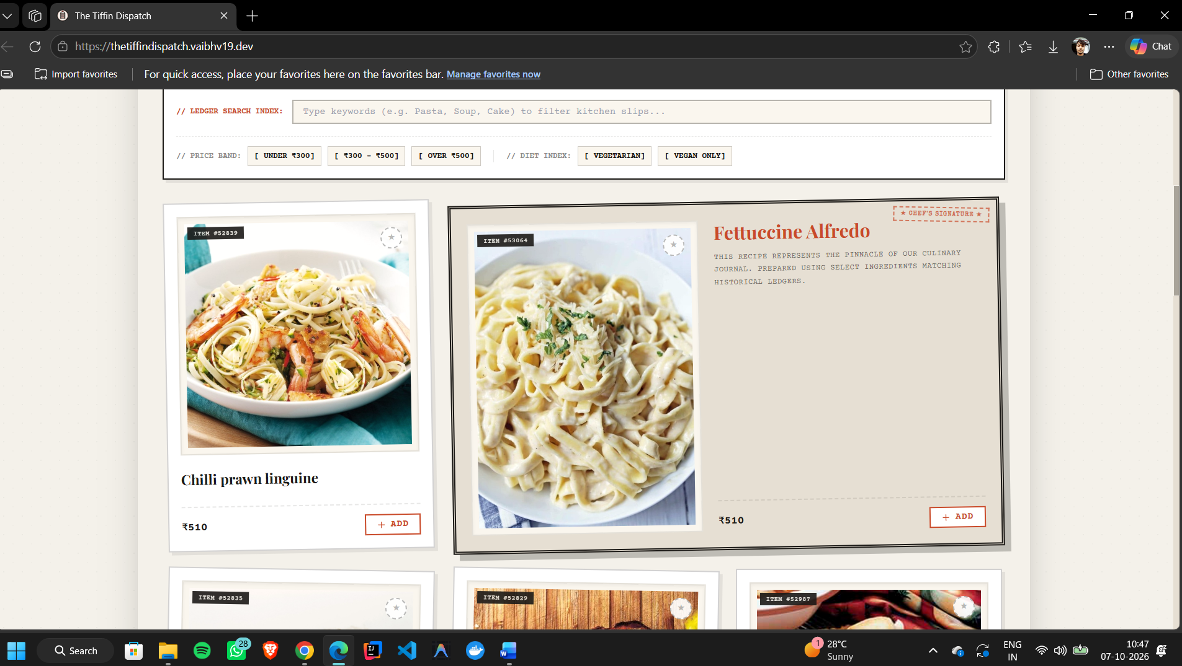
Fig. 4.2: Menu cards, filters and dish detail view
Figure 4.3 shows the cart drawer, presented as the active kitchen slip, with quantities, the total bill and the button that leads to checkout. The floating cart bar is visible at the bottom of the screen.
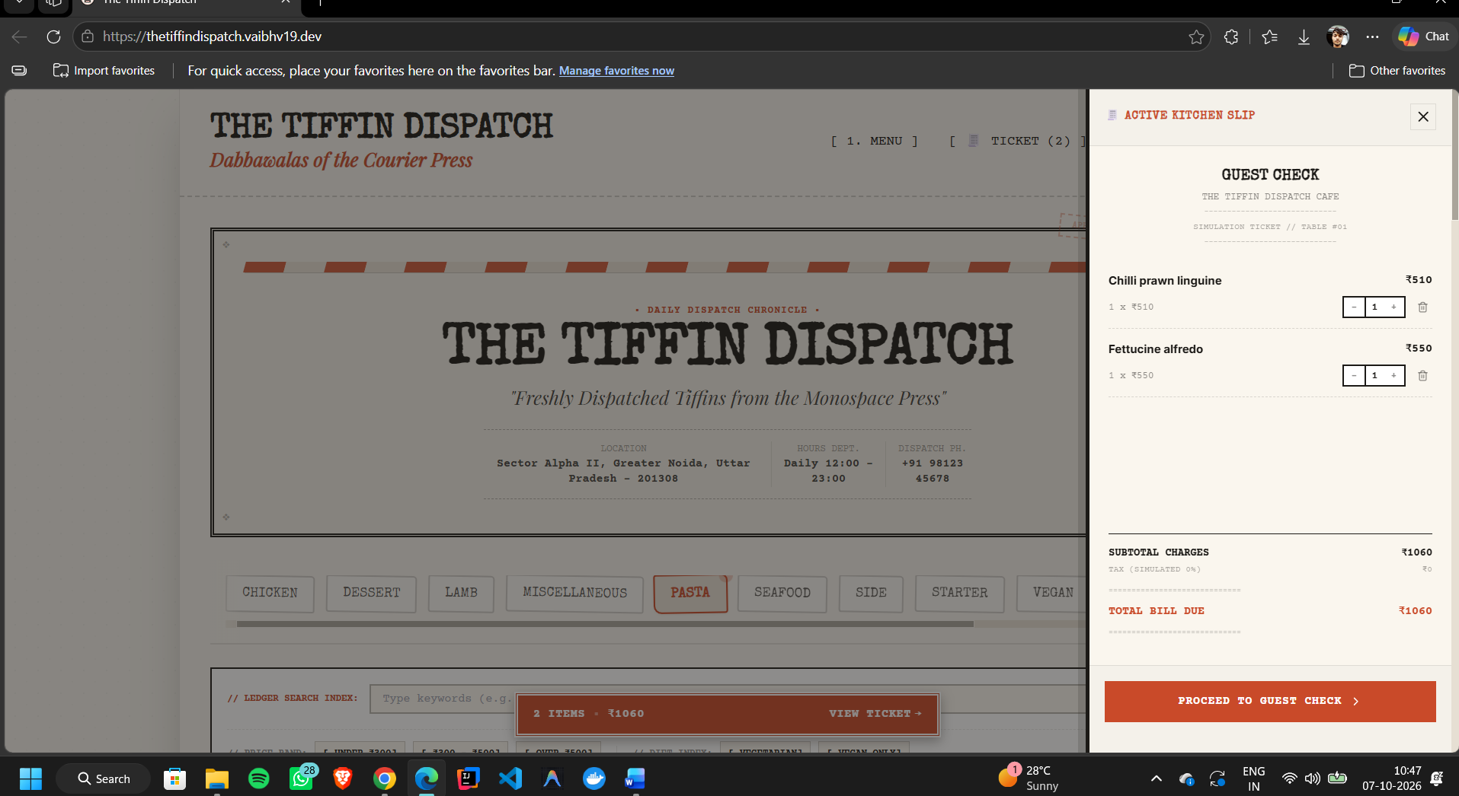
Fig. 4.3: Cart drawer (kitchen slip) and floating cart bar
Figure 4.4 shows the checkout view, the final guest check, with the customer details, the pickup or delivery choice, the special request field and the bill ticket total.
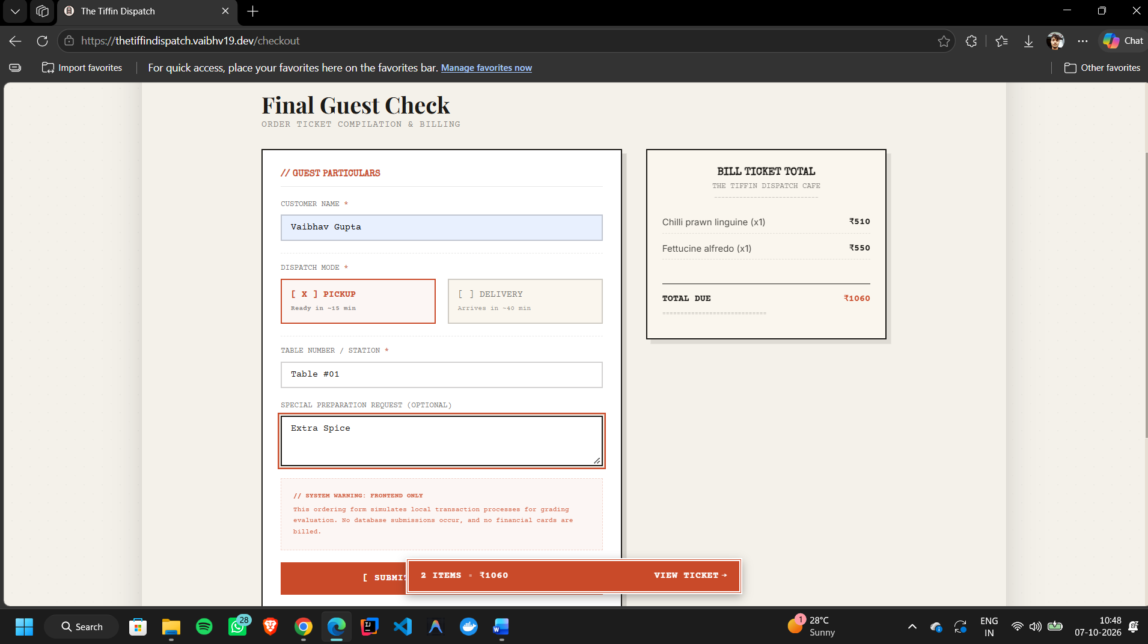
Fig. 4.4: Checkout view (final guest check)

4.3 Discussion of Findings

4.3.1 Shared state keeps every screen consistent
The cart, favourites and dispatch mode are needed by the menu, the drawer, the floating bar and the checkout. Holding them in one Context provider removed repeated data passing between components and meant that an item added from a dish card appeared immediately in the drawer, the floating bar and the bill ticket.

4.3.2 Filters should combine, not replace each other
Category, keyword, price band and dietary filters all act on the same list of dishes. Treating them as independent conditions applied together, rather than as separate views, keeps the interface predictable and lets a user narrow the menu step by step.

4.3.3 Localisation as a presentation layer
Because the menu comes from a public API, its content could not be rewritten. Excluding beef and pork items, showing prices in rupees and using local placeholder details were handled in the application rather than in the data, which keeps the source untouched and the changes easy to adjust. The trade-off is that the menu still reflects the range of the public dataset rather than a real Indian restaurant.

4.3.4 A persistent cart bar improves flow
In the first version, a user had to scroll back to the top to open the cart after adding an item. Adding a floating cart bar that stays visible removed that step and made adding several items in a row smoother.

4.3.5 Honest scope
Stating on the checkout page that the order flow is a simulation avoids implying that a real order or payment takes place. Deciding early not to build a back end or payments kept the project finishable and focused on the front-end skills named in the syllabus.

4.4 Programme Outcomes
The Virtual Internship was completed with a passing grade and a certificate of completion (Appendix A), the final project was submitted successfully with a presentation and a demonstration link, and the Exploratory Data Analysis course was cleared in the Gold Category.

5. RESOURCES AND LIMITATIONS

5.1 Resources Used
Table 5.1: Software and services used
Category | Resources
Languages | JavaScript (ES6+), HTML5, CSS3
Libraries and tools | React.js, React Router, TailwindCSS, Vite
Data | TheMealDB API
Tooling | Git and GitHub, Antigravity, web browser developer tools
Hosting | Vercel with a custom subdomain
Programme platform | FutureSkills Prime, IBM Developer Skills Network (IBMMooc), DigiLocker

5.2 Limitations
- No back end or database: the cart, favourites and orders are not stored on a server, and orders are not received by any restaurant system.
- No real payment processing: checkout is a simulation, as stated in the application.
- Dependence on a free public API whose availability and data quality are outside the author's control; the menu content and images come from it.
- No automated test suite: correctness was checked by manually exercising the browsing, filtering, cart and checkout flows.
- Limited accessibility and cross-browser testing beyond common desktop and mobile browsers.
- A single-contributor repository with a commit-to-main workflow, so code review and branching practices were not exercised.

6. CONCLUSIONS AND RECOMMENDATIONS

6.1 Conclusions
The objectives of the project were met. The Tiffin Dispatch is a complete front-end food ordering application that covers browsing, search, filtering, favourites, a cart, a pickup or delivery choice, checkout and a printable receipt. It was localised for an Indian audience, deployed on a public custom subdomain and accepted as the final PBEL submission. The programme certificate was issued on 26 September 2026 and the mandatory EDA course was cleared in the Gold Category.
The experience showed that the skills that matter most are not specific to one library: bounding the scope, keeping shared state in one place, treating filters as composable, and being clear with the user about what the application does and does not do.

6.2 Recommendations and Future Work
- Add a Node.js and Express back end with MongoDB so that orders, users and menus are stored, reusing the authentication approach covered in the syllabus modules on server-side development and APIs.
- Integrate a payment gateway in sandbox mode to make checkout realistic.
- Replace the public dataset with a custom menu and an admin screen, removing the dependence on TheMealDB.
- Add automated tests for the cart and filter logic and run them in a continuous integration workflow.
- Improve accessibility (keyboard navigation, contrast, screen-reader labels) and apply the on-page SEO techniques from Module VI, such as titles, meta tags and analytics.
- Introduce TypeScript to catch data-shape errors where API responses are consumed.

APPENDICES

Appendix A: Certificate of Completion
Virtual Internship via FSP (21 July - 23 Sept 26) - Web, Mobile Development & Marketing, course code PBELWMM331IN, provided by IBMCEP and issued by IBMMooc on 26 September 2026 to Vaibhav Gupta. It is signed by Jagadisha Bhat, Country Manager, IBM Technology Expert Labs, ISA, IBM India Pvt Ltd. The certificate can be verified at https://courses.ibmmooc.skillsnetwork.site/certificates/141d3bb9801442d1810d3f9123171ce0.

Appendix B: Repositories and Live Link
Table B.1: Project links
Project | Link
The Tiffin Dispatch (live application) | https://thetiffindispatch.vaibhv19.dev/
The Tiffin Dispatch (Food Ordering System repository) | https://github.com/vaibhv19/Food-Ordering-System
E-commerce Website (reference) | https://github.com/vaibhv19/E--commerce-Website
Social Media Backend (reference) | https://github.com/vaibhv19/Social-Media-Backend
Weather App (reference) | https://github.com/vaibhv19/Weather-App

The programme repository, github.com/vaibhv19, links to all of the above together with the syllabus, process guide and portal screenshots. The three reference repositories are other PBEL projects and are not discussed in this report.

REFERENCES
- Meta Platforms, Inc., "React Documentation," react.dev, accessed October 2026.
- Remix Software, Inc., "React Router Documentation," reactrouter.com, accessed October 2026.
- Tailwind Labs, "Tailwind CSS Documentation," tailwindcss.com/docs, accessed October 2026.
- "Vite: Next Generation Frontend Tooling," vite.dev, accessed October 2026.
- "TheMealDB API," themealdb.com/api.php, accessed October 2026.
- Vercel, Inc., "Vercel Documentation," vercel.com/docs, accessed October 2026.
- Mozilla, "Fetch API," MDN Web Docs, developer.mozilla.org/en-US/docs/Web/API/Fetch_API, accessed October 2026.
- IBM, "Full Stack Web Development with JavaScript," IBM Collaborative Project-Based Experiential Learning (PBEL) course syllabus, 2026.
- Brown, E., Learning JavaScript, O'Reilly Media.
- Wathan, A., Tailwind CSS: From Zero to Production.
- Hoque, S., Full-Stack React Projects, Packt Publishing.

