Responses to the reviewer's analysis requests
Prior-use in Parkinson's disease: colour-cued Glass-pattern task
This report answers the review points that have been completed. Each section states what was asked, what was done, the result, and how to read it. Every number is reproduced by the named notebook in the project repository; nothing here is quoted from an earlier draft. Three requested analyses remain outstanding and are listed at the end.
Point | Topic | Notebook | Status
1 | Direct subtype contrast | 2.27 | Done
2 | Participant-level paired changes and covariates | 2.28 | Done except levodopa dose
3 | Permutation test | 2.24 | Done
3b | Prior and random-effects sensitivity | 2.29 | Done
4 | DDM multiplicity and model-fit checks | 3.50 | Done except parameter recovery
6 | Continuous occupancy-weighted measure | 4.20 | Done
7 | Cross-model convergence | 4.20 | Done
8 | Colour artifact | 2.31 | Done

Point 1. The subtypes are not shown to differ
Asked: Figure 2 shows a medication x prior effect in tremor-dominant patients and little in bradykinesia-dominant patients. Report the direct three-way contrast, its interval and effect size.
Done: One hierarchical model fitted to both subtypes' single-trial choices, with subtype interacting with every term of the within-subtype model. The subtype x colour x medication coefficient is the difference between the subtypes' medication effects. A second estimate differences the two separately fitted posteriors, which do not share between-participant variance.
Estimate | mean | 2.5% | 97.5% | P(> 0)
1. three-way coefficient (joint model) | 0.469 | -0.291 | 1.241 | 0.897
2. group-mean difference (these 21 participants only) | 0.486 | 0.247 | 0.730 | 1.000
3. difference of separate fits | 0.494 | -0.276 | 1.247 | 0.905
4. bootstrap of per-participant means | 0.488 | -0.116 | 1.066 | 0.945

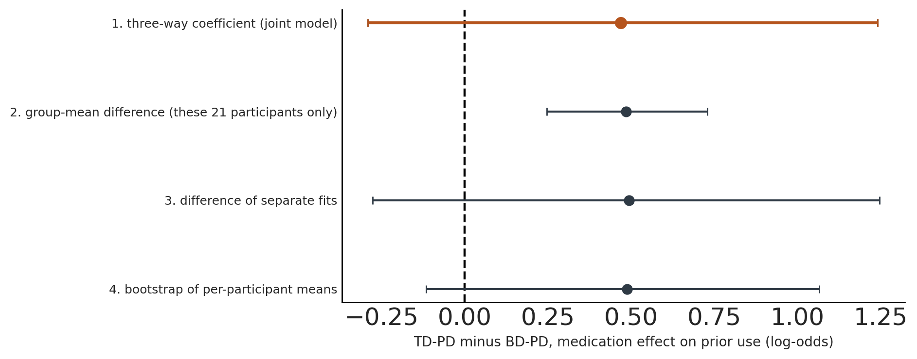
Four estimates of the TD-PD minus BD-PD difference. Rows 1 and 3 answer the population question; rows 2 and 4 do not (see text).
How to read it: The two estimates that answer the question, the joint model and the separate fits, agree at about +0.47 to +0.49 log-odds with roughly 90% posterior probability of being positive, and both intervals include zero. On the probability scale the difference is about 11.5 percentage points of prior-driven bias at 0% coherence, 95% CI -7.3 to +30.3. The direction supports the subtype claim; the data do not establish it.
Do not use: The group-mean difference row has a much narrower interval that excludes zero, but it conditions on these 21 participants and omits the variability from sampling different ones. That variability alone contributes about 0.37 to the uncertainty. The bootstrap row treats shrunken posterior means as exact and is also too narrow.

Point 2. Participant-level paired changes, and covariate adjustment
Asked: With n = 11 and n = 10, group curves can conceal influential individuals. Show paired OFF to ON estimates, and report whether the tremor result survives adjustment for session order, site, colour-orientation mapping, disease severity and levodopa-equivalent dose.
Done: Each patient's prior effect OFF and ON, both as observed choice proportions at 0% coherence and as posterior estimates from the reported model; then the model refitted with each covariate added, entered with its interactions so it can modulate the medication effect.
subtype | n | improved | mean_change | min_change | max_change
bradykinetic | 10 | 5 | -0.021 | -0.350 | 0.343
tremor | 11 | 7 | 0.112 | -0.330 | 0.366

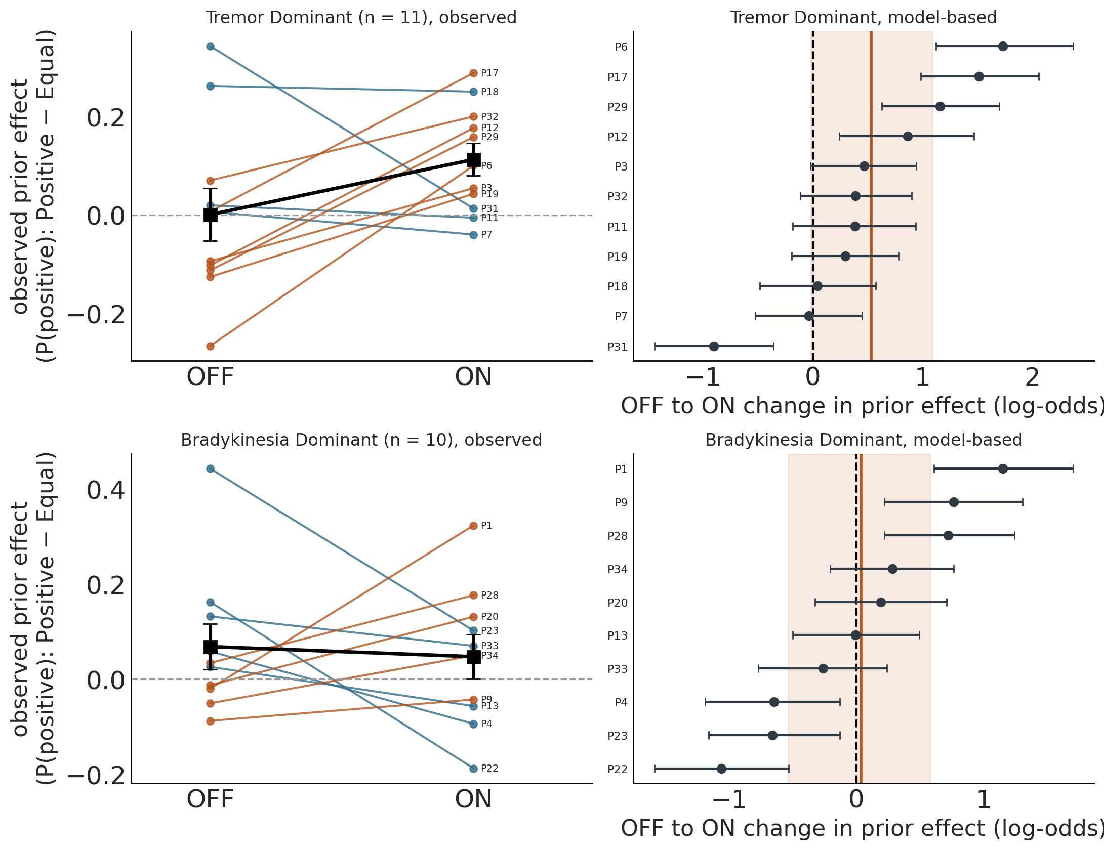
Left: observed paired changes, one line per patient. Right: model-based OFF to ON change with 95% intervals; the shaded band is the population estimate.
model | col:med | 2.5% | 97.5% | P(> 0)
reported model | 0.544 | -0.009 | 1.082 | 0.974
+ session order | 0.520 | -0.073 | 1.122 | 0.959
+ site | 0.419 | -0.231 | 1.049 | 0.908
+ disease severity (UPDRS) | 0.544 | 0.089 | 1.001 | 0.986
+ colour-orientation mapping | 0.450 | -0.032 | 0.954 | 0.966
+ all of the above | 0.265 | -0.130 | 0.669 | 0.925

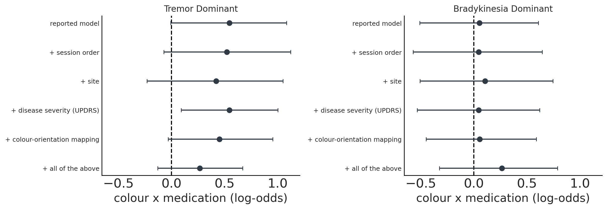
The colour x medication interaction under each adjustment, both subtypes.
How to read it: Four of eleven tremor patients have intervals entirely above zero and one entirely below, so the effect is a majority tendency rather than a uniform shift, and it is not carried by any single patient. The interaction keeps its sign and roughly its size under every single covariate, with posterior probability never below 0.91. Site and the colour-orientation mapping each reduce it by about 20%; mapping is the only one that can confound directly, because every patient had a different mapping in their second session.
Caution: Change is strongly related to starting point (r = -0.84 in tremor). The same correlation appears in bradykinesia patients, where there is no net effect (r = -0.74), which is the signature of regression to the mean. Avoid any claim conditioned on the OFF-medication value, including responder analyses. The all-covariates model adds 16 terms estimated from 11 patients and should be read as a stress test, not as the estimate.
Not done: Levodopa-equivalent dose. The metadata contains no dose column. Free-text prescriptions exist for all 21 patients, so LEDD can be derived, but that needs parsing and clinical checking before use.

Point 3. Permutation test, and why it changed the headline number
Asked: Add a permutation test that swaps OFF and ON labels within participant.
Done: Each patient has one OFF and one ON session, so under the null those labels are exchangeable within a patient. Swapping them at random gives datasets with no medication effect by construction. 300 such datasets per subtype were used to calibrate each inference method, and 1,000 were used for the exact permutation p-value.
Method | False-positive rate, tremor | bradykinesia
Naive pooled logistic | 0.520 | 0.480
Bayesian mixed GLM (variational) | 0.517 | 0.503
Cluster-robust logistic | 0.083 | 0.100
Subject-level Wilcoxon | 0.033 | 0.057

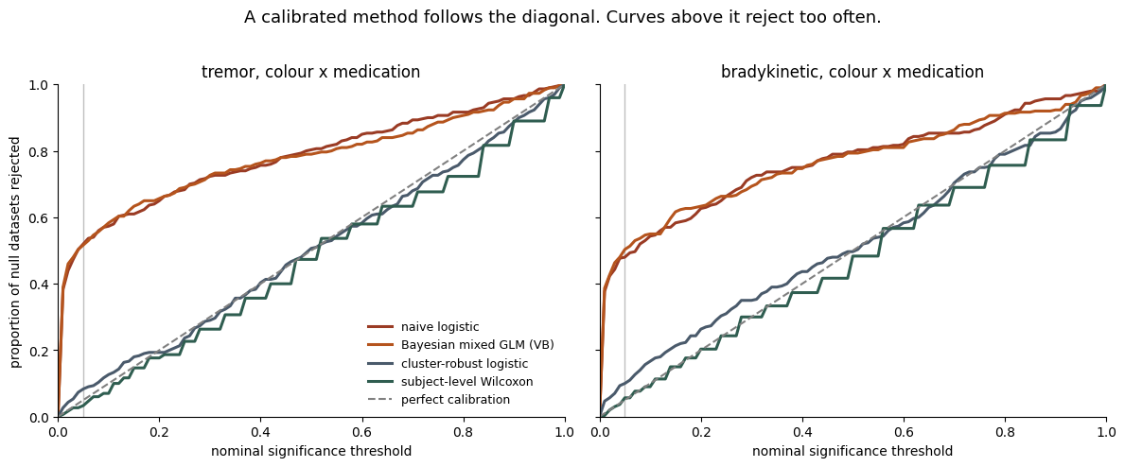
Calibration curves. A correctly calibrated method follows the diagonal. The variational fit lies on top of the naive pooled logistic, far above it.
Method | Colour x medication, tremor
Published variational GLMM | 7.5e-9
Cluster-robust logistic | 0.041
Sign-flip permutation, 1,000 shuffles | 0.067
MCMC, twice the tail probability | 0.060
Subject-level difference-in-differences | 0.148

How to read it: The variational fit rejects a true null in about half of datasets where no medication effect exists, so its p-values cannot be reported. Four sound methods agree on roughly 0.04 to 0.15. The effect is marginal, not decisive. Subject-level tests elsewhere in the paper are correctly calibrated and are unaffected.

Point 3b. Prior and random-effects sensitivity
Asked: Refit under alternative reasonable priors and random-effects specifications.
specification | col:med | SD | 2.5% | 97.5% | P(> 0)
reported | 0.530 | 0.279 | -0.016 | 1.064 | 0.971
wide priors | 0.542 | 0.299 | -0.038 | 1.135 | 0.965
tight priors | 0.507 | 0.240 | 0.015 | 0.959 | 0.978
correlated | 0.520 | 0.302 | -0.065 | 1.132 | 0.959
reduced random effects | 0.462 | 0.245 | -0.021 | 0.927 | 0.970
intercept only | 0.439 | 0.083 | 0.276 | 0.601 | 1.000

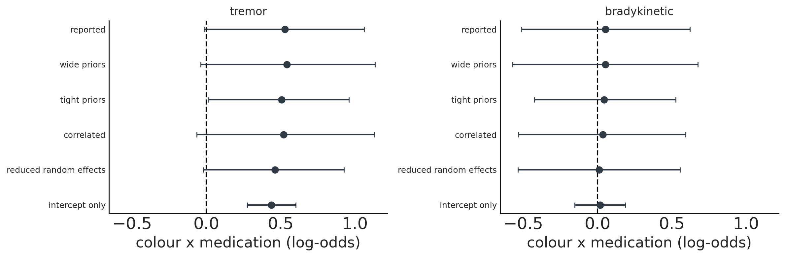
The interaction under six specifications, both subtypes. Zero divergences and R-hat below 1.008 throughout.
How to read it: The estimate sits between +0.46 and +0.54 regardless of prior width, correlated versus uncorrelated random effects, or the number of random slopes, with posterior probability between 0.96 and 0.98. The conclusion does not depend on modelling choices.
The informative row: Dropping random slopes gives a posterior SD of 0.083, against 0.279 for the reported model. That is almost exactly the variational fit's 0.081, so the approximation behaved as though it had no random slopes at all. This independently confirms the calibration result. The tight-priors row is the only other specification whose interval excludes zero, and it does so because the prior contradicts the observed between-participant spread of about 0.85.

Point 4. DDM multiplicity and model fit
Asked: State corrected p values for the drift-offset results or treat them as exploratory, and add parameter-recovery and posterior-predictive checks.
group | n | raw p | Bonferroni | BH-FDR
Healthy controls | 18 | 0.038 | 0.385 | 0.192
Tremor OFF | 11 | 0.577 | 1.000 | 0.998
Tremor ON | 11 | 0.032 | 0.322 | 0.192
Brady OFF | 10 | 0.846 | 1.000 | 0.998
Brady ON | 10 | 0.160 | 1.000 | 0.534

How to read it: None of the ten Figure 3 tests survives either correction. The family is the two parameters you tested times the five group conditions in that figure. Even the narrowest defensible family, the five drift-offset tests alone, leaves both at 0.096 by FDR.
More important: The five within-group tests do not test the paper's claims, which are comparative. Testing them directly, one test each and no family to correct: medication changes the prior's drift shift in tremor patients, +0.011 to +0.513, p = 0.175; controls versus untreated tremor patients, p = 0.132; the subtypes differ, p = 0.550. None is significant even uncorrected. Figure 3 should therefore be presented as a mechanistic illustration consistent with Figure 2, not as independent confirmation.
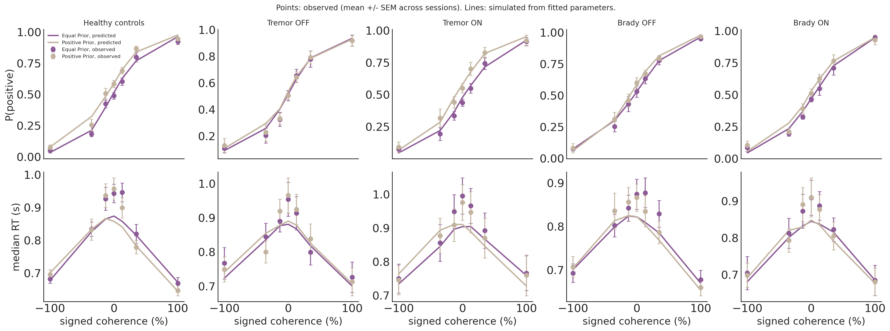
Posterior-predictive check. Points are observed session means; lines are simulated from each session's fitted parameters.
Coherence | Observed median RT (s) | Predicted | Error
0% | 0.987 | 0.909 | -0.077
13% | 0.955 | 0.902 | -0.053
35% | 0.881 | 0.867 | -0.014
100% | 0.756 | 0.747 | -0.009

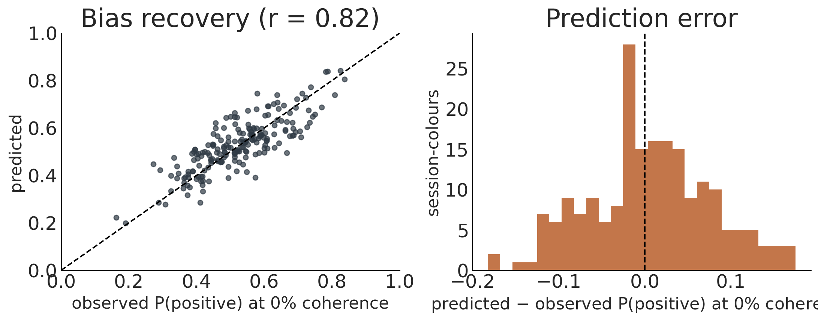
Recovery of each session's choice bias at 0% coherence, where the prior effect lives.
How to read it: Choices are reproduced well, including the prior separation the model is used to explain. Reaction times are systematically under-predicted on hard trials, by 77 ms at 0% coherence, in 90% of session-colours and in every group equally. Per-session bias recovery correlates at r = 0.82 with no systematic offset, but its mean absolute error, 0.056, is the same size as the group prior effects being interpreted. Read Figure 3 at the group level only.
Not done: Parameter recovery. The fitting pipeline requires CUDA and runs differential evolution with 15 simulation repetitions per evaluation, so it belongs on the cluster. Its central question is whether starting point and drift offset are separably identifiable at about 300 trials per session-colour, since both shift choices toward one alternative.

Point 6. A continuous HMM measure, replacing threshold-defined occupancy
Asked: Figure 4e is circular: states are declared colour-sensitive within a group and occupancy is then summarised for those selected states. Make a continuous occupancy-weighted prior effect the primary result.
Done: For each session, the occupancy-weighted average of the state colour weights, one number per session in log-odds, with no thresholding and no state selection. It is on the same scale as the mixed model's colour effect.
group | mean | sem | count
HC | 0.448 | 0.153 | 18
tremor_off | 0.063 | 0.208 | 11
tremor_on | 0.650 | 0.193 | 11
bradykinetic_off | 0.224 | 0.190 | 10
bradykinetic_on | 0.237 | 0.192 | 10

Test | n | Effect (log-odds) | dz | p
Tremor, OFF vs ON (paired) | 11 | +0.587 | 0.57 | 0.102
Bradykinesia, OFF vs ON (paired) | 10 | +0.013 | 0.02 | 1.000
Controls vs tremor OFF | 18 v 11 | +0.385 |  | 0.121
Tremor vs bradykinesia medication effect | 11 v 10 | +0.574 |  | 0.245

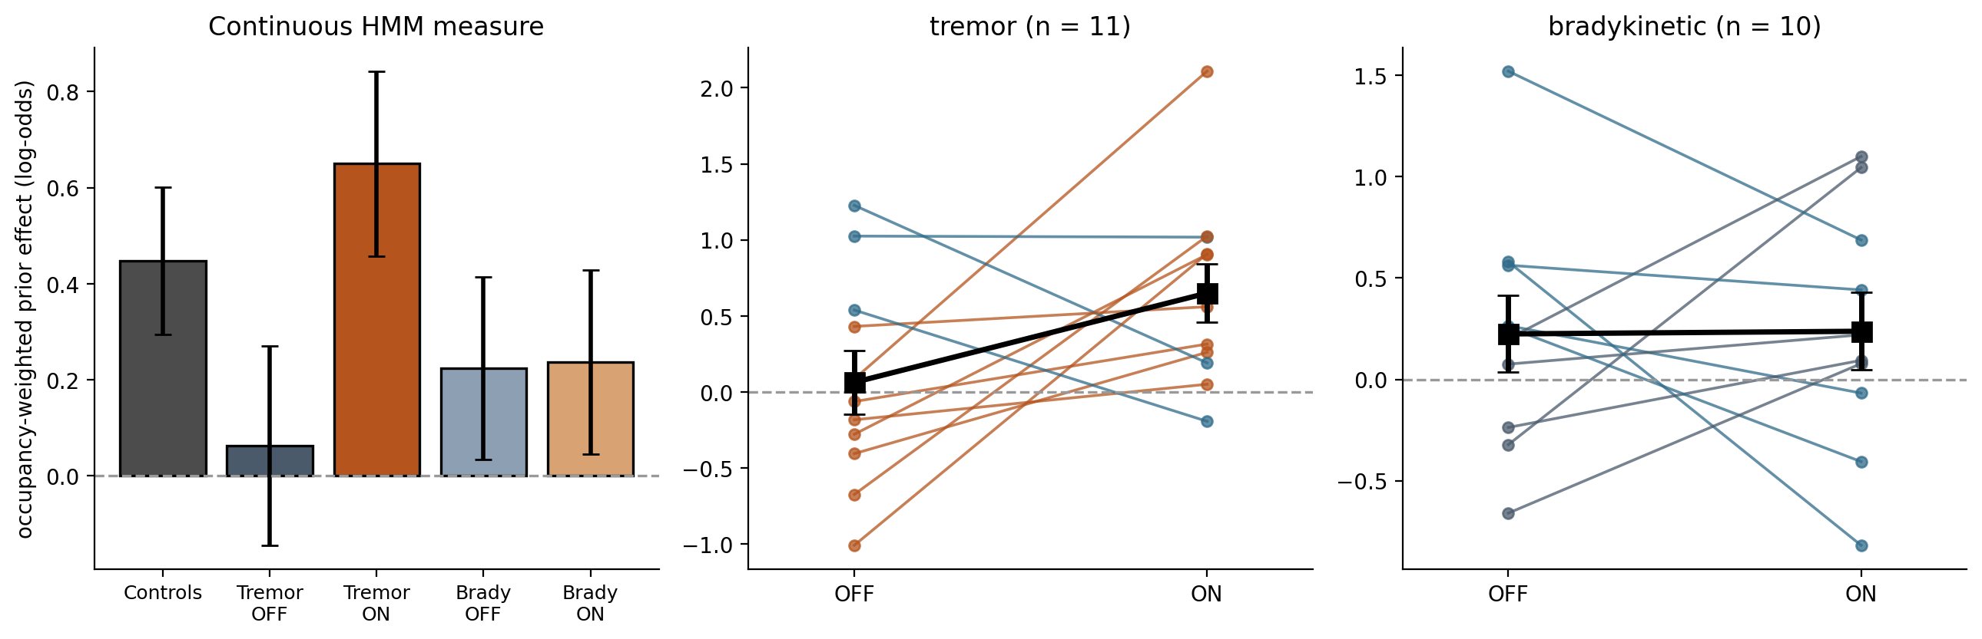
Left: the continuous measure by group. Middle and right: paired OFF to ON changes per patient.
How to read it: This removes both problems with Figure 4e. There is no selection step, and the degenerate conditions disappear: the impressive p-values in the current Table 2 (0.0010 and 0.0020) came from groups where occupancy was identically zero for every session, which the analysis notebook already flagged. The medication effect in tremor patients is +0.587 log-odds, closely matching the mixed model's +0.531 on the same scale, and is not significant. Keep the thresholded occupancy figure as a descriptive panel if you wish, but not as evidence.

Point 7. The three models agree about individual patients
Asked: Test whether participant-level mixed-model medication effects correlate with participant-level HMM changes, with bootstrap intervals, and whether DDM drift-offset changes align with them.
pair | n | rho | 2.5% | 97.5%
mixed_model vs glm_hmm | 21 | 0.977 | 0.893 | 0.999
mixed_model vs ddm | 21 | 0.852 | 0.614 | 0.955
glm_hmm vs ddm | 21 | 0.826 | 0.545 | 0.940

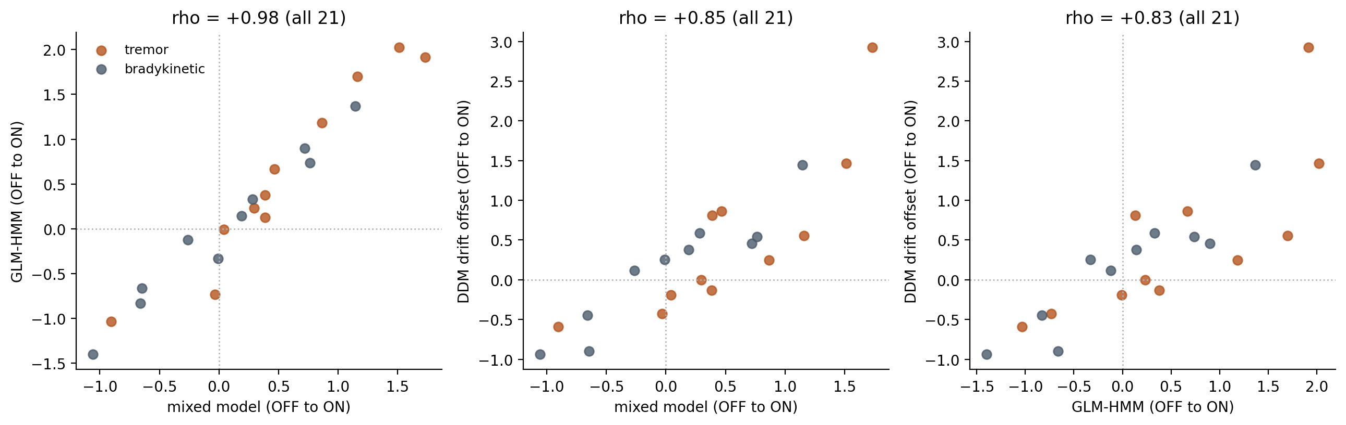
Participant-level OFF to ON medication effects from the three models, 21 patients.
How to read it: All three agree closely, and each interval excludes zero. The correlation between the mixed model and the GLM-HMM, 0.98, is close to tautological, because both measure how much more the colour biases that patient's choices ON versus OFF, from the same trials. It confirms the implementations agree; it is not independent evidence.
The informative one: The DDM, at rho = 0.85 with the mixed model (95% CI 0.61 to 0.96), is a different model class fitted to reaction times as well as choices, and it holds in both subtypes separately (0.92 and 0.95). That supports the claim that the three analyses describe one mechanism rather than three unrelated quantities.

Point 8. The effect is not a colour artifact, but colour does matter
Asked: Because the prior is signalled by red versus green, quantify whether counterbalancing removes colour and mapping effects, and test colour assignment x medication and colour assignment x subtype interactions.
Assignment | vs medication (Fisher p) | vs subtype (Fisher p)
Prior colour (red / green) | 0.758 | 0.374
Prior direction (left / right) | 1.000 | 1.000

model | term | mean | 2.5% | 97.5% | P(> 0)
colour assignment | col:med | 0.252 | -0.097 | 0.582 | 0.928
colour assignment | assign:col | -0.473 | -0.812 | -0.125 | 0.004
colour assignment | assign:col:med | -0.088 | -0.744 | 0.554 | 0.399
colour assignment x subtype | col:med | 0.257 | -0.080 | 0.608 | 0.936
colour assignment x subtype | assign:col | -0.445 | -0.794 | -0.098 | 0.006
colour assignment x subtype | assign:col:med | -0.024 | -0.714 | 0.650 | 0.484
colour assignment x subtype | sub:col:med | 0.400 | -0.289 | 1.099 | 0.878
colour assignment x subtype | sub:assign:col | 0.007 | -0.678 | 0.680 | 0.508
prior direction | col:med | 0.309 | -0.043 | 0.684 | 0.955
prior direction | assign:col | 0.018 | -0.335 | 0.370 | 0.546
prior direction | assign:col:med | 0.196 | -0.560 | 0.934 | 0.699

How to read it: Counterbalancing worked: assignment is balanced against both medication and subtype, and it varies within participant for 16 of 21 patients, so its interactions are properly estimable. The medication effect does not depend on which colour carried the prior (assign:col:med), and neither does the subtype pattern (sub:assign:col). Prior direction shows nothing at all. The effect is therefore not a colour artifact.
A new finding worth reporting: Colour assignment does affect prior use in its own right. The prior biases choice about 0.47 log-odds more strongly when the green stimulus carried it, an interval comfortably excluding zero and one of the clearest effects in these analyses, plausibly a salience or luminance difference between the stimulus colours. It is additive and orthogonal to medication and subtype, so it does not threaten the main claim, but it shows the counterbalancing was necessary rather than merely precautionary.

Outstanding
Item | Why it is not done
DDM parameter recovery | Needs the GPU cluster. Fitting requires CUDA and runs differential evolution with 15 simulation repetitions per evaluation.
Cross-validation with held-out sessions | Current cross-validation holds out interleaved trial blocks from within each session, so training and test data come from the same participants. Repeating it with whole sessions held out could change the selected number of states.
Levodopa-equivalent dose | No dose column exists. Derivable from the free-text prescriptions, which are present for all 21 subtyped patients, after parsing and clinical checking.

Overall
The tremor-dominant medication effect is consistent in direction across every analysis and every specification, is not driven by any single patient, and survives covariate adjustment. It is also marginal rather than decisive once inference is calibrated, and the difference between subtypes is not established. The figures support a careful, subtype-specific association claim, with roughly 0.9 to 0.97 posterior probability depending on the analysis. They do not yet support a definitive between-subtype or mechanistic conclusion.

