**Team 1: Basic Circuit Solver in Python**

**Team list:**

| **S.no** | **NAME** | **REGISTRATION NO.** |
| --- | --- | --- |
| **1** | **VIVIAN HALBEN CASTELINO** | **RSAGWPVLSI30** |
| **2** | **MELRIN DSOUZA** | **RSAGWPVLSI13** |
| **3** | **K SAMBA SIVA REDDY** | **RSAGWPVLSI12** |
| **4** | **N SUMANTH** | **RSAGWPVLSI14** |
| **5** | **Dileepkumar M N** | **RSAGWPESD05** |
| **6** | **ROHAN K** | **RSAGWPVLSI19** |

**1. Title Page**

* Project Name: *Basic Circuit Solver in Python*
* Team Name: *Team1*
* GitHub Repository: [GitHub Repository](https://github.com/vaibruce/Basic_Circuit_Solver_in_Python).
* Submission Deadline: 21/10/2024
* Team Members: List all 6 members and their respective roles (mention your role as KVL).

**2. Abstract**

A brief summary of the project goals, which include creating a basic DC circuit solver using Python. Highlight the importance of solving circuits through Ohm’s Law and Kirchhoff’s Laws and the collaborative aspect of using GitHub for teamwork.

**1. Introduction**

This report documents the contribution to the GitHub project **Basic Circuit Solver in Python**, where a team of six developed a Python-based solver for DC circuits using Ohm’s Law and Kirchhoff’s Laws (KVL, KCL). The project was collaboratively built and version-controlled using GitHub, ensuring smooth integration and teamwork.

As **Person 3**, I was responsible for implementing the solution for **Kirchhoff’s Voltage Law (KVL)**. This report covers the steps I took, including cloning the repository, creating a branch, writing the KVL code, and contributing to the final project.

**2. Project Setup and GitHub Workflow**

1. **Cloning the Repository**: Everyone cloned the main repository created by **Person 6** using the following command:

**git clone** [**https://github.com/vaibruce/Basic_Circuit_Solver_in_Python.git**](https://github.com/vaibruce/Basic_Circuit_Solver_in_Python.git)

**Cd Basic_Circuit_Solver_in_Python.git**

1. **Creating a Branch**: created a separate branch for my work to avoid conflicts with other members:

**git checkout -b <branch name>**

**Cd <branch name>**

1. **Adding Python File**: After creating the Python file, Every one added it to the their branch:

**git add <python file>**

**git add .**

1. **Commit the Changes:** Once the code is ready:

**git commit -m "Added KCL implementation"**

1. **Push Changes to the Remote Repository:**

**git push origin <branch name>**

1. **Create a Pull Request:** Once the changes are pushed, they should visit the link provided by GitHub to create a pull request for review and merging.

**3. Vivian Halben Castelino (Ohm's Law implementation)**

**3.1.Understanding ohm’s law**

Ohm's Law states that the current (I) flowing through a conductor between two points is directly proportional to the voltage (V) across the two points and inversely proportional to the resistance (R) of the conductor.

The formula is:

V=I*R

where V=is the voltage (in volts)

I=I is the current (in amperes)

R=R is the resistance (in ohm)

**3.2.Implementation of Code for ohm law**

I implemented a Python function to compute the ohm law

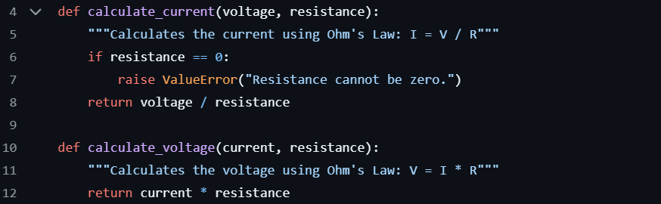

**3.3.Code Explanation**

**calculate_current(voltage, resistance):**

. It calculates the current(I)using Ohm's Law,I=V/R,where V is voltage and R is resistance.

. If resistance is zero, it raises a ValueError to avoid division by zero, as resistance cannot be zero in this context.

**calculate_voltage(current, resistance):**

.It calculates the voltage (V)using V=I*R,where I is current and R is resistance.

These functions implement the basic relationships of Ohm's Law to compute current and voltage.

**4. Melrin Dsouza(Kirchhoff’s current law)**

**4.1 Understanding KCL**

Kirchhoff’s current law states that the algebraic sum of all currents entering and exiting a node must equal zero.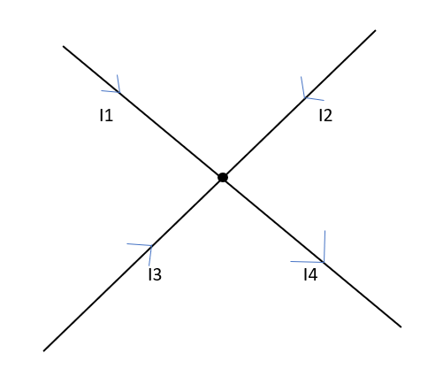

For the above figure the mathematics equation is given as :

I1+I2+I3-I4=0

Where, I1,I2,I3 are the currents entering the nodes and I4 Is the current leaving the node.

**4.2 Implementation of KCL code**

Implemented the computation of sum of currents in a node or a junction in python.

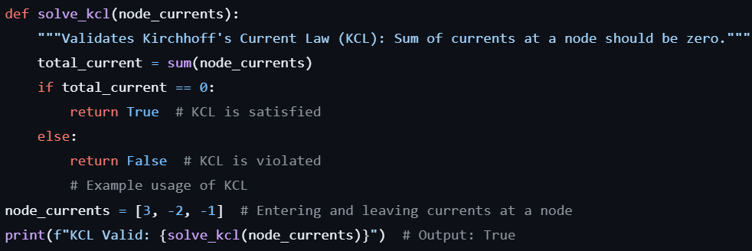

**4.3 KCL code explanation:**

* **total_current :** This calculates the sum of currents entering and leaving the node. If this total current is equal to zero then KCL is true and satisfied otherwise KCL is violated.

**5. K Samba Siva Reddy (Kirchhoff’s Voltage Law - KVL)**

**5.1. Understanding KVL**

Kirchhoff’s Voltage Law (KVL) states that the sum of the electrical potential differences (voltages) around any closed loop or mesh is zero. This is mathematically represented as:

∑i=1nVi=0\sum_{i=1}^{n} V_i = 0i=1∑n​Vi​=0

Where ViV_iVi​ represents the voltage across each element in the circuit.

**5.2. KVL Code Implementation**

I implemented a Python function to compute the sum of voltages around a loop, ensuring it adheres to KVL.

def solve_kvl(loop_voltages):

    """Validates Kirchhoff's Voltage Law (KVL): Sum of voltages in a loop should be zero."""

    total_voltage = sum(loop_voltages)

    if total_voltage == 0:

        return True  # KVL is satisfied

    else:

        return False  # KVL is violated

# Example usage of KVL

loop_voltages = [10, -5, -5]  # Voltages in a closed loop

print(f"KVL Valid: {solve_kvl(loop_voltages)}")  # Output: True

Python

**5.3. Code Explanation**

* **kvl_solver**: This function computes the sum of voltages for a given loop and checks if the total is zero, confirming KVL is satisfied.
* **Example**: If the loop contains voltages of 10V, -5V, and -5V, the sum is 0, meaning the law holds.

This implementation was tested with various sets of data to ensure correctness and accuracy.

**6. Sumanth (Unit Tests for Ohm’s Law and KCL)**

**6.1. Understanding Unit Testing**

Unit testing is essential for verifying that each individual function behaves as expected. It allows us to test the smallest parts of our application independently, ensuring correctness and reliability. Sumanth was responsible for writing unit tests for **Ohm’s Law** and **Kirchhoff's Current Law (KCL)** to ensure they performed correctly under various conditions.

**6.2. Unit Test Implementation for Ohm’s Law & KCL**

For Ohm’s Law, the unit test checks if the implemented code correctly computes voltage, current, or resistance when given the other two variables. KCL, the unit test validates that the sum of currents entering and exiting a node equals zero, which confirms KCL is satisfied.

Python

import unittest

class TestCircuitSolver(unittest.TestCase):

    # Testing Ohm's Law functions

    def test_calculate_current(self):

        self.assertEqual(calculate_current(10, 5), 2)

        self.assertRaises(ValueError, calculate_current, 10, 0)

    def test_calculate_voltage(self):

        self.assertEqual(calculate_voltage(2, 5), 10)

    # Testing KCL

    def test_solve_kcl(self):

        self.assertTrue(solve_kcl([3, -2, -1]))  # Should satisfy KCL

        self.assertFalse(solve_kcl([3, -2, -2]))  # Should violate KCL

# Running the tests

unittest.main(argv=[''], verbosity=2, exit=False)

**6.4. Code Explanation**

* **test_calculate_voltage / current / resistance**: These functions check if Ohm's Law correctly computes voltage, current, or resistance when given appropriate values.
* **test_kcl_satisfied / test_kcl_violated**: These functions validate that KCL holds by checking if the sum of currents at a node is zero.

By writing these tests, Sumanth ensured that the logic implemented for Ohm's Law and KCL would work under various conditions, improving the overall reliability of the project.

**7. Dileepkumar M N (Unit tests for KVL and code refactoring)**

**7.1. Understanding Unit Testing**

Unit testing is essential for verifying that each individual function behaves as expected. It allows us to test the smallest parts of our application independently, ensuring correctness and reliability. Sumanth was responsible for writing unit tests for Ohm’s Law and Kirchhoff's Current Law (KCL) to ensure they performed correctly under various conditions.

**7.2. KVL Code Implementation**

I implemented a Python function to compute the sum of voltages around a loop, ensuring it adheres to KVL.

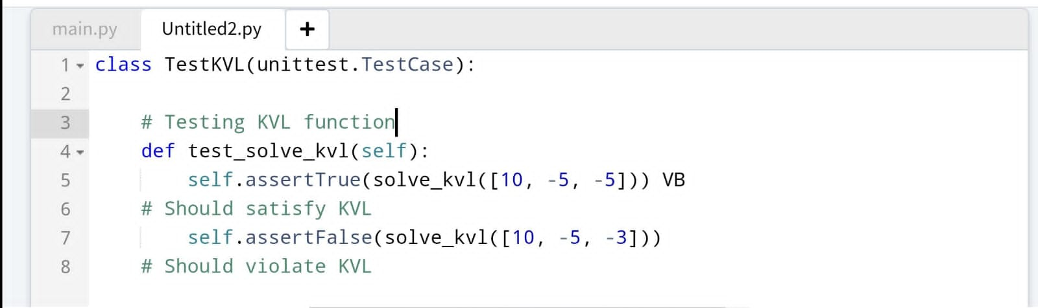

**7.3 Code Explaination**

In the test_solve_kvl method, two assertions are made:

1.self.assertTrue(solve_kvl([10, -5, -5])): This tests a scenario where the sum of the voltages (10 - 5 - 5 = 0) satisfies KVL, expecting the function to return True.

2.self.assertFalse(solve_kvl([10, -5, -3])): Here, the sum (10 - 5 - 3 = 2) does not satisfy KVL, so the test expects the function to return False.

These assertions help ensure that the solve_kvl function behaves correctly under specified conditions.

**8.Rohan K (Repository Manager)**

I was responsible for creating and managing the github repository. It included various aspects like creating a good description of our project in the README file, creating various issues and assigning the various functions to my team. I managed and reviewed all the pull requests made by my teammates. I was also responsible for resolving all the merge conflicts that came into picture while merging various parts of the code. Solving the merge conflicts was one of the major challenges I faced while doing this project as most of the pull requests had the code written in the same lines which led to the conflicts causing errors in the code . 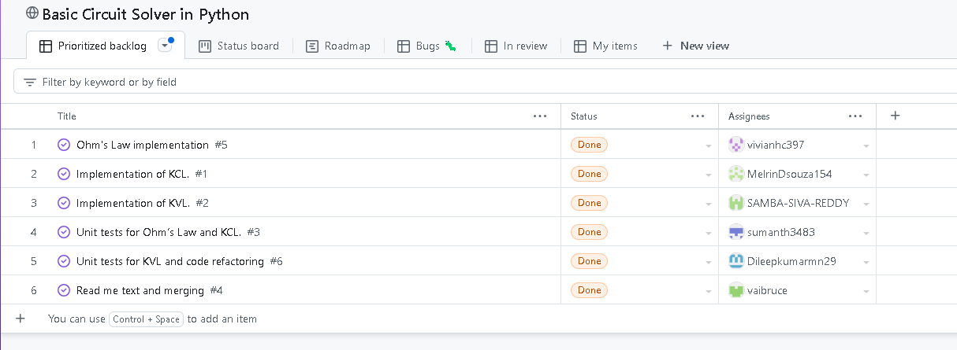

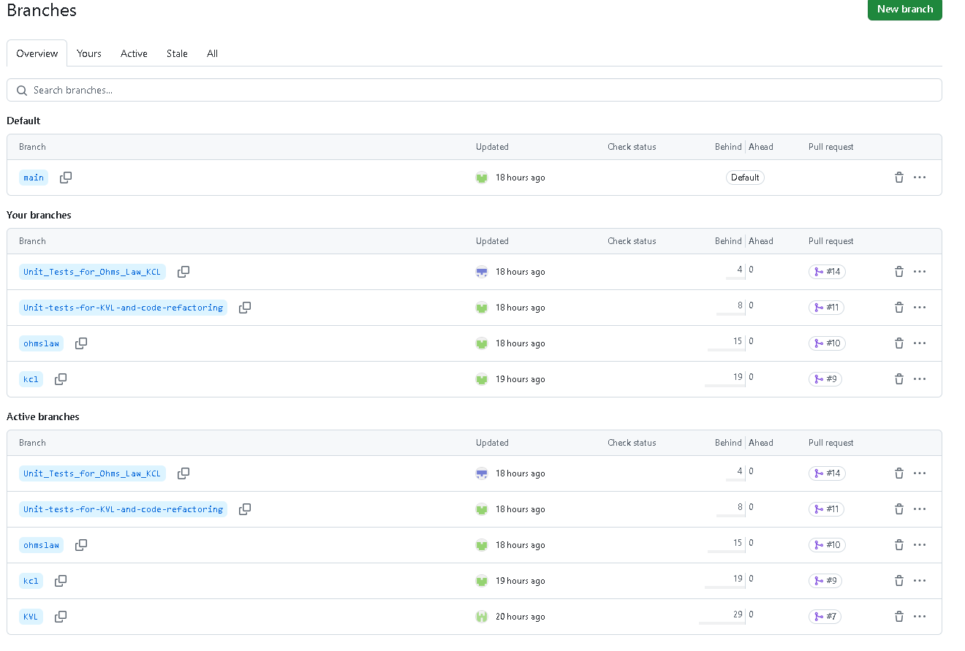

**9. Project Structure and Overall Collaboration**

The repository was structured so that each team member contributed their respective functions. The key divisions were:

* **Person 1 (Ohm’s Law)**: Developed functions for calculating voltage, current, and resistance based on Ohm's Law.
* **Person 2 (KCL)**: Created functions to solve current flow using Kirchhoff’s Current Law.
* **Person 3 (KVL)**: Developed functions to calculate the sum of voltages using Kirchhoff’s Voltage Law (KVL).
* **Person 4:(** **Unit tests for Ohm’s Law and KCL)** Created unit tests for Ohm's Law and KCL implementations to ensure their correctness.
* **Person 5**:**(** **Unit tests for KVL and code refactoring)** Developed unit tests for KVL and also worked on code refactoring to ensure the code was clean, efficient, and free of errors.
* **Person 6 (Repository Manager)**: Managed repository creation, merging all branches, and resolving conflicts.

**10. GitHub Collaboration Process**

The following steps ensured smooth collaboration and final integration:

* **Branching**: Each team member created their branch to avoid conflicts while coding.
* **Pull Requests**: Once code was complete and tested, each team member submitted a pull request.
* **Merging**: The sixth team member merged all branches, ensuring that the code worked together without conflicts.
* **Final Submission**: After merging all the code, the final repository was submitted.

**11 Conclusion**

This project successfully implemented key principles of electrical circuit analysis, including **Ohm’s Law**, **Kirchhoff's Current Law (KCL)**, and **Kirchhoff's Voltage Law (KVL)**, to solve DC circuits using Python. Each team member contributed to the development of a robust circuit solver that handled various aspects of circuit calculations, testing, and user interaction.

We leveraged GitHub as our version control system, allowing seamless collaboration across the team. Each team member worked in individual branches, and the final code was efficiently merged, ensuring a smooth workflow. The use of unit tests and a command-line interface further enhanced the functionality and reliability of the project.

Through strong teamwork, effective version control, and collaborative problem-solving, we were able to develop a comprehensive solution for analysing DC circuits. This project demonstrates the power of Python for solving real-world electrical engineering problems while showcasing the importance of collaborative development using modern tools like GitHub.