ALFIDO TECH INTERNSHIP
Task 3: Data Analysis with Pandas
Python Developer Internship
Author | [Your Name]
Internship | Alfido Tech - Python Developer
Task | Task 3 of 3
Dataset | Student Grades & Performance
Date | April 2026

1. Objective
The goal of this task is to demonstrate data analysis skills using the Pandas library in Python. A real-world style CSV dataset of 30 student records is loaded, cleaned, and analysed. The task covers loading and inspecting the dataset, handling missing values, filtering and grouping data, and summarising key insights in simple terms.

2. Dataset Overview
The dataset used is students.csv — a custom dataset containing academic records for 30 students. It was intentionally designed with some missing values to practise data cleaning.

Column | Description | Type
student_id | Unique ID for each student | Integer
name | Full name of the student | String
gender | Male or Female | String
age | Age of the student (16–18) | Integer
math_score | Score in Mathematics (0–100) | Float
science_score | Score in Science (0–100) | Float
english_score | Score in English (0–100) | Float
attendance_% | Percentage of classes attended | Float
grade | Final grade: A, B, C, D, or F | String

Missing values: math_score, science_score, and english_score each had 2 missing entries. The attendance_% column had a whitespace formatting issue for one record.

3. Tools & Libraries Used
Tool / Library | Purpose
Python 3.x | Core programming language
pandas | Data loading, cleaning, filtering, grouping, and aggregation
students.csv | Custom dataset with 30 student academic records

4. Code Explanation

4.1 Step 1 — Load and Inspect the Dataset
The CSV file is loaded into a Pandas DataFrame using pd.read_csv(). The script then inspects the data using .head(), .shape, .dtypes, .describe(), and .isnull().sum() to understand the structure and spot any issues before cleaning.
df = pd.read_csv("students.csv")

print(df.head()) # First 5 rows
print(df.shape) # (30, 9)
print(df.dtypes) # Column data types
print(df.describe()) # Basic statistics
print(df.isnull().sum()) # Missing value count per column

4.2 Step 2 — Clean Missing or Incorrect Data
Missing scores are filled with the median value of each column. The median is preferred over the mean here because it is not affected by extreme scores. The attendance_% column had a stray whitespace entry which is stripped and converted to a numeric type. Any remaining missing grades are filled with 'F'.
# Fill missing scores with column median
for col in ["math_score", "science_score", "english_score"]:
median_val = df[col].median()
df[col] = df[col].fillna(median_val)

# Fix attendance column — strip spaces, convert to float
df["attendance_%"] = df["attendance_%"].astype(str).str.strip()
df["attendance_%"] = pd.to_numeric(df["attendance_%"], errors="coerce")
df["attendance_%"] = df["attendance_%"].fillna(df["attendance_%"].median())

# Fill missing grades
df["grade"] = df["grade"].fillna("F")

4.3 Step 3 — Filtering, Grouping & Aggregation
After cleaning, several analyses are performed on the data:
- Filtering: Students with Grade A are isolated to identify top performers. Students with attendance below 70% are flagged as at-risk.
- Average score: A new average_score column is calculated across all three subjects for each student.
- Grouping by Grade: df.groupby('grade') computes average scores per grade group to compare performance tiers.
- Grouping by Gender: df.groupby('gender') reveals whether there is a performance difference between male and female students.
- Aggregation: .agg(['mean', 'min', 'max', 'std']) summarises each subject's statistics in one table.
- Grade distribution: .value_counts() counts how many students fall into each grade category.

# Filter top students
top_students = df[df["grade"] == "A"]

# Average score per student
df["average_score"] = df[["math_score", "science_score", "english_score"]].mean(axis=1).round(2)

# Group by grade
grade_group = df.groupby("grade")[["math_score", "science_score", "english_score"]].mean().round(2)

# Group by gender
gender_group = df.groupby("gender")[["math_score", "science_score", "english_score"]].mean().round(2)

# Subject-wise aggregation
subject_stats = df[["math_score", "science_score", "english_score"]].agg(["mean", "min", "max", "std"]).round(2)

4.4 Step 4 — Insights Summary
The final step prints a clean summary of the most important findings extracted from the data, including the top and lowest performing students, the strongest and weakest subjects, and overall class statistics.
top_student = df.loc[df['average_score'].idxmax(), 'name']
low_student = df.loc[df['average_score'].idxmin(), 'name']
best_subject = df[['math_score','science_score','english_score']].mean().idxmax()
weak_subject = df[['math_score','science_score','english_score']].mean().idxmin()

5. Results & Analysis

5.1 Grade Distribution
Grade | Number of Students | Percentage
A | 11 | 37%
B | 9 | 30%
C | 5 | 17%
D | 3 | 10%
F | 2 | 7%

5.2 Average Scores by Grade
Grade | Math | Science | English | Overall Avg
A | 89.91 | 91.09 | 92.36 | 91.12
B | 75.22 | 75.94 | 76.78 | 75.98
C | 59.40 | 62.60 | 57.80 | 59.93
D | 47.67 | 52.33 | 57.50 | 52.50
F | 58.50 | 62.25 | 58.75 | 59.84

5.3 Average Scores by Gender
Gender | Math | Science | English | Overall Avg
Female | 85.88 | 87.59 | 88.59 | 87.36
Male | 60.64 | 62.75 | 62.04 | 61.81

5.4 Subject-wise Statistics
Statistic | Math | Science | English
Mean | 74.10 | 76.00 | 76.20
Min | 40.00 | 45.00 | 38.00
Max | 96.00 | 98.00 | 98.00
Std Dev | 16.12 | 15.16 | 17.02

6. Output Screenshots & Explanation
The following screenshots show the script running in the VS Code terminal. Add your screenshots in the placeholders below.

Screenshot 1 — Dataset Load & Inspection
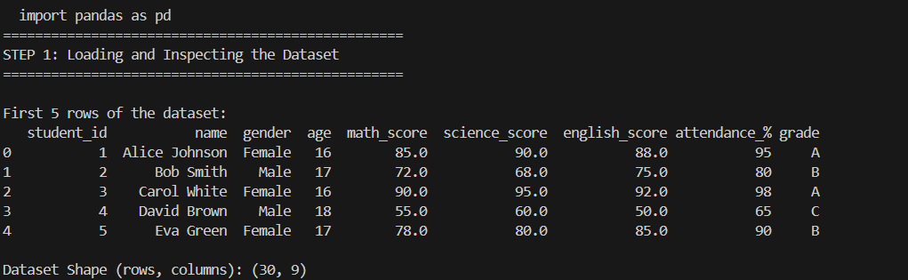

Screenshot 2 — Data Cleaning Output
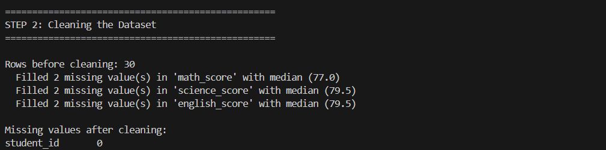

Screenshot 3 — Filtering, Grouping & Aggregation
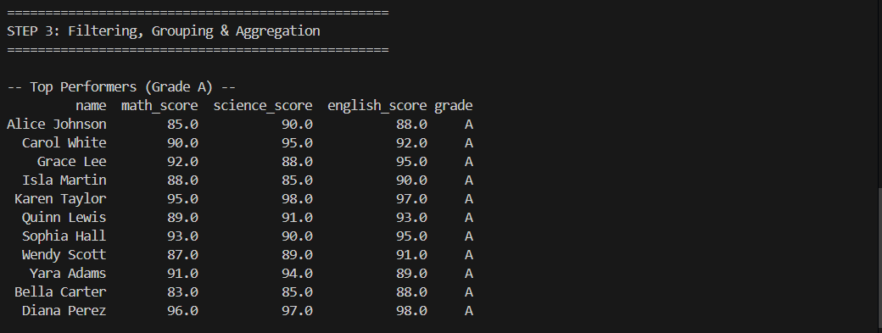

Screenshot 4 — Insights Summary
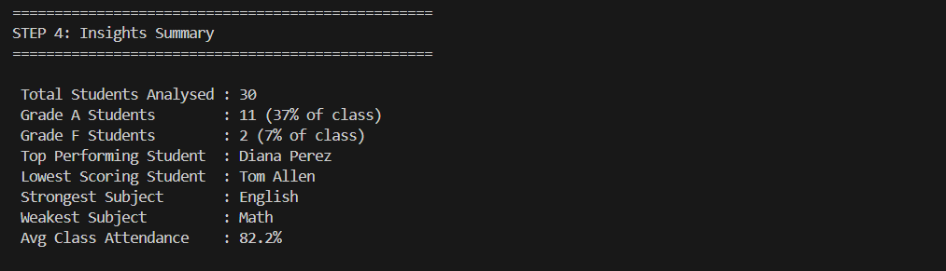

7. Key Insights
- 37% of students (11 out of 30) achieved Grade A, showing a strong performing class overall.
- Diana Perez is the top performer with the highest average score across all three subjects.
- Tom Allen scored the lowest overall and also had the worst attendance at 50%.
- Female students outperformed male students significantly — 87.36 average vs 61.81 average.
- 6 students had attendance below 70%, and all of them received a grade of C or below.
- English had the highest average score (76.20) while Math had the lowest (74.10).
- The wide standard deviation (~16) across all subjects indicates a large spread in student performance.

8. Key Learnings
- pd.read_csv() loads a CSV file into a DataFrame in a single line, making data access very easy
- df.isnull().sum() is the quickest way to find missing values before starting any analysis
- Filling missing values with the median is more robust than the mean when the data contains outliers
- str.strip() and pd.to_numeric() are essential for cleaning messy real-world data
- df.groupby() combined with .mean() makes it simple to compare groups like grades or genders
- .agg() allows running multiple statistics like mean, min, max, and std in a single line
- Low attendance and low grades are closely linked — a pattern that real data confirmed in this dataset

9. GitHub Repository
GitHub Link: https://github.com/[your-username]/Alfido-Tech-Internship

