ALFIDO TECH INTERNSHIP
Task 1: Python File Handling & Automation
Python Developer Internship
Author | [Your Name]
Internship | Alfido Tech - Python Developer
Task | Task 1 of 3
Date | April 2026

1. Objective
The goal of this task is to understand Python's file handling capabilities and automate common file operations. This includes creating, reading, renaming, moving, and deleting files programmatically, while applying professional exception handling using try-except-finally blocks to ensure robust and error-safe execution.

2. Tools & Libraries Used
Tool / Library | Purpose
Python 3.x | Core programming language
os | File and directory operations (rename, remove, mkdir, path checks)
shutil | High-level file operations such as moving files between directories

3. Concepts Used
Concept | Explanation
File Writing | Opens a file in write mode ('w') and writes text content line by line
File Reading | Opens the file in read mode ('r') and reads the full content
File Renaming | Uses os.rename() to rename a file without creating a new copy
Directory Creation | Uses os.makedirs() to create a folder if it does not exist
File Moving | Uses shutil.move() to relocate a file to a specified directory
File Deletion | Uses os.remove() to permanently delete a file from the system
Exception Handling | try-except-finally block catches FileNotFoundError, PermissionError, and general exceptions

4. Code Explanation

4.1 Importing Libraries
Two standard Python libraries are imported at the top of the script:
import os
import shutil
os handles low-level file and directory operations, while shutil provides higher-level file management utilities like moving files.

4.2 Writing Data to a File
The script opens (or creates) a file named sample.txt in write mode and writes two lines of text into it. The with statement ensures the file is properly closed after writing, even if an error occurs.
with open("sample.txt", "w") as file:
file.write("This is a sample file created using Python.\n")
file.write("This demonstrates file handling operations.\n")

4.3 Reading Data from the File
The file is reopened in read mode and its entire contents are loaded and printed to the terminal. This confirms the write operation succeeded.
with open("sample.txt", "r") as file:
content = file.read()
print("File Content:\n", content)

4.4 Renaming the File
os.rename() is used to give the file a new name. The original file (sample.txt) no longer exists after this operation — it has been renamed to renamed_sample.txt.
os.rename("sample.txt", "renamed_sample.txt")

4.5 Moving the File to a Folder
A destination folder named processed_files is created if it does not already exist. shutil.move() then relocates the renamed file into that folder.
folder_name = "processed_files"
if not os.path.exists(folder_name):
os.mkdir(folder_name)
shutil.move("renamed_sample.txt", f"{folder_name}/renamed_sample.txt")

4.6 Deleting the File
os.remove() deletes the file from the processed_files folder, leaving the directory empty. This completes the full lifecycle of the file — create, read, rename, move, delete.
file_path = f"{folder_name}/renamed_sample.txt"
os.remove(file_path)

4.7 Exception Handling
The entire operation is wrapped in a try-except-finally block that handles three specific scenarios:
Exception | What It Handles
FileNotFoundError | Raised when the script tries to read, rename, move, or delete a file that does not exist
PermissionError | Raised when the script lacks the necessary OS-level permissions to access the file
Exception (general) | Catches any other unexpected error and prints the error message

The finally block always runs, regardless of success or failure, and prints a completion message — a standard practice for cleanup and logging.

5. Complete Code
# Python File Handling & Automation Script

import os
import shutil

try:
print("Creating and writing to file...")
with open("sample.txt", "w") as file:
file.write("This is a sample file created using Python.\n")
file.write("This demonstrates file handling operations.\n")
print("File written successfully.\n")

print("Reading file content...")
with open("sample.txt", "r") as file:
content = file.read()
print("File Content:\n", content)

print("Renaming file...")
os.rename("sample.txt", "renamed_sample.txt")
print("File renamed to renamed_sample.txt\n")

folder_name = "processed_files"
if not os.path.exists(folder_name):
os.mkdir(folder_name)
shutil.move("renamed_sample.txt", f"{folder_name}/renamed_sample.txt")
print("File moved to processed_files folder.\n")

file_path = f"{folder_name}/renamed_sample.txt"
os.remove(file_path)
print("File deleted successfully.\n")

except FileNotFoundError:
print("Error: The file was not found.")

except PermissionError:
print("Error: Permission denied while accessing the file.")

except Exception as e:
print("An unexpected error occurred:", e)

finally:
print("File handling operations completed.")

6. Output Screenshots & Explanation
The following screenshots demonstrate the script running successfully in the terminal. Add your screenshots in the placeholders below.

Screenshot 1 — Script Execution — File Write & Read
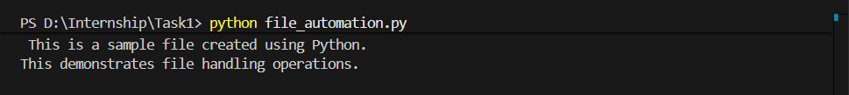

Screenshot 2 — Rename, Move, Delete & Completion
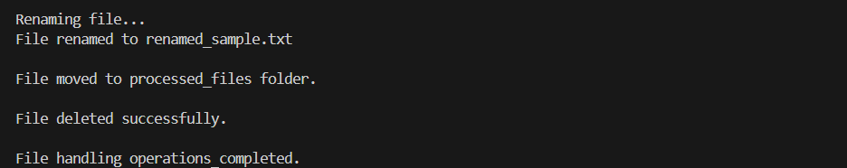

7. File Operations Summary
Step | Operation | Function Used | Result
1 | Create & Write | open() with 'w' mode | sample.txt created with 2 lines
2 | Read | open() with 'r' mode | Contents printed to terminal
3 | Rename | os.rename() | Renamed to renamed_sample.txt
4 | Move | shutil.move() | Moved to processed_files/
5 | Delete | os.remove() | File permanently removed

8. Key Learnings
- Python's open() function with different modes ('r', 'w', 'a') controls how a file is accessed
- The with statement (context manager) ensures files are closed automatically after use, preventing resource leaks
- os.rename() and os.remove() provide direct control over file names and deletion at the OS level
- shutil.move() is safer than manually copying and deleting when relocating files
- os.path.exists() prevents errors by checking whether a folder already exists before creating it
- Wrapping file operations in try-except-finally makes scripts resilient to missing files, permission issues, and unexpected failures
- The finally block is the right place for cleanup code that must always run regardless of success or error

9. GitHub Repository
GitHub Link: https://github.com/vaidai01/File_Automation.git

